PROTOTYPE:

ANALOG CIRCUIT – LOW PASS FILTER

**1. Simulation Results:**

Components required

* Breadboard: 1
* CRO 20/30Mhz: 1
* Capacitors:
* Resistors:
* Op-amp
* Power supply
* Connecting wires
* Probe: 2

Firstly, Simulation Setup: Assemble the low pass filter circuit on the breadboard. Connect CRO channel one for input signal and channel two for output signal. Apply input signals of different frequencies and amplitudes.4. Observe the output waveform and measure relevant parameters.

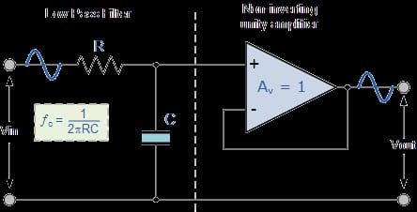

Top of Form

Bottom of Form

**2.Key Aspects of the Simulation:**

* Attenuation of high-frequency components in the output signal.
* Cutoff frequency and Rolloff characteristics.
* Phase shift introduced by the filter.

**3. Hardware Results:**

* Implement the low pass filter prototype on the breadboard.
* Measure the output waveform and relevant parameters.
* Record observations regarding performance and deviations from simulation.

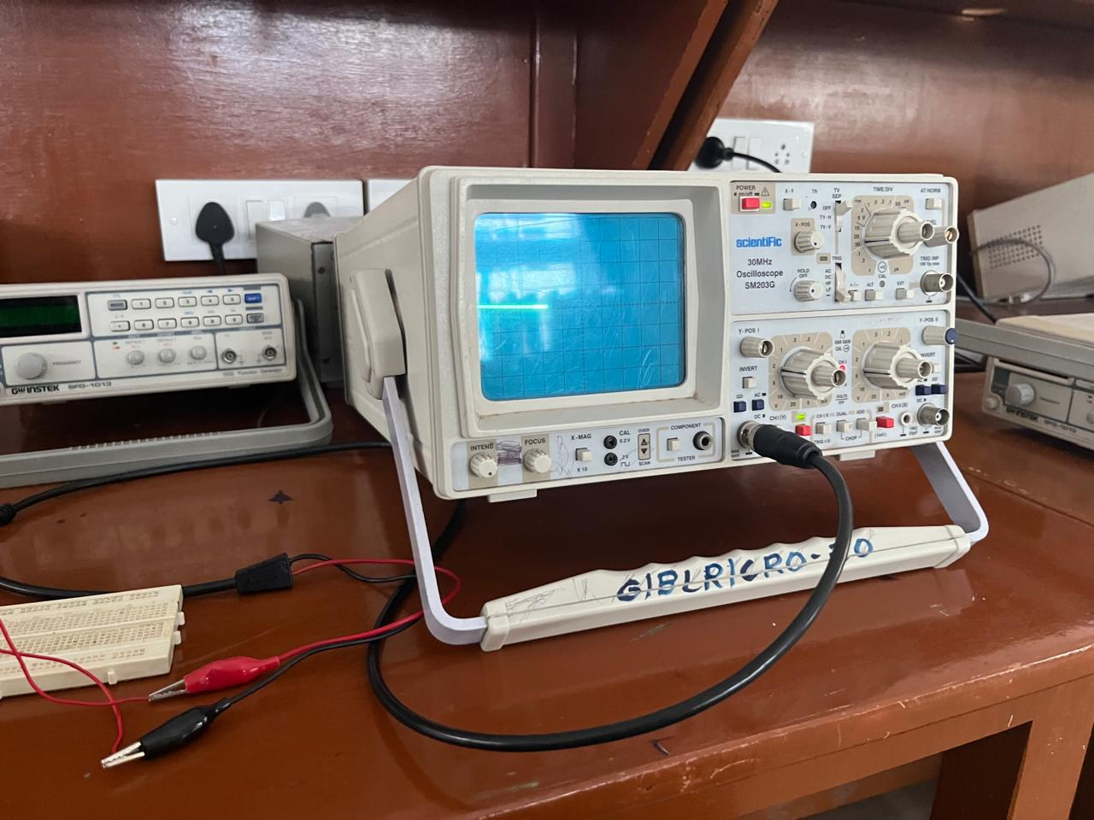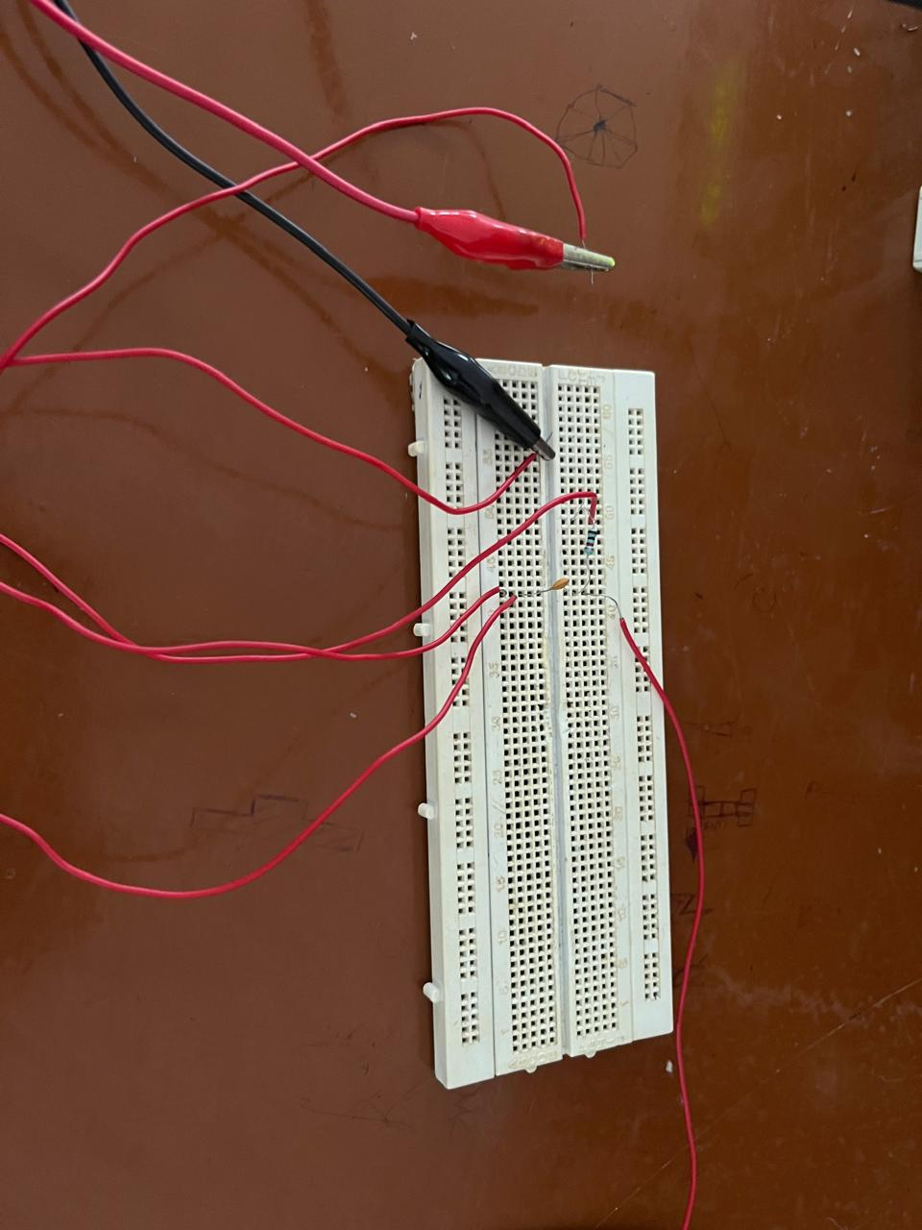

**4. Comparison of Simulation and Hardware Results:**

**Simulation Results:**

* Attenuation characteristics at different frequencies.
* Cutoff frequency accuracy.
* Phase shift analysis.

**Hardware Results:**

* Differences due to component tolerances.
* Deviations from ideal behaviour due to non-idealities.
* Possible discrepancies in frequency response.

**5.Design finalization:**

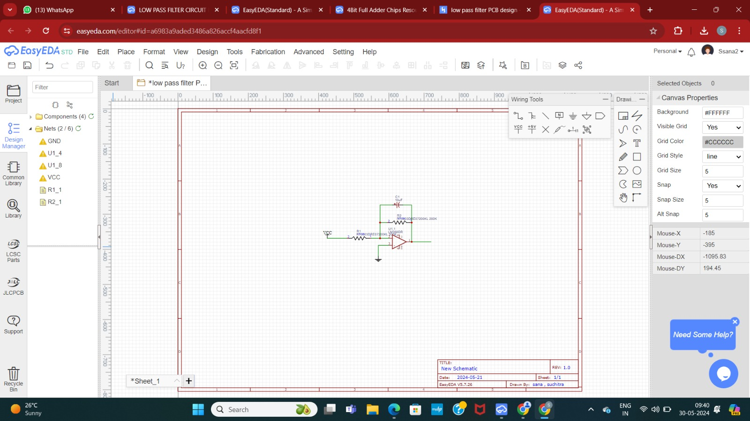

**6.Circuit building on Easy EDA tools:**

* In Easy EDA Software draw the circuit accordingly



* Then save the circuit and Convert schematic to PCB
* Then arrange the components and auto route so that it will arrange accordingly

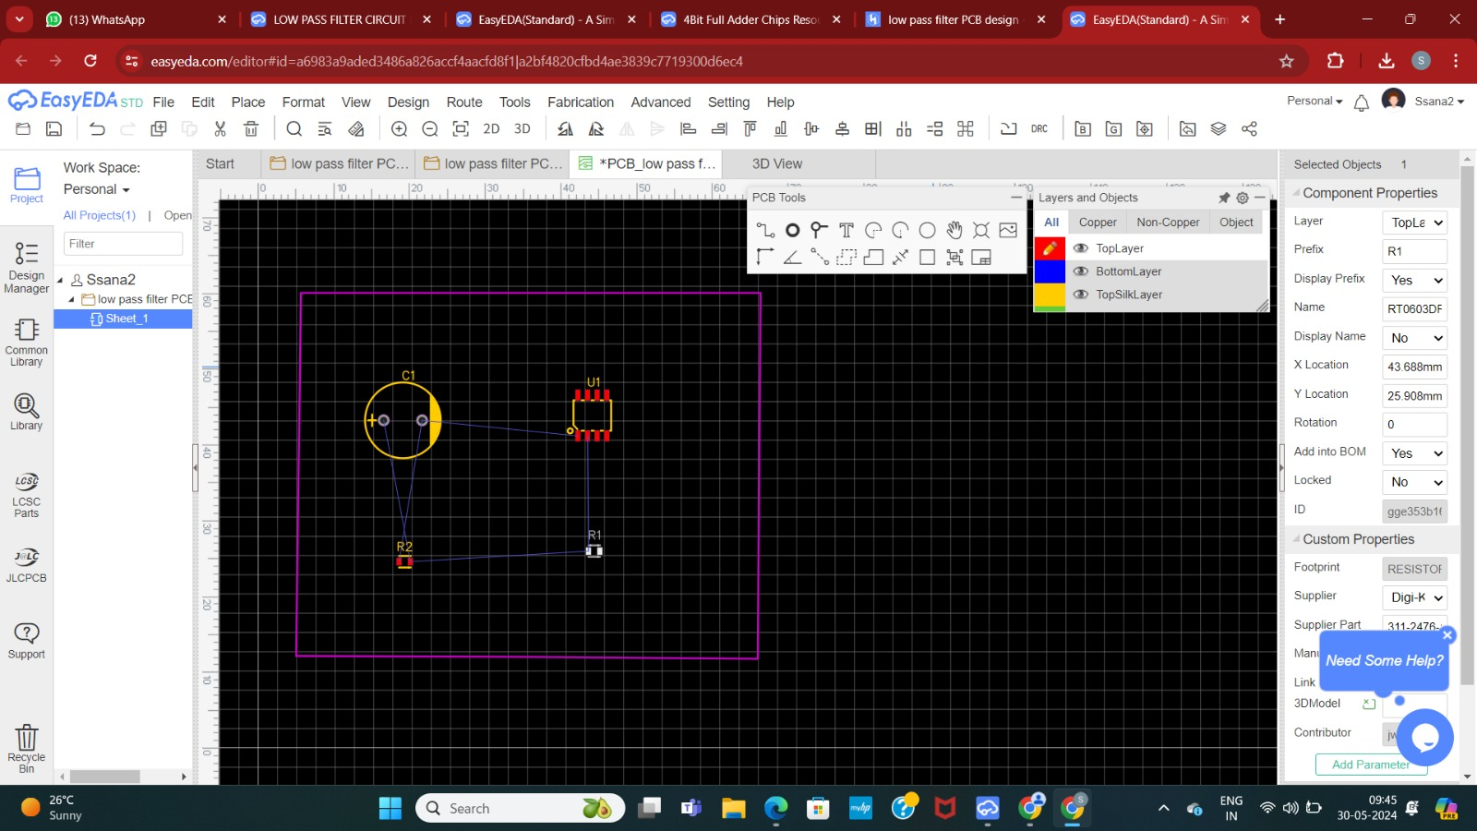

* Change PCB to any 2D and 3D model view

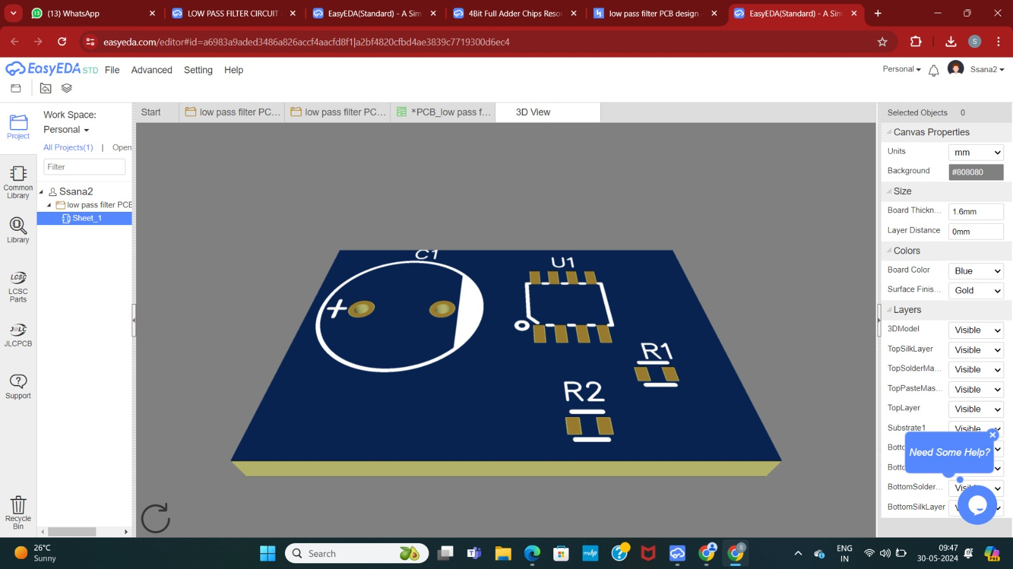

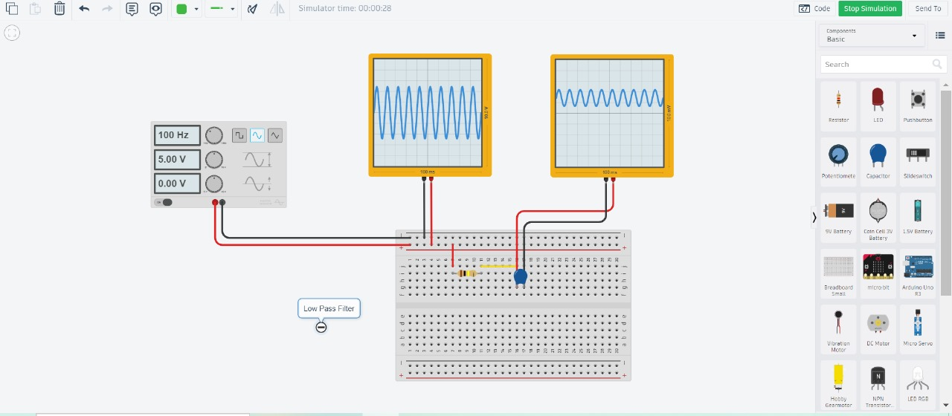

**7. PCB Designing on Easy EDA Tools:**

* Design the schematic of the low pass filter circuit.
* Convert the schematic to a PCB layout.
* Place components considering space constraints and routing requirements.
* Use auto route for optimal trace connections.
* Verify the design in 2D and 3D models.
* Insert mounting holes as necessary.

**8. Verification of the Final Design:**

* + Perform Design Rule Check (DRC) to ensure layout compliance with manufacturing constraints.
  + Verify the functionality of the low pass filter circuit on the PCB prototype