**PROTOTYPE: DIGITAL CIRCUIT – HALFADDER**

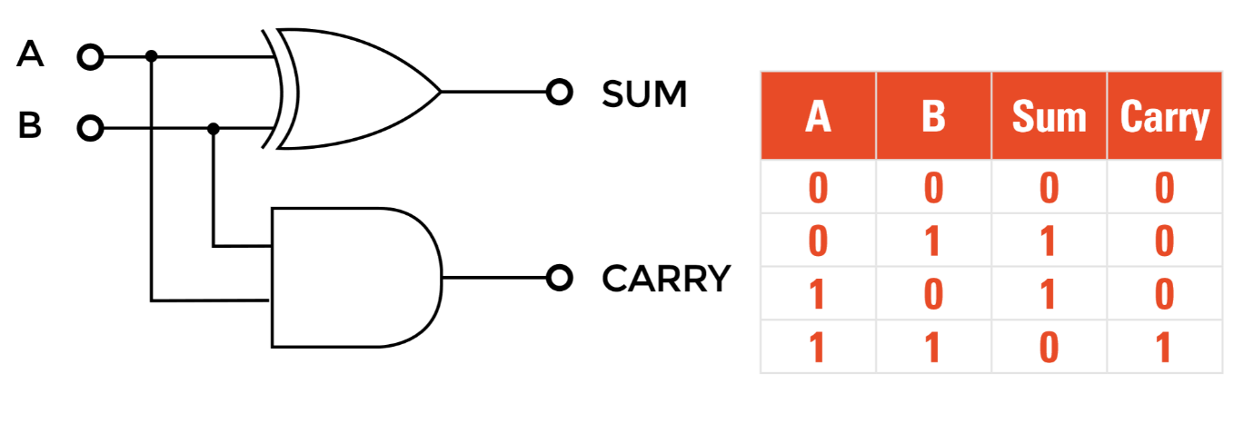

**1. Simulation Results:**

Components required –

- Breadboard: 1

- Logic Gates (AND, XOR)

- Power supply (5V DC)

- LEDs for output indication :2

- Connecting wires

- Probes: 2 (for CRO usage)

Simulation Setup:

1. Assemble the half adder circuit on the breadboard.

2. Connect the power supply to the logic gates.

3. Connect the inputs of the half adder to switches.

4. Connect the outputs to LEDs for visual indication.

5. Apply all possible combinations of input signals (00, 01, 10, 11).

6. Observe and record the output states of the SUM and CARRY.

Key Aspects of the Simulation:

- Correct functionality of the half adder (truth table verification).

- Accurate generation of SUM and CARRY outputs.

- Ensure proper power and ground connections.

**2. Hardware Results:**

- Implement the half adder prototype on the breadboard.

- Apply the same input combinations (00, 01, 10, 11).

- Measure and record the output states.

- Compare the observed outputs with the expected results from the truth table.

**3. Comparison of Simulation and Hardware Results:**

Simulation Results:

- Verify the truth table:

- Inputs 00 -> SUM 0, CARRY 0

- Inputs 01 -> SUM 1, CARRY 0

- Inputs 10 -> SUM 1, CARRY 0

- Inputs 11 -> SUM 0, CARRY 1

- Check the response times of the gates.

**4.Implementation of circuit in TinkerCAD:**

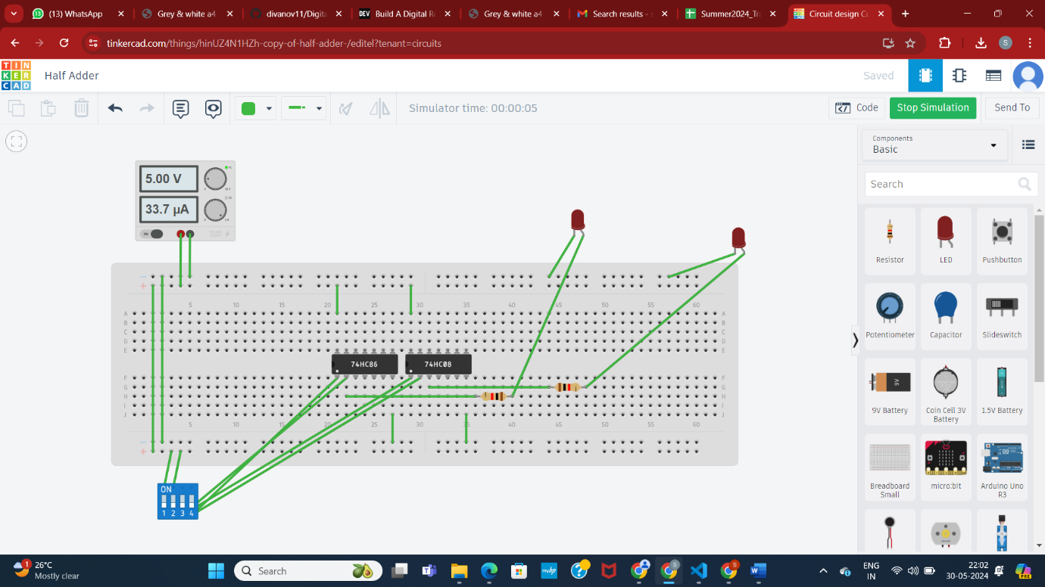

**4. PCB Designing on Easy EDA Tools:**

1. Design the schematic of the half adder circuit.

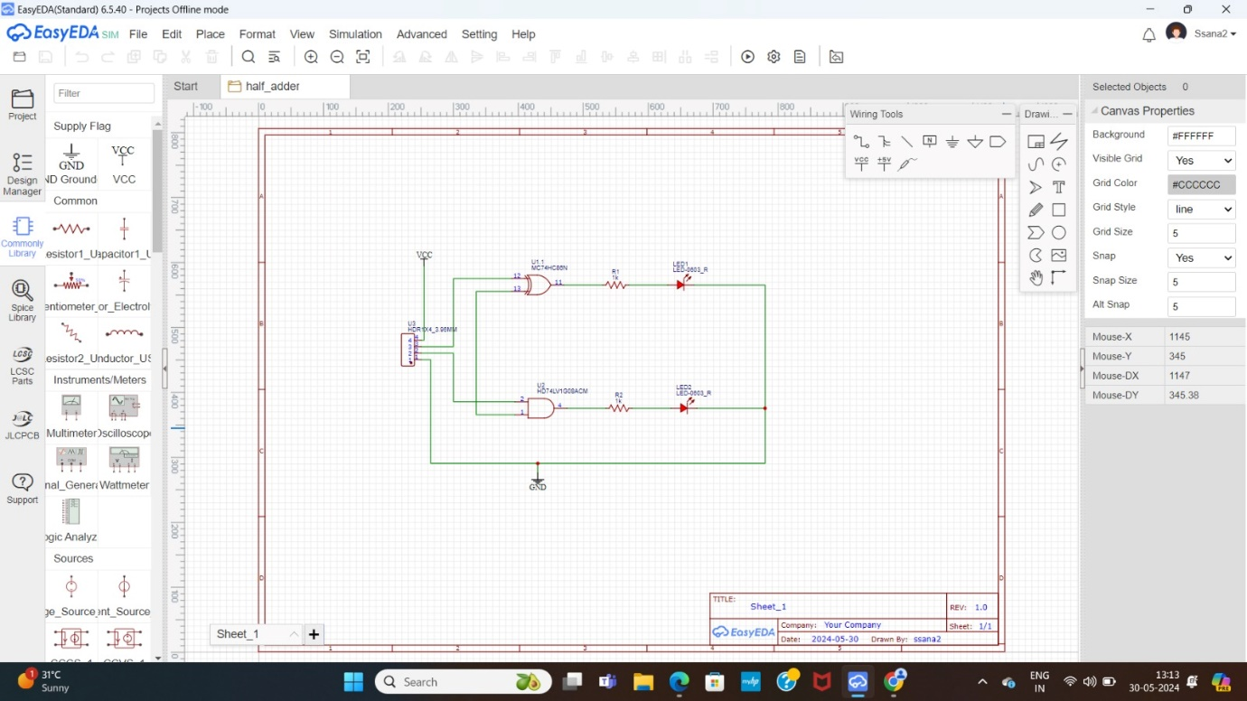

2. Convert the schematic to a PCB layout.

3. Place components considering space constraints and routing requirements.

4. Use auto route for optimal trace connections.

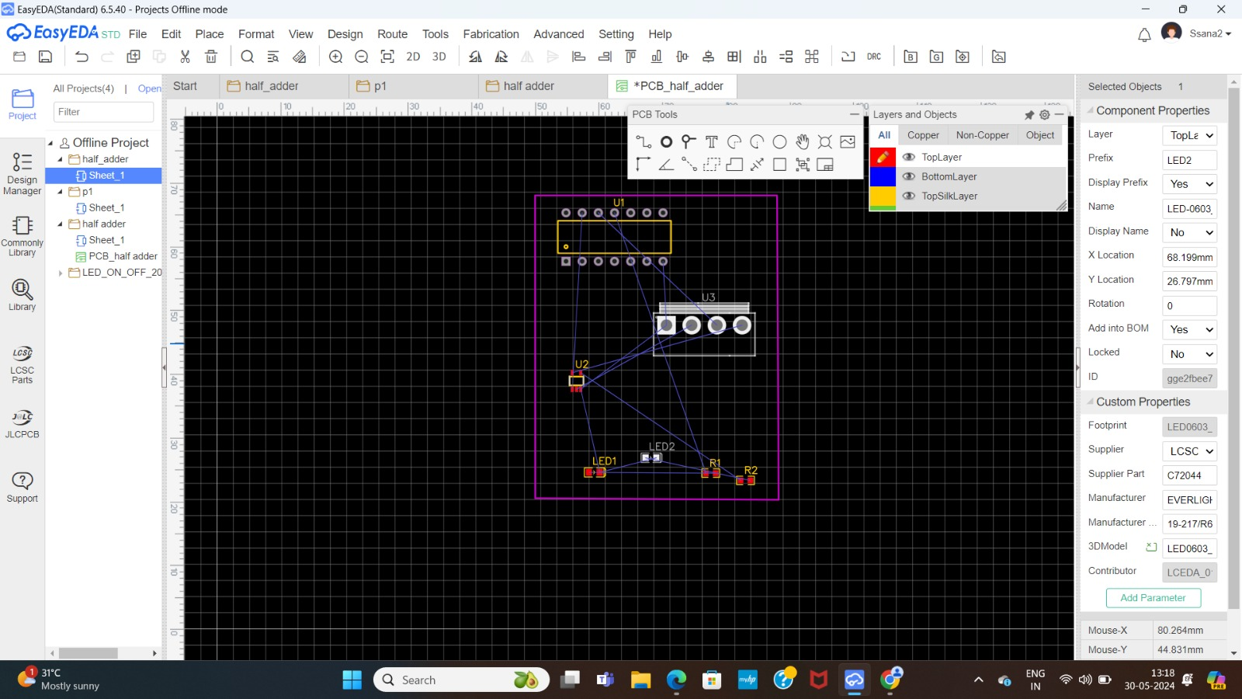

5. Verify the design in 2D and 3D models.

6. Insert mounting holes as necessary.

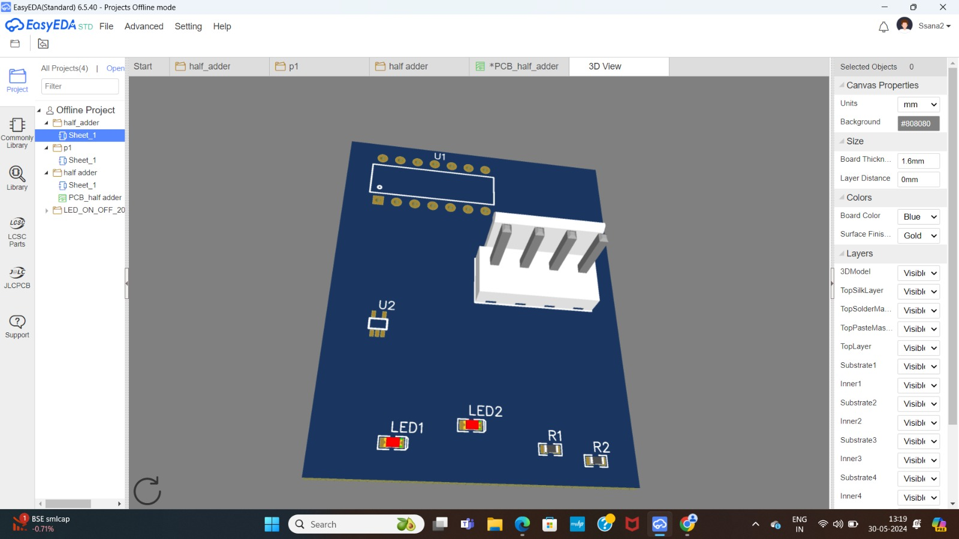

**Result:**

PCB Design generated using EasyEDA and the results are verified by Hardware Analysis.