Czechoslovakia Banking Data Analysis (1993–1998)

Dataset Overview
This project uses the Czechoslovakia Bank Dataset sourced from GitHub.
The dataset spans 1993 to 1998 and provides insights into customer demographics, account behaviour, credit card usage, loan patterns, and transaction activity across different regions.
The analysis focuses on:
- Account distribution by gender and age group
- Credit card ownership by card type and customer role
- Loan patterns by duration, status, and region
- Transaction behaviour across accounts and banks

Data Cleaning & Transformation (Power Query)

Account Table
- Standardized column names (e.g., Account_type → account_type)
- Converted account type values to uppercase
- Extracted year, month, day from the date column
- Dropped original date column

Card Table
- Extracted year, month, day, and time from issue date
- Reset data types (integer & time)
- Converted card type values to uppercase
- Removed redundant issued column

Client Table
- Created gender column using Czech birth number logic (month > 50 → Female)
- Extracted year, month, day from birth number
- Created age and age group columns
Age Groups:
- 0–14: Children
- 15–24: Youth
- 25–64: Adults
- 65+: Seniors
- Dropped original birth_number column

Loan Table
- Created loan_type column
  - A → Good Debt
  - B, C, D → Bad Debt
- Extracted loan_year and loan_month

District Table
- Renamed coded columns to meaningful names
(district_code, district_name, region, population, cities, avg_salary, crime data)
- Removed unnecessary columns
- Standardized region names to uppercase

Order Table
- Renamed Bank_to → bank_to
- Converted values to lowercase

Data Model & Relationships (Power Pivot)

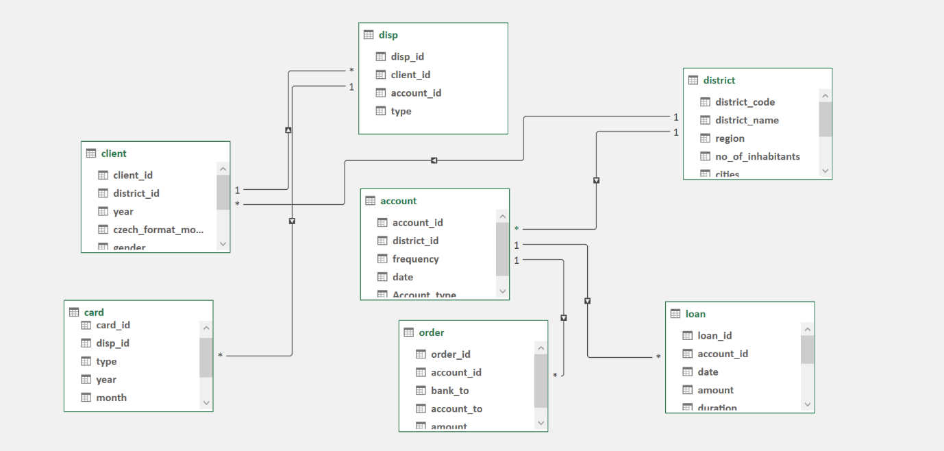
The Account table serves as the parent table and is connected to:
- Loan
- Order
- District
The District table further connects to:
- Client
- Disp
- Card
All relationships are established using primary and foreign keys, enabling integrated, cross-table analysis.

Dashboard Insights

Key KPIs
- Total Accounts: 4,500
- Unique Customers: 5,363
- Credit Cards Issued: 892
- Total Loan Amount: 103,261,740
- Average Loan Amount: 151,410
- Average Salary: 9,032
Average loan amount is significantly higher than average salary, indicating higher credit exposure.

Customer & Account Insights
- Male and female card ownership is nearly equal
- Adults are the dominant credit card holders
- 84% accounts are owner-type; 16% are user-type
- Saving and NRI accounts are most common
- Good loans: 30% | Bad loans: 70% → increased credit risk
- Classic cards dominate (74%), followed by Junior (16%) and Gold (**10%)

Geographic Insights
- Hl. m. Praha has the highest card holders (554)
- North & South Moravia have the highest account and loan volumes
- Bohemia region has the lowest credit card penetration
- Account distribution is uneven across cities

Loan & Transaction Insights
- Total Loans: 682
- Total Amount Transferred: 21,228,993
- Long-duration loans (4–5 years) dominate
- Loan growth spiked sharply in 1994 (510%), followed by a decline in 1995
- Gradual recovery observed from 1996–1998
- Peak loan activity in May, June, and December
- October shows the weakest loan growth

Strategic Observations
- High proportion of bad loans increases credit risk
- Opportunity to convert users to owners
- Untapped potential among youth customers
- Growth opportunity in Gold card segment

