**Command and Data Handling**

The command and data handling (CDH) subsystem is responsible for receiving commands, collecting and processing data, ensuring communication between different subsystems, and providing telemetry data of the satellite. As seen in Figure 1, the CDH subsystem acts as the brain of the satellite. A carrier RF signal modulates the base band signal that transmits the encoded command and message to the satellite. The signal is captured by the spacecraft’s receiver and modulator, which then demodulates the command message and transmits it to the decoder. The decoder decodes the message to generate an output after the command logic validates the command. When the command is validated, the command logic activates the relevant interface circuitry to carry out the command (Perez, 1998).

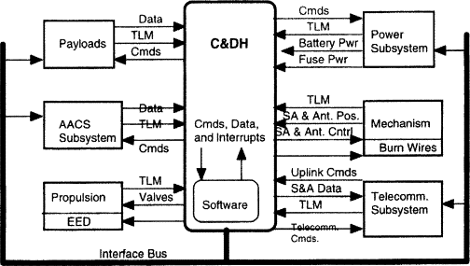

Figure : An overview of the CDH subsystem

The CDH system for SOS-CUBE will have components including the Onboard Computer (OBC), a data storage unit, communication interfaces, telemetry system, and software components. For the OBC, ARM Cortex-M4 microcontroller of [STM32L4+](https://www.st.com/en/microcontrollers-microprocessors/stm32l4-plus-series.html?icmp=tt20277_gl_lnkon_mar2021) series will be used as the processor. STM32L4+ is a single-core, low-power, high-performance microcontroller with 512-2048 kB of flash storage, 320-640 kB of RAM and 120 MHz speed. This microcontroller provides plenty of storage for mission data and logging as well as has enough RAM to ensure smooth operation.

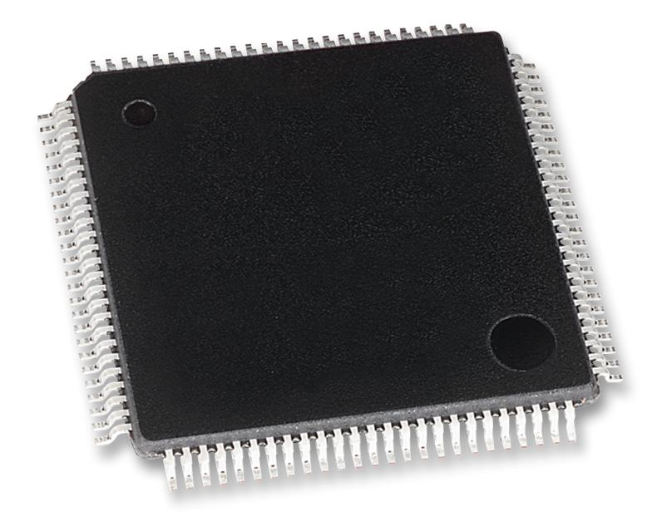

Figure : STM32L4+ microcontroller

VxWorks operating system will be used because the mission requires a Real-Time Operating System (RTOS). VxWorks is an ideal choice for critical missions and is cost-effective and has high-performance capabilities. For storing data, NAND flash will be the primary storage for critical data. Additionally, microSD card slots can be used for expanding storage. Using RAID 10 configuration will ensure that there is data protection, no data loss, and low access time. As seen in Figure 3, RAID 10 combines RAID 0 and RAID 1. RAID 0 allows twice the amount of read-write operations to be performed at the same time, significantly decreasing access time. RAID 1 duplicates all the data to minimize data loss and data fault. However, unlike other RAID configurations, RAID 10 configuration requires a minimum of 4 disks.

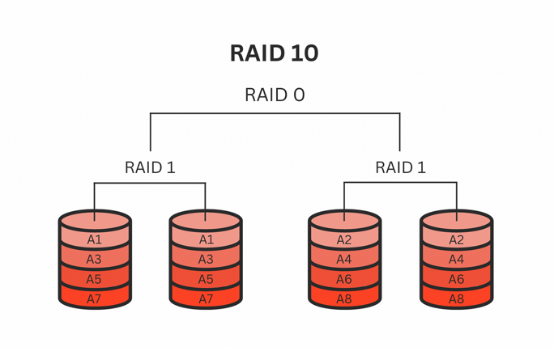

Figure : RAID 10 configuration

For the telemetry system, data will be gathered from multiple sensors including thermal sensors, attitude sensors, and health sensors, and broadcast the satellite health status to the main ground station using a beacon. The CDH system will also be able to send commands to actuators that will be responsible for attitude control. The flight software will be responsible for decoding and executing commands received from the ground station, and collecting, storing, and processing data from the payloads as well as the subsystems. The flight software will decode and execute commands received from the ground station using a command decoder based on the Consultative Committee for Space Data Systems (CCSDS) protocol. An RTL-SDR based receiver will be used for decoding telemetry information. The data will be processed using algorithms that filter, calibrate, and compress information before storage in the onboard memory. It is also important for the flight software to provide acknowledgment signals to the ground station to notify whether a command has been executed successfully or not.

Finally, the CDH will be integrated with other subsystems such as the thermal control to ensure that it operates within optimal temperature limits, the EPS to ensure it operates within the power budget, and ADCS to provide data from attitude sensors.

The ISIS Onboard Computer (IOBC) is a high-performance processing unit tailored for CubeSat missions. It includes on-board telemetry, a fail-safe file system, and a flexible daughterboard architecture for additional interfaces. It is compact and weighs less than 100 grams. It uses FreeRTOS operating system, which is a real-time operating system, making it ideal for our mission. Its architecture supports various communication protocols and interfaces, as well as provides compatibility with subsystems. It operates on 3.3V power supply and can operate between -25 and +65 degree Celsius. The average power consumption of IOBC is 400mW. It offers 512 KB of fRAM which is used for critical data storage and allocates two slots for any size standard SD card which is used to store mass data. Additionally, its proven reliability in space missions enhance the overall mission success rate, making it an ideal for managing and processing data within the SOS-CUBE.

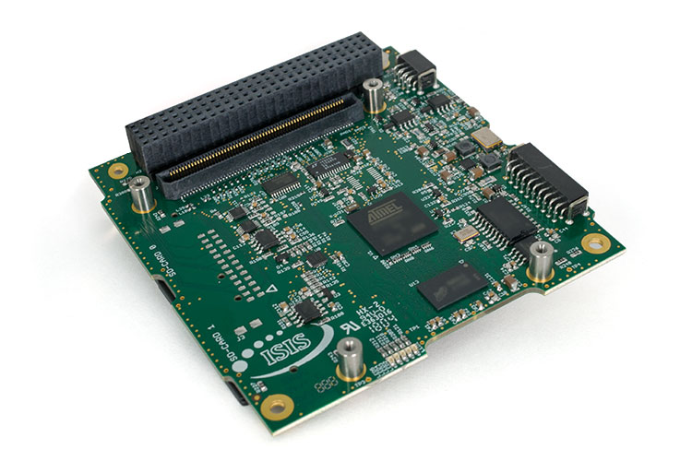

The Rad Hard NAND flash storage offers 32-Gb high density storage, making it an ideal storage solution for space missions. It uses Single-Level Cell (SLC) NAND technology, which ensures fast read/write capabilities. Its high-density storage makes it an important component for data storage. The RAD-PAK flash from Data Device Corporation (DDC) provides integrated radiation shielding, eliminating the need for external box shielding and ensuring protection against radiation. This makes it suitable for long-duration space missions, offering excellent endurance and reliability. Moreover, weighing only 20 grams, RAD-PAK is a light-weight and compact storage option for a CubeSat mission.

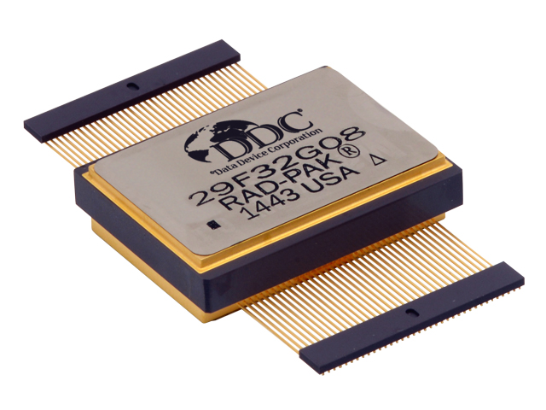

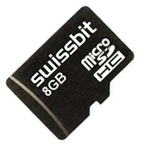

The Swissbit S-300u microSD card, with 8GB storage, is a high-performance, non-volatile memory for the SOS-CUBE’s data handling needs. Operating in SD/SDHC and SPI modes, it supports SD High Speed mode with up to 50MHz clock frequency. It can operate with 3.3V of power supply and in temperatures between -25 and 85 degrees Celsius making it compatible with the OBC. The card features an intelligent controller for managing interface protocols, data storage, retrieval, and error correction. It is also highly durable, making it suitable for our mission’s duration.



**References**

<https://www.sciencedirect.com/science/article/pii/S1874610199800180>

<https://www.st.com/content/st_com/en/arm-32-bit-microcontrollers/arm-cortex-m4.html>

<https://www.st.com/en/microcontrollers-microprocessors/stm32l4-plus-series.html?icmp=tt20277_gl_lnkon_mar2021>

<https://www.techtarget.com/searchstorage/definition/RAID-10-redundant-array-of-independent-disks>