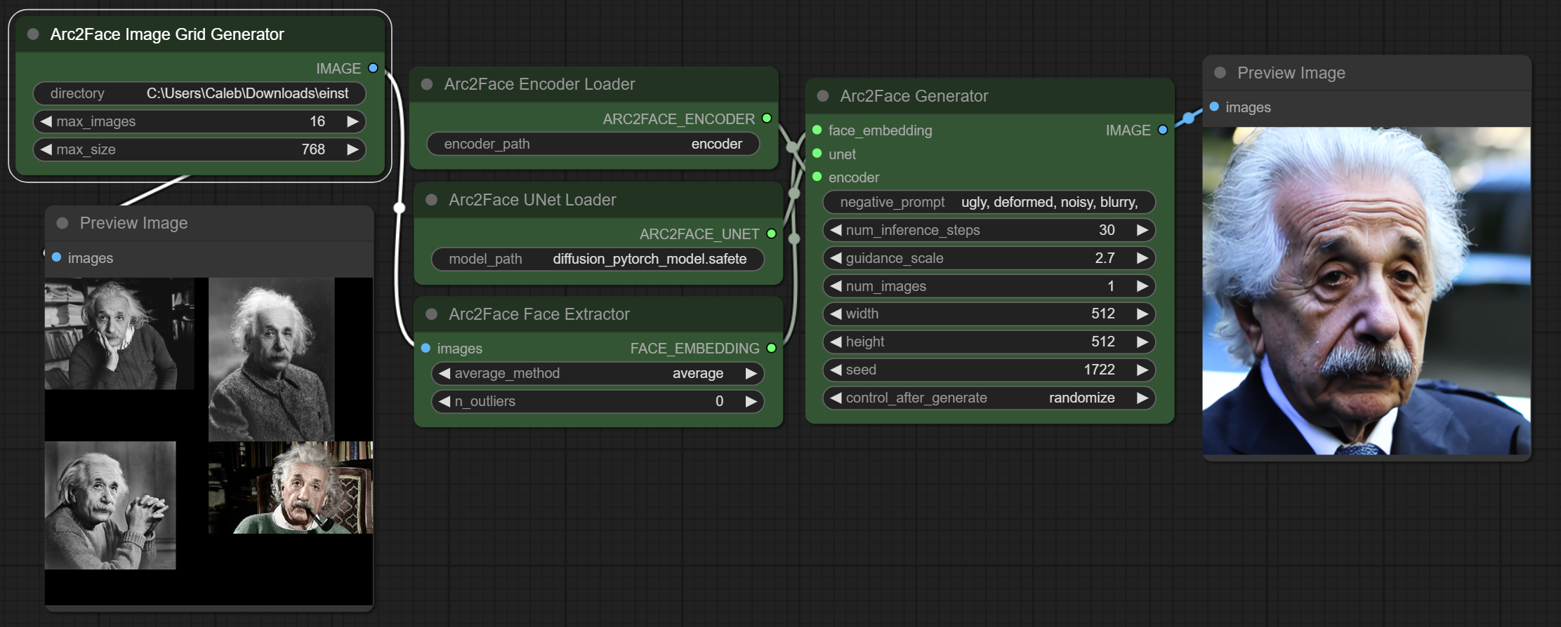

Arc2Face is a model designed to transform facial images into embeddings and then fine-tune these embeddings on Stable Diffusion 1.5 using millions of images. This technique allows for high-quality face generation and image-to-image (img2img) transformations. The model works optimally at a resolution of 512x512 pixels, with recommendations to scale images to this size before performing any upscaling or downscaling to achieve desired dimensions.

**Features and Techniques**

1. **Embedding Transformation**:
   * The model converts facial images into embeddings, which are then used for fine-tuning.
2. **Multiple Faces Averaging**:
   * When using multiple faces, different averaging methods can be applied to combine the embeddings.
   * **Median Averaging**: Best for a few inputs.
   * **Ensemble Averaging**: Suitable for a larger number of inputs.
3. **Face Extraction**:
   * The n_outliers parameter on the face extractor node can remove the n faces farthest from the cluster. This is useful for excluding background faces or other irrelevant faces that differ significantly from the main character.
4. **Inpainting**:
   * While there isn't a dedicated inpainting node, automatic inpainting can be achieved using Face Analysis nodes. For example, see the techniques discussed in Latent Vision's video.

**Arc2Face Nodes:**

1. **Arc2Face Face Extractor**:
   * **Function**: This node extracts all faces from a single input image. It can handle up to 64 faces in one image.
   * **Processing**: The extracted faces are averaged using the selected averaging scheme (e.g., median, ensemble).
   * **Output**: The node outputs a facial embedding that can be used by generators to create or transform images.
2. **Arc2Face UNet Loader**:
   * **Function**: This node is responsible for loading the Arc2Face model itself.
   * **Purpose**: The UNet model is used for face extraction and transformation tasks within the workflow.
3. **Arc2Face Encoder Loader**:
   * **Function**: Loads the encoder model used in Arc2Face.
   * **Purpose**: The encoder processes facial data to generate embeddings which can then be used for various transformations.
4. **Arc2Face Generator**:
   * **Function**: Takes in a facial embedding and outputs images based on that embedding.
   * **Purpose**: This node generates new images using the embeddings produced by the Face Extractor and Encoder.
5. **Arc2Face Img2Img Generator**:
   * **Function**: This node combines an embedding with an initial image and a denoise parameter to perform image-to-image transformations.
   * **Purpose**: It allows for more detailed image transformations by starting with an initial image and modifying it based on the embedding.
6. **Arc2Face Image Grid Generator**:
   * **Function**: Takes a directory path, loads all images from that directory, and combines them into a single large grid image.
   * **Purpose**: This grid image can then be used as input for the Face Extractor node. It is useful for processing multiple images at once.

**Usage in Workflows:**

* **Face Extraction**: Start by using the Face Extractor to process images and obtain facial embeddings.
* **Model Loading**: Load the necessary models using the UNet Loader and Encoder Loader nodes.
* **Image Generation**: Use the Generator node to create new images from the embeddings or the Img2Img Generator for transforming existing images.
* **Image Preparation**: Use the Image Grid Generator to prepare and organize multiple images for batch processing.

These nodes facilitate creating sophisticated workflows for face-based image generation and transformation in ComfyUI, making it easier to handle and process facial data effectively.

Reactor and Arc2Face Comparison

Arc2Face and Reactor

Arc2Face and Reactor are both facial transformation techniques, but they have distinct methodologies and applications.

Arc2Face:

1. Transformation to Embeddings: Arc2Face converts a face into an embedding, a numerical representation that captures the essential features of the face.

2. Fine-tuning on SD1.5: The embeddings are fine-tuned using Stable Diffusion 1.5 (SD1.5) on millions of faces, enhancing the model's capability to generate high-quality facial images.

3. Multiple Faces and Averaging Methods: Users can load multiple faces and employ different averaging methods to combine them, which can increase the quality of the resulting images.

4. Focus on Quality: The technique aims to improve image quality by leveraging extensive fine-tuning and advanced averaging methods.

Reactor:

1. Reconstruction Focus: Reactor typically focuses on reconstructing faces from given images or embeddings, maintaining a high degree of fidelity to the original input.

2. Different Methodology: While Reactor also works with embeddings, its primary goal is to reconstruct or generate faces based on these embeddings, often focusing on maintaining consistency and detail.

3. Application Specificity: Reactor might be used more in applications where consistent and accurate reconstruction of facial features is critical, such as identity verification or detailed facial analysis.

Key Differences:

Approach: Arc2Face emphasizes transforming faces into embeddings and fine-tuning on a large dataset to improve overall quality, whereas Reactor focuses more on the accurate reconstruction of faces from embeddings.

Output Quality: Arc2Face aims for high-quality, visually appealing images by combining multiple faces and using advanced averaging techniques. Reactor prioritizes faithful reconstruction and consistency.

-Use Cases: Arc2Face might be more suitable for creative applications where quality and visual appeal are paramount. In contrast, Reactor is often used in scenarios where precise facial reconstruction is necessary.

In summary, while both techniques involve facial embeddings, Arc2Face focuses on enhancing image quality through extensive fine-tuning and averaging, whereas Reactor emphasizes accurate and consistent reconstruction of faces.