

**Tribhuwan University**

**Institute of Engineering**

Pulchowk Campus, Lalitpur

**Lab report :10**

**Configuration of BGP and Servers**

Experiment Date: 2080/04/23

Submission Date: 2080/04/31

**Submitted by:** **Submitted to:**

Sujata Chaudhary Department of Computer

076BCT085 Engineering

**Objectives:**

❖ To be familiar with BGP for inter-AS routing and its configuration

❖ To be familiar with different servers & their configuration: DHCP, Web, DNS

**Requirements:**

* Network simulation tool: Packet Tracer

**Activity No. A**

1. On each PC, the IP address, subnet mask, and default gateway were configured. Each router interface’s IP address was likewise established.
2. OSPF was setup on routers without involving another AS.
3. Connections between PCs within the same AS were successful, but connections between PCs in various ASs were unsuccessful.
4. BGP was enabled in Router1 to broadcast the whole network of AS 100 to another AS.
5. BGP in Router2 was setup as follows:
   1. Router2 (config)# router bgp 200
   2. Router2 (config-router)# neighbor 222.2.2.1 remote-as 100
   3. Router2 (config-router)# network 220.0.1.0 mask 255.255.255.0
   4. Router2 (config-router)# network 220.0.2.0 mask 255.255.255.0
   5. Router2 (config-router)# network 220.0.3.0 mask 255.255.255.0
6. The PCs linked to Routers 1 and 2 were able to connect, whereas the other PCs were unable to connect. This is due to the fact that Routers 0 and 3 are unable to return packets.
7. Router0 was set to forward traffic to Router1, and Router3 was configured to forward traffic to Router2.
8. The connectivity between each PC was successful since Router0 and Router3 may now forward packets due to the default route setup.
9. All routers' default routes were eliminated.
10. Router1 was set up to disseminate BGP route information in OSPF as follows:
    1. Router1 (config)# router ospf 1
    2. Router1 (config-router)# redistribute bgp 100
    3. Router1 (config-router)# end

Similarly, Router2 was set up in OSPF to disseminate BGP route information.

1. Ping attempts were all successful.

**Activity No. B**

1. The network configuration depicted in the image was constructed.
2. The IP configurations received by DHCP in PC0 and PC2 are as follows:
   1. PC0: 169.254.161.227/16
   2. PC2: 169.254.61.146/16
3. A DHCP server was established in Router0 for net1.
4. The IP configurations received by DHCP in PC0 and PC2 are as follows:
   1. PC0: 192.168.1.2/24
   2. PC2: 169.254.61.147/16
5. A DHCP server was established in Router1 for net2.
6. The IP configurations received by DHCP in PC0 and PC2 are as follows:
   1. PC0: 192.168.1.2/24
   2. PC2: 192.168.2.2/24
7. The IP addresses 192.168.1.1 through 192.168.1.20 were eliminated.
8. The IP configurations retrieved via DHCP in PC1 and PC3 are as follows:
   1. PC1: 192.168.1.21/24
   2. PC3: 192.168.2.3/24
9. The addresses 192.168.2.1 through 192.168.2.40 were omitted.
10. The IP configurations received via DHCP in Laptop0 and Laptop1 are as follows:
    1. 192.168.1.22/24 Laptop0
    2. 192.168.2.41/24 Laptop1

Activity No. C

1. An IP address of 192.168.1.3 was assigned to a web server for cisco.com.
2. To resolve the domain cisco.com, a DNS server with the IP address 192.168.1.2 was set up.
3. From a PC, cisco.com was accessed as follows:

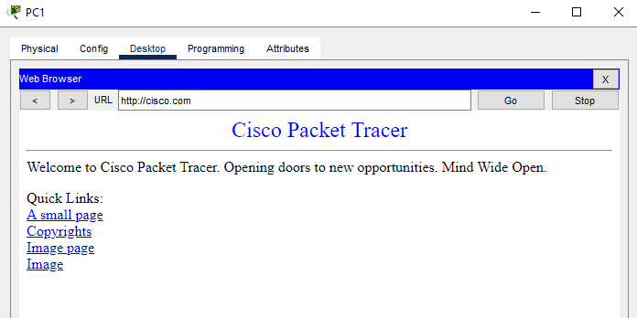

1. For IP address, subnet mask, default gateway, and DNS server, Router0 was setup with DHCP for network 192.168.1.0/24. The IP address range 192.168.1.1-192.168.1.30 was not included.
2. Switch0 was used to connect a new PC. Using DHCP, the following IP configuration was obtained: 192.168.1.31/24.
3. The URL 'cisco.com' was successfully accessed.
4. The necessary routing was completed.
5. PC2 was setup with the required IP parameters, and 'cisco.com' was successfully visited.

**Exercises:**

1. Why is BGP necessary to route network traffic between ASes? Explain.

Because of its capacity to provide policy management, path selection, and dynamic adaptation in the internet's linked and dynamic landscape, BGP is critical for routing network traffic between Autonomous Systems (ASes). It enables administrators to set routing preferences, optimize traffic flows, maintain fault tolerance, and manage different peer connections, all of which are required for global interdomain routing to be efficient, reliable, and regulated.

2. What is DHCP? Why is it used? Explain its importance.

DHCP, or Dynamic Host Configuration Protocol, is a network management protocol that automates and simplifies the process of assigning IP addresses and other configuration settings to devices on a TCP/IP network (referred to as "hosts"). Its principal function is to provide for the efficient and centralized control of IP address allocation, subnet masks, default gateways, DNS server addresses, and other network-related parameters.

DHCP is important for the following reasons:

1. IP address management
2. Efficiency and Scalability
3. Ease of network configuration
4. Reduced Human Errors
5. Mobility Support

3. What is DNS? Why is it used? Explain its importance in the Internet System.

DNS, or Domain Name System is a critical component of the internet's architecture that converts human-readable domain names (such as www.example.com) into numerical IP addresses (such as 192.0.2.1) that computers use to identify one another on a network. DNS is a distributed and hierarchical system that maps clearly identifiable domain names to matching IP addresses, allowing for smooth communication and accessibility throughout the internet. It is used for the following reasons:

1. Human-Readable Naming
2. Address Resolution
3. Scalability
4. Load Balancing

**Discussion and Conclusion**

In this lab, we engaged with essential pillars of contemporary computer networks and the internet: BGP, DHCP, DNS, and web servers. Through practical exercises, we gained firsthand familiarity with how BGP facilitates efficient traffic routing, DHCP streamlines IP address allocation, DNS enables seamless domain-to-IP translation, and web servers store and disseminate online content. This hands-on approach underscored the integral roles these technologies play in the functionality of modern digital systems, fostering a holistic understanding of their significance and interactions.