INTRODUCATION

Avinya is a non-profit organization, founded in 2021, based in Bengaluru. We focus on empowering persons with disabilities (Divyangs), helping them lead self-reliant and independent lives. Our mission is to break the barriers faced by individuals with disabilities by giving them opportunities to work, earn, and reintegrate into society.

Since our inception, we have successfully impacted over 2000 individuals, aged 15 and above, by providing them with training, skill development, and job placement services. We believe that by providing Divyangs with the right resources and support, we can help them become contributing members of society.

PROBLEM STATEMENT

At Avinya, we are dedicated to empowering people with disabilities and helping them lead independent lives. However, despite our best efforts, we are facing some challenges that limit our ability to reach more people and scale our impact.

First, as a non-profit organization, our funding options are limited. While we have been able to help over 2,000 individuals with disabilities so far, we need more financial resources to expand our services and make a bigger difference in the lives of many more people.

Second, although we've made an impact, many people still don’t know about the work we do. We need to increase awareness of our cause so we can reach more individuals who could benefit from our programs.

Finally, financial inclusion for people with disabilities remains a challenge. Many individuals with disabilities struggle to access the financial support they need to achieve independence. By improving financial inclusion, providing support, training and by giving awareness can help them create better opportunities for themselves.

Our goal is to overcome these challenges by becoming a social enterprise. By listing Avinya on a stock exchange, we hope to raise the funds needed to grow, increase awareness, and help even more people with disabilities gain the independence they deserve.

PROPOSED SOLUTIONS:

Avinya’s Impact Strategy for Persons with Disabilities (PwDs)

To enhance the lives of PwDs, Avinya should focus on entrepreneurship, employment, sports, financial inclusion, emergency assistance, and skill development. Below is a detailed strategic plan with real data, funding opportunities, and execution steps.

1. Entrepreneurship & Self-Employment for PwDs

Many PwDs struggle with finding traditional jobs. Avinya can promote self-reliance through entrepreneurship programs:

A. Start-Up Incubation & Microbusiness Support

How?

- Provide micro-loans (₹50,000-₹10L) under Divyangjan Swavalamban Yojana.

- Help PwDs register under Start-Up India benefits & Mudra Loans (₹10L).

- Organize business mentorship with successful entrepreneurs with disabilities.

- Set up digital stores on Amazon and Flipkart for selling handmade products.

Example:

- Samarthanam Trust’s Parisara Waste Management employs PwDs in recycling.

- Divyangjan Swavalamban Yojana provides credit for PwDs' businesses.

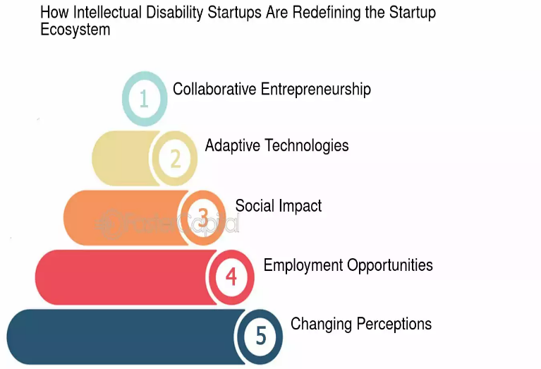

<https://fastercapital.com/content/Intellectual-disability-startups-Empowering-Entrepreneurship--How-Intellectual-Disability-Startups-Are-Making-Waves.html>

B. Social Enterprises for PwDs

How?

- Launch PwD-driven e-commerce business selling handicrafts, textiles, or assistive devices.

- Establish PwD-led food delivery services (like Swiggy Access).

- Form cooperatives for visually impaired & hearing-impaired individuals (e.g., digital call centers).

- Partner with Skill India, NSDC for vocational training.

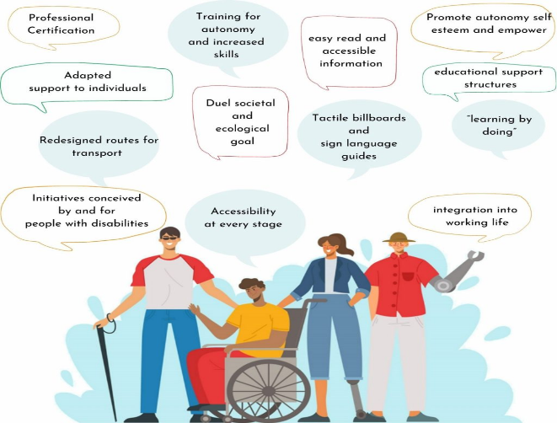

<https://samarthanam.org/>

Example:

- Sunadha Cultural Troupe empowers disabled artists through music & dance.

- Microsoft-funded tech startups support PwDs in AI-based businesses.

2. Job Opportunities for PwDs

Only 36% of working-age PwDs in India are employed. Avinya must bridge this gap by providing:

A. Corporate Hiring & Skill Development

How?

- Partner with Microsoft, Infosys, Accenture to create PwD hiring quotas.

- Provide Digital Skills & Coding Bootcamps with AI-based accessibility tools.

- Launch "Work from Home" (WFH) & Gig Work platforms for PwDs in data entry, graphic design, testing, etc.

- Tie-up with NSDC & PM Daksh portal for skill-based placements.

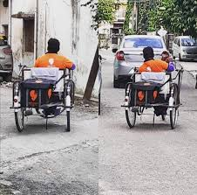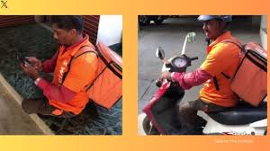

Example:

- Nasscom FutureSkills provides AI-driven learning tools for disabled job-seekers.

- Tata Power’s CSR hires 30% disabled staff in call center operations.

<https://www.futureskillsprime.in/>

<https://depwd.gov.in/><https://youtu.be/y0ACZWcyZIk>

B. Reserved Government & Private Jobs

How?

- Help PwDs apply for Govt. & PSU jobs (3% PwD reservation).

- Assist in specialized roles (e.g., sign language interpreters, mobility trainers).

- Offer resume-building, AI-driven job matching, & mentorship.



<https://depwd.gov.in/><https://youtu.be/y0ACZWcyZIk>

Example:

- Sarthak Trust has trained 50,000 PwDs for banking, IT, & retail jobs.

- RBI mandates 4% PwD hiring in banking – leverage this for Avinya-trained candidates.

3. Sports & Fitness Programs for PwDs

Sports can empower PwDs through mental well-being, fitness, and global recognition.

A. Inclusive Sports Infrastructure

How?

- Establish para-sports training centers (funded by NSDF & private sponsors).

- Organize state & national para-sports events for talent identification.

- Offer scholarships for Paralympic & Special Olympics training (₹5L+ funding).

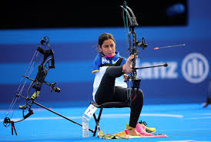 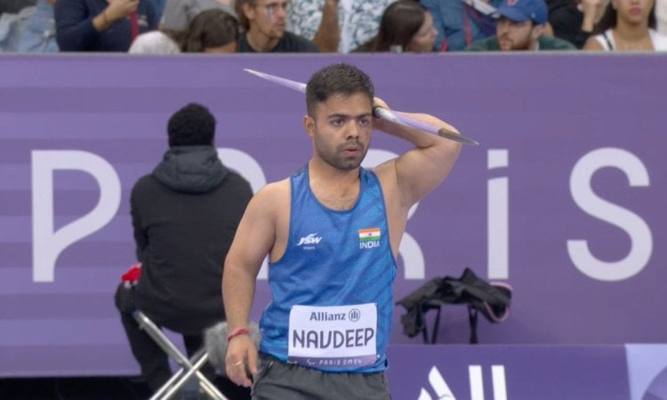

<https://www.paralympic.org/news/indian-para-athlete-suvarna-raj-wins-un-sdg-action-awards>

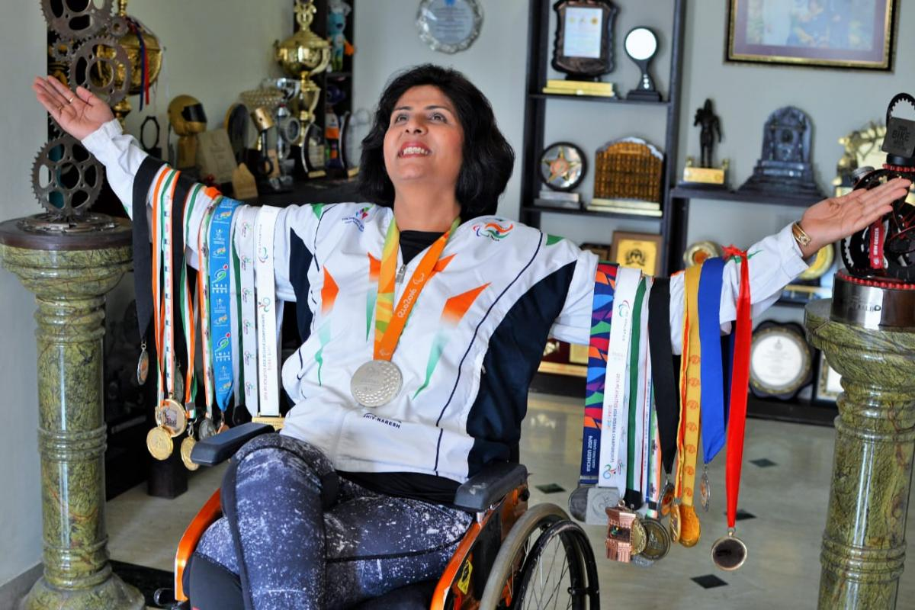

<https://kheloindia.gov.in/>

Example:

- Deepa Malik (Paralympic medalist) runs “Wheeling Happiness” NGO for disabled athletes.

- Khelo India funds ₹6L per para-athlete per year – leverage this.

B. Job & Sponsorship Support for PwD Athletes

How?

- Employ former para-athletes as sports coaches & trainers.

- Create a scholarship fund for high-performance PwD athletes.

- Partner with corporate sponsors (e.g., JSW Sports, Adidas, Tata Trusts) for funding.

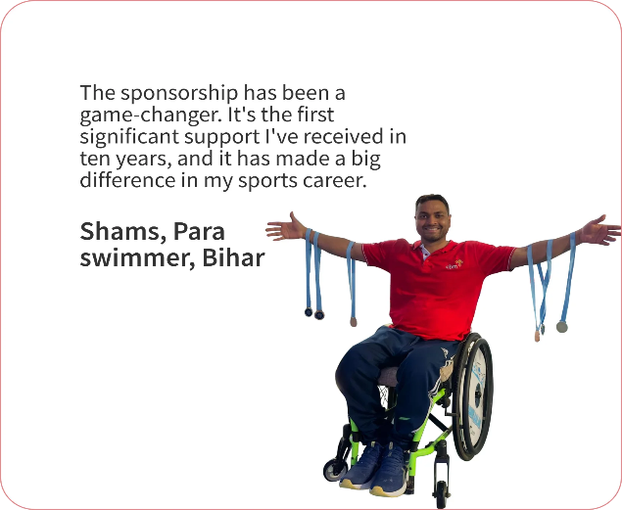

<https://dasasports.org/contact/athlete-resources/>

Example:

- Para-badminton star Manasi Joshi got funding from HSBC India.

- ONGC sponsors 10+ para-athletes with ₹10L per year per athlete.

4. Financial Inclusion & Emergency Funds for PwDs

Many PwDs lack financial security & access to emergency funds.

A. Disability Pension & Insurance Coverage

How?

- Ensure all eligible PwDs get Indira Gandhi National Disability Pension (₹1,300/month).

- Enroll PwDs under Niramaya Health Insurance (₹1L medical cover, free for BPL families).

- Provide "Micro-savings Plans" (₹500/month) for PwDs.

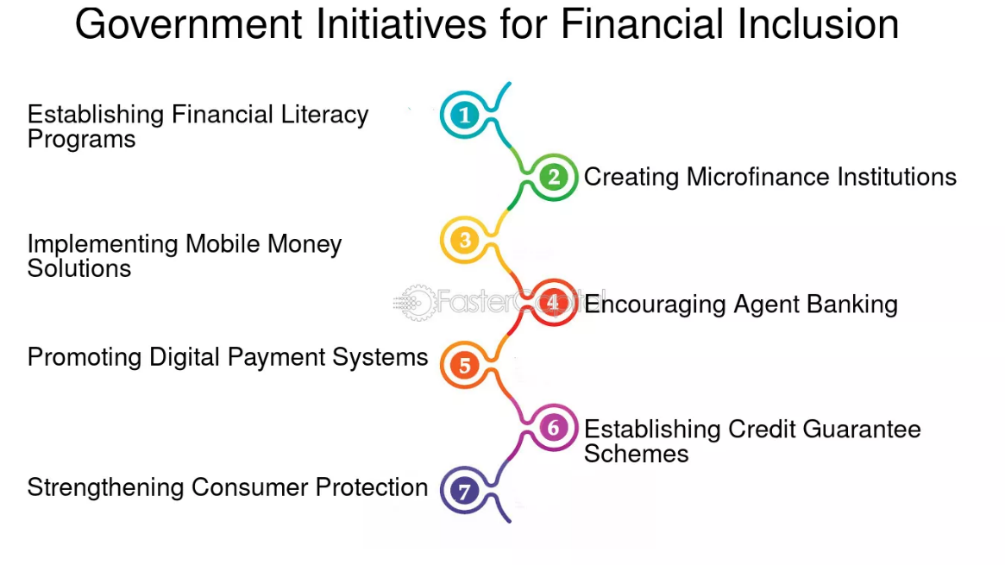<https://depwd.gov.in/national-handicapped-finance-and-development-corporation/>

Example:

- 2.5M PwDs in India now receive pension, but millions are unaware – Avinya must assist in enrollments.

- Aditya Birla Health covers PwDs with disability-friendly health plans.

B. Emergency Relief & Direct Cash Transfers

How?

- Create a Digital Relief Fund for PwDs (₹5,000-₹20,000 grants for medical, housing, crisis needs).

- Set up a "PwD Emergency Wallet" linked to UPI, enabling instant relief payments.

- Partner with crowdfunding platforms like Ketto, Milaap for medical emergencies.



<https://dbtbharat.gov.in/central-scheme/list>

Example:

- PM CARES Fund allocated ₹300Cr for PwDs during COVID-19 – leverage similar funding.

- NGOs like Goonj provide direct financial aid to PwDs in disasters.

5. Tech-Driven Solutions for PwDs

Develop an “Avinya Digital” App to:

- Match PwDs with Jobs, Business Opportunities, & Training.

- Provide financial aid tracking & instant emergency cash transfers.

- Offer AI-powered assistive tech (text-to-speech, voice assistants, sign language AI interpreters).

- Enable direct access to government schemes, loans, & health insurance.

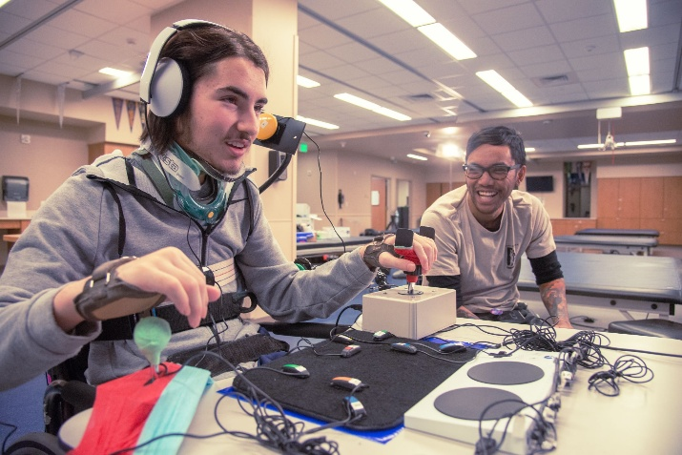

<https://communitytechnetwork.org/blog/digital-disability-inclusion-accessibility-solutions/>

Example: - Be My Eyes (AI-based visual assistance app) has 10M+ users – Avinya can build a similar model.

- Skill India’s AI-driven career portal for PwDs is an example to integrate.

6. Funding & Sustainability Plan

To sustain these programs, Avinya should:

1️. Register under NSE Social Stock Exchange (SSE) – allows public fundraising.

2️. Seek CSR grants from companies like Tata, Infosys, Accenture (₹10L-₹50L annually).

3️. Leverage National & International NGO Grants (e.g., UNDP, WHO, Ford Foundation).

4️. Raise ₹1Cr+ via Crowdfunding & Direct Donations (Milaap, Ketto, GiveIndia).

5️. Monetize the “Avinya Digital” App via premium employer services & paid training programs.

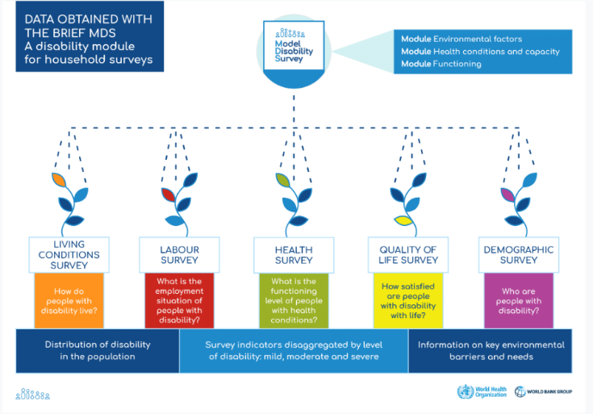<https://social.desa.un.org/issues/disability/sustainable-development-goals-sdgs-and-disability>

Final Strategy Summary

Empower PwDs via entrepreneurship, corporate jobs, and social enterprises.

Ensure sports inclusion & scholarships for para-athletes.

Provide financial security via emergency funds, pensions & micro-savings.

Leverage tech (Avinya App) for accessibility, job matching, and direct relief support.

List on the NSE Social Stock Exchange to scale nationwide.

Impact Goal: Empower 1M+ PwDs in 5 Years with Jobs, Business & Financial Inclusion.