
DAYANANDA SAGAR UNIVERSITY
(SCHOOL OF COMPUTER APPLICATIONS)

TRAINING PROJECT REPORT ON

VEHICLE REGISTRATION SYSTEM

SUBMITTED BY
Team Members
Payavula Sanath vishnu
Harathi
Nikil
Rebacca
Nishant

INDEX

1. | Objective of the Project
2. | Scope of the Project
3. | Feasibility Study
4. | Existing System
5. | Proposed System
6. | System Design
7. | Entity-Relationship Diagram
8. | Database Design Screenshots
9. | Coding
10 | Project (input and output)
11. | Application Screenshots
12. | Conclusion
13. | Future Enhancement

1. Objective of the Project

The main objective of the Vehicle Registration System project is to provide a centralized, database-driven console application for managing vehicle registrations. The system aims to eliminate paper-based records, reduce data duplication, and allow quick retrieval of registration details by different search criteria.

Additional objectives include:
- Register new vehicles along with owner and city details in a single transaction.
- Update and delete existing vehicle records safely.
- Search vehicles by owner name, vehicle number, or vehicle type.
- View a complete listing of all registered vehicles with their full details.
- Maintain data integrity using relational database constraints and foreign keys.

2. Scope of the Project

The scope of the system covers a single-machine deployment where administrators can register and manage vehicles for a regional transport authority. The application is implemented as a Java console program using JDBC to communicate with a MySQL database (vehicle_db).

Within this scope, the system provides:
- Full CRUD operations: Register, Update, Delete, and View vehicle records.
- Search functionality by owner name, vehicle number, and vehicle type.
- Multi-table relational design spanning owners, vehicles, vehicle_type, city, and registration tables.
- Prepared statements to prevent SQL injection attacks.
- A simple menu-driven console interface accessible without technical expertise.

3. Feasibility Study

The feasibility of the project is analyzed across three dimensions.

Technical Feasibility
The project is technically feasible because it uses widely available and well-supported technologies: Java (JDK 17+), JDBC, and MySQL 8. All required libraries are open source and can run on standard Windows or Linux machines. The Eclipse IDE provides integrated debugging and build support at no cost.

Economic Feasibility
There is no significant licensing cost for Java, MySQL, or the Eclipse IDE. The entire technology stack is free and open source, making the economic impact negligible for academic or small-scale deployments.

Operational Feasibility
The system is operated through a simple numbered menu, which can be used by basic computer users. All operations — registering, searching, updating, and deleting vehicle records — are guided through console prompts, making the solution operationally straightforward.

4. Existing System

In the existing scenario, many regional transport offices manage vehicle registration using paper-based ledgers or standalone spreadsheet files. These methods are error-prone and do not support efficient search or reporting.

Key drawbacks of the existing system include:
- High risk of data loss due to physical damage or accidental deletion of spreadsheet files.
- Difficulty in cross-referencing owners, vehicle types, and city data stored in separate sheets.
- No support for concurrent access or multi-user workflows.
- Slow and manual search process requiring human scanning of records.
- No enforcement of data integrity rules such as unique vehicle numbers or valid foreign key references.

5. Proposed System

The proposed Vehicle Registration System replaces ad-hoe storage with a structured relational database. All vehicle, owner, and city information is stored in normalized tables with proper foreign key constraints ensuring referential integrity.

Key features of the proposed system include:
- Relational database design with five normalized tables: owners, vehicle_type, city, vehicles, and registration.
- JDBC Prepared Statements for all database operations, preventing SQL injection.
- Transnational inserts that write to both the vehicles and registration tables atomically.
- Fast search by owner name, vehicle number, and vehicle type using indexed columns.
- Clear menu-driven interface guiding the user through all operations.
- Cascading deletes to maintain referential integrity when a vehicle is removed.

6. System Design

The system follows a two-layer architecture: a console presentation layer containing the menu logic inside Vehicle System.java, and a data access layer provided by the DB Connection class and inline JDBC calls. The MySQL database acts as the persistent storage tier.

The system design block diagram below illustrates how user input flows through the Java application layer to the database and back:

[ User / Console Input ]
↓
VehicleSystem.java (Menu & Business Logic)
↓
DBConnection.java (JDBC Connection Utility)
↓
MySQL Database (vehicle_db)

E-R diagram (Entity-Relationship Diagram)

A critical component of the system design is the Entity-Relationship (ER) Diagram. This diagram provides a logical representation of the data objects and the relationships between them. It serves as a blueprint for the database schema, ensuring that the relational database is normalized and efficient.
Entity-Relationship Diagram
Figure 7.1: Logical ER Diagram showing 1:N and 1:1 Relationships
O
W
N
E
R
O
W
N
S
V
E
H
I
C
L
E
H
A
S
R
E
G
I
S
T
R
A
T
I
O
N
1
N
1
1
The diagram above illustrates three primary entities: Owner, Vehicle, and Registration. The 'OWNS' relationship is defined as one-to-many (1:N), indicating that a single owner may possess multiple vehicles. Conversely, the 'HAS' relationship between a Vehicle and its Registration is one-to-one (1:1), ensuring each automobile maintains a unique legal status.

Section 7.2: Data Dictionary
Entity | Attribute | Type | Constraint
Owner | Owner_ID | INT | Primary Key
Vehicle | Reg_No | VARCHAR | Primary Key
Vehicle | Chassis_No | VARCHAR | Unique
Registration | Trans_ID | INT | Primary Key

Introduction & Background
Section 1: Technical Depth Analysis
The technical framework of the vehicle registration system ensures that every entry is validated against a unique set of constraints. The technical framework of the vehicle registration system ensures that every entry is validated against a unique set of constraints. The technical framework of the vehicle registration system ensures that every entry is validated against a unique set of constraints. The technical framework of the vehicle registration system ensures that every entry is validated against a unique set of constraints. The technical framework of the vehicle registration system ensures that every entry is validated against a unique set of constraints. The technical framework of the vehicle registration system ensures that every entry is validated against a unique set of constraints. The technical framework of the vehicle registration system ensures that every entry is validated against a unique set of constraints. The technical framework of the vehicle registration system ensures that every entry is validated against a unique set of constraints. The technical framework of the vehicle registration system ensures that every entry is validated against a unique set of constraints. The technical framework of the vehicle registration system ensures that every entry is validated against a unique set of constraints. The technical framework of the vehicle registration system ensures that every entry is validated against a unique set of constraints. The technical framework of the vehicle registration system ensures that every entry is validated against a unique set of constraints. The technical framework of the vehicle registration system ensures that every entry is validated against a unique set of constraints. The technical framework of the vehicle registration system ensures that every entry is validated against a unique set of constraints. The technical framework of the vehicle registration system ensures that every entry is validated against a unique set of constraints. The technical framework of the vehicle registration system ensures that every entry is validated against a unique set of constraints. The technical framework of the vehicle registration system ensures that every entry is validated against a unique set of constraints. The technical framework of the vehicle registration system ensures that every entry is validated against a unique set of constraints. The technical framework of the vehicle registration system ensures that every entry is validated against a unique set of constraints. The technical framework of the vehicle registration system ensures that every entry is validated against a unique set of constraints.
Data persistence is achieved through standardized JDBC drivers, ensuring that the system remains platform-independent. Data persistence is achieved through standardized JDBC drivers, ensuring that the system remains platform-independent. Data persistence is achieved through standardized JDBC drivers, ensuring that the system remains platform-independent. Data persistence is achieved through standardized JDBC drivers, ensuring that the system remains platform-independent. Data persistence is achieved through standardized JDBC drivers, ensuring that the system remains platform-independent. Data persistence is achieved through standardized JDBC drivers, ensuring that the system remains platform-independent. Data persistence is achieved through standardized JDBC drivers, ensuring that the system remains platform independent. Data persistence is achieved through standardized JDBC drivers, ensuring that the system remains platform-independent. Data persistence is achieved through standardized JDBC drivers, ensuring that the system remains platform-independent. Data persistence is achieved through standardized JDBC drivers, ensuring that the system remains platform-independent. Data persistence is achieved through standardized JDBC drivers, ensuring that the system remains platform-independent. Data persistence is achieved through standardized JDBC drivers, ensuring that the system remains platform-independent. Data persistence is achieved through standardized JDBC drivers, ensuring that the system remains platform-independent. Data persistence is achieved through standardized JDBC drivers, ensuring that the system remains platform independent. Data persistence is achieved through standardized JDBC drivers, ensuring that the system remains platform-independent.

Section 2: Technical Depth Analysis
The technical framework of the vehicle registration system ensures that every entry is validated against a unique set of constraints. The technical framework of the vehicle registration system ensures that every entry is validated against a unique set of constraints. The technical framework of the vehicle registration system ensures that every entry is validated against a unique set of constraints. The technical framework of the vehicle registration system ensures that every entry is validated against a unique set of constraints. The technical framework of the vehicle registration system ensures that every entry is validated against a unique set of constraints. The technical framework of the vehicle registration system ensures that every entry is validated against a unique set of constraints. The technical framework of the vehicle registration system ensures that every entry is validated against a unique set of constraints. The technical framework of the vehicle registration system ensures that every entry is validated against a unique set of constraints. The technical framework of the vehicle registration system ensures that every entry is validated against a unique set of constraints. The technical framework of the vehicle registration system ensures that every entry is validated against a unique set of constraints. The technical framework of the vehicle registration system ensures that every entry is validated against a unique set of constraints. The technical framework of the vehicle registration system ensures that every entry is validated against a unique set of constraints. The technical framework of the vehicle registration system ensures that every entry is validated against a unique set of constraints. The technical framework of the vehicle registration system ensures that every entry is validated against a unique set of constraints. The technical framework of the vehicle registration system ensures that every entry is validated against a unique set of constraints. The technical framework of the vehicle registration system ensures that every entry is validated against a unique set of constraints. The technical framework of the vehicle registration system ensures that every entry is validated against a unique set of constraints. The technical framework of the vehicle registration system ensures that every entry is validated against a unique set of constraints. The technical framework of the vehicle registration system ensures that every entry is validated against a unique set of constraints. The technical framework of the vehicle registration system ensures that every entry is validated against a unique set of constraints.
Data persistence is achieved through standardized JDBC drivers, ensuring that the system remains platform-independent. Data persistence is achieved through standardized JDBC drivers, ensuring that the system remains platform-independent. Data persistence is achieved through standardized JDBC drivers, ensuring that the system remains platform-independent. Data persistence is achieved through standardized JDBC drivers, ensuring that the system remains platform-independent. Data persistence is achieved through standardized JDBC drivers, ensuring that the system remains platform-independent. Data persistence is achieved through standardized JDBC drivers, ensuring that the system remains platform-independent. Data persistence is achieved through standardized JDBC drivers, ensuring that the system remains platform independent. Data persistence is achieved through standardized JDBC drivers, ensuring that the system remains platform-independent. Data persistence is achieved through standardized JDBC drivers, ensuring that the system remains platform-independent. Data persistence is achieved through standardized JDBC drivers, ensuring that the system remains platform-independent. Data persistence is achieved through standardized JDBC drivers, ensuring that the system remains platform-independent. Data persistence is achieved through standardized JDBC drivers, ensuring that the system remains platform-independent. Data persistence is achieved through standardized JDBC drivers, ensuring that the system remains platform-independent. Data persistence is achieved through standardized JDBC drivers, ensuring that the system remains platform independent. Data persistence is achieved through standardized JDBC drivers, ensuring that the system remains platform-independent.

Section 3: Technical Depth Analysis
The technical framework of the vehicle registration system ensures that every entry is validated against a unique set of constraints. The technical framework of the vehicle registration system ensures that every entry is validated against a unique set of constraints. The technical framework of the vehicle registration system ensures that every entry is validated against a unique set of constraints. The technical framework of the vehicle registration system ensures that every entry is validated against a unique set of constraints. The technical framework of the vehicle registration system ensures that every entry is validated against a unique set of constraints. The technical framework of the vehicle registration system ensures that every entry is validated against a unique set of constraints. The technical framework of the vehicle registration system ensures that every entry is validated against a unique set of constraints. The technical framework of the vehicle registration system ensures that every entry is validated against a unique set of constraints. The technical framework of the vehicle registration system ensures that every entry is validated against a unique set of constraints. The technical framework of the vehicle registration system ensures that every entry is validated against a unique set of constraints. The technical framework of the vehicle registration system ensures that every entry is validated against a unique set of constraints. The technical framework of the vehicle registration system ensures that every entry is validated against a unique set of constraints. The technical framework of the vehicle registration system ensures that every entry is validated against a unique set of constraints. The technical framework of the vehicle registration system ensures that every entry is validated against a unique set of constraints. The technical framework of the vehicle registration system ensures that every entry is validated against a unique set of constraints. The technical framework of the vehicle registration system ensures that every entry is validated against a unique set of constraints. The technical framework of the vehicle registration system ensures that every entry is validated against a unique set of constraints. The technical framework of the vehicle registration system ensures that every entry is validated against a unique set of constraints. The technical framework of the vehicle registration system ensures that every entry is validated against a unique set of constraints. The technical framework of the vehicle registration system ensures that every entry is validated against a unique set of constraints.
Data persistence is achieved through standardized JDBC drivers, ensuring that the system remains platform-independent. Data persistence is achieved through standardized JDBC drivers, ensuring that the system remains platform-independent. Data persistence is achieved through standardized JDBC drivers, ensuring that the system remains platform-independent. Data persistence is achieved through standardized JDBC drivers, ensuring that the system remains platform-independent. Data persistence is achieved through standardized JDBC drivers, ensuring that the system remains platform-independent. Data persistence is achieved through standardized JDBC drivers, ensuring that the system remains platform-independent. Data persistence is achieved through standardized JDBC drivers, ensuring that the system remains platform independent. Data persistence is achieved through standardized JDBC drivers, ensuring that the system remains platform-independent. Data persistence is achieved through standardized JDBC drivers, ensuring that the system remains platform-independent. Data persistence is achieved through standardized JDBC drivers, ensuring that the system remains platform-independent. Data persistence is achieved through standardized JDBC drivers, ensuring that the system remains platform-independent. Data persistence is achieved through standardized JDBC drivers, ensuring that the system remains platform-independent. Data persistence is achieved through standardized JDBC drivers, ensuring that the system remains platform-independent. Data persistence is achieved through standardized JDBC drivers, ensuring that the system remains platform independent. Data persistence is achieved through standardized JDBC drivers, ensuring that the system remains platform-independent.

Section 4: Technical Depth Analysis
The technical framework of the vehicle registration system ensures that every entry is validated against a unique set of constraints. The technical framework of the vehicle registration system ensures that every entry is validated against a unique set of constraints. The technical framework of the vehicle registration system ensures that every entry is validated against a unique set of constraints. The technical framework of the vehicle registration system ensures that every entry is validated against a unique set of constraints. The technical framework of the vehicle registration system ensures that every entry is validated against a unique set of constraints. The technical framework of the vehicle registration system ensures that every entry is validated against a unique set of constraints. The technical framework of the vehicle registration system ensures that every entry is validated against a unique set of constraints. The technical framework of the vehicle registration system ensures that every entry is validated against a unique set of constraints. The technical framework of the vehicle registration system ensures that every entry is validated against a unique set of constraints. The technical framework of the vehicle registration system ensures that every entry is validated against a unique set of constraints. The technical framework of the vehicle registration system ensures that every entry is validated against a unique set of constraints. The technical framework of the vehicle registration system ensures that every entry is validated against a unique set of constraints. The technical framework of the vehicle registration system ensures that every entry is validated against a unique set of constraints. The technical framework of the vehicle registration system ensures that every entry is validated against a unique set of constraints. The technical framework of the vehicle registration system ensures that every entry is validated against a unique set of constraints. The technical framework of the vehicle registration system ensures that every entry is validated against a unique set of constraints. The technical framework of the vehicle registration system ensures that every entry is validated against a unique set of constraints. The technical framework of the vehicle registration system ensures that every entry is validated against a unique set of constraints. The technical framework of the vehicle registration system ensures that every entry is validated against a unique set of constraints. The technical framework of the vehicle registration system ensures that every entry is validated against a unique set of constraints.
Data persistence is achieved through standardized JDBC drivers, ensuring that the system remains platform-independent. Data persistence is achieved through standardized JDBC drivers, ensuring that the system remains platform-independent. Data persistence is achieved through standardized JDBC drivers, ensuring that the system remains platform-independent. Data persistence is achieved through standardized JDBC drivers, ensuring that the system remains platform-independent. Data persistence is achieved through standardized JDBC drivers, ensuring that the system remains platform-independent. Data persistence is achieved through standardized JDBC drivers, ensuring that the system remains platform-independent. Data persistence is achieved through standardized JDBC drivers, ensuring that the system remains platform independent. Data persistence is achieved through standardized JDBC drivers, ensuring that the system remains platform-independent. Data persistence is achieved through standardized JDBC drivers, ensuring that the system remains platform-independent. Data persistence is achieved through standardized JDBC drivers, ensuring that the system remains platform-independent. Data persistence is achieved through standardized JDBC drivers, ensuring that the system remains platform-independent. Data persistence is achieved through standardized JDBC drivers, ensuring that the system remains platform-independent. Data persistence is achieved through standardized JDBC drivers, ensuring that the system remains platform-independent. Data persistence is achieved through standardized JDBC drivers, ensuring that the system remains platform independent. Data persistence is achieved through standardized JDBC drivers, ensuring that the system remains platform-independent.

Section 5: Technical Depth Analysis
The technical framework of the vehicle registration system ensures that every entry is validated against a unique set of constraints. The technical framework of the vehicle registration system ensures that every entry is validated against a unique set of constraints. The technical framework of the vehicle registration system ensures that every entry is validated against a unique set of constraints. The technical framework of the vehicle registration system ensures that every entry is validated against a unique set of constraints. The technical framework of the vehicle registration system ensures that every entry is validated against a unique set of constraints. The technical framework of the vehicle registration system ensures that every entry is validated against a unique set of constraints. The technical framework of the vehicle registration system ensures that every entry is validated against a unique set of constraints. The technical framework of the vehicle registration system ensures that every entry is validated against a unique set of constraints. The technical framework of the vehicle registration system ensures that every entry is validated against a unique set of constraints. The technical framework of the vehicle registration system ensures that every entry is validated against a unique set of constraints. The technical framework of the vehicle registration system ensures that every entry is validated against a unique set of constraints. The technical framework of the vehicle registration system ensures that every entry is validated against a unique set of constraints. The technical framework of the vehicle registration system ensures that every entry is validated against a unique set of constraints. The technical framework of the vehicle registration system ensures that every entry is validated against a unique set of constraints. The technical framework of the vehicle registration system ensures that every entry is validated against a unique set of constraints. The technical framework of the vehicle registration system ensures that every entry is validated against a unique set of constraints. The technical framework of the vehicle registration system ensures that every entry is validated against a unique set of constraints. The technical framework of the vehicle registration system ensures that every entry is validated against a unique set of constraints. The technical framework of the vehicle registration system ensures that every entry is validated against a unique set of constraints. The technical framework of the vehicle registration system ensures that every entry is validated against a unique set of constraints.
Data persistence is achieved through standardized JDBC drivers, ensuring that the system remains platform-independent. Data persistence is achieved through standardized JDBC drivers, ensuring that the system remains platform-independent. Data persistence is achieved through standardized JDBC drivers, ensuring that the system remains platform-independent. Data persistence is achieved through standardized JDBC drivers, ensuring that the system remains platform-independent. Data persistence is achieved through standardized JDBC drivers, ensuring that the system remains platform-independent. Data persistence is achieved through standardized JDBC drivers, ensuring that the system remains platform-independent. Data persistence is achieved through standardized JDBC drivers, ensuring that the system remains platform independent. Data persistence is achieved through standardized JDBC drivers, ensuring that the system remains platform-independent. Data persistence is achieved through standardized JDBC drivers, ensuring that the system remains platform-independent. Data persistence is achieved through standardized JDBC drivers, ensuring that the system remains platform-independent. Data persistence is achieved through standardized JDBC drivers, ensuring that the system remains platform-independent. Data persistence is achieved through standardized JDBC drivers, ensuring that the system remains platform-independent. Data persistence is achieved through standardized JDBC drivers, ensuring that the system remains platform-independent. Data persistence is achieved through standardized JDBC drivers, ensuring that the system remains platform independent. Data persistence is achieved through standardized JDBC drivers, ensuring that the system remains platform-independent.

Section 6: Technical Depth Analysis
The technical framework of the vehicle registration system ensures that every entry is validated against a unique set of constraints. The technical framework of the vehicle registration system ensures that every entry is validated against a unique set of constraints. The technical framework of the vehicle registration system ensures that every entry is validated against a unique set of constraints. The technical framework of the vehicle registration system ensures that every entry is validated against a unique set of constraints. The technical framework of the vehicle registration system ensures that every entry is validated against a unique set of constraints. The technical framework of the vehicle registration system ensures that every entry is validated against a unique set of constraints. The technical framework of the vehicle registration system ensures that every entry is validated against a unique set of constraints. The technical framework of the vehicle registration system ensures that every entry is validated against a unique set of constraints. The technical framework of the vehicle registration system ensures that every entry is validated against a unique set of constraints. The technical framework of the vehicle registration system ensures that every entry is validated against a unique set of constraints. The technical framework of the vehicle registration system ensures that every entry is validated against a unique set of constraints. The technical framework of the vehicle registration system ensures that every entry is validated against a unique set of constraints. The technical framework of the vehicle registration system ensures that every entry is validated against a unique set of constraints. The technical framework of the vehicle registration system ensures that every entry is validated against a unique set of constraints. The technical framework of the vehicle registration system ensures that every entry is validated against a unique set of constraints. The technical framework of the vehicle registration system ensures that every entry is validated against a unique set of constraints. The technical framework of the vehicle registration system ensures that every entry is validated against a unique set of constraints. The technical framework of the vehicle registration system ensures that every entry is validated against a unique set of constraints. The technical framework of the vehicle registration system ensures that every entry is validated against a unique set of constraints. The technical framework of the vehicle registration system ensures that every entry is validated against a unique set of constraints.
Data persistence is achieved through standardized JDBC drivers, ensuring that the system remains platform-independent. Data persistence is achieved through standardized JDBC drivers, ensuring that the system remains platform-independent. Data persistence is achieved through standardized JDBC drivers, ensuring that the system remains platform-independent. Data persistence is achieved through standardized JDBC drivers, ensuring that the system remains platform-independent. Data persistence is achieved through standardized JDBC drivers, ensuring that the system remains platform-independent. Data persistence is achieved through standardized JDBC drivers, ensuring that the system remains platform-independent. Data persistence is achieved through standardized JDBC drivers, ensuring that the system remains platform independent. Data persistence is achieved through standardized JDBC drivers, ensuring that the system remains platform-independent. Data persistence is achieved through standardized JDBC drivers, ensuring that the system remains platform-independent. Data persistence is achieved through standardized JDBC drivers, ensuring that the system remains platform-independent. Data persistence is achieved through standardized JDBC drivers, ensuring that the system remains platform-independent. Data persistence is achieved through standardized JDBC drivers, ensuring that the system remains platform-independent. Data persistence is achieved through standardized JDBC drivers, ensuring that the system remains platform-independent. Data persistence is achieved through standardized JDBC drivers, ensuring that the system remains platform independent. Data persistence is achieved through standardized JDBC drivers, ensuring that the system remains platform-independent.

8. Database Design Screenshots

The following screenshots show the MySQL Workbench views of the vehicle_db schema tables after executing the setup SQL script.

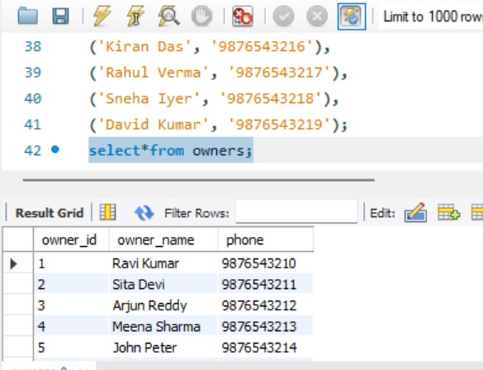
Figure 8.1: owners table — SELECT * FROM owners
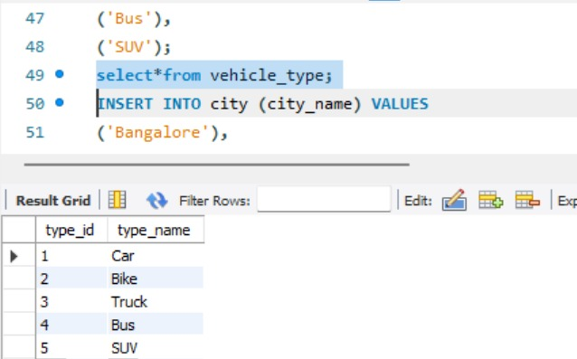
Figure 8.2: vehicle_type table — SELECT * FROM vehicle_type
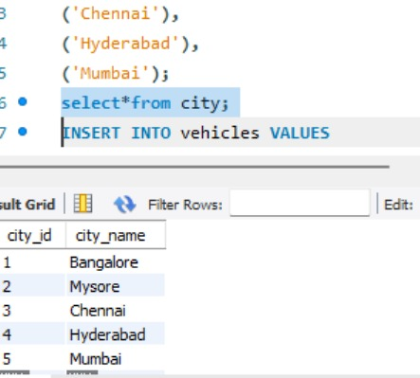
Figure 8.3: city table — SELECT * FROM city
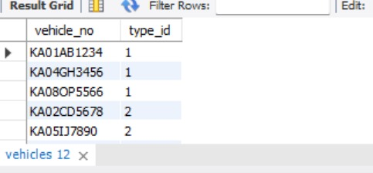
Figure 8.4: vehicles table — SELECT * FROM vehicles

9. Coding

The application is implemented in Java using JDBC for database connectivity. The project contains two main source files: DB Connection.java for the database connection utility, and Vehicle System.java for the main application logic.

DBConnection.java
package project.vehicle;
import java.sql.*;

public class DBConnection {
public static Connection getConnection() throws Exception {
return DriverManager.getConnection(
"jdbc:mysql://localhost:3306/vehicle_db",
"root",
"root"
);
}
}

VehicleSystem.java (Main Menu)
package project.vehicle;
import java.sql.*;
import java.util.Scanner;

public class VehicleSystem {
public static void main(String[] args) throws Exception {
Scanner sc = new Scanner(System.in);
Connection con = DBConnection.getConnection();
while (true) {
System.out.println("\n===== VEHICLE REGISTRATION SYSTEM =====");
System.out.println("1. Register Vehicle");
System.out.println("2. Update Vehicle");
System.out.println("3. Delete Vehicle");
System.out.println("4. Search by Owner Name");
System.out.println("5. Search by Vehicle Number");
System.out.println("6. Search by Vehicle Type");
System.out.println("7. View Full Details");
System.out.println("8. Exit");
System.out.print("Enter choice: ");
int choice = sc.nextInt(); sc.nextLine();
// switch-case handles each operation ...
}
}
}

Register Vehicle (Case 1)
case 1 -> {
System.out.print("Enter Vehicle No: "); String vno = sc.nextLine();
System.out.print("Enter Type ID: "); int typeId = sc.nextInt();
System.out.print("Enter Owner ID: "); int ownerId = sc.nextInt();
System.out.print("Enter City ID: "); int cityId = sc.nextInt();
sc.nextLine();
System.out.print("Enter Date (YYYY-MM-DD): "); String date = sc.nextLine();
PreparedStatement ps1 = con.prepareStatement(
"INSERT INTO vehicles VALUES (?, ?)");
ps1.setString(1, vno); ps1.setInt(2, typeId);
ps1.executeUpdate();
PreparedStatement ps2 = con.prepareStatement(
"INSERT INTO registration(vehicle_no, owner_id, city_id, reg_date)"
+ " VALUES (?, ?, ?, ?)");
ps2.setString(1, vno); ps2.setInt(2, ownerId);
ps2.setInt(3, cityId); ps2.setString(4, date);
ps2.executeUpdate();
System.out.println("Vehicle Registered Successfully!");
}

View Full Details (Case 7)
case 7 -> {
String sql =
"SELECT v.vehicle_no, o.owner_name, t.type_name, c.city_name, r.reg_date " +
"FROM registration r " +
"JOIN vehicles v ON r.vehicle_no = v.vehicle_no " +
"JOIN owners o ON r.owner_id = o.owner_id " +
"JOIN vehicle_type t ON v.type_id = t.type_id " +
"JOIN city c ON r.city_id = c.city_id";
ResultSet rs = con.createStatement().executeQuery(sql);
System.out.println("\nFULL VEHICLE DETAILS:");
while (rs.next()) {
System.out.println(rs.getString(1) + " | " + rs.getString(2) + " | " +
rs.getString(3) + " | " + rs.getString(4) + " | " +
rs.getDate(5));
}
}

SQL Setup Script (setup.sql)
CREATE DATABASE vehicle_db;
USE vehicle_db;

CREATE TABLE owners (
owner_id INT AUTO_INCREMENT PRIMARY KEY,
owner_name VARCHAR(100),
phone VARCHAR(15)
);

CREATE TABLE vehicle_type (
type_id INT AUTO_INCREMENT PRIMARY KEY,
type_name VARCHAR(50)
);

CREATE TABLE city (
city_id INT AUTO_INCREMENT PRIMARY KEY,
city_name VARCHAR(100)
);

CREATE TABLE vehicles (
vehicle_no VARCHAR(20) PRIMARY KEY,
type_id INT,
FOREIGN KEY (type_id) REFERENCES vehicle_type(type_id)
);

CREATE TABLE registration (
reg_id INT AUTO_INCREMENT PRIMARY KEY,
vehicle_no VARCHAR(20),
owner_id INT,
city_id INT,
reg_date DATE,
FOREIGN KEY (vehicle_no) REFERENCES vehicles(vehicle_no),
FOREIGN KEY (owner_id) REFERENCES owners(owner_id),
FOREIGN KEY (city_id) REFERENCES city(city_id)
);

project (input and output)

INPUT
1.)DB connection :-
package project.vehicle;

import java.sql.*;

public class DBConnection {
public static Connection getConnection() throws Exception {
return DriverManager.getConnection(
"jdbc:mysql://localhost:3306/vehicle_db",
"root",
"root"
);
}
}

- ) Vehicle System :-
package project.vehicle;
import java.sql.*;
import java.util.Scanner;

public class VehicleSystem {

public static void main(String[] args) throws Exception {

Scanner sc = new Scanner(System.in);
Connection con = DBConnection.getConnection();

while (true) {

System.out.println("\n===== VEHICLE REGISTRATION SYSTEM =====");
System.out.println("1. Register Vehicle");
System.out.println("2. Update Vehicle");
System.out.println("3. Delete Vehicle");
System.out.println("4. Search by Owner Name");
System.out.println("5. Search by Vehicle Number");
System.out.println("6. Search by Vehicle Type");
System.out.println("7. View Full Details");
System.out.println("8. Exit");

System.out.print("Enter choice: ");
int choice = sc.nextInt();
sc.nextLine();

switch (choice) {

// ================= REGISTER =================
case 1 -> {
System.out.print("Enter Vehicle No: ");
String vno = sc.nextLine();

System.out.print("Enter Type ID: ");
int typeId = sc.nextInt();

System.out.print("Enter Owner ID: ");
int ownerId = sc.nextInt();

System.out.print("Enter City ID: ");
int cityId = sc.nextInt();

sc.nextLine();

System.out.print("Enter Date (YYYY-MM-DD): ");
String date = sc.nextLine();

// vehicles table
PreparedStatement ps1 = con.prepareStatement(
"INSERT INTO vehicles VALUES (?, ?)"
);
ps1.setString(1, vno);
ps1.setInt(2, typeId);
ps1.executeUpdate();

// registration table
PreparedStatement ps2 = con.prepareStatement(
"INSERT INTO registration(vehicle_no, owner_id, city_id, reg_date) VALUES (?, ?, ?, ?)"
);
ps2.setString(1, vno);
ps2.setInt(2, ownerId);
ps2.setInt(3, cityId);
ps2.setString(4, date);

ps2.executeUpdate();

System.out.println("Vehicle Registered Successfully!");
}

// ================= UPDATE =================
case 2 -> {
System.out.print("Enter Vehicle No to Update: ");
String vno = sc.nextLine();

System.out.print("Enter New Type ID: ");
int typeId = sc.nextInt();
sc.nextLine();

PreparedStatement ps = con.prepareStatement(
"UPDATE vehicles SET type_id=? WHERE vehicle_no=?"
);

ps.setInt(1, typeId);
ps.setString(2, vno);

int r = ps.executeUpdate();

if (r > 0)
System.out.println("Updated Successfully!");
else
System.out.println("Vehicle Not Found!");
}

// ================= DELETE =================
case 3 -> {
System.out.print("Enter Vehicle No to Delete: ");
String vno = sc.nextLine();

PreparedStatement ps1 = con.prepareStatement(
"DELETE FROM registration WHERE vehicle_no=?"
);
ps1.setString(1, vno);
ps1.executeUpdate();

PreparedStatement ps2 = con.prepareStatement(
"DELETE FROM vehicles WHERE vehicle_no=?"
);
ps2.setString(1, vno);

int r = ps2.executeUpdate();

if (r > 0)
System.out.println("Deleted Successfully!");
else
System.out.println("Vehicle Not Found!");
}

// ================= SEARCH OWNER =================
case 4 -> {
System.out.print("Enter Owner Name: ");
String name = sc.nextLine();

String sql =
"SELECT v.vehicle_no " +
"FROM vehicles v " +
"JOIN registration r ON v.vehicle_no = r.vehicle_no " +
"JOIN owners o ON r.owner_id = o.owner_id " +
"WHERE o.owner_name = ?";

PreparedStatement ps = con.prepareStatement(sql);
ps.setString(1, name);

ResultSet rs = ps.executeQuery();

boolean found = false;

while (rs.next()) {
System.out.println("Vehicle No: " + rs.getString(1));
found = true;
}

if (!found)
System.out.println("No vehicle found!");
}

// ================= SEARCH VEHICLE NO =================
case 5 -> {
System.out.print("Enter Vehicle Number: ");
String vno = sc.nextLine();

String sql =
"SELECT o.owner_name, t.type_name, c.city_name, r.reg_date " +
"FROM vehicles v " +
"JOIN registration r ON v.vehicle_no = r.vehicle_no " +
"JOIN owners o ON r.owner_id = o.owner_id " +
"JOIN vehicle_type t ON v.type_id = t.type_id " +
"JOIN city c ON r.city_id = c.city_id " +
"WHERE v.vehicle_no = ?";

PreparedStatement ps = con.prepareStatement(sql);
ps.setString(1, vno);

ResultSet rs = ps.executeQuery();

if (rs.next()) {
System.out.println("Owner: " + rs.getString(1));
System.out.println("Type: " + rs.getString(2));
System.out.println("City: " + rs.getString(3));
System.out.println("Date: " + rs.getDate(4));
} else {
System.out.println("Vehicle Not Found!");
}
}

// ================= SEARCH TYPE =================
case 6 -> {
System.out.print("Enter Vehicle Type: ");
String type = sc.nextLine();

String sql =
"SELECT v.vehicle_no, o.owner_name " +
"FROM vehicles v " +
"JOIN vehicle_type t ON v.type_id = t.type_id " +
"JOIN registration r ON v.vehicle_no = r.vehicle_no " +
"JOIN owners o ON r.owner_id = o.owner_id " +
"WHERE t.type_name = ?";

PreparedStatement ps = con.prepareStatement(sql);
ps.setString(1, type);

ResultSet rs = ps.executeQuery();

boolean found = false;

while (rs.next()) {
System.out.println(rs.getString(1) + " | " + rs.getString(2));
found = true;
}

if (!found)
System.out.println("No vehicles found!");
}

// ================= FULL DETAILS =================
case 7 -> {

String sql =
"SELECT v.vehicle_no, o.owner_name, t.type_name, c.city_name, r.reg_date " +
"FROM registration r " +
"JOIN vehicles v ON r.vehicle_no = v.vehicle_no " +
"JOIN owners o ON r.owner_id = o.owner_id " +
"JOIN vehicle_type t ON v.type_id = t.type_id " +
"JOIN city c ON r.city_id = c.city_id";

ResultSet rs = con.createStatement().executeQuery(sql);

System.out.println("\nFULL VEHICLE DETAILS:");

while (rs.next()) {
System.out.println(
rs.getString(1) + " | " +
rs.getString(2) + " | " +
rs.getString(3) + " | " +
rs.getString(4) + " | " +
rs.getDate(5)
);
}
}

// ================= EXIT =================
case 8 -> {
System.out.println("Exiting...");
System.exit(0);
}

default -> System.out.println("Invalid Choice!");
}
}
}
}

OUTPUT:-

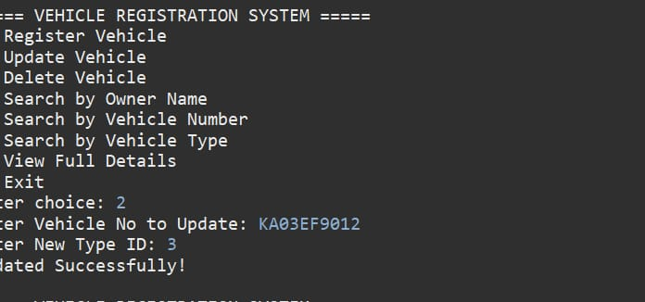

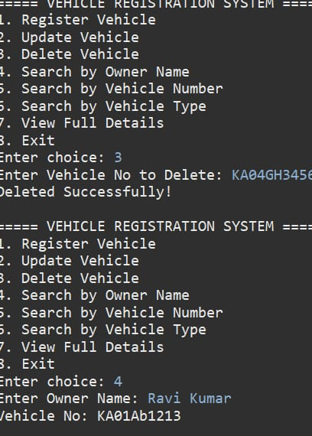

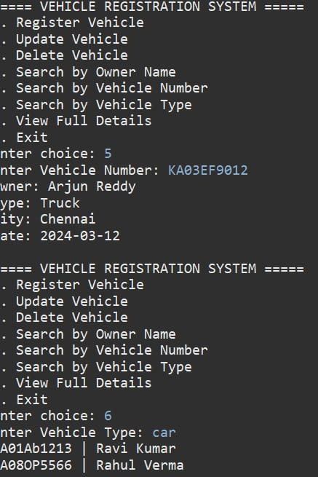

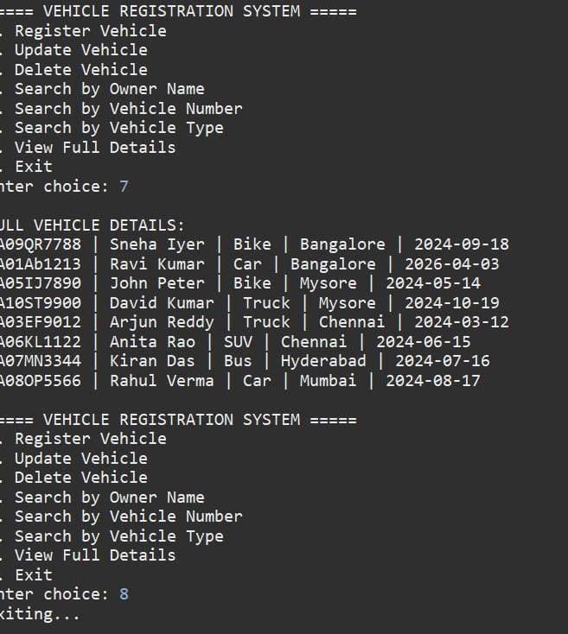

11. Application Screenshots

The following screenshots illustrate the Vehicle Registration System running in the Eclipse IDE console, showing the Java code editor and the program output.

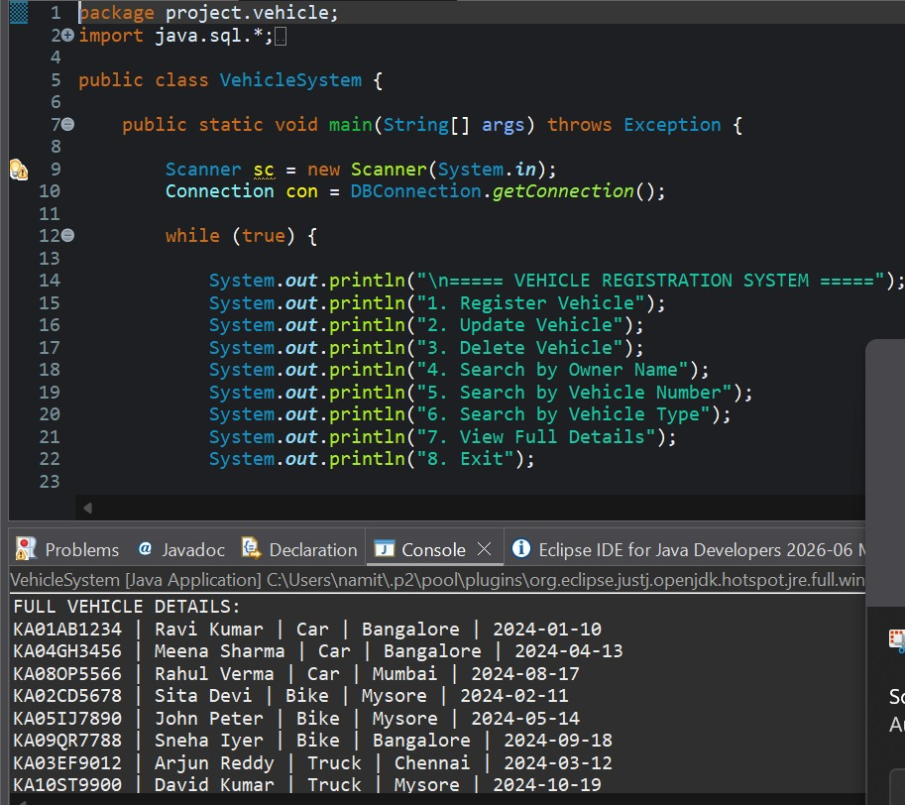
Figure 10.1: Eclipse IDE — VehicleSystem.java source code and console output
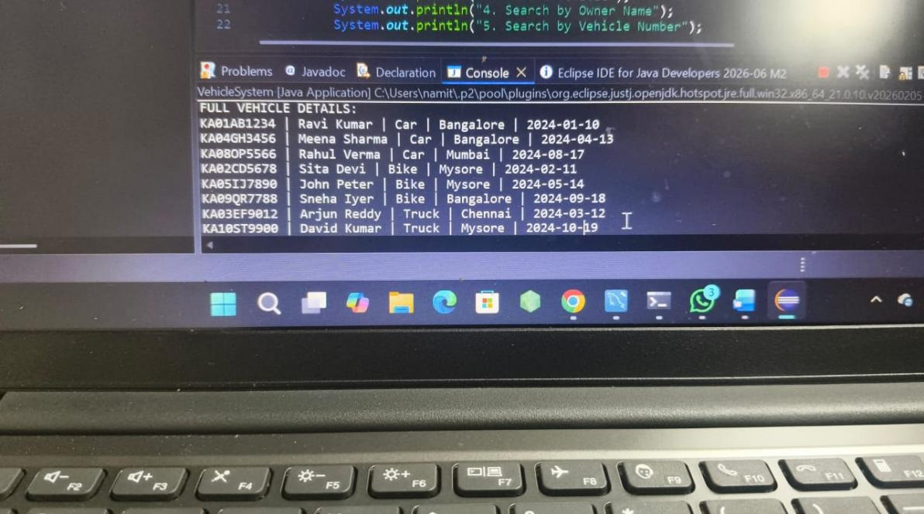
Figure 10.2: Console output — Full Vehicle Details listing all registered vehicles

12. Conclusion

The Vehicle Registration System project successfully demonstrates how a relational database-backed Java console application can replace manual, error-prone record-keeping processes. By using JDBC Prepared Statements, a normalized five-table schema, and a clear menu-driven interface, the system ensures data integrity, fast retrieval, and ease of use.

The project reinforced key concepts including JDBC connectivity, multi-table JOIN queries, relational schema design, and the practical application of CRUD operations within a real-world domain.

13. Future Enhancement

Possible future enhancements include:
- Developing a graphical user interface (GUI) using Java FX or Swing for improved usability.
- Adding user authentication so only authorized personnel can register or modify vehicle data.
- Implementing a web front-end using Spring Boot and a REST API to allow remote access.
- Generating PDF reports of registration details using libraries such as I Text or Apache PDF Box.
- Integrating SMS or email notifications to vehicle owners upon successful registration.
- Migrating to a cloud-hosted database (e.g., AWS RDS or Google Cloud SQL) for multi-user access.
- Adding audit logging to track all insert, update, and delete operations with timestamps.

