**Introduction:**

Today’s globalized world have changed the lifestyle and priorities of people, their inclination is mostly to travel around the globe to explore and experience new place and new ideas. This shift has given a great push to the airline industry. It is observed that the change has accelerated in the post-pandemic period and has ramped up the customer perception and expectations about the service provided by the airlines. For any industry it’s vital to have a strong customer base and retain a competitive edge over other company. Our project covers the customer satisfaction scores of 120k+ airline passengers and have evaluated it on various factors. This report will help the stakeholders of the airlines to know the pain points for the customers and chart their CX strategy to maximize their business channels and refine their strategy and become more receptive to the customers.

**Analysis:**

From all of the passengers surveyed, the most passengers were from those who flew business class and were loyal to the airline, a passenger who has flown with the airline before. It seems much easier for airlines to retain customers for continued business as opposed to attract new customers from extra advertising and marketing costs. Over half of the passengers surveyed were from this group, so it is crucial airlines ensure that their business flights are top of the line in quality and service, as that is where the most volume of customers come from. The second most are still those who are loyal but fly personal class instead, so ensuring all airlines have the features to keep everyone satisfied enough to want to use your airline again is a must. If a passenger was a first-time customer, it was more likely that they would be flying business class over personal according to those surveyed. Business class flights need to be a priority for all airlines. There are more passengers needing business class flights, whether first time or returning. Passengers who need services and features that enable them to continue their work on flights, something airlines need to put much more priority on to satisfy customers.

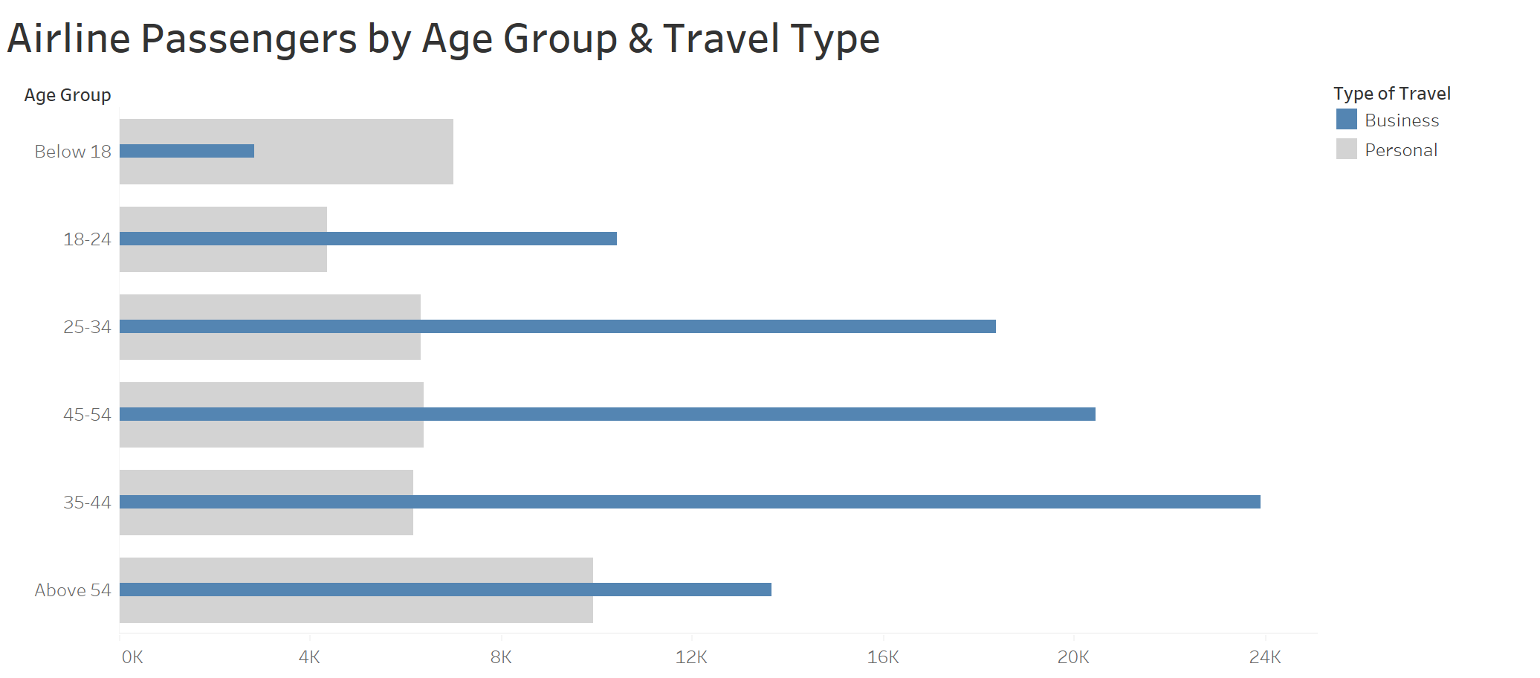

In terms of the age group of those flying airlines, most are coming from the age group of 35-44, and over 20,000 from that same age group are business passengers. The second highest came from the age group of 45-54 and the third being 25-34. The working class still takes up the majority of flights, and especially the business class. While it is important to make sure flights accommodate passengers of all ages, focusing on business class flights that are more suitable for the working-class age group can give certain airlines a huge competitive advantage if they can delivery on quality and service.

Going into more specifics for the demographics of passengers, over 55,000 of those passengers flew business class for a business trip. Surprisingly though, people who needed to fly for business purposes still flew economy class a lot, with over 25,000 passengers in that specific group. Passengers flying for business trips, business meetings or any other work-related activities are on all types of flights, so if an airline could provide features to ensure passengers always stay connected on both business class and economy class could benefit airlines and help satisfy their customers more, hopefully leading to an increase in sales from customer retention. Customers flying for personal reasons however did not choose many other options other than economy class, with under 10,000 picking classes other than economy, while over 30,000 personal passengers chose economy class. If airlines were ever met with the decision on only needing to focus on one type of class for personal passengers, making sure economy class flights were suitable for them would be the best allocation of their attention and resources.

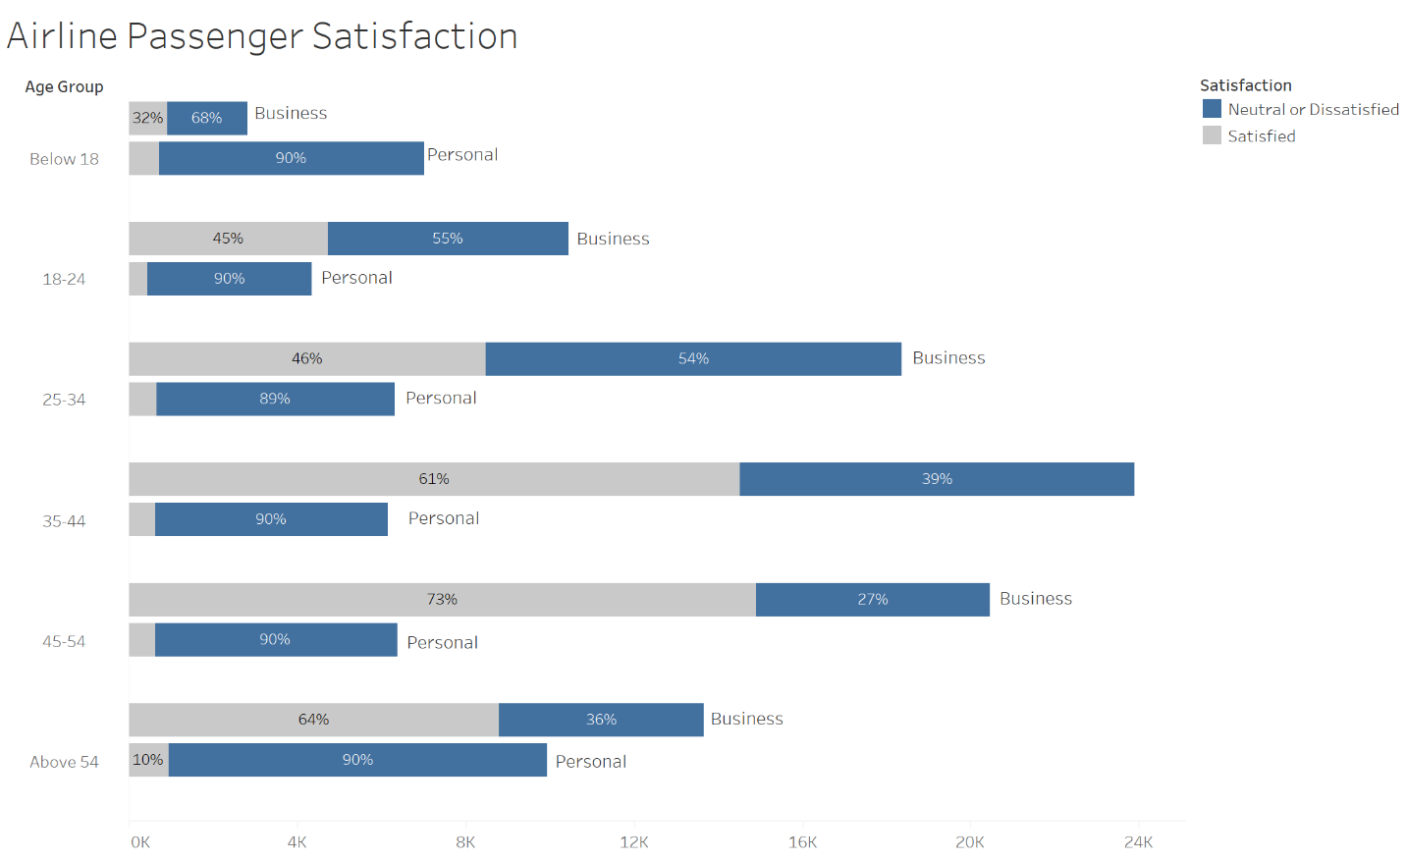

In the survey for the dataset, passengers were given the option to choose satisfied, neutral or dissatisfied. Airlines have been doing a pretty good job at keeping their passengers satisfied who were flying for business reasons, but the age groups from 18-24 and 25-34 had more neutral/dissatisfied passengers than satisfied. Ensuring better quality features and service to make sure these age groups are more content with the flights they are on, perhaps more services to keep them connected to continue their work could ensure more satisfaction and more customer retention for airlines. Passengers flying for personal reasons however for all age groups were for the most part neutral or dissatisfied. Working on accommodations and services to keep personal passengers happy could lead to any airline company using that as a competitive advantage, and being the go-to for personal flights.

Going into the more specific satisfaction levels separated by the type of flights the passengers are using, economy class needs a lot of improvements to satisfy customers across the airline industry. Most passengers, regardless of the purpose of the flight, are unhappy with the economy class flights, while the business class flights are doing relatively well in comparison. As seen from a previous chart, most of those flying economy class are flying for personal reasons, so the market is there for any airlines to try to be the airline to go for personal flights. It is crucial that flights continue to keep satisfying business customers, as they are majority of the market, but improving quality of service for personal passengers can significantly increase satisfaction and customer retention.

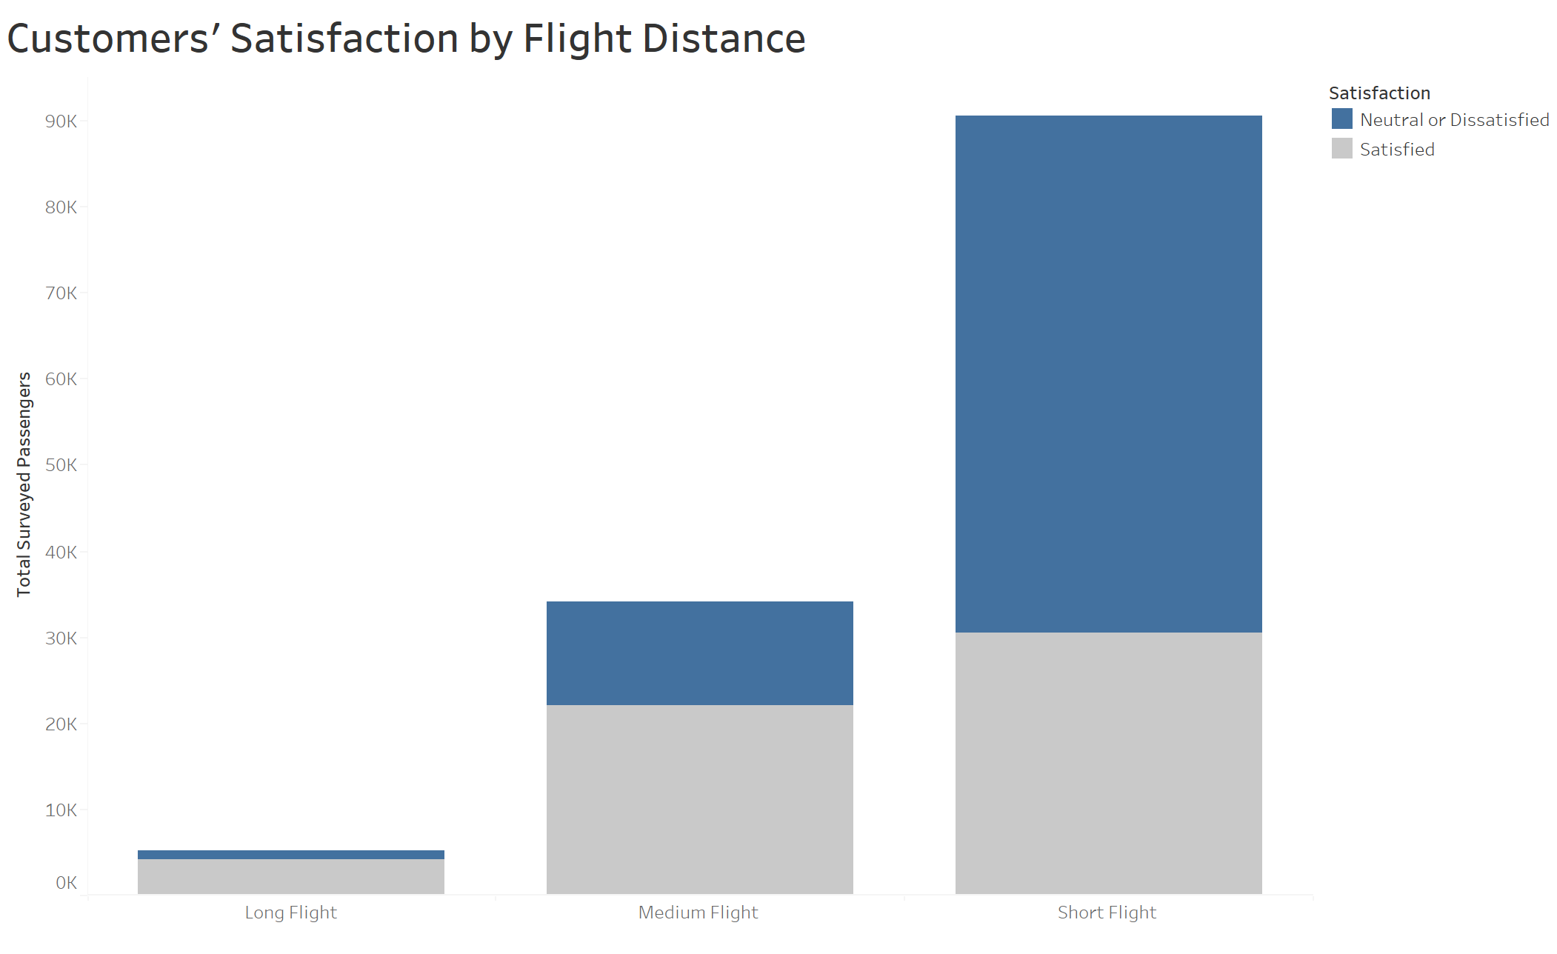

Further looking at the satisfaction levels based on the flight distance, it can be seen from the above graph that both medium flight and long flight lengths have customers satisfied for the most part. However, majority of customers surveyed being neutral or dissatisfied after the experience of a short flight. This is something for airline stakeholders to look into, as majority of their flights are short, but majority of the passengers on those flights are not happy.

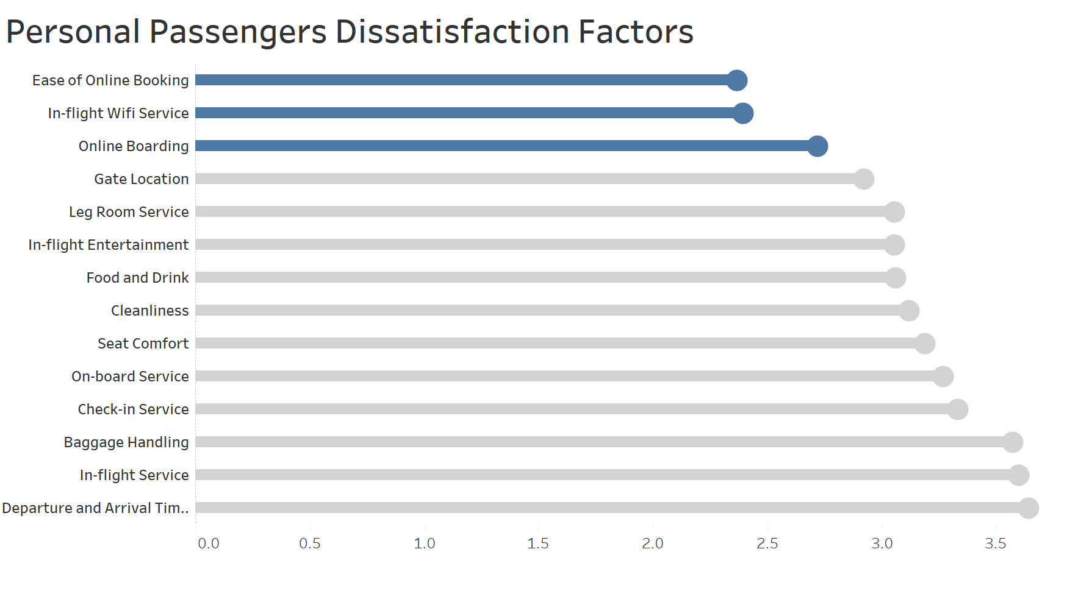Based on the dataset survey, ease of online booking, in-flight Wi-Fi and online boarding were the three biggest factors that caused the most dissatisfaction for casual passengers. With the internet being a huge part of our lives now, even a few hours without internet can cause a huge inconvenience. Improvement on Wi-Fi services to make sure it is stable enough for use is a key factor. Online boarding is another feature causing dissatisfaction among customers. Online boarding is supposed to make the lives of passengers easier allowing them to confirm presence on a flight via the internet and print their own passes. Improvements in all three of these areas related to the online experience can go a long way for airlines.

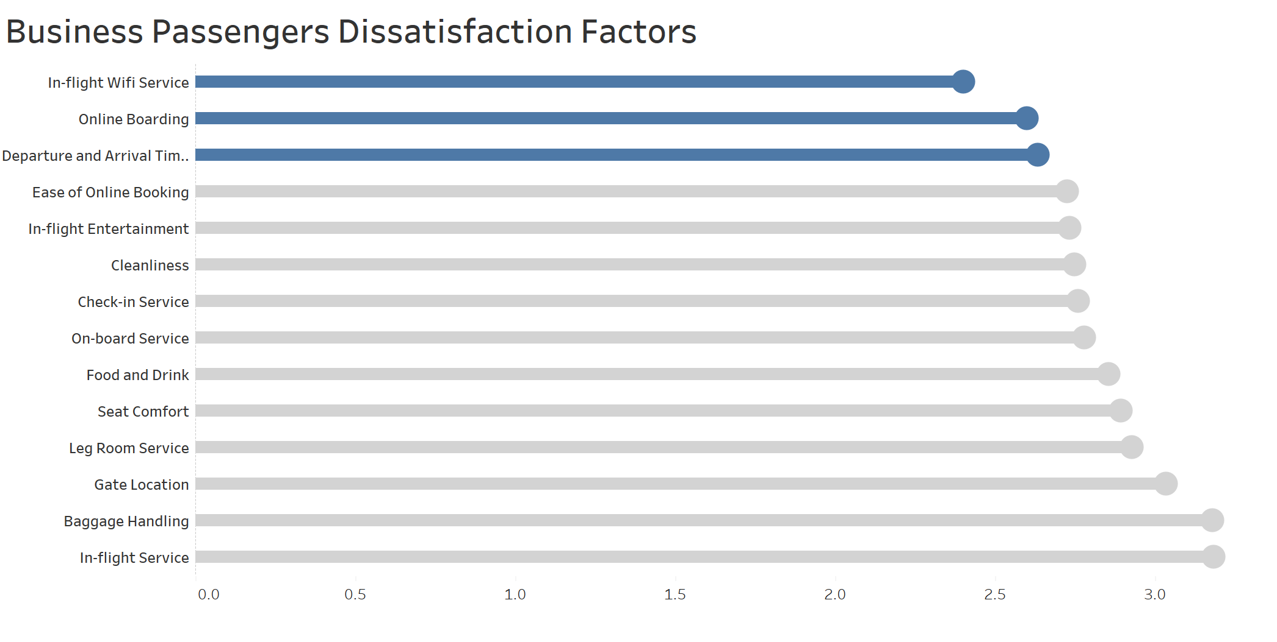

From the collected data, it was founded that the three biggest factors that caused business passengers to be unhappy were in-flight Wi-Fi service, online boarding and departure and arrival time convenience. As in the case of personal passengers, business passengers deemed Wi-Fi and online boarding as the most valuable service which is not up to the expectations of the business travellers. To add to it, they are also unhappy with the departure and arrival time of the flights. The aviation team might need to flight schedules to make it more convenient for travel so that they don’t face any unpleasant experiences for departure and after arrival. Nevertheless, the flight companies should consider finding root cause of flight delays and resolve it so that further such happenings can be prevented.

**Recommendations:**

It is evident that the online experience of the customers is it in-flight or during the booking process is a nuisance and that is impacting the loyalty of the customers. Airlines do provide the in-flight entertainment source but having in-flight wifi would empower the customers to have their own source of amusement with a wide range of their own choices. A survey published by Inmarsat has specified that inflight WI-FI is a key driver in forming customer loyalty and satisfaction. It claims that 2/3rd of the passengers is likely to rebook the tickets from the same airlines if high-quality inflight WI-FI is offered. Airlines can tie up with in-flight broadband providers like GoGo and ViaSat to give their customers the best WIFI experience during their journey.

The online booking experience is another struggling point for most of the customers even though online sales play an important source in airline revenue. According to a study conducted by Berry and Jia in 2010, flight tickets sold from online platform took around 50-60% overall tickets of the U.S market. Customers must rely on multiple APIs and third-part components for the reservations, and flight systems and these complex transactions are to be managed with utmost efficiency. Every single time a potential customer interacts with the website on whatever device and platform they’re using it’s a big undertaking. The airline’s website must deliver a responsive, smooth booking experience on each occasion to avoid disappointing prospects before they hit the buy button. Airlines can pull in more revenue by focusing on customers’ needs.

Overall, developing an optimal CX strategy to align with different airlines’ positioning and customer segment would be a long-term solution for airline companies to enhance customers’ satisfaction; otherwise, it will get in the way of revenue generation. Forrester Research has reported that US airlines have been not gaining in the average of $1.4 billion annual revenue from not improving customer experience. The first and foremost step is to chart the airlines’ CX ambition to clearly lay down where & how much the investment needs to be focused.

**\*References:**

Deloitte, Through Passengers’ eyes – Delivering the “right” airline customer experience, 2016,

<https://www2.deloitte.com/us/en/pages/consumer-business/articles/airline-customer-experience.html>

Adam Matther, 4 Simple Tips on How Airlines Can Provide a Better Online Experience to Customers, Jun 08 2015,

<https://www.liveadmins.com/blog/4-simple-tips-on-how-airlines-can-provide-a-better-online-experience-to-customers/>

Inmarsat, Demand for In-flight Wifi is Driving Airline Loyalty Amongst Passengers, Aug 07 2018,

<https://www.inmarsat.com/en/news/latest-news/aviation/2018/demand-for-inflight-wi-fi-is-driving-airline-loyalty-amongst-passengers.html>