Numerical Simulation of Vertical Aperture Opening of a Uni-axial Slit Crack in an Infinite medium

November 15, 2015

Sanath Keshav

2013a4ps359g

2015

# Acknowledgement

I would like to take this opportunity to thank Dr. Gaurav Singh for providing us with a chance to work on such a wonderful problem. This problem has given me a new perspective for looking at real life problems using mathematical models. I would like to particularly thank K. Balaje (2012B4A4443G) and Siddhartha Govilkar (2012B4A4452G) with whom I have had a number of constructive interactive sessions and it would not have been possible without their insights. The problem has been solved and written completely by myself to the best of my knowledge.

# Problem Statement

Singular integral equations play a great role in the mechanics of discontinuous solids. The numerical solutions of such equations gives a better understanding of stress and strain fields in the neighborhood of dislocations, etc. For a uni-axial slit of length 2a in an infinite medium, the vertical aperture opening of the crack is given by

$$v\left(x\right)=-L[M\int_{-a}^{x}{\frac{1}{\sqrt{a^{2}-x^{2}}}}\frac{1}{ω-x}dx\int_{-a}^{+a}{Nv\left(ω\right)\sqrt{a^{2}-ω^{2}}}dω+\int_{-a}^{x}{O \frac{x}{ \sqrt{a^{2}-x^{2}}} dx}$$

$where L,M,N,O are constants while-a<x<+a$.

# Solution

$$v\left(x\right)=-LMN\int_{-a}^{x}{\frac{1}{\sqrt{a^{2}-x^{2}}}\frac{1}{ω-x} \int_{-a}^{+a}{v\left(ω\right) \sqrt{a^{2}-x^{2} }dωdx}}-LO\int_{-a}^{x}{\frac{x}{\sqrt{a^{2}-x^{2}}}dx}$$

$$Let us consider -LO\int_{-a}^{x}{\frac{x}{\sqrt{a^{2}-x^{2}}}=f\left(x\right)}$$

$$Rearranging terms$$

$$v\left(x\right)= -LMN\int_{-a}^{x}{\frac{1}{\sqrt{a^{2}-x^{2}}} \int_{-a}^{+a}{\frac{v\left(ω\right)\sqrt{a^{2}-ω^{2}}}{ω-x} dω dx }}+f\left(x\right)$$

... **(1)**

$$Approximating v\left(x\right)with second kind of chebyshev polynomial$$

$$v\left(x\right)=\sum_{k=0}^{n}{C_{k}U_{k}\left(\frac{x}{a}\right)}$$

… **(2)**

$$-a≤x≤+a -1≤\frac{x}{a}≤ +1$$

$$where U_{k}\left(x\right)→Second type chebyshev polynomial -1≤x<+1$$

$$Substituting \left(2\right) into (1)$$

$$\sum_{k=0}^{n}{C_{k}U_{k}\left(\frac{x}{a}\right)}= -LMN\int_{-a}^{x}{\frac{1}{\sqrt{a^{2}-x^{2}}} \left( \int_{-a}^{a}{\frac{\left(\sum_{k=0}^{n}{C_{k}U_{k}\left(\frac{ω}{a}\right)}\right)\sqrt{a^{2}-ω^{2}}}{ω-x} dω }\right) dx}+f\left(x\right)$$

$$\sum_{k=0}^{n}{C_{k}U_{k}\left(\frac{x}{a}\right)}= -LMN \sum_{k=0}^{n}{C_{k}\left[ \int_{-a}^{x}{\frac{1}{\sqrt{a^{2}-x^{2}}}\left(\int_{-a}^{+a}{\frac{U_{k}\left(\frac{ω}{a}\right)\sqrt{a^{2}-ω^{2}}}{ω-x} dω}\right) dx}\right]+f\left(x\right)}$$

$$Let us take a substitution of$$

$$ω=au$$

$$dω=adu$$

$$\sum_{k=0}^{n}{C_{k}U_{k}\left(\frac{x}{a}\right)}= -LMN \sum_{k=0}^{n}{C_{k} \left[\int_{-a}^{x}{\frac{1}{\sqrt{a^{2}-x^{2}}} \left(\int_{-1}^{+1}{\frac{U_{k}\left(\frac{au}{a}\right)\sqrt{a^{2}-a^{2}u^{2}}}{au-x} adu}\right) dx }\right] }+f\left(x\right)$$

$$\sum_{k=0}^{n}{C_{k}U_{k}\left(\frac{x}{a}\right)}= -LMN\sum_{k=0}^{n}{C_{k}\left[\int_{-a}^{x}{\frac{a}{\sqrt{a^{2}-x^{2}}} \left( \int_{-1}^{+1}{\frac{U_{k}\left(u\right)\sqrt{1-u^{2}}}{u-\frac{x}{a}}du}\right)dx}\right] }+f(x)$$

… **(3)**

$$We know the identity \int_{-1}^{+1}{\frac{\sqrt{1-t^{2}}{ U}_{i}\left(t\right)}{t-x} dt }= -π T_{i+1}\left(x\right)$$

$$where T_{i}\left(x\right)→Chebyshev polynomial of first kind$$

$$In equation \left(3\right) we can observe that$$

$$\int_{-1}^{+1}{\frac{U_{k}\left(u\right)\sqrt{1-u^{2}}}{u-\frac{x}{a}}du} = -πT_{k+1}\left(\frac{x}{a}\right)$$

$$\sum_{k=0}^{n}{C_{k}U_{k}\left(\frac{x}{a}\right)}=LMN \sum_{k=0}^{n}{C_{k}\left[ \int_{-a}^{x}{\frac{aπT_{k+1}\left(\frac{x}{a}\right)}{\sqrt{a^{2}-x^{2}}} dx}\right]}+f\left(x\right)$$

$$Simplifying..$$

$$f\left(x\right)=\sum_{k=0}^{n}{C_{k} \left( U_{k}\left(\frac{x}{a}\right)-LMNaπ \int_{-a}^{x}{\frac{T_{k+1}\left(\frac{x}{a}\right)}{\sqrt{a^{2}-x^{2}}} dx}\right)}$$

… **(4)**

$$We know that$$

$$f\left(x\right)= -LO\int_{-a}^{x}{\frac{x}{\sqrt{a^{2}-x^{2}}} dx}$$

$$Let us take a substitution to integrate for f\left(x\right)$$

$$x=acost$$

$$dx= -asint dt$$

$$t=\cos^{-1}\left(\frac{x}{a}\right)$$

$$f\left(x\right)=LO \int{\frac{ acost}{\sqrt{a^{2}-a^{2}\cos^{2}{t}}} asint dt }$$

$$f\left(x\right)=LO\int{\frac{cost}{sint }} a sint dt$$

$$f\left(x\right)=LO \sqrt{a^{2}-x^{2}}$$

… **(5)**

$$Substituting \left(5\right)in (4)$$

$$LO\sqrt{a^{2}-x^{2}}= \sum_{k=0}^{n}{C_{k} \left( U_{k}\left(\frac{x}{a}\right)-LMNaπ \int_{-a}^{x}{\frac{T_{k+1}\left(\frac{x}{a}\right)}{\sqrt{a^{2}-x^{2}}} dx}\right)}$$

$$I_{k}= -LMNaπ\int_{-a}^{x}{\frac{T_{k+1}\left(\frac{x}{a}\right)}{\sqrt{a^{2}-x^{2}}} dx}$$

$$LO\sqrt{a^{2}-x^{2}}= \sum_{k=0}^{n}{C_{k} \left( U_{k}\left(\frac{x}{a}\right)+I_{k}\right)}$$

… **(6)**

Above equation is a system of linear equations in which the constants Ck are unknowns.

Equation **(6)** can be written for multiple x values and the resulting system of linear equations can be solved simultaneously using some numerical Direct/Iterative methods.

We have the following recurrence relations for first and second type of chebyshev polynomials.

$$T_{n+1}\left(x\right)=2xT_{n}\left(x\right)-T_{n-1}\left(x\right)$$

$$U_{n+1}\left(x\right)=2xU_{n}\left(x\right)-U_{n-1}\left(x\right)$$

From the above recurrence relations we can construct the chebyshev polynomials

$$T_{0}\left(x\right)=1$$

$$T_{1}\left(x\right)=x$$

$$T_{2}\left(x\right)=2x^{2}-1$$

$$T_{3}\left(x\right)=4x^{3}-3x$$

$$T_{4}\left(x\right)=8x^{4}-8x^{2}+1$$

$$T_{5}\left(x\right)=16x^{5}-20x^{3}+5x$$

$$T_{6}\left(x\right)=32x^{6}-48x^{4}+18x^{2}-1$$

$$T_{7}\left(x\right)=64x^{7}-112x^{5}+56x^{3}-7x$$

$$U_{0}\left(x\right)=1$$

$$U_{1 }(x)=2x$$

$$U_{2}\left(x\right)=4x^{2}-1$$

$$U_{3}\left(x\right)=8x^{3}-4x$$

$$U_{4}\left(x\right)=16x^{4}-12x^{2}+1$$

$$U_{5}\left(x\right)=32x^{5}-32x^{3}+6x$$

$$U_{6}\left(x\right)=64x^{6}-80x^{4}+24x^{2}-1$$

$U_{7}\left(x\right)=128x^{7}-192x^{5}+80x^{3}-8x$

The system of linear equations to be solved are

$$LO\sqrt{a^{2}-x_{0}^{2}}=C_{0}\left( U_{0}\left(\frac{x_{0}}{a}\right)+I_{0}\right)+C_{1}\left(U_{1}\left(\frac{x_{0}}{a}\right)+I_{1}\right)+⋯+C_{n}\left(U_{n}\left(\frac{x_{0}}{a}\right)+I_{n}\right)$$

$$LO\sqrt{a^{2}-x_{1}^{2}}=C_{0}\left( U_{0}\left(\frac{x_{1}}{a}\right)+I_{0}\right)+C_{1}\left(U_{1}\left(\frac{x_{1}}{a}\right)+I_{1}\right)+⋯+C_{n}\left(U_{n}\left(\frac{x_{1}}{a}\right)+I_{n}\right)$$

$$⋮$$

$$LO\sqrt{a^{2}-x_{n}^{2}}=C_{0}\left( U_{0}\left(\frac{x_{n}}{a}\right)+I_{0}\right)+C_{1}\left(U_{1}\left(\frac{x_{n}}{a}\right)+I_{1}\right)+⋯+C_{n}\left(U_{n}\left(\frac{x_{n}}{a}\right)+I_{n}\right)$$

Where Cks are unknowns. We have n equations and n variables.

Representing the above equations as $AX=B$

$$\left[\begin{matrix} U_{0}\left(\frac{x_{0}}{a}\right)+I_{0} & U_{1}\left(\frac{x_{0}}{a}\right)+I_{1} & ⋯ & U_{n}\left(\frac{x_{0}}{a}\right)+I_{n} \\ U_{0}\left(\frac{x_{1}}{a}\right)+I_{0} & U_{1}\left(\frac{x_{1}}{a}\right)+I_{1} & ⋯ & U_{n}\left(\frac{x_{1}}{a}\right)+I_{n} \\ ⋮ & ⋮ & ⋮ & ⋮ \\ U_{0}\left(\frac{x_{n}}{a}\right)+I_{0} & U_{1}\left(\frac{x_{n}}{a}\right)+I_{1} & ⋯ & U_{n}\left(\frac{x_{n}}{a}\right)+I_{n}\end{matrix}\right] \left[\begin{matrix}C_{1} \\ C_{2} \\ ⋮ \\ C_{n}\end{matrix}\right]=\left[\begin{matrix}LO\sqrt{a^{2}-x_{0}^{2}} \\ LO\sqrt{a^{2}-x_{1}^{2}} \\ ⋮ \\ LO\sqrt{a^{2}-x_{n}^{2}}\end{matrix}\right]$$

$$AX=B$$

$$X=A^{-1}B$$

$$Let us calculate I_{3}$$

$$We know that I_{k}= -LMNaπ\int_{-a}^{x}{\frac{T_{k+1}\left(\frac{x}{a}\right)}{\sqrt{a^{2}-x^{2}}} dx}$$

$$I_{3}= -LMNaπ\int_{-a}^{x}{\frac{T_{4}\left(\frac{x}{a}\right)}{\sqrt{a^{2}-x^{2}}}dx}$$

$$T_{4}\left(x\right)=8x^{4}-8x^{2}+1→T_{4}\left(\frac{x}{a}\right)=8{\left(\frac{x}{a}\right)}^{4}-8{\left(\frac{x}{a}\right)}^{2}+1$$

$$I_{3}= -LMNaπ\int_{-a}^{x}{\frac{\left(8{\left(\frac{x}{a}\right)}^{4}-8{\left(\frac{x}{a}\right)}^{2}+1\right)}{\sqrt{a^{2}-x^{2}}}dx}$$

$$let us take a substitution of t=ax→dt=adx$$

$$I_{3}= -LMNaπ\int_{-1}^{\frac{x}{a}}{\frac{\left(8t^{4}-8t^{2}+1\right)}{\sqrt{1-t^{2}}}dt}$$

$$let us take a substitution of t=cosθ→dt=-sinθdθ$$

$$I_{3}=-LMNaπ∫8\cos^{4}{θ}-8\cos^{2}{θ}+1 dθ$$

$$using the relation→ 2\cos^{2}{θ-1=cos2θ}$$

$$I_{3}= -LMNaπ∫cos4θ dθ$$

$$I_{3}= -LMNaπ\frac{1}{4}sin4θ$$

$$Substituting limits we get$$

$$I_{3}= -LMNaπ\frac{x}{a^{4}}\sqrt{a^{2}-x^{2}}\left(2x^{2}-a^{2}\right)$$

Similarly the other integrations can be done to get the system of linear equations.

# Results

An interactive program is written on *MATLAB R2015a* to solve the singular integral equation to accept the constants (Material properties and other) and the number of chebyshev polynomials used in the approximation and display the solution profile graphically and as a function. Here are some of the results

$$For the constants$$

$$L=1$$

$$M=1$$

$$O=1$$

$$a=4$$

$$Number of chebyshev polynomials used for approximation n=5$$

Plots for a number of N (=0, 1, 5, 10, 50,100) values are displayed.

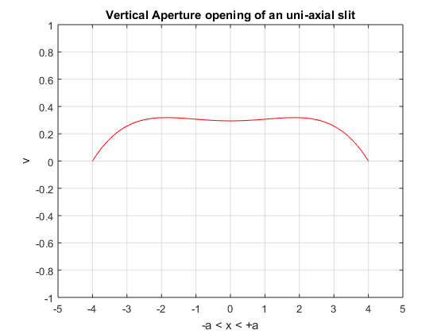

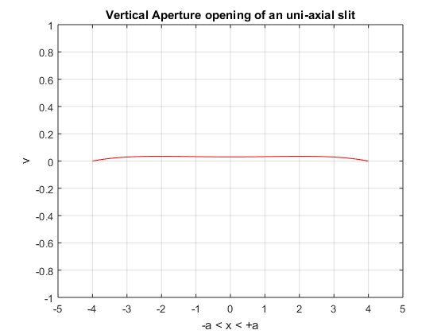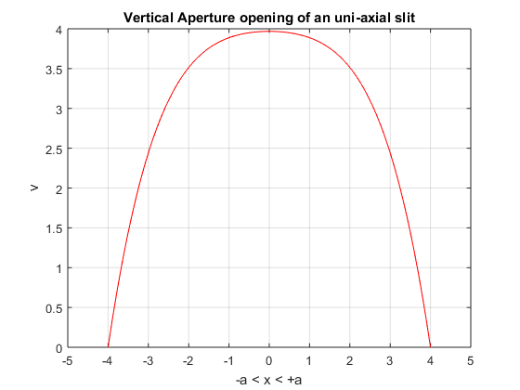 N = 0 N=1

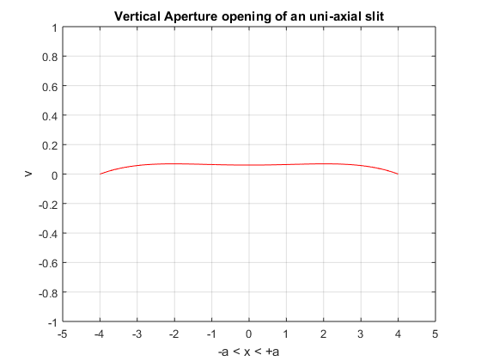 N=5 N=10

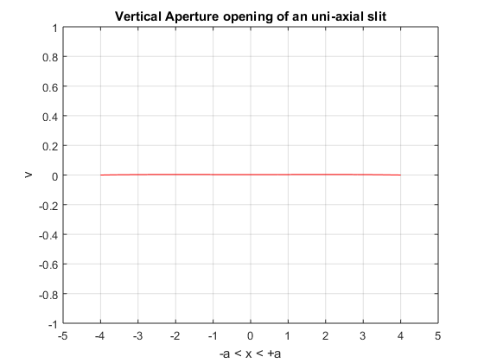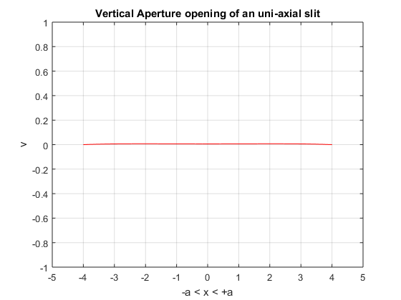 N=50 N=100

The program uses symbolic variables so that we obtain a polynomial function as the approximated vertical aperture opening profile. For a = 4, L=1, M=1, N=1, O=1, n=5 we obtain,

$$v\left(x\right)= 1.68×{10}^{-21}x^{5}- 0.00202x^{4}- 3.2×{10}^{-19}x^{3}+ 0.0139x^{2}+ 2.07×{10}^{-18}x + 0.295$$

$$where-a≤x≤+a.$$

# Validation of code

To validate the code N was taken to be zero. When N=0 then then

$$v\left(x\right)=-L[M\int_{-a}^{x}{\frac{1}{\sqrt{a^{2}-x^{2}}}}\frac{1}{ω-x}dx\int_{-a}^{+a}{Nv\left(ω\right)\sqrt{a^{2}-ω^{2}}}dω+\int_{-a}^{x}{O \frac{x}{ \sqrt{a^{2}-x^{2}}} dx}$$

Would turn into

$$v\left(x\right)= -LO\int_{-a}^{x}{\frac{x}{\sqrt{a^{2}-x^{2}}} dx}$$

Which has a simple analytic solution

$$v\left(x\right)= LO \sqrt{a^{2}-x^{2}}$$

Which is a parabolic equation, which was obtained by running the code.

# Behavior of Maximum aperture with increasing value of N

It is clear from the obtained data that with increasing value of N the maximum aperture opening length decreases which suggests N being a cohesive material property. A parametric study was done by running the code for a wide range of N and comparing the maximum aperture opening length. The below figure shows how as the value of N increases the slit refuses to open and the maximum aperture opening tends to zero as N increases.

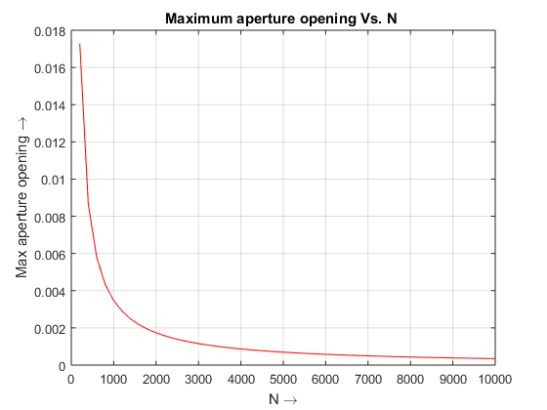

*Matlab* Code

The following code has been written in *Matlab R2015a .* Copy and paste the following code in a script file and run it. Input all the required parameters when prompted.

clear all; close all;clc; format long;

syms y; %Symbolic variable

A=input('Enter slit length: ');

a=A/2;

L=input('Enter the value of L :');

M=input('Enter the value of M :');

n=input('Enter the value of N :');

O=input('Enter the value of O :');

N=input('Enter the number of chebychev polynomials used in the approximation : ');

fprintf('Calculating..... Please wait... ');

h = (2*a/N); %Step size

x = -a:h:a;

x1 = -a:0.01:a;

T = sym(zeros(N+2,1)); %Chebyshev polynomials of first type

U = sym(zeros(N+1,1)); %Chebyshev polynomials of second type

f1 = zeros(N+1,1);

f2 = f1;

T(1) = 1;

T(2) = y;

U(1) = 1;

U(2) = 2*y;

%Finding Chebyshev polynomials with the help of recursive relations

for j=1:N-1

T(j+2) = 2*y*T(j+1) - T(j);

U(j+2) = 2*y*U(j+1) - U(j);

%U(j+2) = y*U(j+1) + T(j+2);

end

T(N+2) = 2*y*T(N+1) - T(N);

T1 = subs(T,y,y/a); %Finding chebyshev polynomials for -a to a

U1 = subs(U,y,y/a);

I = zeros(N+1,N+1);

A = zeros(N+1,N+1);

for i=1:N+1

for j=1:N+1

I(i,j) = int(L*M*n*pi*T1(j+1)*( a/(sqrt(a^2-y^2))),-a,x(i));

A(i,j) = subs(U1(j),x(i)) - I(i,j);

end

f1(i) = L*O*sqrt(a^2 - x(i)^2); %f(x) = -LO*sqrt(a^2 - x^2)

end

c1 = A\f1; %Gaussian elimination for a system of linear equations

c2 = A\f2;

v1=0;

for i=1:N+1

v1 = v1 + c1(i)*U1(i);

end

sol1 = subs(v1,x1); %Finding solution profile by substituting discrete values

plot(x1,sol1,'r'); %Ploting the slit crack profile

xlabel('-a < x < +a \rightarrow ')

ylabel('v\rightarrow')

title('Vertical Aperture opening of an uni-axial slit')

xlim([-a-1,a+1]);

ylim([-1,1]);

grid on

hold on

syms x

fprintf('The function V(x) is :');

vpa(simplify(subs(v1,x)),3)

# References

* Piessens, R. (2000). Computing integral transforms and solving integral equations using Chebyshev polynomials approximations. *Journal of computational and applied mathematics, 121(1),* 113-124.
* Z.K.Eshkuvatov , N.M.A.Nik long, M.Abdulkawi (2008). Approximate solution of singular integral equation of the first kind with Cauchy kernel. *Elsevier, Applied mathematics letters.*
* J.C Mason, D.C Handscomb (2003). Chebyshev Polynomials. *Chapman and Hall/CRC* ISBN-0849303559.