**Raising Hand Disaster Management Mobile Application**

# DESIGN MODULES

This section introduces various Disaster management and mitigation modules.

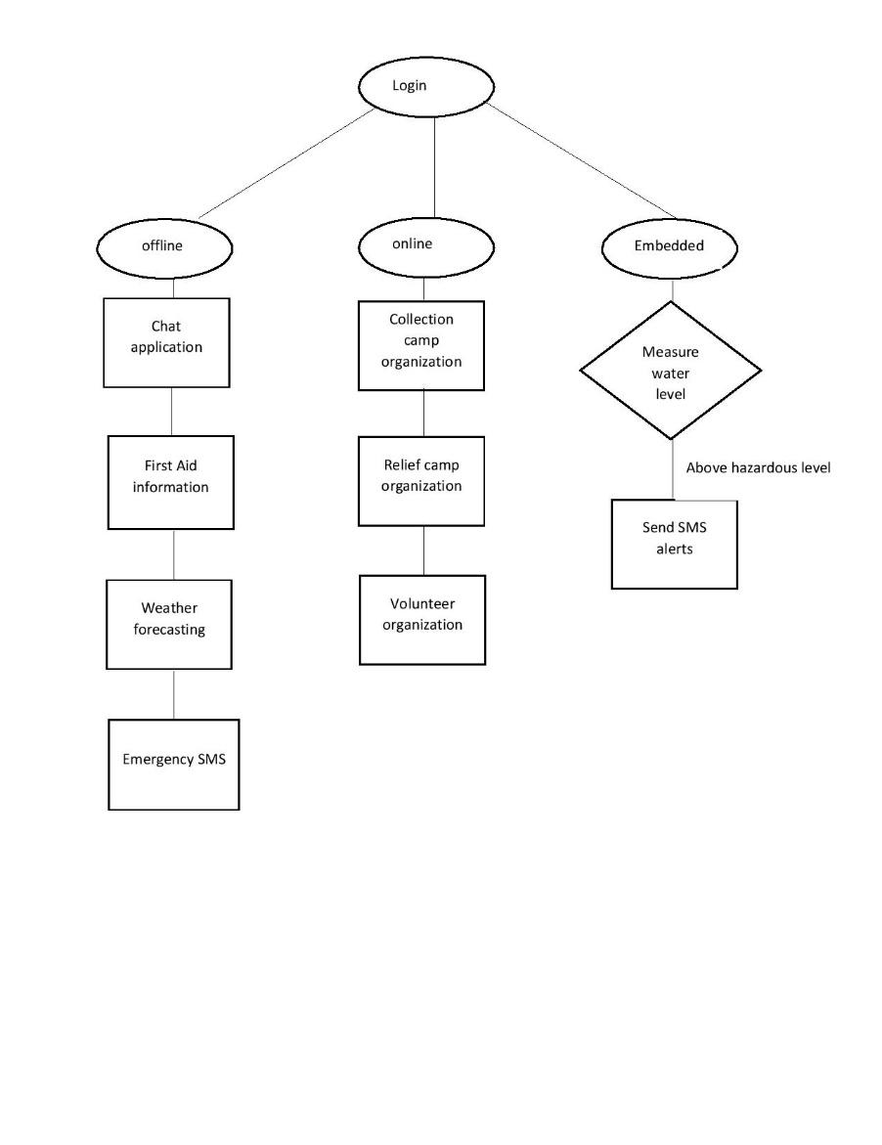

1. **RAISING HANDS**
2. *EMERGENCY*

Raising hand which works in both offline and online modes in case of emergency situations due to network issues. Users can able to share their live locations in case of emergency and to request vehicle assistance and medical support for those who are affected in critical conditions.

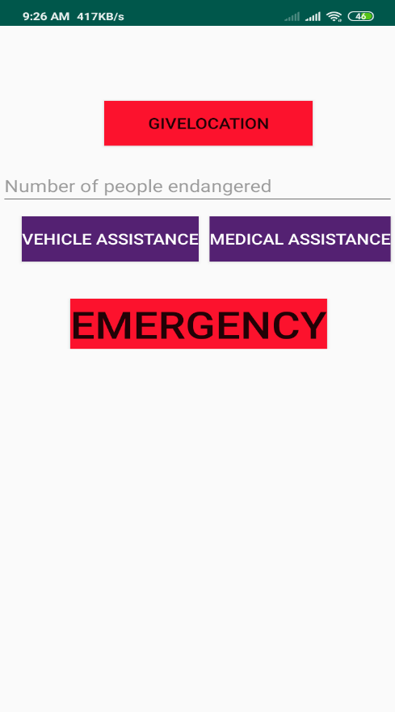

1. *ENABLE DATA*

Enable Data is a method which turns on our mobile radio power. By turning off aeroplane mode, it allows to detect and connect to any telecom connection, if the telecom companies provide exception in disaster hit areas, to use the internet.

1. *WEATHER*

This provides recent weather updates up to 3 days which helps victims to take precautions or plan their evacuation. The weather updates are available only when there is internet connection. Application which uses of open weather map API to get the updated report.

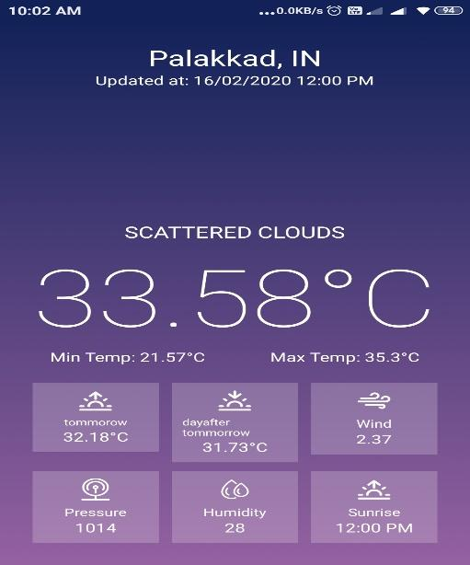

1. *FIRST AID*

It shows necessary First Aid methods to the affected persons, this activity can save lives or allows to improve the chances of survival until proper treatments available. First Aid practices can be given until proper medical treatment is available.

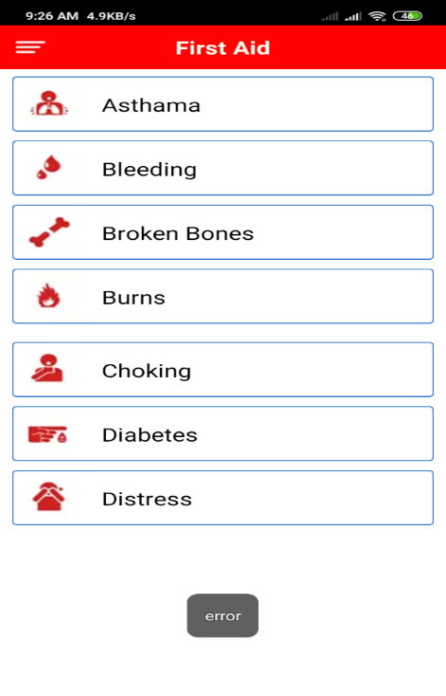

1. DANGER NOTIFICATION

Messages are displayed over the notification screen for alerting victims about the current situation.

1. **HELPING HAND**
2. *FACE RECOGNIZER*

It uses tensor flow model to create a face model by training. The face can be detected with the autofocus feature of camera and Face Detect library. It allows to recognize the face from already trained models and the name can be searched from the database to get other required details. It can be used to find details of trapped or helpless persons by scanning their face.

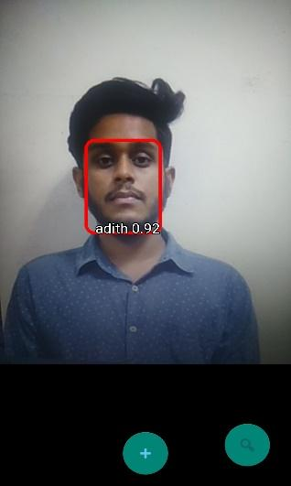 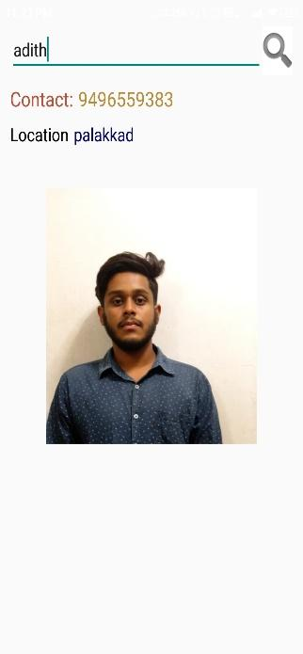

1. *VOLUNTEER MANAGEMENT*

This activity manages the volunteer registration and allocation of volunteers according to the rising needs posted by the administrator or authorities. It improves the functioning of volunteer system.

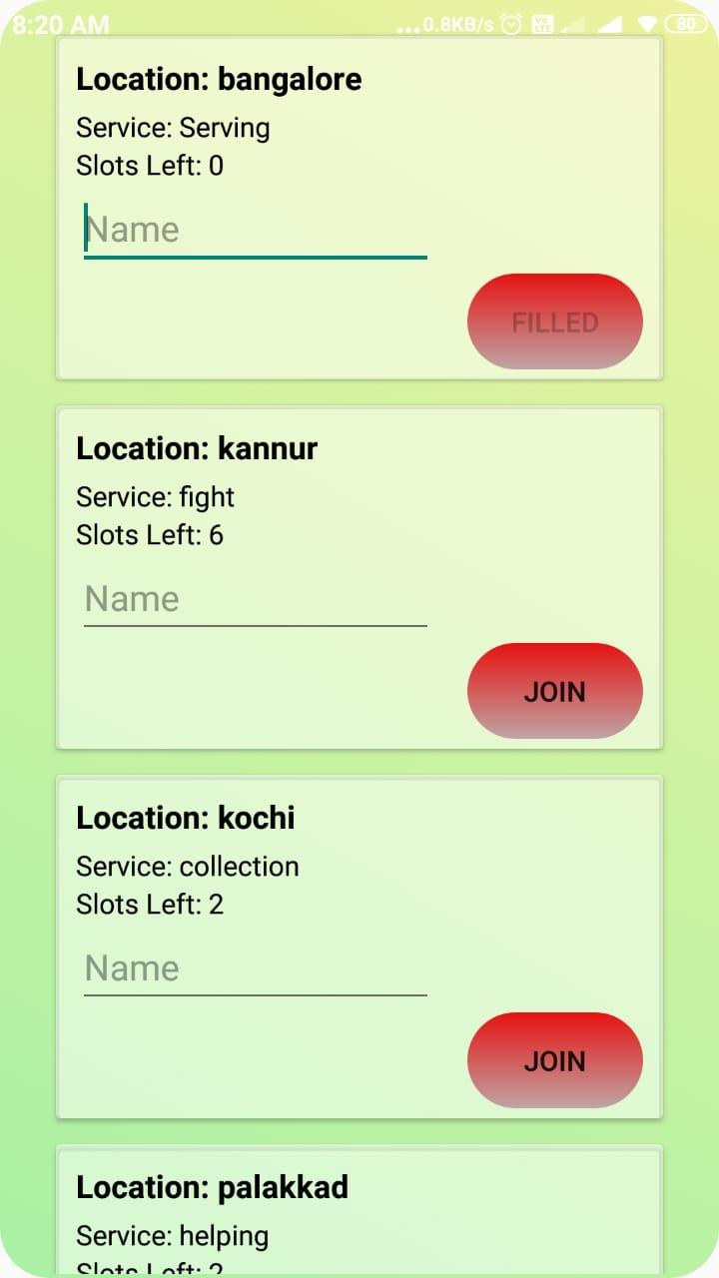

1. *REFUGEE CAMP MANAGEMENT*

This provides a supervisory control over the registered refugee camps. It allows the camps to request for goods, services and medical assistance. It ensures the requirements a provided in time.

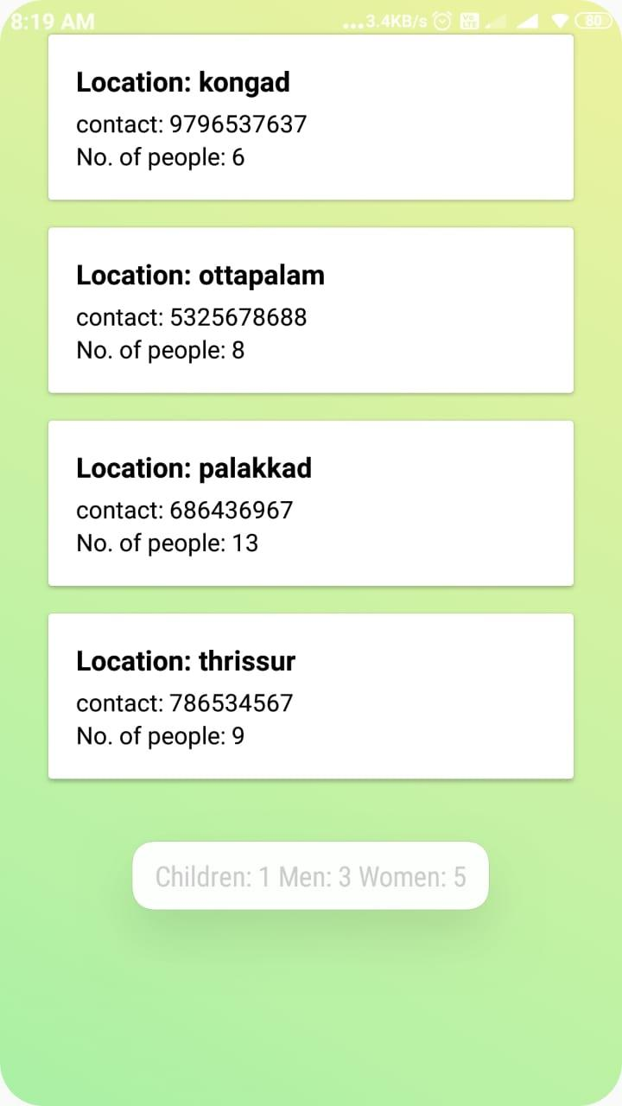

1. **CONCLUSION**

The application allows easy tracking of affected persons with a mobile. Victims can ask for help and other aids or alert officials if required which improves their chances of survival. Injured victims can be identified which allows the authorities to inform their close relatives. The application can help victims to survive the situation by providing help and services. It can also integrate various relief activities so that the effectiveness of the activities improves to improve safety of the affected

Organization of various relief facilities can improve the efficiency of disaster management activities in future the warning systems can be integrated with disaster warnings from government departments and improvement in offline features.