SQL PROJECT 1: EMPLOYEE MANAGEMENT SYSTEM

Sanathkumar A

Table of Contents:

- Introduction
- ER Diagram
- CREATE TABLE SQL Scripts
- INSERT Values in to Table SQL Scripts
- Basic SELECT and WHERE Queries.
- Sorting & Filtering Queries
- JOIN Queries
- Subqueries & Advanced Thinking

INTRODUCTION:
- The main motive of this project to manage employee information in an organization.
- It allows storing and managing employee details, departments, job roles, and salaries.

ER DIAGRAM:
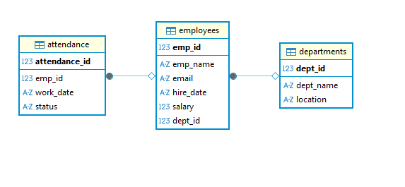

CREATE TABLE SQL Scripts:

Employee table:

CREATE TABLE employees (
emp_id INT PRIMARY KEY,
emp_name VARCHAR(100) NOT NULL,
email VARCHAR(100) UNIQUE,
hire_date DATE,
salary DECIMAL(10,2),
dept_id INT,
FOREIGN KEY (dept_id) REFERENCES departments(dept_id)
);

Department Table:

CREATE TABLE departments (
dept_id INT PRIMARY KEY,
dept_name VARCHAR(100) NOT NULL,
location VARCHAR(100)
);

Attendance Table:

CREATE TABLE attendance (
attendance_id INT PRIMARY KEY,
emp_id INT,
work_date DATE,
status VARCHAR(20),
FOREIGN KEY (emp_id) REFERENCES employees(emp_id)
);
INSERT Values in to Table SQL Scripts:
Employee table:
INSERT INTO employees VALUES
(101, 'Alice', 'alice@gmail.com', '2022-01-10', 60000, 2),
(102, 'Bob', 'bob@gmail.com', '2021-06-15', 55000, 1),
(103, 'Charlie', 'charlie@gmail.com', '2023-03-01', 50000, 3);

Department Table:
INSERT INTO departments VALUES
(1, 'HR', 'New York'),
(2, 'IT', 'San Francisco'),
(3, 'Finance', 'Chicago');

Attendance Table:

INSERT INTO attendance VALUES
(1, 101, '2024-01-01', 'Present'),
(2, 102, '2024-01-01', 'Absent'),
(3, 103, '2024-01-01', 'Present');

Basic SELECT & WHERE Queries:
- Display all employees from the employees table.

SELECT * FROM EMPLOYEES;

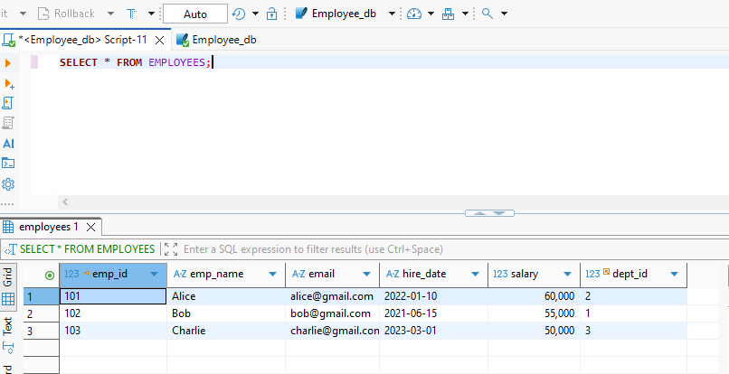

- Show employee names and emails only.

SELECT emp_name, email FROM EMPLOYEES;
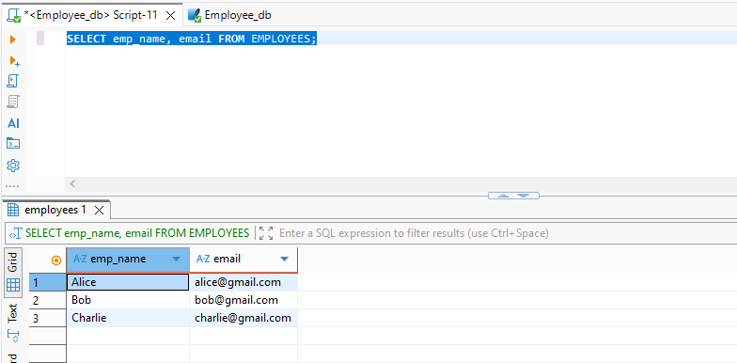

- List employees who work in the IT department
SELECT employees.emp_id, employees.emp_name, employees.email, employees.salary, departments.dept_name from employees join departments
on employees.dept_id = departments.dept_id
WHERE departments.dept_name = 'IT';

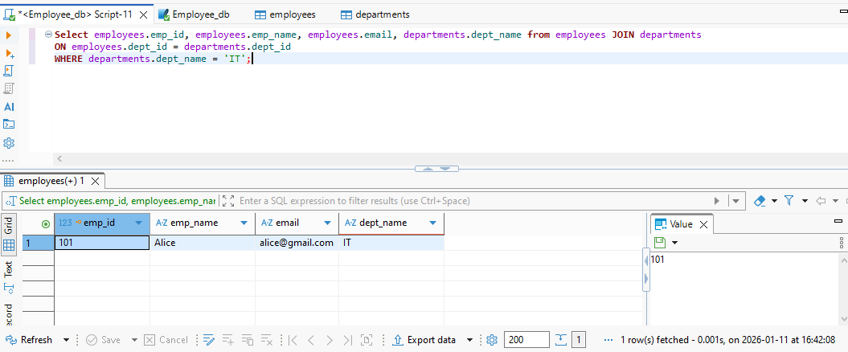

- Find employees whose salary is greater than 50,000.
SELECT * FROM EMPLOYEES
WHERE salary>50000;

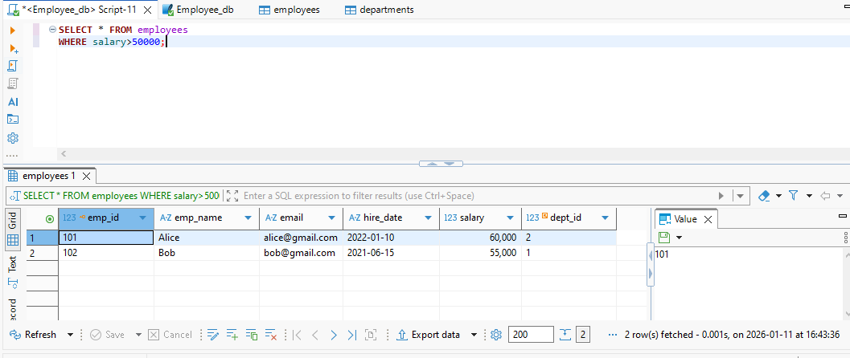

- Display employees hired after 2022-01-01.
SELECT * FROM EMPLOYEES
WHERE hire_date > '2022-01-01';

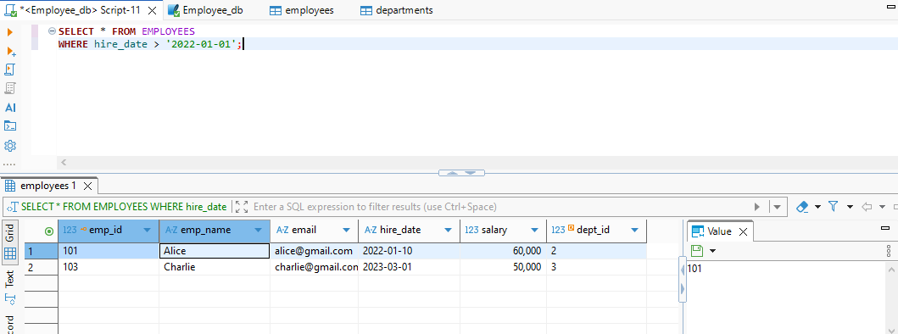

Sorting & Filtering Queries:

- Show all employees ordered by salary (highest to lowest).
SELECT * FROM EMPLOYEES;
ORDER BY salary DESC;
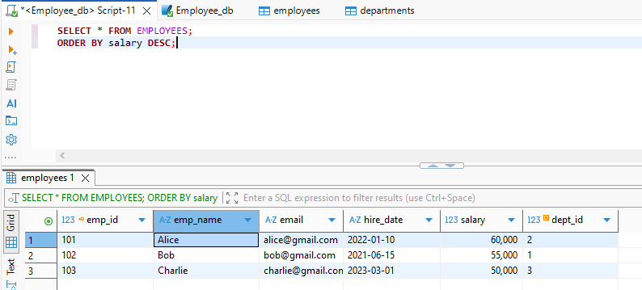

- List employees whose name starts with the letter A
SELECT emp_name, emp_id, email, salary FROM EMPLOYEES
WHERE emp_name like 'A%';

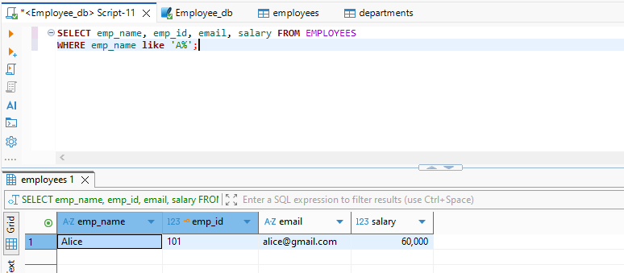

- Find employees whose email contains gmail
SELECT emp_name, emp_id, email FROM EMPLOYEES
WHERE email LIKE '%gmail%';

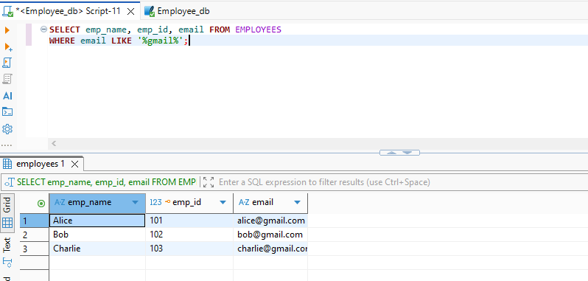

Aggregation (COUNT, AVG, SUM) Queries:
- Count the total number of employees

SELECT COUNT(*) AS Totalemployees FROM EMPLOYEES;
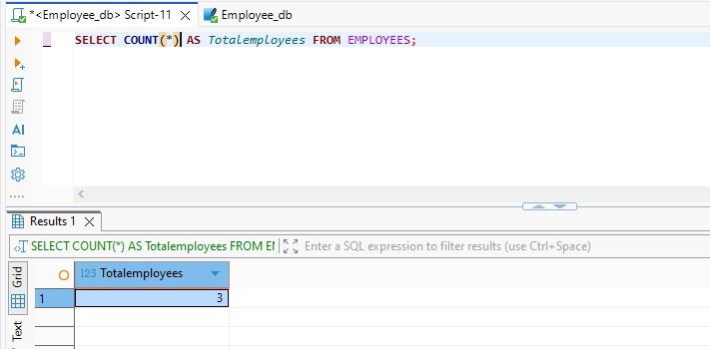

- Find the average salary of all employees

SELECT AVG(salary) AS Averagesalary from EMPLOYEES;

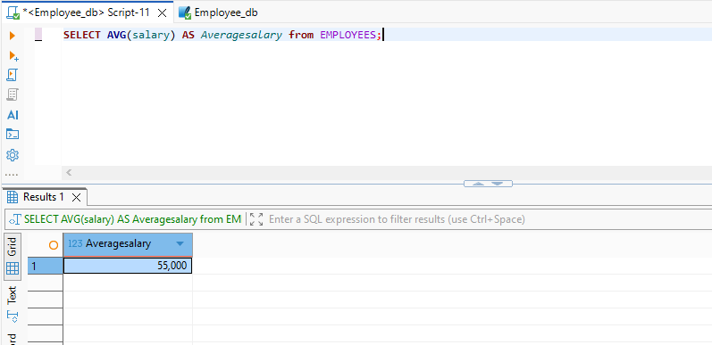

- Show the total salary paid by each department
SELECT d.dept_name,
SUM(e.salary) AS total_salary
FROM departments d
JOIN employees e
ON d.dept_id = e.dept_id
GROUP BY d.dept_name;

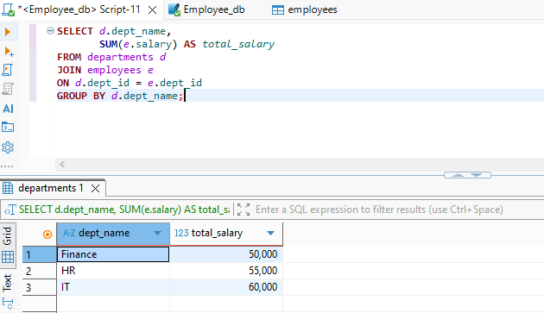

- Find the department with the highest average salary.
SELECT d.dept_name,
AVG(e.salary) AS average_salary
FROM departments d
JOIN employees e
ON d.dept_id = e.dept_id
GROUP BY d.dept_name
ORDER BY average_salary DESC
LIMIT 1;

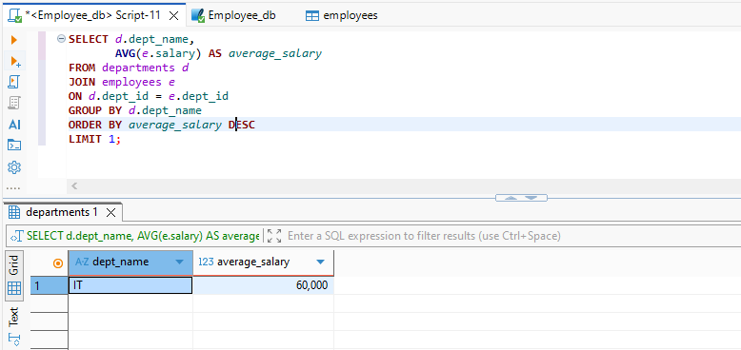

GROUP BY & HAVING Queries:
- Show departments that have more than 1 employee
SELECT departments.dept_name,
COUNT(employees.emp_id) AS employee_count
FROM Departments
JOIN Employees ON departments.dept_id = employees.dept_id
GROUP BY departments.dept_name
HAVING COUNT(employees.emp_id) > 1;

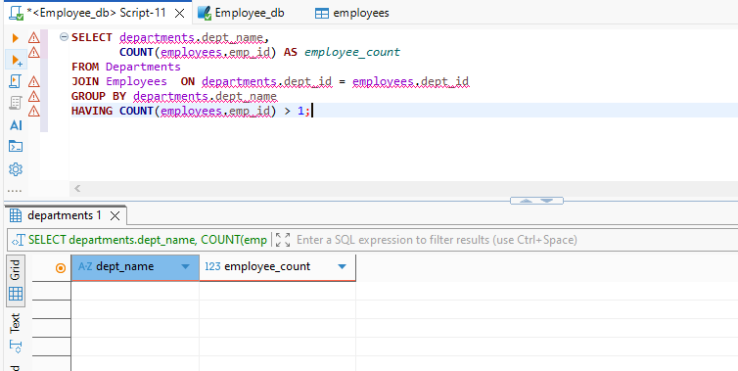
- List departments where the average salary is greater than 55,000.
SELECT departments.dept_name, AVG(salary) as Average_salary from departments
join employees on departments.dept_id = employees.dept_id
GROUP BY departments.dept_id
HAVING AVG(salary) >55000;

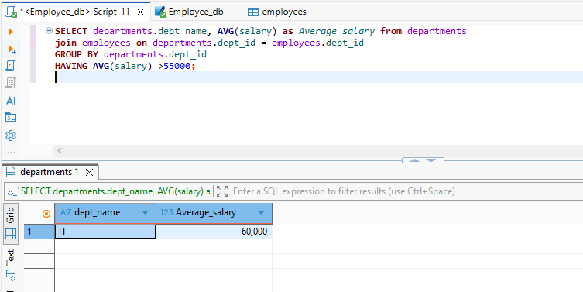

JOIN Queries:
- Display employee names along with their department names

SELECT employees.emp_id, employees.emp_name, employees.email, employees.salary, departments.dept_name from employees LEFT JOIN
departments on employees.dept_id = departments.dept_id;

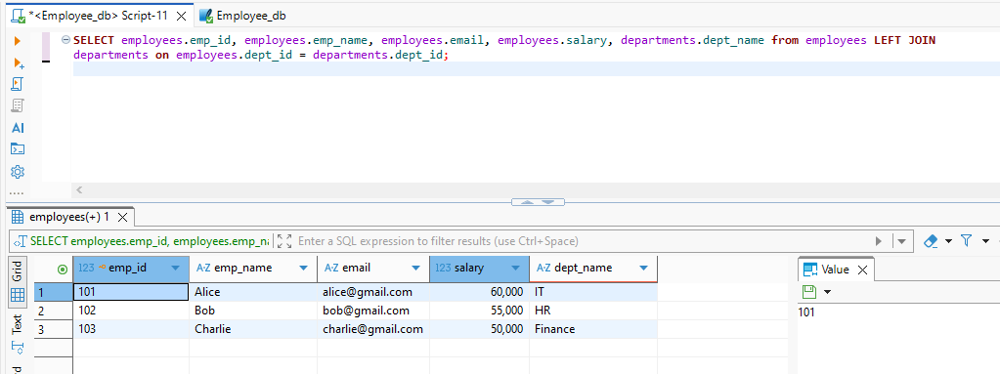

- Show all employees who belong to the HR department
SELECT employees.emp_id, employees.emp_name, employees.email, employees.salary, departments.dept_name from employees LEFT JOIN
departments on employees.dept_id = departments.dept_id
WHERE departments.dept_name = 'HR';

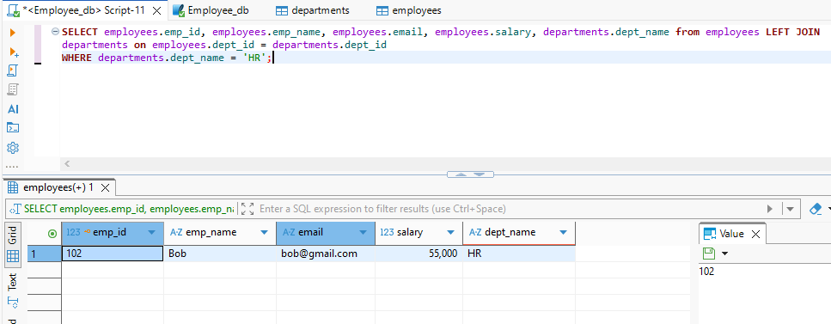

- Display attendance details including employee name and status.
SELECT attendance.attendance_id, attendance.work_date, attendance.status, employees.emp_name from attendance left join
employees on attendance.emp_id = employees.emp_id;

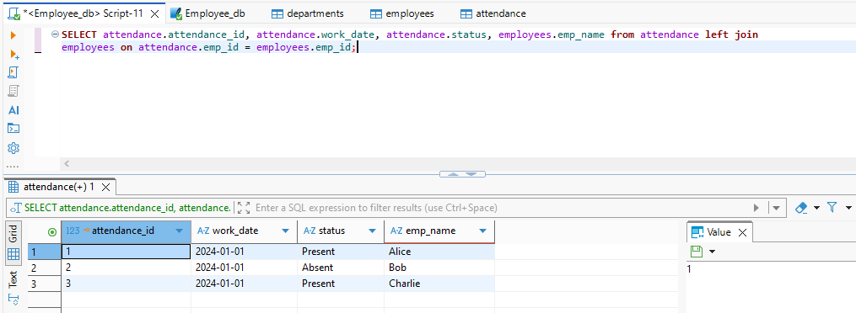

Subqueries & Advanced Thinking
- Find the employee(s) who earn the highest salary

SELECT * from employees
WHERE salary = (SELECT MAX(salary) from employees);

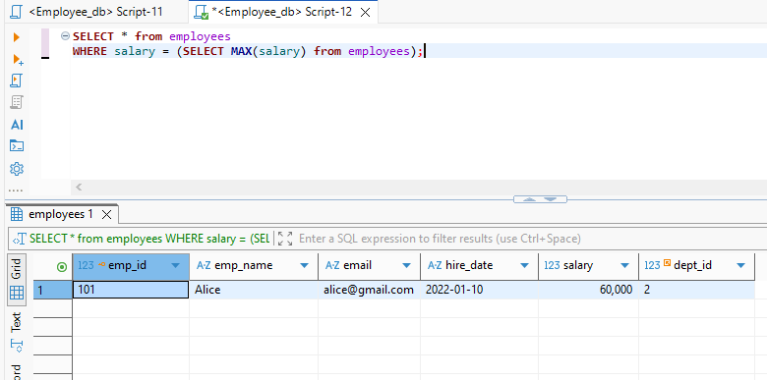

- List employees who do not have any attendance record
SELECT employees.emp_name, employees.email, employees.salary, attendance.status from employees left join attendance
on employees.emp_id = attendance.emp_id
where attendance.status is NULL;

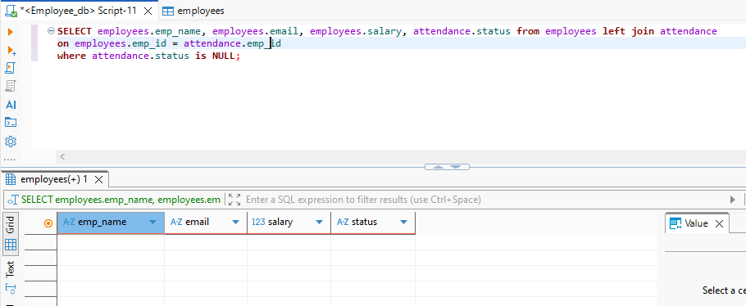

- Display departments that do not have any employees
SELECT departments.dept_id, departments.dept_name, employees.emp_id from departments left join employees
on departments.dept_id = employees.dept_id
where employees.emp_id is NULL;

