SANA-ULLAH



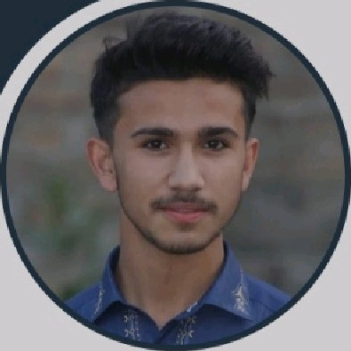About Me

Passionate web developer skilled in front-end design and basic back-end development. Focused on creating responsive, userfriendly websites, Committed to learning and growing in the field.

+92 344 9828233

Sanaullakhan@gmail.com

pacha kalay. Pir baba, Buner



* English
* Urdu
* Pashto



• **Creative Problem-Solving**

• **Front-End Development (React,Tailwind, JavaScript)**

• **Responsive Web Design**

• **Web Performance Optimization**  
• **Time Management**  
• **Team Collaboration & Communication**  
• **UI/UX Thinking**  
• **Project Management Skills**  
• **Attention to Detail**  
• **Adaptability & Continuous Learning**

Web developer

EDUCATION

AL-FAROOQ PUBLIC SCHOOL AND COLLEGE

BUNER

Matric

Completed in 2021

GOVT POST GRADUATE MINGORA DEGREE COLLEGE

SWAT

Fsc part-I & part-Il

Completed in 2023

# THE UNIVERSITY OF AGRICULTURE PESHAWAR

Beachlor in information technology

Still in progress

# EXPERIENCE

Front-end Web Developer

Self-Employed | 2024 - Present

Specialized in front-end development. Built and maintained personal and client based projects. Creating responsive and visually appealing websites using responsive websites using HTML CSS, JavaScript, and frameworks like React or Bootstrap.

SKILLS SU MMARY

Front-End Development:

HTML CSS. JavaScript. React.js, TailwindCSS and Bootstrap.

Back-End Development (Basic).

Node.js, Express.js, MongoDB.