

Course Code: EEE111.6

Group Project: **Design of a DC Power Supply (220V AC to 5V DC)**

# Name: Sanaulla Haq

I/D: 1721380042

# Name: Ferdous Zeaul Islam

I/D: 1731136642

# Name: S.M Shouvik Islam

I/D: 1712767642

# Name: Taqsim Ahmed

I/D: 1512400042  
  
Submission Date:   
24/08/2019

# Submitted to: Mr. Fahimul Haque

***Objective:***

Our task is to design an AC to DC converter that takes in 220V, 50Hz input AC signal and provides a stable enough DC output of voltage of 8V.

***Design Strategy:***

InputAC signal can be taken directly from our household electricity supply which we will attempt to get an output of fixed DC voltage that can be used for powering up variable size loads.

The entire circuit comprises of four different parts:

1. *Step-Down Transformer:  
     
     
   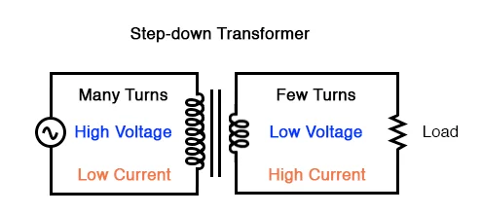*

AC signal of 220V, 50Hz gets transformed to 12V, 50Hz (approx.). The next parts of the circuit will deal with this lower voltage AC signal.

1. *Rectifier:   
   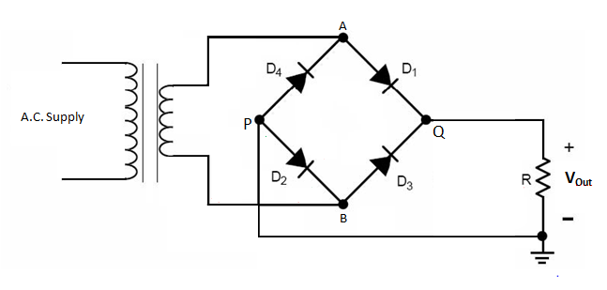*

A bridge rectifier comprising of four diodes (Si) are used to rectify the AC signal into a full-wave signal.

1. *Filter:  
    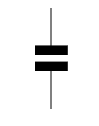*

This is perhaps the most important part of the circuit. The intent is to filter the rectified full-wave signal and provide a straight line output voltage. We will use shunt capacitor for this, connected parallel with the load. The capacitor’s capacitance will be determined through simulation.

1. *Voltage Regulator:  
    *

To further ensure a stable DC output and also to supply a fixed

Output voltage to variable load a voltage regulator IC is added at the last part just before output.

***List of Equipment’s:***

1. Step-down transformer 12V (1A)
2. Silicon diodes (4 units)
3. Capacitor (units and capacitance not determined yet)
4. Voltage Regulator IC-LM7805
5. 1Kohm resistor
6. LED.

***Circuit Diagram & Schematics:***

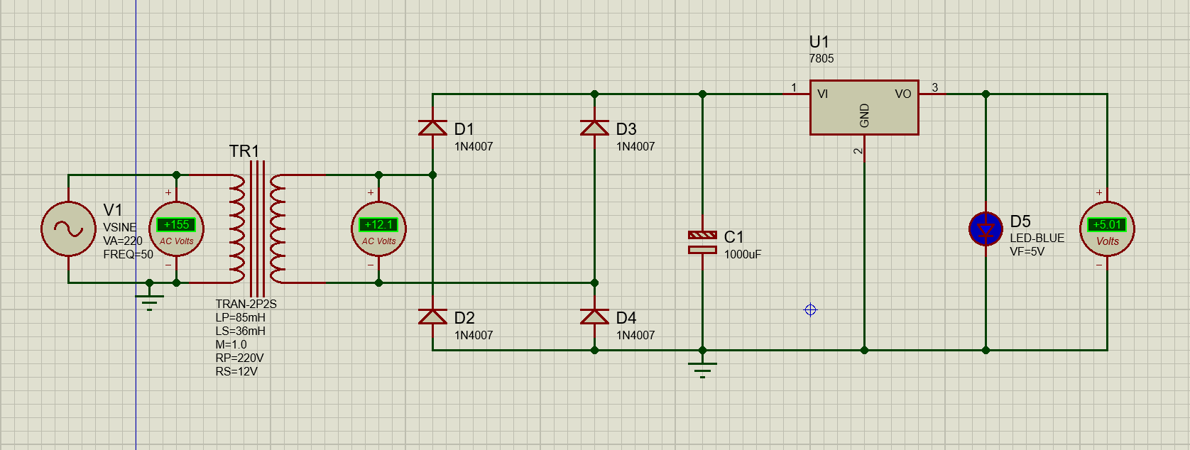

*Figure:* AC to DC converter.