**Schematics and Simulation(Using Proteus)**

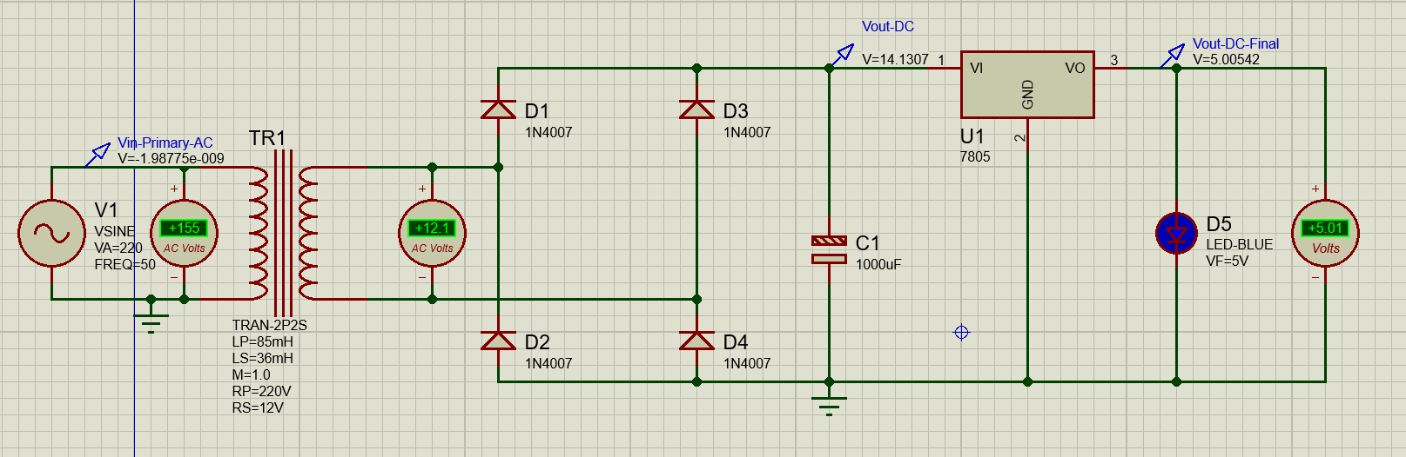

**Circuit Diagram: DC power Supply**

**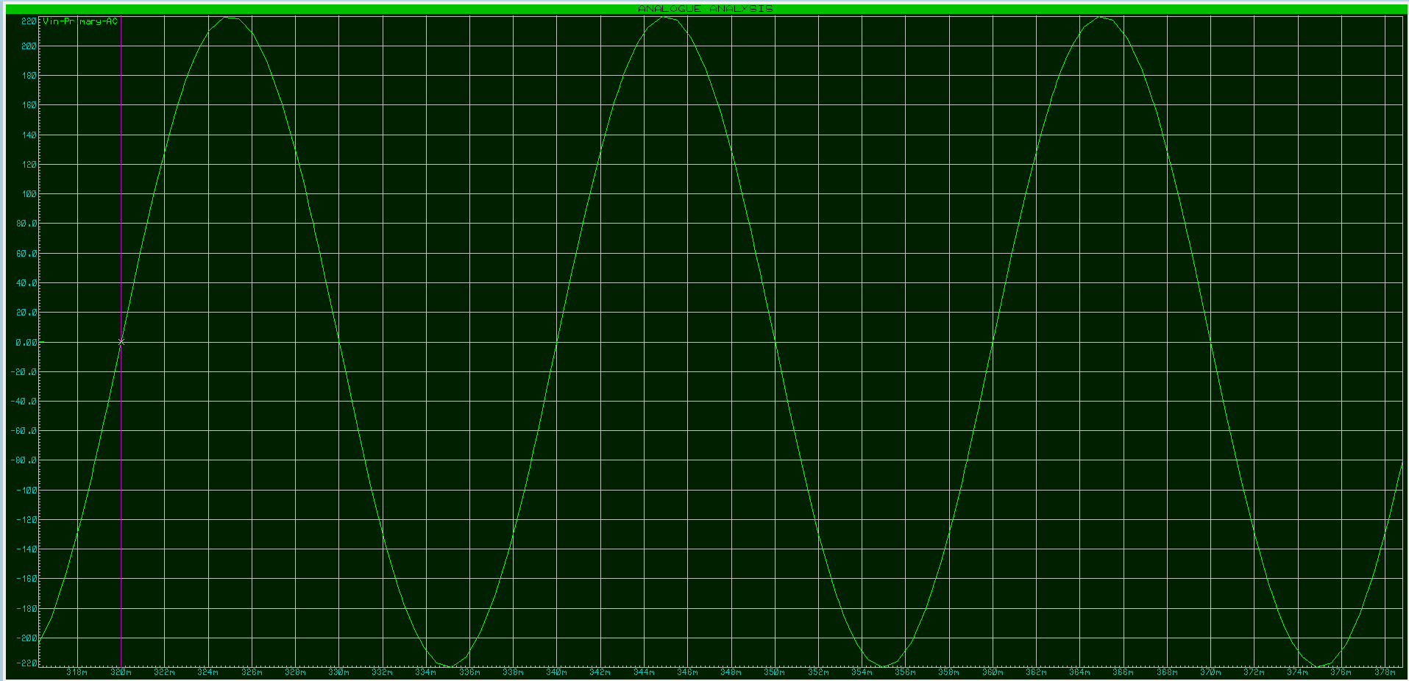  
Fig: Primary AC Vin**

**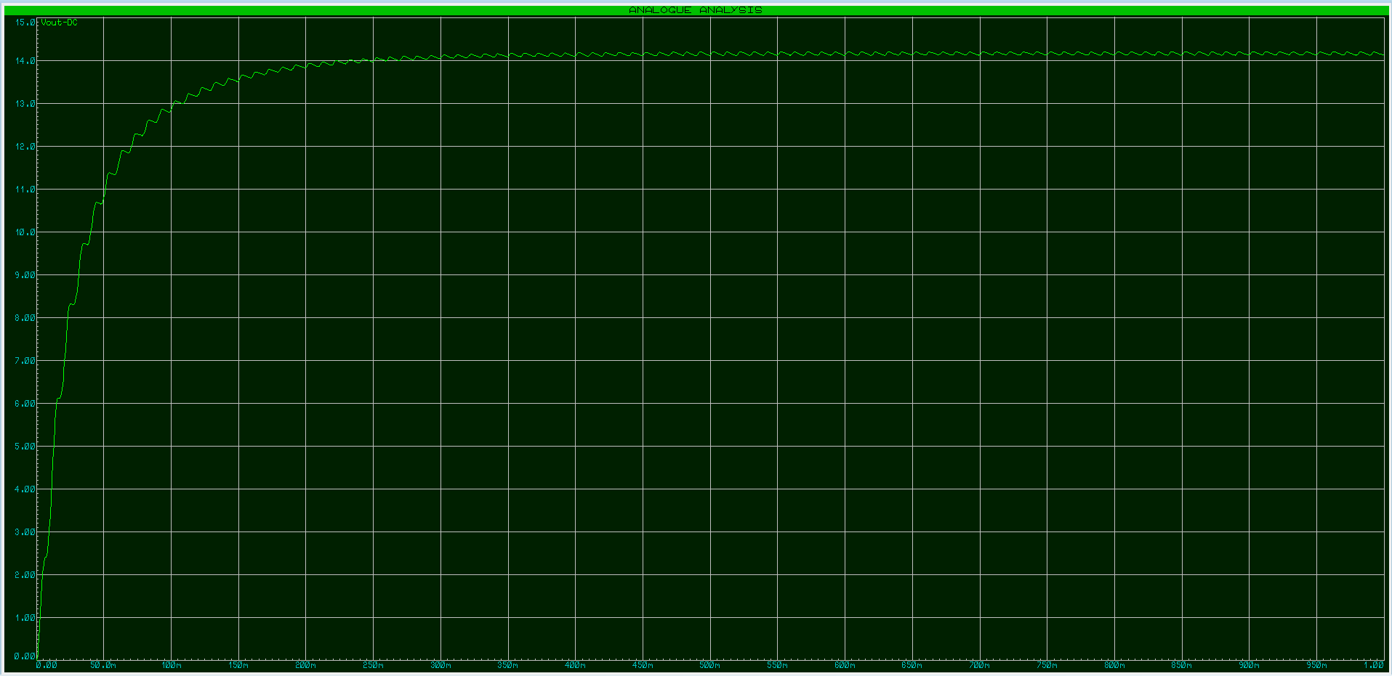  
Fig: DC Vout  
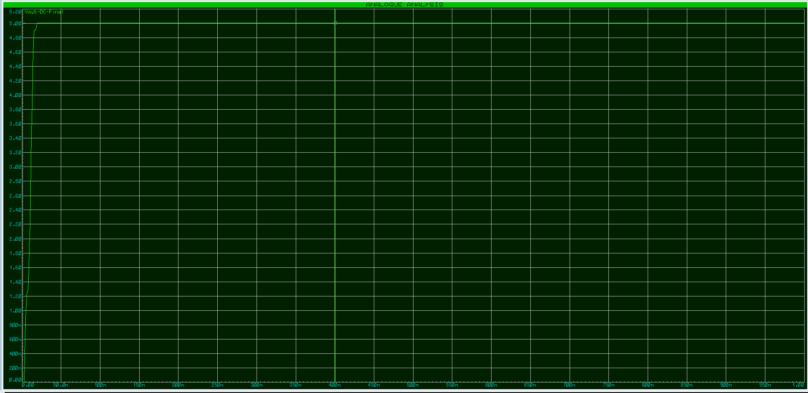  
Fig: DC Vout Final 5V**