Air University, Islamabad
Department of Cyber Security

Lab Report
Flask Web Application Development
Secure Software Development Lifecycle (SSDLC)

Student Name | Sanawar Imran
Roll Number | 243633
Program | BS Cyber Security – Section A
Subject | Secure Software Design System (SSDLC)
Submitted To | Babar Ahmad
Date | 14 April 2026

1. Introduction
This lab report documents the development of a Flask-based web application as part of the Secure Software Development Lifecycle (SSDLC) course. The objective of this lab is to build a functional web application incorporating secure authentication, session management, and modular HTML templating using Jinja2.
Flask is a lightweight Python web framework that follows the WSGI standard and is widely used for building secure, scalable web applications. This lab covers the complete workflow from environment setup to application deployment and testing.

2. Environment Setup

2.1 Python Installation
The first step in the development process is installing Python. Python is the underlying runtime for Flask. The following screenshots show the installation process and verification.
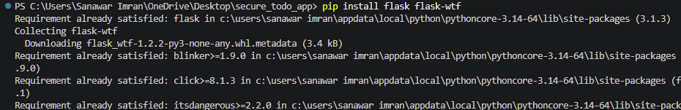
Figure 1: Python Installation – Step 1
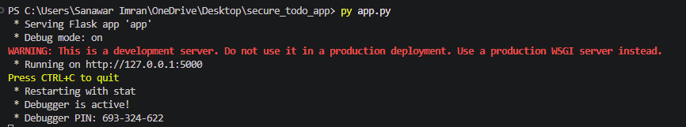
Figure 2: Python Installation – Step 2 (Verification)

3. Application Source Code

3.1 Main Application File (app.py)
The app.py file is the entry point of the Flask application. It defines routes, handles HTTP requests, manages user sessions, and integrates with HTML templates. Key components include route decorators, session-based authentication, and form handling.
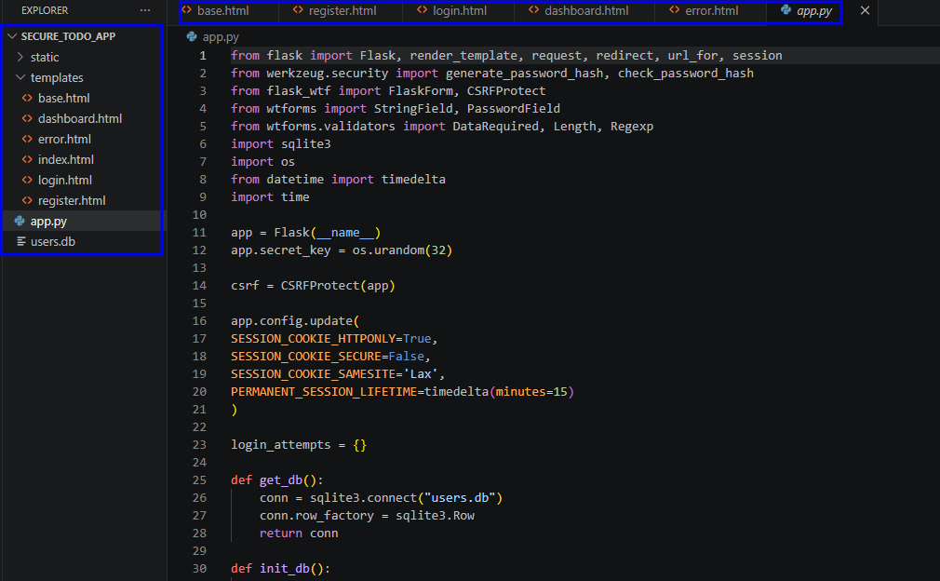
Figure 3: app.py – Main Flask Application File

3.2 Base Template (base.html)
The base.html file serves as the master layout template using Jinja2 templating. It contains the common HTML structure (navbar, head, footer) that is inherited by all other pages, following the DRY (Don't Repeat Yourself) principle.
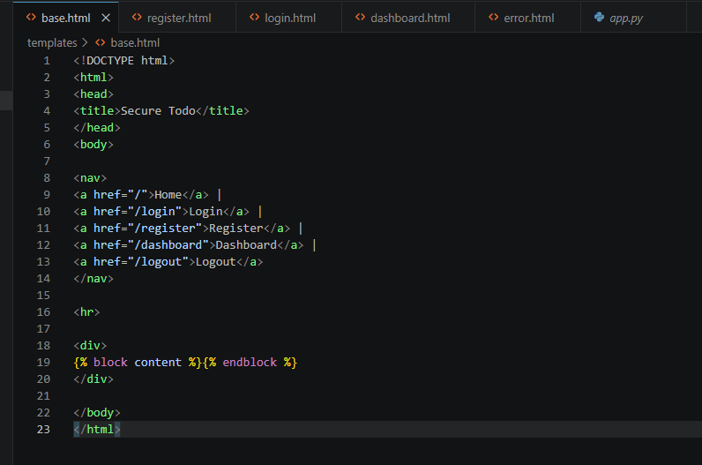
Figure 4: base.html – Master Layout Template

3.3 Register Page (register.html)
The register.html template provides the user registration form. It extends base.html and includes input fields for username and password with CSRF protection and input validation.
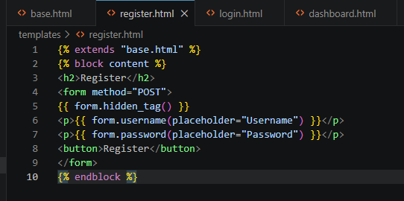
Figure 5: register.html – User Registration Template

3.4 Login Page (login.html)
The login.html template handles user authentication. It captures credentials, submits them to the Flask backend, and manages session tokens upon successful verification.
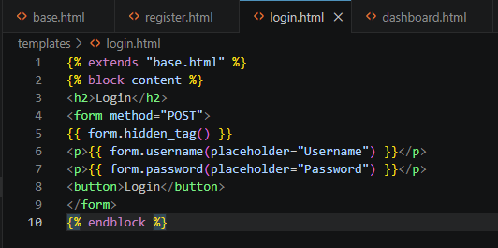
Figure 6: login.html – User Login Template

3.5 Dashboard Page (dashboard.html)
The dashboard.html template is the protected landing page accessible only to authenticated users. It demonstrates session-based access control — a core principle of secure web application development.
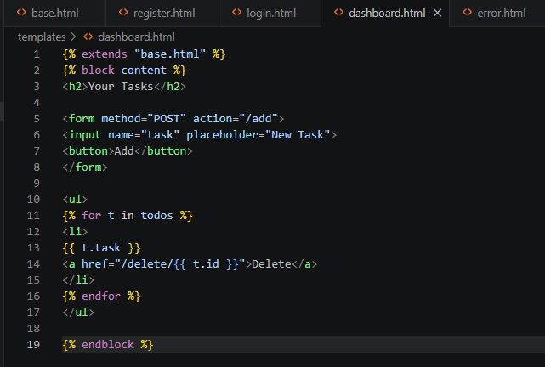
Figure 7: dashboard.html – Authenticated Dashboard Template

4. Application Testing & Output

4.1 Launching the Application
The Flask development server is started by running app.py. The application listens on the local port (default: 5000). The screenshot below shows the application running in the browser.
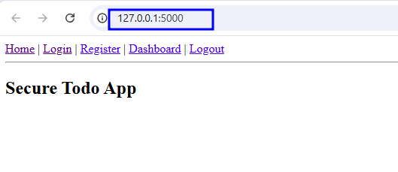
Figure 8: Flask Application – Home/Welcome Screen

4.2 User Registration
A new user account is created through the registration form. The application accepts the username and password, stores the credentials securely, and redirects to the login page upon successful registration.
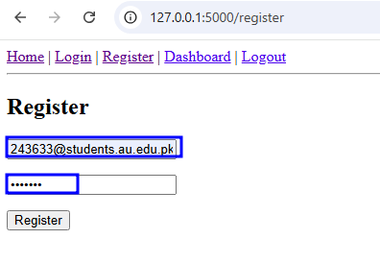
Figure 9: User Registration – Form Submission

4.3 User Login
After registration, the user logs in using the provided credentials. A session token is generated and stored server-side to maintain the authenticated state across requests.
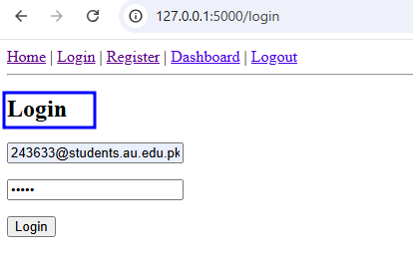
Figure 10: User Login – Successful Authentication

4.4 Dashboard Access
Upon successful login, the user is redirected to the protected dashboard. The application validates the session before rendering the dashboard, ensuring only authenticated users can access it.
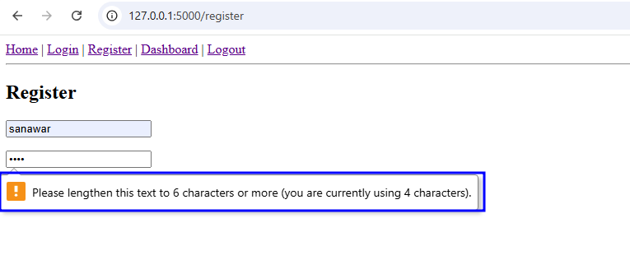
Figure 11: Dashboard – Authenticated User View

5. Errors Encountered & Debugging

5.1 Error Observation
During development and testing, the following errors were encountered. These are documented below as part of the SSDLC debugging and troubleshooting phase.
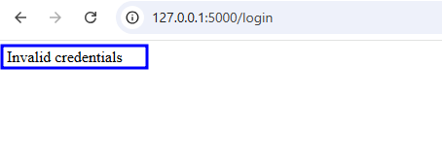
Figure 12: Error Observed During Testing – Error Message
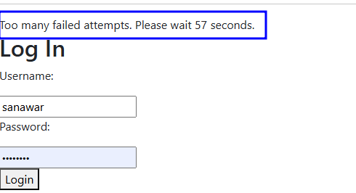
Figure 13: Additional Error / Debug Output
These errors were investigated by reviewing the Flask debug console output, checking template paths, and validating session configuration. Proper error handling was implemented to address edge cases.

6. Security Analysis

6.1 SSDLC Principles Applied
This lab demonstrates several key SSDLC principles:
- Session Management: Flask sessions used for stateful authentication
- Input Handling: Form inputs validated server-side to prevent injection
- Access Control: Protected routes require active session token
- Secure Templating: Jinja2 auto-escapes output, preventing XSS attacks
- Modular Architecture: Separation of concerns via templates and routes

7. Conclusion
This lab successfully demonstrated the development of a Flask-based web application following SSDLC principles. The application implements secure user authentication with session management, modular Jinja2 templating, and protected route access control.
Errors encountered during development were documented and resolved, reinforcing the importance of systematic debugging in secure software development. The lab provided hands-on experience with Python web development in a security-focused context.

Submitted by: Sanawar Imran | Roll No: 243633 | BS Cyber Security – A

