Classification of Pests using Computer Vision CNN Algorithm

Across globe farmers in agriculture sector loss their crops because of pests as they don’t know type of pest so they cannot purchase suitable pesticide which can kill current pests. To control different pests different pesticides are available in market and to control pest framer must know the type of pests so they can purchase pesticide which can kill available pests.

To help farmers in knowing pest type we are utilizing computer vision based Artificial intelligence algorithm called Convolution Neural Network (CNN). CNN can be trained on all available pest’s images and whenever we upload any pest image then CNN will analyse and classify type of pests. So by using this classification results farmers can purchase required pesticide and can control pests to increase their crop production.

In the past decade CNN has proved its classification accuracy in almost all fields such as Face Recognition, Road Side traffic pattern classification, healthcare disease classification and many more areas. CNN best known for features extraction, optimization and hierarchical learning during training time by utilizing multiple neurons. CNN consist of many layers such as CNN layer, Dense, Maxpooling2D and many more. CNN layer used to filter features and then Maxpool2d layer will collect relevant filtered features and then drop irrelevant features so model get trained on essential features. Dense layer is used to define prediction output which will analyse input image features and then classify image into one label from multiple labels.

So above advantages of CNN leads us to help farmers in classifying pest type using CNN algorithm. To train this algorithm we have used PEST dataset from KAGGLE repository which can be download from below URL

<https://www.kaggle.com/datasets/gauravduttakiit/agricultural-pests-dataset>

Above dataset contains images of 12 different pests and each pest contains more than 500 images. To train CNN we have resized all images into equal size, shuffle and normalize pixel values. Processed images will be split into train and test where application using 80% images for training and 20% for testing. 80% dataset images will be input to CNN algorithm to train a model and then 20% images will be applied on trained model to calculate prediction accuracy.

To classify pest images we have given friendly user interface using DJANGO REST API where user can train CNN model to calculate prediction accuracy and then user can upload pest image and then DJANGO will read image and input to CNN algorithm to classify pest type

To implement this project we have designed following modules

1. Train Pest Classification CNN Model: using this module user can train and load CNN model and then perform prediction on 20% test images to calculate prediction accuracy
2. Predict Pest Type using Test Image: using this module user can upload test image and then DJANGO will read image and input to CNN to get classification result

SCREEN SHOTS

To run project double click on ‘run.bat’ file to start python server and get below page

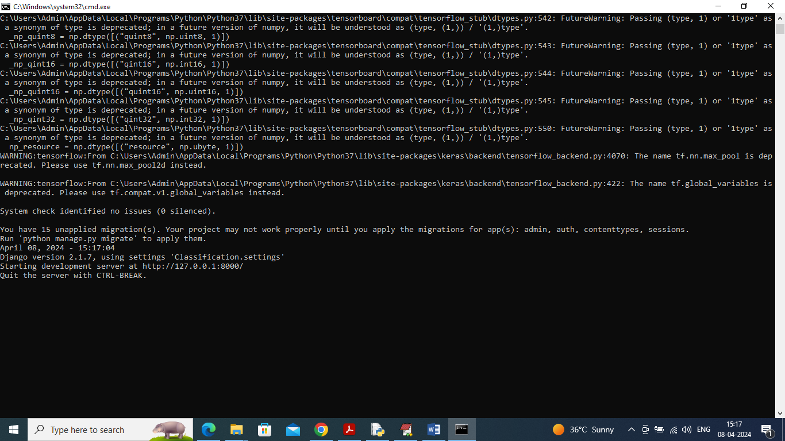

In above screen python server started and now open browse and enter URL as <http://127.0.0.1:8000/index.html> and press enter key to get below page

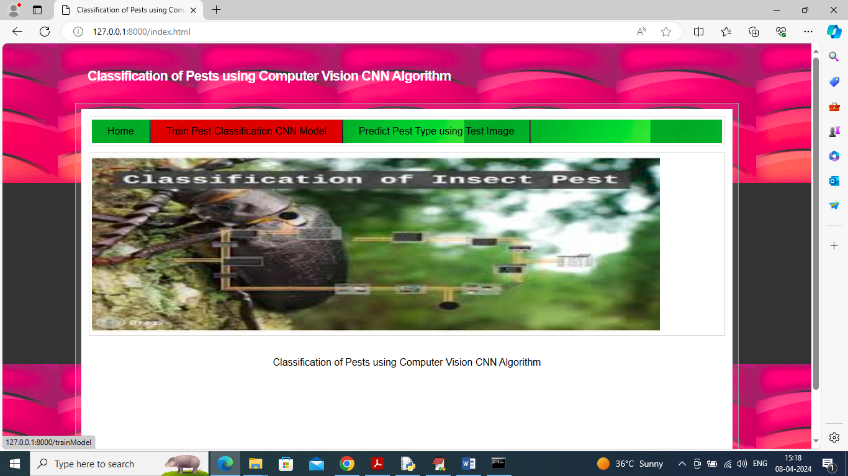

In above screen user can click on ‘Train Pest Classification CNN Model’ link to train CNN and get below page

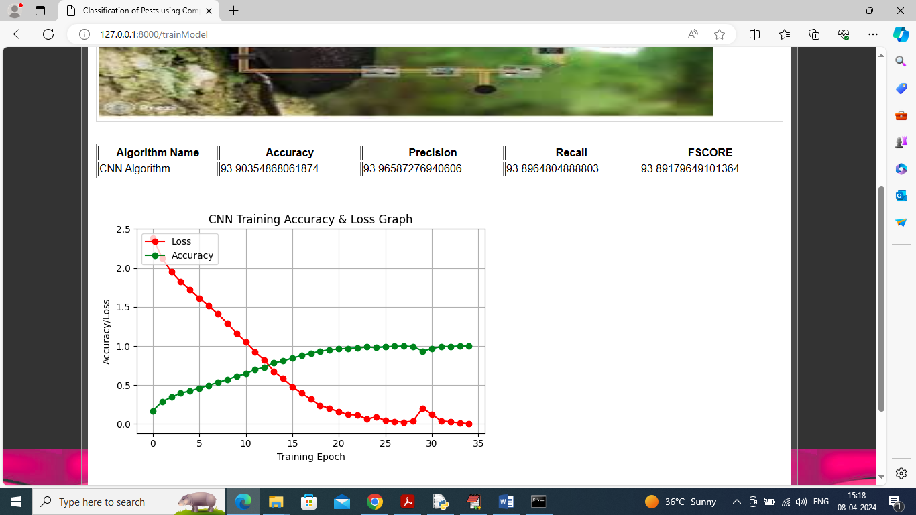

In above screen CNN model training completed and can see its accuracy as 93% and can see other metrics as Precision, Recall and FSCORE. In above graph we are plotting CNN training accuracy and loss values. In graph x-axis represents Training Epoch and y-axis represents accuracy/loss values and then red line represents loss and green line represents accuracy. In above graph can see with each increasing epoch accuracy got increase and reached closer to 1 and loss got decreased and reached closer to 0. Now click on ‘Predict Pest Type using Test Image’ link to get below page

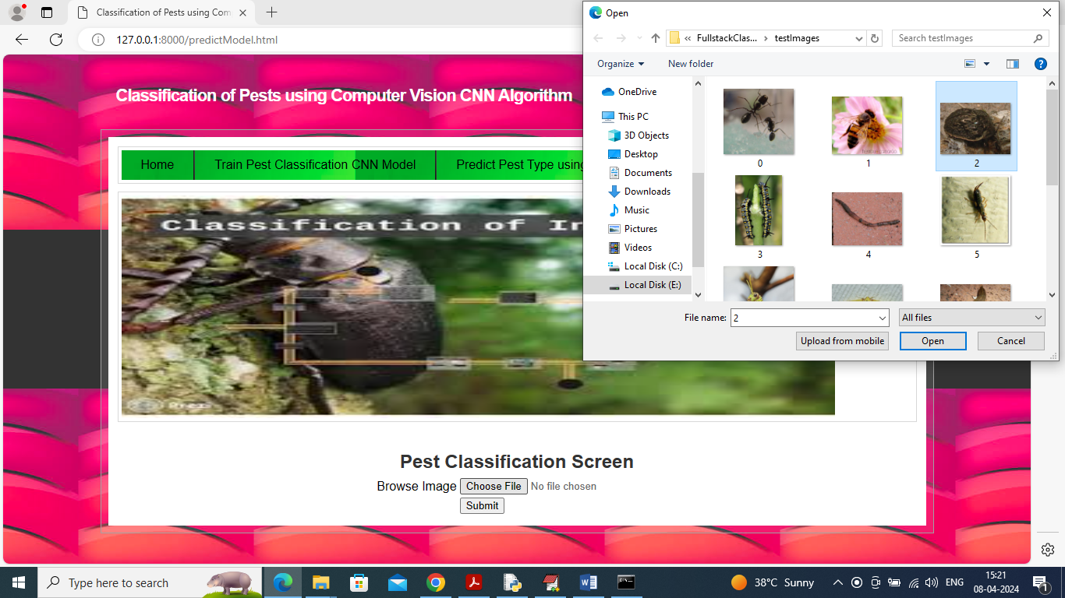

In above screen click on ‘’Choose File’ and then upload test image and then click on ‘Open’ and ‘Submit’ button to upload image to server and get below classification output

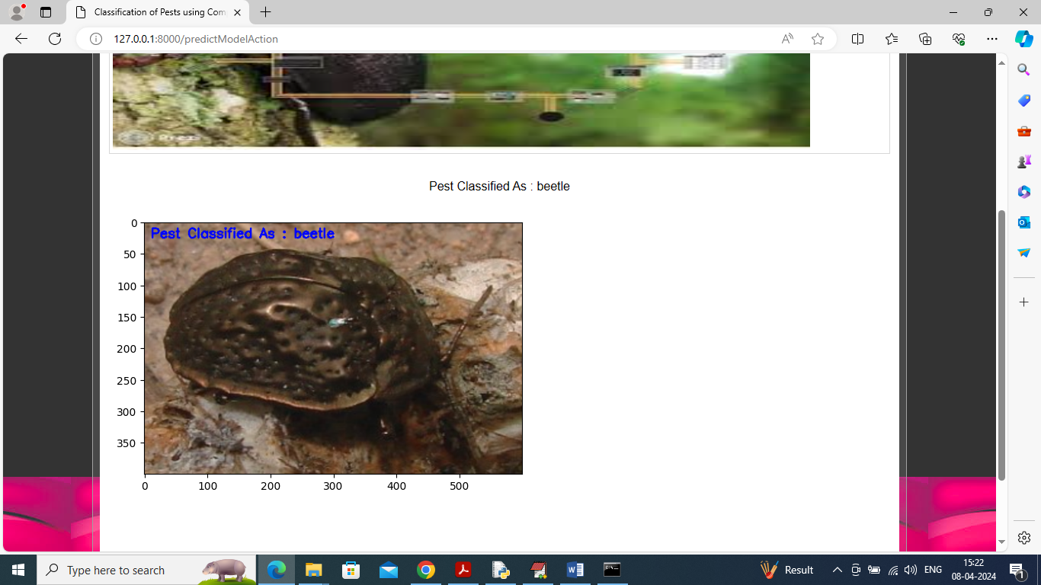

In above screen in blue colour text on image can see pest classify as ‘beetle’ and similarly you can upload and test other images

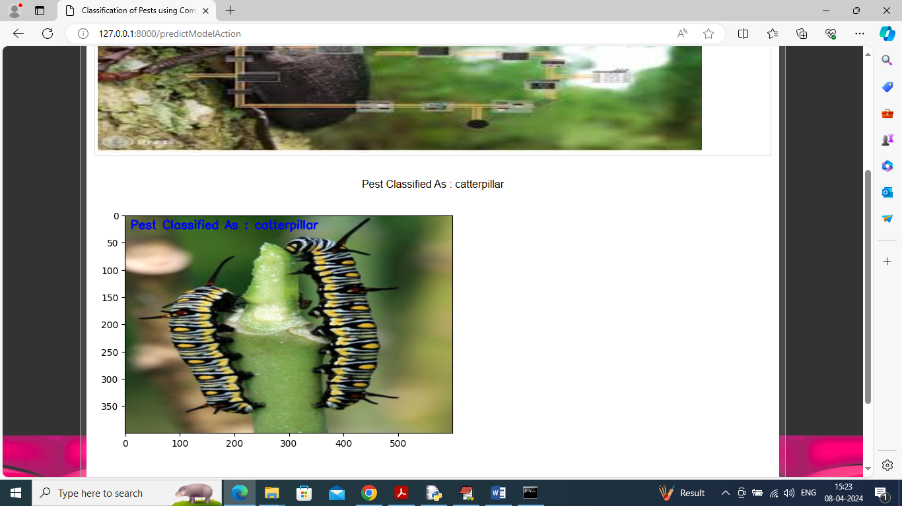

Above pest classify as ‘Caterpillar’.

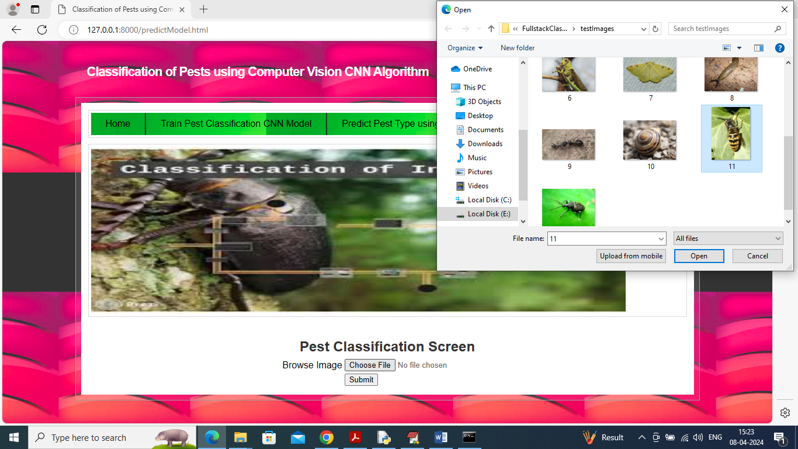

In above screen uploading another image and then press button to get below output

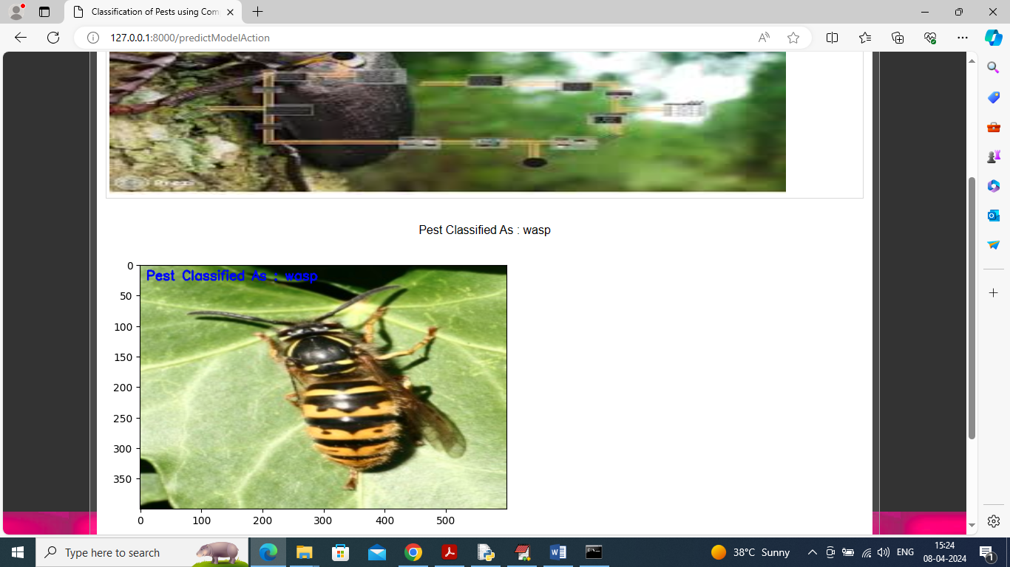

In above screen pest classified as ‘wasp’.