#### Step 1

Go to <https://teachablemachine.withgoogle.com/train/image>

#### Step 2

Name the different classes for your model

#### Step 3

Upload Different Image from different angles for each class or click on webcam to open webcam and take photo realtime

#### Step 4

Click on Train Model

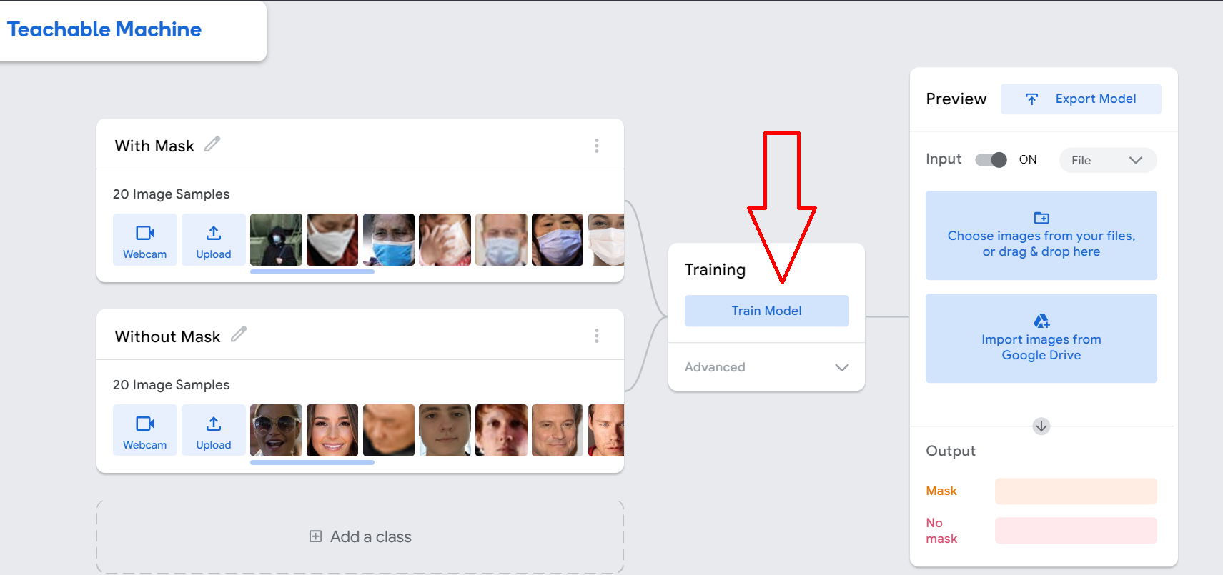

#### Step 5

Click on Export Model

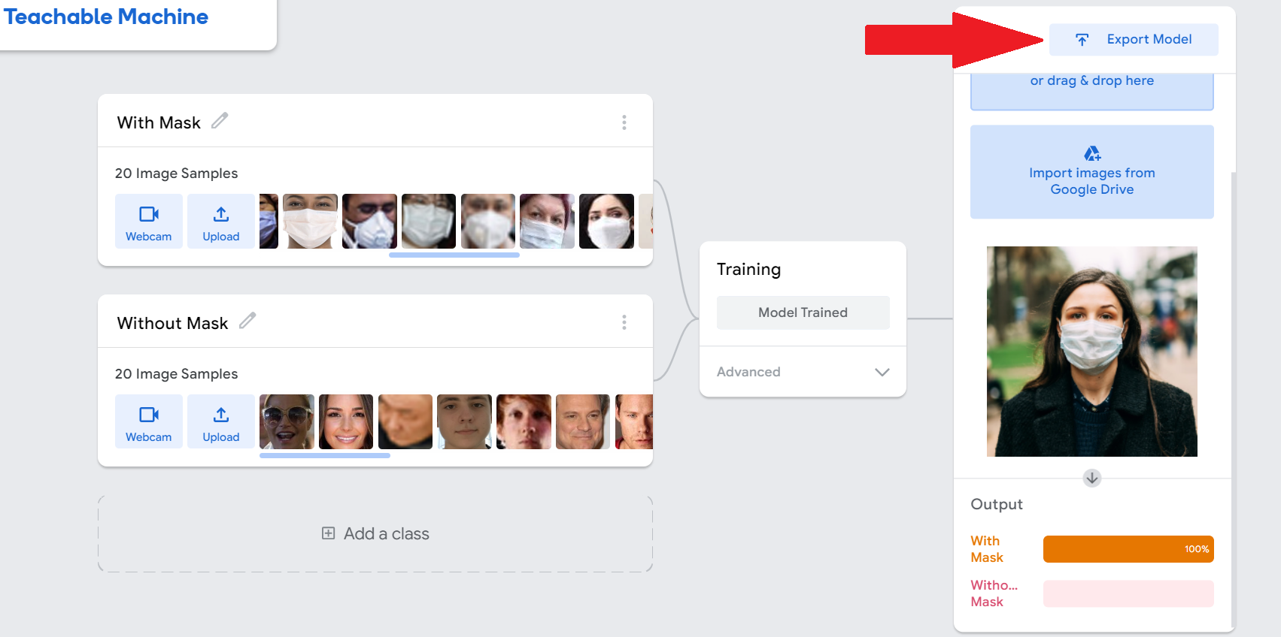

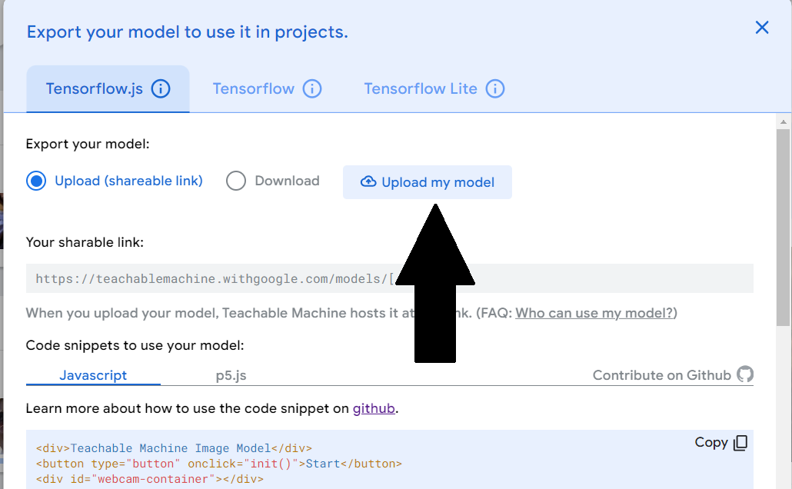Upload or Download your Model

## SETUP THE SERVER

## Step 1

* Download the zip and Extract the files 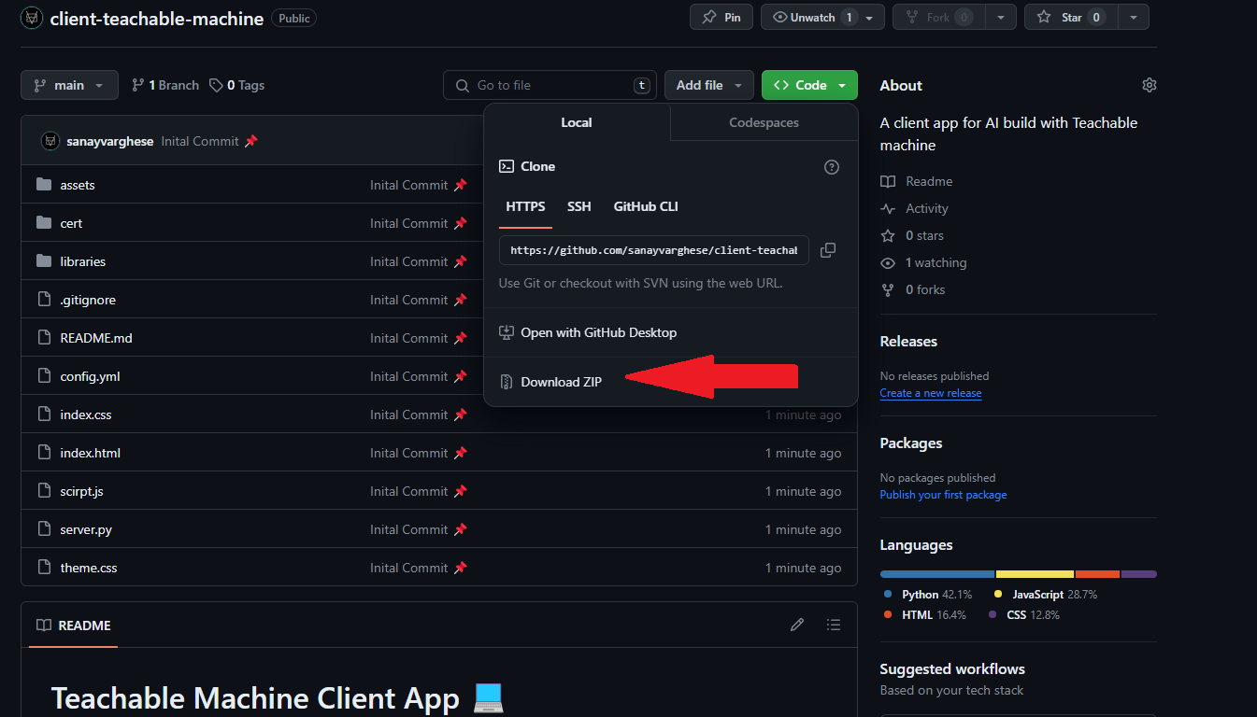
* Open the folder and click on the address bar and type cmd.exe

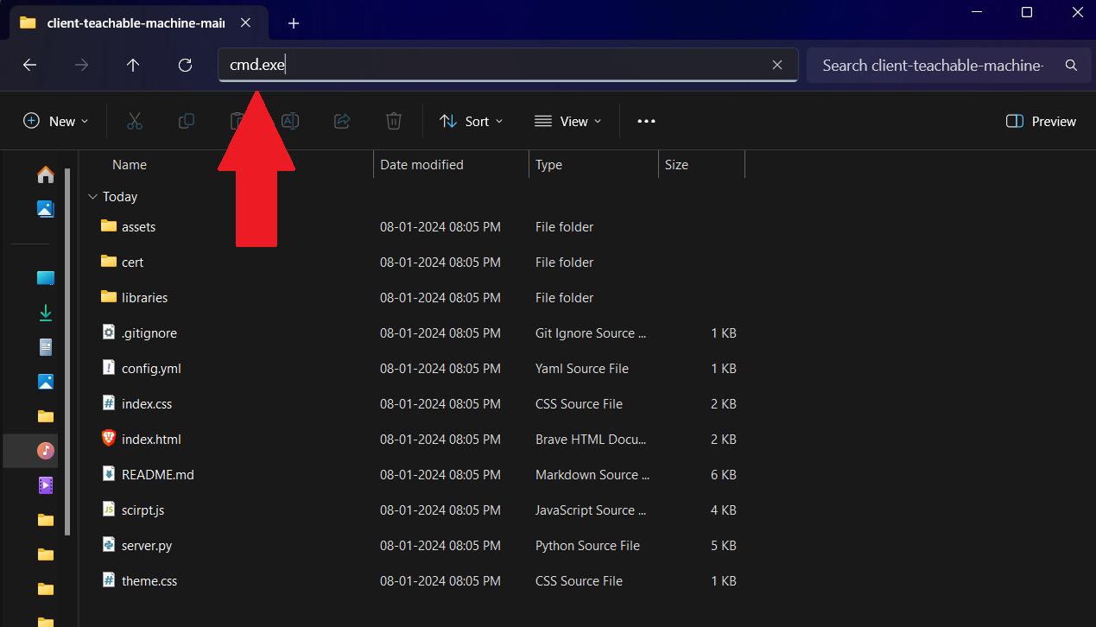

This will open cmd.exe on the project folder

## Step 2

Now open the browser and get your Teachable machine trained AI model link or download the model and edit the [config.yml](./config.yml) file

#### First upload your model

#### 

#### Copy the sharable link

#### 

#### Paste the link in config.yml file for the field TEACHABLE_MACHINE_URL

Eg: [config.yml](./config.yml)

TEACHABLE_MACHINE_URL: *https://teachablemachine.withgoogle.com/models/XXXXXX/*

Replace https://teachablemachine.withgoogle.com/models/XXXXXX/ with your model link

## Step 3

**Start server and host the app on the local machine**

In cmd.exe type:

python server.py

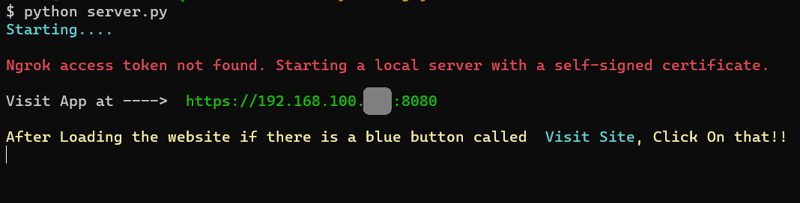

Our app will be now hosted on https://<your ip>:8080 Now visit this url using a browser on same device or another device on same network.

Now this warning page will appear.

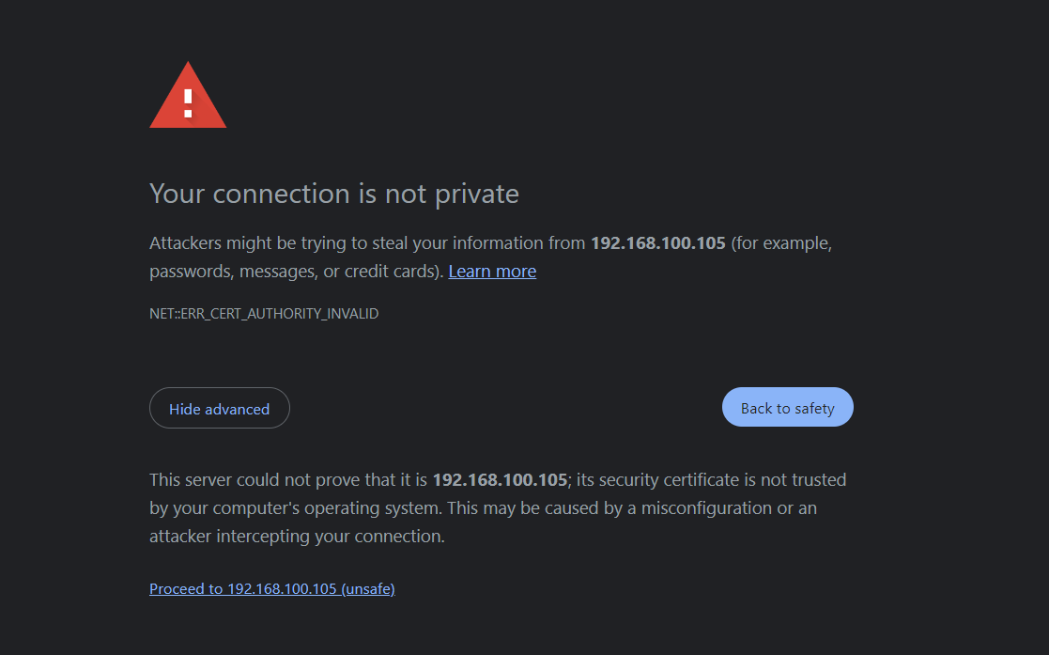

Click on Advanced and click on Proceed to ... Accept the camera permission to enable camera.

Now our app is perfectly working! 🥳🎉

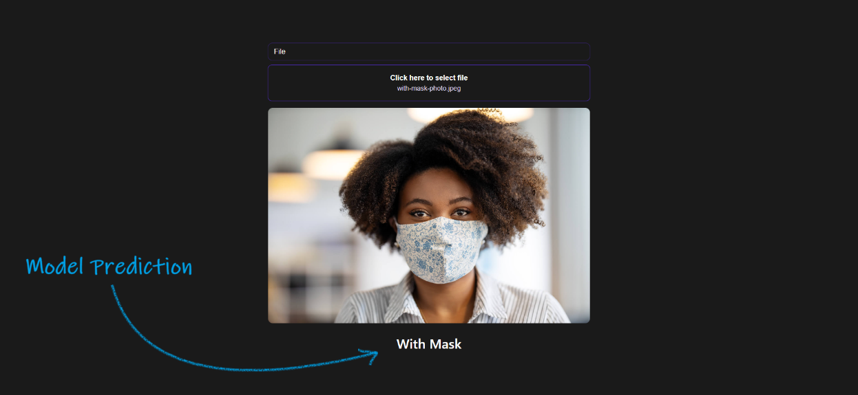

FOR MORE DETAILS READ THE GITHUB README.md file