Deep Learning-Based Pneumonia Detection from Chest X-Ray Images Using Convolutional Neural Networks and Transfer Learning

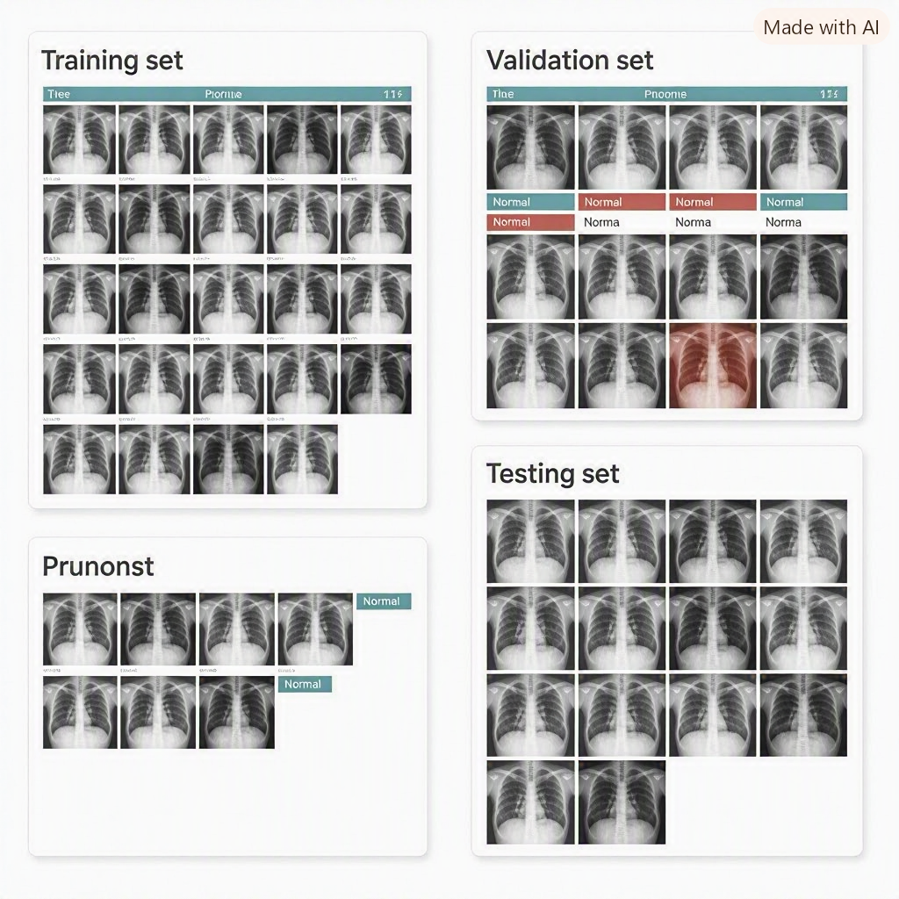

Table of Contents
Abstract 3
1. Introduction 3
1.1 Background 3
1.2 Deep Learning in Medical Image Analysis 4
1.3 Problem Statement 4
1.4 Aim of the Project 4
1.5 Objectives 5
1.6 Research Questions 5
2. Literature Review 5
2.1 Artificial Intelligence in Medical Imaging 5
2.2 Convolutional Neural Networks (CNNs) 6
2.3 Transfer Learning 6
2.4 MobileNetV2 7
2.5 EfficientNetB0 7
2.6 Explainable Artificial Intelligence (XAI) 7
3. Dataset Description 7
3.1 Dataset Overview 7
3.3 Features of the Dataset 8
4. Data Preprocessing 8
4.1 Image Resizing 8
4.2 Image Normalization 8
4.3 Data Augmentation 9
4.4 Data Splitting 9
5. Methodology 9
5.1 Research Methodology 9
5.2 Development Environment 10
5.3 Data Preparation 11
5.4 Transfer Learning 11
5.5 MobileNetV2 Architecture 11
5.6 EfficientNetB0 Model Architecture 12
5.7 Model Training 12
5.8 Model Evaluation 12
6. Results and Discussion 13
6.1 Summary of Experimental Results 13
6.2 Baseline CNN Performance 14
6.3 MobileNetV2 Results 14

Abstract

Pneumonia is a grave pulmonary ailment that afflicts many individuals across the globe and continues to be the main cause of death, especially in susceptible individuals. The proper identification of the disease is very crucial towards proper treatment and minimizing its complications. One of the most widely used methods for pneumonia diagnosis is the use of chest x-ray scanning since it is relatively inexpensive, easily accessible and clinically important. However, the interpretation of chest x-rays requires expertise and may be compromised by workload and experience. Deep learning, especially CNN, has recently shown its high capabilities in processing and classifying medical images automatically? by learning visual patterns from a large number of images. The present research aims at investigating the possibility of employing deep learning in order to automatically classify pneumonia based on chest X-ray images. Three different methods have been employed for classification tasks: a traditional CNN model built from scratch, MobileNetV2 with transfer learning and efficientNetB0 with transfer learning and fine-tuning techniques. The experiments have been done using Chest X-ray Pneumonia dataset consisting of normal and pneumonia chest X-ray images. Image preprocessing including resizing, normalization, and augmentation was carried out before training and evaluating models. Models have been evaluated using several evaluation metrics such as accuracy, precision, recall, F1-score, confusion matrix, and ROC-AUC. From the experimental results, it is evident that the MobileNetV2 was the most efficient of all the algorithms, with test accuracy, F1-score, and AUC of 87.98%, 0.87, and 0.972, respectively. In addition, Grad-CAM (Gradient-weighted Class Activation Mapping) was used to enhance the ability of the models to interpret their predictions using visualization of the key regions from the chest X-ray images contributing towards model predictions. It is clear that transfer learning-based deep learning models, specifically lightweight models such as MobileNetV2, can be effective tools for detecting pneumonia with reasonable computation time. The application of explainable artificial intelligence methods enhances the transparency of models and expands the scope of their applicability in the field of medical image analysis.

Keywords: Deep Learning, Convolutional Neural Networks, Pneumonia Detection, Chest X-Ray, Transfer Learning, MobileNetV2, EfficientNet, Grad-CAM, Medical Image Analysis

1. Introduction

1.1 Background

Pneumonia is the inflammation of the air sacs of one or both lungs and causes serious complications in the respiratory system. As per the report by WHO, pneumonia continues to be a significant problem in global health especially for children, elderly, and immune-compromised patients. The chest X-ray images play a vital role in diagnosing the patient of pneumonia as the images are useful in revealing the abnormalities in the lungs such as infection, inflammation, and fluid accumulation. However, the correct analysis of the chest X-ray images needs specialized skills. Furthermore, the increase in medical images produced by the healthcare systems makes it difficult to analyze the images in time. Artificial intelligence (AI), especially through deep learning, has turned out to be a powerful tool in helping medical practitioners interpret images used in healthcare. This is unlike other machine learning methods where features need to be manually extracted as opposed to deep learning models that learn automatically from raw data (LeCun et al., 2015).

1.2 Deep Learning in Medical Image Analysis

Deep learning can be defined as an area of machine learning where models built using artificial neural networks with numerous layers are used. The convolutional neural network (CNN) approach is widely used in image analysis among other deep learning methods, and it is the prevailing one for image classification since it allows for automatic extraction of spatial patterns from images. CNNs have numerous layers and include computational convolutional layers, pooling layers, and fully connected layers. The former layer detects low-level features such as edges and textures, while the latter layer recognizes high-level features. This allows CNNs to be particularly helpful in medical imaging applications (Litjens et al., 2017). Prior research has shown that deep learning models can be used effectively to identify different diseases by analyzing medical images. For instance, Rajpurkar et al. (2017) proposed CheXNet, a deep learning model which uses the DenseNet architecture and performs radiologist-level accuracy in pneumonia identification from chest x-rays images.

1.3 Problem Statement

Despite the success of deep learning algorithms in classifying medical images, there are various issues that still persist:

Interpretability problems:
Some deep learning algorithms are like black boxes; therefore, it is not easy for medical experts to understand the rationales of predictions made by such models.

Computational burden:
Deep learning algorithms sometimes need massive computing power because of their complex structure.

Dataset imbalanced:
There are often fewer samples in one class than the other in medical datasets.

Challenges with generalization:
Sometimes, models trained using some specific dataset cannot generalize well when used with different datasets collected from other hospitals or communities.

Consequently, the present project explores the possibility of building a lightweight and pretrained deep learning algorithm for detecting pneumonia.

1.4 Aim of the Project

The aim of this project is:

Development and evaluation of deep learning models for automated pneumonia detection using chest X-ray images, and determination of the best architecture of deep learning model by classification results and explainability of the model.

1.5 Objectives

The objectives of this project are:

- Preparation and preprocessing of chest X-ray images dataset for deep learning classification.
- Creation of CNN baseline model for pneumonia detection.
- Using of transfer learning techniques for creation of models based on MobileNetV2 and EfficientNetB0.
- Comparison of deep learning architectures with using of such evaluation metrics as accuracy, precision, recall, F1-score and ROC-AUC.
- Visualization of the model with Grad-CAM technique.
- Analysis of advantages and disadvantages of deep learning approaches for classification of medical images.

1.6 Research Questions

This study will focus on answering the following research questions:

RQ1:
How effective is deep learning in classifying pneumonia from chest X-ray imaging?

RQ2:
Is there any improvement in the classification performance of pneumonia using transfer learning as compared to the CNN-based classifier that has been developed from scratch?

RQ3:
Which architecture offers a better trade-off between performance and computational costs?

RQ4:
How does explainable AI, for example, Grad-CAM, help in improving interpretability?

2. Literature Review

2.1 Artificial Intelligence in Medical Imaging

Artificial intelligence (AI) has significantly impacted healthcare, giving rise to intelligent solutions that help clinicians in disease diagnosis, prognosis, and treatment. Among different approaches in AI, deep learning has proven to be the most effective technique for medical imaging due to its potential of automatic hierarchical feature learning from images without the need for manual feature design (LeCun et al., 2015). Medical imaging methods like X-ray, Computed Tomography (CT), Magnetic Resonance Imaging (MRI) and ultrasound produce an overwhelming amount of data that should be accurately interpreted. Interpretation made manually by radiologists might be slow and prone to errors due to observer differences. As a result, the importance of artificial intelligence (AI) supported systems has increased dramatically (Litjens et al., 2017). Deep learning has achieved tremendous results in the detection of anomalies in medical imaging such as diabetic retinopathy, skin cancer, breast cancer, lung diseases and pneumonia. The ability to detect complicated patterns makes deep learning an ideal technique for computer-aided diagnosis systems.

2.2 Convolutional Neural Networks (CNNs)

Convolutional Neural Networks (CNNs) refer to deep neural network architectures used in image recognition and computer vision applications. As opposed to conventional machine learning models that use manually engineered features, CNN models automatically learn distinctive visual features from image pixels by performing various convolutions (LeCun et al., 2015).

Some of the main components of the CNN model include:

- Convolutional layers used for learning local visual features like edges and texture.
- Activation functions, typically ReLU, to introduce non-linearities.
- Pooling layers that reduce the dimensionality of data.
- Fully connected layers for performing high-level inference.
- Output layer for generating output probabilities.

The depth of CNN increases with the increased complexity of the feature representations learned in the process. Therefore, CNNs can be effective in medical image classification applications.

2.3 Transfer Learning

Training deep neural networks from scratch usually demands millions of labeled images and high computing power. However, medical data sets are relatively small compared to big image sets. In order to overcome this problem, transfer learning technique makes use of models that were trained on large image databases like ImageNet. In contrast to learning of visual features from scratch, transfer learning allows for transferring learned features to new medical imaging task, which considerably shortens the process and improves classification (Pan & Yang, 2010).

Transfer learning usually includes the following steps:

- Taking advantage of the pretrained network as a fixed feature extractor.
- Fine-tuning of selected layers in order to adjust the model to the target data set.

- This approach became one of the most popular in medical image analysis field.

2.4 MobileNetV2

MobileNetV2 is a lightweight convolutional neural network architecture that was developed for image classification tasks performed on limited resource devices (Sandler et al., 2018). In contrast to classic CNNs, MobileNetV2 utilizes depthwise separable convolutions, thus reducing the number of trainable parameters to the minimum while preserving the comparable accuracy.

There are two key architectural innovations included in MobileNetV2:

- Inverted Residual Blocks
- Linear Bottlenecks

These architectural innovations allow MobileNetV2 to deliver outstanding results in classification tasks using much less number of parameters in comparison to classic CNN architectures. Due to the high efficiency and predictive performance, MobileNetV2 is widely used for medical image analysis.

2.5 EfficientNetB0

The EfficientNet is an architecture family of Convolutional Neural Networks that uses compound scaling for boosting the performance of the model (Tan & Le, 2019). Rather than scaling either network depth or width separately, EfficientNet scales network depth, width, and image resolution through a mathematically optimized scaling factor. EfficientNetB0 represents the baseline architecture within the EfficientNet family and has proved itself to be a leader in image classification benchmarks despite having relatively low computational complexity. In spite of outstanding results for general computer vision, the EfficientNet should be carefully tuned on medical images.

2.6 Explainable Artificial Intelligence (XAI)

While deep learning approaches have proven their exceptional accuracy, these approaches are usually considered as black box systems. In medicine, it is essential to provide an explanation to make sure that the prediction of the AI model can be trusted. XAI attempts to make AI systems more transparent by providing explanations of the mechanism of prediction. The most popular approach to generating XAI for CNNs is Gradient-weighted Class Activation Mapping (Grad-CAM) (Selvaraju et al., 2017). Grad-CAM produces heat maps that mark those areas of the image that significantly influence the predicted class. In the case of pneumonia detection, Grad-CAM allows clinicians to check whether the model attends to clinically significant lung areas or not.

3. Dataset Description

3.1 Dataset Overview

In the current research, the Chest X-ray Pneumonia dataset will be employed. It is a freely accessible dataset of medical images presented in the publication by Kermany et al. (2018).

It includes posterior-anterior chest X-ray images, classified into two categories:

- NORMAL
- PNEUMONIA

All images included in the dataset were verified by medical experts.

The dataset is organized into three subsets:

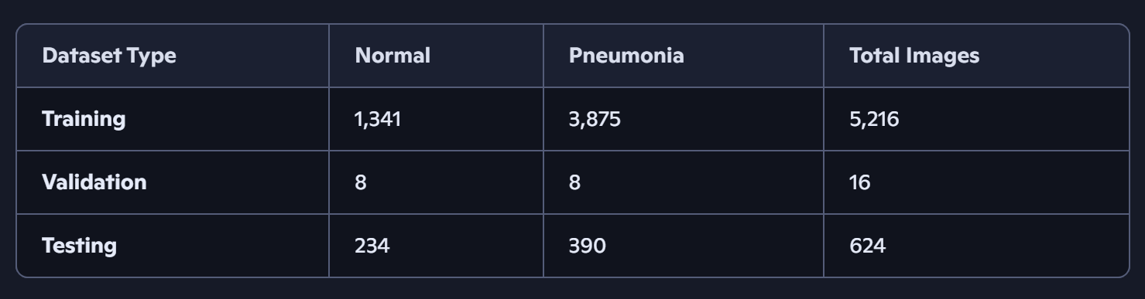

3.3 Features of the Dataset

It is worth mentioning several features of the dataset:

- The dataset is a binary classification problem since there are only two classes in the dataset.
- The class of pneumonia has many more samples than the class of normal; thus, class imbalance occurs.
- Images differ by their brightness, contrast, and anatomy.
- Chest X-rays images are grayscale but were transformed into three channels in order to meet the demands of pre-trained CNN architecture.

Class imbalance is one of the most popular issues in medical datasets.

4. Data Preprocessing

4.1 Image Resizing

Deep learning algorithms need images with a fixed spatial dimension as their input. Hence, all the images of chest x-rays were resized to 224 × 224 pixels, which is the recommended input size for MobileNetV2 and EfficientNetB0.

Image resizing standardizes the input dimensions while minimizing computational effort during training.

4.2 Image Normalization

The raw value of pixels was within the interval 0 to 255. In order to increase numerical stability and speed up convergence during training, all images were normalized by dividing the value of pixels by 255.

Normalization avoids the problem of very large gradient values during optimization and is a common pre-processing technique in deep learning.

4.3 Data Augmentation

To overcome overfitting and enhance the generalization ability of the models, several data augmentation methods were employed on the training dataset.

The following data augmentation transformations were performed:

- Random Rotation
- Random Zoom
- Horizontal Flip
- Shear Transformation
- Width Shift
- Height Shift

These transformations helped increase the diversity of the training samples without losing clinically important image features.

4.4 Data Splitting

The data was split into three parts:

Training Set – used for training the model.
Validation Set – used for monitoring the hyperparameters and early stopping.
Testing Set – used solely for evaluation of the model’s performance.

Splitting data in this way ensures that there is no information leak and an accurate performance evaluation of the model.

5. Methodology

5.1 Research Methodology

This study used an experimental research methodology in order to examine the efficiency of deep learning methods for automatic detection of pneumonia based on chest X-ray images. The entire process comprised of five key phases: data collection, data preprocessing, model creation, model evaluation, and model explanation. In total, three models were developed in order to find the best one for binary pneumonia detection.

Figure 5.1 demonstrates the entire workflow of the proposed project.

Project Workflow

- Dataset Collection
- Data Preprocessing
- Data Augmentation
- CNN Model Development
- Transfer Learning Models
- Model Training
- Model Evaluation
- Grad-CAM Visualization
- Performance Comparison

The above-presented workflow has been used in order to provide consistency in all experiments due to identical data preprocessing and evaluation metrics used for each model.

5.2 Development Environment

The experiments were carried out on Google Colab, which offers cloud-based GPUs that are adequate for deep learning tasks.

The software libraries utilized in the development are listed below:

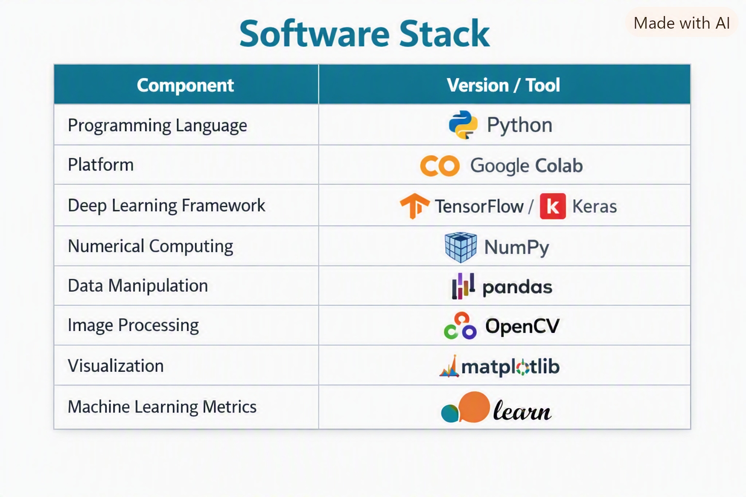

Google Colab greatly helped to lighten the computational load due to GPU acceleration during model training.

5.3 Data Preparation

Once the Chest X-ray Pneumonia data set was downloaded, the images were segregated into training, validation, and test folders.

Each image was resized to 224 × 224 pixels and normalized to the interval of [0,1] using Keras ImageDataGenerator.

In order to enhance the robustness of the trained model and prevent overfitting, some augmentation techniques were used for the training data set only.

The following augmentation values were used:

- Rotation Range = 20°
- Zoom Range = 0.20
- Horizontal Flip = True
- Width Shift = 0.20
- Height Shift = 0.20
- Shear Range = 0.20

5.4 Transfer Learning

Training of deep neural networks from scratch usually involves having large datasets. Given that medical image datasets tend to be smaller than natural image datasets, transfer learning becomes an ideal approach that relies on pretrained models which learn rich visual features from ImageNet (Pan & Yang, 2010).

Pretrained weights were used for training rather than random initialization of weights to reduce time and to enhance feature learning. The first step involved keeping the convolutional backbone of each pretrained model frozen, and training only the classification layers that had been added.

5.5 MobileNetV2 Architecture

MobileNetV2 was chosen due to its lightweight nature and high computational efficiency (Sandler et al., 2018).

The pre-trained weights on ImageNet dataset were loaded but the original classification layer was ignored.

The classification head was implemented as follows:

- Global Average Pooling Layer
- Dropout Layer
- Fully Connected Layer (128 neurons)
- Sigmoid Activation Layer

The base MobileNetV2 model was kept frozen during the first training phase. Once the model converged, some layers were partially unfrozen to evaluate the fine-tuning results. In comparison to the baseline CNN model, MobileNetV2 utilized less number of parameters and provided higher classification accuracy.

5.6 EfficientNetB0 Model Architecture

EfficientNetB0 was additionally evaluated to determine whether a better pretrained architecture can further enhance pneumonia classification results.

The model architecture consisted of:

- Pretrained EfficientNetB0 on ImageNet
- Global Average Pooling
- Dropout
- Dense Layer
- Sigmoid Output Layer

In the beginning, all pretrained layers were frozen. Later, the chosen higher layers were unfrozen to be fine-tuned. Despite EfficientNetB0 having a high performance in many benchmark datasets (Tan & Le, 2019), it showed poor performance compared to MobileNetV2 in our study. The possible causes are a small number of images and an imbalanced data set.

5.7 Model Training

Optimization parameters were kept consistent across all models for fair comparison.

- Parameter Value
- Optimizer Adam
- Loss function Binary Crossentropy
- Batch size 32
- Number of epochs 10
- Learning rate Adam default
- Early stopping Enabled

Early stopping criterion involved the validation loss value while training. If there was no improvement in validation loss for three consecutive epochs, training was stopped and the best-performing weights were reloaded.

5.8 Model Evaluation

A variety of well-known classification performance metrics were used to evaluate the model's performance comprehensively.

Accuracy

Accuracy is defined as the ratio of images correctly classified to the total number of test samples.

Precision

Precision calculates the ratio of true pneumonia patients out of those predicted as such by the model. High precision means low false positives.

Recall (Sensitivity)

Recall is the ratio of pneumonia patients correctly classified to the total number of pneumonia patients. Recall becomes crucial in the context of medical diagnostics since missing one such patient might result in severe consequences.

F1-Score

The F1-Score is an average of Precision and Recall and offers a fair assessment when class imbalance exists.

Confusion Matrix

Confusion Matrix gives information on the following aspects:

- True Positive (TP)
- True Negative (TN)
- False Positive (FP)
- False Negative (FN)

ROC

ROC curves demonstrate the relationship between sensitivity and specificity at various levels of classification.

Area Under Curve (AUC)

The Area Under the Curve is the summary measure for ROC curve.

AUC near 1.0 is an indicator of great discriminative power.

6. Results and Discussion

6.1 Summary of Experimental Results

In total, three deep learning models were developed and tested in order to detect pneumonia from chest X-ray images. In particular, the aim was to test the performance of a CNN architecture that is designed from scratch, compared to two transfer learning techniques, i.e., MobileNetV2 and EfficientNetB0. Each of the three architectures was tested under identical experimental setup and evaluation criteria. The measures used included accuracy, precision, recall, F1-score, confusion matrix, and ROC-AUC analysis. The results obtained indicate clear disparities between the three models with respect to classification and generalization capabilities.

6.2 Baseline CNN Performance

The first experiment focused on training a standard Convolutional Neural Network (CNN) using random initialization weights.

Following the completion of ten epochs of training, the CNN was able to reach a test accuracy of 75.00%, implying that while the model was successful at learning meaningful image representations, it was not capable of competing against the transfer learning models.

The classification report provided the following results:

- Metric Value
- Test Accuracy 75.00%
- Precision (Weighted) 0.81
- Recall 0.75
- F1-score 0.71

The confusion matrix obtained was as follows:

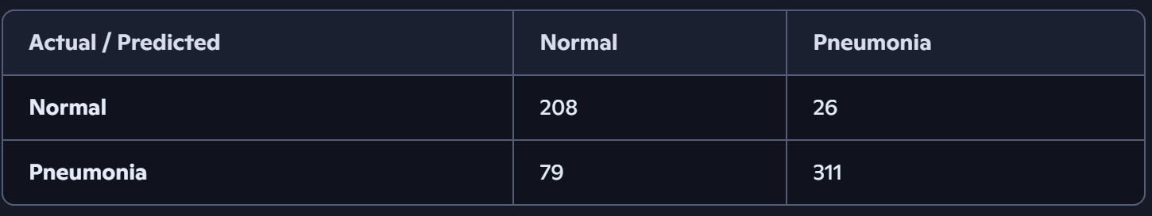

From the confusion matrix above, it can be seen that while the CNN was able to classify most of the normal images correctly, it failed to classify several images affected by pneumonia as such. From a clinical point of view, this is a key issue since it could result in late detection of infections in patients.While the model performed acceptably well, its performance implies that learning feature representations from scratch is difficult if the dataset used for training is not large.

6.3 MobileNetV2 Results

In the second experiment, MobileNetV2 was used along with transfer learning approach. ImageNet pre-trained weights offered highly representative visualizations, which significantly enhanced the process of features extraction.

Learning behavior during the training period was stable since validation accuracy increased while validation loss decreased.

Final test results were as follows:

- Metric Value
- Test Accuracy 87.98%
- Test Loss 0.2899
- Precision 0.89
- Recall 0.88
- F1-score 0.87

The confusion matrix is presented below.

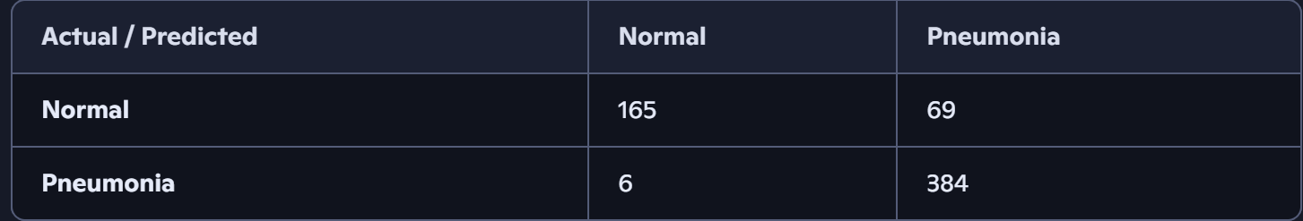

As seen from the confusion matrix above, MobileNetV2 almost perfectly recognized pneumonia instances and generated only six false negatives. This is especially important because false negative rate reduction is extremely important for clinical diagnoses since misdiagnosed pneumonia can be life-threatening for patients. Though the number of false positive instances increased compared to the baseline CNN, the preference is usually given to sensitivity in screening systems because false positive diagnoses require further examination but not false negative.

Overall, MobileNetV2 showed the best trade-off between sensitivity and other metrics.

EfficientNetB0 Experiment 6.4

In the third experiment, EfficientNetB0 was studied.

As opposed to expectations, the efficiency of EfficientNetB0 was significantly less compared to MobileNetV2.

The results of the last experiment are:

Metric Value
Test Accuracy 62.50%
Test Loss 0.6883
Precision 0.39
Recall 0.62
F1-score 0.48

The confusion matrix was:

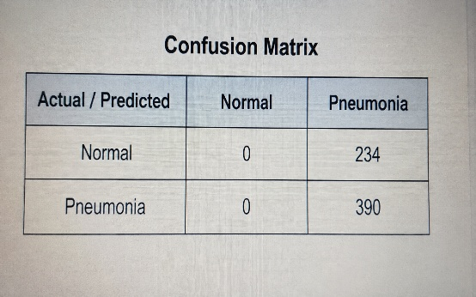

EfficientNetB0 classified nearly all the pictures as pneumonia. Thus, this network did not learn any good decision borders for the two categories.

There can be several reasons for such result:

- Class imbalance in the dataset.
- Too small number of validation pictures.
- Lack of fine tuning of pretrained layers.
- Incorrect hyperparameters setting.

Thus, although EfficientNetB0 is one of the most successful neural networks in computer vision tasks, it did not work well for this dataset in the current experiment.

