DATA SCIENCE PROJECT REPORT
Movie Recommender System with Popularity-Bias Mitigation
Collaborative Filtering (Item-KNN and SVD) on MovieLens with Temporal Evaluation, Popularity-Bias Analysis, Diversity Re-ranking and Cold-Start Handling
Author: [Your Name]
Date: October 2026
Dataset: MovieLens Latest Small (GroupLens)
Tools: Python, pandas, NumPy, SciPy, scikit-learn, Matplotlib, Seaborn

Executive Summary
Recommendation engines drive engagement and revenue on streaming and e-commerce platforms. This project builds and evaluates a movie recommender on the MovieLens dataset, compares two collaborative filtering models against a popularity baseline, quantifies the popularity bias of their output, and tests a re-ranking method that trades a small amount of accuracy for more diverse recommendations.
Key results
- Both collaborative filtering models clearly beat the popularity baseline. HitRate@10 rose from 0.326 to 0.460 (Item-KNN) and 0.470 (SVD), and Precision@10 rose by roughly 35% to 45%. Item-KNN and SVD are very close to each other, and the difference between them is too small to call.
- All models are strongly popularity-biased. Between 63% and 76% of recommendation slots come from the 100 most popular movies (about 1% of the 9,724-movie catalog), and catalog coverage is at most 6.1%.
- A popularity-penalty re-ranking improves diversity at a measurable cost. For SVD at penalty weight 1.0, NDCG@10 falls about 6% while catalog coverage rises about 67%; at 1.5, NDCG falls about 15% and coverage rises 2.3 times, with NDCG still above the popularity baseline. Item-KNN degrades much faster under the same penalty.
- Cold start is handled with a popularity fallback and seed-movie similarity. A mild penalty gives sensible results for a new user who names two liked movies, while a strong penalty returns unrelated obscure titles.

1. Introduction and Business Problem
A streaming platform wants to show each user movies they are likely to enjoy, in order to increase viewing time and retention. Two practical problems make this harder than it looks. First, most users have rated only a tiny fraction of the catalog, so the data is extremely sparse. Second, recommender systems tend to over-recommend already popular items, which creates a "rich get richer" effect, hides the long tail of the catalog and gives users little variety.
The project therefore addresses four questions:
- How much better than simple popularity can collaborative filtering do, when evaluated realistically in time?
- How popularity-biased are the recommendations?
- Can the bias be reduced, and what does it cost in accuracy?
- How should a brand-new user without history be handled?

2. Data
The MovieLens Latest Small dataset contains explicit star ratings (0.5 to 5.0) given by users to movies, with timestamps, plus movie titles and genres.
Property | Value
Ratings | 100,836
Users | 610
Movies | 9,724
Matrix sparsity | 98.30% of user-movie pairs are unrated
Mean rating | 3.50
Share of ratings of 4.0 or higher | 48.2%

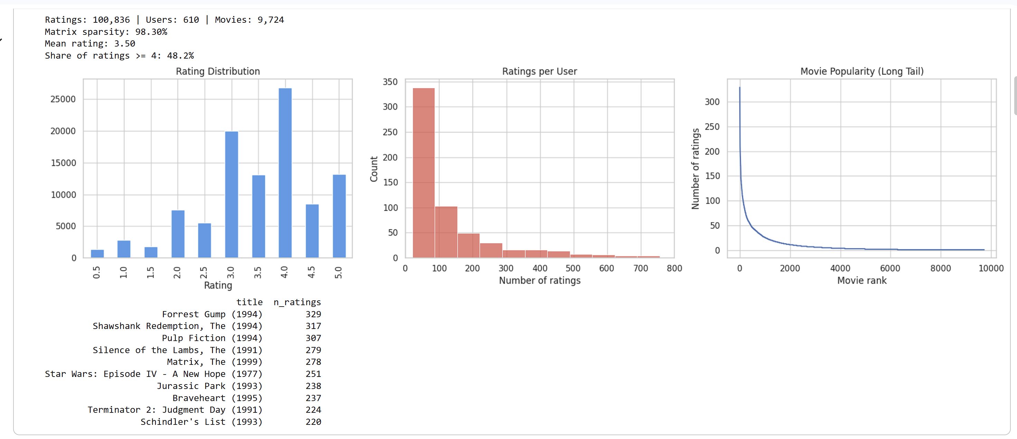
Figure 1. Dataset summary: rating distribution, ratings per user, movie popularity long tail, and the ten most-rated movies.
Three properties of the data shape the whole project:
- Positive skew in ratings. The most common rating is 4.0, so we define a "liked" movie as one rated 4.0 or higher.
- Uneven user activity. Most of the 610 users have rated fewer than 100 movies, while a small group is very active.
- A pronounced long tail. The most-rated movie (Forrest Gump) has 329 ratings, but the vast majority of movies have very few. Popular movies therefore dominate any model that learns from raw interaction counts.

3. Methodology

3.1 Temporal Train/Test Split
For every user, the most recent 20% of their ratings were held out as the test set, and the rest were used for training (80,419 training and 20,417 test ratings). This mimics real deployment, where the system sees the past and must predict the future, and is stricter than a random split, which leaks future information into training.

3.2 Models
Model | Description
Popularity (baseline) | Recommends the same most-liked movies to every user, excluding movies the user has already rated.
Item-KNN (cosine) | Item-based collaborative filtering. Movies are compared by the cosine similarity of the sets of users who liked them; a user's score for a movie is the sum of its similarity to the movies that user liked.
SVD (50 factors) | Truncated singular value decomposition of the user-movie "liked" matrix with 50 latent factors; scores are reconstructed from the low-rank approximation.

All models learn from positive interactions only (ratings of 4.0 or higher) and never recommend a movie the user has already rated in the training period.

3.3 Evaluation Metrics
A movie in the test period counts as relevant if the user rated it 4.0 or higher. For each user the top 10 recommendations are scored, and the metrics are averaged over users who have at least one relevant test movie:
- Precision@10: share of the 10 recommendations that are relevant.
- Recall@10: share of the user's relevant movies that appear in the top 10.
- NDCG@10: rewards placing relevant movies higher in the list.
- HitRate@10: share of users with at least one relevant movie in their top 10.
- Coverage: share of the whole catalog that is recommended to at least one user.

4. Model Comparison
Model | Precision@10 | Recall@10 | NDCG@10 | HitRate@10 | Coverage
Popularity | 0.0615 | 0.0496 | 0.0800 | 0.3260 | 0.0093
Item-KNN (cosine) | 0.0885 | 0.0831 | 0.1098 | 0.4595 | 0.0563
SVD (50 factors) | 0.0834 | 0.0888 | 0.1107 | 0.4696 | 0.0607

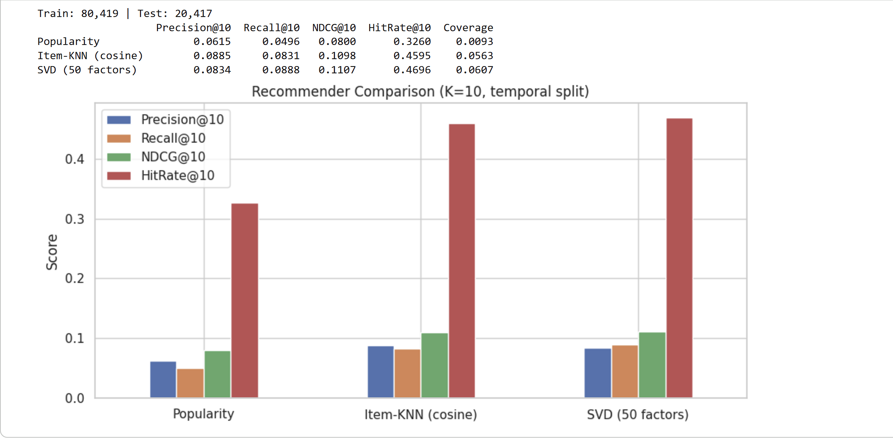
Figure 2. Comparison of the three models (K = 10, temporal split).
Findings:
- Collaborative filtering clearly beats popularity. Precision@10 improves from 0.0615 to 0.0885 (Item-KNN) and 0.0834 (SVD), and HitRate@10 from 33% to 46% and 47%. For nearly half of the users at least one of the ten recommendations is a movie they later liked.
- Item-KNN and SVD are practically tied. KNN is ahead on Precision, SVD on Recall, NDCG, HitRate and Coverage, but the gaps are small and were measured on only 610 users without confidence intervals, so no claim of a winner is made.
- Absolute scores look low, which is expected. With 98.3% sparsity, a strict temporal split and a strict relevance rule, only a few of ten recommendations can be hits.
- Coverage is very low for all models. Popularity recommends only about 0.9% of the catalog (roughly 90 movies), and the collaborative filtering models reach about 6%.

4.1 Example: Recommendations for One User
User 1 liked movies such as Star Wars: Return of the Jedi, Dumb & Dumber, Bambi, Gladiator, American Beauty and Billy Madison, a mix of comedy, science fiction and animation. The three models returned the following top 10 lists:
Popularity | Item-KNN | SVD
Shawshank Redemption | Groundhog Day | Die Hard
Silence of the Lambs | The Terminator | Fight Club
Fight Club | Ferris Bueller's Day Off | Crouching Tiger, Hidden Dragon
Schindler's List | Die Hard | Edward Scissorhands
The Godfather | The Godfather | The Lion King
LOTR: Fellowship of the Ring | Back to the Future | American Pie
LOTR: Return of the King | Ghostbusters | Seven
Terminator 2 | The Godfather: Part II | Snatch
LOTR: The Two Towers | Aliens | Aladdin
Seven | Terminator 2 | Austin Powers: The Spy Who Shagged Me

Popularity returns the same acclaimed classics that anyone would be shown. Item-KNN returns well-known 1980s and 1990s action and comedy films. SVD is the most varied, including comedies (American Pie, Austin Powers) and family animation (The Lion King, Aladdin) that match the user's history. This is a qualitative observation on a single user, not statistical evidence.

5. Popularity Bias Analysis
To measure bias, movies were ranked by popularity (rank 0 = most liked), and for each model the share of recommended slots coming from the top 100 movies and from the long tail (rank above 1,000) was computed.
Model | Top-100 share | Long-tail share | Median popularity rank
Popularity | 99.8% | 0.0% | 8
Item-KNN (cosine) | 76.2% | 3.9% | 38
SVD (50 factors) | 62.7% | 0.8% | 59

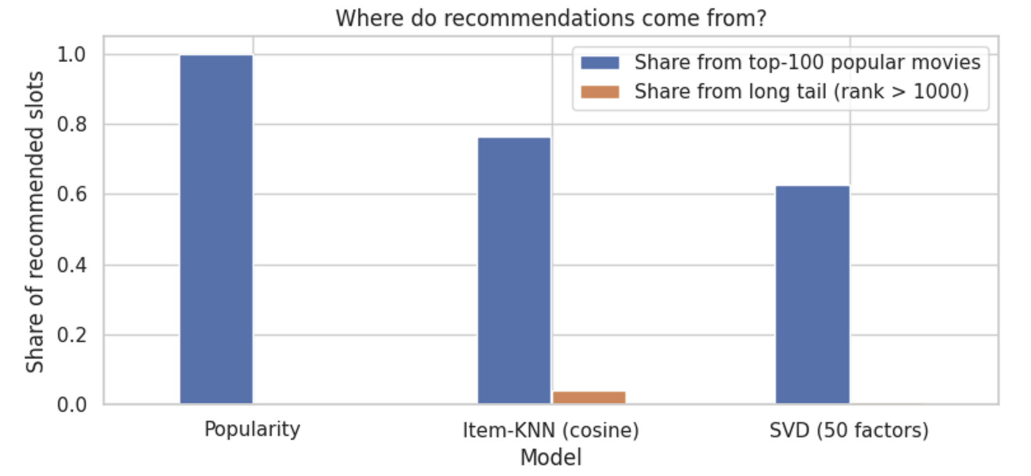
Figure 3. Where recommendations come from: share of slots from the 100 most popular movies versus the long tail.
Neither collaborative filtering model escapes popularity. Between 63% and 76% of all recommended slots go to the 100 most popular movies, which is about 1% of the catalog. SVD relies less on the very top (median rank 59 versus 38 for Item-KNN), while Item-KNN reaches the long tail slightly more often (3.9% versus 0.8%), so neither is clearly the more diverse one.
Part of this bias reflects the data itself: the popularity baseline reaches a HitRate of 33% with only about 90 distinct movies, which shows that real future viewing is concentrated on popular titles as well. Accuracy and diversity are therefore partly in conflict, which motivates the next section.

6. Reducing Popularity Bias by Re-ranking

6.1 Method
Each user's scores are first standardized (z-scores across movies), and a penalty proportional to the standardized log-popularity of each movie is subtracted:
adjusted score = z(score) − λ × z(log(1 + popularity))
The weight λ controls the strength of the penalty. λ = 0 reproduces the original ranking, and larger values push recommendations toward less popular movies. Each λ in {0, 0.25, 0.5, 0.75, 1.0, 1.5, 2.0, 3.0} was evaluated on the same test set.

6.2 Results
Model | λ | Prec.@10 | Recall@10 | NDCG@10 | HitRate | Coverage | Top-100 | Long-tail
Item-KNN | 0 | 0.0885 | 0.0831 | 0.1098 | 0.4595 | 0.0563 | 0.762 | 0.039
Item-KNN | 0.25 | 0.0802 | 0.0805 | 0.1028 | 0.4375 | 0.0795 | 0.631 | 0.110
Item-KNN | 0.5 | 0.0652 | 0.0761 | 0.0858 | 0.4003 | 0.1032 | 0.457 | 0.260
Item-KNN | 0.75 | 0.0424 | 0.0651 | 0.0611 | 0.2889 | 0.1220 | 0.289 | 0.475
Item-KNN | 1.0 | 0.0257 | 0.0472 | 0.0400 | 0.1824 | 0.1288 | 0.135 | 0.724
Item-KNN | 1.5 | 0.0056 | 0.0114 | 0.0090 | 0.0439 | 0.1241 | 0.013 | 0.971
Item-KNN | 2.0 | 0.0024 | 0.0041 | 0.0029 | 0.0186 | 0.1219 | 0.000 | 0.999
Item-KNN | 3.0 | 0.0020 | 0.0033 | 0.0029 | 0.0152 | 0.1684 | 0.000 | 1.000
SVD | 0 | 0.0834 | 0.0888 | 0.1107 | 0.4696 | 0.0607 | 0.627 | 0.008
SVD | 0.25 | 0.0807 | 0.0890 | 0.1094 | 0.4611 | 0.0734 | 0.599 | 0.026
SVD | 0.5 | 0.0794 | 0.0900 | 0.1083 | 0.4510 | 0.0820 | 0.575 | 0.037
SVD | 0.75 | 0.0797 | 0.0899 | 0.1073 | 0.4527 | 0.0923 | 0.548 | 0.050
SVD | 1.0 | 0.0770 | 0.0887 | 0.1041 | 0.4459 | 0.1012 | 0.521 | 0.064
SVD | 1.5 | 0.0667 | 0.0843 | 0.0938 | 0.4139 | 0.1407 | 0.456 | 0.146
SVD | 2.0 | 0.0475 | 0.0675 | 0.0747 | 0.3074 | 0.2126 | 0.324 | 0.388
SVD | 3.0 | 0.0113 | 0.0195 | 0.0269 | 0.0997 | 0.2158 | 0.077 | 0.886

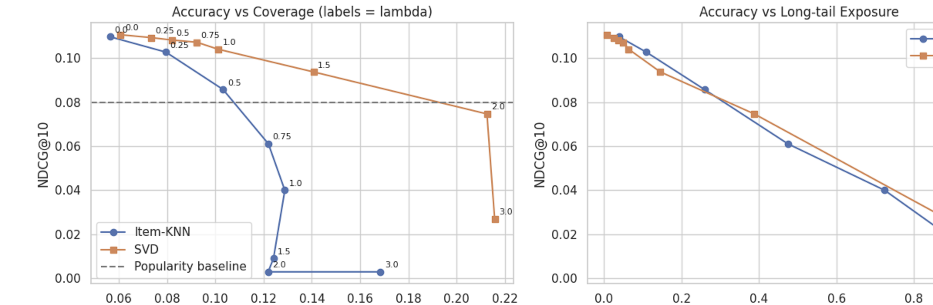
Figure 4. Left: accuracy (NDCG@10) versus catalog coverage, labelled by λ; the dashed line is the popularity baseline. Right: accuracy versus share of recommendations from the long tail.

6.3 Findings
- SVD degrades gracefully. At λ = 1.0, NDCG@10 falls from 0.1107 to 0.1041 (about 6%) while coverage rises from 6.1% to 10.1% (about 67%). At λ = 1.5, NDCG falls about 15% while coverage rises 2.3 times to 14.1%, and NDCG (0.0938) is still above the popularity baseline (0.0800). At λ = 2.0, coverage reaches 21% but NDCG (0.0747) drops below the baseline.
- Item-KNN collapses under the same penalty. At λ = 0.5 NDCG already falls about 22%, and from λ = 0.75 it is below the popularity baseline. A plausible explanation is that its scores are sparse and skewed, so after standardization the penalty dominates, but this was not tested directly.
- At equal long-tail exposure the two models are similar (right panel of Figure 4). The difference is that SVD gains diversity through mid-ranked movies and coverage first, while Item-KNN jumps quickly to very obscure titles.
- Recommended operating point: SVD with λ between 1.0 and 1.5. This range markedly raises diversity while keeping accuracy above the popularity baseline.
- Offline metrics understate the value of diversity. Held-out ratings are themselves popularity-biased, so accuracy is measured against a biased reference. The best λ should be confirmed with an online A/B test measuring engagement and discovery.

7. Cold-Start Handling
A new user has no history, so neither model can be applied. Two fallbacks were implemented:
- No information: recommend the most-liked movies (Shawshank Redemption, Forrest Gump, Pulp Fiction, The Matrix, Silence of the Lambs and so on). This is a safe default.
- A few liked movies named by the user: score every movie by its mean cosine similarity to those seed movies, standardize, and apply the same popularity penalty.
As an example, a user who says they like Toy Story and The Matrix was given recommendations under three penalty strengths:
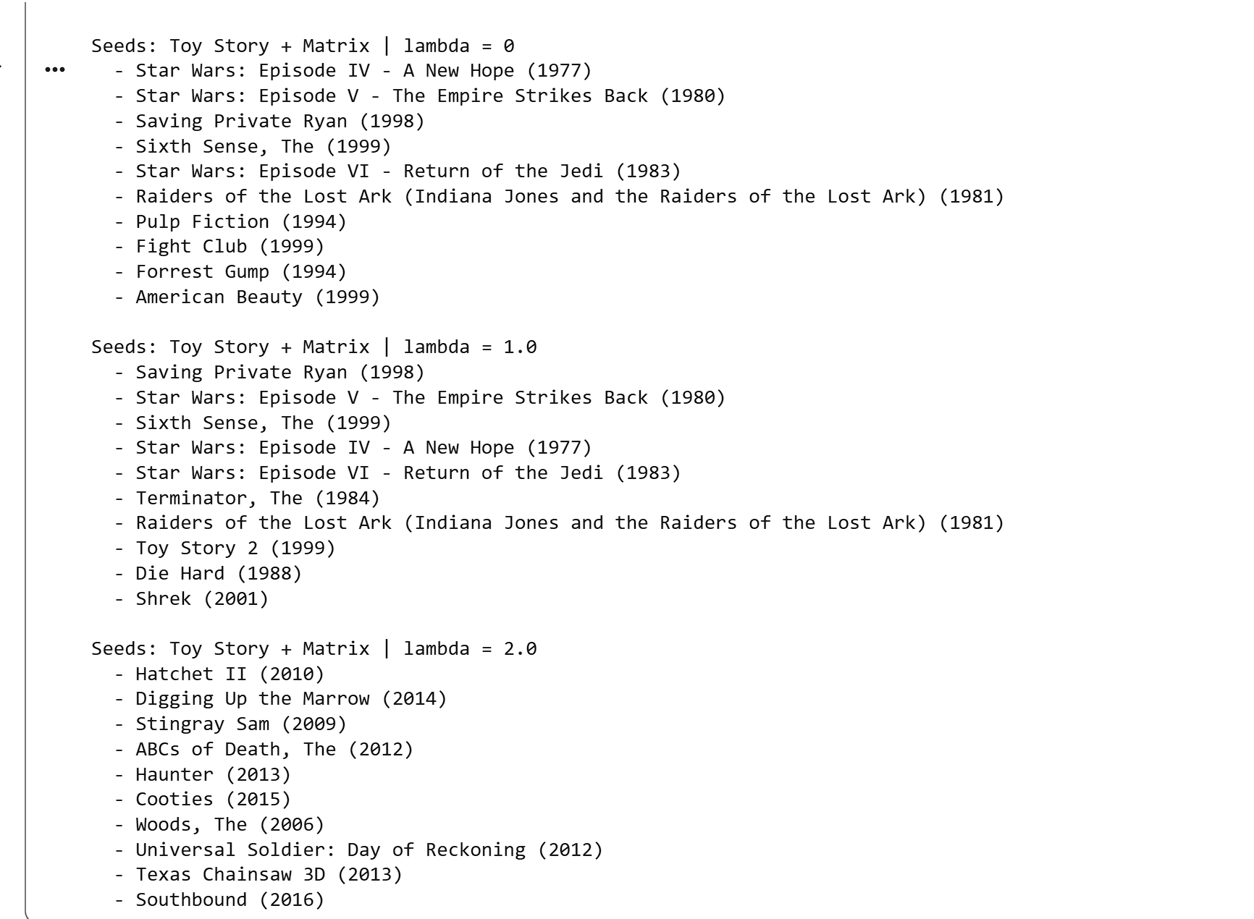
Figure 5. Cold-start recommendations for a user who likes Toy Story and The Matrix, for λ = 0, 1.0 and 2.0.
- λ = 0: only blockbusters (three Star Wars films, Pulp Fiction, Forrest Gump); nothing reflects the animation taste.
- λ = 1.0: the best result. Toy Story 2 and Shrek match the first seed, and The Terminator and Die Hard match the second.
- λ = 2.0: unrelated obscure horror titles (for example Hatchet II and Texas Chainsaw 3D). The penalty is so strong that obscurity alone lifts a movie into the list.
This is a single qualitative example and not a statistical evaluation, but it agrees with the offline results: moderate penalties help, extreme ones hurt.

8. Business Recommendations
Topic | Evidence | Recommendation
Choice of model | CF beats popularity (HitRate 0.46-0.47 vs 0.33); SVD and KNN are tied | Deploy SVD; it tolerates diversity re-ranking much better
Diversity setting | SVD at λ 1.0-1.5: coverage +67% to +132%, NDCG -6% to -15% | Start at λ around 1.0 and tune with an online A/B test
Catalog exposure | At most 6.1% of the catalog is ever recommended without re-ranking | Use re-ranking to give less-known titles a chance and justify content licensing costs
New users | No history for new users | Ask for 2-3 favourite titles at sign-up and use similarity with a mild penalty
Measurement | Offline data is popularity-biased | Track engagement, catalog coverage and discovery in production

9. Limitations
- Small dataset. 610 users and 9,724 movies; results may differ at production scale, and differences between close models cannot be confirmed statistically.
- No confidence intervals or tuning. Metrics are single-split averages, and hyperparameters (50 factors, cosine similarity) were not tuned.
- Offline evaluation only. Offline accuracy is a proxy for user satisfaction and is biased toward popular items; only an online experiment can measure real impact.
- Implicit-style modeling. The models use only "liked or not" signals and ignore ratings below 4.0, genres, timestamps and any user or item metadata.
- Limited diversity metrics. Diversity is measured by coverage and popularity share; genre diversity and novelty were not measured.
- Qualitative examples. The single-user demo and the cold-start example illustrate behaviour but are not evidence.
- Untested explanation. The reason Item-KNN collapses under the penalty is a hypothesis.

10. Conclusion and Future Work
This project built a complete recommender pipeline on MovieLens: a temporal evaluation protocol, a popularity baseline and two collaborative filtering models, a quantitative analysis of popularity bias, a tunable re-ranking method with an explicit accuracy-diversity trade-off curve, and a cold-start strategy. Collaborative filtering gave a clear gain over popularity (HitRate 0.46-0.47 versus 0.33), the models were nonetheless strongly popularity-biased, and SVD with a moderate popularity penalty (λ between 1.0 and 1.5) offered a favourable compromise, more than doubling catalog coverage at the upper end for a modest loss in NDCG.
Possible extensions:
- Add content features (genres) and a hybrid model to improve cold start and diversity.
- Try matrix factorization trained on ratings (for example ALS or implicit-feedback methods) and neural recommenders.
- Report confidence intervals via repeated splits, and measure genre diversity and novelty.
- Choose λ per user, for example more exploration for users with long histories.
- Deploy as an interactive app and validate the diversity setting with an A/B test.

Appendix: Technical Summary
Component | Details
Language and libraries | Python; pandas, NumPy, SciPy (sparse matrices), scikit-learn, Matplotlib, Seaborn
Data source | MovieLens Latest Small, GroupLens Research
Split | Per-user temporal split: last 20% of each user's ratings held out for testing
Relevance | Rating of 4.0 or higher
Training signal | Binary user-item matrix of ratings of 4.0 or higher
Item-KNN | Cosine similarity on L2-normalized item columns, self-similarity set to zero
SVD | TruncatedSVD, 50 components, random_state = 42
Recommendation rule | Top 10 by score, excluding movies already rated in training
Re-ranking | z-scored user scores minus λ times z-scored log(1 + popularity); λ from 0 to 3
Cold start | Popularity fallback; seed-movie mean cosine similarity with popularity penalty

