Student Name: Sanaz Pahlavani
TP Number: TP089710
Intake Code: APDMF2505DSBA (BI)
Programme: Data Management Module
Lecturer: DR. MURUGANANTHAN VELAYUTHAM

Stroke Data Analysis
Abstract:
Healthcare analytics has changed specifically in recent years, specifically how we process the patient data. We can use machine learning to process the data and better process the health information. For example, the Stroke Prediction Dataset enables us to solve a common problem such as predicting strokes based on people's profiles and health signs, we will use SAS Studio to analyse the types of data, how we clean it up, where we store it away and how data warehouses help.
Keywords: Data management, exploratory data analysis, metadata, feature engineering, data warehouse, stroke prediction.
Introduction
Patient Demographics, lifestyle, and health features applicable for stroke prediction exist in the Healthcare Dataset Stroke Data. Both quantitative (numeric) features like age and mean glucose level and qualitative (categorical) features like gender, ever married, type of work, and smoking status (nominal scale) exist in this data set. Heart disease and hypertension are also binary nominal variables, while certain qualities like BMI are continuous ratio data.
Different machine learning algorithms have different degrees of ability to deal with the data. For instance, Logistic Regression is intended for categorical variables whereas decision Trees and Random Forests are bespoke methods to deal with mixed data (Han et al., 2022). Datasets are often converted to data warehouses for analytics or stored in relational databases for operational systems. According to Inmon (2005), a data warehouse is an OLAP oriented system meant for query and analysis rather than transaction. In a data warehouse, historical patient information is consolidated and organized to facilitate trend analysis, predictive modelling, or policy review in the healthcare industry.
The information is of small scale (5,110 records) and can be prepared from latest dataset snapshots for loading as flat files (CSV) into SAS yet an extended integration with hospital systems will likely call for a star schema design with associated fact tables, patient visit records and dimension tables, social/demographics/lifestyle facts to improve indexing and querying performance (Kimball & Ross, 2013).
Faster Analytical Queries It is called B-tree indexing, and we usually build it for numerical attributes like avg_glucose_level to provide fast range queries in SAS or SQL-based data warehouses. Bitmap indexing can be more space-efficient for categorical variables such as gender, especially when the column cardinality is low (Garcia-Molina et al., 2009). Therefore in this scenario, the efficiency of class-based queries increases when indexing stroke as a target variable.

1-Metadata and Attribute-Level Definitions and creation
Metadata provides structural and semantic information about the dataset, enhancing interoperability and discoverability. For this dataset, metadata should include
Description: Patient health and demographic records for stroke prediction modelling.
Attributes: Data type, measurement scale, allowable values, and null counts for each column.
Attribute Types: Nominal, Ordinal, Interval, Ratio
Each attribute in the Stroke dataset has been categorized based on its measurement scale.
(1)Nominal attributes represent categories with no specific order. (2) Ordinal attributes represent ranked categories with a meaningful sequence. (3) Interval attributes are numeric values with no true zero point. (4) Ratio attributes are numeric values with a true zero point.

Variable Name | Description | Measurement Level | Unis | Allowed Values | Missing Codes | Notes
id | Unique identifier for each patient record | Nominal | N/A | Unique integer values | NA | Drop before modeling
gender | Gender of the patient | Nominal | N/A | Male, Female, Other | NA | Categorical variable
age | Age of the patient | Ratio | Years | 0-82 | NA | Continuous numeric variable
hypertension | Whether the patient has hypertension | Nominal | N/A | 0 (No), 1 (Yes) | NA | Binary categorical variable
heart_disease | Whether the patient has heart disease | Nominal | N/A | 0 (No), 1 (Yes) | NA | Binary categorical variable
ever_married | Marital status of the patient | Nominal | N/A | Yes, No | NA | Categorical variable
work_type | Type of work the patient does | Nominal | N/A | Private, Self-employed, Govt_job, children, Never_worked | NA | Categorical variable
Residence_type | Type of residence area | Nominal | N/A | Urban, Rural | NA | Categorical variable
avg_glucose_level | Average glucose level in the blood | Ratio | mg/dL | 55.12 - 271.74 | NA | Continuous numeric variable
bmi | Body Mass Index of the patient | Ratio | kg/m² | 10.3 - 97.6 | NA | Continuous numeric variable
smoking_status | Smoking habits of the patient | Nominal | N/A | formerly smoked, never smoked, smoke,Unknown | NA | Categorical variable
stroke | Whether the patient had a stroke | Nominal | N/A | 0 (No), 1 (Yes) | NA | Target variable

Exploratory Data Analysis (EDA) in SAS Studio
explore the dataset’s structure, missingness, and distributional properties.
Import and Structural Overview
PROC CONTENTS lists the type (character or numeric), length, formats, and number of non-missing observations per variable, helping confirm correct import and identify unexpected missingness.
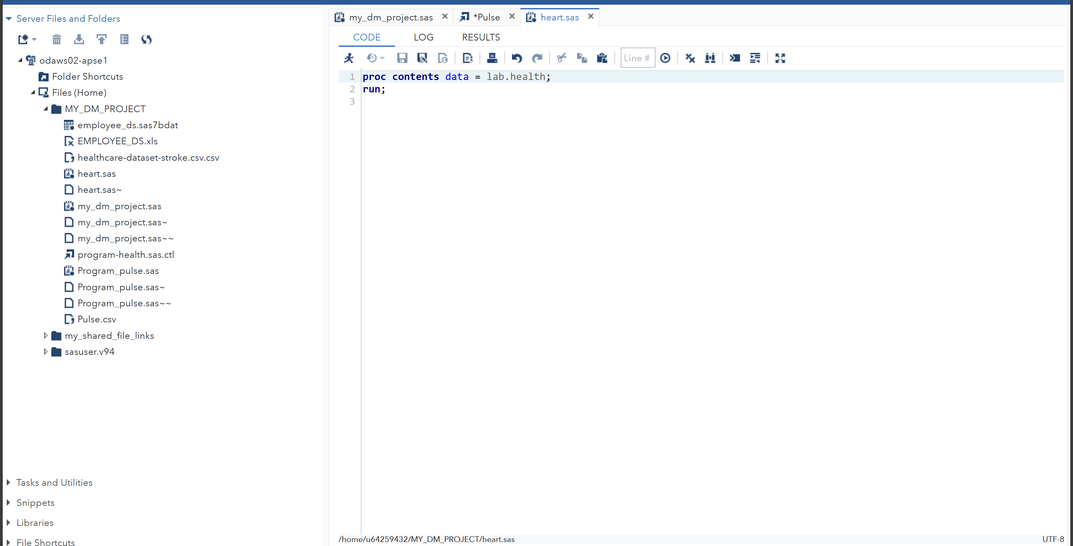

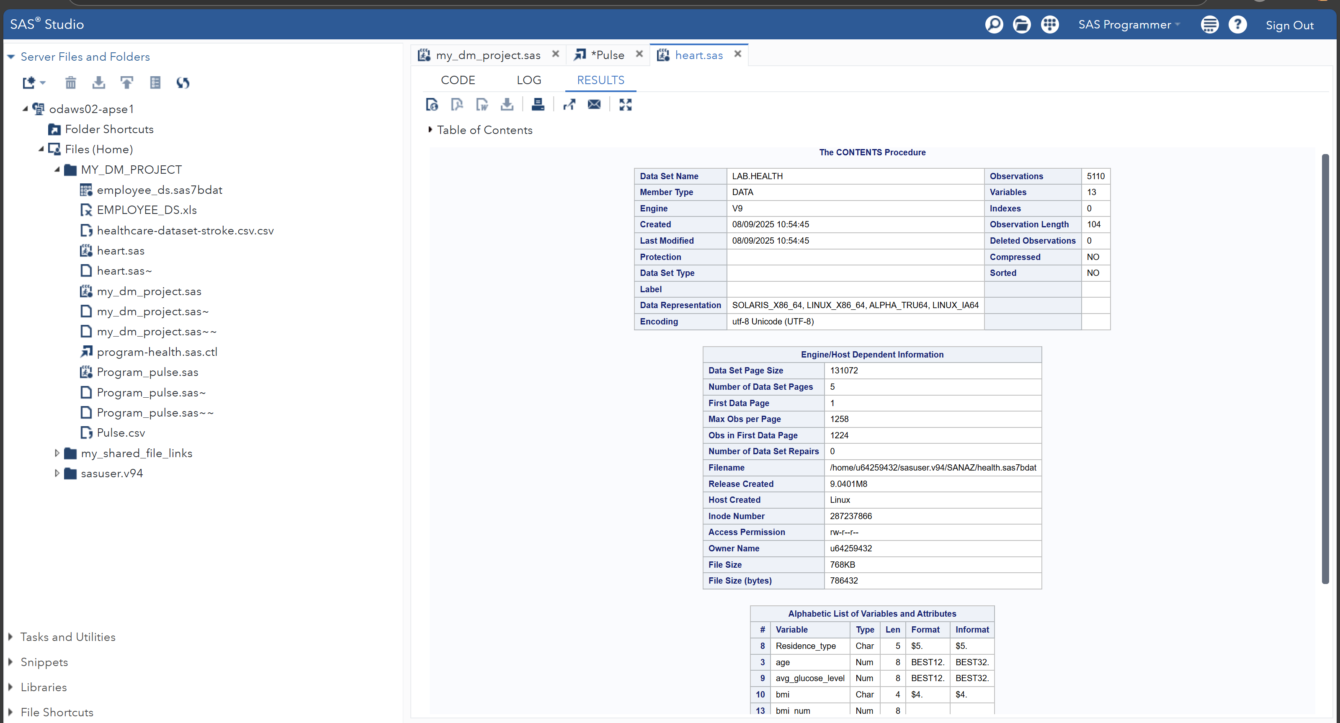

Row count and uniqueness check
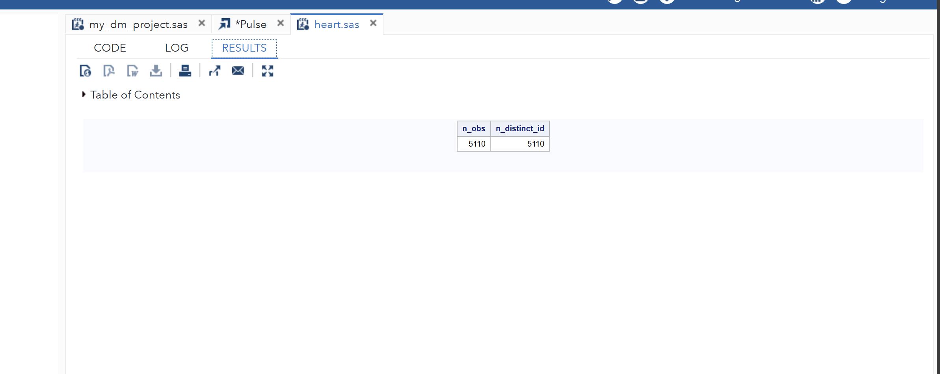

Classify each attribute by measurement level
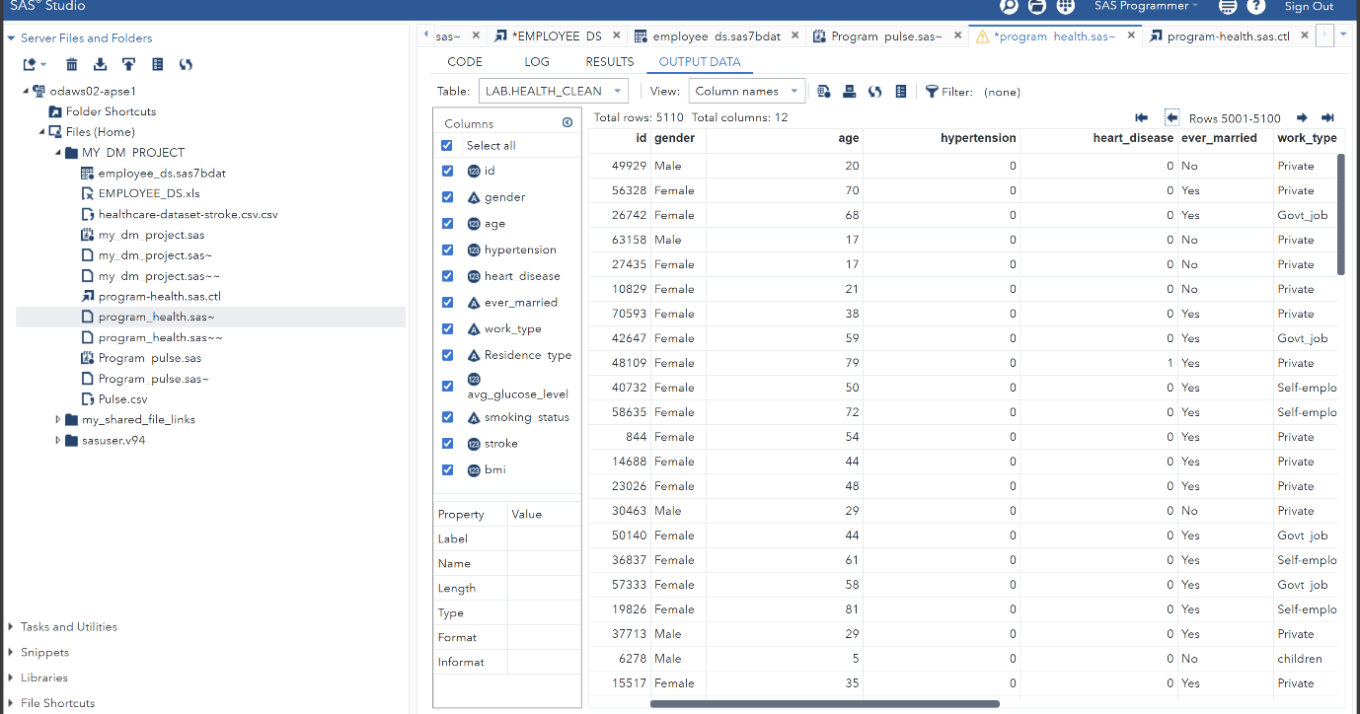

2-Numeric Descriptive Statistics (Numeric summaries (age, avg_glucose_level, bmi))
Summary statistics help us figure out the overall structure of the data, including its distribution, missing values, outliers, and extreme values. These statistics include mean, median, minimum, maximum, range, variance, percentiles, standard deviation for numerical data, and frequency counts for categorical attributes. This process is significant for identifying inconsistencies or outliers that can affect the data quality or the result of the analysis.
Variable bmi in list does not match type prescribed for this list because means bmi is not numeric in your dataset, it’s likely stored as a character variable (maybe because of missing values stored as text).

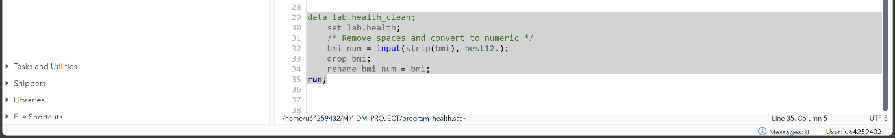
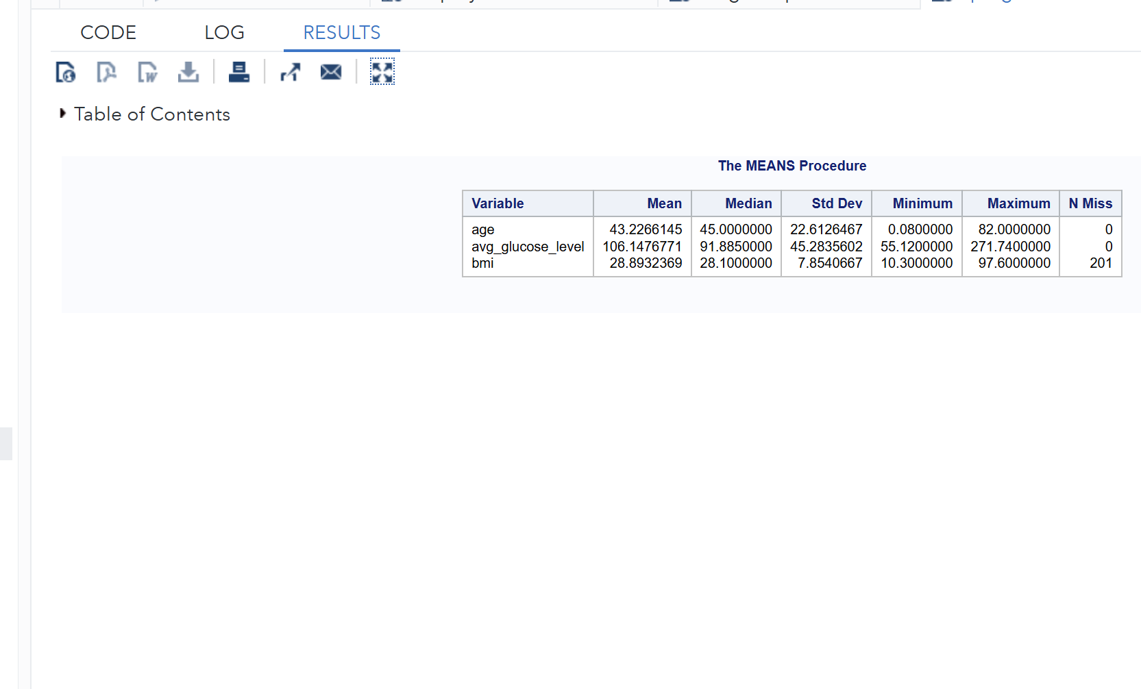
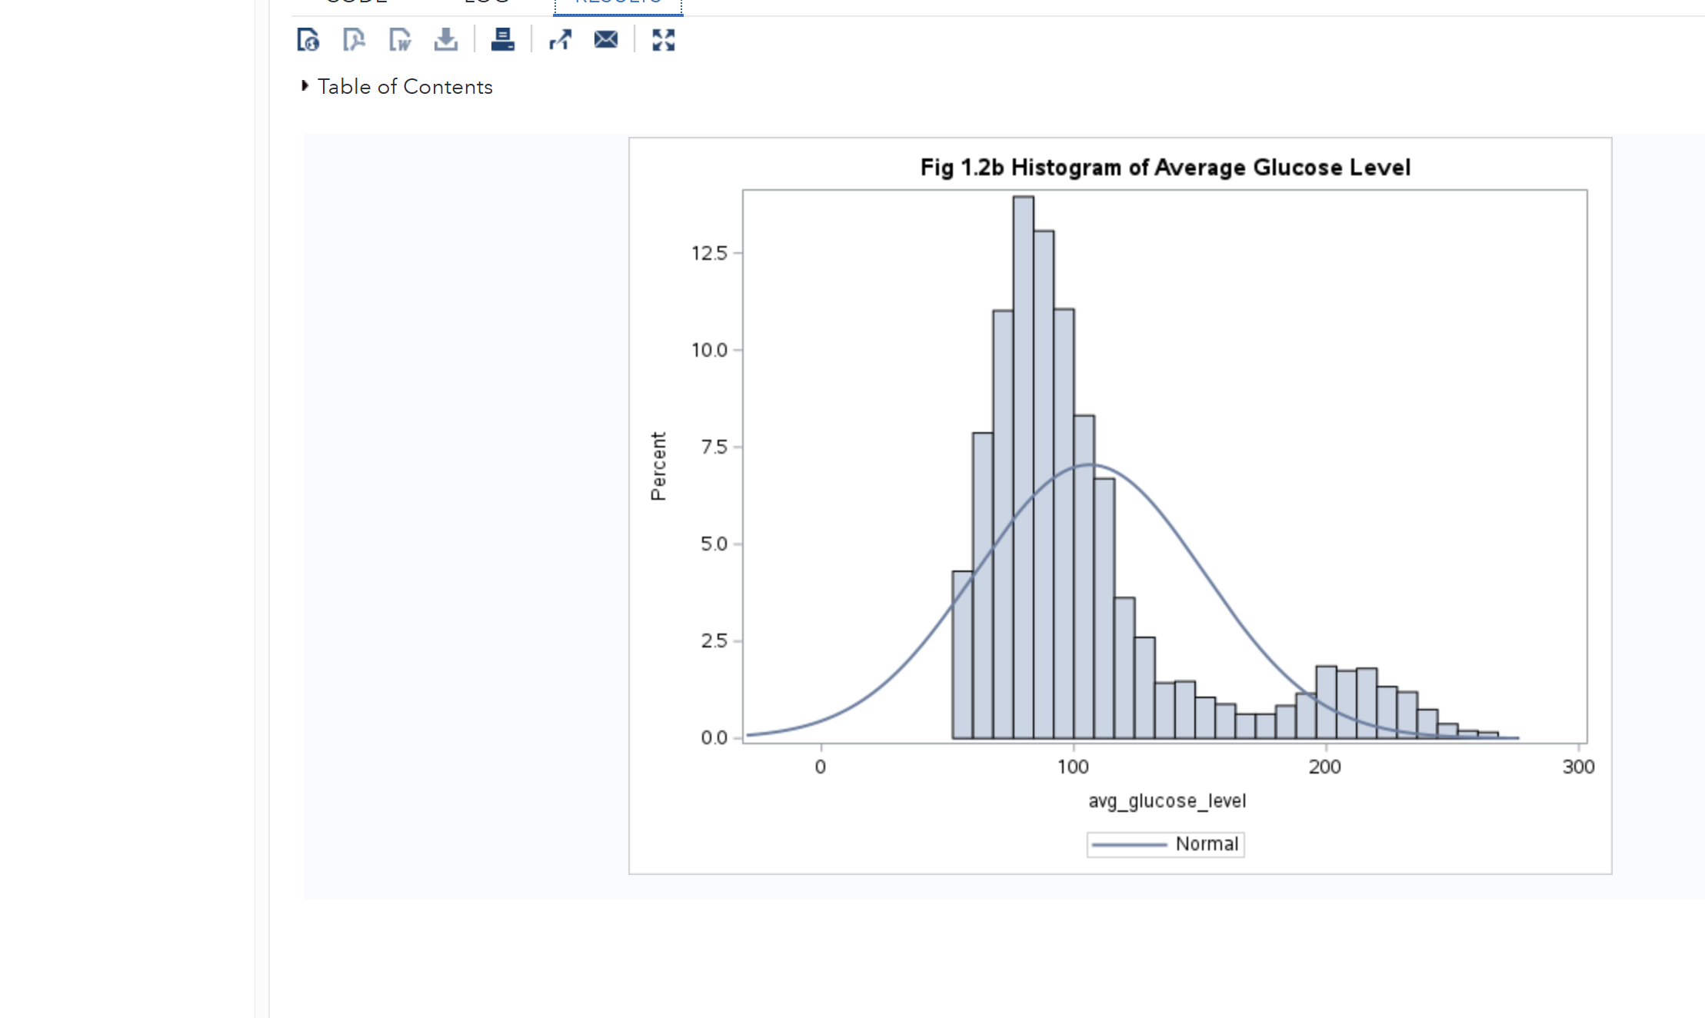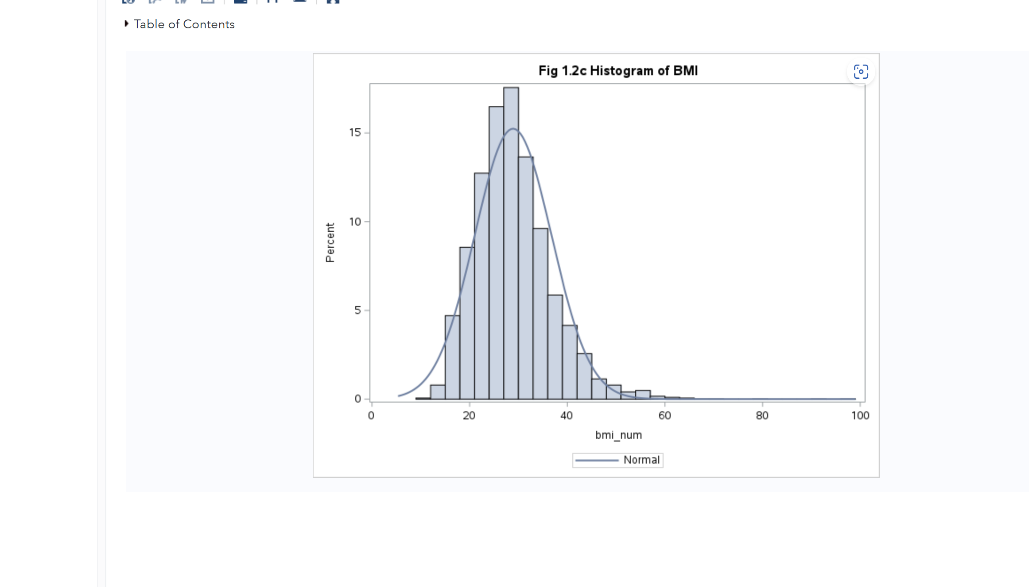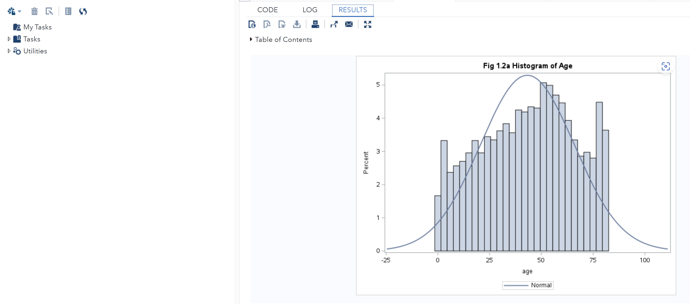
Histogram of Age, Average Glucose Level, and BMI The histograms show how the numerical attributes are distributed. The Age histogram leans slightly to the right, which means older individuals make up a larger portion of the dataset. The Average Glucose Level histogram has a long tail to the right, suggesting that some patients have unusually high glucose levels. The BMI distribution also leans slightly right, with a few high values that could be seen as outliers. In all three cases, the normal density curve on top reveals clear differences from a normal distribution, which shows that we should think about data transformation or more robust modelling methods.

3-Categorical Frequency Counts (gender, work type, smoking status, hypertension, heart disease, ever married, Residence type, stroke)
Frequency tables:
Each category (Male/Female in gender).
Count of observations in each category.
Percentage share of each category.

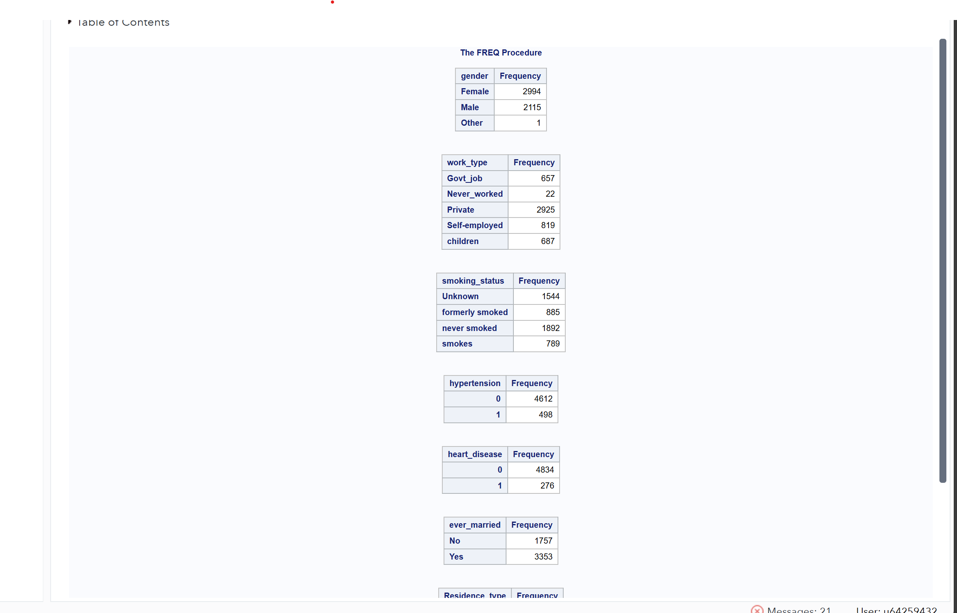
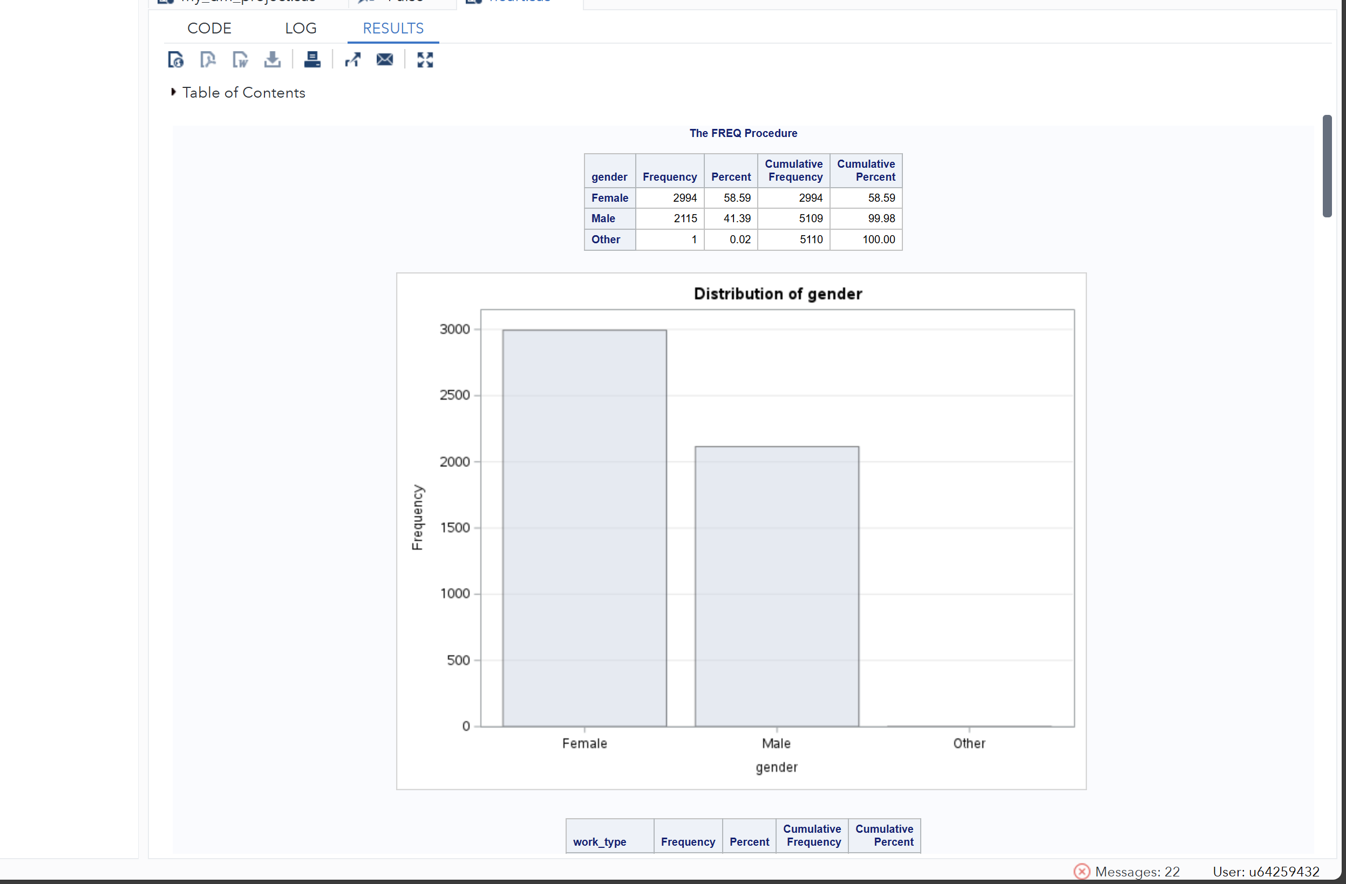

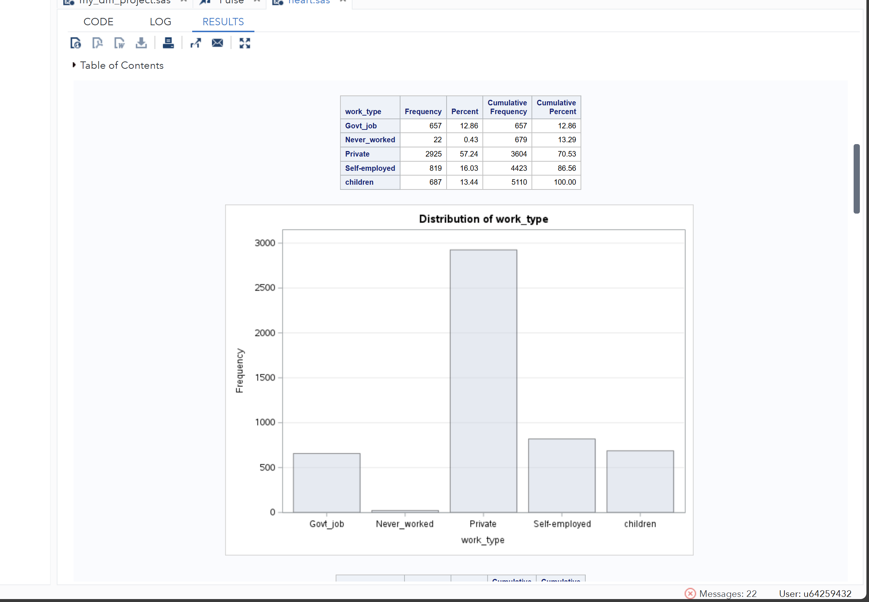
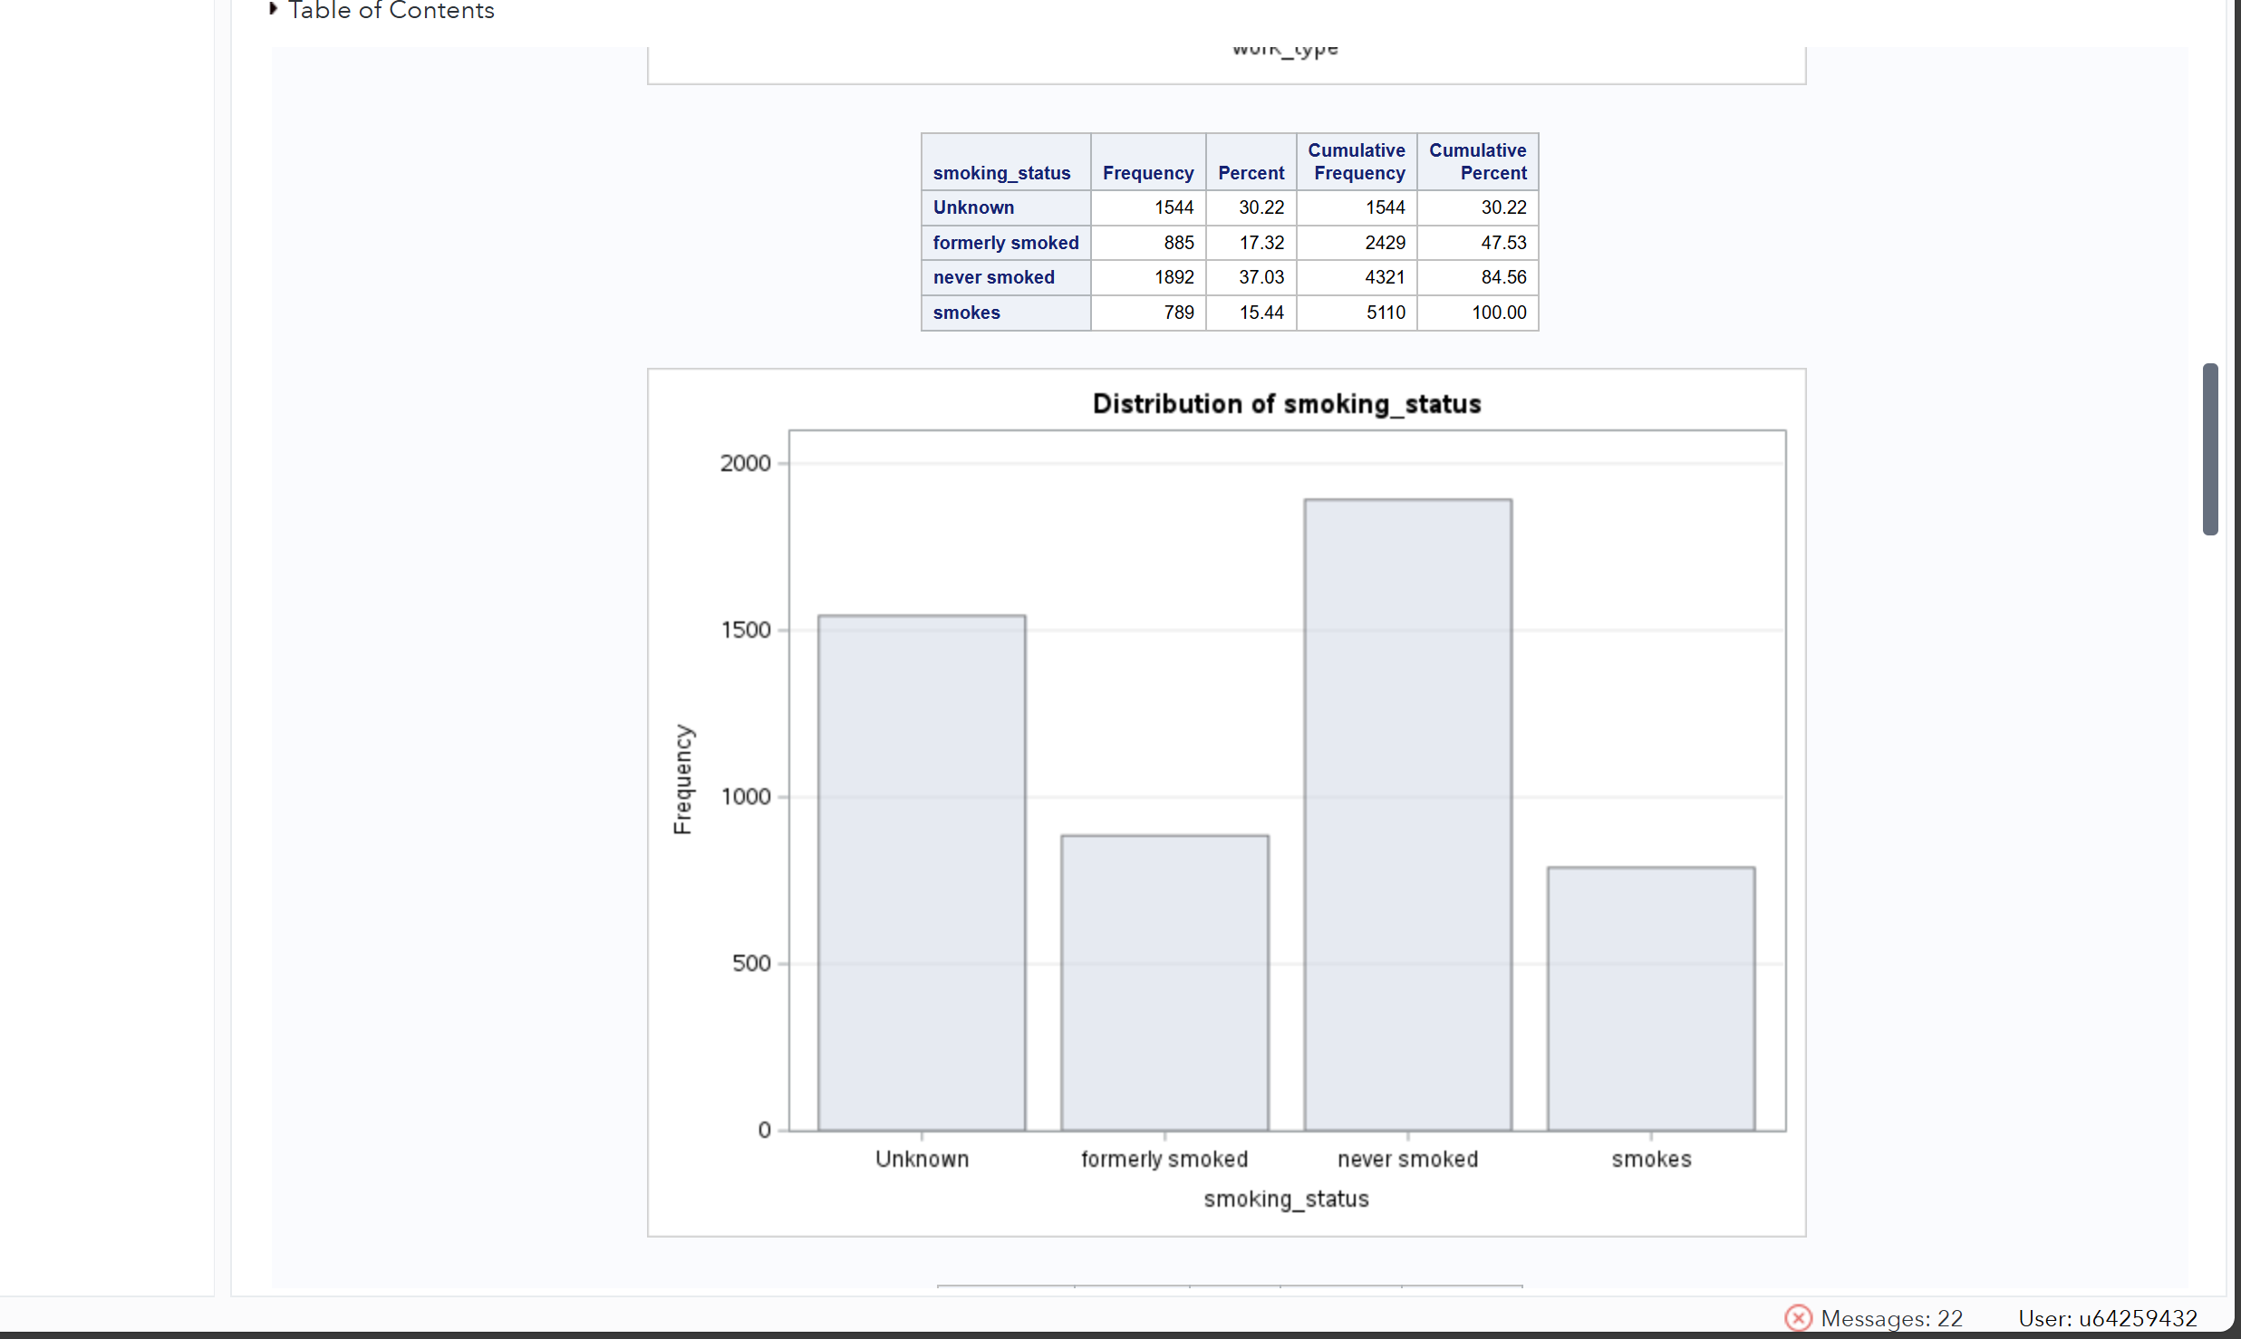
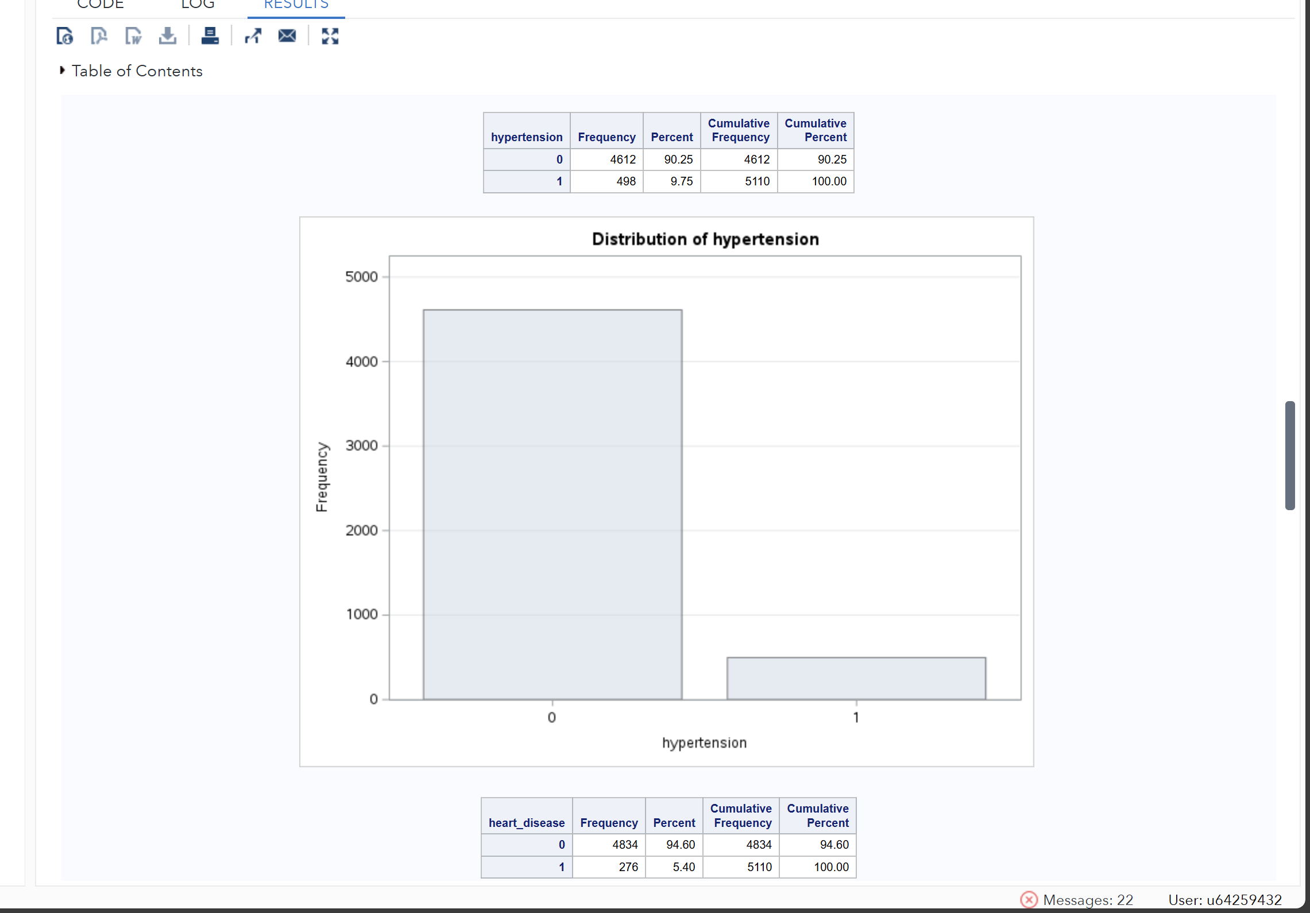
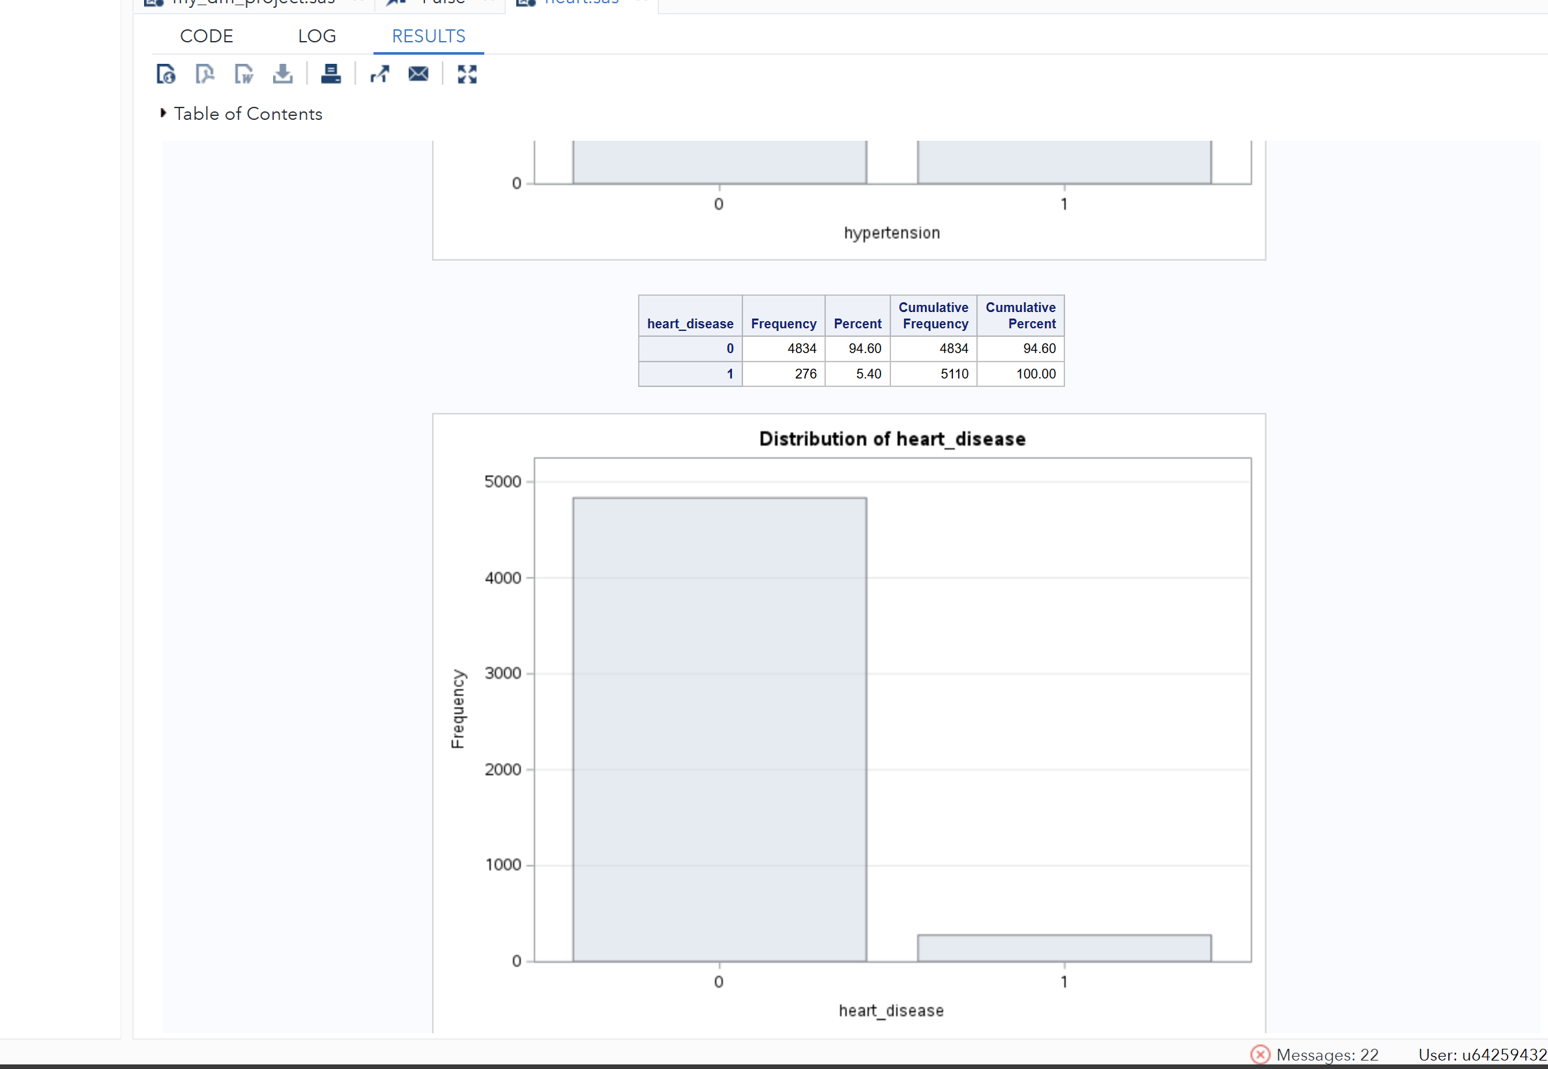
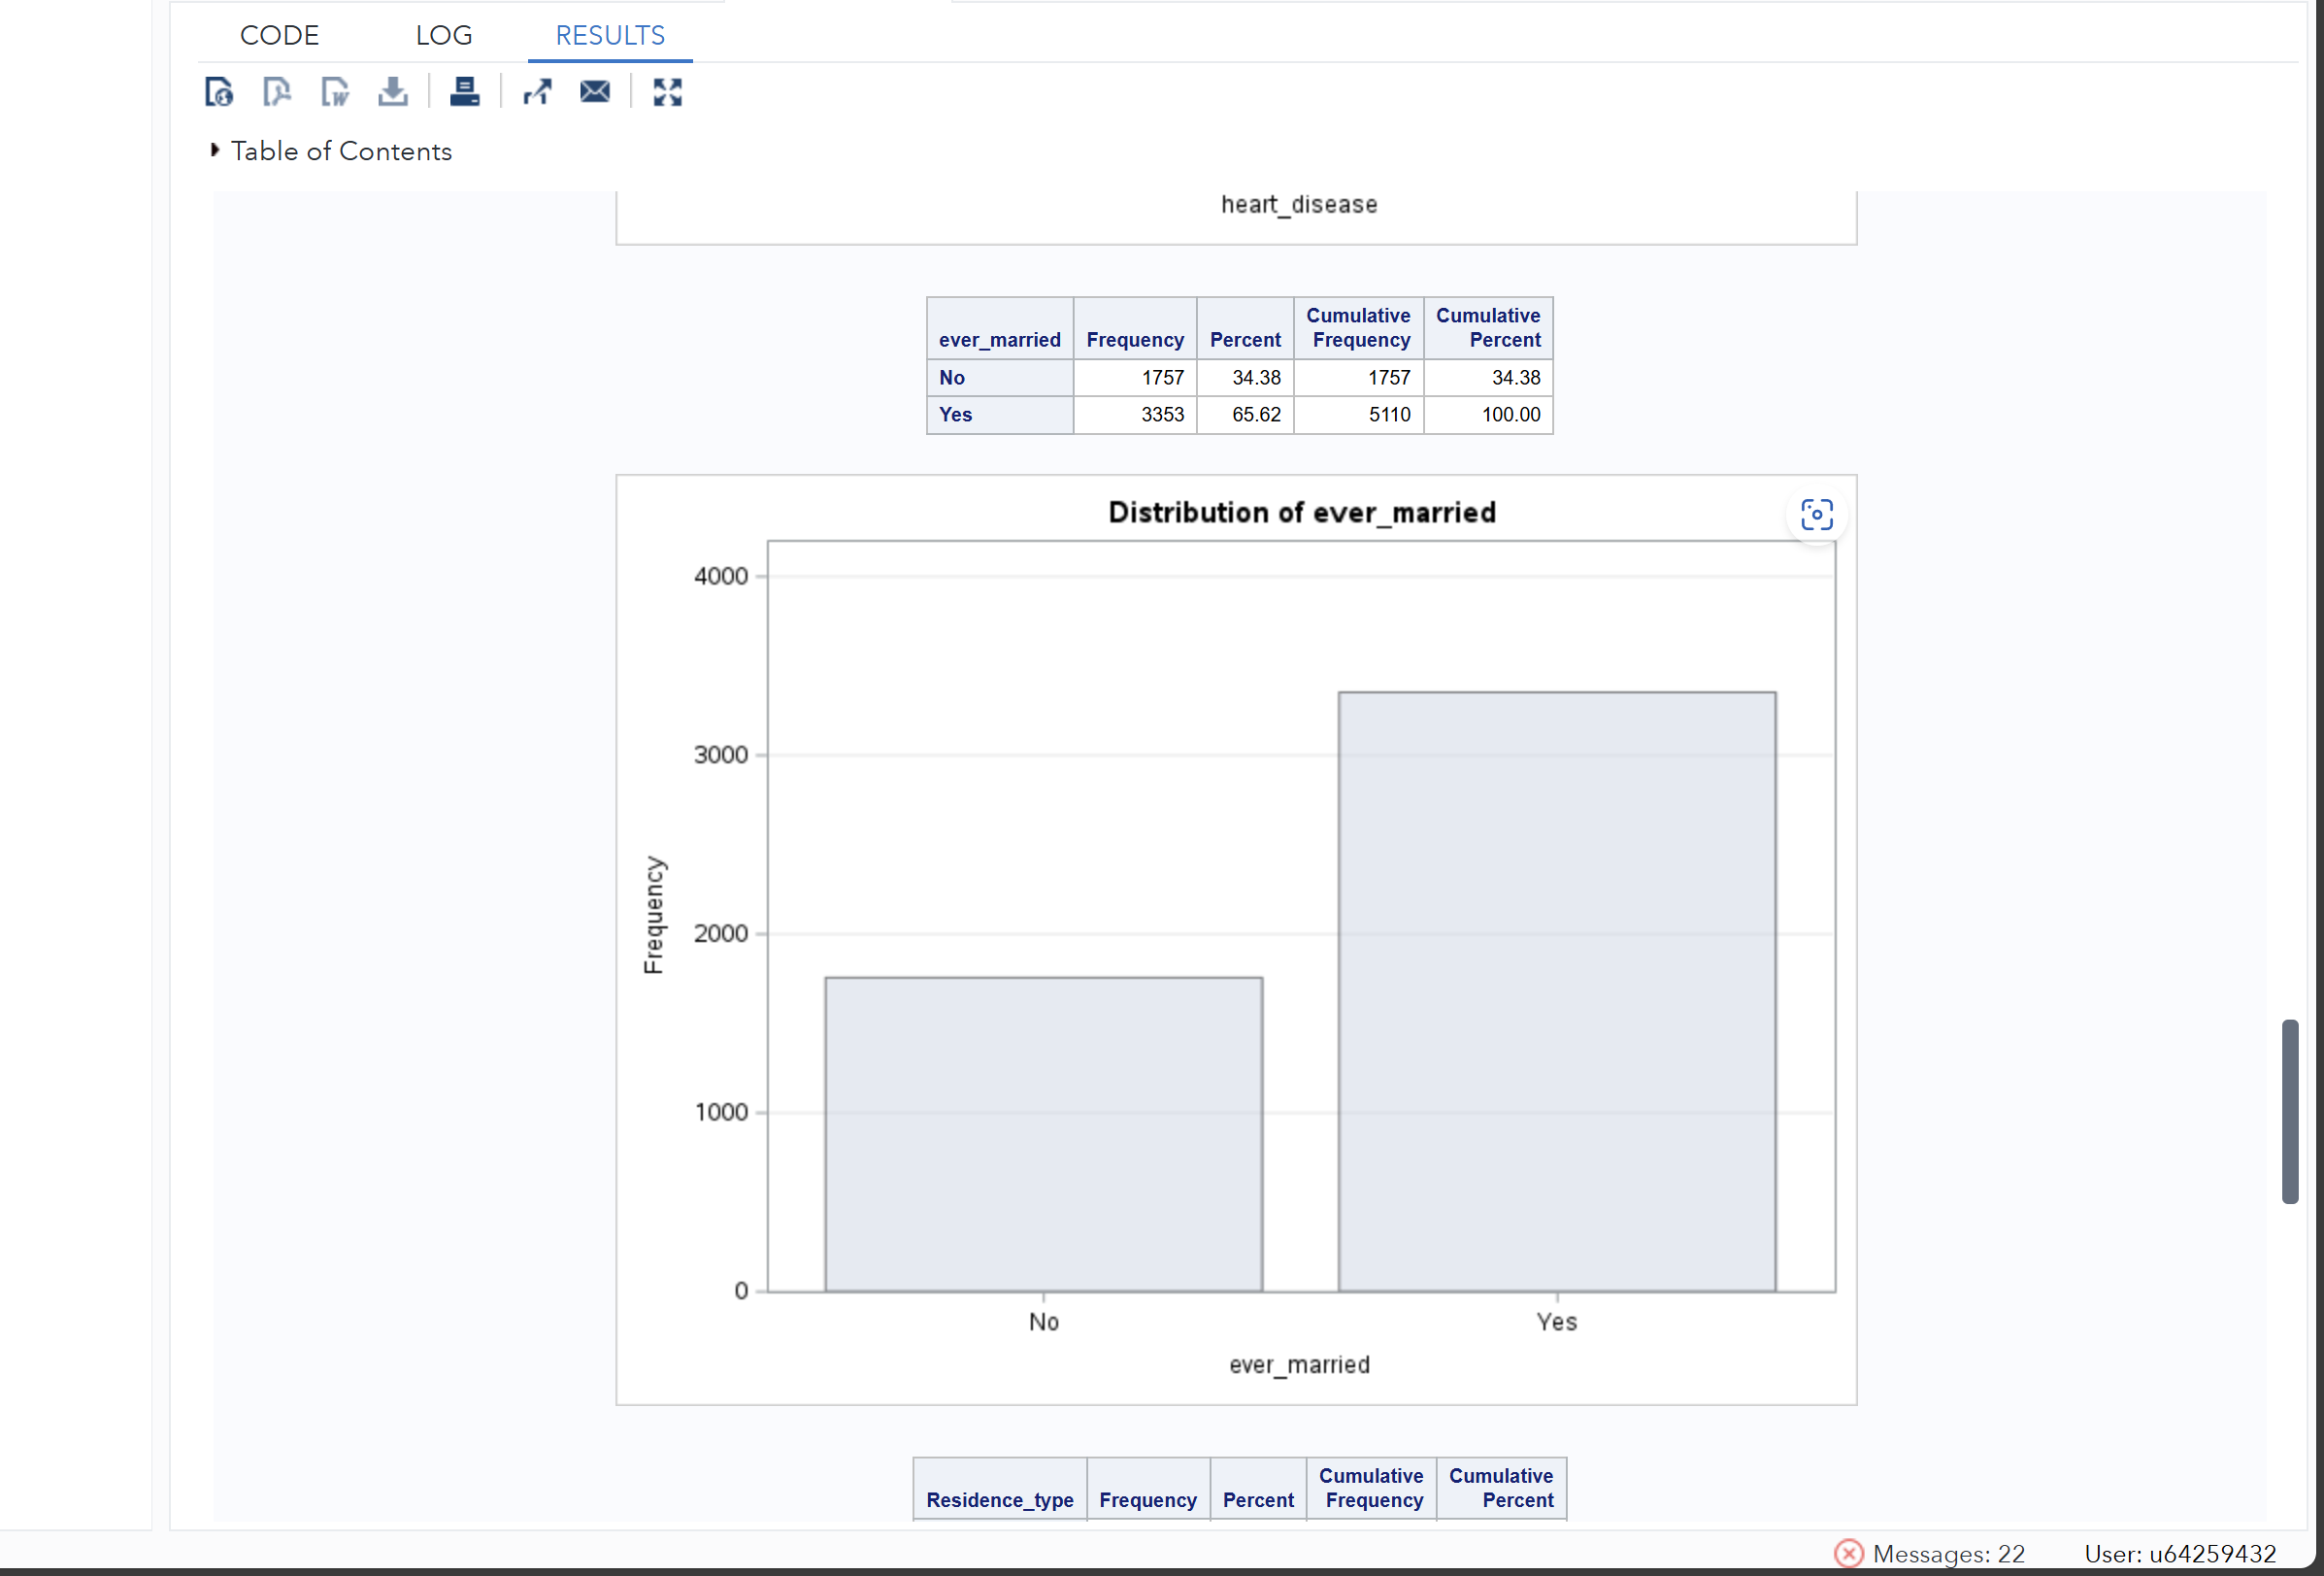
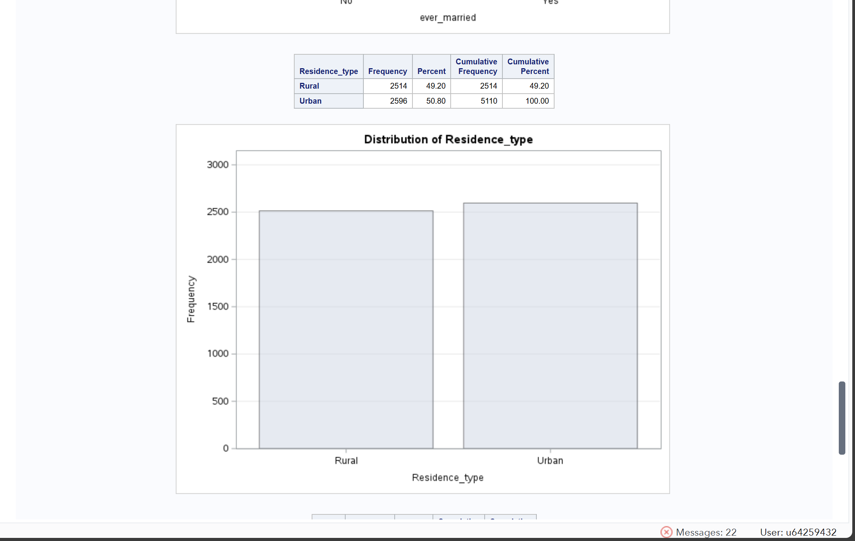
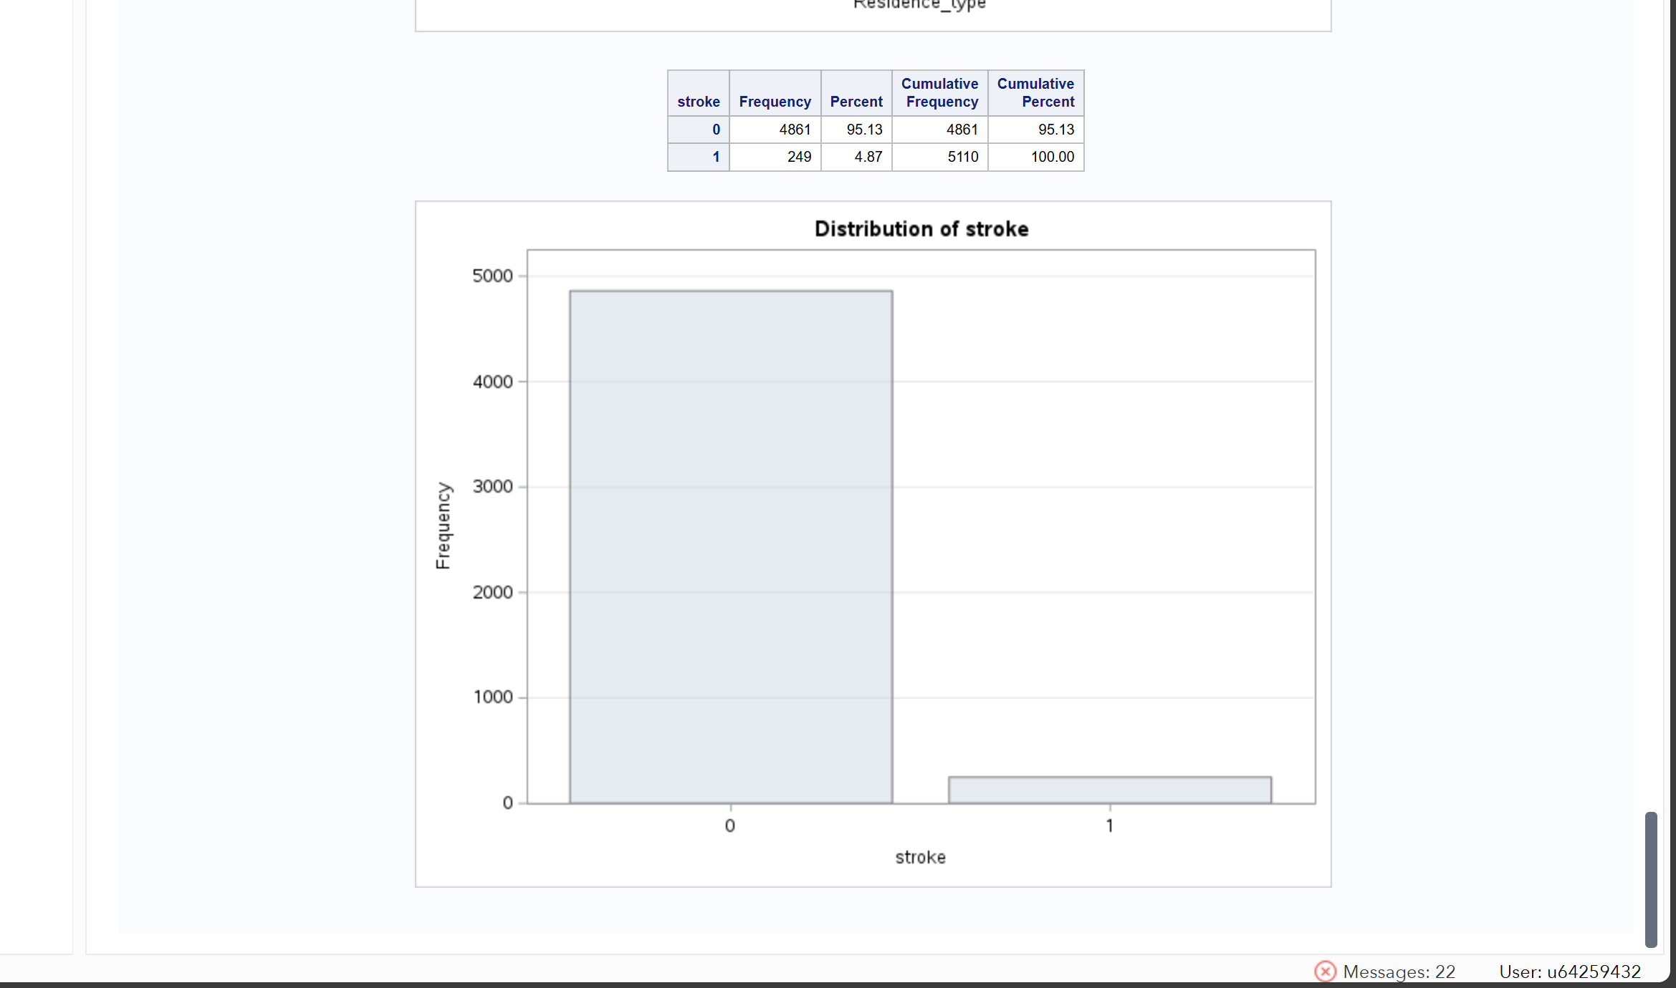

4-Identify outliers, missing values, inconsistencies
Missing Value for Numerical Variables
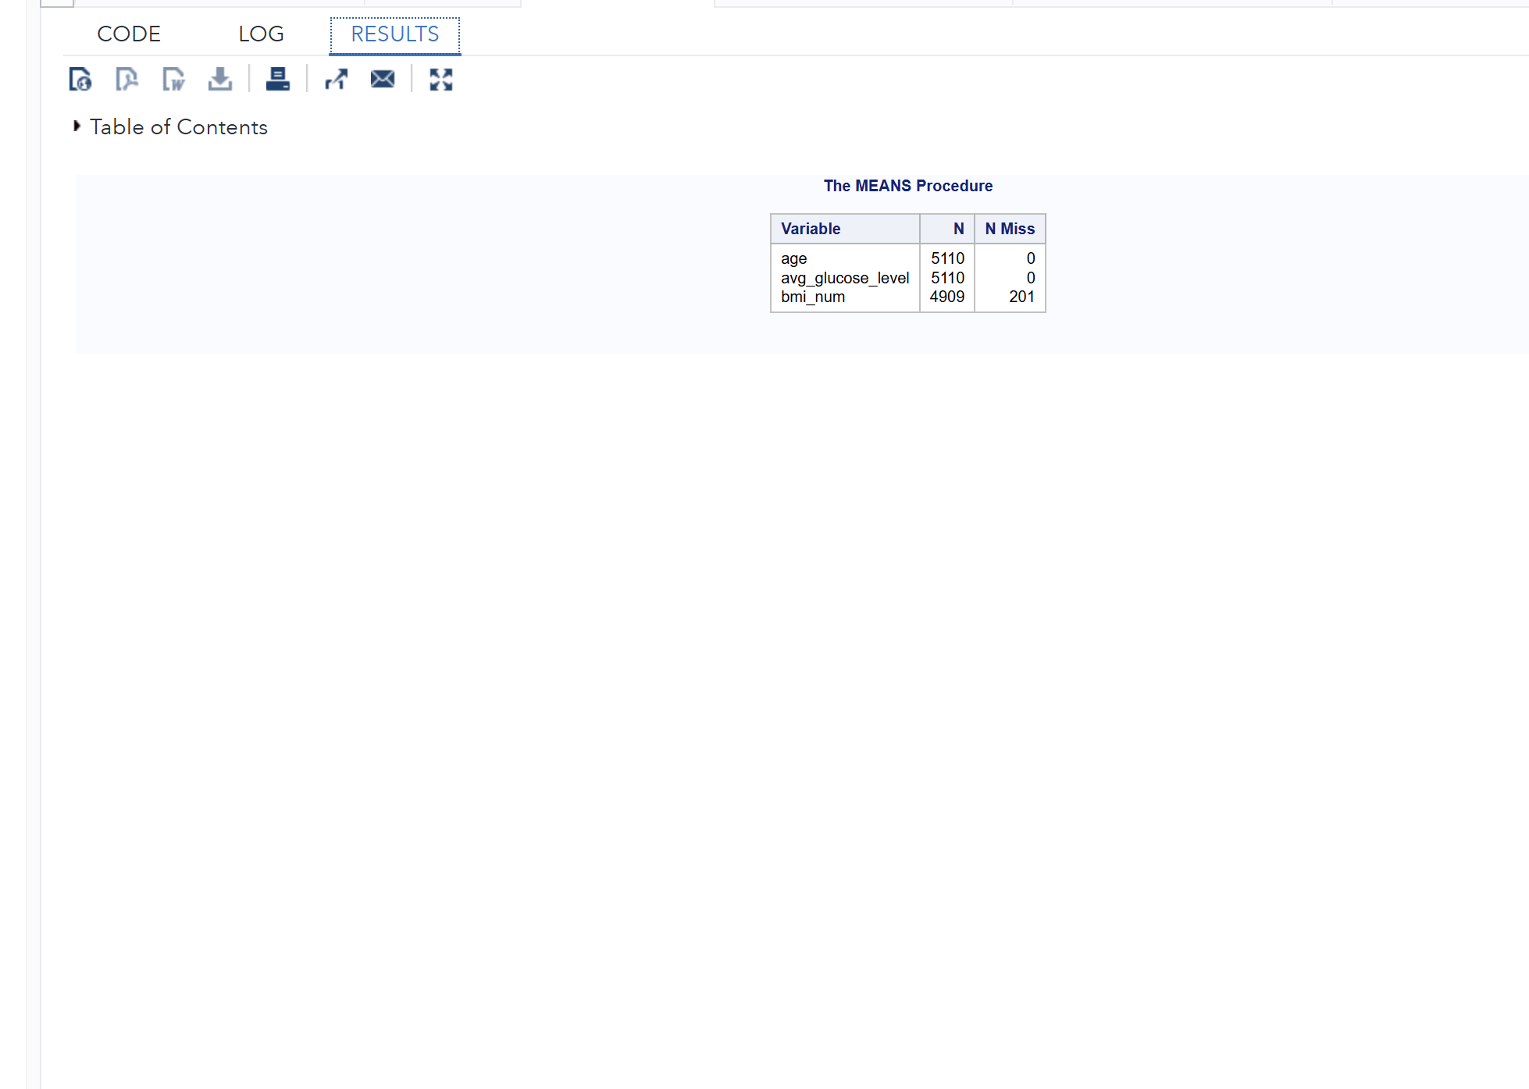

Missing Value Quantification
Calculate the missing BMI values.
bmi variable is stored as character, we first check missing values.
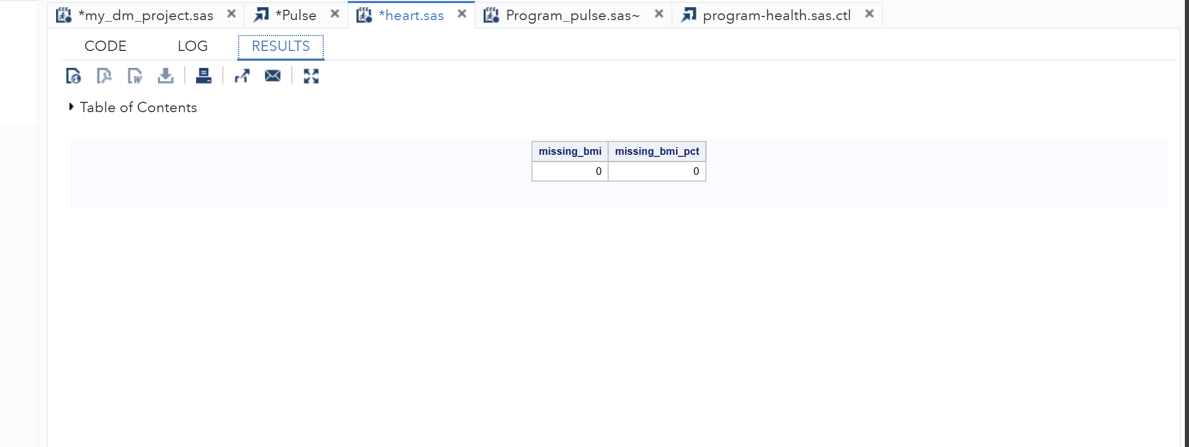
Detect Outliers
For BMI, age and glucose, we should convert BMI to numeric first:
(Step 4: Box plot for outliers)
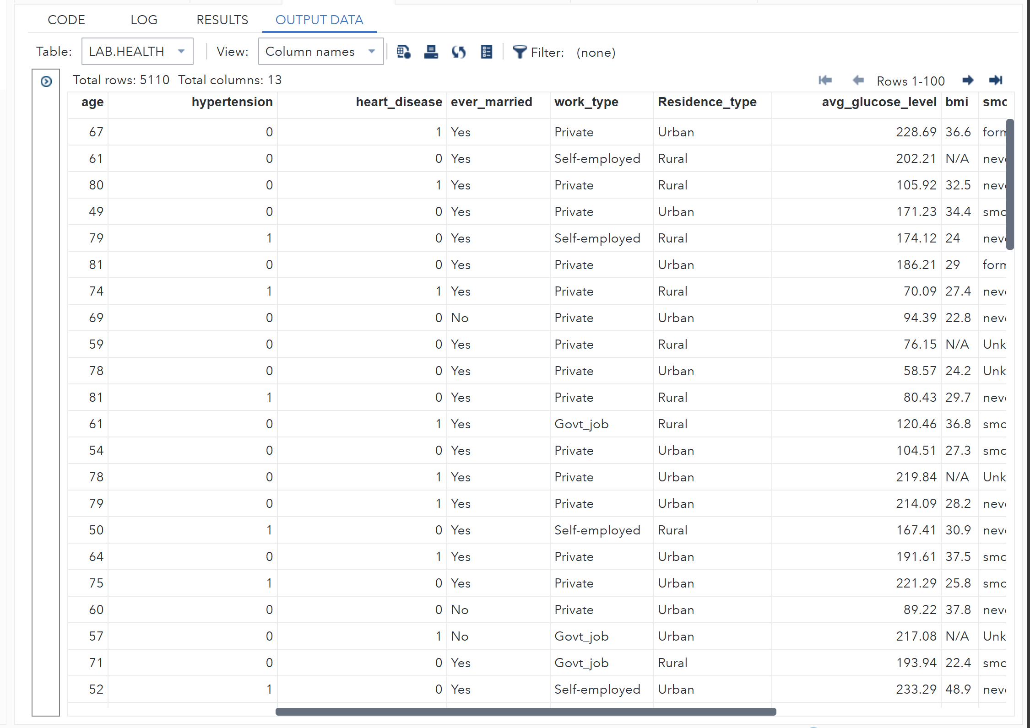
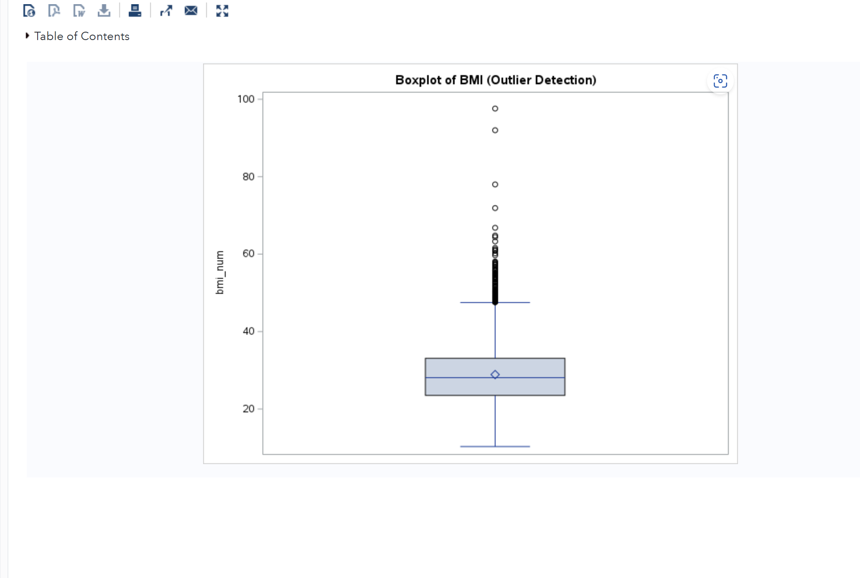 Description: A boxplot was used to visually detect potential outliers in the BMI variable, the central box represents the interquartile range (IQR). The horizontal line inside the box indicates the median. The "whiskers" extend to the minimum and maximum values that fall within 1.5×IQR. Any individual points outside the whiskers are possible outliers. The resulting plot showed several high BMI values appearing as isolated points above the upper whisker. This indicates the presence of extreme observations that may need to be reviewed or minorized before modelling.
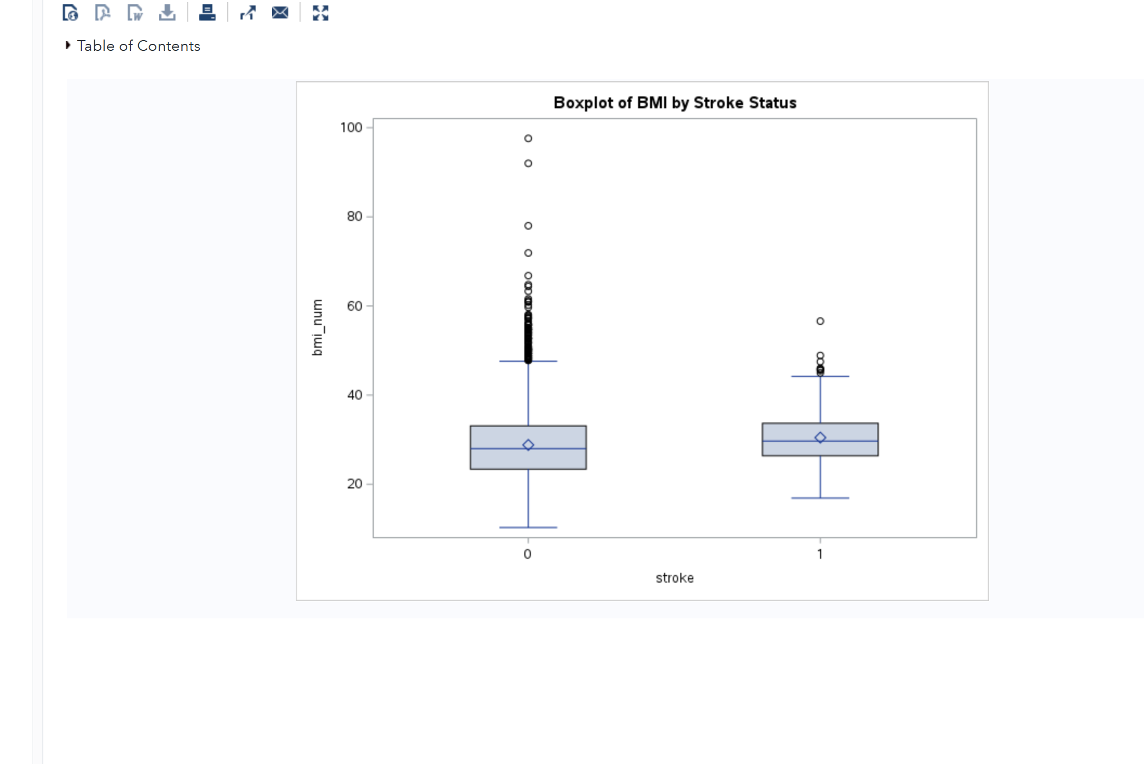 To see if outliers differ between patients with and without stroke, a second boxplot was made, grouping the BMI values by the stroke variable. The plot showed that both groups had a few high outliers. However, the median BMI in the stroke group was slightly higher than in the non-stroke group. This suggests a possible link between higher BMI and stroke incidence.
5- Identifying Inconsistencies in Health Data
To ensure data integrity, certain variables were examined for values outside plausible human ranges. Three key checks were applied:
1-BMI Plausibility
Condition: bmi_num < 10 or bmi_num > 80
Rationale: BMI values below 10 are too low to be healthy for most adults, while values above 80 are extremely rare.
2-Age Validity
Condition: age < 0 or age > 120
Rationale: Negative ages or ages above 120 are unrealistic and likely result from data entry mistakes.
3-Average Glucose Level Plausibility
Condition: avg_glucose_level < 40 or avg_glucose_level > 400
Rationale: Average glucose levels below 40 may indicate hypoglycemia or data errors, while values above 400 are extremely rare and may also indicate errors.

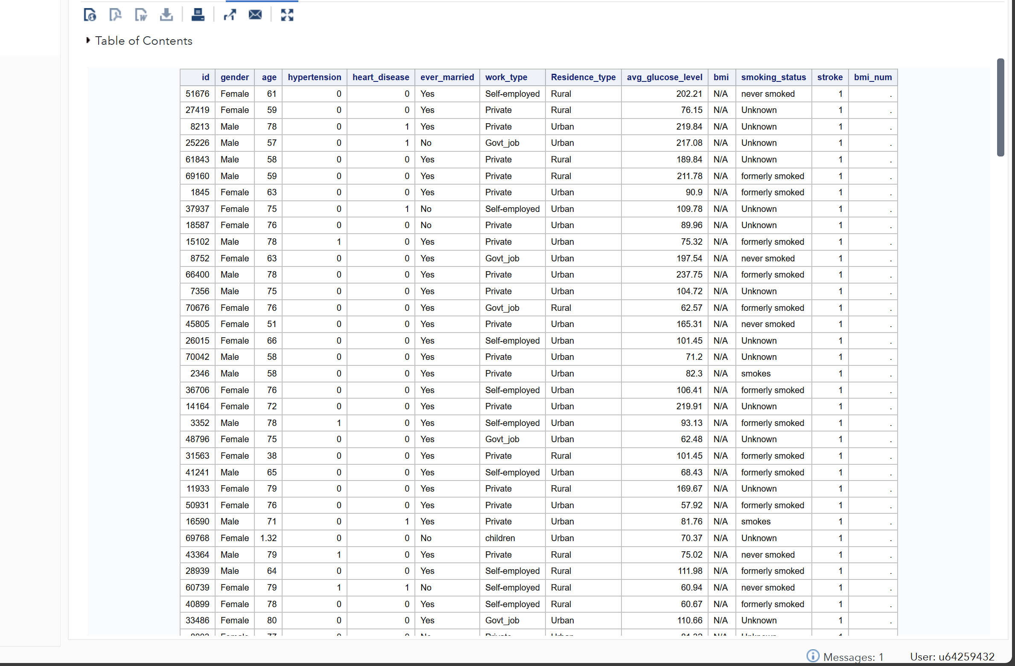

6-Evaluation of Data Warehouse Concepts
The healthcare-dataset-stroke has existed for years and contains medically interesting demographic and behavioural information, we should probably manage it in a mature data warehouse environment with proper security designed from day one to scale easily out of the box. The first one is the quality of data. The clinical data should be full, accurate and internally consistent, as relatively minor queried items (such as age or glucose values of doubtful reality) may give rise to misleading inferences relevant to the risk of stroke (Little& Rubin, 2019). The other fundamental requirements are Performance & Scalability. Healthcare can have a lot of history and the warehouse must be able to easily support fast queries on vast amounts of historical data and it needs to scale (Kimball & Ross, 2013). data integration capability Although for the stroke dataset, we have only one flat file, in a real-world scenario, integration with other systems such as electronic medical records (EMR), lab results or diagnostic imaging will be needed and they may have different structures and formats. Hence, a proper warehouse should also support easy per-schema ETL/ET processes to allow schema harmonisation (Inmon, 2019). Fourth, security and compliance are of the most importance in regards to any system that is dealing with personal health information to ensure security and regulatory compliance (HIPAA or GDPR, ISO, 2022) with role-based access control, encryption, data masking and audit trails. At the end, usability and accessibility do count, Analysts, and to a lesser extent clinical staff, should be able to pull information (e.g., stroke across age groups) out of the warehouse with much more general-purpose tools and interfaces with less programming skill. In conclusion, we have set the requirements for data warehousing to fine a scalable engine to accommodate this dataset by developing automatic down/upstream data quality and integration methods to handle protected healthcare information between the bio-stores clinic Data Base (DB), as well provide active services for querying the relevant data.
Data Warehouse Architecture for the healthcare-dataset-stroke
Patient risk calculation like stroke prediction it should be again followed robust Datawarehouse architecture. The healthcare-dataset-stroke. Although csv might seem like an elementary flat file, it is part of a larger clinical analytics ecosystem in action. A data warehouse provides a structured solution so that high-quality, secure, and business ready data from operational systems such as Electronic Health Records (EHR) can be accessed and analysed consistent.
1) Data Sources
This is data from different healthcare system components, such as electronic medical records (EMR), laboratory information systems, patient monitoring devices. In addition to these, outside data could be employed from variables such as demographic statistics or the millions of disease surveillance reports that stroke dataset can benefit. The second are structured (lab results), semi-structured (XML clinical notes) and unstructured sources (physicians free-text reports). Together, they are the raw data for stroke risk analytics.
2) ETL / ELT (Extract, Transform and Load) Process
Ref – Customised attributes extracted from all data sources, Quality checks and standardisation at scale of raw data. E.g., impossible values detected in the stroke dataset ( BMI =120) are corrected/flagged; missing values (BMI) are imputed using clinically acceptable methods (such as median imputation). Data is also manipulated by adding new questions like age bins, or glucose divisions. After the transformation is done, we can upload this clean and harmonised data in data warehouse.
3) Data Warehouse Storage
The platform will act as the single, authoritative resource for all certified data in healthcare. Stores data in a dimensional model, usually a star schema. With the stroke dataset, a primary fact table may include patient encounters and stroke outcomes, such as demographic data (sex, age group), clinical history (hypertension, heart disease), and lifestyle information (smoking status) incorporated into dimension tables which gives an efficient query path over combinations of risk factors.

4) Metadata repository
The metadata repository is responsible for keeping a record of the structure, definitions, and transformation rules of the data. It describes the way in which age groups were constructed and gives an overview of the thresholds identified to categorize glucose levels. This also helps users such as data analysts or clinicians understand the meaning and source of each variable and will make sure that each analysis maintains the same definition.

5) Query and Reporting Tools
The frontend tools like SAS Visual Analytics, Power BI, or Tableau connect to the data warehouse to allow users to create visualizations and reports. A kind of demonstration with the use of these tools would include showing stroke rates by age group or reporting glucose level distribution over different regions. These are query tools that ease access and action for non-technical users, including clinicians and hospital administrators.
Architecture Model: Three-Tier Architecture
Tier | Description
Bottom Tier | Operational systems and external data sources (EMR, lab systems, demographic datasets).
Middle Tier | Data warehouse server and ETL/ELT layer where data are cleaned, transformed, and stored.
Top Tier | Reporting and analytics tools used by healthcare analysts and clinicians for decision support.
This layered architecture helps keep data secure, ensures scalability, and enables fast analytical queries, which are all critical in a healthcare environment where decisions can directly impact patient outcomes.

Analyst–Architect Communication Requirements
Effective communication between system analysts and data warehouse architects is needed to make certain that business requirements are adequately articulated in the technical data warehouse design. To achieve this, formal and regular forms of communication must be established. There need to be first formally defined lines of communication so that both parties are aware of where and how they are to share information. A monthly data warehouse council maintains alignment current and gives both sides an opportunity to raise issues, report progress and align priorities. In addition, a specialist analyst–architect retreat (quarterly) gives both teams time to be out of day-to-day work and discuss long-term strategy in a more structured and collaborative setting and It should also be clearly established who the analysts and who the architects are. This is to prevent confusion and ensure that the right personnel participate in the discussion. The organisation should also ensure both groups consist of employees of the same seniority and experience level.
The knowledge of the business requirements that architects need to know why they need the data and the analysts need to know how it is technically implemented. To facilitate transparency, the architectural goals also need to be conveyed to the analysts (so that they know about the platform capabilities and limitations) and the analysts agendas and problems in real time must also be communicated to the architects. When both sides are that perceptive, there is greater cooperation, fewer misunderstandings, and the resultant data warehouse is more likely to meet the genuine needs of the organisation.

1.Warehousing Issues
These are design and operational issues concerning the warehouse itself. Examples are selecting the correct schema (star or snowflake), loading new hospital systems into the ETL process, and keeping the warehouse in sync with the receipt of new data (weekly biometric refreshes).
2. Business Issues
These are issues that relate to the organisation's policies and goals, not technology. For example the Lack of agreement across departments on what variables to include when defining "high risk" stroke patients. Uncertainty surrounding data-governance ownership (IT believes clinical team should own the data and believes IT should own it).
3-Data Issues
Issues around quality, completeness or accuracy of the data such as Missing BMI values. Improbable values ( age > 120, glucose < 40). Different systems recording the same variable in different formats ( Male/Female in one system and M/F in another). High numbers of Unknown entries for variables (smoking status).
4. Analysis Issues
Problems only apparent once analysts start working with the data: Class imbalance (a very small number of stroke = 1 cases), leading to biased models. Non-normal distributions ( glucose levels) and extreme outliers affecting statistical tests, analysts not understanding clinical interpretation of variables, therefore incorrect interpretation ( hypertension as an ordinal instead of binary variable).
5. User Interface Issues
These relate to how users can access the warehouse: Clinicians might judge the reporting tool (SAS or Power BI) as too technical or clunky. Dashboards end up being overwhelmed by data and don't permit simple filtering (show only patients aged greater than 50 and hypertensive). Analysts may not be able to save or define their own queries.
6. Intelligent Processing Issues
This is talking about intelligent or automatic behaviour such as real-time recommendations or prediction models: Warehouse might not be able to automatically re-train models when new data comes in and system might not be able to push alerts (identified high stroke risk patient) back into clinical systems. It is difficult to integrate rule-driven or AI-driven processing (combining logistic regression + clinical decision rules).

References
Garcia-Molina, H., Ullman, J. D., & Widom, J. (2009). Database systems: The complete book (2nd ed.). Pearson.
Han, J., Pei, J., & Kamber, M. (2022). Data mining: Concepts and techniques (4th ed.). Morgan Kaufmann.
Inmon, W. H. (2005). Building the data warehouse (4th ed.). John Wiley & Sons.
Kimball, R., & Ross, M. (2013). The Data Warehouse Toolkit: The Definitive Guide to Dimensional Modeling (3rd ed.). John Wiley & Sons.
Inmon, W. H. (2019). Building the data warehouse (5th ed.). Wiley.
ISO. (2022). ISO/TS 82304-2 Health Software — Quality and Reliability. International Organization for Standardization.
Little, R. J. A., & Rubin, D. B. (2019). Statistical analysis with missing data (3rd ed.). Wiley.

