Sphere Systems Pty Ltd

PRODUCT SERVICE NOTES

Issue Date 28-Jan-2000 Number 3

Facility DDC - Security System

- RS485 Communications

RS485 Communications

Introduction
The RS485 communications standard has been widely adopted for network communications in industrial and scientific applications. It is a very robust system when installed correctly. There are constraints which must be observed during installation to ensure satisfactory network performance. This document describes how to install an RS485 network.

Cabling

Cabling Specifications
RS485 communication cable is a constant impedance, shielded, twisted pair cable. Many cable manufacturers supply cable meeting the RS485 standard. The characteristic impedance is generally close to 120 Ohms although other impedances are sometimes available. The lower impedance limit is set by the drive capability of the RS485 chips. The driver chips used by Sphere are sourced from Maxim, National Semiconductor and Texas Instruments (SN75176/DS75176) and can drive impedances down to approximately 50ohms
Other cabling media such as telephone cable, coaxial cable and non-constant impedance cables such as shielded wire, multi-core wires, building wire and wet string will prove problematical and not provide satisfactory performance.

A typical cable specification is:

1. Cable Code | DCK4702
2. Cable Description | 2 pair 7/0.2tcw (24AWG) polyethylene insulated aluminium polyester tape screened including a 7/0.2 TCW drain. TCW braided PVC sheathed. EIS RS485 Data Cable. Low voltage, not for mains connection.
3. Construction
3.1 Conductor | 7 strands of 0.2mm tinned annealed copper to AS1125, drawn from Class 11A “Electrolytic tough pitch copper” to AS 1574.  Max DC conductor resistance at 20C 89.0 Ω/km
3.2 Insulation | Coloured polyethylene to AS1049  Nominal Diameter 1.7mm  Nominal Wall 0.5mm
3.3 Lay Up | 2 pairs twisted  PAIR 1 Black + White  PAIR 2 Red + Green
3.4 Screen | Aluminium/Polyester tape over layup plus 7/0.2 TCW Drain
3.4 Braid | Tinned annealed copper wire braid to 80% cover
3.5 Sheath | Coloured 4V75 PVC to AS3191  Nominal diameter 7.0mm  Nominal wall 0.76mm
3.6 Typical Electrical Properties | Nominal impedance 120Ω  Nominal capacitance 42pF/m cond to cond  Velocity of Propagation 66%
This cable is manufactured by Tycab and distributed by AIM.

Topology
RS485 allows multiple network nodes to be connected to a single cable. The cable must be installed to pass close by each node. Stubs (cables joining the node to the cable) or stars (multiple cable segments brought back to a single point) are not permitted.
If stubs or stars are required then a repeater must be installed to drive the stub or star segment.

Cable Length
The maximum length of a single cable run is 1200 metres.

Termination
The cable must be terminated at each end with a terminating resistor equal to the characteristic impedance of the cable. This is to prevent reflections which would disrupt communications. A cable with a 120 Ohm characteristic impedance must have a 120 Ohm resistor at each end. A power rating of ¼ Watt is adequate. The terminating resistors should be carbon composition or carbon or metal film. Wire-wound resistors have substantial inductance and should not be used.
The characteristic impedance of the cable is published by the cable manufacturer as part of the cable specifications.

Repeaters
Sphere supplies repeater types for different applications.
The standard repeater is used to connect to a stub or to extend cable length
An optically-isolated repeater is used to maintain electrical isolation between cable runs in separate buildings. Note: Electrical isolation is required where separate MEN grounds are installed but are desirable for any data link between buildings.

Cable Isolation
The communication cable must not be run in cable trays carrying power wiring nor in close proximity to power wiring. Current surges in power wiring due to high equipment starting currents or to faults can disrupt communications and may cause damage to Sphere equipment.

Ground and Earth Connections
The grounding and earthing connections in RS485 provide two separate functions. The first is related to safety and the second to establish a reference voltage.

Safety
The RS485 cable screen must be bonded to the protective earth system of a building at one point only.
The cable screen must be electrically continuous throughout the entire cable run.

Voltage Refererence
The screen of the RS485 cable establishes a ground reference voltage for the RS485 signal conductors. For this reason the cable shield must be connected to the ground reference for each node on the network.
It is not acceptable practice to tie the node ground reference to the building protective earth as this will introduce electrical noise into the system and may lead to equipment damage in the event of electrical fault currents.

Installation throughout Multiple Buildings
There are two separate installation procedures depending on the type of electrical earthing system.

MEN System at one building
In this case the installation may be made as though it exists in a single building. The cable shield will be continuous throughout the installation.

MEN System in each building
In this case there must be electrical isolation between buildings with different MEN systems. Each building is wired as a separate and complete installation with the cable shield tied to the building protective earth at one point.
Optically isolated repeaters or optical fibre must be used to connect the communications network between buildings.

Wiring Details
Figure 1 shows how the RS485 network should be wired between various network nodes. The essential features to note are:
- All the cable shields are tied together and are tied to a Ground connection (GD or Shield) on EACH node. Without the cable shield connected there will be no ground reference voltage established for the RS485 drivers and receivers. Reliable communications will not be achieved.
- The cable shield is connected to a building protective earth at ONE POINT. Any point along the shielded cable can be used to attach this protective earth. This earthing is required to ensure that the network cabling cannot float to dangerous voltages.
- The DP11, or in fact any other node, can be connected at any point along the cable. It does not need to be at one end.
- Termination resistors must be connected at each end of the cable. The nominal resistance is 120Ω. These resistors make it appear that the cable continues indefinitely and hence eliminate reflections from the end of the cable. These resistors can be ¼ or ½ Watt resistors.
- The polarity of the cable is important. For ease of installation and maintenance it is recommended that a consistent colour code be adopted throughout the network. An acceptable scheme may be Blue for COM- and White for COM+.
- Beyond any repeater the cable must be 2-pair with one pair connecting the COM terminals and the second pair connecting the TRX terminals. In figure 2 the 2-pair cable as shown as fatter lines

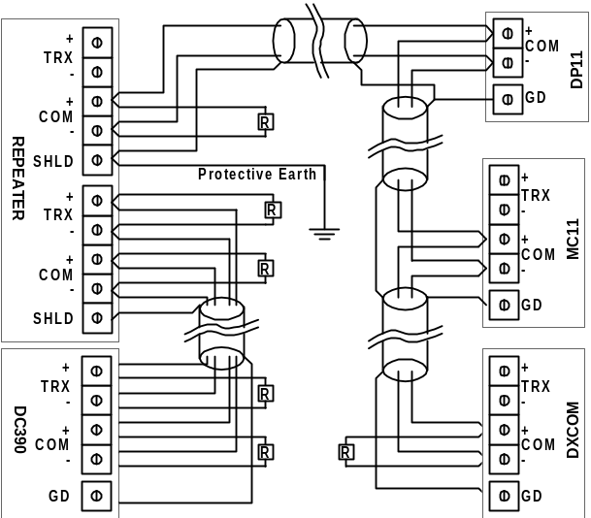
Figure 1 Wiring Details for RS485 Network

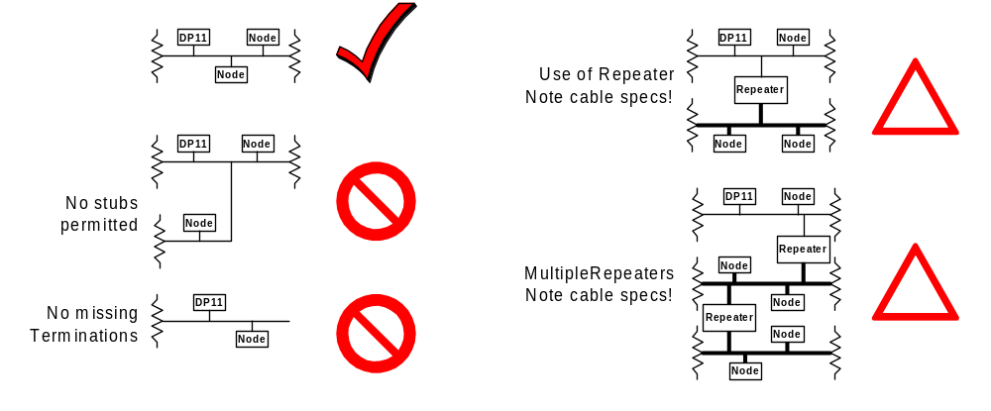
Figure 2 RS 485 Cabling Topologies

References
TIA/EIA-485 ELECTRICAL CHARACTERISTICS OF GENERATORS & RECEIVERS FOR USE IN BALANCED DIGITAL MULTIPOINT SYSTEMS (http://global.ihs.com/)
AUSTEL Customer Premises Cabling Manual. (http://www.standards.com.au/)

