The SGA 3D Graph
Where the data comes from, how it is transformed, and how the graph is built
Covers the Box-document pipeline in SGA-3D-Graph-Ready (1)/ and the live #graph page on branch feat/graph-3d-live. Figures in this document come from a fresh run of the build scripts on the supplied Archive.zip.
1. The short answer
2. Pipeline A at a glance
3. The source: Box documents
What a Box contains
4. Step 1: parse_boxes.py (Word → boxes.json)
How it works
Key functions
Worked example: Explore Box 07
5. Step 2: build_graph.py (inference)
5.1 Event kind of each element
5.2 Transitions (screen → screen links)
5.3 Reuses
5.4 Foundations (which shared service a dataset comes from)
5.5 Output: page-data.json
6. Step 3: make_rev2.py (build the graph)
6.1 What becomes a node
6.2 How the dataset decides Db or API
6.3 What becomes a link
6.4 Hard-coded mappings to know about
6.5 Output
7. Step 4: drawing it (template_rev2.html)
Other pages built from the same data
8. Pipeline B: the live #graph page
8.1 Where the data comes from
8.2 How it is transformed: graphview.Build
8.3 Endpoint and page
8.4 Layers in the live view
9. What is real and what is inferred (pipeline A)
10. File reference
Rebuild pipeline A after the Boxes change
See pipeline B

1. The short answer
There are two different 3D graphs, built by two independent pipelines. They look alike but read completely different sources. Knowing which one you are showing is the first thing to get right.
 | A. Box-document graph (rev 2) | B. Live app graph (#graph)
What it shows | The product as specified: every screen described in the Box Word documents, its UI elements, rules and data | The product as running: the State graph the backend actually serves
Source of data | 49 Box .docx files in Archive.zip | infra/seed/graph.yaml loaded into Postgres (or Neo4j)
Transformed by | Python: parse_boxes.py → build_graph.py → make_rev2.py | Go: graphview.Build (runs the Spider on every State)
Delivered as | One self-contained HTML file: sga-graph-rev2.html | JSON from GET /api/graph/architecture
Drawn by | template_rev2.html + 3d-force-graph from a CDN | React page frontend/src/pages/GraphView/index.tsx + react-force-graph-3d
When it updates | Only when someone re-runs the scripts | Every page load, or "Reload from the graph"
Size today | 3,595 nodes, 4,205 links | Depends on the seeded graph

The file you have open, build_graph.py, is the middle step of pipeline A. Sections 2 to 7 explain pipeline A end to end; section 8 explains pipeline B.
One-line pitch for pipeline A: "We take the Word documents that specify each screen, parse their tables into JSON, infer how screens link to each other and which services they use, then lay all of it out as a four-layer 3D graph in a single HTML page."

2. Pipeline A at a glance
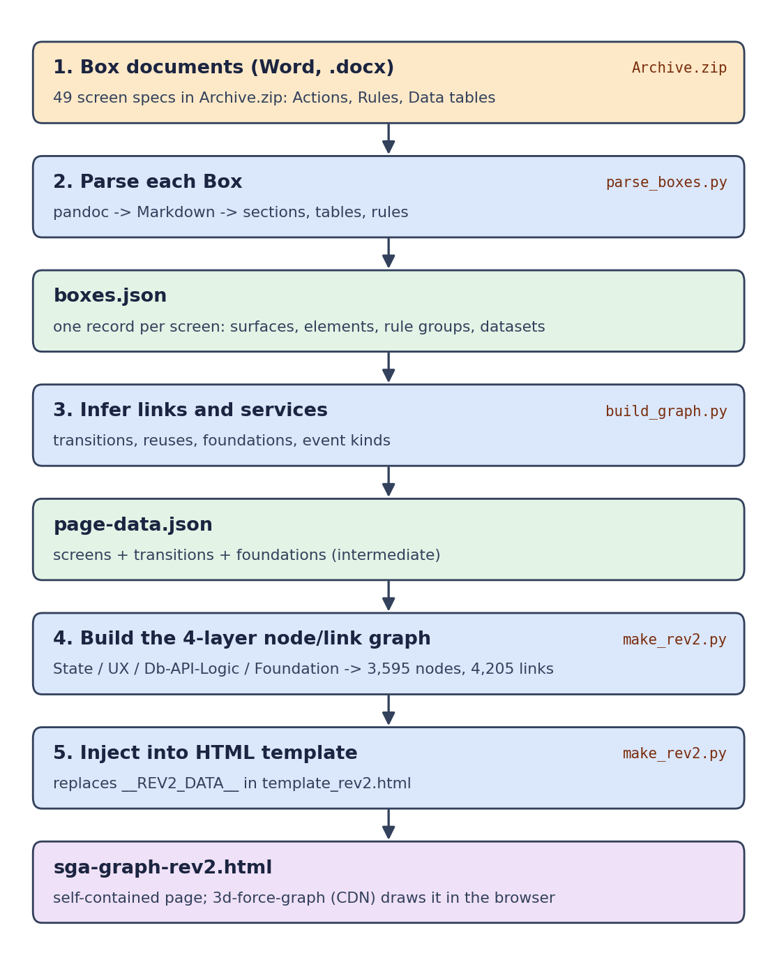
Figure 1. From Box documents to the 3D page. Blue = code that transforms; green = data files it produces.
Step | Input → output | Command
Parse | Archive.zip → boxes.json (944 KB) | python3 parse_boxes.py Archive.zip boxes.json
Infer + build + inject | boxes.json + template_rev2.html → page-data.json + sga-graph-rev2.html (1.4 MB) | python3 make_rev2.py boxes.json template_rev2.html sga-graph-rev2.html

make_rev2.py imports build_graph.py and calls its main() first, so build_graph.py never needs to be run by hand. page-data.json is written next to the output HTML as a side effect.
Requirements: Python 3 and pandoc (for step 1 only). Opening the finished HTML needs internet access because the 3D library loads from a CDN.

3. The source: Box documents
A Box is a Word document that specifies one screen (one "state") of the product. They live in Google Drive in an Archive folder, one sub-folder per module, and are downloaded as Archive.zip.
Module | Boxes parsed | Share
Value | 20 | 41%
Build | 15 | 31%
Explore | 9 | 18%
Plan | 4 | 8%
Command | 1 | 2%
Total | 49

Only files whose name starts with Box are read. Anything else in the zip (for example Command Audit Template.docx) is skipped.

What a Box contains
Every Box follows the same template. The parser looks for these headings:
Heading in the Word doc | What it holds | Becomes in the graph
Title (first line) | "Box 07 — Cooper Recommendations (Explore)" | The state node's number, name and id
Screen description | Prose about the screen | State description
The Actions | Tables of UI elements, grouped under surface headings. Columns: Element / What it does / Type / Mock (Figma link) | Surfaces and UI elements (UX layer); transitions
The Rules | Rule-group headings with numbered rules | Logic subgraph
The Data | Table with Dataset / Columns / Source | Db and API subgraphs, foundation services

4. Step 1: parse_boxes.py (Word → boxes.json)
Purpose: turn each Word document into one structured JSON record. Nothing is inferred here; it is a faithful extraction of what the Box says.

How it works
- Open the zip and pick Boxes. main() loops over every .docx whose path contains /Box . The module name comes from the folder: Explore Boxes → Explore.
- Convert Word to Markdown. Each file is run through pandoc <file> -t gfm --wrap=none. Word tables become Markdown pipe tables, which are easy to parse line by line.
- Walk the Markdown. parse_markdown() reads line by line with a small state machine. When a line matches a section name in SECTION_NAMES it switches section to description, actions, rules or data.
- Read tables. A run of lines starting with | is a table. parse_table() splits it into rows keyed by lower-cased header. In The Actions a table with an "Element" column gives UI elements; in The Data a table with a "Dataset" column gives datasets.
- Read headings and rules. In The Actions, a short line without a full stop (≤ 90 chars) starts a new surface (a part of the screen, e.g. "Explore header"). In The Rules, a short line or bold heading starts a rule group; numbered lines become rules in it.
- Pick up Figma links. The FIGMA regex pulls the file URL and node-id from the Mock column. The most common file URL becomes the Box's figma link; each element keeps its own node id.
- Name and id the Box. box_number_and_name() splits the title into number and name ("07", "Cooper Recommendations"). The id is <module>-<number>, e.g. explore-07.
- Sort and write. Boxes are sorted by module and number and written to boxes.json.

Key functions
Function | Role
clean(text) | Strips Markdown bold, links, HTML spans and escapes to plain text
split_row / parse_table | Turn a Markdown pipe table into a list of {header: cell} dicts
col(row, *names) | Finds a column by header prefix, so "What it does" and "What" both match
parse_markdown(md, module, file) | The state machine that fills surfaces, ruleGroups, datasets, notes, figma
box_number_and_name(title, stem) | Parses "Box 02a — ... (Explore)" into ("02a", name), dropping the module suffix
main(zip, out) | Unzips, calls pandoc, parses, sorts, writes JSON

Worked example: Explore Box 07
One row of the Actions table under the "Explore header" surface in the Word document:
Element | What it does | Type | Mock
"7 risks surfaced" pill | Opens the Cooper panel on the recommendation list. Hidden while Cooper has surfaced nothing. | Local change | Figma link, node 29:351488

Becomes this in boxes.json:

5. Step 2: build_graph.py (inference)
Purpose: add the things a single Box cannot tell you on its own: how screens connect and which shared services they rely on. This is the only step that interprets text rather than copying it, so it is where to be careful when presenting.
It is called from make_rev2.py, reads boxes.json and writes page-data.json.

5.1 Event kind of each element
Only elements of Type Navigation, Local change or External are treated as interactive. event_kind() labels each one from its name and text:
- text_entry if the label looks like an input (TEXT_ENTRY regex: input, search field, editor, "ask ...")
- menu_choice if it mentions a menu, dropdown, tab, filter, chip, toggle, select ... (MENU regex)
- button_click otherwise

5.2 Transitions (screen → screen links)
A transition says "an element on screen A takes you to screen B". They are found in four ways, strongest first. When the same pair is found more than once, the strongest basis is kept.
Basis | Rule in the code | Example | Count
box-ref | The element's "What it does" text names another Box: regex Box\s+(\d+...), resolved by resolve_box_ref() (prefers the same module, or the module named in brackets) | "... specified in Box 14" | 46
module-nav | A Navigation element goes to a module or home ("Goes to Value", the top nav, "Explore full map"). Target is the module's landing screen from LANDING | "Goes to Value" → value-01 | 13
name-match | The element text contains a known alias of another screen in the same module (the hand-written ALIASES table). Longest alias wins | "Goes to the investment details" → build-06 | 26
demo-path | Hard-coded in DEMO_LINKS to match the demo video click path | explore-01 → explore-07 | 1*
 |  | Total | 86 found, 85 drawn

* DEMO_LINKS holds two links; the other one was already found by a stronger rule, so it keeps that basis. One module-nav link (Explore → Results) is dropped when drawing, because the Results module has no Box.
The code itself says name-match links are "a first pass for people to review, not ground truth". 26 of the 85 transitions come from that alias table.

5.3 Reuses
Notes such as "As Box 00 — Shared Components ..." mean a screen reuses another Box's parts. These become 6 reuses records. They are kept in page-data.json but are not drawn by make_rev2.py.

5.4 Foundations (which shared service a dataset comes from)
The Data tables contain free-text "Source" phrases (over 300 different ones). foundation_for_source() maps each phrase to one shared service with the ordered keyword list FOUNDATIONS; the first match wins, and other catches the rest. External actions are mapped the same way with the EXTERNAL list (external_for()).
Foundation | Kind | Keywords (abridged) | Uses
Cooper AI service | service | cooper | 128
Plan and portfolio records | database | plan, scenario, portfolio | 55
Other or unnamed source | database | (anything else) | 43
Investment records | database | investment, cost, budget | 42
Value and strategy frameworks | database | framework, goal, formula | 37
Asset register and risk models | database | asset, risk, sensor | 34
Collaboration store | database | comment, thread, presence | 29
Voice input service | service | voice, mic (external actions) | 26
Document store | database | document, file, photo | 20
GIS and map service | service | gis, map, tile, feeder | 18
User directory | database | user, role, team | 18
8 smaller ones |  | files, search, versions, session, notify, other external | 46

5.5 Output: page-data.json

6. Step 3: make_rev2.py (build the graph)
Purpose: turn page-data.json into the final nodes and links in the four-layer SGA structure, then paste them into the HTML template.
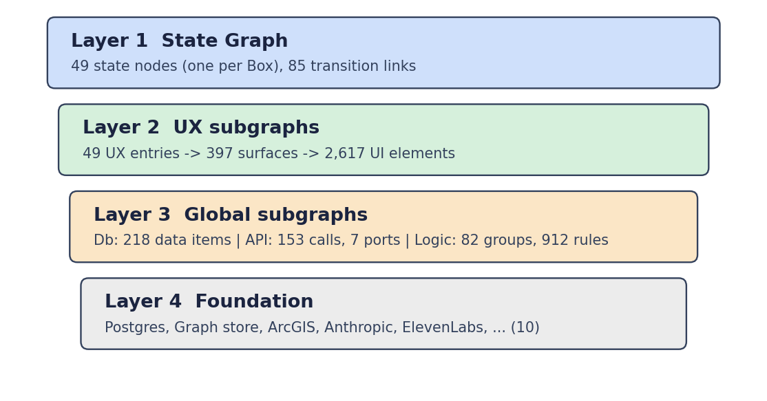
Figure 2. The four layers of the rev 2 graph, with today's counts.

6.1 What becomes a node
Layer | Node kind | Made from | Id pattern
1 State | state | One per Box | explore-07
2 UX | ux (entry) | One per state | ux:explore-07
2 UX | surface | Each surface heading in The Actions | sf:explore-07:0
2 UX | element | Each row of an Actions table | el:explore-07:0:0
3 Global | entry | One each for Db, API, Logic (whole app) | db:entry
3 Db | group / item | Data area / one dataset, de-duplicated by area + name | area:assets, data:12
3 API | group / item | Port / one outside call (External elements and service datasets) | port:cooper, call:5
3 Logic | item | One per rule group of a Box | logic:explore-07:0
4 Foundation | foundation | Fixed list FOUNDATION, only those in use | fd:postgres, fd:anthropic

Shared, not copied. A dataset or API call used by several screens is one node, with a users list of the states that use it. This is done by keying on (area, norm(name)) or (port, norm(name)), where norm() lower-cases and strips punctuation.

6.2 How the dataset decides Db or API
For each dataset, the foundation chosen in step 2 decides the side: a service foundation (Cooper, GIS, voice, search, ...) becomes an API call under a port; a database foundation becomes a Db item under a data area.

6.3 What becomes a link
Link kind | From → to | Meaning
has_ux | state → ux | Each state owns exactly one UX subgraph
has_surface, has_element | ux → surface → element | Screen structure
uses_data | ux → Db item | This screen reads this dataset
uses_api | element or ux → API call | This element or screen calls an outside service
uses_logic | ux → Logic item | This screen follows these rules
contains | entry → group → item | Hierarchy inside Db, API and Logic
resolves_to | Db entry / port → foundation | Where it really runs (Postgres, ArcGIS, Anthropic ...)
planned | logic:entry → fd:calc | Calculation service, not built yet
transition | state → state | From step 2, with basis and via

6.4 Hard-coded mappings to know about
- COMPONENTS: UI component type (button, tab, dropdown ...) is estimated from the element name, because Boxes do not record it. 1,216 of 2,617 elements fall into "other".
- DB_AREAS and API_PORTS: fixed names for the groups in Layer 3.
- FOUNDATION: the real systems (Postgres, Neo4j, ArcGIS, Anthropic, ElevenLabs ...). These names are chosen in the script, not read from the Boxes.

6.5 Output
The script builds {meta, nodes, links}, serialises it as JSON (escaping </ so it cannot close the script tag), and replaces the placeholder __REV2_DATA__ inside template_rev2.html:
meta field | Value today
states / surfaces / elements | 49 / 397 / 2,617
Db items / areas | 218 / 10
API calls / ports | 153 / 7
Logic groups / rules | 82 / 912
Foundation nodes | 10
Transitions | 85
Total | 3,595 nodes, 4,205 links, 1.4 MB page

7. Step 4: drawing it (template_rev2.html)
The finished page needs no server. When it opens in a browser:
- It reads the embedded JSON: JSON.parse(document.getElementById('rev2-data').textContent).
- Each node is pinned to its layer height. It sets n.fy (fixed y) from the node kind: state, ux, surface, element, entry, group, item, foundation each have their own height. That is why the graph reads as floors.
- States are grouped by module. Each state starts near its module's position (MODULE_XZ), and its UX nodes start under it. Db, API and Logic sit in their own regions (REGION_X). Foundations are fully fixed (fx, fz).
- The force layout arranges nodes within each floor. 3d-force-graph (loaded from a CDN, on three.js) runs a physics simulation; link distance and charge strength are tuned per kind, and the default centring force is switched off.
- It builds lookup maps for the side panel (children, users of each shared item, links per node) and draws the controls: layer toggles, search, "find all dropdowns", the details panel with Figma links, and a guided tour.

Other pages built from the same data
These do not re-parse the Boxes. They copy the JSON out of sga-graph-rev2.html into another template.
Page | Built by | Notes
sga-vision.html | SGA-Vision-update/make_vision.py + template_vision.html | Apple Vision Pro version
sga-spatial.html | make_vision.py + template_spatial.html | Adds glow, live pulses, a 10-step tour
sga-atlas.html | SGA-Atlas/make_atlas.py + template_atlas.html | Atlas view of the same states and subgraphs

Two copies of make_rev2.py exist. The one in SGA-Vision-update/ has a stricter "dropdown list box" rule (27 dropdowns instead of 49). The figures in this document come from the copy in SGA-3D-Graph-Ready (1)/.

8. Pipeline B: the live #graph page
This is the in-app version, added on branch feat/graph-3d-live (not committed yet). Instead of Word documents it reads the real graph the backend serves, so it can never drift from the running app.
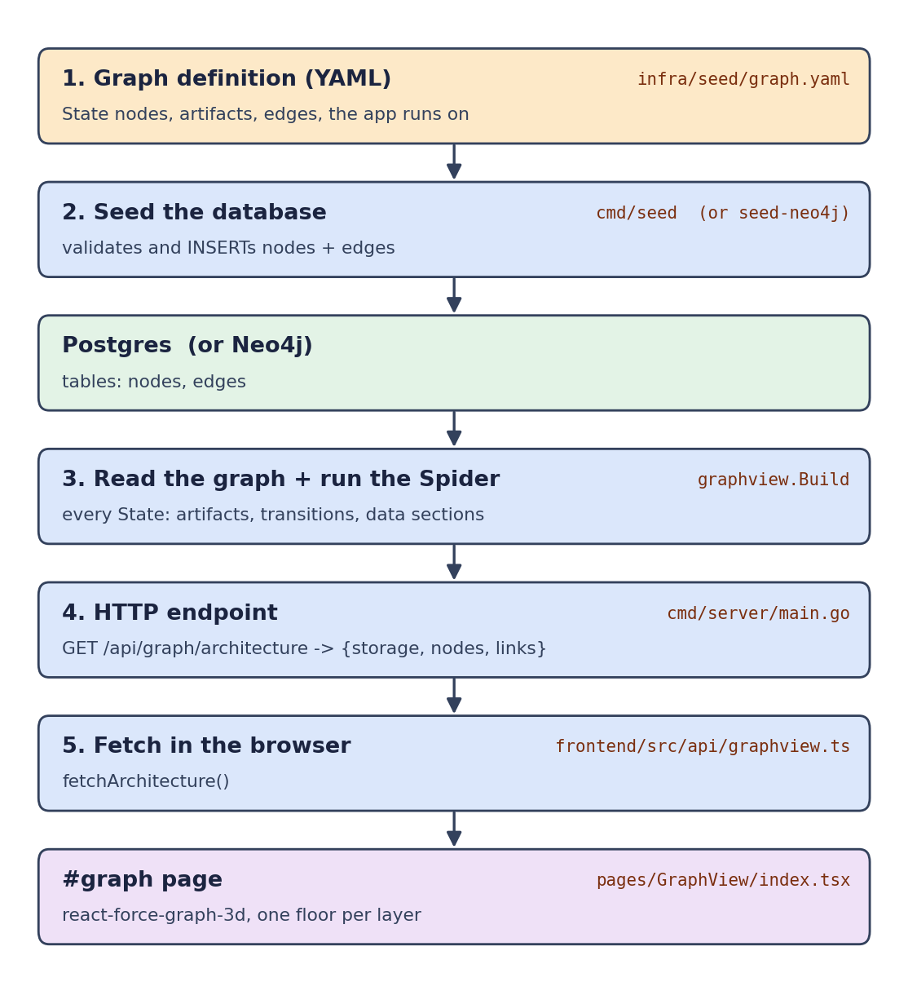
Figure 3. From the seed YAML to the #graph page.

8.1 Where the data comes from
- infra/seed/graph.yaml (plus asset-details.yaml) declares nodes (State, artifacts, data) and edges.
- backend/cmd/seed/main.go validates the files and runs INSERT INTO nodes ... and INSERT INTO edges ... in Postgres. cmd/seed-neo4j does the same for Neo4j.
- The server picks the store from GRAPH_BACKEND (postgres by default, or neo4j) and reads it through the graph.GraphReader interface (backend/internal/graph/reader.go).

8.2 How it is transformed: graphview.Build
File: backend/internal/graphview/graphview.go.
- reader.GetNodesByType(ctx, "State") lists every State, sorted by id.
- Adds a spider node and a foundation:<storage> node.
- Runs the Spider on every State (8 in parallel via errgroup). The Spider result says which data items each screen section holds. A Spider error is stored on the State as spiderError rather than failing the whole view.
- For each State: adds the State node, a serves link from the Spider, and state_transition links from reader.GetEdges(...).
- Reads three artifacts per State with reader.GetArtifact: UX, DATA_COLLECT, BUSINESS_RULE. Under UX, each viewHints key becomes a UX node. Under DATA_COLLECT, a collects link goes to each data type the Spider found. Under BUSINESS_RULE, rules() splits the spec into rules, and each rule gets reads links to the data types of the sections it names.
- Finally one datatype:<Type> node per data type seen, with nodesCollected, linked stored_in the foundation.

8.3 Endpoint and page
File | Role
backend/cmd/server/main.go | Registers GET /api/graph/architecture, calls graphview.Build and returns {storage, nodes, links}
frontend/src/api/graphview.ts | fetchArchitecture() and the ViewNode / ViewLink types
frontend/src/main.tsx | When the URL hash is #graph, lazy-loads GraphView behind the AuthGate (three.js stays out of the main bundle)
frontend/src/pages/GraphView/index.tsx | Pins each node to its layer's height (fy from LAYERS), pulls Data and Logic sideways with forceX, draws with react-force-graph-3d. Search, "find all UX of a kind", subtree highlight, layer toggles
backend/internal/graphview/graphview_test.go | Tests for the builder
e2e/graph-view.spec.ts | End-to-end test of the page

8.4 Layers in the live view
Layer | Contents
Spider | One node: the engine that serves every State
State | Every State node, with state_transition arrows
Artifact | UX, DATA_COLLECT and BUSINESS_RULE of each State
UX | One node per viewHints key
Logic | One node per business rule
Data | One node per data type the Spider collected, sized by how many
API | Empty: the graph has no API artifact yet
Foundation | The storage backend (postgres or neo4j)

9. What is real and what is inferred (pipeline A)
Useful when someone asks "is this link in the spec?". Ordered from most to least reliable.
Part of the graph | Reliability | Why
States, surfaces, elements, rules, datasets | From the Box | Copied from the Word tables and headings by parse_boxes.py
Figma links on elements | From the Box | Taken from the Mock column
box-ref transitions (46) | Strong | The Box text names the target Box
module-nav transitions (13, 12 drawn) | Strong | Explicit "Goes to <module>" or top navigation
Foundation of each dataset | Inferred | First keyword match on the free-text Source; 43 fall into "other"
name-match transitions (26) | Inferred | Hand-written alias list; the code says to review them
Component type (button, dropdown ...) | Estimated | Guessed from the element name; 1,216 are "other"
Foundation systems (Postgres, ArcGIS, Anthropic ...) | Chosen | Fixed in make_rev2.py, not in the Boxes
demo-path link | Hand-added | Matches the demo video

10. File reference
File | What it does
SGA-3D-Graph-Ready (1)/Archive.zip | Source: the Box Word documents
SGA-3D-Graph-Ready (1)/parse_boxes.py | Word → boxes.json (extraction)
SGA-3D-Graph-Ready (1)/build_graph.py | boxes.json → page-data.json (transitions, foundations, event kinds)
SGA-3D-Graph-Ready (1)/make_rev2.py | Builds nodes and links, injects into the template
SGA-3D-Graph-Ready (1)/template_rev2.html | Renderer: layout, controls, details panel
SGA-3D-Graph-Ready (1)/sga-graph-rev2.html | Generated page to open (not the template)
SGA-Vision-update/make_vision.py | Vision Pro and spatial pages from rev 2 data
SGA-Atlas/make_atlas.py | Atlas page from rev 2 data
infra/seed/graph.yaml | Source of the live graph
backend/cmd/seed/main.go | Loads the YAML into Postgres
backend/internal/graphview/graphview.go | Builds the live layered view
backend/cmd/server/main.go | GET /api/graph/architecture
frontend/src/pages/GraphView/index.tsx | The #graph 3D page

Rebuild pipeline A after the Boxes change

See pipeline B

