1. Login page: We do not want any option to login via Facebook, it should ONLY be via email address and password. Please remove Facebook link

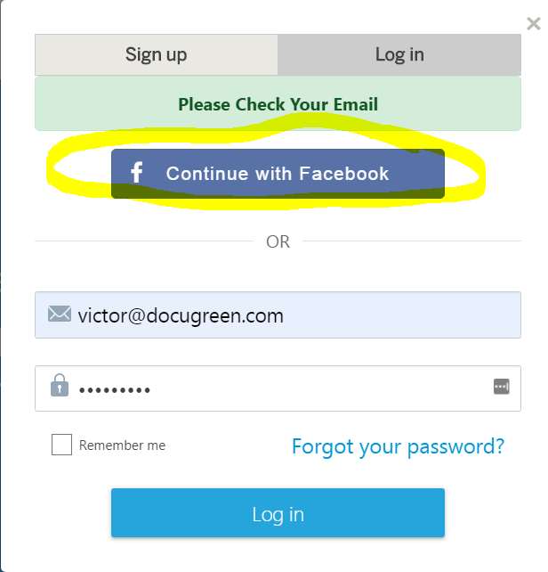

1. Password recovery: After entering email and clicking to request password reset, box says “Please check your email” but then it has “Forgot password” with place to enter email to send Reset Password again. It should only say “Please check your email as well as spam folder in event you do not see reset link in your Inbox.”

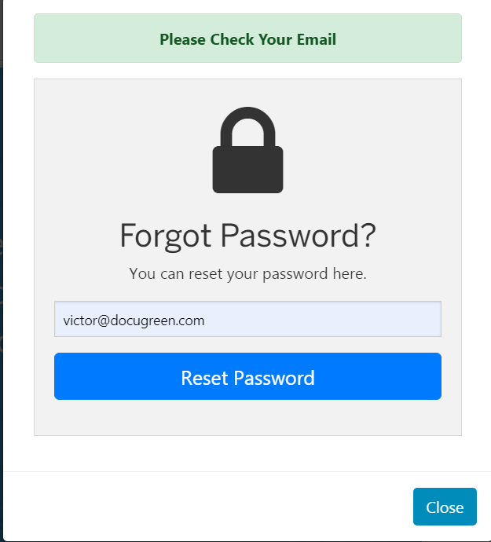

1. The reset email shows coming from Sandeep. Please change this to come from [noreply@dgsign.com](mailto:noreply@dgsign.com)

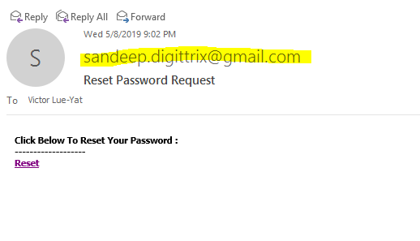

1. When I clicked on link, it just took me back to main page <http://96.126.126.6:5200/> and this page was greyed out. I then went back and clicked on link and it took me to correct reset page.
2. Once logged in
   1. Below DGSign logo, please remove DIGISIGN Founder of App text and image of person.
   2. Next to little icons on menu, please add text example: Delete, Upload and the third one I think is called Filter.
   3. New Folder, Send for Signing, Move To please make font smaller and put appropriate graphics for each.

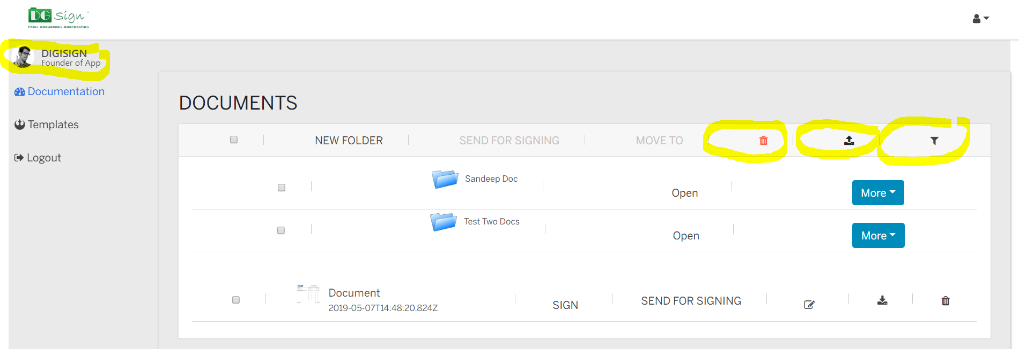

1. Next to Document, the text for SIGN and SEND FOR SIGNING are not lined up correctly.

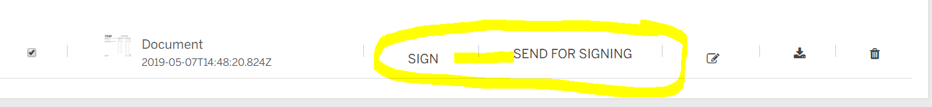

1. When I selected Document and then Send for Signing, the pop up appeared but text was cut from border at top, please take a look

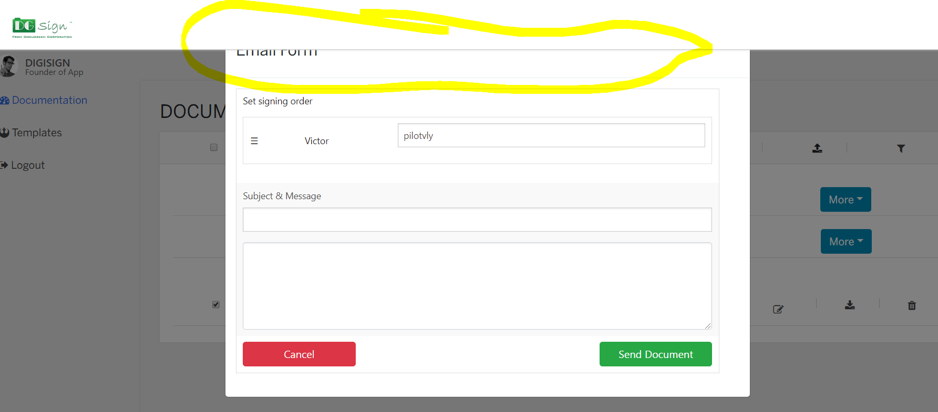

1. After hitting Send Document, it says Document Shared Successfully which is correct, but it still shows preview of previous screen. This should be removed, all user needs to see is document was shared successfully.

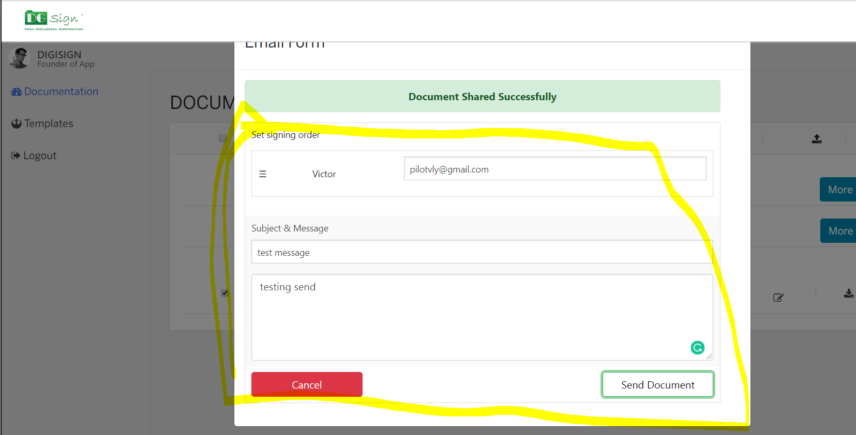

1. Message receive shows as coming from [sandeep.digittrix@gmail.com](mailto:sandeep.digittrix@gmail.com). The message should come from sender’s email address.

