**Fall Detection – Group 4**

**QA Report**

For testing the software, we decided to cover all the functional aspects of the system. This will determine if our project meets the Software Requirements Specification (SRS) document’s functional requirements. We also chose to test a few non-functional requirements that were strongly desired by our stakeholders.

*Test cases are written with Python’s unittest library.*

Test Plan:

|  |  |  |  |
| --- | --- | --- | --- |
| **Requirement(s)** | |  |  | | --- | --- | | **Test Case** | **Test Case Description** | |
| FR.1 The system must detect and classify a human as a “human” object.  FR.2 The system must alert the user when an object classified as a “human” falls in an indoor environment. | |  |  | | --- | --- | | testDetectHuman | *Tests if the system detects a dog’s movements as a human fall.* | |
| FR.3 The system must detect when an object classified as “human” falls when an object is obstructing them. | |  |  | | --- | --- | | testObstructed_15_20 | *Tests if the system detects an obstructed fall from 15 feet away from the camera’s lens.* | |
| FR.4 The system must determine if an object classified as “human” is lying or sitting down. | |  |  | | --- | --- | | testSittingDown | *Test if the system detects a human sitting down as a “sitting” state.* | | testLyingDown | *Test if the system detects a human lying down as a “lying” state.* | |
| FR.5 The system must be able to differentiate between when a person falls down and when they go to sit or lay down of their own will. | |  |  | | --- | --- | | Test0_5_foreward_fall | *Tests if the system detects a falling person as a “fall” state within 5 feet from the camera’s lens.* | | testSittingDown | *Test if the system detects a human sitting down as a “sitting” state.* | | testLyingDown | *Test if the system detects a human lying down as a “lying” state.* | |
| FR.6 The system must access the live video feed. | |  |  | | --- | --- | | testCamera | *Test if the system can access a camera for live video feed.* | |
| FR.7 The system must eliminate background noise of non-moving entities. | |  |  | | --- | --- | | testRemoveNonMovingEntites | *Tests if the system is able to remove static background noise from the camera’s live video feed.* | |
| FR.8 The system must use a relational database to query templates. | |  |  | | --- | --- | | testDBConnection | *Tests if the system is able to connect to the relational database and query a set of templates.* | |
| NFR.2 The system must detect when an object classified as a “human” falls between a distance of 5 feet and 50 feet inclusively from the viewing lens of the camera. | |  |  | | --- | --- | | Test0_5_female | *Test if the system detects a human female falling within 5 feet of the camera’s lens.* | | Test0_5_forward_fall | *Test if the system detects a human male falling forward within 5 feet of the camera’s lens.* | | Test5_10_forewards | *Test if the system detects a human male falling forward within 5 to 10 feet of the camera’s lens.* | | Test15_20_1 | *Tests if the system detects a human male falling within 15 to 20 feet of the camera’s lens.* | | Test15_20_2 | *Tests if the system detects a human male falling within 15 to 20 feet of the camera’s lens.* | |
| NFR.3 The system must alert the user if an object classified as a “human” falls when the source image’s RGB pixel values have a standard deviation above 10. | |  |  | | --- | --- | | testLowLight_15_20 | *Tests if the system detects a fall when the system is placed in low lighting conditions.* | |

Test Plan Results:

|  |  |
| --- | --- |
| **Result** | **Result Description** |
| OK | The test is set to “OK” state when all steps are in “OK” state. The real result is compliant to the expected result. |
| NOK | The test is set to “NOK” state when all steps of the test are set to “NOK” state or when the result of a step differs from the expected result. |
| Partial OK | The test sheet is set to “Partial OK” state when at least one step of the test is set to “NOK” state or when the result of a step is partially compliant to the expected result. |
| NOT RUN | Default state of a test sheet not yet executed. |
| NOT COMPLETED | The test is set to “Not Completed” state when at least one step of the test is set to “Not Run” state. |

|  |  |  |  |  |
| --- | --- | --- | --- | --- |
| **Requirement(s)** | |  |  |  | | --- | --- | --- | | **Test Case** | **Result** | **Comments** | |
| FR.1 The system must detect and classify a human as a “human” object. | |  |  |  | | --- | --- | --- | | testDetectHuman | NOK | *The system cannot accurately tell the difference between a human and an animal.* | |
| FR.3 The system must detect when an object classified as “human” falls when an object is obstructing them.  FR.2 The system must alert the user when an object classified as a “human” falls in an indoor environment. | |  |  |  | | --- | --- | --- | | testObstructed_15_20 | *OK* | *The system detects a fall from the video.* | |
| FR.4 The system must determine if an object classified as “human” is lying or sitting down.  FR.2 The system must alert the user when an object classified as a “human” falls in an indoor environment. | |  |  |  | | --- | --- | --- | | testSittingDown | Partial OK | *The system does throw some sitting flags but not enough for the system to officially label that a fall has occurred. This can be improved with more templates.* | | testLyingDown | Partial OK | *The system does throw some lying flags but not enough for the system to officially label that a fall has occurred. This can be improved with more templates.* | |
| FR.5 The system must be able to differentiate between when a person falls down and when they go to sit or lay down of their own will.  FR.2 The system must alert the user when an object classified as a “human” falls in an indoor environment. | |  |  |  | | --- | --- | --- | | Test0_5_foreward_fall | *OK* | *The system detected a fall from the video.* | | testSittingDown | *Partial OK* | *The system does throw some sitting flags but not enough for the system to officially label that a fall has occurred. This can be improved with more templates.* | | testLyingDown | *Partial OK* | *The system does throw some lying flags but not enough for the system to officially label that a fall has occurred. This can be improved with more templates.* | |
| FR.6 The system must access the live video feed. | |  |  |  | | --- | --- | --- | | testCamera | *OK* | *The system is able to access live video feed.* | |
| FR.7 The system must eliminate background noise of non moving entities. | |  |  |  | | --- | --- | --- | | testRemoveNonMovingEntites | *OK* | *The static background is removed, and a black binary image is the result.* | |
| FR.8 The system must use a relational database to query templates. | |  |  |  | | --- | --- | --- | | testDBConnection | *OK* | *The system is able to connect to the database.* | |
| NFR.2 The system must detect when an object classified as a “human” falls between a distance of 5 feet and 50 feet inclusively from the viewing lens of the camera.  FR.2 The system must alert the user when an object classified as a “human” falls in an indoor environment. | |  |  |  | | --- | --- | --- | | Test0_5_female | *OK* | *The system detects a fall from the video.* | | Test0_5_forward_fall | *OK* | *The system detects a fall from the video.* | | Test5_10_forewards | *OK* | *The system detects a fall from the video.* | | Test15_20_1 | *Partial OK* | *The system does throw some fall flags but not enough for the system to officially label that a fall has occurred. This can be improved with more templates.* | | Test15_20_2 | *Partial OK* | *The system does throw some fall flags but not enough for the system to officially label that a fall has occurred. This can be improved with more templates.* | |
| NFR.3 The system must alert the user if an object classified as a “human” falls when the source image’s RGB pixel values have a standard deviation above 10. | |  |  |  | | --- | --- | --- | | testLowLight_15_20 | *NOK* | *The system did not detect the fall in the video. And the system wasn’t able to make accurate templates.* | |

Test Result Statistics:

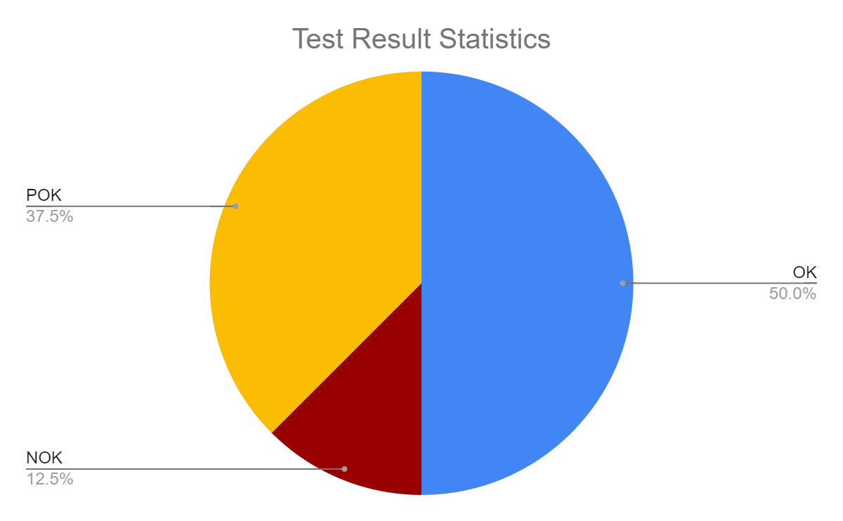

POK: 4

NOK: 2

OK: 8

Total test cases: 14

Bug Statistics:

• Total number: 2

• Number of Critical bugs: 0

• Number of Major bugs: 1

• Number of Minor bugs: 1

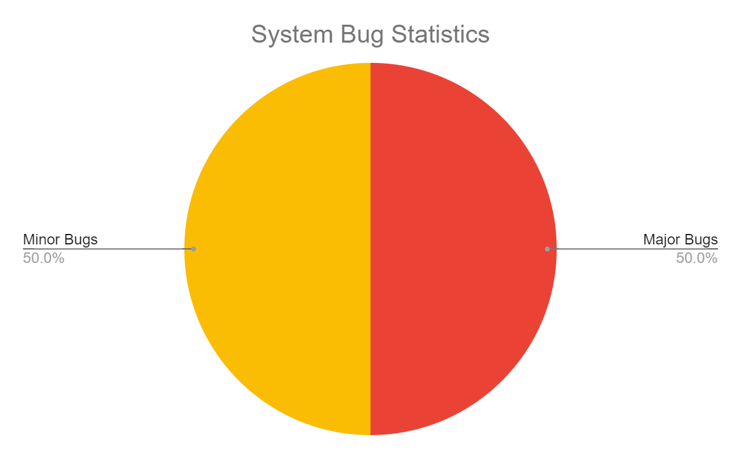

The system is unable to differentiate between humans and other living objects; this is a major bug. The system is unable to detect falls in low lighting conditions; this is a minor bug.

**Summary:**

Not all tests with pre-recorded video are passing. This could indicate a few things: Either the system is not fully optimized for low lighting conditions. Or the camera that was used for recording fall videos for test cases is causing issues. Either way, more testing should be done with different types of cameras. The software system’s quality is acceptable for customer deployment as live video is not impacted as testing is using pre-recorded videos.