

GRADUATION PROJECT – II
MIDTERM REPORT

MCP Based AI Powered Telecommunications Network Analysis and Decision Support System

PROJECT TEAM:
210315074 Hatice AKGÜL
210315076 Hacer SANCAR

PROJECT ADVISOR: Volkan ALTINTAŞ

2026
ABSTRACT

This study proposes an MCP (Model Context Protocol)-based analysis and decision support system that integrates multiple data sources in telecommunication networks, including network metrics, fault records, customer complaints, and station inventory, into a unified decision layer. The primary objective of the project is to provide fast, consistent, and explainable answers to critical questions frequently encountered by NOC (Network Operation Center) operators, such as “which cell is experiencing an issue, what is the root cause, and what is its impact?”. The proposed system consists of two main components: an offline anomaly detection pipeline and an online query/decision layer. In the offline stage, network metrics are analyzed using Isolation Forest and Z-Score methods, and the resulting anomaly scores are stored in the anomaly_results table. This approach eliminates the need for repeated model training during each query by relying on precomputed, traceable anomaly records.
In the online layer, MCP-based tools and FastAPI services are used to combine anomaly detection results with other data sources, producing meaningful and actionable operational outputs. A key contribution of the system is the integration of a Large Language Model (LLM)-based orchestration mechanism. When a user submits a query in natural language, the LLM interprets the intent, determines the appropriate MCP tools to invoke, triggers the necessary service calls, and aggregates the results into a coherent and user-friendly response. This enables users to interact with the system without requiring in-depth technical knowledge.
Additionally, a lightweight AJAX-based chat interface has been developed to support real-time query processing and interaction. The modular architecture of the proposed system provides a scalable foundation that can be easily adapted for both demonstration purposes and real-world operational environments. Overall, this work aims to improve efficiency and responsiveness in telecom network management by combining anomaly detection, data integration, and LLM-driven decision-making within a unified framework.

Keywords: Model Context Protocol (MCP), LLM-Driven Decision Support, Anomaly Detection, Network Operations Center (NOC), Telecom Data Integration

- INTRODUCTION

Telecommunication networks are inherently complex and distributed systems where multiple heterogeneous data sources coexist but are not natively integrated. In real-world telecom operators, network management is not performed through a single unified platform. Instead, key performance indicators (KPIs) are monitored in dedicated network monitoring systems, fault and alarm records are maintained within fault management platforms, and customer complaints are handled through separate CRM systems. Additionally, station inventory and location-related data are managed through independent services. While each of these systems provides valuable insights individually, they lack a unified context for holistic analysis. This fragmented architecture creates a significant operational challenge, particularly during incident response scenarios.
In practical operations, Network Operation Center (NOC) engineers are required to manually correlate multiple symptoms of a single issue, such as increased latency, packet loss, alarm triggers, and rising customer complaints. This process involves accessing multiple dashboards, interpreting raw data, and synthesizing information from various systems. As a result, identifying the root cause of a network issue can take between 30 to 60 minutes. Such delays directly impact service quality, user satisfaction, and operational efficiency. The fundamental problem is not the absence of data, but rather the lack of an intelligent mechanism that can unify, interpret, and contextualize this data in real time.
This project addresses the aforementioned challenge by proposing an MCP (Model Context Protocol)-based architecture that acts as a unified context layer between distributed telecom systems and intelligent decision-making components. Within this approach, each data source is abstracted as an independent “tool” that can be dynamically accessed. These tools include network KPI queries, anomaly detection results, fault records, customer complaint data, and station status information. By structuring the system in this way, it becomes possible to modularly integrate multiple data sources while maintaining scalability and extensibility. The MCP layer serves as a bridge that enables an AI-driven system to interact with real-time and historical network data in a structured and efficient manner.
A core design principle of the system is the separation between offline analytical processing and online decision-making. In the offline layer, network telemetry data is continuously or periodically collected and analyzed using anomaly detection techniques such as Isolation Forest and Z-Score. These methods allow the system to identify deviations from normal network behavior by modeling statistical distributions and detecting outliers. The results of these analyses are stored in a dedicated anomaly_results database table, ensuring that anomaly detection is performed in advance and does not introduce latency during real-time queries. This design choice significantly improves system performance by eliminating the need for on-demand model training or recalculation.
The online layer is responsible for query processing and decision support. In this layer, MCP tools and FastAPI-based services retrieve precomputed anomaly results and combine them with fault records, customer complaints, and station-level information. This enables the system to generate comprehensive and context-aware operational insights. Instead of presenting raw metrics, the system provides enriched outputs such as severity levels, potential root causes, and triggering factors. This enhances explainability and aligns with real-world NOC workflows, where actionable insights are more valuable than raw data streams.
A key innovation of this project is the integration of a Large Language Model (LLM) as an orchestration and reasoning component. Unlike traditional rule-based systems, the LLM enables natural language interaction between the user and the system. When a user submits a query such as “Why is the internet slow in Bornova?”, the LLM interprets the intent, determines which MCP tools should be invoked, and dynamically executes the necessary sequence of operations. For example, the system may retrieve network KPIs, analyze anomaly results, check fault records, and evaluate customer complaints before synthesizing a final response. This process transforms the LLM into an intelligent agent that mimics the behavior of a network engineer by reasoning over multiple data sources.
Furthermore, an AJAX-based chat interface has been developed to facilitate real-time interaction with the system. This interface allows users to submit queries in natural language and receive immediate, structured responses. The chat-based design abstracts technical complexity and enables non-expert users to interact with advanced network analytics capabilities. From a system architecture perspective, the solution follows a layered design consisting of a data layer (telemetry and relational databases), a service layer (FastAPI endpoints), an MCP tool layer (API wrappers), and an intelligence layer (LLM-based reasoning engine).
The proposed system also reflects real-world telecom architectures, where telemetry data is generated continuously and processed through monitoring pipelines. Although this project uses simulated or simplified data sources, it is designed to be compatible with industry-standard technologies such as streaming platforms, time-series databases, and monitoring dashboards. This ensures that the system can be extended or adapted to production environments with minimal architectural changes.
In summary, this study introduces an AI-driven, MCP-based framework that unifies distributed telecom data sources into a single decision-making layer. By combining anomaly detection, data integration, and LLM-based reasoning, the system significantly reduces analysis time, improves consistency, and enhances explainability. The proposed approach demonstrates how modern AI techniques can be leveraged to transform traditional network operations into a more automated, scalable, and intelligent process.

- REALISTIC CONSTRAINTS AND CONDITIONS

  - Sustainable Development Goal

This project is directly aligned with Sustainable Development Goal 9: Industry, Innovation and Infrastructure, which emphasizes building resilient infrastructure, promoting inclusive and sustainable industrialization, and fostering innovation. In modern societies, telecommunication networks represent a critical digital infrastructure that supports economic activities, public services, and daily communication. Ensuring the reliability, efficiency, and scalability of these networks is therefore essential for sustainable development.
The proposed MCP-based architecture contributes to SDG 9 by enhancing the resilience and operational efficiency of telecom infrastructure. By integrating heterogeneous data sources such as network metrics, fault records, and customer complaints into a unified decision layer, the system enables faster detection and resolution of network issues. This reduces downtime and improves service continuity, which is a key requirement for robust infrastructure systems. Additionally, the use of offline anomaly detection mechanisms ensures that potential problems are identified proactively, rather than reactively, supporting predictive maintenance strategies.
Furthermore, the integration of Large Language Models (LLMs) and AI-driven decision-making introduces an innovative approach to network operations. By automating complex analysis tasks and enabling natural language interaction, the system reduces the dependency on manual processes and accelerates operational workflows. This not only increases efficiency but also contributes to the development of intelligent, next-generation infrastructure systems.
Another important contribution of the project is resource optimization. By accurately identifying overloaded cells, network anomalies, and regional demand patterns, the system supports more efficient allocation of network resources. This leads to reduced energy consumption and improved infrastructure utilization, aligning with sustainability principles.
In summary, the project supports SDG 9 by combining advanced technologies such as AI, anomaly detection, and modular system design to improve the reliability, efficiency, and innovation capacity of telecommunication infrastructure.

  - Effects on Health, Environment and the Problems of the Age Reflected in the Field of Engineering

This project contributes to addressing critical challenges related to health, environment, and modern engineering by improving the management of telecommunication infrastructure. In today’s world, communication networks are not only essential for personal use but also play a vital role in emergency services, healthcare systems, and public safety operations. Network outages or performance degradation can negatively impact the communication of emergency response units such as ambulances and fire departments, posing direct risks to human health and safety. The system developed in this project aims to minimize such risks by enabling faster and more accurate detection of network issues, thereby reducing downtime and supporting the continuity of critical communication services.
From an environmental perspective, the project promotes more efficient use of resources. By accurately detecting anomalies and capacity-related issues within the network, unnecessary field interventions, maintenance operations, and excessive energy consumption can be reduced. Identifying overloaded cells and optimizing capacity planning allows for more efficient infrastructure utilization, which contributes to lowering energy usage and reducing the overall carbon footprint. In this sense, the project aligns with sustainable engineering practices and supports environmentally responsible infrastructure management.
Furthermore, the project addresses key engineering challenges of the modern era. Telecommunication networks generate massive volumes of data that require real-time analysis, creating challenges in big data processing, low-latency system design, and scalable architectures. The proposed system tackles these challenges by separating offline analytical processes from online decision-making, achieving a balance between performance and efficiency. In addition, the need for transparency and explainability in AI-driven systems is a major concern in contemporary engineering. This project enhances explainability and auditability by storing anomaly detection results in a database and ensuring that decision processes remain traceable.
In conclusion, this work provides a comprehensive approach that addresses health, environmental sustainability, and modern engineering challenges by developing a reliable, efficient, and intelligent infrastructure management system.

  - Legal Consequences

The proposed system involves the processing and integration of various types of data, including network metrics, fault records, and customer-related information, which introduces important legal considerations. One of the primary concerns is the protection of personal data and traffic-related information in compliance with data protection regulations such as KVKK (Turkish Personal Data Protection Law) and GDPR (General Data Protection Regulation). Although the system primarily focuses on technical network data, customer complaints and location-based information may indirectly involve personal data, requiring careful handling, anonymization, and adherence to data minimization principles.
Another critical aspect is access control and log management. The system must ensure that only authorized personnel can access sensitive data and operational tools. Proper authentication and authorization mechanisms should be implemented to prevent unauthorized use. Additionally, all system interactions, including data queries, anomaly detection results, and operational decisions, should be logged systematically. This creates an audit trail that enables traceability, accountability, and compliance with regulatory requirements.
The integration of AI and automated decision-making mechanisms also raises legal and ethical concerns. While the system provides intelligent recommendations based on anomaly detection and multi-source analysis, relying solely on automated decisions may lead to incorrect or biased outcomes. Therefore, it is essential to incorporate human-in-the-loop mechanisms, where critical operational decisions are validated or supervised by qualified personnel. This approach ensures that the system supports decision-making rather than fully replacing human judgment.
Furthermore, transparency and explainability are key legal requirements, especially in AI-assisted systems. The ability to trace how a decision was made, which data sources were used, and what factors influenced the outcome is crucial for regulatory compliance and trust. By storing anomaly detection results and maintaining structured logs, the proposed system enhances both transparency and accountability.
In conclusion, the project emphasizes compliance with data protection laws, secure system access, traceable operations, and responsible AI usage, ensuring that legal risks are minimized while maintaining operational efficiency.

- LITEARTURE ANALYSIS

The rapid evolution of telecommunication networks, driven by emerging technologies such as 5G, Software-Defined Networking (SDN), Network Function Virtualization (NFV), and the Internet of Things (IoT), has significantly increased both the scale and complexity of network operations. Modern networks generate massive volumes of heterogeneous data, including performance metrics, logs, alarms, and user-related information, which must be processed in real time to ensure service continuity. Traditional rule-based and threshold-driven monitoring approaches are no longer sufficient to handle this complexity. As highlighted in recent studies, this limitation has led to the emergence of Artificial Intelligence for IT Operations (AIOps), which aims to automate and enhance network management through machine learning and data-driven techniques .
One of the most fundamental research areas in this domain is anomaly detection in network telemetry data. Machine learning techniques such as Isolation Forest, autoencoders, clustering-based approaches, and statistical methods like Z-Score are widely used to detect deviations from normal network behavior. These methods enable early identification of abnormal conditions such as increased latency, packet loss, and congestion. As a result, they support proactive fault detection and predictive maintenance, reducing downtime and improving overall network reliability. However, literature consistently emphasizes that anomaly detection alone is insufficient for real-world operational decision-making. While these techniques can identify that an anomaly exists, they often fail to explain why the anomaly occurred or how it relates to other network events.
To overcome this limitation, recent research has focused on integrating anomaly detection with root cause analysis and multi-source data correlation. AIOps systems increasingly combine network telemetry data with fault logs, system events, and customer complaints to generate more comprehensive and context-aware insights. This multi-source integration significantly improves fault localization accuracy and reduces the Mean Time to Resolution (MTTR). In real-world scenarios, operators must correlate multiple signals—such as performance degradation, alarms, and user complaints—to understand the underlying issue. Therefore, unified architectures that bring together heterogeneous data sources have become a key research direction.
Another major development in the literature is the use of real-time telemetry and streaming data processing. Advanced telemetry techniques, such as in-band network telemetry (INT), enable fine-grained monitoring of network conditions, including queue occupancy, packet delay, and traffic patterns. These telemetry streams provide high-resolution visibility into network behavior, which can be leveraged by machine learning models for dynamic optimization. AI-driven systems can analyze telemetry data in real time to predict congestion, reroute traffic, and prevent service degradation. Experimental results demonstrate that such approaches can reduce latency by up to 30% and significantly improve throughput and network efficiency .
Despite these advancements, a critical challenge in AI-based network management systems is the lack of interpretability. Many machine learning models operate as “black-box” systems, making it difficult for operators to understand how decisions are made. This lack of transparency poses a major barrier to the adoption of AI in critical infrastructure domains, where reliability and accountability are essential. To address this issue, Explainable Artificial Intelligence (XAI) has emerged as a key research area. Techniques such as SHAP and LIME provide insights into model behavior by identifying the contribution of individual features to a given prediction. Integrating XAI into network operations improves trust, enhances decision validation, and supports human-AI collaboration .
In addition to interpretability, the literature highlights the importance of automation through closed-loop network management systems. These systems continuously collect telemetry data, analyze it using machine learning models, and automatically adjust network configurations based on the results. For example, reinforcement learning algorithms can optimize routing strategies and resource allocation by learning from historical and real-time data. This paradigm represents a shift toward autonomous or self-healing networks, where systems can detect, analyze, and resolve issues with minimal human intervention. However, fully autonomous systems also raise concerns regarding reliability and safety, leading to the adoption of human-in-the-loop approaches for critical decision-making processes.
A particularly important recent development in the field is the integration of Large Language Models (LLMs) into network management systems. Unlike traditional AIOps solutions, which rely on predefined rules and workflows, LLM-based systems enable more flexible and adaptive decision-making through natural language understanding. One of the pioneering works in this area is Toolformer, which demonstrates that LLMs can learn to use external tools (APIs) in a self-supervised manner . In this approach, the model learns when to call an API, which parameters to use, and how to incorporate the returned results into its reasoning process. This capability allows LLMs to overcome inherent limitations such as lack of real-time knowledge and computational precision.
The Toolformer framework introduces a novel paradigm in which language models are no longer passive text generators but active decision-makers capable of interacting with external systems. By embedding API calls directly into the text generation process, the model can dynamically retrieve information and enhance its predictions. This approach is particularly relevant for complex systems such as telecom networks, where decisions often depend on real-time data from multiple sources. The MCP-based architecture proposed in this project closely aligns with this concept, as it enables the LLM to orchestrate multiple tools and services in a structured manner.
Building on this idea, ToolLLM extends the concept of tool-augmented language models by enabling interaction with a large-scale ecosystem of real-world APIs. The ToolLLM framework introduces ToolBench, a dataset containing over 16,000 APIs across multiple domains, and demonstrates how LLMs can perform complex reasoning tasks by chaining multiple API calls . This multi-tool capability is crucial for solving real-world problems that require combining different types of data and functionalities. Unlike earlier approaches that rely on single-tool interactions, ToolLLM supports multi-step reasoning and dynamic tool selection, making it highly relevant for complex operational scenarios.
Furthermore, OR-Toolformer explores the application of tool-augmented LLMs in operations research and optimization problems. In this framework, the model translates natural language problem descriptions into structured API calls and interacts with external solvers to compute optimal solutions . This demonstrates that LLMs can bridge the gap between high-level human instructions and low-level computational processes. The ability to integrate reasoning with external computation is particularly important in domains where accuracy and precision are critical.
From a system architecture perspective, the literature emphasizes the importance of modular and scalable designs. Microservice architectures, API-based communication, and abstraction layers are widely used to manage the complexity of distributed systems. These approaches enable independent development, scalability, and interoperability across different components. The MCP (Model Context Protocol) approach used in this project can be seen as a specialized abstraction layer that integrates multiple data sources and services into a unified decision-making framework. By modeling each data source as a “tool,” the system achieves both modularity and flexibility.
Despite the significant progress in this field, several challenges remain open. These include handling large-scale and high-velocity telemetry data, ensuring low-latency inference for real-time applications, achieving interoperability across different vendors and technologies, and maintaining data privacy and security. Additionally, balancing automation with human oversight remains a critical issue. While AI systems can significantly improve efficiency, human expertise is still necessary to validate decisions and handle unexpected scenarios.
In conclusion, the literature indicates a clear trend toward intelligent, data-driven, and AI-powered network management systems. The integration of anomaly detection, real-time telemetry, explainable AI, and tool-augmented LLMs represents the current state-of-the-art in the field. The approach proposed in this project, which combines MCP-based data integration with LLM-driven orchestration, aligns strongly with these trends. By enabling dynamic tool usage, multi-source data integration, and natural language interaction, the proposed system provides a scalable and innovative solution for modern network management challenges.

- STANDARTS TO BE USED

The development of this project is guided by widely accepted engineering standards and best practices to ensure scalability, maintainability, security, and interoperability. One of the primary standards adopted in the system design is the use of RESTful API principles. The system follows standard HTTP method semantics (GET, POST, PUT, DELETE) to define clear and consistent communication between components. This approach enables modular interaction between services and ensures compatibility with modern web-based architectures.
For data exchange, the system utilizes JSON (JavaScript Object Notation) as the standard format. JSON is lightweight, human-readable, and widely supported across different platforms and programming languages, making it suitable for efficient communication between the MCP layer, backend services, and client interfaces. This standardization simplifies data processing and integration across different system components.
In terms of data management, PostgreSQL is used as the relational database system, adhering to relational integrity principles. Primary keys (PK), foreign keys (FK), and indexing strategies are applied to ensure data consistency, efficient querying, and referential integrity. These database design practices are critical for maintaining reliable and structured storage of anomaly detection results, fault records, and other operational data.
Security is another key consideration in the system design. Sensitive information such as API keys, database credentials, and configuration parameters are managed using environment variables (.env files). This approach prevents hardcoding sensitive data into the source code and enhances overall system security. Additionally, the principle of least privilege is applied when defining database users and access permissions, ensuring that each component only has access to the resources necessary for its operation.
From a software engineering perspective, the system follows a modular architecture with clear separation of concerns. The MCP layer, API layer, and service layer are designed as independent components, enabling easier maintenance, testing, and scalability. This layered approach aligns with modern software development standards and supports the integration of additional tools or services in the future without significant modifications to the existing system.
In summary, the project adopts industry-standard practices in API design, data exchange, database management, security, and software architecture to build a robust, scalable, and maintainable system.

- APPROACHES, TECHNIQUES, AND TECHNOLOGIES TO BE USED

This project adopts a multi-layered, modular, and data-driven approach to address the complexity of modern telecommunication network management. The overall system design combines machine learning techniques, API-based architectures, and Large Language Model (LLM)-driven orchestration to provide an intelligent decision support system. The implementation is structured around distinct layers, including data processing, backend services, MCP-based tool abstraction, and a lightweight frontend interface.
From a backend development perspective, the system is implemented using Python and the FastAPI framework. FastAPI is chosen due to its high performance, asynchronous capabilities, and ease of integration with modern web technologies. It enables the development of scalable RESTful APIs that serve as the communication layer between different system components. The backend is responsible for handling incoming requests, processing queries, and coordinating interactions between the database, MCP tools, and machine learning outputs.
A key component of the system is the MCP (Model Context Protocol) layer, which is implemented using the `fastmcp` library. In this architecture, each data source or functionality is encapsulated as a “tool.” These tools include querying anomaly results, retrieving network metrics, accessing fault records, and analyzing customer complaints. The MCP layer provides a standardized interface for interacting with these tools, enabling the LLM to dynamically select and invoke them based on user queries. This abstraction significantly improves system flexibility and supports multi-tool orchestration, which is essential for handling complex, real-world queries.
The data layer of the system is built on PostgreSQL, a robust and widely used relational database management system. PostgreSQL is selected for its reliability, strong support for relational integrity, and ability to handle complex queries efficiently. The database schema includes structured tables such as `network_metrics`, `anomaly_results`, `fault_records`, and `complaints`. Relationships between these tables are maintained using primary and foreign keys, ensuring data consistency and enabling efficient multi-source queries. Indexing strategies are also applied to optimize query performance, particularly for time-series and location-based data.
Machine learning techniques are applied in the offline data processing pipeline for anomaly detection. The system utilizes a hybrid approach combining Isolation Forest and Z-Score methods. Isolation Forest is a tree-based algorithm that identifies anomalies by isolating data points in feature space, making it particularly suitable for high-dimensional network data. Z-Score, on the other hand, provides a statistical measure of deviation from the mean, enabling the detection of extreme values in time-series data. By combining these two techniques, the system achieves a balance between robustness and interpretability. The anomaly detection process runs offline, and the results are stored in the `anomaly_results` table. This design choice eliminates the need for real-time model execution during query processing, significantly reducing system latency and improving performance.
On the frontend side, a lightweight web interface is developed using HTML, CSS, and AJAX. This interface allows users to interact with the system through a chat-based input mechanism. AJAX is used to send asynchronous requests to the backend, enabling real-time interaction without requiring full page reloads. Although the frontend is intentionally kept simple within the scope of the project, it effectively demonstrates how users can query the system using natural language.
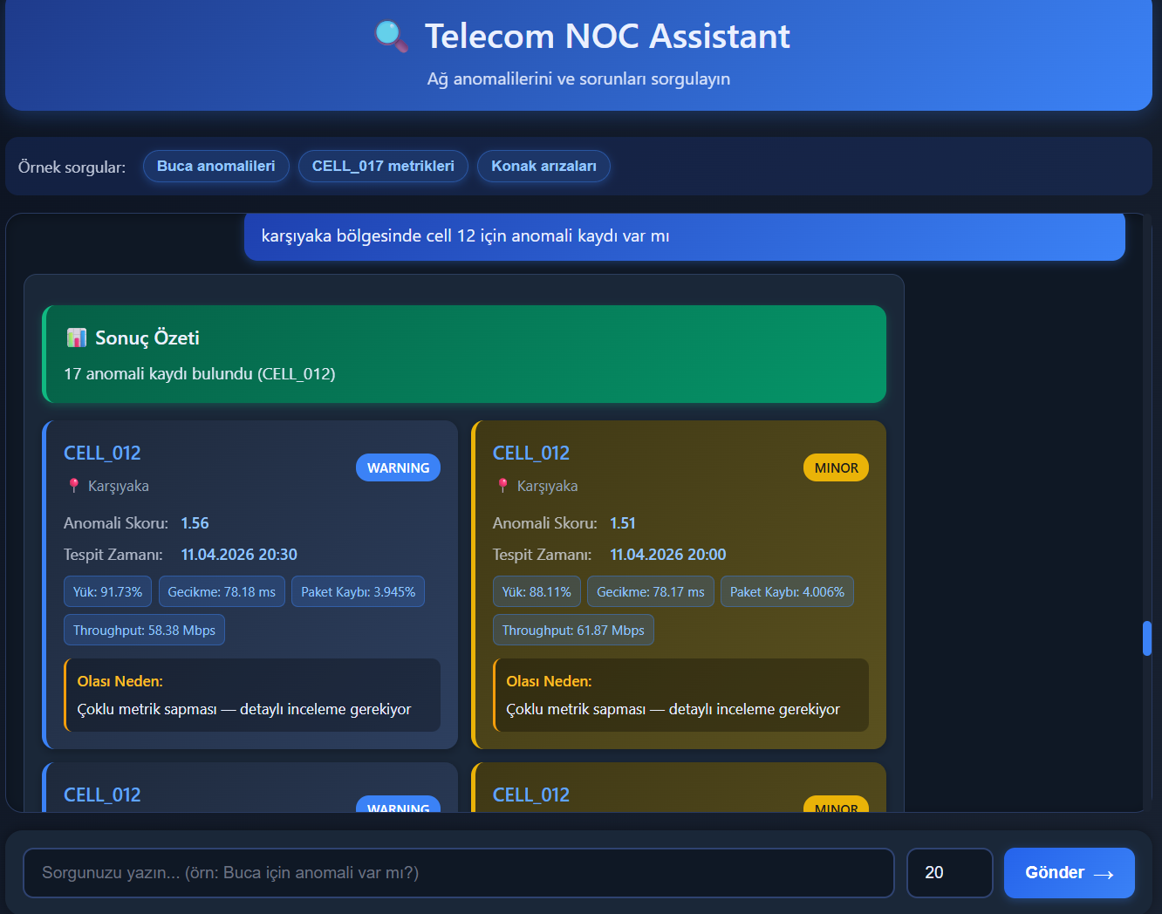
Figure 1: HTML, CSS, AJAX based frontend side
One of the most innovative aspects of the system is the integration of a chat-based interface with an LLM-driven decision layer. The `/chat` endpoint, implemented in the FastAPI backend, receives user queries in natural language. These queries are then processed by the LLM, which interprets the user’s intent and determines which MCP tools should be invoked. For example, a query such as “Is there any anomaly in CELL_017?” may trigger calls to anomaly detection tools and network metric queries, while a question like “Are there active faults in Buca?” may involve fault and complaint-related tools. The results obtained from these tools are then aggregated and transformed into a coherent and user-friendly response.
The system architecture follows a modular design with clear separation of concerns. The `services.py` module contains the core business logic, including database queries, data processing functions, and integration with machine learning outputs. The `main.py` file defines MCP tools, which act as wrappers around service functions and expose them to the LLM as callable components. The `api.py` file implements FastAPI endpoints, including the `/chat` endpoint, which serves as the main interface between the user and the system. This layered architecture enhances maintainability, testability, and scalability, allowing new features or tools to be added with minimal impact on existing components.
From a system design perspective, the project emphasizes the separation of offline and online processes. The offline layer is responsible for data collection, preprocessing, and anomaly detection, while the online layer focuses on query handling and decision-making. This separation ensures that computationally intensive tasks do not affect real-time system performance. Additionally, storing precomputed anomaly results in the database improves traceability and enables auditability, which are important for operational environments.
Another important technique used in this project is multi-source data integration. By combining data from network metrics, fault records, and customer complaints, the system provides a holistic view of network conditions. This approach enables more accurate and context-aware decision-making compared to traditional single-source analysis methods.
In summary, this project combines modern software engineering practices, machine learning techniques, and AI-driven orchestration to develop a scalable and intelligent network management system. The use of FastAPI, MCP-based tool abstraction, PostgreSQL, offline anomaly detection, and LLM integration ensures that the system is both technically robust and aligned with current industry trends.

- PROJECT SCHEDULE AND TASK SHARING

WP No | Work Package Name | Assigned project staff | Time Period (..-.. Week) | Success Criteria
1 | Literature Review & Analysis | Project Team | Weeks 1-2 | Completion of the state-of-the-art analysis and selection of methodologies.
2 | Database & Dataset Design | Project Team | Weeks 3-4 | Successful setup of PostgreSQL schemas and loading of synthetic telecom data.
3 | Anomaly Detection Pipeline | Project Team | Weeks 5-7 | Implementation of Isolation Forest and Z-Score models in the offline layer.
4 | Backend & MCP Layer Development | Project Team | Weeks 8-10 | Integration of FastAPI and FastMCP to wrap data sources as tools.
5 | LLM Integration & Reasoning | Project Team | Weeks 11-12 | Successful intent interpretation and multi-tool orchestration by the LLM.
6 | Frontend (AJAX) Implementation | Project Team | Week 13 | Completion of the real-time chat interface for natural language queries.
7 | System Testing & Final Reporting | Project Team | Weeks 14-15 | Performance evaluation and documentation of quantitative results.

- RISK MANAGEMENT

WP No | Risks | Risk Management (Plan B)
1 | Low accuracy or high false-positive rates in anomaly detection. | Perform hyperparameter tuning or implement alternative models like Autoencoders.
2 | LLM hallucinations or incorrect tool-calling parameters. | Refine Prompt Engineering instructions and provide more descriptive tool metadata.
3 | High latency in LLM response times affecting user experience | Utilize optimized models (e.g., GPT-4o mini) or implement asynchronous processing.
4 | Missing or noisy data within the synthetic dataset affecting results. | Apply data cleaning and imputation techniques during the preprocessing stage.
5 | Compliance issues regarding personal data protection (KVKK/GDPR). | Enforce strict data anonymization and implement role-based access control.

- SYSTEM REQUIREMENTS ANALYSIS

  - Use Case Model

Use Case 1: System Interaction & Intent Interpretation
- Description: The NOC Operator submits a natural language query (e.g., "Why is there a slowdown in Bornova?") through the AJAX-based chat interface. The system sends this query to the LLM-based orchestration layer, which interprets the user's intent and determines the necessary sequence of tool calls to satisfy the request.
- Actors: NOC Operator (Primary), LLM Engine (Internal System)
. 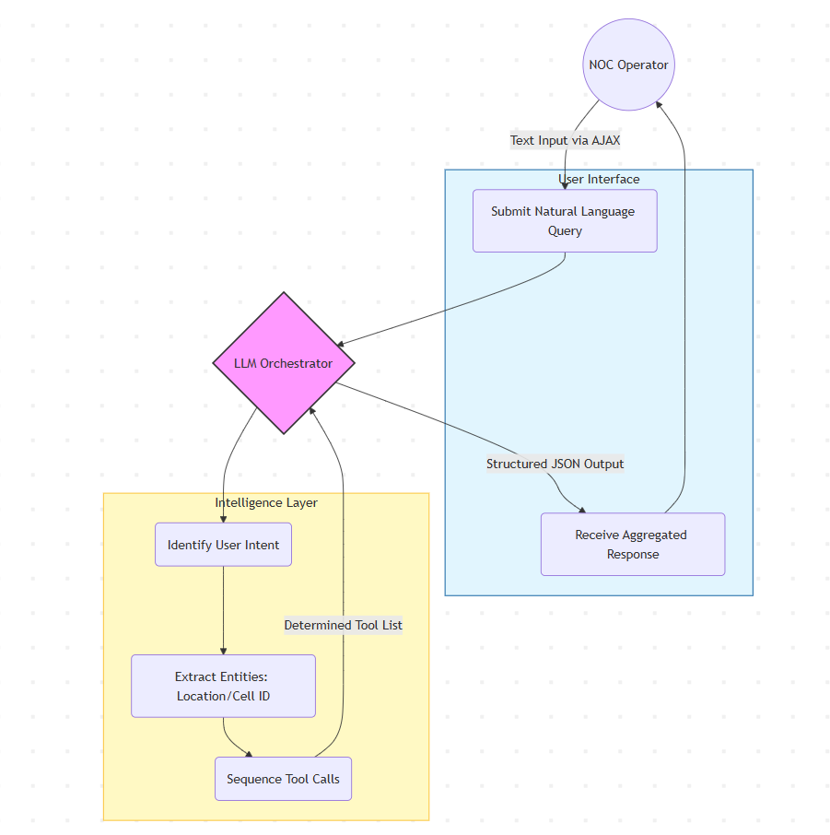

Use Case 2: Multi-Source Data Retrieval via MCP
- Description: Following the LLM's orchestration plan, the system invokes various MCP tools to aggregate data from fragmented sources. These tools fetch real-time network metrics, fault records from the database, and customer complaints related to the specific region or cell. The retrieved data is unified into a single context layer for analysis.
- Actors: LLM Engine (Primary), PostgreSQL Database (External System), MCP Tool Layer.

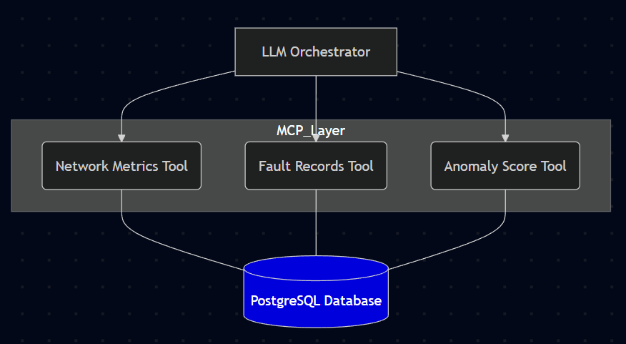
Use Case 3: Offline Anomaly Analysis & Correlation
- Description: The system queries the anomaly_results table to retrieve precomputed scores generated by the Isolation Forest and Z-Score algorithms. By comparing these scores with historical baseline data stored in the database, the system identifies statistical deviations and confirms if a legitimate network anomaly exists without needing real-time model training.
- Actors: MCP Tool Layer (Primary), Anomaly Detection Pipeline (Offline System).
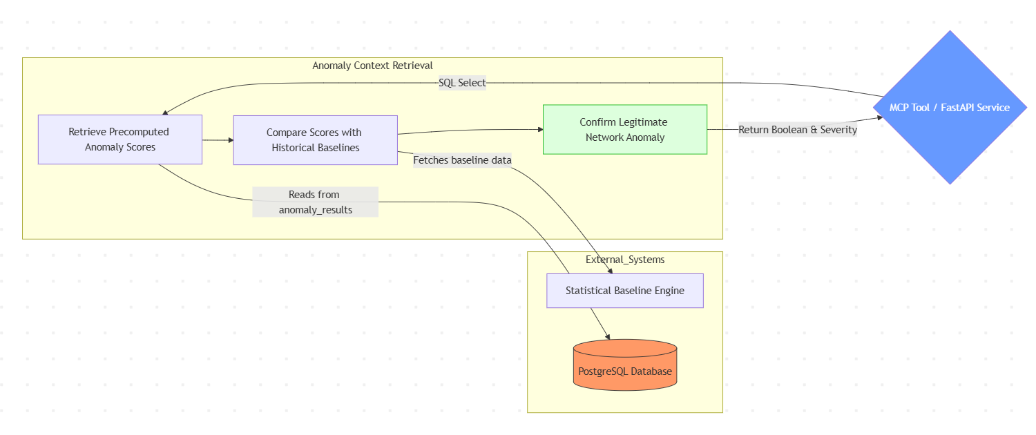
Use Case 4: Intelligent Root Cause & Decision Support
- Description: The LLM receives the aggregated outputs from the anomaly detection, fault logs, and customer complaints. It performs reasoning to correlate these heterogeneous signals—such as matching a packet loss anomaly with a specific hardware fault alarm—and generates a user-friendly, explainable response outlining the root cause and its potential impact.
- Actors: LLM Engine (Primary), NOC Operator (Recipient).
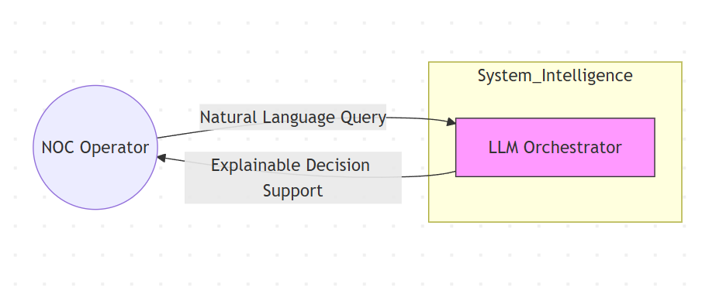

Use Case 5: Offline Model Retraining & Database Update
- Description: On a periodic basis, telemetry data is collected and processed through the offline pipeline. The Isolation Forest and Z-Score models are retrained or updated using the latest network behaviors to ensure accuracy. The new anomaly scores and statistical thresholds are then updated in the anomaly_results table to maintain the system's predictive performance.
- Actors: System Administrator (Primary), Machine Learning Pipeline (System).
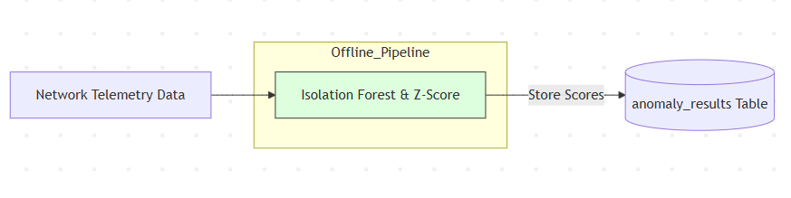

  - Object Model

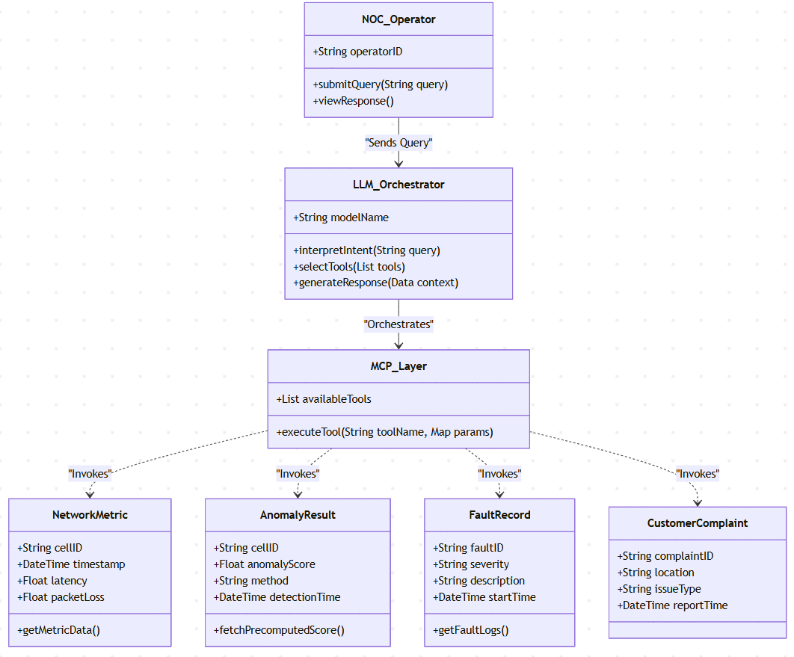

The Object Model provides a structured, class-based perspective of the MCP-based analysis system, detailing the orchestration between Large Language Models (LLMs), technical tool layers, and the underlying telecommunication data structures. The architecture follows a modular and decoupled pattern, separating natural language reasoning from technical data retrieval and statistical analysis.

1. Interaction and Intelligence Layer
- NOC_Operator (The Primary Actor):
  - Definition: Represents the Network Operation Center engineer who interacts with the system to diagnose network issues.
  - Attributes: operatorID (Unique identifier for session tracking and access control).
  - Methods: submitQuery(String) (Initiates the diagnostic process by sending a natural language request), viewResponse() (Handles the visualization of the explainable results).

- LLM_Orchestrator (The Reasoning Core):
  - Definition: The central intelligence unit responsible for interpreting human intent and managing the workflow of the Model Context Protocol (MCP).
  - Attributes: modelName (The specific LLM version, e.g., GPT-4o or Claude 3.5 Sonnet).
  - Methods: interpretIntent() (Analyzes the query to identify if it is an anomaly check or a status request), selectTools() (Determines which MCP tools are required), generateResponse() (Synthesizes raw data into a human-readable explanation).
  - Role: Acts as the brain of the system, translating ambiguous queries into structured technical execution plans.

2. Tool and Integration Layer
- MCP_Layer (The Tool Registry):
  - Definition: A framework-level component (based on FastMCP) that exposes backend functions as "tools" to the LLM. It acts as a bridge between the AI and the database.
  - Attributes: availableTools (A dynamic list of registered functions like get_metrics or check_faults).
  - Methods: executeTool(toolName, params) (Invokes specific data retrieval functions based on the LLM’s instruction).
  - Design Principle: Implements a strict separation between the AI’s reasoning and the actual data execution, ensuring security and modularity.

3. Network Data and Analytical Layer
- NetworkMetric (Real-Time Telemetry):
  - Definition: Represents the technical performance indicators of a specific network cell.
  - Attributes: cellID, timestamp, latency, and packetLoss.
  - Methods: getMetricData() (Retrieves raw performance logs from the database).
- AnomalyResult (Statistical Insight):
  - Definition: Represents precomputed statistical scores generated by the offline pipeline (Isolation Forest and Z-Score).
  - Attributes: anomalyScore (Numerical deviation value), method (The algorithm used), detectionTime.
  - Role: Provides the system with immediate access to complex analytical results without requiring real-time model training, ensuring high performance.
- FaultRecord (Operational Context):
  - Definition: Represents hardware or software alarms logged by the network infrastructure.
  - Attributes: faultID, severity (Critical, Major, Minor), description, and startTime.
  - Relationship: Provides the "context" used by the LLM to correlate a statistical anomaly with a known technical failure.

4. External Support and Feedback Layer
- CustomerComplaint (Quality of Experience):
  - Definition: Encapsulates end-user reports which serve as a secondary validation source for network issues.
  - Attributes: complaintID, location, issueType (e.g., "No Signal").
  - Role: Adds a "human layer" to the technical analysis, allowing the LLM to weigh technical metrics against actual user impact.
- Architectural Implications

This object model emphasizes a Zero-Latency Intelligence approach. By decoupling the AnomalyResult (precomputed) from the LLM_Orchestrator (real-time reasoning), the system can provide deep insights into complex telecommunication problems in seconds. The NOC_Operator only interacts with the LLM_Orchestrator, while the MCP_Layer ensures that the AI only accesses the specific data objects (Metrics, Faults, Complaints) necessary for the current task. This structure ensures that the system is both scalable for larger network datasets and adaptable to new AI models as they evolve.

- REFERENCES
O. O. Aramide, "Explainable AI (XAI) for Network Operations and Troubleshooting," International Journal for Research Publication and Seminar, vol. 16, no. 1, pp. –, Jan.–Mar. 2025. doi: 10.36676/jrps.v16.i1.286.

J. Zhang, J. Zhou, and C. Liu, "OR-Toolformer: Modeling and Solving Operations Research Problems with Tool-Augmented Large Language Models," arXiv preprint arXiv:2510.01253, 2025.

T. Schick, J. Dwivedi-Yu, R. Dessì, R. Raileanu, M. Lomeli, L. Zettlemoyer, N. Cancedda, and T. Scialom, "Toolformer: Language Models Can Teach Themselves to Use Tools," arXiv preprint arXiv:2302.04761, 2023.

Y. Qin, S. Liang, Y. Ye, K. Zhu, L. Yan, Y. Lu, Y. Lin, X. Cong, X. Tang, B. Qian, S. Zhao, L. Hong, R. Tian, R. Xie, J. Zhou, M. Gerstein, D. Li, Z. Liu, and M. Sun, "ToolLLM: Facilitating Large Language Models to Master 16000+ Real-World APIs," arXiv preprint arXiv:2307.16789, 2023.

M. Handigol et al., "Reproducible Network Experiments Using In-Band Network Telemetry," IEEE Communications Magazine, 2020.

P. Kalmbach, J. Zerwas, P. Babarczi, A. Blenk, W. Kellerer, and S. Schmid, "Empowering Self-Driving Networks," in Proc. ACM SIGCOMM, 2020.

M. Du, F. Li, G. Zheng, and V. Srikumar, "DeepLog: Anomaly Detection and Diagnosis from System Logs through Deep Learning," in Proc. ACM CCS, 2017.

- CHOOSE INTERDISCIPLINARY DOMAIN OF YOUR STUDY

Telecommunications

- CHOOSE SUSTAINABILITY DEVELOPMENT GOAL OF YOUR PROJECT

9: Industry, Innovation and Infrastructure

