SVM
Constraint in SVM (Hard vs soft margin)
Optemization problem of SVM
Derive margin between two hyper plane
Lagrange multiplier
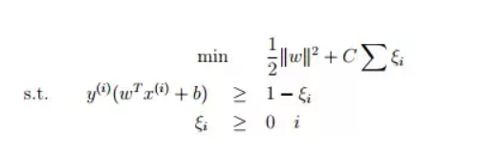
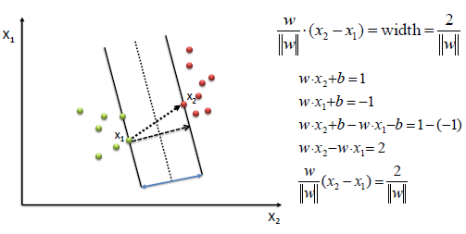

Points
- Hyper parameter in SVM is = C which is 1/lambda
- The value of C always positive ,
- As the value of C is increase model learn the training data vary well. It mean high variance. Train error will be less. Overfitting
- As value of C is decrease model is high baised , mean in train data model not performed well . under fitting .
- C always multiplied with loss term
- Lambda always multiplied with regularizer term
- Zita () measure the distance between misclassified points from negative direction of plane.
It is calculated for all point
- Zita will be 0 if point correctly classified
- Will negative real value if point misclassified.
- Distance will be measured from correct plane
- Type of losses
- Squared error loss
- Hinge loss max(0,1-zi) -> zi =yi( wTxi+b )
- Log loss
- Log loss or logistic loss is not differentiable
- Hinge loss is not differentiable.

- Which loss should be use and when?
- Dual form of svm formulation
Primal form of svm
Dual form:-
Similarity matrix is helpful

Linear SVM

Dual form
Kernel functions :-

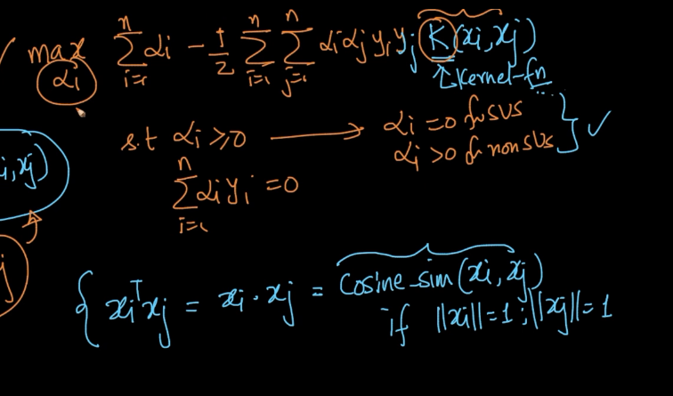

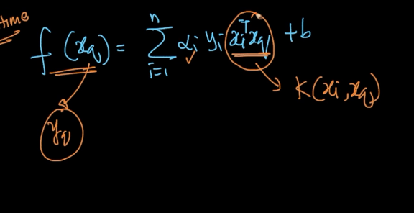

Kernal SVM
Internally do Feature Transform.
Mercers theorem
Different type of kernel
- Polynomial kernel
- RBF Kernal

RBF
RBF vs KNN
SVM vs logistic regression
Hyperperamter = > C or lambda and Sigma
Sigma for kernal

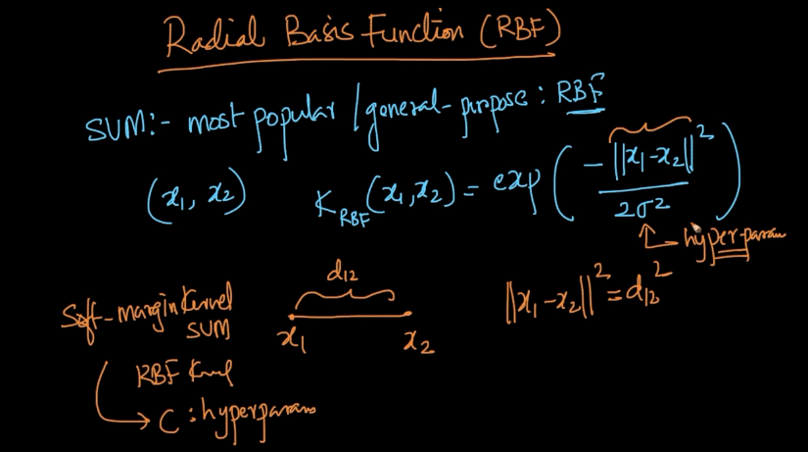

Kernal trick

Hinge loss
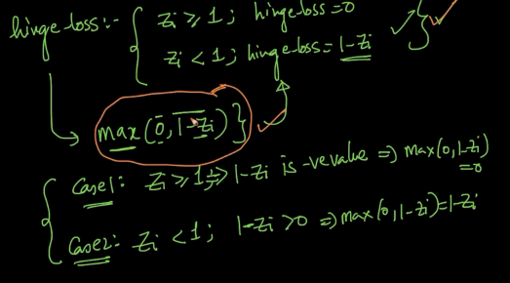

1.

Questions
- Why we take +1 and -1 for support vectors
- What is unit vector ? property of unit vetors
- Why SVM will fail if ||w|| norm of w will be unit vector?

