Statstic
https://www.kdnuggets.com/2018/12/introduction-statistics-data-science.html
https://towardsdatascience.com/the-5-basic-statistics-concepts-data-scientists-need-to-know-2c96740377ae
https://www.kdnuggets.com/2017/11/10-statistical-techniques-data-scientists-need-master.html
https://www.learndatasci.com/tutorials/data-science-statistics-using-python/
https://towardsdatascience.com/probability-and-statistics-explained-in-the-context-of-deep-learning-ed1509b2eb3f
https://www.datascience.com/blog/statistics-data-science-interview
https://www.datasciencecentral.com/profiles/blogs/29-statistical-concepts-explained-in-simple-english-part-1

- Variance , stand deviation
- Mean, median, mode
- Normal distribution
- Feature and importance
- center limit theorem
- Probability distribution function
- Area under curve
- How it help in analysis , interpretation
- Dependent events , independent event and mutually exclusive events
- Bayes theorem
- Law of total probability
- Min-max normalization
- Hypothesis
- Posterior
- Likelihood
- Composite function
- Chain rule
- Perturbation test :- to check multicollinearity in logistic regression
- Multicollinearity :- how it impact regression and classification
- Naïve baye
- Posterior
- Multinomial distribution
- Binomial distribution
- Continuous and discrete data
- Power loss
- Chi-squre test ( need to learn_)
- Kulback divergence
- Feature selection , feature engineering , feature importance , feature transformation
Feature extraction(need to read)
https://datascience.stackexchange.com/questions/29006/feature-selection-vs-feature-extraction-which-to-use-when
- Lagrange multiplier

Mean
Mean absolute deviation
The median absolute deviation(MAD) is a robust measure of how spread out a set of data is.
Example,: Let your friend Amal has taken a weekly math quiz for 9 weeks and consistently received scores between 83 and 86. Her mean score is 84.6 with a very narrow spread. Amal’s twin brother,Kamal, has the identical scores for the first 8 weeks. For some reason, maybe illness, the result of kamals’s ninth quiz is very low: 45.This score throws off kamal’s performance report and produces a spread(The spread of a distribution is also referred to as dispersion and variability also called standard deviation) which misrepresents the actual consistency of his quiz scores. In this lesson, we describe a measure of the spread called the median absolute deviation, which ignores data outside of a trend.

Power law distribution
Paratoo distribution

Lasso Regression
When most of the feature useless
Ridge Regression
When most of the feature usefull
Elastic net regression
- Elastic net regression is use full when there is correlation between parameters/features.
- Elastic net is hybrid of Ridge and lasso Regression (IT is two lambda one for lasso and one for Ridge) penality
- When
- When
- When
Least Squre Estimate

Performance and metric
Accuracy (between [0,1] range or 0 % to 100% percent)
Case 1:- imbalanced data => accuracy is not good measure if we have imbalanced data , because in case of imbalanced data it always give us good or higher accuracy
Case 2:- when model returning Probability score than accuracy could not use the probability value.

* choice of error metric doesn’t depend on the which model we are working it depends on the data

Confusion Matrix:-
Very useful incase of imbalanced dataset
The four values TPR,TNR,FPR,FNR can used to used to understand the model. In some cases FNR , FPR can be crucial ,such as medical domain.so those value must be low.
Case binary classification:-
Multi class classification confusion matrix:-

Precision , recall, f1score ->
Precision and recall is mostly used in information retrieval (search engingin)

Precision and recall lie between 0,1.
F1 score is harmonic mean of Precision and recall.

F1-score for Multi-label classification
- Micro average F1-score
- Macro averaged F1-score (dosen’t take frequency of occurrence of target), non weighted simple average .
When to use micro average f1-score vs macro averaged average

Micro-averaged metrics such as micro-F1 score, precision , recall can be a useful measure when your dataset varies in size while Macro-averaged metrics are used when we want to evaluate systems performance across on different datasets.
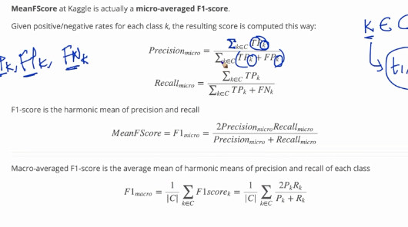

F1-Score for MultiClass classification

Hamming Loss:- matric for multi label classificaiton:-

No. We need the performance/error of the model on train and CV datasets to determine overfitting and underfitting. In a nutshell:
1. Large error on CV data AND a Small error on train-data => Overfitting.
2. Large error on CV data AND a Large error on train-data => Underfitting.

P

Log loss :-

KNN – we can get probability score from KNN by calling predict_proba() mrthod

