AndroidManifest.XML

*<?*xml version="1.0" encoding="utf-8"*?>*

<manifest xmlns:android="http://schemas.android.com/apk/res/android"

package="com.example.style">

<application

android:allowBackup="true"

android:icon="@mipmap/ic_launcher"

android:label="@string/app_name"

android:roundIcon="@mipmap/ic_launcher_round"

android:supportsRtl="true"

android:theme="@style/Theme.AppCompat.Light.DarkActionBar">

<activity

android:name=".MainActivity"

android:exported="true">

<intent-filter>

<action android:name="android.intent.action.MAIN" />

<category android:name="android.intent.category.LAUNCHER" />

</intent-filter>

</activity>

</application>

</manifest>

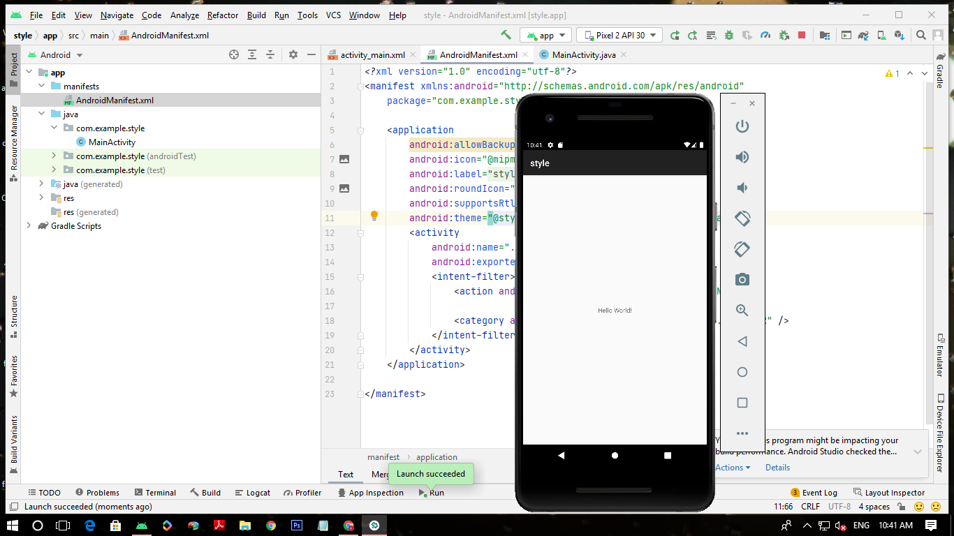

*<?*xml version="1.0" encoding="utf-8"*?>*

<manifest xmlns:android="http://schemas.android.com/apk/res/android"

package="com.example.style">

<application

android:allowBackup="true"

android:icon="@mipmap/ic_launcher"

android:label="@string/app_name"

android:roundIcon="@mipmap/ic_launcher_round"

android:supportsRtl="true"

android:theme="@style/Theme.AppCompat.Light">

<activity

android:name=".MainActivity"

android:exported="true">

<intent-filter>

<action android:name="android.intent.action.MAIN" />

<category android:name="android.intent.category.LAUNCHER" />

</intent-filter>

</activity>

</application>

</manifest>

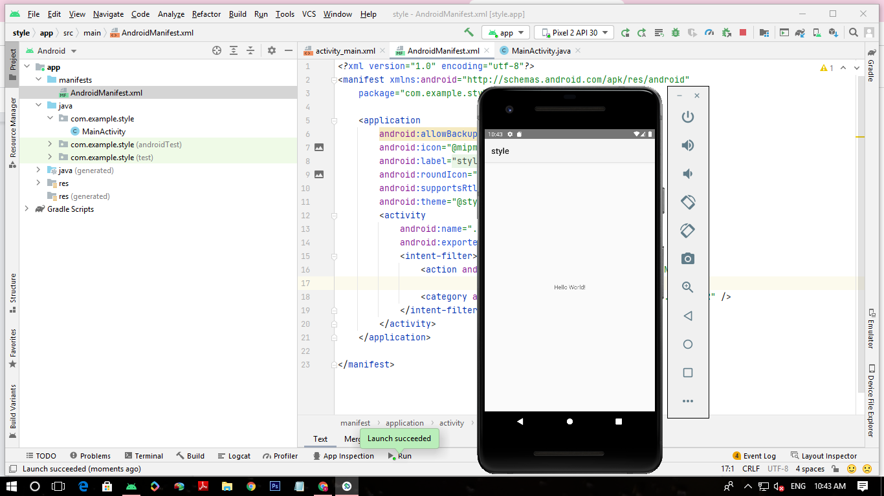

*<?*xml version="1.0" encoding="utf-8"*?>*

<manifest xmlns:android="http://schemas.android.com/apk/res/android"

package="com.example.style">

<application

android:allowBackup="true"

android:icon="@mipmap/ic_launcher"

android:label="@string/app_name"

android:roundIcon="@mipmap/ic_launcher_round"

android:supportsRtl="true"

android:theme="@style/Theme.AppCompat.Light.NoActionBar">

<activity

android:name=".MainActivity"

android:exported="true">

<intent-filter>

<action android:name="android.intent.action.MAIN" />

<category android:name="android.intent.category.LAUNCHER" />

</intent-filter>

</activity>

</application>

</manifest>

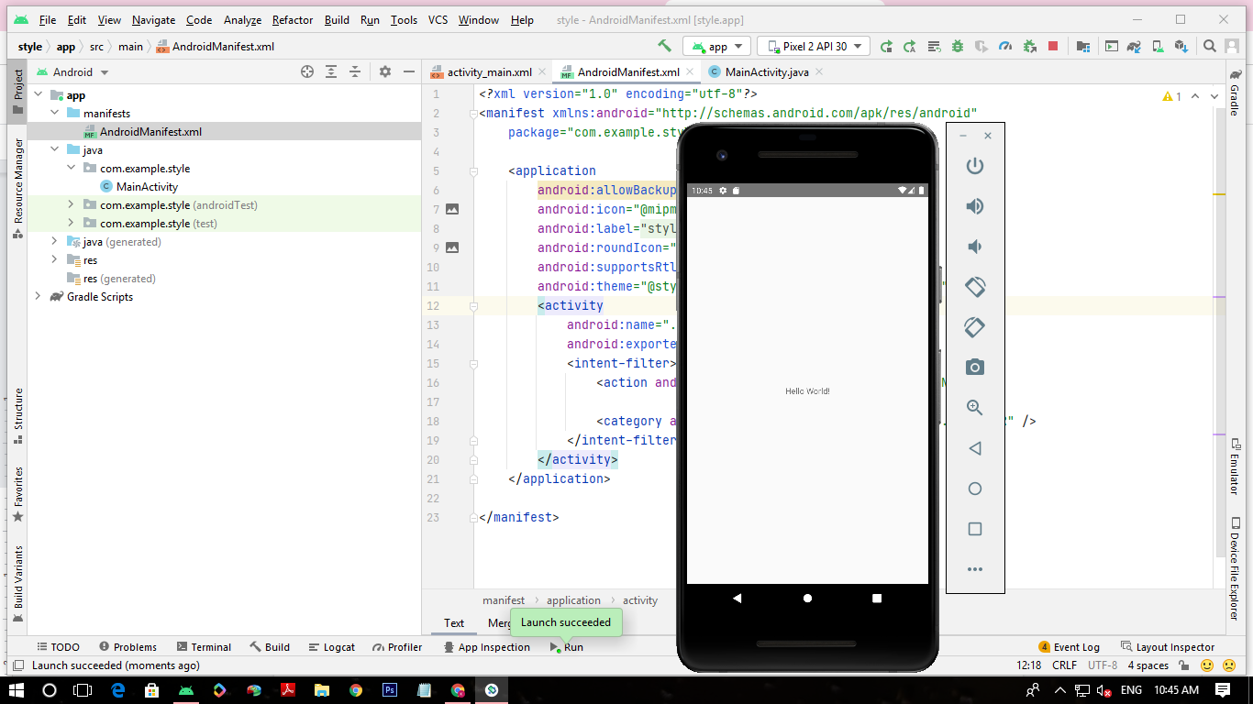

*<?*xml version="1.0" encoding="utf-8"*?>*

<manifest xmlns:android="http://schemas.android.com/apk/res/android"

package="com.example.style">

<application

android:allowBackup="true"

android:icon="@mipmap/ic_launcher"

android:label="@string/app_name"

android:roundIcon="@mipmap/ic_launcher_round"

android:supportsRtl="true"

android:theme="@style/Theme.AppCompat.NoActionBar">

<activity

android:name=".MainActivity"

android:exported="true">

<intent-filter>

<action android:name="android.intent.action.MAIN" />

<category android:name="android.intent.category.LAUNCHER" />

</intent-filter>

</activity>

</application>

</manifest>

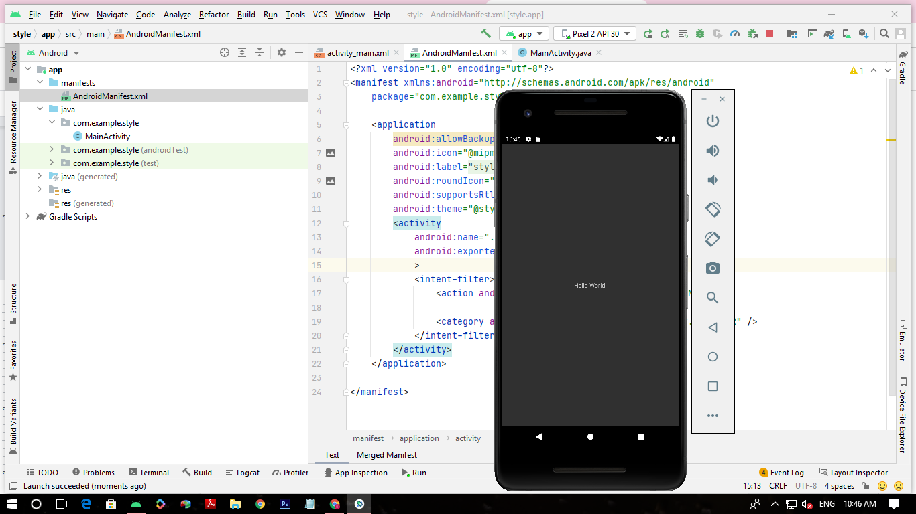

Activity.xml

*<?*xml version="1.0" encoding="utf-8"*?>*

<androidx.constraintlayout.widget.ConstraintLayout xmlns:android="http://schemas.android.com/apk/res/android"

xmlns:app="http://schemas.android.com/apk/res-auto"

xmlns:tools="http://schemas.android.com/tools"

android:layout_width="match_parent"

android:layout_height="match_parent"

tools:context=".MainActivity">

<TextView

android:layout_width="wrap_content"

android:layout_height="wrap_content"

android:text="Hello World!"

app:layout_constraintBottom_toBottomOf="parent"

app:layout_constraintLeft_toLeftOf="parent"

app:layout_constraintRight_toRightOf="parent"

app:layout_constraintTop_toTopOf="parent"

style="@style/mystyle"/>

</androidx.constraintlayout.widget.ConstraintLayout>

Themes.XML

<resources xmlns:tools="http://schemas.android.com/tools">

*<!-- Base application theme. -->*

<style name="Theme.Style" parent="Theme.MaterialComponents.DayNight.DarkActionBar">

*<!-- Primary brand color. -->*

<item name="colorPrimary">@color/purple_500</item>

<item name="colorPrimaryVariant">@color/purple_700</item>

<item name="colorOnPrimary">@color/white</item>

*<!-- Secondary brand color. -->*

<item name="colorSecondary">@color/teal_200</item>

<item name="colorSecondaryVariant">@color/teal_700</item>

<item name="colorOnSecondary">@color/black</item>

*<!-- Status bar color. -->*

<item name="android:statusBarColor" tools:targetApi="l">?attr/colorPrimaryVariant</item>

*<!-- Customize your theme here. -->*

</style>

<style name="mystyle">

<item name="android:textColor">#1BEF70</item>

<item name="android:textStyle">italic</item>

<item name="android:textSize">30sp</item>

</style>

</resources>

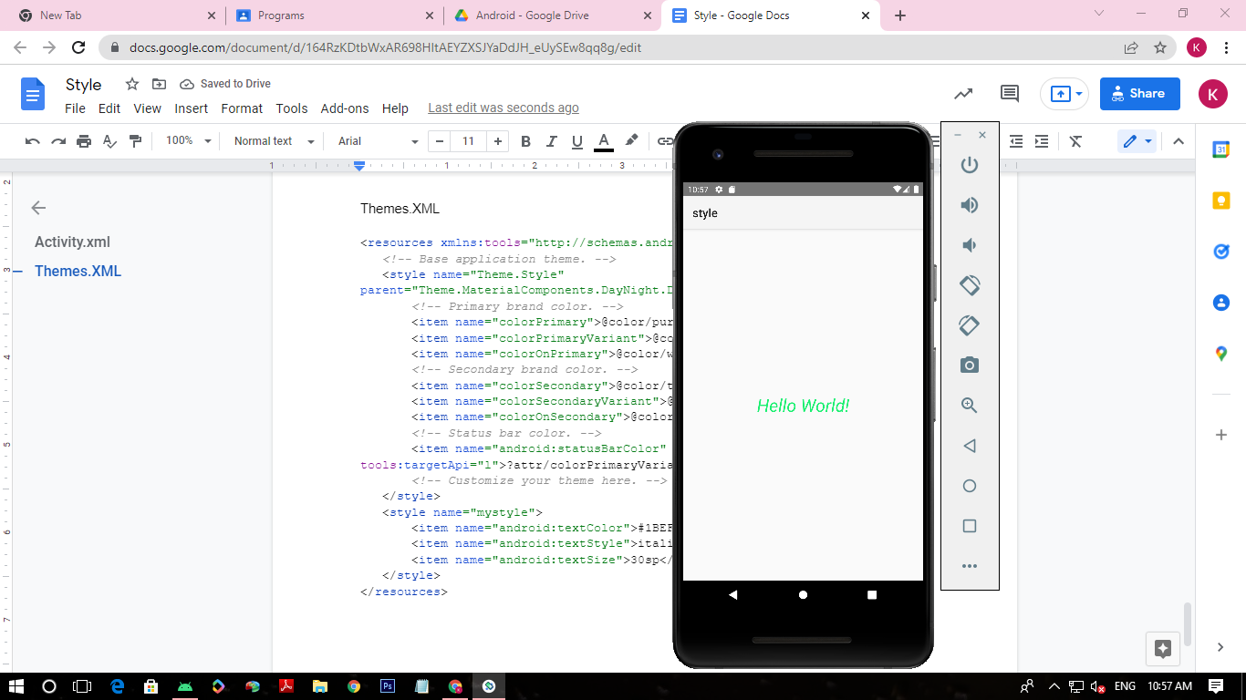

AndroidMAnifest.XML

*<?*xml version="1.0" encoding="utf-8"*?>*

<manifest xmlns:android="http://schemas.android.com/apk/res/android"

package="com.example.style">

<application

android:allowBackup="true"

android:icon="@mipmap/ic_launcher"

android:label="@string/app_name"

android:roundIcon="@mipmap/ic_launcher_round"

android:supportsRtl="true"

android:theme="@style/mystyle">

<activity

android:name=".MainActivity"

android:exported="true"

android:theme="@style/Theme.AppCompat.Light">

<intent-filter>

<action android:name="android.intent.action.MAIN" />

<category android:name="android.intent.category.LAUNCHER" />

</intent-filter>

</activity>

</application>

</manifest>

Themes.XML

<resources xmlns:tools="http://schemas.android.com/tools">

*<!-- Base application theme. -->*

<style name="Theme.Style" parent="Theme.MaterialComponents.DayNight.DarkActionBar">

*<!-- Primary brand color. -->*

<item name="colorPrimary">@color/purple_500</item>

<item name="colorPrimaryVariant">@color/purple_700</item>

<item name="colorOnPrimary">@color/white</item>

*<!-- Secondary brand color. -->*

<item name="colorSecondary">@color/teal_200</item>

<item name="colorSecondaryVariant">@color/teal_700</item>

<item name="colorOnSecondary">@color/black</item>

*<!-- Status bar color. -->*

<item name="android:statusBarColor" tools:targetApi="l">?attr/colorPrimaryVariant</item>

*<!-- Customize your theme here. -->*

</style>

<style name="mystyle" parent="Theme.AppCompat.DayNight.DarkActionBar">

<item name="android:textColor">#1BEF70</item>

<item name="android:textStyle">italic</item>

<item name="android:textSize">30sp</item>

</style>

</resources>

