📊 Analysis: Barriers to Skilled Worker Visa Transition for International Graduates

- Project Overview

Many international graduates in the United Kingdom successfully secure employment after completing their studies. However, a significant proportion are unable to transition from the Graduate Route visa to the Skilled Worker visa, often resulting in their departure from the UK labour market.

This issue has become increasingly relevant following major immigration policy changes introduced in 2024, including higher salary thresholds and revised occupational eligibility criteria. These changes have raised concerns about whether current visa requirements align with the realities of graduate-level employment.

This report examines the structural factors that limit the ability of international graduates to transition to Skilled Worker sponsorship. Specifically, it focuses on the interaction between salary thresholds, occupational eligibility, and sectoral employment patterns. The analysis is based on datasets covering the period between 2024 and 2025, allowing for an assessment of the impact of recent policy changes.

- Objective

This project aims to identify the key structural barriers preventing international graduates from transitioning from the Graduate Route to Skilled Worker sponsorship in the UK.

It addresses the following questions:

- Do UK graduate salaries meet Skilled Worker visa salary thresholds?
- Which sectors and occupations account for the majority of Skilled Worker visa sponsorship?
- How has the distribution of visa sponsorship changed following the 2024 policy reforms?
- To what extent do structural and institutional factors limit access to sponsorship opportunities for graduates?

The hypothesis is that structural constraints within both the labour market and immigration system significantly reduce the likelihood of international graduates transitioning to Skilled Worker visas.

- Data Sources & Preparation

This analysis draws on secondary data from the UK Home Office and the Office for National Statistics to examine the structural barriers affecting international graduates’ transition from the Graduate Route to the Skilled Worker visa. The datasets used include Graduate Labour Market Statistics (2024), which provide information on median salaries by industry for graduates aged 21–30, and Immigration System Statistics (2025), which report Skilled Worker visa grants by sector, occupation, and year. These sources are supplemented by UK Visas and Immigration (UKVI) policy guidance on salary thresholds, eligible occupations, and shortage occupation lists.

The datasets were not available in a directly comparable format and required preprocessing prior to analysis. This involved cleaning, filtering, and restructuring the data to isolate relevant variables such as industry classifications, occupational groups, and salary levels, enabling consistent comparison across sources.

The analysis adopts a quantitative and comparative approach. Graduate salary data is evaluated against the New Entrant Skilled Worker visa threshold (£33,400) to assess the extent to which entry-level earnings meet eligibility requirements. This is complemented by an examination of the distribution of visa grants across sectors and occupations, allowing for comparison between where graduates are employed and where sponsorship opportunities are concentrated.

To further assess access to sponsorship, occupational data is analysed using the Standard Occupational Classification (SOC) framework. Occupations are grouped into higher-skilled (RQF Level 6+) and medium-skilled (RQF Levels 3–5) categories in line with recent policy changes. This enables an evaluation of how skill-level requirements interact with graduate labour market entry points.

Rather than examining these factors in isolation, the analysis integrates salary, sectoral, and occupational dimensions to identify patterns of alignment and mismatch between labour market outcomes and immigration policy requirements. The focus is therefore on identifying structural constraints that shape access to Skilled Worker visa sponsorship.

A limitation of the analysis is its reliance on aggregate data, particularly median salary figures, which do not capture the full distribution of individual earnings or variation within sectors and occupations. As such, the findings should be interpreted as indicative of broader structural trends rather than precise individual-level outcomes.

- Analysis

  - Salary Threshold Constraints

Analysis of graduate salaries across industries (Source: Graduate labour market statistics, 2024) shows that five out of nine sectors have median salaries above the New Entrant Skilled Worker visa threshold of £33,400 (see Figure 1). However, in those five sectors, salaries exceed the threshold only marginally—typically by £1,600 to £2,600—indicating that many entry-level roles operate close to the minimum eligibility requirement. As a result, a substantial proportion of graduates are likely to fall below the threshold despite the median exceeding it. This creates a “cliff-edge” effect, where small variations in pay can determine visa eligibility, making access to sponsorship highly uncertain even within sectors whose median salaries formally meet the requirement.

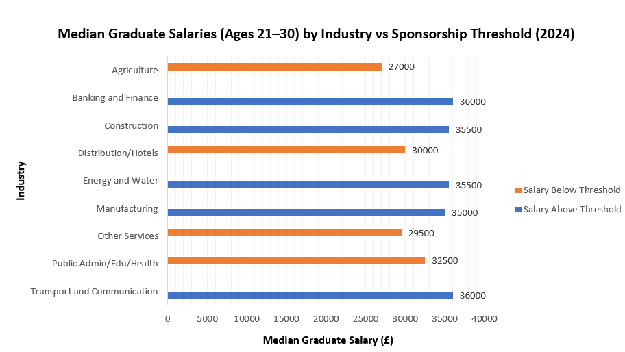
Fig. 1. Median Graduate Salaries (Ages 21–30) by Industry Compared to Sponsorship Threshold (2024)

In contrast, four out of nine sectors fall below the threshold, meaning that approximately 45% of the most common industries employing graduates do not meet the minimum salary requirement for visa eligibility. This suggests that a substantial proportion of graduates are concentrated in sectors where sponsorship is structurally difficult to achieve based on salary criteria alone.

At the aggregate level, the overall median salary for graduates aged 21–30 is £33,250, which falls slightly below the threshold. This reinforces the finding that graduate-level pay is closely aligned with entry-level labour market conditions rather than immigration policy requirements, leaving many graduates just below the level required for Skilled Worker sponsorship.

  - Sectoral Distribution of Employment

The constraints imposed by salary thresholds are further reinforced by the distribution of visa grants across industries (Source: UK Home Office Immigration system statistics 2025). A significant proportion of migrants are concentrated in sectors such as agriculture, public administration, education, health, and other service industries. While these sectors account for a large share of Skilled Worker visa grants, their average salaries for graduates (aged 21–30) as referenced from section 1, tend to fall below the New Entrant threshold of £33,400.

This apparent contradiction can be explained by differences in career stage. Many sponsored roles within these sectors are filled by experienced workers who meet higher salary thresholds or occupation-specific pay requirements. In contrast, graduates entering these industries at entry level are more likely to receive salaries below the required threshold, limiting their ability to access sponsorship despite working in sectors with high levels of migrant employment.

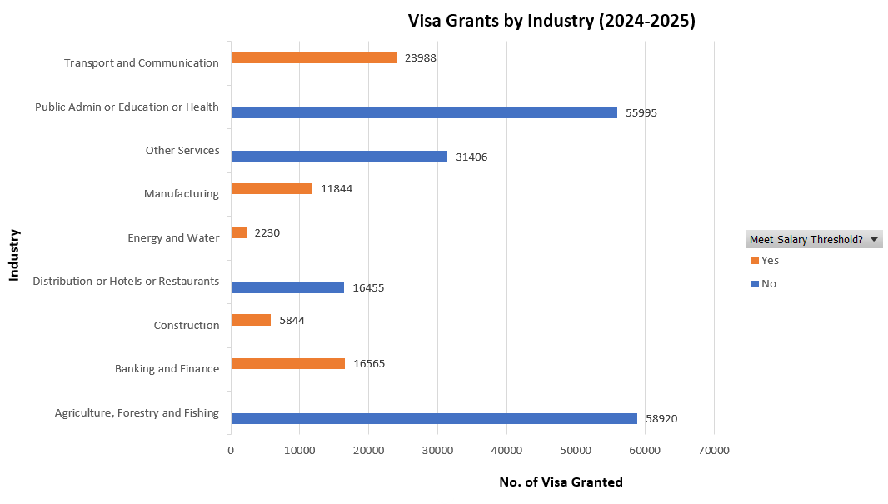
Fig. 2. Visa Granted by Industry between 2024-2025

In comparison, industries that consistently meet or exceed the salary threshold—such as banking and finance, construction, manufacturing, energy and water, and transport and communication – employ a relatively smaller share of migrants, and therefore an even smaller proportion of recent graduates. Although these sectors offer roles that are technically eligible for sponsorship, access to such opportunities remains limited. This reveals a segmentation of the labour market in which sponsorship opportunities are structurally concentrated in roles that are not aligned with graduate entry points.

Taken together, this reveals a segmentation of the labour market in which sponsorship opportunities are structurally concentrated in roles that do not align with typical graduate entry points. Sectors with high levels of migrant employment tend to offer lower-paying roles that fall below visa requirements, while sectors that meet salary thresholds employ relatively fewer graduates. Consequently, access to sponsorable jobs is not evenly distributed but concentrated within a narrow segment of the labour market .

To provide broader context, Figure 3 presents the trend in Skilled Worker visa grants between 2021 and 2025. The data shows a substantial increase in visa grants from 123,306 in 2021 to a peak of 279,501 in 2023, followed by a sharp decline to 154,109 in 2024 and 112,757 in 2025.
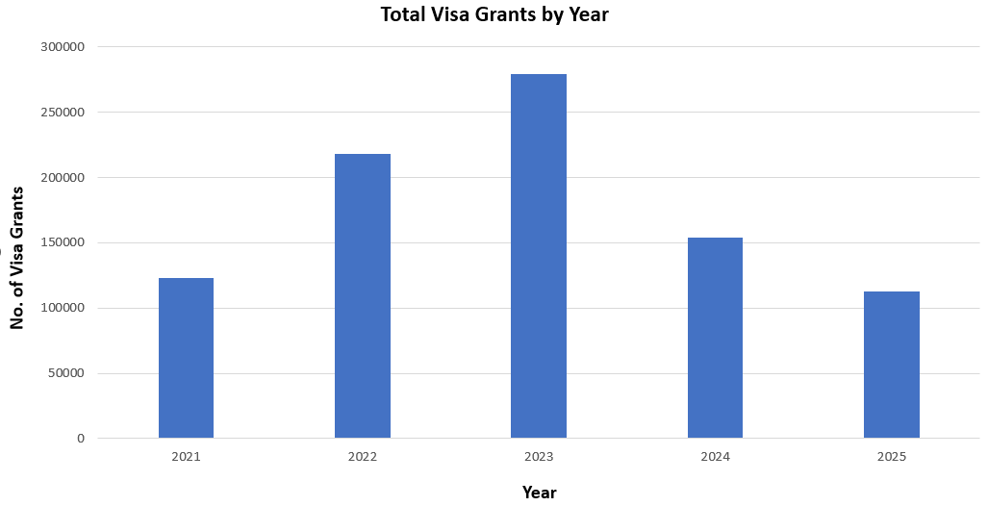
Fig. 3. Total Visa Granted by Year

This reversal coincides with major immigration policy changes introduced in 2024, including higher salary thresholds and more restrictive occupational eligibility criteria. While this report does not focus on long-term trends, the observed decline suggests that recent policy changes may have reduced overall access to Skilled Worker visa sponsorship.

  - Occupational Skill-Level Constraints

Beyond sectoral differences, visa eligibility is also strongly shaped by occupational structure. Occupational structure represents a critical constraint in the transition from the Graduate Route to the Skilled Worker visa. The UK labour market is classified using the Standard Occupational Classification (SOC) system, developed by the Office for National Statistics and applied by the UK Home Office in determining visa eligibility.

Under the policy change implemented on 22 July 2025, occupations are categorised into “higher-skilled” (RQF Level 6+) and “medium-skilled” (RQF levels 3-5) roles. Higher-skilled occupations—primarily Managers, Directors and Senior Officials (SOC 1) and Professional Occupations (SOC 2)—are fully eligible for Skilled Worker visa sponsorship. In contrast, medium-skilled occupations, largely corresponding to Associate Professional roles (SOC 3), are no longer universally eligible and can only qualify for sponsorship if they appear on specific shortage-based lists, such as the Immigration Salary List or Temporary Shortage List (Sources: UKVI Skilled Worker visa: eligible occupations and codes, Immigration Salary List or Temporary Shortage List).

A key limitation of higher-skilled occupations is that they are typically associated with experienced workers rather than recent graduates. Roles within SOC 1 and many SOC 2 occupations often require several years of prior experience, specialised expertise, or managerial responsibility. Although these roles meet visa eligibility criteria, they are not generally accessible to individuals at the early stages of their careers.

This creates a structural mismatch between visa eligibility and graduate labour market entry points. While higher-skilled occupations account for a large share of Skilled Worker visa sponsorship, they do not represent realistic entry-level opportunities for most international graduates. Conversely, roles that are more accessible to graduates—particularly Associate Professional occupations—are subject to greater restrictions in terms of eligibility, salary thresholds, and employer sponsorship. As a result, graduates are effectively positioned outside the primary pathways to visa sponsorship despite active participation in the labour market.

Although many medium-skilled roles meet the formal skill threshold, their conditional eligibility significantly narrows access to sponsorship. In practice, this shifts the functional threshold for visa eligibility towards higher-skilled occupations, further limiting opportunities for early-career workers.

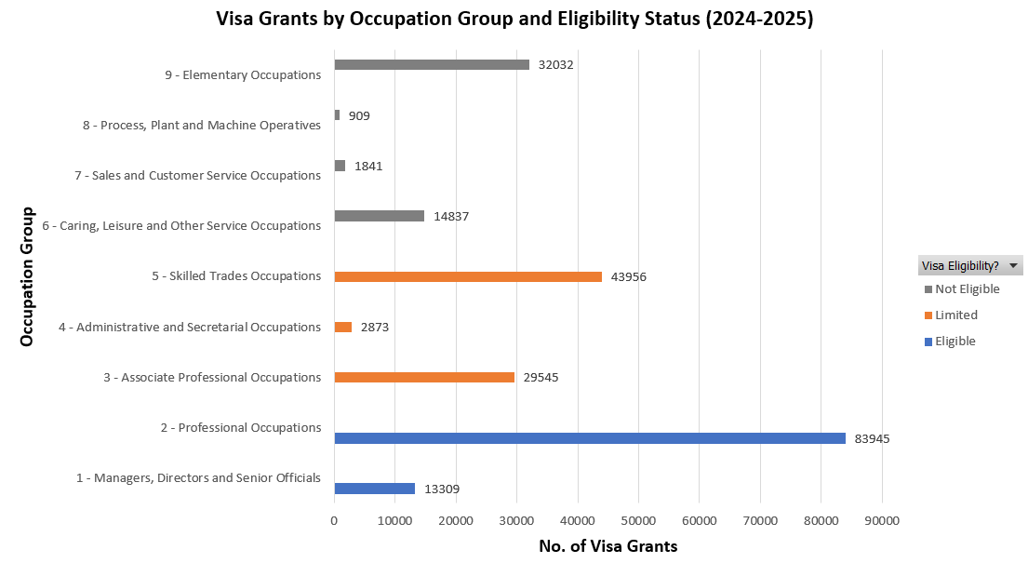
Fig. 4. Visa Grants by Occupational Skill Level (SOC Classification)

Figure 4 illustrates the distribution of Skilled Worker visa grants across occupational groups. The data shows that sponsorship is heavily concentrated in Professional Occupations (SOC 2), with comparatively fewer grants in Associate Professional roles (SOC 3), despite their relevance to graduate employment. This reinforces the finding that eligibility does not translate into accessibility.

At the same time, a substantial number of visa grants are observed in occupations classified as lower-skilled or conditionally eligible, such as Caring, Leisure and Other Service Occupations (SOC 6) and Skilled Trades (SOC 5). These roles often appear on shortage occupation lists and benefit from reduced salary thresholds but are typically not aligned with graduate career pathways.

Taken together, the occupational structure functions as a hierarchical filter within the visa system. Higher-skilled roles provide clear routes to sponsorship but remain largely inaccessible to graduates due to experience requirements. Medium-skilled roles, which align more closely with early-career employment, are constrained by policy restrictions. Meanwhile, lower-skilled roles may offer sponsorship through exception mechanisms but fall outside typical graduate trajectories.

Consequently, occupational structure acts as a hierarchical filter within the visa system. Graduates are not only required to be employed but must also be positioned within a narrow set of occupations that satisfy multiple criteria simultaneously. This significantly reduces the likelihood of transitioning to Skilled Worker sponsorship and reinforces the broader structural barriers identified in this study.

- Key Insights

The findings of this analysis indicate that barriers to transitioning from the Graduate Route to the Skilled Worker visa are structural and mutually reinforcing. Salary thresholds, sectoral employment patterns, and occupational eligibility criteria do not operate independently; rather, they interact in ways that collectively restrict access to sponsorship for international graduates.

A key issue is the misalignment between graduate labour market outcomes and visa requirements. Although some sectors meet the Skilled Worker salary threshold, graduate salaries are often clustered around or just below the eligibility cutoff, meaning that a significant proportion of graduates remain ineligible despite being employed. At the same time, many sectors that employ large numbers of graduates tend to offer lower-paying roles that fall below sponsorship requirements.

This misalignment is reinforced by sectoral distribution. Sectors with high levels of Skilled Worker visa sponsorship do not necessarily provide accessible pathways for graduates, as many sponsored roles are occupied by experienced workers. Conversely, sectors that meet salary thresholds tend to employ fewer graduates, limiting access to eligible roles.

Occupational structure further intensifies these constraints. Higher-skilled roles, which provide clearer routes to sponsorship, are typically inaccessible to graduates due to experience requirements. In contrast, medium-skilled roles that align more closely with entry-level employment are subject to stricter eligibility conditions following recent policy changes. This creates a situation in which graduates are active in the labour market but positioned outside the main pathways to sponsorship.

In addition, employer behaviour may further influence access to sponsorship. Sponsorship involves financial and administrative costs, which may reduce willingness to sponsor early-career employees. However, this factor is considered secondary within the scope of this analysis.

Overall, the findings suggest a structural mismatch between immigration policy design and graduate labour market realities, where access to sponsorship is shaped by overlapping constraints rather than a single barrier.

- Conclusion

This study examined the structural factors affecting the transition of international graduates from the Graduate Route to the Skilled Worker visa in the UK. The findings demonstrate that the transition is constrained not by a lack of graduate employment, but by a misalignment between labour market conditions and immigration policy requirements.

Although international graduates successfully enter the UK labour market, they are concentrated in roles and sectors that frequently fall below salary thresholds or do not meet eligibility criteria. At the same time, roles that satisfy visa requirements are often positioned at higher skill levels and are therefore inaccessible at the early stages of a graduate career.

Overall, the evidence indicates that the Skilled Worker visa system functions less as a broad post-study retention pathway and more as a selective mechanism that filters individuals based on salary level, occupational status, and sectoral distribution. As a result, employment alone is insufficient to guarantee progression onto long-term skilled migration routes.

These findings highlight a structural tension between post-study work policy objectives and labour market realities, where eligibility for long-term residence is determined by a narrow set of economic and occupational criteria rather than graduate participation in employment.

This study examined the barriers affecting international graduates’ transition from the Graduate Route to the Skilled Worker visa in the UK. It found that access to sponsorship is shaped by a combination of structural constraints within both the labour market and immigration system.

Overall, the evidence indicates that the transition to Skilled Worker sponsorship is restricted by a misalignment between graduate-level employment conditions and visa eligibility requirements. While graduates participate actively in the labour market, the available routes to sponsorship are concentrated in roles and sectors that do not typically align with entry-level positions.

The findings suggest that the current visa framework is primarily structured around experienced and higher-paid employment, rather than early-career progression. As a result, the pathway from study to long-term skilled employment is narrow and uneven for international graduates.

These results highlight a broader tension between post-study work policy objectives and labour market realities, where participation in employment does not necessarily translate into eligibility for long-term residency pathways.

