**Project Summary**

Scrum Poker Planning is a web application that has the purpose of replicating the Scrum Poker Planning method in an online format.

Scrum poker is a consensus-based, gamified technique for estimating, mostly used to estimate effort or relative size of the development goals in software development. In planning poker, members of the group make estimates by playing numbered cards face-down to the table, instead of speaking them aloud. The cards are revealed, and the estimates are then discussed. By hiding the figures in this way, the group can avoid the cognitive bias of anchoring, where the first number spoken aloud sets a precedent for subsequent estimates.

The idea is to build a Web application that can be used to replicate that method in the Work from home environment that we are living in those days.

**Background**

The idea of building this project came from a directly observation that as we changed our company to a Work-From-Home environment, we lost the ability to use Scrum planning efficiently.

People cannot avoid the cognitive bias of anchoring, seeing others estimates before choosing, so then we got less conflict between the choices, therefore causing less discussion about a topic that should be discussed.

The idea was well sold to the company where I work (Cloudsphere), and they will implement and user this software on a weekly basis.

**Objectives**

* Create a Web Application with user control, hosted in an Azure environment allowing a team to make planning sessions.
* Implement the Code using C# Core 3.1
* Implement Source control using GIT and GITHUB
* Implement Continuous integration between GIT and AZURE
* Implement a WebApi to ability the scalable of the application
* Implement a MSSQL Server Database
* Host the database in a remote and secure host
* Implement JIRA as project and task control
* Use Kanban as agile methodology
* Implement tests using the Mock Framework

**Technical Requirements**

Coding

* Visual Studio 2019
* C# ASPNET Core 3.1
* Razor Pages as Main Layout for the ASPNET
* Javascript
* JQuery
* CSS
* HTML 5
* Entity Framework

Source Control

* GIT
* GITHUB

Project and Tasks control

* JIRA

Hosting and CI

* Azure
* Gear Host

Database

* MS SQL

**Risk Assessment**

The risks of the project are associated mostly with information security, to minimize those risks the technology used are:

* Core technology from Dotnet
* Bearer Token in the Web API as Authentication method
* IdentityUser from Dotnet used to protect passwords and to control the session of the users in the application
* Email confirmation on user singing up

**Project Methodology/Approach**

* The source control of the project is in a public GIT repository (<https://github.com/sanchessls/PersonalSanches>)
* The Documentation is under a folder called Documentation
* Jira holds all the changes and modifications (https://pokerplanningsession.atlassian.net/)
* Kanban is being used as agile methodology under JIRA to control the entire flow of the application modifications and improvements
* Test are being made with the Mocking Framework
* The Database is documented under the code since is a Code first created database, generated by the entity framework, the database graphic will be available on the documentation folder

**Project Plan**

This is the Gantt chart from JIRA, directly taken from the real schedule from the project

https://pokerplanningsession.atlassian.net/

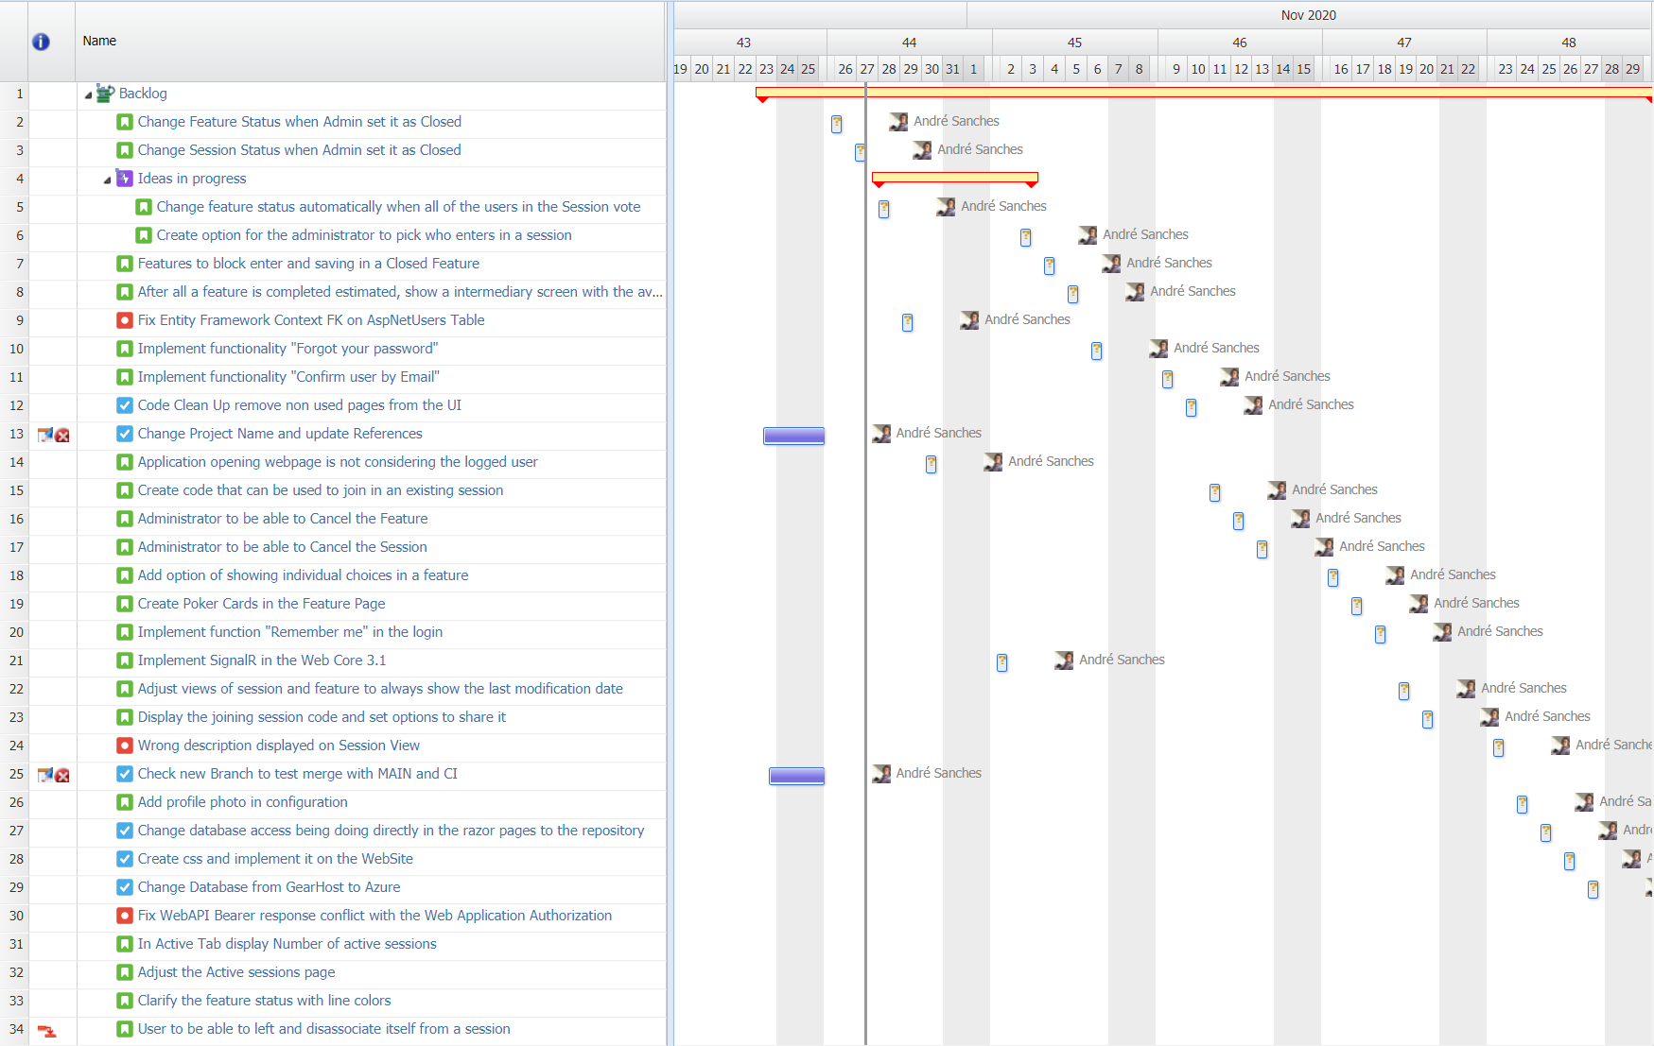

**Conclusion**

This project has great potential of supply a real demand, in a simple and objective way.

It will be implemented and used by a big software company (Cloudsphere) that uses scrum as agile methodology and scrum poker planning as features and tasks estimative.

The application will have an interactive and adjustable design to simplify the users experience, working also in a mobile environment through a web browser.

**Bibliography/ Reference**

Docs.microsoft.com. 2020. *ASP.NET Documentation*. [online] Available at: <https://docs.microsoft.com/en-us/aspnet/core/?view=aspnetcore-3.1> [Accessed 27 October 2020].

Azure.microsoft.com. 2020. *Cloud Computing Services | Microsoft Azure*. [online] Available at: <https://azure.microsoft.com/en-gb/> [Accessed 27 October 2020].

GitHub. 2020. *Github: Where The World Builds Software*. [online] Available at: <https://github.com/> [Accessed 27 October 2020].

Atlassian. 2020. *Jira | Issue & Project Tracking Software | Atlassian*. [online] Available at: <https://www.atlassian.com/software/jira> [Accessed 27 October 2020].

Gearhost.com. 2020. *.NET And PHP Cloud Hosting | Gearhost*. [online] Available at: <https://www.gearhost.com/> [Accessed 27 October 2020].