Control of Mobile Robotics

Spring 2016

Lab 3

Sensors and Actuators

11 April, 2016

Gerardo Sanchez

Adeoluwa Oyenusi

**Task Description**

The objective of this lab is to develop an algorithm to navigate, localize, and build maps for three different mazes. The lab is divided into 3 tasks.

1. This task requires us to develop an algorithm to navigate all of 3 different mazes and the robot must visit each cell at least once. The robot can start in any cell and must complete the navigation without any human intervention.
2. This task requires us to develop an algorithm to navigate the mazes and mark which cells have been visited. “0” represents the visited cells and “X” represents the cells that have not been visited. These will be displayed on the LCD display. Additionally, the LCD must provide a flashing color every time the robot moves to a new grid. When moving to a grid on the right, the color red will be flashed, when moving to a grid on the left, green will be flashed, when moving to a grid up, blue will be flashed, and when moving to a grid down, yellow will be flashed. Other than these cases, the LCD should show a white background.

**Navigation**

*Video link:*

For the purposes of navigating through a maze, the mobile robot is configured to wall follow and to detect corners. Our navigation algorithm is focused on sensor readings from the LEFT and FRONT infrared sensor. Using left wall following, the system has a variable speed component that will adjust the robot to follow the wall accordingly, given a specified threshold.

In addition to this, there are two scenarios that the robot will encounter in a maze and they have their respective behaviors. For example, when encountering a corner whilst wall following, the robot will sample the FRONT sensor multiple times to ensure the presence of a wall. Upon confirmation of the vicinity of the front and left wall, the robot will initiate a RIGHT turn sequence. The RIGHT turn sequence is set to an arbitrary delay that will rotate the robot 90 degrees to evaluate further conditions in the maze. The robot will take a proper course of action to prevent colliding into walls. Our algorithm comes equipped with a failsafe algorithm that will double check the sensor conditions to avoid false positives.

There are cases where the robot may not have a wall to follow, it will assume that it needs to make a LEFT turn until it finds a wall to follow. This will allow the robot to overcome paths that require more than one left turn. With this final component of the navigation algorithm, the robot proves successful when traversing all three configurations of the mazes.

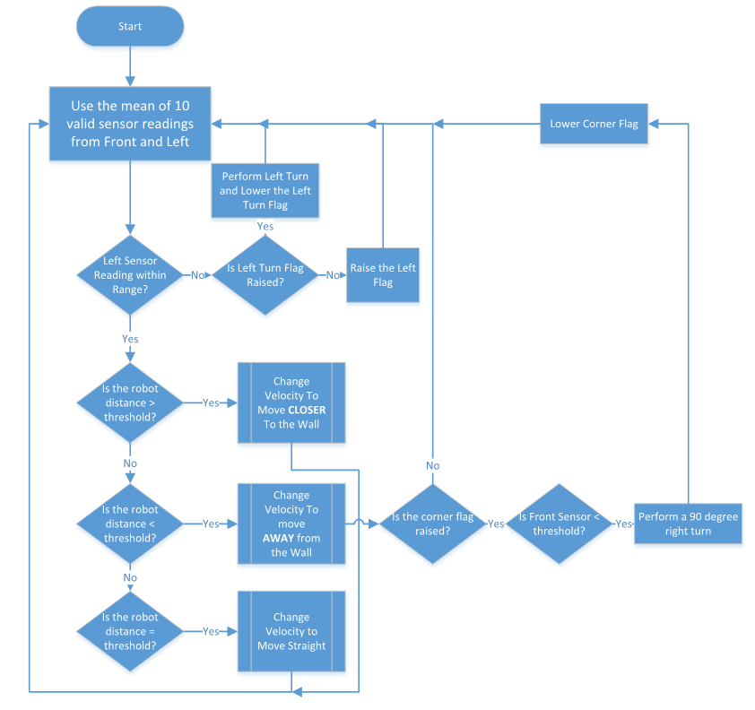

**Figure 1 - Navigation Test**

**Localization**

*Video link:*

The localization technique is a continuation of the navigation algorithm which integrates a conscious orientation for the robot to utilize. The localization algorithm requires a known starting position and direction. From this, the robot will be able to recognize any direction and properly mark new cells as visited. A counter has been implemented into the sampling algorithm which represents roughly the number of samples that can occur within the traversal of a cell. This counter will help keep track of when a whole cell has been traversed since the last left or right turn.

We can extrapolate the direction and the counter value to mark cells as visited via a 2D array representation of the maze. The data structure represents all the cells in the grid and it will be scanned constantly throughout the robot’s traversal of the maze. The robot will stop only when all cells have been visited; otherwise, it will continue to perform the navigation techniques in the previous part.

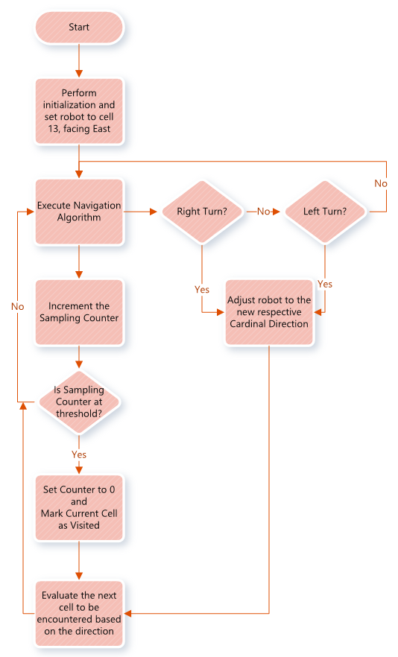

**Figure 2 – Localization Test**

**Code Description**

**Navigation**

Description

Code

**Localization**

Description

Code

**Mapping**

Description

Code

**Conclusion**

This lab proved to be arduous and unintuitive. The variance in battery levels made it very hard to develop working code for the system. While the T.A. and the professor helped with techniques for the shortcomings, it would have been nice to know how to deal with such problems before exhausting all the other ideas. Otherwise, it was pleasurable being able to implement traversal functionality into a system, it is a novel concept and was very rewarding.