Supplementary material for: A reproducible computational framework for decoupled wildfire ignition and propagation benchmarking in the Gran Chaco (2018–2025)
  - D2 target construction, calibration, evaluation protocol, extended tables and figures
Author: Martín Sánchez Insfrán
Independent Researcher, Asunción, Paraguay
E-mail: sanchez.martin093@gmail.com · ORCID: 0000-0003-4138-9668

Supplementary contents
Click any entry to jump to the corresponding note, table or figure.
Supplementary notes (5 entries)
• Note S1. Data, D2 target construction, quality control and sampling
• Note S2. Bounded monotonic Platt calibration and hyperparameters
• Note S3. Evaluation protocol and extended analyses
• Note S4. Implementation of the FWI and INPE indices
• Note S5. Robustness analyses
Tables (41 entries)
• Table S1. Variable dictionary and physical role of the predictors.
• Table S2. Operational and ablation hyperparameters.
• Table S3. D2 test performance by department.
• Table S4. Stage-level profile for 2024-09-09.
• Table S5. Empirical conformal coverage. These values are not a formal guarantee under temporal shift.
• Table S6. Population-level evaluation with prevalence correction (retrospective 2024–2025 test).
• Table S7. Paired ROC-AUC differences for the six confirmatory comparisons (four against FWI and INPE and two M3−M2)...
• Table S8. Full spatial block results on 2023 development blocks.
• Table S9. Evaluation with t-1 weather (24-h anticipation) on 2023 validation.
• Table S10. D2 sampling counts and class ratios.
• Table S11. Full benchmark on the retrospective 2024–2025 test.
• Table S11 (continued). GBT with the M3 feature set plus full FWI and local INPE risk. ΔROC is this model minus M3,...
• Table S12. Controlled ablation of M1, M2 and M3 on the retrospective 2024–2025 test. Models were retrained for this...
• Table S13. Mean absolute TreeSHAP values for the hybrid ignition model.
• Table S14. Cost-loss values by region, task, model and , with 95 % date-grouped bootstrap intervals (B = 1 000). FW...
• Table S14 (continued). Threshold and metric sensitivity. Cutoffs for F0.5, F1, F2 and Youden are selected on 2023 v...
• Table S15. Data audit log generated by the repository checks.
• Table S16. M1 biophysical baseline on 2023 validation.
• Table S17. Operational gated M3/M2 policy on the retrospective 2024–2025 test. M3 is used where freq_hist_1km > 0;...
• Table S18. Independent spatial confirmation holdout on 2023. Models were retrained excluding the 31 confirmation bl...
• Table S19. Coupled t-1 baseline versus the decoupled task architecture on the combined fire sample. The coupled bas...
• Table S20. D2 sensitivity with full retraining. Each row is an independent run: the 1:10 ignition sample was regene...
• Table S21. Weather-only GBT baseline on the retrospective 2024–2025 test. The model uses the same learner, capacity...
• Table S22. Sensitivity of the INPE Fire Risk to the flammability constant A on the retrospective 2024–2025 test. Th...
• Table S23. Net benefit per 1 000 sampled cell-days at selected threshold probabilities from the decision curve anal...
• Table S23 (continued). Operational load at the frozen population cutoff and at top-k alert budgets (K = 10, 50, 100...
• Table S24. Paired date-grouped bootstrap differences in decision value, ΔV(α) = V(M3) − V(reference), for M2 and FW...
• Table S25. Stability of M2 and M3 to random seed and capacity (5 seeds × 2 capacities per region). The high-capacit...
• Table S26. Rolling-origin backtest. Each fold trains through Y−2, validates on Y−1 (cutoff and Platt calibration),...
• Table S27. Train/test overlap sensitivity on the retrospective 2024–2025 test. Metrics are recomputed with the froz...
• Table S27 (continued). Paired M3 − M2 ROC-AUC and PR-AUC differences by subset. Positive values favor M3. Intervals...
• Table S28. Sampling-ratio sensitivity. The 1:5 row downsamples training negatives from the frozen 1:10 sample; the...
• Table S29. Adversarial validation between training (2018–2022) and test (2024–2025) rows using the M3 feature set....
• Table S30. VIIRS label-quality variants. high_confidence keeps high-confidence detections; frp_ge_10 keeps detectio...
• Table S31. Gate threshold ablation. The baseline gate is VPD ≥ 0.8 kPa and 48-h rainfall < 10 mm; stricter variants...
• Table S32. Negative control and permutation importance. The negative control retrains M3 with permuted training lab...
• Table S33. External spatial validation in Boquerón. Boquerón and a 25-km buffer were excluded from training and val...
• Table S33b. Buffer sensitivity for the Boquerón external validation. M2/M3 were retrained with 20, 25 and 30 km buf...
• Table S34. G0-C external validation in Formosa (case-control, 1:10). M2/M3 are frozen Chaco boosters with Platt rec...
• Table S34b. G0 arms and mandatory sensitivities. ROC-AUC is shown as M2/M3. H-C is not comparable to the primary re...
• Table S34c. Classic benchmarks in Formosa (case-control, 1:10). The Canadian FWI and the INPE Fire Risk were comput...
Figures (10 entries)
• Figure S1. TreeSHAP comparison for the hybrid ignition model. The two regions use separate models and feature sets.
• Figure S2. Controlled ablation under the D2 test. The figure complements Table S12.
• Figure S3. Cost-loss curves with 95 % date-grouped bootstrap bands (B = 1 000). The propagation panel uses the full...
• Figure S4. Decision curve analysis: net benefit per 1 000 sampled cell-days as a function of the threshold probabil...
• Figure S5. Rolling-origin ROC-AUC by test year for M1, M2 and M3. Numbers next to M3 are ΔROC(M3−M2).
• Figure S6. Validation precision, recall, F0.5, F1 and F2 versus cutoff for M3 ignition and the propagation model, b...
• Figure S7. Permutation importance of the M3 features on the retrospective test (mean ΔROC after shuffling, three re...
• Figure S8. Population precision as a function of the daily alert budget. Curves sweep the population-corrected scor...
• Figure S9. External validation in Boquerón: ROC and precision–recall curves for M2, M3, FWI and INPE on 2024–2025.
• Figure S10. External cross-country validation in Formosa. ROC and precision–recall curves for G0-C in 2024 (left) a...

Supplementary Note S1. Data, D2 target construction, quality control and sampling
VIIRS active-fire detections from Suomi-NPP, NOAA-20 and NOAA-21 are acquired as 375-m cross-track swaths from NASA FIRMS (NASA FIRMS, 2026). At the swath edge the projected pixel can reach approximately 1.6 km along scan and 0.8 km along track, producing the geometric Bow-Tie effect: repeated detections of the same fire, dilution of fire radiative power (FRP) over a larger apparent area and incorrect assignment to the national 1-km² grid (Schroeder et al., 2014). The implemented kinematic filter is
$$D_{\text{filtered}}=\left\{f∈D_{\text{raw}}∣\text{scan}(f)≤1.5 \text{km} ∧ \text{confidence}(f)≠\text{’low’}\right\}.$$
The observed maximum scan in the study window was 0.8 km, so the rule removed no records but remains active for orbital windows with larger view angles. Duplicate overpasses on the same civil date are consolidated by 1-km² cell, retaining num_focos_dia, max_frp_dia and sum_frp_dia.
D2 separates primary ignition from tactical propagation. Let $F_{t}$ be the set of cells with a thermal detection on day $t$. D2 ignition at cell $i$ and day $t$ requires (i) $i∈F_{t}$, (ii) no cell in $F_{t−1}$ within 25 km and (iii) no detection in cell $i$ during the preceding 10 days. D2 propagation requires $i∈F_{t}$ and at least one cell in $F_{t−1}$ within 25 km. Same-cell detections recurring within 2–10 days without an active neighbor within 25 km on day $t−1$—typically multi-day smoldering holdovers or cloud-obscured satellite omissions—are not assigned to either positive target set; they remain candidate negatives, which prevents holdover persistence from entering the ignition target. The two target sets are disjoint. The 25-km threshold defines the target domain and is not a negative-sampling buffer; no 20-km buffer is applied to the test set. The 20-km buffer is used only in the spatial block holdout.
The case-control sample is drawn at 1:10 per task and region. Training uses 2018–2022, validation uses 2023 and the test is the frozen 2024–2025 period. Population denominators are kept separately and are used for prior correction. The same test rows are used for every model, FWI and INPE, so comparisons are paired. Sampling counts and class ratios are in Table S10. The variable dictionary is in Table S1; the full audit log is in Table S15.
Data quality checks collapse duplicate VIIRS overpasses, remove low-confidence detections, reconstruct daily precipitation from sub-daily increments and reject impossible values above 300 mm/day. ERA5-Land nodes (Muñoz-Sabater et al., 2021) are mapped to cells with a precomputed cKDTree. The processed data archive contains test targets, probabilities, benchmark layers, sampling plans and trained artifacts, so the result tables can be regenerated without the raw multi-terabyte archive.

Supplementary Note S2. Bounded monotonic Platt calibration and hyperparameters
Let $z_{i}∈R$ be the margin produced by the LightGBM ensemble (Ke et al., 2017) for cell $i$, and let $y_{i}∈\{0,1\}$ be the binary fire label. Standard Platt scaling (Platt, 1999) estimates $w,b∈R$ by minimizing binary cross-entropy:
$$L(w,b)=−\sum_{i=1}^{M}{\left[y_{i}logσ(wz_{i}+b)+(1−y_{i})log(1−σ(wz_{i}+b))\right]}, σ(v)=\frac{1}{1+e^{−v}}.$$
If and only if $w>0$, the map $p(z)=σ(wz+b)$ is strictly increasing and preserves the ranking of the ensemble. Its derivative is
$$\frac{dp}{dz}=w σ(wz+b) [1−σ(wz+b)],$$
and the sigmoid factor is strictly positive, so $sign(dp/dz)=sign(w)$. A positive slope therefore leaves ROC-AUC unchanged. Unconstrained logistic regression can converge to $w<0$ under extreme imbalance or bimodal margins, inverting the ranking and turning a ROC-AUC of 0.77 into 0.23.
The implementation minimizes a bounded Brier loss with L-BFGS-B in src/modelo.py:
$$\min_{w,b}\frac{1}{M}\sum_{i=1}^{M}{{\left(y_{i}−\frac{1}{1+exp(−(wz_{i}+b))}\right)}^{2}}, 0.10≤w≤10.00, −10.0≤b≤10.0.$$
The lower bound guarantees strict monotonicity and prevents gradient collapse in asymptotic regions. Calibration is fitted on 2023 and frozen for 2024–2025. The same cutoff logic is used for M1, M2, M3 and propagation; cutoffs are selected on validation with an F0.5 criterion and applied after prior correction. Hyperparameters are in Table S2. The ablation uses a common capacity (45/60 rounds and 23/31 leaves) to isolate the feature effect.

Supplementary Note S3. Evaluation protocol and extended analyses
The harness is fixed before the test is opened. It contains five components:
(1) A strictly temporal split: training 2018–2022, validation 2023 and test 2024–2025.
(2) A 50-km spatial block holdout with a 20-km buffer; priors are recomputed without held-out fires.
(3) A paired bootstrap grouped by date ($B=1 000$) for confidence intervals and differences against FWI (Van Wagner, 1987) and INPE (Setzer et al., 2019).
(4) A lead-time analysis using t-1 weather to quantify the nowcast-to-forecast gap.
(5) Population-level, conformal and cost-loss analyses.
Bootstrap resampling is by date, not by row, because daily fire activity is strongly clustered. All cells from a sampled date are retained; this preserves within-day dependence. The spatial holdout removes an entire 50-km block plus a 20-km buffer, recomputes historical priors without the held-out fires and evaluates both held-in and held-out cells. The primary metrics are ROC-AUC and PR-AUC; Brier score, expected calibration error, precision, recall, F0.5 and false positives are also reported. AUC intervals use 500 grouped bootstrap replicates; paired differences use 1 000. The six confirmatory comparisons are corrected with Holm–Bonferroni and Benjamini–Hochberg; all remain significant at α = 0.05. The bootstrap resolution is 0.001, so adjusted values at the floor are upper bounds.
The full benchmark is in Table S11 and its continuation, paired significance in Table S7, the complete spatial block results in Table S8 and the lead-time results in Table S9. Seed/capacity stability, the rolling-origin backtest and adversarial validation are in Tables S25, S26 and S29 and Figure S5; threshold sensitivity is in Table S14 (continuation) and Figure S6. The controlled ablation is in Table S12 and Figure S2; SHAP is in Table S13 and Figure S1; population evaluation is in Table S6; conformal coverage is in Table S5; cost-loss is in Table S14 and Figure S3. The computational profile is in Table S4. All analyses use the frozen test rows archived with the code release.

Supplementary Note S4. Implementation of the FWI and INPE indices
This note documents the two benchmark indices exactly as they are implemented. The full Canadian FWI is produced by scripts/02d_calcular_fwi_completo.py from src/fwi.py; the INPE Risco de Fogo by scripts/02e_calcular_inpe.py from src/inpe.py; the benchmark joins both to the 1-km grid by nodo_clima_id and fecha in scripts/13_benchmarking_modelos.py. Neither index was fitted to the fire labels.

S4.1 Canadian Fire Weather Index

Fuel codes
The standard six-code system is implemented without a custom fuel type:
- FFMC (Fine Fuel Moisture Code): moisture of surface litter and fine fuels (approximately the top 1–2 cm); scale 0–101.
- DMC (Duff Moisture Code): moisture of the loosely compacted organic layer; medium-term drying.
- DC (Drought Code): moisture of the deep, compacted organic layer; seasonal drought storage.
- BUI (Buildup Index): fuel available for combustion, derived from DMC and DC.
- ISI (Initial Spread Index): initial spread potential, derived from FFMC and wind.
- FWI (Fire Weather Index): frontal fire intensity, derived from ISI and BUI.

Equations
Let $F_{t}$, $D_{t}$ and $Q_{t}$ be FFMC, DMC and DC on day $t$; let $T$ be the 15:00 UTC temperature (°C), $H$ the corresponding relative humidity (%), $W$ the 10-m wind speed (km h⁻¹) and $r$ the 00–24 h rainfall (mm). The recursion is applied per node in chronological order.
The fine-fuel moisture content is
$$m_{t−1}=\frac{147.2(101−F_{t−1})}{59.5+F_{t−1}}.$$
For $r>0.5$ mm, with $r_{f}=r−0.5$,
$$m_{0}=m_{t−1}+42.5 r_{f} e^{−100/(251−m_{t−1})}\left(1−e^{−6.93/r_{f}}\right)+ϵ,$$
where $ϵ=0.0015(m_{t−1}−150)^{2}\sqrt{r_{f}}$ is the small correction term coded in src/fwi.py; $m_{0}$ is capped at 250. The equilibrium moisture contents are
$$E_{d}=0.942H^{0.679}+11e^{(H−100)/10}+0.18(21.1−T)(1−e^{−0.115H}),$$
$$E_{w}=0.614H^{0.753}+10e^{(H−100)/10}+0.18(21.1−T)(1−e^{−0.115H}).$$
The drying and wetting rates are
$$k_{d}=\left[0.424\left(1−{\left(\frac{100−H}{100}\right)}^{1.7}\right)+0.0694\sqrt{W}\left(1−{\left(\frac{100−H}{100}\right)}^{8}\right)\right]0.581e^{0.0365T},$$
$$k_{w}=\left[0.424\left(1−{\left(\frac{H}{100}\right)}^{1.7}\right)+0.0694\sqrt{W}\left(1−{\left(\frac{H}{100}\right)}^{8}\right)\right]0.581e^{0.0365T}.$$
The moisture content after one day is
$$m_{t}=\left\{\begin{matrix}E_{d}+(m_{0}−E_{d}){10}^{−k_{d}}, & m_{0}<E_{d}, \\ E_{w}+(m_{0}−E_{w}){10}^{−k_{w}}, & m_{0}>E_{w}, \\ m_{0}, & \text{otherwise,}\end{matrix}\right.$$
and
$$F_{t}=clip\left(\frac{59.5(250−m_{t})}{147.2+m_{t}}, 0, 101\right).$$
For DMC, when $r>1.5$ mm,
$$r_{e}=0.92r−1.27, m_{0}=20+280e^{−0.023D_{t−1}},$$
$$b=\left\{\begin{matrix}100/(0.5+0.3D_{t−1}), & D_{t−1}≤33, \\ 14−1.3lnD_{t−1}, & 33<D_{t−1}≤65, \\ 6.2lnD_{t−1}−17.2, & D_{t−1}>65,\end{matrix}\right.$$
$$m_{r}=m_{0}+\frac{1000r_{e}}{48.77+br_{e}}, D^{′}=43.43(5.6348−ln(m_{r}−20)),$$
with $D^{′}$ floored at zero; when $r≤1.5$ mm, $D^{′}=D_{t−1}$. The daily update uses
$$T_{+}=max(T,−1.1), H_{c}=clip(H,1,100),$$
$$K=1.894(T_{+}+1.1)(100−H_{c})L_{e}{10}^{−4}, D_{t}=D^{′}+K,$$
where $L_{e}$ is the effective day-length factor. For the study domain (20°S), the twelve monthly values are $L_{e}=(10.1,9.6,9.1,8.5,8.1,7.8,7.9,8.3,8.9,9.4,9.9,10.2)$.
For DC, when $r>2.8$ mm,
$$r_{d}=0.83r−1.27, Q_{0}=800e^{−Q_{t−1}/400}+3.937r_{d},$$
with $Q_{0}$ capped at 800 and $Q^{′}=400ln(800/Q_{0})$; otherwise $Q^{′}=Q_{t−1}$. Then
$$Q_{t}=Q^{′}+\frac{0.36max(T,−2.8)+L_{f}}{2},$$
where $L_{f}$ is the day-length factor for DC. For 20°S, $L_{f}=(6.4,5.0,2.4,0.4,−1.6,−1.6,−1.6,−1.6,−1.6,0.9,3.8,5.8)$; the update is floored at zero.
BUI is
$$U_{t}=0 \text{if }D_{t}≤0,$$
$$U_{t}=\frac{0.8D_{t}Q_{t}}{D_{t}+0.4Q_{t}} \text{if }D_{t}≤0.4Q_{t},$$
$$U_{t}=D_{t}−\left(1−\frac{0.8Q_{t}}{D_{t}+0.4Q_{t}}\right)⋅\left(0.92+(0.0114D_{t})^{1.7}\right) \text{otherwise.}$$
ISI is
$$m=\frac{147.2(101−F_{t})}{59.5+F_{t}}, f_{W}=e^{0.05039W},$$
$$f_{F}=91.9e^{−0.1386m}\left(1+\frac{m^{5.31}}{4.93×{10}^{7}}\right), R_{t}=0.208f_{W}f_{F}.$$
Finally,
$$f_{D}=0.626U_{t}^{0.809}+2 \text{if }U_{t}≤80,$$
$$f_{D}=\frac{1000}{25+108.64e^{−0.023U_{t}}} \text{if }U_{t}>80,$$
$$B_{t}=0.1R_{t}f_{D},$$
$$FWI_{t}=e^{2.72(0.434lnB_{t})^{0.647}} \text{if }B_{t}>1,$$
$$FWI_{t}=B_{t} \text{if }B_{t}≤1.$$

Meteorology, timing and resolution
The 15:00 UTC fields (approximately local noon) are extracted from the ERA5-Land 3-hourly archive (Muñoz-Sabater et al., 2021): 2-m temperature, 2-m dew point, and the 10-m wind components $u_{10}$ and $v_{10}$. Relative humidity is derived from temperature and dew point with the Tetens saturation vapor pressure $e_{s}=0.61078e^{17.27T/(T+237.3)}$ and $H=100e_{a}/e_{s}$, clipped to 1–100 %. Wind speed is $W=3.6\sqrt{u_{10}^{2}+v_{10}^{2}}$ km h⁻¹. Rainfall is the 00–24 h total from the daily climate table.
The FWI uses same-day meteorology, not $t−1$: the codes for day $t$ are driven by the 15:00 UTC fields and the rainfall of day $t$. This is a nowcast configuration. The lagged $t−1$ experiment used to quantify the lead-time gap is a separate analysis (Note S3) and does not enter the benchmark.
The climate analysis uses a 0.25° node grid (640 nodes). Each node is matched to the nearest ERA5-Land pixel, and each 1-km² cell inherits one node through nodo_clima_id; the mapping is precomputed with a cKDTree. The full FWI series is stored in fwi_completo_diario.parquet. The ffmc and isi columns used as features by M1/M2/M3 are a separate daily approximation computed by src/clima.py from daily maximum temperature, VPD-derived relative humidity, daily maximum wind and daily rainfall; they are not the same series as the benchmark FWI.

Initialization and warm-up
At the first day of each node series (1 January 2018) the codes are initialized as $F=85$, $D=6$ and $Q=15$. The recursion is then run continuously through 2025. No pre-2018 spin-up is available and no separate warm-up window is discarded: the 2018 calendar year is used only in the training split, so any initialization transient is confined to training. By the 2023 validation and the 2024–2025 test the codes have been iterated for at least five years, and the memory of the initial values is negligible.

S4.2 INPE Risco de Fogo (2019)
The implementation follows the INPE 2019 version 11 formulation (Setzer et al., 2019). The public product applies a correction for hotspots in the previous three days; that correction is deliberately omitted here because it would leak the ignition label. The benchmark therefore uses the weather-only formulation.

Dryness index (PSE)
Let $r_{j}$ be daily rainfall and let
$$R_{k}(t)=\sum_{j=t−k+1}^{t}{r_{j}}$$
be the rainfall accumulated over the $k$ days ending on day $t$, with days before 1 January 2018 treated as zero. The PSE (período de secura; 0–105) is
$$PSE_{t}=105\prod_{j=1}^{11}{exp}\left[−λ_{j}\left(R_{k_{j}}(t)−R_{k_{j−1}}(t)\right)\right],$$
with $R_{0}=0$, windows $k=(1,2,3,4,5,10,15,30,60,90,120)$ and coefficients
$$λ=(0.14,0.07,0.04,0.03,0.02,0.01,0.008,0.004,0.002,0.001,0.0007).$$
The 120-day window is left-truncated at the start of the 2018 series and is complete after 120 days. PSE is driven by same-day rainfall, not $t−1$.

Flammability constant and basic risk
The primary specification uses a local, land-cover-weighted constant
$$A=\frac{6.0f_{p}+3.0f_{s}+1.72f_{ds}+1.72f_{dh}+1.5f_{pa}}{f_{p}+f_{s}+f_{ds}+f_{dh}+f_{pa}},$$
where $f_{p}$, $f_{s}$, $f_{ds}$, $f_{dh}$ and $f_{pa}$ are the MapBiomas percentages of pasture, savanna, dry forest, humid forest and palm (MapBiomas Chaco, 2023). If the denominator is zero, $A=0$. The basic risk is
$$R_{b}=0.8\frac{1+sin\left(min\left(\frac{A PSE_{t}}{120},2\right)\frac{π}{2}−\frac{π}{2}\right)}{2}.$$
The local $A$ is the primary version; a fixed $A=3.0$ (the INPE open-savanna coefficient) is reported as a sensitivity in Table S22.

Observed risk and timing
The observed risk is
$$RF_{t}=clip\left(R_{b}F_{UR}F_{T}F_{lat}F_{alt}, 0, 1\right),$$
with
$$F_{UR}=1.3−0.006H_{min}, F_{T}=0.4+0.02T_{max},$$
$$F_{lat}=1+0.003|ϕ|, F_{alt}=1+0.00003z,$$
where $H_{min}$ and $T_{max}$ are the same-day daily minimum relative humidity and maximum temperature, $ϕ$ is latitude and $z$ is elevation (m). The 1-km grid table does not carry elevation, so $F_{alt}=1$ in the benchmark. The INPE series is stored in inpe_diario.parquet; it uses the same-day daily fields and the same 0.25° node-to-cell mapping as the FWI. No $t−1$ lag is applied.

S4.3 Calibration and operating points
No local calibration was applied to either index. The FWI remains on the Canadian index scale and INPE on a 0–1 risk scale; neither is a calibrated probability. For ignition in each region, the operating cutoff was selected on 2023 validation by maximizing F0.5 and then frozen for 2024–2025 (Tables S11 and S22). The local $A$ weighting is a land-cover parameterization, not a calibration to fire observations.

Supplementary Note S5. Robustness analyses
This note documents the protocols behind Tables S25–S32 and Figures S5–S7. All analyses use the frozen 2018–2025 data and the same feature definitions as the main models unless stated otherwise.

S5.1 Rolling-origin backtest
Four folds were evaluated for test years $Y=2022,…,2025$. In each fold, models were trained through $Y−2$, calibrated and thresholded on $Y−1$, and evaluated on $Y$. M1, M2 and M3 were retrained with the operational capacity of Table S2; the F0.5 cutoff was selected on $Y−1$ and frozen for $Y$. ROC-AUC and PR-AUC were computed on the case-control test rows. The M3−M2 ROC-AUC difference uses a paired bootstrap grouped by date ($B=1 000$). The fold construction is strictly nested, so no test year contributes to training or threshold selection (Table S26; Figure S5).

S5.2 Seed and capacity stability
M2 and M3 were trained with seeds 42, 7, 13, 21 and 33 and two capacities: the operational configuration and a +20 % variant in num_leaves and num_boost_round (Chaco 28/54; Oriental 37/72). All other hyperparameters were fixed. ROC-AUC and PR-AUC were evaluated on the frozen test. ΔROC is M3−M2 within the same seed and capacity; the table reports the mean, standard deviation, range, a t interval for the mean and the fraction of positive runs (Table S25).

S5.3 Threshold and metric sensitivity
For M3 ignition and the propagation model, cutoffs were selected on 2023 validation by maximizing F0.5, F1, F2 and Youden’s J. Precision, recall, F0.5, F1 and F2 were then evaluated on the 2024–2025 test. Figure S6 shows the validation curves; Table S14 (continued) reports the test metrics. The operational F0.5 cutoff is retained for the main tables; this analysis tests whether the ranking depends on that choice.

S5.4 Adversarial validation
A LightGBM classifier was trained to separate training rows (2018–2022) from test rows (2024–2025) using the M3 feature set. Five stratified folds were used, with 100 boosting rounds, 31 leaves, learning rate 0.05 and gain importance. The reported AUC is the mean across folds; the top features are ranked by mean gain. Adversarial AUC measures distribution shift and is not a performance metric for the fire model (Table S29).

S5.5 Negative control and permutation importance
The negative control retrains M3 after randomly permuting the training labels while keeping the features and validation labels unchanged; each reported value uses one fixed permutation of the training rows (seed = 123), with validation labels unchanged. A correctly specified, leakage-free pipeline should yield an AUC near 0.5. The control was repeated with and without the historical features (dist_foco_hist_km, densidad_hist_25km, freq_hist_1km). Permutation importance shuffles each feature, or each feature family, on the test rows and records the mean drop in ROC-AUC over three repeats. Families are weather, fuel, anthropogenic, historical and calendar. The control and permutation results are in Table S32 and Figure S7. An AUC above 0.5 in the control indicates residual cell-level or feature information; it is a diagnostic of what the score can and cannot support, not a substitute for the main ranking.

S5.6 Gate thresholds and the no-gate sample
The baseline gate is fuel and VPD ≥ 0.8 kPa with 48-h rainfall < 10 mm. Stricter variants use VPD ≥ 1.0/1.2 kPa and rainfall < 5/2 mm. A no-gate ignition sample was generated from the full candidate archive with the same D2 operator, a 1:10 ratio and no biophysical filter (Table S31). Positives are all D2 ignitions in the sampled domain; negatives are all non-fire candidates. The no-gate sample is independent of the frozen gated sample; validation and test years are unchanged. FWI is evaluated on the same retained rows.

S5.7 Sampling-ratio sensitivity
The 1:5 sample was obtained by downsampling training negatives from the frozen 1:10 sample. The 1:20 sample was generated independently from the full candidate archive with the baseline gate and 20 negatives per positive. Validation and test remain at 1:10 so ROC-AUC, PR-AUC and the prevalence-corrected population precision are comparable across training ratios (Table S28). The 1:5 and 1:20 analyses change the training class balance only.

S5.8 VIIRS label-quality variants
The raw FIRMS archive (2018–2025) was filtered to scan ≤ 1.5 km and non-low confidence; the FIRMS type field was retained and is not used as a D2 exclusion. Two variants were built: high confidence (h) and FRP ≥ 10 MW. The variants were applied to the positive rows of the frozen 1:10 sample; negatives were unchanged. This is a label sensitivity, not a full reconstruction of D2 under the variant fire masks: removing a low-confidence or low-FRP detection can also change the t−1 buffer and the recent-fire state. The cloud-cover < 40 % variant is not reported because FIRMS lacks a cloud mask and the ERA5 total-cloud proxy did not complete in the CDS queue (Table S30).

S5.9 Clean-environment verification
A separate Python 3.12 environment was created from requirements-lock.txt. The 76-test suite passed, and shasum -a 256 -c auditoria/HASHES.sha256 returned OK. The run is recorded in auditoria/R12_VERIFICACION_ENTORNO_LIMPIO.md. The hashes cover the generated tables, figures, manuscript sources and analysis scripts.

The 1-km² grid is the modeling unit. Fuel fractions come from annual MapBiomas Collection 2 maps (2017–2023), joined to each row with the prior-year map; 2024 uses 2023 with lag 1 and 2025 reuses 2023 with lag 2 (MapBiomas Chaco, 2023). Historical priors use a causal three-year rolling window rather than the full 2018–2022 record. rafaga_max_kmh is a linear proxy and is not used as a feature. M3 contains 44 variables in the Chaco and 45 in the Oriental Region; M2 contains 35 and M1 contains 24.
Table S1. Variable dictionary and physical role of the predictors.
Variable | Description | Source | Role
temp_max_c | Daily maximum temperature at 2 m (°C) | ERA5-Land | Ignition and propagation
temp_min_c | Daily minimum temperature at 2 m (°C) | ERA5-Land | Ignition and propagation
rango_termico_diario | Intraday thermal range (Tmax − Tmin) | Derived | Ignition and propagation
vpd_max_kpa | Maximum vapor pressure deficit (kPa) | Derived | Gate, ignition and propagation
deficit_hidrico_acumulado | Integrated desiccation stress (VPD × (CDD + 1), kPa·d) | Derived | Ignition and propagation
precipitacion_mm | Daily rainfall (00–24 h, mm) | ERA5-Land | Ignition and propagation
precipitacion_48h_mm | Antecedent 48-h rainfall (mm) | Derived | Gate, ignition and propagation
dias_secos_consecutivos | Consecutive days with rainfall <1.0 mm (CDD) | Derived | Ignition and propagation
viento_max_kmh | Maximum 10-m wind speed (km/h) | ERA5-Land | Ignition and propagation
rafaga_max_kmh | Linear wind proxy (1.3 × wind); not an ERA5-Land gust | Proxy | Not used
potencial_viento_cuadratico | Dynamic wind pressure ((v/10)², dimensionless) | Derived | Ignition and propagation
interaccion_viento_vpd | Advective–desiccant coupling (wind × VPD) | Derived | Ignition and propagation
swvl1_m3m3 | Topsoil volumetric water content, 0–7 cm (m³/m³) | ERA5-Land | M1, M2, M3 and propagation
fdd_heladas_60d | Antecedent frost severity over 60 days (°C-days) | ERA5-Land; derived | M1, M2, M3 and propagation
deficit_hidro_60d | Antecedent water deficit over 60 days (mm) | ERA5-Land; derived | M1, M2, M3 and propagation
riesgo_estero_seco | Dry estero risk (wetland × 60-day deficit) | Derived | M1, M2, M3 and propagation
combustible_curado_helada | Frost-cured pasture and grassland fuel | Derived | M1, M2, M3 and propagation
ffmc | Fine Fuel Moisture Code | FWI derived | Ignition and propagation
isi | Initial Spread Index | FWI derived | Ignition and propagation
dia_semana | Civil weekday (0 = Monday … 6 = Sunday) | Calendar | Ignition and propagation
es_fin_de_semana | Weekend indicator (Saturday/Sunday) | Calendar | Ignition and propagation
mes | Month of year (1–12) | Calendar | Ignition and propagation
dia_del_anio | Ordinal day of year (1–366) | Calendar | Ignition and propagation
pct_pastura | Total pasture, annual agriculture and forest plantation (0–100 %) | Derived from MapBiomas C2 annual (Y-1) | INPE benchmark only; not a model feature
pct_pastura_ganadera | Cultivated pasture fraction (0–100 %) | MapBiomas C2 annual (Y-1) | M1, M2, M3 and propagation
pct_agricultura_anual | Annual agriculture fraction (0–100 %) | MapBiomas C2 annual (Y-1) | M1, M2, M3 and propagation
pct_plantacion_forestal | Forest plantation fraction (0–100 %) | MapBiomas C2 annual (Y-1) | M1, M2, M3 and propagation
pct_sabana_pastizal | Savanna and natural grassland fraction (0–100 %) | MapBiomas C2 annual (Y-1) | Ignition and propagation
pct_humedal_palmar | Wetland and palm swamp fraction (0–100 %) | MapBiomas C2 annual (Y-1) | Ignition and propagation
pct_bosque_seco | Dry Chaco forest fraction (0–100 %) | MapBiomas C2 annual (Y-1) | Ignition and propagation (Chaco)
pct_bosque_humedo | Atlantic humid forest fraction (0–100 %) | MapBiomas C2 annual (Y-1) | Ignition and propagation (Oriental)
indice_ecotono | Forest–pasture edge disruption index | Derived | Ignition and propagation
borde_bosque_agro_pct | Forest–agriculture edge fraction (0–100 %) | Derived from MapBiomas C2 annual (Y-1) | M2, M3 and propagation
pct_desmonte_t1 | Tree-cover loss in the prior year (0–100 %) | Hansen GFC-2025 v1.13 (Y-1) | M2, M3 and propagation
pct_desmonte_t2 | Tree-cover loss two years before (0–100 %) | Hansen GFC-2025 v1.13 (Y-2) | M2, M3 and propagation
presion_desmonte_vpd | Deforestation × VPD pressure | Derived (Hansen Y-1 × VPD) | M2, M3 and propagation
dist_foco_hist_km | Minimum distance to training fires (km) | FIRMS, causal 3-year window | Ignition and propagation
densidad_hist_25km | Cumulative historical fire density within 25 km | FIRMS, causal 3-year window | Ignition and propagation
dist_foco_t1_km | Minimum distance to an active t-1 fire (km) | Causal spatial kernel | Propagation only
focos_25km_t1 | Active t-1 fires within 25 km | Causal spatial kernel | Propagation only
frp_25km_t1 | Accumulated t-1 FRP within 25 km (MW) | Causal spatial kernel | Propagation only
dist_corredor_antropico_km | Distance to chronic-recurrence cells (≥3 events, 2018–2022) | Anthropogenic prior | M3 only
densidad_hist_5km | Kernel density of historical fires within 5 km | Anthropogenic prior | M3 only
densidad_hist_10km | Kernel density of historical fires within 10 km | Anthropogenic prior | M3 only
freq_hist_1km | Point recurrence in the 1-km² cell (2018–2022) | Anthropogenic prior | M3 Oriental and M2 fallback selector
temporada_quema_ganadera | Livestock burning season indicator (August–October) | Anthropogenic calendar | M3 only
doy_sin | Continuous seasonal sine harmonic | Derived | M3 only
doy_cos | Continuous seasonal cosine harmonic | Derived | M3 only
presion_quema_pastura | Pasture burning pressure (pasture × VPD × month weight) | Human–climate interaction | M3 only
focalizacion_antropica_local | Local-to-macro concentration ratio (5 km / 25 km) | Multiscale ratio | M3 only
interaccion_acceso_vpd | Accessibility–desiccation synergy (exp(−d_hist/5) × VPD) | Human–climate interaction | M3 only
es_combustible | Combustible biomass indicator | MapBiomas C2 annual (Y-1) | Biophysical gate
The operational models were not selected through a fully registered search. The table reports the configuration of the boosters trained by scripts/06_entrenar_modelos.py and scripts/16_ablacion_modelo_hibrido.py.
Table S2. Operational and ablation hyperparameters.
Hyperparameter | M2 Chaco | Propagation Chaco | M2 Oriental | Propagation Oriental | M3 Chaco | M3 Oriental
objective | binary | binary | binary | binary | binary | binary
learning_rate | 0.03 | 0.03 | 0.03 | 0.03 | 0.03 | 0.03
num_leaves | 15 | 15 | 15 | 15 | 23 | 31
max_depth | 5 | 5 | 5 | 5 | 5 | 5
min_child_samples | 20 | 20 | 10 | 10 | 20 | 10
scale_pos_weight | 1.0 | 1.0 | 2.0 | 2.0 | 1.0 | 2.0
feature_fraction | 0.80 | 0.80 | 0.80 | 0.80 | 0.80 | 0.80
bagging_fraction | 0.80 | 0.80 | 0.80 | 0.80 | 0.80 | 0.80
lambda_l1 | 0.20 | 0.20 | 0.20 | 0.20 | 0.20 | 0.20
lambda_l2 | 1.00 | 1.00 | 1.00 | 1.00 | 1.00 | 1.00
num_boost_round | 20 | 20 | 40 | 40 | 45 | 60
early_stopping | None | None | None | None | None | None
The values were generated by scripts/14_auditoria_suplementaria.py.
Table S3. D2 test performance by department.
Department | Region | Sovereign cells | Test samples | Test fires | Ignition ROC-AUC | Propagation ROC-AUC | Tactical precision
SAN PEDRO | Oriental | 20 854 | 22 859 | 2 763 | 0.7150 | 0.7590 | 60.7 %
CONCEPCIÓN | Oriental | 18 523 | 24 486 | 2 022 | 0.7050 | 0.8110 | 74.3 %
ITAPÚA | Oriental | 15 868 | 21 861 | 1 355 | 0.7760 | 0.7800 | 50.4 %
CANINDEYÚ | Oriental | 15 052 | 19 820 | 1 700 | 0.8510 | 0.8340 | 65.3 %
ALTO PARANÁ | Oriental | 14 206 | 23 639 | 869 | 0.8430 | 0.8560 | 51.5 %
CAAGUAZÚ | Oriental | 12 901 | 14 333 | 1 571 | 0.7260 | 0.7490 | 54.9 %
AMAMBAY | Oriental | 12 555 | 15 122 | 1 517 | 0.7590 | 0.8360 | 76.1 %
ÑEEMBUCÚ | Oriental | 11 672 | 15 506 | 1 555 | 0.6380 | 0.7190 | 54.8 %
CAAZAPÁ | Oriental | 9 554 | 10 662 | 1 388 | 0.7130 | 0.7240 | 49.8 %
PARAGUARÍ | Oriental | 8 593 | 9 631 | 1 139 | 0.6250 | 0.7030 | 57.0 %
MISIONES | Oriental | 8 157 | 9 786 | 912 | 0.5970 | 0.7070 | 58.2 %
CORDILLERA | Oriental | 4 791 | 4 947 | 561 | 0.6790 | 0.7310 | 55.2 %
GUAIRÁ | Oriental | 3 866 | 4 455 | 469 | 0.6880 | 0.7160 | 46.8 %
CENTRAL | Oriental | 2 406 | 2 751 | 347 | 0.7040 | 0.7780 | 68.0 %
ASUNCIÓN | Oriental | 128 | 78 | 8 | 0.6800 | 0.7920 | 55.6 %
BOQUERÓN | Chaco | 88 623 | 66 587 | 5 038 | 0.8080 | 0.9270 | 88.9 %
ALTO PARAGUAY | Chaco | 78 613 | 60 983 | 4 075 | 0.8130 | 0.9210 | 86.9 %
PRESIDENTE HAYES | Chaco | 73 644 | 49 046 | 6 943 | 0.7090 | 0.8550 | 80.0 %
ASUNCIÓN has only eight test fires; its department-level metrics are reported for completeness and should not be interpreted as stable estimates.
The profile was measured on macOS ARM64; x86_64 was not measured. The point-in-polygon row is a reference for 50 000 points and is not used at inference.
Table S4. Stage-level profile for 2024-09-09.
Stage | Method | Cells | Time (s) | Peak RAM (MB) | Note
Integer cell_id lookup (O(1)) | NumPy int64 | 400 006 | 0.00073 | — | Median of 100 repetitions
Point-in-Polygon | GeoPandas sjoin | 50 000 | 0.02610 | — | 50 000 points; non-linear extrapolation
Ingestion, priors and gate | Polars/cKDTree | 400 006 | 2.40000 | — | Measured 2024-09-09
Dual inference | LightGBM C++ | 400 006 | 1.03800 | — | Measured 2024-09-09
Aggregation and bulletin | Polars | 400 006 | 0.03700 | — | Measured 2024-09-09
Total pipeline | Integrated | 400 006 | 3.47400 | 2 212.9 | ARM64; x86_64 not measured
Table S5. Empirical conformal coverage. These values are not a formal guarantee under temporal shift.
Region | ${\hat{q}}_{90}$​ | Coverage 90 (%) | ${\hat{q}}_{95}$​ | Coverage 95 (%)
Chaco | 0.3552 | 90.17 % | 0.8394 | 95.32 %
Oriental | 0.3583 | 90.31 % | 0.8637 | 94.79 %
Population metrics apply prior correction from the case-control sample to the population denominator. Population precision is the relevant operational quantity, not case-control precision.
Table S6. Population-level evaluation with prevalence correction (retrospective 2024–2025 test).
Region | Task | Model | Pop. prevalence | Sample prevalence | Pop. cutoff | ROC-AUC | PR-AUC | Precision (%) [W; B] | Recall (%) [W; B] | F0.5 | Brier | BSS | ECE | Pop. N | Pop. positives
Chaco | ignition | M3_hybrid_ignition | 0.000153 | 0.090909 | 0.000467 | 0.8059 | 0.0009 | 0.082 [0.080–0.084; 0.075–0.088] | 27.304 [26.62–28.00; 26.16–28.56] | 0.0010 | 0.000153 | 0.0003 | 0.0000 | 104 976 526 | 16 056
Chaco | ignition | M2_base_ignition | 0.000153 | 0.090909 | 0.000428 | 0.8078 | 0.0007 | 0.090 [0.087–0.093; 0.082–0.098] | 24.589 [23.93–25.26; 23.26–25.91] | 0.0011 | 0.000153 | 0.0003 | 0.0000 | 104 976 526 | 16 056
Chaco | propagation | Prop_tactical | 0.001553 | 0.090909 | 0.022388 | 0.9088 | 0.1270 | 9.667 [9.557–9.778; 9.087–10.316] | 50.652 [50.22–51.08; 49.01–52.02] | 0.1153 | 0.001447 | 0.0666 | 0.0002 | 33 748 163 | 52 405
Oriental | ignition | M3_hybrid_ignition | 0.000414 | 0.090909 | 0.001084 | 0.7627 | 0.0019 | 0.198 [0.192–0.204; 0.178–0.222] | 20.731 [20.15–21.33; 19.26–22.31] | 0.0025 | 0.000414 | 0.0005 | 0.0001 | 43 887 357 | 18 176
Oriental | ignition | M2_base_ignition | 0.000414 | 0.090909 | 0.000959 | 0.7549 | 0.0015 | 0.166 [0.161–0.171; 0.149–0.184] | 22.106 [21.51–22.72; 20.42–23.86] | 0.0021 | 0.000414 | 0.0005 | 0.0000 | 43 887 357 | 18 176
Oriental | propagation | Prop_tactical | 0.002102 | 0.090909 | 0.017575 | 0.7963 | 0.0287 | 4.784 [4.709–4.860; 4.129–5.491] | 18.771 [18.50–19.05; 16.71–21.01] | 0.0562 | 0.002069 | 0.0135 | 0.0004 | 37 235 186 | 78 269
Ign. = ignition; Prop. = propagation. M2 is the baseline ignition model; Prop_tactical is the causal t−1 propagation model and is not the ignition fallback. M3 is the hybrid ignition model. Precision and recall brackets are 95 % intervals: Wilson on population counts; date-grouped bootstrap (B = 1 000).
Table S7. Paired ROC-AUC differences for the six confirmatory comparisons (four against FWI and INPE and two M3−M2), grouped by date (retrospective 2024–2025 test). Holm–Bonferroni and Benjamini–Hochberg adjusted p-values are reported.
Region | Task | Comparison | ΔROC | p raw | p Holm | p BH | B
Oriental | ignition | Incendios_PY (Hybrid Ignition M3) vs Full Canadian FWI | 0.1922 | ≤0.001 | 0.0060 | 0.0010 | 1 000
Oriental | ignition | Incendios_PY (Hybrid Ignition M3) vs INPE Risco de Fogo | 0.2561 | ≤0.001 | 0.0060 | 0.0010 | 1 000
Oriental | ignition | Incendios_PY (Hybrid Ignition M3) vs Incendios_PY (Base Ignition M2) | 0.0128 | ≤0.001 | 0.0060 | 0.0010 | 1 000
Chaco | ignition | Incendios_PY (Hybrid Ignition M3) vs Full Canadian FWI | 0.2963 | ≤0.001 | 0.0060 | 0.0010 | 1 000
Chaco | ignition | Incendios_PY (Hybrid Ignition M3) vs INPE Risco de Fogo | 0.2756 | ≤0.001 | 0.0060 | 0.0010 | 1 000
Chaco | ignition | Incendios_PY (Hybrid Ignition M3) vs Incendios_PY (Base Ignition M2) | 0.0030 | ≤0.001 | 0.0060 | 0.0010 | 1 000
The family is pre-specified as the six confirmatory comparisons. With B = 1 000 the bootstrap resolution is 0.001, so the raw p-values sit at the resolution floor and the adjusted values are upper bounds. Values are retrospective diagnostics, not a blind confirmation.
Table S8. Full spatial block results on 2023 development blocks.
Region | Model | Split | n | n positive | Prevalence | ROC-AUC | PR-AUC | Brier | BSS | ECE | Precision | Recall | F0.5 | FP | FN
Chaco | M1_biophysical | holdout_espacial_2023 | 19 304 | 1 758 | 0.091069 | 0.6456 | 0.1668 | 0.0806 | 0.0259 | 0.0065 | 0.1680 | 0.2685 | 0.1816 | 2 337 | 1 286
Chaco | M1_biophysical | heldin_referencia_2023 | 78 079 | 7 095 | 0.090870 | 0.6280 | 0.1429 | 0.0812 | 0.0176 | 0.0031 | 0.1611 | 0.2280 | 0.1712 | 8 423 | 5 477
Chaco | M2_base | holdout_espacial_2023 | 19 304 | 1 758 | 0.091069 | 0.6773 | 0.1760 | 0.0843 | -0.0183 | 0.0589 | 0.4828 | 0.0080 | 0.0374 | 15 | 1 744
Chaco | M2_base | heldin_referencia_2023 | 78 079 | 7 095 | 0.090870 | 0.7832 | 0.2526 | 0.0748 | 0.0942 | 0.0049 | 0.3344 | 0.2148 | 0.3009 | 3 033 | 5 571
Chaco | M3_hybrid | holdout_espacial_2023 | 19 304 | 1 758 | 0.091069 | 0.6496 | 0.1630 | 0.0849 | -0.0262 | 0.0606 | 0.4286 | 0.0085 | 0.0395 | 20 | 1 743
Chaco | M3_hybrid | heldin_referencia_2023 | 78 079 | 7 095 | 0.090870 | 0.7821 | 0.2511 | 0.0596 | 0.0926 | 0.0051 | 0.2761 | 0.3326 | 0.2858 | 6 189 | 4 735
Oriental | M1_biophysical | holdout_espacial_2023 | 25 961 | 1 998 | 0.076962 | 0.7176 | 0.1574 | 0.0683 | 0.0386 | 0.0123 | 0.1867 | 0.1957 | 0.1885 | 1 703 | 1 607
Oriental | M1_biophysical | heldin_referencia_2023 | 65 163 | 6 286 | 0.096466 | 0.6899 | 0.1857 | 0.0835 | 0.0423 | 0.0009 | 0.2430 | 0.2140 | 0.2366 | 4 190 | 4 941
Oriental | M2_base | holdout_espacial_2023 | 25 961 | 1 998 | 0.076962 | 0.7470 | 0.1820 | 0.0701 | 0.0137 | 0.0392 | 0.4286 | 0.0015 | 0.0074 | 4 | 1 995
Oriental | M2_base | heldin_referencia_2023 | 65 163 | 6 286 | 0.096466 | 0.7365 | 0.2231 | 0.0814 | 0.0659 | 0.0066 | 0.2628 | 0.2719 | 0.2646 | 4 794 | 4 577
Oriental | M3_hybrid | holdout_espacial_2023 | 25 961 | 1 998 | 0.076962 | 0.7277 | 0.1608 | 0.0716 | -0.0075 | 0.0474 | 0.3750 | 0.0015 | 0.0074 | 5 | 1 995
Oriental | M3_hybrid | heldin_referencia_2023 | 65 163 | 6 286 | 0.096466 | 0.7473 | 0.2384 | 0.0806 | 0.0757 | 0.0048 | 0.3087 | 0.2151 | 0.2840 | 3 028 | 4 934
M1 = biophysical only; M2 = macro-anchor baseline; M3 = multiscale socio-ecological hybrid. Holdout = 50-km spatial block; Held-in = reference cells not excluded from training. The confirmation holdout is evaluated separately in Table S18.
Table S9. Evaluation with t-1 weather (24-h anticipation) on 2023 validation.
Region | Model | n | n positive | ROC-AUC | PR-AUC | Brier | BSS | ECE | Cutoff F0.5 | Precision | Recall | F0.5
Chaco | M1_biophysical_t1 | 97 383 | 8 853 | 0.6342 | 0.1467 | 0.0810 | 0.0201 | 0.0032 | 0.129195 | 0.1749 | 0.1799 | 0.1759
Chaco | M2_base_t1 | 97 383 | 8 853 | 0.7818 | 0.2444 | 0.0752 | 0.0902 | 0.0066 | 0.197253 | 0.2834 | 0.3063 | 0.2877
Chaco | M3_hybrid_t1 | 97 383 | 8 853 | 0.7831 | 0.2523 | 0.0749 | 0.0940 | 0.0039 | 0.219858 | 0.2935 | 0.2913 | 0.2931
Oriental | M1_biophysical_t1 | 91 124 | 8 284 | 0.6965 | 0.1765 | 0.0792 | 0.0412 | 0.0017 | 0.157237 | 0.2093 | 0.2703 | 0.2192
Oriental | M2_base_t1 | 91 124 | 8 284 | 0.7463 | 0.2167 | 0.0770 | 0.0677 | 0.0056 | 0.193621 | 0.2586 | 0.2572 | 0.2583
Oriental | M3_hybrid_t1 | 91 124 | 8 284 | 0.7613 | 0.2384 | 0.0759 | 0.0810 | 0.0038 | 0.213015 | 0.2852 | 0.2646 | 0.2808
M1 = biophysical only; M2 = base ignition; M3 = multiscale socio-ecological hybrid; t-1 = previous-day weather.
Table S10. D2 sampling counts and class ratios.
Partition | Task | Positives | Negatives | Ratio
Train | Ignition | 91 271 | 912 710 | 1:10.00
Validation | Ignition | 17 137 | 171 370 | 1:10.00
Test | Ignition | 34 232 | 342 320 | 1:10.00
Train | Propagation | 499 293 | 4 992 930 | 1:10.00
Validation | Propagation | 75 706 | 757 060 | 1:10.00
Test | Propagation | 130 674 | 1 306 740 | 1:10.00
The full benchmark includes M2, propagation, FWI, INPE and the climatological baseline; its continuation adds a GBT with the M3 features plus both indices. FWI and INPE are normalized indices, not calibrated probabilities. The weather-only GBT uses the same learner, capacity and calibration as M1/M2/M3 but only the FWI information set; its full detail is in Table S21. All cutoffs, including those of FWI and INPE, were selected on the 2023 validation set by maximizing F0.5 and then frozen for the 2024–2025 test; neither index received local calibration. The INPE constant A is land-cover-weighted (local A); Table S22 repeats the benchmark with a fixed A = 3.0 and shows that the ranking conclusion is unchanged. FWI is reported on the Canadian index scale (3.1285 in Chaco, 20.4720 in Oriental) and INPE on a 0–1 risk scale (0.0364 in Chaco, 0.0596 in Oriental).
Table S11. Full benchmark on the retrospective 2024–2025 test.
Region | Task | Model | ROC-AUC | PR-AUC | Brier | BSS | ECE | Cutoff | Precision | Recall | F0.5 | FP
Chaco | ignition | Incendios_PY (Hybrid Ignition M3) | 0.8021 | 0.2842 | 0.0733 | 0.1131 | 0.0082 | 0.2218 | 0.3282 | 0.3030 | 0.3228 | 9 960
Chaco | ignition | Incendios_PY (Base Ignition M2) | 0.7991 | 0.2766 | 0.0737 | 0.1083 | 0.0104 | 0.2071 | 0.3328 | 0.2725 | 0.3187 | 8 773
Chaco | ignition | Full Canadian FWI | 0.5059 | 0.0897 | — | — | — | 3.1285 | 0.0925 | 0.9573 | 0.1130 | 150 705
Chaco | ignition | INPE Risco de Fogo | 0.5266 | 0.0964 | — | — | — | 0.0364 | 0.0924 | 0.9247 | 0.1126 | 145 918
Chaco | ignition | Weather-only GBT | 0.5512 | 0.1071 | 0.0824 | 0.0025 | 0.0013 | 0.1020 | 0.1143 | 0.1932 | 0.1245 | 24 036
Chaco | ignition | Climatological baseline | 0.5000 | 0.0909 | 0.0826 | 0.0000 | 0.0000 | 0.0909 | 0.0000 | 0.0000 | 0.0000 | 0
Chaco | propagation | Incendios_PY (Tactical Propagation) | 0.9039 | 0.6935 | 0.0442 | 0.4656 | 0.0086 | 0.5467 | 0.8369 | 0.5240 | 0.7476 | 5 353
Chaco | propagation | Climatological baseline | 0.5000 | 0.0909 | 0.0826 | 0.0000 | 0.0000 | 0.0909 | 0.0000 | 0.0000 | 0.0000 | 0
Oriental | ignition | Incendios_PY (Hybrid Ignition M3) | 0.7534 | 0.2340 | 0.0765 | 0.0748 | 0.0082 | 0.2186 | 0.3013 | 0.1859 | 0.2680 | 7 835
Oriental | ignition | Incendios_PY (Base Ignition M2) | 0.7406 | 0.2146 | 0.0774 | 0.0640 | 0.0070 | 0.1983 | 0.2610 | 0.1958 | 0.2447 | 10 075
Oriental | ignition | Full Canadian FWI | 0.5611 | 0.1122 | — | — | — | 20.4720 | 0.1222 | 0.2185 | 0.1340 | 28 526
Oriental | ignition | INPE Risco de Fogo | 0.4973 | 0.0902 | — | — | — | 0.0596 | 0.0924 | 0.8256 | 0.1123 | 147 439
Oriental | ignition | Weather-only GBT | 0.5645 | 0.1077 | 0.0823 | 0.0042 | 0.0013 | 0.0975 | 0.1108 | 0.4244 | 0.1300 | 61 905
Oriental | ignition | Climatological baseline | 0.5000 | 0.0909 | 0.0826 | 0.0000 | 0.0000 | 0.0909 | 0.0000 | 0.0000 | 0.0000 | 0
Oriental | propagation | Incendios_PY (Tactical Propagation) | 0.7859 | 0.3752 | 0.0691 | 0.1633 | 0.0092 | 0.4320 | 0.6503 | 0.1984 | 0.4468 | 8 351
Oriental | propagation | Climatological baseline | 0.5000 | 0.0909 | 0.0826 | 0.0000 | 0.0000 | 0.0909 | 0.0000 | 0.0000 | 0.0000 | 0
FWI = full Canadian Fire Weather Index; INPE = INPE Fire Risk; M2 = baseline ignition model in the ignition task and tactical propagation model in the propagation task; M3 = hybrid ignition model; Climatology = climatological baseline; Ign. = ignition; Prop. = propagation.
Table S11 (continued). GBT with the M3 feature set plus full FWI and local INPE risk. ΔROC is this model minus M3, with a paired date-grouped bootstrap (B = 1 000). Positive values favor the augmented model.
Region | Model | ROC-AUC [95 % CI] | PR-AUC | Brier | BSS | ECE | Cutoff | Precision | Recall | F0.5 | FP | ΔROC vs M3 (p)
Chaco | M3 + FWI/INPE (local context) | 0.8018 [0.796 - 0.807] | 0.2862 | 0.0731 | 0.1153 | 0.0059 | 0.2642 | 0.3702 | 0.2352 | 0.3320 | 6 425 | -0.0003 (0.612)
Oriental | M3 + FWI/INPE (local context) | 0.7548 [0.749 - 0.760] | 0.2360 | 0.0764 | 0.0760 | 0.0079 | 0.2185 | 0.3038 | 0.1890 | 0.2709 | 7 870 | +0.0015 (0.001)
Table S12. Controlled ablation of M1, M2 and M3 on the retrospective 2024–2025 test. Models were retrained for this ablation; small differences from Tables 2 and 3 reflect independent training runs.
Region | Architecture | Variables | ROC-AUC | PR-AUC | Brier | BSS | ECE | Precision (%) | Recall (%) | F0.5 | FP
Chaco | M3: multiscale socio-ecological hybrid | 44 | 0.8021 | 0.2842 | 0.0733 | 0.1131 | 0.0082 | 32.81 | 30.31 | 0.3228 | 9 963
Chaco | M2: macro-anchor ignition (v1) | 35 | 0.7991 | 0.2766 | 0.0737 | 0.1083 | 0.0104 | 33.27 | 27.26 | 0.3187 | 8 778
Chaco | M1: biophysical only (no anthropic) | 24 | 0.6421 | 0.1574 | 0.0806 | 0.0250 | 0.0045 | 17.78 | 18.22 | 0.1787 | 13 525
Chaco | Benchmark: full Canadian FWI | 6 | 0.5059 | 0.0897 | — | — | — | 9.25 | 95.73 | 0.1130 | 150 705
Chaco | Benchmark: INPE Fire Risk | 7 | 0.5266 | 0.0964 | — | — | — | 9.24 | 92.47 | 0.1126 | 145 918
Oriental | M3: multiscale socio-ecological hybrid | 45 | 0.7534 | 0.2340 | 0.0765 | 0.0748 | 0.0082 | 30.13 | 18.59 | 0.2680 | 7 835
Oriental | M2: macro-anchor ignition (v1) | 35 | 0.7406 | 0.2146 | 0.0774 | 0.0640 | 0.0070 | 26.09 | 19.59 | 0.2447 | 10 085
Oriental | M1: biophysical only (no anthropic) | 24 | 0.6840 | 0.1660 | 0.0798 | 0.0345 | 0.0052 | 19.17 | 24.63 | 0.2006 | 18 876
Oriental | Benchmark: full Canadian FWI | 6 | 0.5611 | 0.1122 | — | — | — | 12.22 | 21.85 | 0.1340 | 28 526
Oriental | Benchmark: INPE Fire Risk | 7 | 0.4973 | 0.0902 | — | — | — | 9.24 | 82.56 | 0.1123 | 147 439
M1 = biophysical only; M2 = macro-anchor baseline; M3 = multiscale socio-ecological hybrid; FWI = full Canadian Fire Weather Index; INPE = INPE Fire Risk. Feature counts are 24 (M1), 35 (M2), and 44/45 (M3 Chaco/Oriental).
Table S13. Mean absolute TreeSHAP values for the hybrid ignition model.
Region | Feature | Description | Mean abs. SHAP | Rank
Chaco | dist_foco_hist_km | Distance to historical fire (km) | 0.488547 | 1
Chaco | pct_bosque_seco | Dry Chaco forest (%) | 0.138441 | 2
Chaco | focalizacion_antropica_local | Local focalization index (5 km / 25 km) | 0.077683 | 3
Chaco | dist_corredor_antropico_km | Distance to active anthropogenic corridor (km) | 0.062769 | 4
Chaco | presion_desmonte_vpd | Deforestation × VPD pressure | 0.062013 | 5
Chaco | densidad_hist_5km | Local anthropogenic ignition density (5 km) | 0.021952 | 6
Chaco | pct_desmonte_t1 | Tree-cover loss, Y-1 (%) | 0.021775 | 7
Chaco | doy_cos | doy_cos | 0.018402 | 8
Chaco | borde_bosque_agro_pct | Forest–agriculture edge fraction (%) | 0.014573 | 9
Chaco | precipitacion_mm | Daily rainfall (mm) | 0.011608 | 10
Oriental | dist_foco_hist_km | Distance to historical fire (km) | 0.222959 | 1
Oriental | focalizacion_antropica_local | Local focalization index (5 km / 25 km) | 0.201239 | 2
Oriental | pct_agricultura_anual | Annual agriculture cover (%) | 0.166784 | 3
Oriental | dist_corredor_antropico_km | Distance to active anthropogenic corridor (km) | 0.101604 | 4
Oriental | presion_desmonte_vpd | Deforestation × VPD pressure | 0.090960 | 5
Oriental | pct_humedal_palmar | Flooded grassland / estero cover (%) | 0.070122 | 6
Oriental | freq_hist_1km | Chronic recurrence in a 1-km² cell | 0.056753 | 7
Oriental | riesgo_estero_seco | Dry estero risk (wetland × deficit) | 0.048684 | 8
Oriental | pct_sabana_pastizal | Savanna / natural grassland cover (%) | 0.043830 | 9
Oriental | pct_desmonte_t1 | Tree-cover loss, Y-1 (%) | 0.033324 | 10
$α=C/L$ is the ratio of false-alarm cost to avoided loss; $V(α)$ is the normalized value. This is a simple decision model, not an estimate of agency budgets. TP, FP and FN are expressed as fractions of the population; rows with $V(α)=0$ are retained for completeness. M2 = baseline ignition model in the ignition task and tactical propagation model in the propagation task; M3 = hybrid ignition model.
Table S14. Cost-loss values by region, task, model and $α$, with 95 % date-grouped bootstrap intervals (B = 1 000). FWI and INPE rows use their frozen F0.5 cutoffs (3.1285/20.4720 and 0.0364/0.0596, Chaco/Oriental); model rows use $p≥α$. $V$ is clipped at −1; the frozen FWI/INPE rows reach this bound for $α≥0.001$.
Region | Task | Model | α | V(α) | V low | V high | TP rate | FP rate | FN rate | Prevalence
Chaco | Ign. | M3 | 0.0001 | 0.371968 | 0.355026 | 0.388001 | 0.000135 | 0.449056 | 0.000018 | 0.000153
Chaco | Ign. | M3 | 0.0002 | 0.371293 | 0.346042 | 0.394553 | 0.000104 | 0.238459 | 0.000048 | 0.000153
Chaco | Ign. | M3 | 0.0005 | 0.102264 | 0.087819 | 0.115987 | 0.000037 | 0.043532 | 0.000116 | 0.000153
Chaco | Ign. | M3 | 0.0010 | 0.015548 | 0.010366 | 0.020359 | 0.000006 | 0.003896 | 0.000147 | 0.000153
Chaco | Ign. | M3 | 0.0020 | 0.001293 | -0.000340 | 0.002881 | 0.000001 | 0.000244 | 0.000152 | 0.000153
Chaco | Ign. | M3 | 0.0050 | 0.000000 | 0.000000 | 0.000000 | 0.000000 | 0.000000 | 0.000153 | 0.000153
Chaco | Ign. | M3 | 0.0100 | 0.000000 | 0.000000 | 0.000000 | 0.000000 | 0.000000 | 0.000153 | 0.000153
Chaco | Ign. | M3 | 0.0200 | 0.000000 | 0.000000 | 0.000000 | 0.000000 | 0.000000 | 0.000153 | 0.000153
Chaco | Ign. | M3 | 0.0300 | 0.000000 | 0.000000 | 0.000000 | 0.000000 | 0.000000 | 0.000153 | 0.000153
Chaco | Ign. | M3 | 0.0500 | 0.000000 | 0.000000 | 0.000000 | 0.000000 | 0.000000 | 0.000153 | 0.000153
Chaco | Ign. | M3 | 0.1000 | 0.000000 | 0.000000 | 0.000000 | 0.000000 | 0.000000 | 0.000153 | 0.000153
Chaco | Ign. | M3 | 0.1500 | 0.000000 | 0.000000 | 0.000000 | 0.000000 | 0.000000 | 0.000153 | 0.000153
Chaco | Ign. | M3 | 0.2000 | 0.000000 | 0.000000 | 0.000000 | 0.000000 | 0.000000 | 0.000153 | 0.000153
Chaco | Ign. | M3 | 0.3000 | 0.000000 | 0.000000 | 0.000000 | 0.000000 | 0.000000 | 0.000153 | 0.000153
Chaco | Ign. | M3 | 0.4000 | 0.000000 | 0.000000 | 0.000000 | 0.000000 | 0.000000 | 0.000153 | 0.000153
Chaco | Ign. | M3 | 0.5000 | 0.000000 | 0.000000 | 0.000000 | 0.000000 | 0.000000 | 0.000153 | 0.000153
Chaco | Ign. | M2 | 0.0001 | 0.373056 | 0.356332 | 0.389129 | 0.000135 | 0.442730 | 0.000018 | 0.000153
Chaco | Ign. | M2 | 0.0002 | 0.369399 | 0.344195 | 0.392619 | 0.000104 | 0.239955 | 0.000048 | 0.000153
Chaco | Ign. | M2 | 0.0005 | 0.095787 | 0.083549 | 0.108823 | 0.000029 | 0.028926 | 0.000124 | 0.000153
Chaco | Ign. | M2 | 0.0010 | 0.014202 | 0.008608 | 0.019183 | 0.000006 | 0.003873 | 0.000147 | 0.000153
Chaco | Ign. | M2 | 0.0020 | 0.000775 | -0.001213 | 0.002864 | 0.000001 | 0.000397 | 0.000152 | 0.000153
Chaco | Ign. | M2 | 0.0050 | 0.000000 | 0.000000 | 0.000000 | 0.000000 | 0.000000 | 0.000153 | 0.000153
Chaco | Ign. | M2 | 0.0100 | 0.000000 | 0.000000 | 0.000000 | 0.000000 | 0.000000 | 0.000153 | 0.000153
Chaco | Ign. | M2 | 0.0200 | 0.000000 | 0.000000 | 0.000000 | 0.000000 | 0.000000 | 0.000153 | 0.000153
Chaco | Ign. | M2 | 0.0300 | 0.000000 | 0.000000 | 0.000000 | 0.000000 | 0.000000 | 0.000153 | 0.000153
Chaco | Ign. | M2 | 0.0500 | 0.000000 | 0.000000 | 0.000000 | 0.000000 | 0.000000 | 0.000153 | 0.000153
Chaco | Ign. | M2 | 0.1000 | 0.000000 | 0.000000 | 0.000000 | 0.000000 | 0.000000 | 0.000153 | 0.000153
Chaco | Ign. | M2 | 0.1500 | 0.000000 | 0.000000 | 0.000000 | 0.000000 | 0.000000 | 0.000153 | 0.000153
Chaco | Ign. | M2 | 0.2000 | 0.000000 | 0.000000 | 0.000000 | 0.000000 | 0.000000 | 0.000153 | 0.000153
Chaco | Ign. | M2 | 0.3000 | 0.000000 | 0.000000 | 0.000000 | 0.000000 | 0.000000 | 0.000153 | 0.000153
Chaco | Ign. | M2 | 0.4000 | 0.000000 | 0.000000 | 0.000000 | 0.000000 | 0.000000 | 0.000153 | 0.000153
Chaco | Ign. | M2 | 0.5000 | 0.000000 | 0.000000 | 0.000000 | 0.000000 | 0.000000 | 0.000153 | 0.000153
Chaco | Prop. | Propagation | 0.0001 | -0.000000 | -0.000000 | 0.000000 | 0.001553 | 0.998447 | 0.000000 | 0.001553
Chaco | Prop. | Propagation | 0.0002 | -0.000000 | -0.000000 | 0.000000 | 0.001553 | 0.998447 | 0.000000 | 0.001553
Chaco | Prop. | Propagation | 0.0005 | 0.330444 | 0.313593 | 0.344566 | 0.001502 | 0.566814 | 0.000051 | 0.001553
Chaco | Prop. | Propagation | 0.0010 | 0.540306 | 0.518331 | 0.561899 | 0.001271 | 0.177558 | 0.000282 | 0.001553
Chaco | Prop. | Propagation | 0.0020 | 0.627818 | 0.607931 | 0.645834 | 0.001082 | 0.053233 | 0.000471 | 0.001553
Chaco | Prop. | Propagation | 0.0050 | 0.548056 | 0.529375 | 0.565812 | 0.000957 | 0.021117 | 0.000596 | 0.001553
Chaco | Prop. | Propagation | 0.0100 | 0.487266 | 0.469234 | 0.504644 | 0.000885 | 0.012704 | 0.000668 | 0.001553
Chaco | Prop. | Propagation | 0.0200 | 0.411943 | 0.395154 | 0.427191 | 0.000801 | 0.007887 | 0.000752 | 0.001553
Chaco | Prop. | Propagation | 0.0300 | 0.354662 | 0.338463 | 0.369301 | 0.000752 | 0.006516 | 0.000801 | 0.001553
Chaco | Prop. | Propagation | 0.0500 | 0.270765 | 0.254209 | 0.285067 | 0.000652 | 0.004407 | 0.000900 | 0.001553
Chaco | Prop. | Propagation | 0.1000 | 0.149222 | 0.138649 | 0.159973 | 0.000372 | 0.001260 | 0.001181 | 0.001553
Chaco | Prop. | Propagation | 0.1500 | 0.033145 | 0.025803 | 0.040243 | 0.000084 | 0.000182 | 0.001469 | 0.001553
Chaco | Prop. | Propagation | 0.2000 | 0.008640 | 0.006040 | 0.011320 | 0.000019 | 0.000021 | 0.001534 | 0.001553
Chaco | Prop. | Propagation | 0.3000 | 0.000000 | 0.000000 | 0.000000 | 0.000000 | 0.000000 | 0.001553 | 0.001553
Chaco | Prop. | Propagation | 0.4000 | 0.000000 | 0.000000 | 0.000000 | 0.000000 | 0.000000 | 0.001553 | 0.001553
Chaco | Prop. | Propagation | 0.5000 | 0.000000 | 0.000000 | 0.000000 | 0.000000 | 0.000000 | 0.001553 | 0.001553
Chaco | Ign. | FWI | 0.0001 | 0.070405 | 0.054639 | 0.087849 | 0.000146 | 0.864111 | 0.000007 | 0.000153
Chaco | Ign. | FWI | 0.0002 | -0.172889 | -0.253054 | -0.103929 | 0.000146 | 0.864111 | 0.000007 | 0.000153
Chaco | Ign. | FWI | 0.0005 | -1.000000 | -1.000000 | -1.000000 | 0.000146 | 0.864111 | 0.000007 | 0.000153
Chaco | Ign. | FWI | 0.0010 | -1.000000 | -1.000000 | -1.000000 | 0.000146 | 0.864111 | 0.000007 | 0.000153
Chaco | Ign. | FWI | 0.0020 | -1.000000 | -1.000000 | -1.000000 | 0.000146 | 0.864111 | 0.000007 | 0.000153
Chaco | Ign. | FWI | 0.0050 | -1.000000 | -1.000000 | -1.000000 | 0.000146 | 0.864111 | 0.000007 | 0.000153
Chaco | Ign. | FWI | 0.0100 | -1.000000 | -1.000000 | -1.000000 | 0.000146 | 0.864111 | 0.000007 | 0.000153
Chaco | Ign. | FWI | 0.0200 | -1.000000 | -1.000000 | -1.000000 | 0.000146 | 0.864111 | 0.000007 | 0.000153
Chaco | Ign. | FWI | 0.0300 | -1.000000 | -1.000000 | -1.000000 | 0.000146 | 0.864111 | 0.000007 | 0.000153
Chaco | Ign. | FWI | 0.0500 | -1.000000 | -1.000000 | -1.000000 | 0.000146 | 0.864111 | 0.000007 | 0.000153
Chaco | Ign. | FWI | 0.1000 | -1.000000 | -1.000000 | -1.000000 | 0.000146 | 0.864111 | 0.000007 | 0.000153
Chaco | Ign. | FWI | 0.1500 | -1.000000 | -1.000000 | -1.000000 | 0.000146 | 0.864111 | 0.000007 | 0.000153
Chaco | Ign. | FWI | 0.2000 | -1.000000 | -1.000000 | -1.000000 | 0.000146 | 0.864111 | 0.000007 | 0.000153
Chaco | Ign. | FWI | 0.3000 | -1.000000 | -1.000000 | -1.000000 | 0.000146 | 0.864111 | 0.000007 | 0.000153
Chaco | Ign. | FWI | 0.4000 | -1.000000 | -1.000000 | -1.000000 | 0.000146 | 0.864111 | 0.000007 | 0.000153
Chaco | Ign. | FWI | 0.5000 | -1.000000 | -1.000000 | -1.000000 | 0.000146 | 0.864111 | 0.000007 | 0.000153
Chaco | Ign. | INPE | 0.0001 | -0.010928 | -0.032447 | 0.009790 | 0.000141 | 0.895616 | 0.000012 | 0.000153
Chaco | Ign. | INPE | 0.0002 | -0.246668 | -0.332211 | -0.173252 | 0.000141 | 0.895616 | 0.000012 | 0.000153
Chaco | Ign. | INPE | 0.0005 | -1.000000 | -1.000000 | -1.000000 | 0.000141 | 0.895616 | 0.000012 | 0.000153
Chaco | Ign. | INPE | 0.0010 | -1.000000 | -1.000000 | -1.000000 | 0.000141 | 0.895616 | 0.000012 | 0.000153
Chaco | Ign. | INPE | 0.0020 | -1.000000 | -1.000000 | -1.000000 | 0.000141 | 0.895616 | 0.000012 | 0.000153
Chaco | Ign. | INPE | 0.0050 | -1.000000 | -1.000000 | -1.000000 | 0.000141 | 0.895616 | 0.000012 | 0.000153
Chaco | Ign. | INPE | 0.0100 | -1.000000 | -1.000000 | -1.000000 | 0.000141 | 0.895616 | 0.000012 | 0.000153
Chaco | Ign. | INPE | 0.0200 | -1.000000 | -1.000000 | -1.000000 | 0.000141 | 0.895616 | 0.000012 | 0.000153
Chaco | Ign. | INPE | 0.0300 | -1.000000 | -1.000000 | -1.000000 | 0.000141 | 0.895616 | 0.000012 | 0.000153
Chaco | Ign. | INPE | 0.0500 | -1.000000 | -1.000000 | -1.000000 | 0.000141 | 0.895616 | 0.000012 | 0.000153
Chaco | Ign. | INPE | 0.1000 | -1.000000 | -1.000000 | -1.000000 | 0.000141 | 0.895616 | 0.000012 | 0.000153
Chaco | Ign. | INPE | 0.1500 | -1.000000 | -1.000000 | -1.000000 | 0.000141 | 0.895616 | 0.000012 | 0.000153
Chaco | Ign. | INPE | 0.2000 | -1.000000 | -1.000000 | -1.000000 | 0.000141 | 0.895616 | 0.000012 | 0.000153
Chaco | Ign. | INPE | 0.3000 | -1.000000 | -1.000000 | -1.000000 | 0.000141 | 0.895616 | 0.000012 | 0.000153
Chaco | Ign. | INPE | 0.4000 | -1.000000 | -1.000000 | -1.000000 | 0.000141 | 0.895616 | 0.000012 | 0.000153
Chaco | Ign. | INPE | 0.5000 | -1.000000 | -1.000000 | -1.000000 | 0.000141 | 0.895616 | 0.000012 | 0.000153
Oriental | Ign. | M3 | 0.0001 | 0.118356 | 0.103991 | 0.133034 | 0.000403 | 0.773058 | 0.000011 | 0.000414
Oriental | Ign. | M3 | 0.0002 | 0.227428 | 0.210583 | 0.243789 | 0.000380 | 0.603330 | 0.000034 | 0.000414
Oriental | Ign. | M3 | 0.0005 | 0.312940 | 0.283686 | 0.337783 | 0.000245 | 0.231522 | 0.000169 | 0.000414
Oriental | Ign. | M3 | 0.0010 | 0.109388 | 0.090944 | 0.126584 | 0.000098 | 0.052440 | 0.000316 | 0.000414
Oriental | Ign. | M3 | 0.0020 | 0.027366 | 0.018049 | 0.036984 | 0.000027 | 0.007784 | 0.000387 | 0.000414
Oriental | Ign. | M3 | 0.0050 | 0.002752 | 0.001157 | 0.004441 | 0.000002 | 0.000122 | 0.000412 | 0.000414
Oriental | Ign. | M3 | 0.0100 | 0.000000 | 0.000000 | 0.000000 | 0.000000 | 0.000000 | 0.000414 | 0.000414
Oriental | Ign. | M3 | 0.0200 | 0.000000 | 0.000000 | 0.000000 | 0.000000 | 0.000000 | 0.000414 | 0.000414
Oriental | Ign. | M3 | 0.0300 | 0.000000 | 0.000000 | 0.000000 | 0.000000 | 0.000000 | 0.000414 | 0.000414
Oriental | Ign. | M3 | 0.0500 | 0.000000 | 0.000000 | 0.000000 | 0.000000 | 0.000000 | 0.000414 | 0.000414
Oriental | Ign. | M3 | 0.1000 | 0.000000 | 0.000000 | 0.000000 | 0.000000 | 0.000000 | 0.000414 | 0.000414
Oriental | Ign. | M3 | 0.1500 | 0.000000 | 0.000000 | 0.000000 | 0.000000 | 0.000000 | 0.000414 | 0.000414
Oriental | Ign. | M3 | 0.2000 | 0.000000 | 0.000000 | 0.000000 | 0.000000 | 0.000000 | 0.000414 | 0.000414
Oriental | Ign. | M3 | 0.3000 | 0.000000 | 0.000000 | 0.000000 | 0.000000 | 0.000000 | 0.000414 | 0.000414
Oriental | Ign. | M3 | 0.4000 | 0.000000 | 0.000000 | 0.000000 | 0.000000 | 0.000000 | 0.000414 | 0.000414
Oriental | Ign. | M3 | 0.5000 | 0.000000 | 0.000000 | 0.000000 | 0.000000 | 0.000000 | 0.000414 | 0.000414
Oriental | Ign. | M2 | 0.0001 | 0.115532 | 0.101955 | 0.129397 | 0.000404 | 0.782261 | 0.000010 | 0.000414
Oriental | Ign. | M2 | 0.0002 | 0.217896 | 0.203703 | 0.231666 | 0.000388 | 0.650334 | 0.000026 | 0.000414
Oriental | Ign. | M2 | 0.0005 | 0.302413 | 0.274158 | 0.327699 | 0.000239 | 0.228395 | 0.000175 | 0.000414
Oriental | Ign. | M2 | 0.0010 | 0.084210 | 0.067654 | 0.101712 | 0.000084 | 0.049473 | 0.000330 | 0.000414
Oriental | Ign. | M2 | 0.0020 | 0.022331 | 0.015035 | 0.029399 | 0.000020 | 0.005288 | 0.000394 | 0.000414
Oriental | Ign. | M2 | 0.0050 | 0.000000 | 0.000000 | 0.000000 | 0.000000 | 0.000000 | 0.000414 | 0.000414
Oriental | Ign. | M2 | 0.0100 | 0.000000 | 0.000000 | 0.000000 | 0.000000 | 0.000000 | 0.000414 | 0.000414
Oriental | Ign. | M2 | 0.0200 | 0.000000 | 0.000000 | 0.000000 | 0.000000 | 0.000000 | 0.000414 | 0.000414
Oriental | Ign. | M2 | 0.0300 | 0.000000 | 0.000000 | 0.000000 | 0.000000 | 0.000000 | 0.000414 | 0.000414
Oriental | Ign. | M2 | 0.0500 | 0.000000 | 0.000000 | 0.000000 | 0.000000 | 0.000000 | 0.000414 | 0.000414
Oriental | Ign. | M2 | 0.1000 | 0.000000 | 0.000000 | 0.000000 | 0.000000 | 0.000000 | 0.000414 | 0.000414
Oriental | Ign. | M2 | 0.1500 | 0.000000 | 0.000000 | 0.000000 | 0.000000 | 0.000000 | 0.000414 | 0.000414
Oriental | Ign. | M2 | 0.2000 | 0.000000 | 0.000000 | 0.000000 | 0.000000 | 0.000000 | 0.000414 | 0.000414
Oriental | Ign. | M2 | 0.3000 | 0.000000 | 0.000000 | 0.000000 | 0.000000 | 0.000000 | 0.000414 | 0.000414
Oriental | Ign. | M2 | 0.4000 | 0.000000 | 0.000000 | 0.000000 | 0.000000 | 0.000000 | 0.000414 | 0.000414
Oriental | Ign. | M2 | 0.5000 | 0.000000 | 0.000000 | 0.000000 | 0.000000 | 0.000000 | 0.000414 | 0.000414
Oriental | Prop. | Propagation | 0.0001 | -0.000000 | -0.000000 | 0.000000 | 0.002102 | 0.997898 | 0.000000 | 0.002102
Oriental | Prop. | Propagation | 0.0002 | 0.033842 | 0.027791 | 0.039150 | 0.002096 | 0.935665 | 0.000006 | 0.002102
Oriental | Prop. | Propagation | 0.0005 | 0.120646 | 0.109791 | 0.130265 | 0.002038 | 0.748713 | 0.000064 | 0.002102
Oriental | Prop. | Propagation | 0.0010 | 0.224014 | 0.203781 | 0.242369 | 0.001828 | 0.500427 | 0.000274 | 0.002102
Oriental | Prop. | Propagation | 0.0020 | 0.399464 | 0.371134 | 0.418532 | 0.001307 | 0.202447 | 0.000795 | 0.002102
Oriental | Prop. | Propagation | 0.0050 | 0.246237 | 0.220007 | 0.272527 | 0.000709 | 0.038032 | 0.001393 | 0.002102
Oriental | Prop. | Propagation | 0.0100 | 0.169867 | 0.146363 | 0.193857 | 0.000505 | 0.014683 | 0.001597 | 0.002102
Oriental | Prop. | Propagation | 0.0200 | 0.110556 | 0.089139 | 0.132778 | 0.000367 | 0.006588 | 0.001735 | 0.002102
Oriental | Prop. | Propagation | 0.0300 | 0.078518 | 0.060126 | 0.098847 | 0.000281 | 0.003749 | 0.001821 | 0.002102
Oriental | Prop. | Propagation | 0.0500 | 0.040991 | 0.026958 | 0.057576 | 0.000167 | 0.001529 | 0.001935 | 0.002102
Oriental | Prop. | Propagation | 0.1000 | 0.008372 | 0.001704 | 0.016569 | 0.000044 | 0.000241 | 0.002058 | 0.002102
Oriental | Prop. | Propagation | 0.1500 | 0.001604 | 0.000060 | 0.003434 | 0.000007 | 0.000019 | 0.002095 | 0.002102
Oriental | Prop. | Propagation | 0.2000 | 0.000000 | 0.000000 | 0.000000 | 0.000000 | 0.000000 | 0.002102 | 0.002102
Oriental | Prop. | Propagation | 0.3000 | 0.000000 | 0.000000 | 0.000000 | 0.000000 | 0.000000 | 0.002102 | 0.002102
Oriental | Prop. | Propagation | 0.4000 | 0.000000 | 0.000000 | 0.000000 | 0.000000 | 0.000000 | 0.002102 | 0.002102
Oriental | Prop. | Propagation | 0.5000 | 0.000000 | 0.000000 | 0.000000 | 0.000000 | 0.000000 | 0.002102 | 0.002102
Oriental | Ign. | FWI | 0.0001 | -1.000000 | -1.000000 | -1.000000 | 0.000090 | 0.116813 | 0.000324 | 0.000414
Oriental | Ign. | FWI | 0.0002 | -0.735555 | -0.875429 | -0.595858 | 0.000090 | 0.116813 | 0.000324 | 0.000414
Oriental | Ign. | FWI | 0.0005 | 0.077378 | 0.050957 | 0.108411 | 0.000090 | 0.116813 | 0.000324 | 0.000414
Oriental | Ign. | FWI | 0.0010 | -0.063860 | -0.093613 | -0.029257 | 0.000090 | 0.116813 | 0.000324 | 0.000414
Oriental | Ign. | FWI | 0.0020 | -0.346762 | -0.404930 | -0.291623 | 0.000090 | 0.116813 | 0.000324 | 0.000414
Oriental | Ign. | FWI | 0.0050 | -1.000000 | -1.000000 | -1.000000 | 0.000090 | 0.116813 | 0.000324 | 0.000414
Oriental | Ign. | FWI | 0.0100 | -1.000000 | -1.000000 | -1.000000 | 0.000090 | 0.116813 | 0.000324 | 0.000414
Oriental | Ign. | FWI | 0.0200 | -1.000000 | -1.000000 | -1.000000 | 0.000090 | 0.116813 | 0.000324 | 0.000414
Oriental | Ign. | FWI | 0.0300 | -1.000000 | -1.000000 | -1.000000 | 0.000090 | 0.116813 | 0.000324 | 0.000414
Oriental | Ign. | FWI | 0.0500 | -1.000000 | -1.000000 | -1.000000 | 0.000090 | 0.116813 | 0.000324 | 0.000414
Oriental | Ign. | FWI | 0.1000 | -1.000000 | -1.000000 | -1.000000 | 0.000090 | 0.116813 | 0.000324 | 0.000414
Oriental | Ign. | FWI | 0.1500 | -1.000000 | -1.000000 | -1.000000 | 0.000090 | 0.116813 | 0.000324 | 0.000414
Oriental | Ign. | FWI | 0.2000 | -1.000000 | -1.000000 | -1.000000 | 0.000090 | 0.116813 | 0.000324 | 0.000414
Oriental | Ign. | FWI | 0.3000 | -1.000000 | -1.000000 | -1.000000 | 0.000090 | 0.116813 | 0.000324 | 0.000414
Oriental | Ign. | FWI | 0.4000 | -1.000000 | -1.000000 | -1.000000 | 0.000090 | 0.116813 | 0.000324 | 0.000414
Oriental | Ign. | FWI | 0.5000 | -1.000000 | -1.000000 | -1.000000 | 0.000090 | 0.116813 | 0.000324 | 0.000414
Oriental | Ign. | INPE | 0.0001 | -0.453935 | -0.539070 | -0.365793 | 0.000342 | 0.731785 | 0.000072 | 0.000414
Oriental | Ign. | INPE | 0.0002 | -0.092976 | -0.133377 | -0.047642 | 0.000342 | 0.731785 | 0.000072 | 0.000414
Oriental | Ign. | INPE | 0.0005 | -0.058159 | -0.135598 | 0.012917 | 0.000342 | 0.731785 | 0.000072 | 0.000414
Oriental | Ign. | INPE | 0.0010 | -0.942962 | -1.000000 | -0.806062 | 0.000342 | 0.731785 | 0.000072 | 0.000414
Oriental | Ign. | INPE | 0.0020 | -1.000000 | -1.000000 | -1.000000 | 0.000342 | 0.731785 | 0.000072 | 0.000414
Oriental | Ign. | INPE | 0.0050 | -1.000000 | -1.000000 | -1.000000 | 0.000342 | 0.731785 | 0.000072 | 0.000414
Oriental | Ign. | INPE | 0.0100 | -1.000000 | -1.000000 | -1.000000 | 0.000342 | 0.731785 | 0.000072 | 0.000414
Oriental | Ign. | INPE | 0.0200 | -1.000000 | -1.000000 | -1.000000 | 0.000342 | 0.731785 | 0.000072 | 0.000414
Oriental | Ign. | INPE | 0.0300 | -1.000000 | -1.000000 | -1.000000 | 0.000342 | 0.731785 | 0.000072 | 0.000414
Oriental | Ign. | INPE | 0.0500 | -1.000000 | -1.000000 | -1.000000 | 0.000342 | 0.731785 | 0.000072 | 0.000414
Oriental | Ign. | INPE | 0.1000 | -1.000000 | -1.000000 | -1.000000 | 0.000342 | 0.731785 | 0.000072 | 0.000414
Oriental | Ign. | INPE | 0.1500 | -1.000000 | -1.000000 | -1.000000 | 0.000342 | 0.731785 | 0.000072 | 0.000414
Oriental | Ign. | INPE | 0.2000 | -1.000000 | -1.000000 | -1.000000 | 0.000342 | 0.731785 | 0.000072 | 0.000414
Oriental | Ign. | INPE | 0.3000 | -1.000000 | -1.000000 | -1.000000 | 0.000342 | 0.731785 | 0.000072 | 0.000414
Oriental | Ign. | INPE | 0.4000 | -1.000000 | -1.000000 | -1.000000 | 0.000342 | 0.731785 | 0.000072 | 0.000414
Oriental | Ign. | INPE | 0.5000 | -1.000000 | -1.000000 | -1.000000 | 0.000342 | 0.731785 | 0.000072 | 0.000414
Table S14 (continued). Threshold and metric sensitivity. Cutoffs for F0.5, F1, F2 and Youden are selected on 2023 validation; precision, recall and Fβ are computed on the 2024–2025 test. Figure S6 shows the validation curves.
Region | Task | Model | Criterion | Cutoff | Precision | Recall | F0.5 | F1 | F2
Chaco | ignition | M3 | F0.5 | 0.2218 | 0.3281 | 0.3031 | 0.3228 | 0.3151 | 0.3078
Chaco | ignition | M3 | F1 | 0.1649 | 0.2728 | 0.4936 | 0.2996 | 0.3514 | 0.4248
Chaco | ignition | M3 | F2 | 0.0827 | 0.1824 | 0.8149 | 0.2159 | 0.2981 | 0.4812
Chaco | ignition | M3 | Youden | 0.0827 | 0.1824 | 0.8149 | 0.2159 | 0.2981 | 0.4812
Oriental | ignition | M3 | F0.5 | 0.2186 | 0.3013 | 0.1859 | 0.2680 | 0.2299 | 0.2013
Oriental | ignition | M3 | F1 | 0.1484 | 0.2354 | 0.3903 | 0.2557 | 0.2937 | 0.3449
Oriental | ignition | M3 | F2 | 0.0884 | 0.1733 | 0.6985 | 0.2040 | 0.2777 | 0.4349
Oriental | ignition | M3 | Youden | 0.0884 | 0.1733 | 0.6985 | 0.2040 | 0.2777 | 0.4349
Chaco | propagation | Propagation | F0.5 | 0.5467 | 0.8369 | 0.5240 | 0.7476 | 0.6445 | 0.5664
Chaco | propagation | Propagation | F1 | 0.2649 | 0.7253 | 0.6068 | 0.6980 | 0.6608 | 0.6273
Chaco | propagation | Propagation | F2 | 0.1091 | 0.5152 | 0.7019 | 0.5441 | 0.5942 | 0.6545
Chaco | propagation | Propagation | Youden | 0.0856 | 0.4338 | 0.7380 | 0.4727 | 0.5464 | 0.6472
Oriental | propagation | Propagation | F0.5 | 0.4320 | 0.6502 | 0.1985 | 0.4468 | 0.3041 | 0.2305
Oriental | propagation | Propagation | F1 | 0.1863 | 0.4122 | 0.3459 | 0.3970 | 0.3761 | 0.3574
Oriental | propagation | Propagation | F2 | 0.0853 | 0.2152 | 0.6318 | 0.2479 | 0.3211 | 0.4554
Oriental | propagation | Propagation | Youden | 0.0828 | 0.2099 | 0.6456 | 0.2427 | 0.3168 | 0.4562
Table S15. Data audit log generated by the repository checks.
Section | Check | Value | Status | Note
Grid | Rows | 400 006 | OK
Grid | Unique cell IDs | 400 006 | OK
Grid | Chaco cells | 240 880 | OK
Grid | Oriental cells | 159 126 | OK
Climate | Rows | 1 870 080 | OK
Climate | Nodes | 640 | OK
Climate | First date | 2018-01-01 | OK
Climate | Last date | 2025-12-31 | OK | May exceed the climate window.
Climate | Precipitation >300 mm | 0 | OK | Plausible but unlikely; review de-accumulation.
Climate | Maximum precipitation (mm) | 237.383 | OK | Within range after sub-daily de-accumulation; values >300 mm/day are rejected.
Climate | Nonzero ET0 | 1 870 080 | OK | Hargreaves-Samani from CDS Tmax/Tmin; not FAO-56.
Climate | Gust proxy 1.3× | 4e-06 | WARN | Gust is a 1.3× wind proxy.
FIRMS | Positive cell-days | 892 533 | OK
FIRMS | First date | 2018-01-01 | OK
FIRMS | Last date | 2026-01-04 | WARN | May exceed the climate window.
Raw FIRMS | Detections | 3 685 836 | OK
Raw FIRMS | Maximum scan (km) | 0.8 | WARN | The Bow-Tie filter retains records when maximum scan ≤1.5 km.
Raw FIRMS | Detections with type != 0 | 5 319 | WARN | Retained in the audit; FIRMS type is not used as a D2 exclusion.
Unified dataset | Rows | 915 561 114 | OK
Unified dataset | Fires | 867 430 | OK
Unified dataset | Prevalence | 0.000947 | OK
Unified dataset | Cells | 397 448 | OK
Partitions | Train ignition rows | 1 003 981 | OK
Partitions | Train ignition prevalence | 0.090909 | OK
Priors | Train Chaco positives at zero historical distance (%) | 48.17 | OK | 100 % would indicate leakage from the event itself.
Priors | Train Oriental positives at zero historical distance (%) | 62.79 | OK | 100 % would indicate leakage from the event itself.
Partitions | Validation ignition rows | 188 507 | OK
Partitions | Validation ignition prevalence | 0.090909 | OK
Priors | Validation Chaco positives at zero historical distance (%) | 59.75 | OK | 100 % would indicate leakage from the event itself.
Priors | Validation Oriental positives at zero historical distance (%) | 78.85 | OK | 100 % would indicate leakage from the event itself.
Partitions | Test ignition rows | 376 552 | OK
Partitions | Test ignition prevalence | 0.090909 | OK
Priors | Test Chaco positives at zero historical distance (%) | 58.78 | OK | 100 % would indicate leakage from the event itself.
Priors | Test Oriental positives at zero historical distance (%) | 71.92 | OK | 100 % would indicate leakage from the event itself.
Spatial leakage | Test cells present in training (%) | 90.65 | WARN | Temporal test; spatial holdout requires blocks or regions.
Models | M3 Chaco booster | present | OK
Models | M3 Oriental booster | present | OK
Models | Propagation Chaco booster | present | OK
Models | Propagation Oriental booster | present | OK
Manifest | Pending hashes | 0 | OK
Manifest | Rows | 69 | OK
Table S16. M1 biophysical baseline on 2023 validation.
Region | Evaluation | ROC-AUC | PR-AUC | F0.5
Chaco | Temporal 2023, all cells | 0.6354 | 0.1480 | 0.1762
Oriental | Temporal 2023, all cells | 0.7041 | 0.1818 | 0.2301
Chaco | Cells without history (freq_hist_1km = 0) | 0.6650 | 0.0841 | —
Oriental | Cells without history (freq_hist_1km = 0) | 0.7018 | 0.0740 | —
M1 is a diagnostic biophysical baseline and was not used operationally. Spatial block results are in Table S8, lead-time results in Table S9, and the retrospective 2024–2025 ablation in Table S12.
Table S17. Operational gated M3/M2 policy on the retrospective 2024–2025 test. M3 is used where freq_hist_1km > 0; M2 where it is zero. The F0.5 cutoff was selected on 2023 validation and frozen.
Region | Policy | ROC-AUC [95 % CI] | PR-AUC | Precision (%) | Recall (%) | F0.5 | FP
Chaco | M3/M2 gated | 0.8035 [0.799–0.809] | 0.2843 | 32.70 | 30.87 | 0.3232 | 10 200
Oriental | M3/M2 gated | 0.7502 [0.744–0.756] | 0.2327 | 30.15 | 18.55 | 0.2679 | 7 811
Population-level metrics after prior correction: Chaco ROC-AUC 0.8081, PR-AUC 0.0009, precision 0.077 %, recall 30.873 %, F0.5 0.0010; Oriental ROC-AUC 0.7598, PR-AUC 0.0019, precision 0.210 %, recall 18.546 %, F0.5 0.0026. Cutoffs: Chaco 0.2218 sample / 0.000436 population; Oriental 0.2186 sample / 0.001158 population. The population precision values above are projected at the sample cutoff; Table S6 uses population-recalibrated cutoffs, which explains the small differences.
Table S18. Independent spatial confirmation holdout on 2023. Models were retrained excluding the 31 confirmation blocks and their 20-km buffer; the cutoff was selected on held-in 2023 cells and applied once to the confirmation cells.
Region | Model | Evaluation | n | Positives | ROC-AUC | PR-AUC | Precision | Recall | F0.5
Chaco | M1 | Confirmation | 16 579 | 1 404 | 0.6435 | 0.1263 | 14.57 % | 9.26 % | 0.1307
Chaco | M2 | Confirmation | 16 579 | 1 404 | 0.6871 | 0.1759 | 44.44 % | 0.57 % | 0.0271
Chaco | M3 | Confirmation | 16 579 | 1 404 | 0.6757 | 0.1663 | 60.00 % | 0.43 % | 0.0208
Chaco | M3/M2 gated | Confirmation | 16 579 | 1 404 | 0.6871 | 0.1759 | 54.55 % | 0.43 % | 0.0207
Oriental | M1 | Confirmation | 14 551 | 1 615 | 0.6388 | 0.1735 | 20.48 % | 25.57 % | 0.2133
Oriental | M2 | Confirmation | 14 551 | 1 615 | 0.6621 | 0.1842 | 25.00 % | 0.12 % | 0.0061
Oriental | M3 | Confirmation | 14 551 | 1 615 | 0.6344 | 0.1700 | 50.00 % | 0.06 % | 0.0031
Oriental | M3/M2 gated | Confirmation | 14 551 | 1 615 | 0.6621 | 0.1842 | 14.29 % | 0.06 % | 0.0030
The held-in 2023 reference rows and full precision/recall/FP/FN counts are in tablas/tablaS18_confirmacion_espacial_2023.csv. The low recall at the frozen cutoff reflects the calibration shift between held-in and confirmation blocks; discrimination (ROC-AUC/PR-AUC) is the primary comparison.
Table S19. Coupled t-1 baseline versus the decoupled task architecture on the combined fire sample. The coupled baseline is a single binary fire-at-t model with the three causal t-1 fire features; the decoupled comparator uses M3 for ignition rows and the propagation model for propagation rows. Both use the same combined case-control test rows.
Region | Comparator | ROC-AUC | PR-AUC | Brier | BSS | ECE | n | Positives
Chaco | Coupled t-1 | 0.8862 | 0.6223 | 0.0513 | 0.3788 | 0.0091 | 753 071 | 68 461
Chaco | Decoupled task models | 0.8868 | 0.6262 | 0.0510 | 0.3829 | 0.0084 | 753 071 | 68 461
Oriental | Coupled t-1 | 0.7871 | 0.3598 | 0.0701 | 0.1512 | 0.0089 | 1 060 895 | 96 445
Oriental | Decoupled task models | 0.7806 | 0.3532 | 0.0705 | 0.1467 | 0.0090 | 1 060 895 | 96 445
This is a comparator for the leakage discussion, not an operational model. Because both sides use the same gated case-control sample, it does not test the effect of removing the gate.
Table S20. D2 sensitivity with full retraining. Each row is an independent run: the 1:10 ignition sample was regenerated, M1/M2/M3 were retrained, the cutoff was selected on 2023 and applied to 2024–2025. Priors and predictors were held fixed; only the D2 radius and same-cell window changed. The 25 km/10 d row is the reference under this harness.
R (km) | W (d) | Region | n 2023 | Pos 2023 | ROC 2023 | PR 2023 | n 2024–25 | Pos 2024–25 | ROC 2024–25 | PR 2024–25
15 | 7 | Chaco | 139 139 | 12 649 | 0.7824 | 0.2499 | 250 470 | 22 770 | 0.7893 | 0.2667
15 | 7 | Oriental | 168 630 | 15 330 | 0.7630 | 0.2491 | 358 952 | 32 632 | 0.7525 | 0.2384
15 | 10 | Chaco | 135 300 | 12 300 | 0.7803 | 0.2458 | 243 518 | 22 138 | 0.7877 | 0.2638
15 | 10 | Oriental | 165 891 | 15 081 | 0.7613 | 0.2464 | 353 650 | 32 150 | 0.7515 | 0.2341
15 | 14 | Chaco | 131 549 | 11 959 | 0.7774 | 0.2406 | 236 368 | 21 488 | 0.7854 | 0.2572
15 | 14 | Oriental | 162 569 | 14 779 | 0.7592 | 0.2402 | 347 204 | 31 564 | 0.7501 | 0.2312
25 | 7 | Chaco | 100 408 | 9 128 | 0.7783 | 0.2417 | 181 852 | 16 532 | 0.7933 | 0.2658
25 | 7 | Oriental | 92 884 | 8 444 | 0.7664 | 0.2555 | 202 928 | 18 448 | 0.7548 | 0.2420
25 | 10 | Chaco | 97 383 | 8 853 | 0.7763 | 0.2422 | 176 616 | 16 056 | 0.7923 | 0.2600
25 | 10 | Oriental | 91 124 | 8 284 | 0.7622 | 0.2433 | 199 936 | 18 176 | 0.7526 | 0.2360
25 | 14 | Chaco | 94 468 | 8 588 | 0.7735 | 0.2379 | 171 281 | 15 571 | 0.7906 | 0.2550
25 | 14 | Oriental | 89 430 | 8 130 | 0.7608 | 0.2410 | 196 053 | 17 823 | 0.7505 | 0.2317
35 | 7 | Chaco | 73 051 | 6 641 | 0.7764 | 0.2428 | 130 449 | 11 859 | 0.7974 | 0.2672
35 | 7 | Oriental | 59 488 | 5 408 | 0.7676 | 0.2513 | 127 446 | 11 586 | 0.7531 | 0.2447
35 | 10 | Chaco | 70 598 | 6 418 | 0.7734 | 0.2361 | 126 357 | 11 487 | 0.7949 | 0.2612
35 | 10 | Oriental | 58 234 | 5 294 | 0.7634 | 0.2445 | 125 510 | 11 410 | 0.7523 | 0.2406
35 | 14 | Chaco | 68 420 | 6 220 | 0.7710 | 0.2342 | 122 386 | 11 126 | 0.7936 | 0.2548
35 | 14 | Oriental | 57 068 | 5 188 | 0.7616 | 0.2434 | 123 068 | 11 188 | 0.7499 | 0.2376
The full table with M1, M2 and the gated policy is in tablas/tablaS20_sensibilidad_d2.csv. The 25 km/10 d row reproduces the same sample and features as the main partitions; its small difference from Table 2 reflects retraining inside this sensitivity harness, not a different target or sample. M3 beat M2 in all 18 region-by-evaluation comparisons (ΔROC +0.004 to +0.016). The 7-day window had the highest ROC-AUC in every region × radius pair, and the radius effect was small: 35 km was slightly better in Chaco and 25 km in Oriental. The ranking and the D2 conclusion are stable.
Table S21. Weather-only GBT baseline on the retrospective 2024–2025 test. The model uses the same learner, capacity, monotonic constraints and monotonic Platt calibration as M1/M2/M3, but only the information set available to the Canadian FWI.
Region | ROC-AUC [95 % CI] | PR-AUC | Brier | BSS | ECE | Cutoff | Precision | Recall | F0.5 | FP | ΔROC vs M3 (p)
Chaco | 0.5512 [0.542–0.560] | 0.1071 | 0.0824 | 0.0025 | 0.0013 | 0.1020 | 0.1143 | 0.1932 | 0.1245 | 24 036 | +0.2509 (≤0.001)
Oriental | 0.5645 [0.556–0.575] | 0.1077 | 0.0823 | 0.0042 | 0.0013 | 0.0975 | 0.1108 | 0.4244 | 0.1300 | 61 905 | +0.1889 (≤0.001)
Features (9): temp_max_c, temp_min_c, vpd_max_kpa, viento_max_kmh, precipitacion_mm, precipitacion_48h_mm, dias_secos_consecutivos, ffmc, isi. BSS is relative to the 2018–2022 training prevalence. ΔROC is M3 minus the weather-only GBT, with a paired bootstrap grouped by date (B = 1 000). The full machine-readable table is tablas/tablaS21_benchmark_weather_only.csv.
Table S22. Sensitivity of the INPE Fire Risk to the flammability constant A on the retrospective 2024–2025 test. The primary version uses the land-cover-weighted A from MapBiomas fractions (local A, cell-specific); the sensitivity version fixes A = 3.0, the INPE coefficient for open savanna, for every cell. Cutoffs were selected on 2023 validation by maximizing F0.5 and frozen for 2024–2025, so precision, recall and F0.5 refer to different operating points and are not directly comparable across rows. ΔROC is fixed A minus local A, with a paired date-grouped bootstrap (B = 1 000); positive values favor the fixed version. Both versions remain far below M3 (ROC-AUC 0.8021/0.7534; Table 2). In the test sample, local A averages 2.89 in Chaco and 3.71 in Oriental.
Region | INPE version | A | ROC-AUC [95 % CI] | PR-AUC | Cutoff | Precision | Recall | F0.5 | FP | ΔROC vs local (p)
Chaco | Local (land cover) | cell | 0.5266 [0.515 - 0.538] | 0.0964 | 0.0364 | 0.0924 | 0.9247 | 0.1126 | 145 918 | —
Chaco | Fixed A = 3.0 | 3.0 | 0.4976 [0.488 - 0.507] | 0.0881 | 0.0052 | 0.0913 | 0.9889 | 0.1115 | 158 080 | -0.0290 (0.001)
Oriental | Local (land cover) | cell | 0.4973 [0.486 - 0.508] | 0.0902 | 0.0596 | 0.0924 | 0.8256 | 0.1123 | 147 439 | —
Oriental | Fixed A = 3.0 | 3.0 | 0.5497 [0.540 - 0.561] | 0.1078 | 0.7653 | 0.1229 | 0.1163 | 0.1216 | 15 082 | +0.0524 (0.001)
Table S23. Net benefit per 1 000 sampled cell-days at selected threshold probabilities from the decision curve analysis (Figure S4), computed on the case-control test sample. References (no alert, alert all, climatology) are shown in the figure.
Region | Task | Model | $p_{t}$​ | NB per 1 000
Chaco | ignition | M1 | 0.05 | 45.888
Chaco | ignition | M2 | 0.05 | 59.032
Chaco | ignition | M3 | 0.05 | 58.714
Chaco | ignition | Gated | 0.05 | 59.032
Chaco | ignition | FWI | 0.05 | 43.114
Chaco | ignition | INPE | 0.05 | 43.062
Chaco | ignition | M1 | 0.10 | 13.459
Chaco | ignition | M2 | 0.10 | 37.682
Chaco | ignition | M3 | 0.10 | 37.628
Chaco | ignition | Gated | 0.10 | 38.083
Chaco | ignition | FWI | 0.10 | -0.009
Chaco | ignition | INPE | 0.10 | -0.476
Chaco | ignition | M1 | 0.20 | 2.190
Chaco | ignition | M2 | 0.20 | 12.587
Chaco | ignition | M3 | 0.20 | 14.618
Chaco | ignition | Gated | 0.20 | 14.683
Chaco | ignition | FWI | 0.20 | -0.020
Chaco | ignition | INPE | 0.20 | 0.000
Chaco | propagation | Propagation | 0.30 | 46.241
Chaco | propagation | Propagation | 0.50 | 38.409
Chaco | propagation | Propagation | 0.70 | 27.821
Oriental | ignition | M1 | 0.05 | 49.050
Oriental | ignition | M2 | 0.05 | 54.201
Oriental | ignition | M3 | 0.05 | 54.725
Oriental | ignition | Gated | 0.05 | 54.301
Oriental | ignition | FWI | 0.05 | 43.291
Oriental | ignition | INPE | 0.05 | 43.016
Oriental | ignition | M1 | 0.10 | 19.882
Oriental | ignition | M2 | 0.10 | 27.247
Oriental | ignition | M3 | 0.10 | 29.432
Oriental | ignition | Gated | 0.10 | 28.830
Oriental | ignition | FWI | 0.10 | 4.083
Oriental | ignition | INPE | 0.10 | -0.058
Oriental | ignition | M1 | 0.20 | 1.313
Oriental | ignition | M2 | 0.20 | 5.247
Oriental | ignition | M3 | 0.20 | 7.515
Oriental | ignition | Gated | 0.20 | 7.474
Oriental | ignition | FWI | 0.20 | 0.000
Oriental | ignition | INPE | 0.20 | 0.000
Oriental | propagation | Propagation | 0.30 | 14.951
Oriental | propagation | Propagation | 0.50 | 8.729
Oriental | propagation | Propagation | 0.70 | 3.459
Table S23 (continued). Operational load at the frozen population cutoff and at top-k alert budgets (K = 10, 50, 100 alerts/day). Alerts/day, precision, recall and lift are population-weighted; alerts/hit = 1/precision; α* maximizes V(α).
Region | Model | Alerts/day | Prec. (op.) % | Rec. (op.) % | Alerts/hit | Lift | R@10 | R@50 | R@100 | P@10 | P@50 | P@100 | α*
Chaco | M3 | 8237.8 | 0.082 | 27.35 | 1226.7 | 5.3 | 0.118 | 0.517 | 0.859 | 0.28 | 0.25 | 0.21 | 0.0001
Chaco | M2 | 6723.1 | 0.090 | 24.60 | 1113.4 | 5.9 | 0.100 | 0.480 | 0.884 | 0.24 | 0.23 | 0.22 | 0.0001
Chaco | Gated | 9834.2 | 0.077 | 30.87 | 1297.5 | 5.0 | 0.112 | 0.511 | 0.909 | 0.26 | 0.25 | 0.21 | 0.0002
Chaco | Propagation | 451.6 | 9.667 | 50.65 | 10.3 | 62.3 | 3.998 | 15.270 | 25.656 | 33.70 | 26.28 | 22.10 | 0.0020
Oriental | M3 | 3072.9 | 0.198 | 20.76 | 504.0 | 4.8 | 0.424 | 1.320 | 2.239 | 1.19 | 0.77 | 0.66 | 0.0005
Oriental | M2 | 3918.5 | 0.166 | 22.10 | 603.8 | 4.0 | 0.286 | 1.084 | 1.821 | 0.83 | 0.63 | 0.53 | 0.0005
Oriental | Gated | 2597.2 | 0.210 | 18.55 | 476.9 | 5.1 | 0.424 | 1.320 | 2.239 | 1.19 | 0.77 | 0.66 | 0.0005
Oriental | Propagation | 525.0 | 4.784 | 18.77 | 20.9 | 22.8 | 1.352 | 4.640 | 7.492 | 17.90 | 12.41 | 10.02 | 0.0020
Table S24. Paired date-grouped bootstrap differences in decision value, ΔV(α) = V(M3) − V(reference), for M2 and FWI. Positive values favor M3. Intervals are 95 % percentile intervals from B = 1 000 date resamples; p is two-sided. “Yes” marks α where the interval excludes zero. For FWI, the threshold at each α was selected on 2023 validation to maximize V(α) and then frozen for the test.
Region | Comparison | α | V(M3) | V(ref) | ΔV | 95% CI | p | CI excludes 0
Chaco | M3 - M2 | 0.0001 | 0.3720 | 0.3731 | -0.0011 | [-0.0051, +0.0030] | 0.584 | no
Chaco | M3 - M2 | 0.0002 | 0.3713 | 0.3694 | +0.0019 | [-0.0050, +0.0090] | 0.598 | no
Chaco | M3 - M2 | 0.0005 | 0.1023 | 0.0958 | +0.0065 | [-0.0035, +0.0163] | 0.196 | no
Chaco | M3 - M2 | 0.0010 | 0.0155 | 0.0142 | +0.0013 | [-0.0026, +0.0055] | 0.532 | no
Chaco | M3 - M2 | 0.0020 | 0.0013 | 0.0008 | +0.0005 | [-0.0009, +0.0020] | 0.498 | no
Chaco | M3 - M2 | 0.0050 | 0.0000 | 0.0000 | +0.0000 | [+0.0000, +0.0000] | 1.000 | no
Chaco | M3 - M2 | 0.0100 | 0.0000 | 0.0000 | +0.0000 | [+0.0000, +0.0000] | 1.000 | no
Chaco | M3 - M2 | 0.0200 | 0.0000 | 0.0000 | +0.0000 | [+0.0000, +0.0000] | 1.000 | no
Chaco | M3 - M2 | 0.0300 | 0.0000 | 0.0000 | +0.0000 | [+0.0000, +0.0000] | 1.000 | no
Chaco | M3 - M2 | 0.0500 | 0.0000 | 0.0000 | +0.0000 | [+0.0000, +0.0000] | 1.000 | no
Chaco | M3 - M2 | 0.1000 | 0.0000 | 0.0000 | +0.0000 | [+0.0000, +0.0000] | 1.000 | no
Chaco | M3 - M2 | 0.1500 | 0.0000 | 0.0000 | +0.0000 | [+0.0000, +0.0000] | 1.000 | no
Chaco | M3 - M2 | 0.2000 | 0.0000 | 0.0000 | +0.0000 | [+0.0000, +0.0000] | 1.000 | no
Chaco | M3 - M2 | 0.3000 | 0.0000 | 0.0000 | +0.0000 | [+0.0000, +0.0000] | 1.000 | no
Chaco | M3 - M2 | 0.4000 | 0.0000 | 0.0000 | +0.0000 | [+0.0000, +0.0000] | 1.000 | no
Chaco | M3 - M2 | 0.5000 | 0.0000 | 0.0000 | +0.0000 | [+0.0000, +0.0000] | 1.000 | no
Chaco | M3 - FWI | 0.0001 | 0.3720 | 0.0689 | +0.3030 | [+0.2816, +0.3219] | ≤0.001 | yes
Chaco | M3 - FWI | 0.0002 | 0.3713 | -0.0058 | +0.3771 | [+0.3495, +0.4052] | ≤0.001 | yes
Chaco | M3 - FWI | 0.0005 | 0.1023 | -0.0001 | +0.1024 | [+0.0879, +0.1160] | ≤0.001 | yes
Chaco | M3 - FWI | 0.0010 | 0.0155 | -0.0003 | +0.0158 | [+0.0106, +0.0206] | ≤0.001 | yes
Chaco | M3 - FWI | 0.0020 | 0.0013 | 0.0000 | +0.0013 | [-0.0003, +0.0029] | 0.134 | no
Chaco | M3 - FWI | 0.0050 | 0.0000 | 0.0000 | +0.0000 | [+0.0000, +0.0000] | 1.000 | no
Chaco | M3 - FWI | 0.0100 | 0.0000 | 0.0000 | +0.0000 | [+0.0000, +0.0000] | 1.000 | no
Chaco | M3 - FWI | 0.0200 | 0.0000 | 0.0000 | +0.0000 | [+0.0000, +0.0000] | 1.000 | no
Chaco | M3 - FWI | 0.0300 | 0.0000 | 0.0000 | +0.0000 | [+0.0000, +0.0000] | 1.000 | no
Chaco | M3 - FWI | 0.0500 | 0.0000 | 0.0000 | +0.0000 | [+0.0000, +0.0000] | 1.000 | no
Chaco | M3 - FWI | 0.1000 | 0.0000 | 0.0000 | +0.0000 | [+0.0000, +0.0000] | 1.000 | no
Chaco | M3 - FWI | 0.1500 | 0.0000 | 0.0000 | +0.0000 | [+0.0000, +0.0000] | 1.000 | no
Chaco | M3 - FWI | 0.2000 | 0.0000 | 0.0000 | +0.0000 | [+0.0000, +0.0000] | 1.000 | no
Chaco | M3 - FWI | 0.3000 | 0.0000 | 0.0000 | +0.0000 | [+0.0000, +0.0000] | 1.000 | no
Chaco | M3 - FWI | 0.4000 | 0.0000 | 0.0000 | +0.0000 | [+0.0000, +0.0000] | 1.000 | no
Chaco | M3 - FWI | 0.5000 | 0.0000 | 0.0000 | +0.0000 | [+0.0000, +0.0000] | 1.000 | no
Oriental | M3 - M2 | 0.0001 | 0.1184 | 0.1155 | +0.0028 | [-0.0045, +0.0101] | 0.390 | no
Oriental | M3 - M2 | 0.0002 | 0.2274 | 0.2179 | +0.0095 | [+0.0022, +0.0164] | 0.016 | yes
Oriental | M3 - M2 | 0.0005 | 0.3129 | 0.3024 | +0.0105 | [+0.0018, +0.0185] | 0.010 | yes
Oriental | M3 - M2 | 0.0010 | 0.1094 | 0.0842 | +0.0252 | [+0.0178, +0.0320] | ≤0.001 | yes
Oriental | M3 - M2 | 0.0020 | 0.0274 | 0.0223 | +0.0050 | [+0.0008, +0.0093] | 0.026 | yes
Oriental | M3 - M2 | 0.0050 | 0.0028 | 0.0000 | +0.0028 | [+0.0012, +0.0044] | ≤0.001 | yes
Oriental | M3 - M2 | 0.0100 | 0.0000 | 0.0000 | +0.0000 | [+0.0000, +0.0000] | 1.000 | no
Oriental | M3 - M2 | 0.0200 | 0.0000 | 0.0000 | +0.0000 | [+0.0000, +0.0000] | 1.000 | no
Oriental | M3 - M2 | 0.0300 | 0.0000 | 0.0000 | +0.0000 | [+0.0000, +0.0000] | 1.000 | no
Oriental | M3 - M2 | 0.0500 | 0.0000 | 0.0000 | +0.0000 | [+0.0000, +0.0000] | 1.000 | no
Oriental | M3 - M2 | 0.1000 | 0.0000 | 0.0000 | +0.0000 | [+0.0000, +0.0000] | 1.000 | no
Oriental | M3 - M2 | 0.1500 | 0.0000 | 0.0000 | +0.0000 | [+0.0000, +0.0000] | 1.000 | no
Oriental | M3 - M2 | 0.2000 | 0.0000 | 0.0000 | +0.0000 | [+0.0000, +0.0000] | 1.000 | no
Oriental | M3 - M2 | 0.3000 | 0.0000 | 0.0000 | +0.0000 | [+0.0000, +0.0000] | 1.000 | no
Oriental | M3 - M2 | 0.4000 | 0.0000 | 0.0000 | +0.0000 | [+0.0000, +0.0000] | 1.000 | no
Oriental | M3 - M2 | 0.5000 | 0.0000 | 0.0000 | +0.0000 | [+0.0000, +0.0000] | 1.000 | no
Oriental | M3 - FWI | 0.0001 | 0.1184 | 0.0088 | +0.1095 | [+0.0842, +0.1345] | ≤0.001 | yes
Oriental | M3 - FWI | 0.0002 | 0.2274 | 0.0615 | +0.1659 | [+0.1439, +0.1864] | ≤0.001 | yes
Oriental | M3 - FWI | 0.0005 | 0.3129 | 0.0911 | +0.2219 | [+0.1963, +0.2471] | ≤0.001 | yes
Oriental | M3 - FWI | 0.0010 | 0.1094 | 0.0094 | +0.0999 | [+0.0810, +0.1175] | ≤0.001 | yes
Oriental | M3 - FWI | 0.0020 | 0.0274 | 0.0000 | +0.0274 | [+0.0180, +0.0370] | ≤0.001 | yes
Oriental | M3 - FWI | 0.0050 | 0.0028 | 0.0000 | +0.0028 | [+0.0012, +0.0044] | ≤0.001 | yes
Oriental | M3 - FWI | 0.0100 | 0.0000 | 0.0000 | +0.0000 | [+0.0000, +0.0000] | 1.000 | no
Oriental | M3 - FWI | 0.0200 | 0.0000 | 0.0000 | +0.0000 | [+0.0000, +0.0000] | 1.000 | no
Oriental | M3 - FWI | 0.0300 | 0.0000 | 0.0000 | +0.0000 | [+0.0000, +0.0000] | 1.000 | no
Oriental | M3 - FWI | 0.0500 | 0.0000 | 0.0000 | +0.0000 | [+0.0000, +0.0000] | 1.000 | no
Oriental | M3 - FWI | 0.1000 | 0.0000 | 0.0000 | +0.0000 | [+0.0000, +0.0000] | 1.000 | no
Oriental | M3 - FWI | 0.1500 | 0.0000 | 0.0000 | +0.0000 | [+0.0000, +0.0000] | 1.000 | no
Oriental | M3 - FWI | 0.2000 | 0.0000 | 0.0000 | +0.0000 | [+0.0000, +0.0000] | 1.000 | no
Oriental | M3 - FWI | 0.3000 | 0.0000 | 0.0000 | +0.0000 | [+0.0000, +0.0000] | 1.000 | no
Oriental | M3 - FWI | 0.4000 | 0.0000 | 0.0000 | +0.0000 | [+0.0000, +0.0000] | 1.000 | no
Oriental | M3 - FWI | 0.5000 | 0.0000 | 0.0000 | +0.0000 | [+0.0000, +0.0000] | 1.000 | no
Table S25. Stability of M2 and M3 to random seed and capacity (5 seeds × 2 capacities per region). The high-capacity variant increases leaves and boosting rounds by 20 %. ΔROC is M3 − M2 within the same seed and capacity; the 95 % CI is a t interval across runs, and the last column is the fraction of runs with positive Δ.
Region | Capacity | Runs | M3 ROC (mean ± SD) | M2 ROC (mean ± SD) | ΔROC mean ± SD | 95 % CI | Range | Δ > 0
Chaco | current | 5 | 0.8021 ± 0.0004 | 0.7985 ± 0.0011 | +0.0036 ± 0.0009 | ±0.0011 | +0.0029 to +0.0047 | 100 %
Chaco | high | 5 | 0.8028 ± 0.0003 | 0.7994 ± 0.0009 | +0.0035 ± 0.0007 | ±0.0009 | +0.0029 to +0.0043 | 100 %
Oriental | current | 5 | 0.7537 ± 0.0003 | 0.7409 ± 0.0002 | +0.0128 ± 0.0002 | ±0.0003 | +0.0124 to +0.0130 | 100 %
Oriental | high | 5 | 0.7545 ± 0.0001 | 0.7417 ± 0.0002 | +0.0128 ± 0.0002 | ±0.0003 | +0.0125 to +0.0130 | 100 %
Table S26. Rolling-origin backtest. Each fold trains through Y−2, validates on Y−1 (cutoff and Platt calibration), and tests on Y. M1/M2/M3 are retrained in each fold; ΔROC is M3−M2 with a paired date-grouped bootstrap (B = 1 000). Figure S5 plots the fold trajectories.
Region | Fold | Model | ROC-AUC | PR-AUC | n train | n val | n test | Pos test | ΔROC M3−M2 (p)
Chaco | test_2022 | M1 | 0.6495 | 0.1455 | 288 376 | 110 275 | 100 111 | 9 101 | —
Chaco | test_2022 | M2 | 0.7682 | 0.2314 | 288 376 | 110 275 | 100 111 | 9 101 | —
Chaco | test_2022 | M3 | 0.7711 | 0.2404 | 288 376 | 110 275 | 100 111 | 9 101 | +0.0030 (0.032)
Chaco | test_2023 | M1 | 0.6334 | 0.1469 | 398 651 | 100 111 | 97 383 | 8 853 | —
Chaco | test_2023 | M2 | 0.7813 | 0.2456 | 398 651 | 100 111 | 97 383 | 8 853 | —
Chaco | test_2023 | M3 | 0.7842 | 0.2531 | 398 651 | 100 111 | 97 383 | 8 853 | +0.0029 (0.082)
Chaco | test_2024 | M1 | 0.6556 | 0.1700 | 498 762 | 97 383 | 101 244 | 9 204 | —
Chaco | test_2024 | M2 | 0.7993 | 0.2764 | 498 762 | 97 383 | 101 244 | 9 204 | —
Chaco | test_2024 | M3 | 0.8030 | 0.2820 | 498 762 | 97 383 | 101 244 | 9 204 | +0.0038 (0.004)
Chaco | test_2025 | M1 | 0.6277 | 0.1424 | 596 145 | 101 244 | 75 372 | 6 852 | —
Chaco | test_2025 | M2 | 0.8001 | 0.2820 | 596 145 | 101 244 | 75 372 | 6 852 | —
Chaco | test_2025 | M3 | 0.8021 | 0.2926 | 596 145 | 101 244 | 75 372 | 6 852 | +0.0019 (0.148)
Oriental | test_2022 | M1 | 0.6862 | 0.1694 | 305 426 | 106 480 | 93 313 | 8 483 | —
Oriental | test_2022 | M2 | 0.7418 | 0.2218 | 305 426 | 106 480 | 93 313 | 8 483 | —
Oriental | test_2022 | M3 | 0.7477 | 0.2310 | 305 426 | 106 480 | 93 313 | 8 483 | +0.0059 (0.006)
Oriental | test_2023 | M1 | 0.7028 | 0.1792 | 411 906 | 93 313 | 91 124 | 8 284 | —
Oriental | test_2023 | M2 | 0.7488 | 0.2223 | 411 906 | 93 313 | 91 124 | 8 284 | —
Oriental | test_2023 | M3 | 0.7608 | 0.2405 | 411 906 | 93 313 | 91 124 | 8 284 | +0.0120 (0.001)
Oriental | test_2024 | M1 | 0.6798 | 0.1615 | 505 219 | 91 124 | 100 507 | 9 137 | —
Oriental | test_2024 | M2 | 0.7366 | 0.2095 | 505 219 | 91 124 | 100 507 | 9 137 | —
Oriental | test_2024 | M3 | 0.7532 | 0.2316 | 505 219 | 91 124 | 100 507 | 9 137 | +0.0166 (0.001)
Oriental | test_2025 | M1 | 0.6896 | 0.1728 | 596 343 | 100 507 | 99 429 | 9 039 | —
Oriental | test_2025 | M2 | 0.7476 | 0.2236 | 596 343 | 100 507 | 99 429 | 9 039 | —
Oriental | test_2025 | M3 | 0.7560 | 0.2396 | 596 343 | 100 507 | 99 429 | 9 039 | +0.0084 (0.001)
Table S27. Train/test overlap sensitivity on the retrospective 2024–2025 test. Metrics are recomputed with the frozen 2023 cutoffs on: the full test; cells never seen in training; cells without any fire detection in training; cells with freq_hist_1km = 0; and 2025 only. BSS uses the full-test prevalence of each region as the reference forecast, so the full rows reproduce Table 2. Δ is relative to the full test for the same model. Precision, recall and F0.5 are fractions at the frozen cutoff.
Ignition
Region | Subset | Model | n | n+ | Prev. (%) | ROC-AUC | ROC 95% CI | PR-AUC | PR 95% CI | Brier | BSS | Prec. | Rec. | F0.5 | FP | ΔROC | ΔF0.5
Chaco | Full | M3 | 176 616 | 16 056 | 9.09 | 0.8021 | [0.797 - 0.807] | 0.2842 | [0.276 - 0.293] | 0.0733 | 0.1131 | 0.3282 | 0.3030 | 0.3228 | 9 960 | — | —
Chaco | Full | M2 | 176 616 | 16 056 | 9.09 | 0.7991 | [0.794 - 0.804] | 0.2766 | [0.269 - 0.285] | 0.0737 | 0.1083 | 0.3328 | 0.2725 | 0.3187 | 8 773 | — | —
Chaco | Full | Gated | 176 616 | 16 056 | 9.09 | 0.8035 | [0.799 - 0.809] | 0.2843 | [0.276 - 0.293] | 0.0733 | 0.1135 | 0.3270 | 0.3087 | 0.3232 | 10 200 | — | —
Chaco | Unseen cell | M3 | 23 074 | 2 115 | 9.17 | 0.7841 | [0.773 - 0.794] | 0.2757 | [0.257 - 0.295] | 0.0747 | 0.1023 | 0.3363 | 0.2652 | 0.3192 | 1 107 | -0.0180 | -0.0036
Chaco | Unseen cell | M2 | 23 074 | 2 115 | 9.17 | 0.7781 | [0.768 - 0.788] | 0.2605 | [0.244 - 0.280] | 0.0754 | 0.0943 | 0.3076 | 0.2520 | 0.2946 | 1 200 | -0.0210 | -0.0241
Chaco | Unseen cell | Gated | 23 074 | 2 115 | 9.17 | 0.7846 | [0.774 - 0.794] | 0.2750 | [0.257 - 0.295] | 0.0748 | 0.1022 | 0.3327 | 0.2695 | 0.3178 | 1 143 | -0.0189 | -0.0054
Chaco | No train fire | M3 | 150 696 | 11 540 | 7.66 | 0.8118 | [0.806 - 0.818] | 0.2736 | [0.264 - 0.284] | 0.0626 | 0.1167 | 0.3384 | 0.2768 | 0.3240 | 6 245 | +0.0097 | +0.0012
Chaco | No train fire | M2 | 150 696 | 11 540 | 7.66 | 0.8096 | [0.804 - 0.815] | 0.2623 | [0.252 - 0.273] | 0.0631 | 0.1106 | 0.3262 | 0.2548 | 0.3088 | 6 074 | +0.0105 | -0.0099
Chaco | No train fire | Gated | 150 696 | 11 540 | 7.66 | 0.8136 | [0.808 - 0.819] | 0.2735 | [0.264 - 0.285] | 0.0626 | 0.1170 | 0.3355 | 0.2832 | 0.3235 | 6 473 | +0.0101 | +0.0003
Chaco | No history | M3 | 132 562 | 6 619 | 4.99 | 0.7806 | [0.773 - 0.787] | 0.1659 | [0.158 - 0.175] | 0.0446 | 0.0923 | 0.3816 | 0.0577 | 0.1798 | 619 | -0.0215 | -0.1430
Chaco | No history | M2 | 132 562 | 6 619 | 4.99 | 0.7841 | [0.777 - 0.791] | 0.1677 | [0.159 - 0.178] | 0.0445 | 0.0931 | 0.3390 | 0.0778 | 0.2028 | 1 004 | -0.0150 | -0.1159
Chaco | No history | Gated | 132 562 | 6 619 | 4.99 | 0.7841 | [0.777 - 0.791] | 0.1677 | [0.159 - 0.178] | 0.0445 | 0.0931 | 0.3550 | 0.0718 | 0.1984 | 863 | -0.0194 | -0.1248
Chaco | 2025 only | M3 | 75 372 | 6 852 | 9.09 | 0.8011 | [0.794 - 0.808] | 0.2874 | [0.277 - 0.300] | 0.0733 | 0.1133 | 0.3306 | 0.2904 | 0.3217 | 4 030 | -0.0010 | -0.0011
Chaco | 2025 only | M2 | 75 372 | 6 852 | 9.09 | 0.7991 | [0.792 - 0.806] | 0.2780 | [0.267 - 0.290] | 0.0738 | 0.1075 | 0.3489 | 0.2583 | 0.3260 | 3 303 | +0.0000 | +0.0073
Chaco | 2025 only | Gated | 75 372 | 6 852 | 9.09 | 0.8026 | [0.796 - 0.810] | 0.2869 | [0.277 - 0.300] | 0.0733 | 0.1135 | 0.3304 | 0.2947 | 0.3226 | 4 092 | -0.0003 | -0.0006
Oriental | Full | M3 | 199 936 | 18 176 | 9.09 | 0.7534 | [0.747 - 0.759] | 0.2340 | [0.224 - 0.244] | 0.0765 | 0.0748 | 0.3013 | 0.1859 | 0.2680 | 7 835 | — | —
Oriental | Full | M2 | 199 936 | 18 176 | 9.09 | 0.7406 | [0.735 - 0.746] | 0.2146 | [0.207 - 0.224] | 0.0774 | 0.0640 | 0.2610 | 0.1958 | 0.2447 | 10 075 | — | —
Oriental | Full | Gated | 199 936 | 18 176 | 9.09 | 0.7502 | [0.744 - 0.756] | 0.2327 | [0.223 - 0.242] | 0.0766 | 0.0736 | 0.3015 | 0.1855 | 0.2679 | 7 811 | — | —
Oriental | Unseen cell | M3 | 9 378 | 882 | 9.40 | 0.7148 | [0.697 - 0.735] | 0.2145 | [0.189 - 0.243] | 0.0803 | 0.0572 | 0.2783 | 0.1451 | 0.2351 | 332 | -0.0386 | -0.0329
Oriental | Unseen cell | M2 | 9 378 | 882 | 9.40 | 0.7089 | [0.693 - 0.727] | 0.2012 | [0.178 - 0.231] | 0.0809 | 0.0504 | 0.2496 | 0.1927 | 0.2357 | 511 | -0.0317 | -0.0090
Oriental | Unseen cell | Gated | 9 378 | 882 | 9.40 | 0.7129 | [0.695 - 0.734] | 0.2141 | [0.188 - 0.242] | 0.0804 | 0.0569 | 0.2783 | 0.1451 | 0.2351 | 332 | -0.0373 | -0.0328
Oriental | No train fire | M3 | 154 948 | 11 049 | 7.13 | 0.7557 | [0.750 - 0.761] | 0.1908 | [0.181 - 0.199] | 0.0621 | 0.0684 | 0.2739 | 0.1326 | 0.2258 | 3 884 | +0.0023 | -0.0422
Oriental | No train fire | M2 | 154 948 | 11 049 | 7.13 | 0.7460 | [0.741 - 0.752] | 0.1769 | [0.169 - 0.185] | 0.0626 | 0.0601 | 0.2314 | 0.1569 | 0.2114 | 5 759 | +0.0054 | -0.0333
Oriental | No train fire | Gated | 154 948 | 11 049 | 7.13 | 0.7514 | [0.746 - 0.757] | 0.1890 | [0.180 - 0.197] | 0.0622 | 0.0668 | 0.2740 | 0.1320 | 0.2255 | 3 866 | +0.0012 | -0.0424
Oriental | No history | M3 | 116 022 | 5 104 | 4.40 | 0.7401 | [0.733 - 0.748] | 0.1104 | [0.105 - 0.117] | 0.0407 | 0.0815 | 0.2353 | 0.0016 | 0.0076 | 26 | -0.0133 | -0.2604
Oriental | No history | M2 | 116 022 | 5 104 | 4.40 | 0.7300 | [0.722 - 0.738] | 0.1018 | [0.097 - 0.108] | 0.0408 | 0.0776 | 0.1429 | 0.0004 | 0.0019 | 12 | -0.0106 | -0.2428
Oriental | No history | Gated | 116 022 | 5 104 | 4.40 | 0.7300 | [0.722 - 0.738] | 0.1018 | [0.097 - 0.108] | 0.0408 | 0.0776 | 0.0000 | 0.0000 | 0.0000 | 2 | -0.0202 | -0.2679
Oriental | 2025 only | M3 | 99 429 | 9 039 | 9.09 | 0.7539 | [0.746 - 0.762] | 0.2377 | [0.224 - 0.252] | 0.0764 | 0.0753 | 0.3189 | 0.1678 | 0.2702 | 3 240 | +0.0005 | +0.0022
Oriental | 2025 only | M2 | 99 429 | 9 039 | 9.09 | 0.7451 | [0.736 - 0.753] | 0.2220 | [0.211 - 0.234] | 0.0771 | 0.0668 | 0.2836 | 0.1829 | 0.2554 | 4 176 | +0.0045 | +0.0107
Oriental | 2025 only | Gated | 99 429 | 9 039 | 9.09 | 0.7515 | [0.743 - 0.760] | 0.2364 | [0.223 - 0.250] | 0.0765 | 0.0744 | 0.3188 | 0.1676 | 0.2701 | 3 237 | +0.0015 | +0.0022
Propagation
Region | Subset | Model | n | n+ | Prev. (%) | ROC-AUC | ROC 95% CI | PR-AUC | PR 95% CI | Brier | BSS | Prec. | Rec. | F0.5 | FP | ΔROC | ΔF0.5
Chaco | Full | Propagation | 576 455 | 52 405 | 9.09 | 0.9039 | [0.899 - 0.909] | 0.6935 | [0.683 - 0.703] | 0.0442 | 0.4656 | 0.8369 | 0.5240 | 0.7476 | 5 353 | — | —
Chaco | No train fire | Propagation | 334 981 | 22 067 | 6.59 | 0.9289 | [0.924 - 0.934] | 0.7466 | [0.735 - 0.759] | 0.0277 | 0.5536 | 0.8611 | 0.6085 | 0.7951 | 2 166 | +0.0250 | +0.0475
Chaco | No history | Propagation | 378 637 | 20 024 | 5.29 | 0.9094 | [0.901 - 0.918] | 0.6892 | [0.668 - 0.708] | 0.0249 | 0.5159 | 0.8428 | 0.5605 | 0.7657 | 2 093 | +0.0055 | +0.0181
Chaco | 2025 only | Propagation | 164 054 | 14 914 | 9.09 | 0.8982 | [0.893 - 0.905] | 0.6915 | [0.678 - 0.707] | 0.0441 | 0.4661 | 0.8719 | 0.5091 | 0.7631 | 1 115 | -0.0057 | +0.0155
Oriental | Full | Propagation | 860 959 | 78 269 | 9.09 | 0.7859 | [0.779 - 0.794] | 0.3752 | [0.359 - 0.395] | 0.0691 | 0.1633 | 0.6503 | 0.1984 | 0.4468 | 8 351 | — | —
Oriental | No train fire | Propagation | 305 498 | 10 005 | 3.28 | 0.7913 | [0.783 - 0.800] | 0.2964 | [0.277 - 0.319] | 0.0267 | 0.2383 | 0.6808 | 0.1989 | 0.4586 | 933 | +0.0054 | +0.0118
Oriental | No history | Propagation | 420 420 | 16 835 | 4.00 | 0.7705 | [0.760 - 0.783] | 0.2654 | [0.233 - 0.305] | 0.0334 | 0.1861 | 0.6542 | 0.1572 | 0.4008 | 1 399 | -0.0154 | -0.0460
Oriental | 2025 only | Propagation | 346 797 | 31 527 | 9.09 | 0.7785 | [0.772 - 0.785] | 0.3578 | [0.345 - 0.371] | 0.0702 | 0.1503 | 0.6583 | 0.1776 | 0.4271 | 2 907 | -0.0074 | -0.0197
Intervals are 95 % bootstrap percentiles with 500 replicates resampling dates, not rows. Subsets change prevalence, so PR-AUC, precision, recall and F0.5 are not directly comparable across rows; ROC-AUC is the primary comparison. The unseen-cell subset is small and spatially biased, especially in Oriental, and is not a substitute for a blind spatial holdout. Propagation is not evaluated on the unseen-cell subset because it contains only 3 292/145 rows (115/2 positives). The no-history subset has lower prevalence (4.0–5.3 %), so the frozen cutoffs yield low recall there; this is a composition effect, not evidence of model failure.
Table S27 (continued). Paired M3 − M2 ROC-AUC and PR-AUC differences by subset. Positive values favor M3. Intervals are 95 % paired bootstrap percentiles grouped by date (B = 1 000); p is two-sided and has a resolution of 0.001.
Region | Subset | n | n+ | ΔROC (M3 − M2) | 95% CI | p | ΔPR-AUC | 95% CI | p
Chaco | Full | 176 616 | 16 056 | +0.0030 | [+0.0014, +0.0046] | ≤0.001 | +0.0076 | [+0.0026, +0.0128] | 0.004
Chaco | Unseen cell | 23 074 | 2 115 | +0.0059 | [+0.0022, +0.0093] | 0.004 | +0.0152 | [+0.0048, +0.0260] | 0.012
Chaco | No train fire | 150 696 | 11 540 | +0.0022 | [+0.0005, +0.0038] | 0.008 | +0.0113 | [+0.0054, +0.0164] | 0.002
Chaco | No history | 132 562 | 6 619 | -0.0035 | [-0.0056, -0.0014] | 0.002 | -0.0019 | [-0.0060, +0.0024] | 0.380
Chaco | 2025 only | 75 372 | 6 852 | +0.0020 | [-0.0006, +0.0044] | 0.120 | +0.0094 | [+0.0022, +0.0161] | 0.014
Oriental | Full | 199 936 | 18 176 | +0.0128 | [+0.0105, +0.0149] | ≤0.001 | +0.0194 | [+0.0160, +0.0226] | ≤0.001
Oriental | Unseen cell | 9 378 | 882 | +0.0059 | [-0.0027, +0.0147] | 0.174 | +0.0133 | [+0.0023, +0.0237] | 0.018
Oriental | No train fire | 154 948 | 11 049 | +0.0097 | [+0.0075, +0.0120] | ≤0.001 | +0.0139 | [+0.0109, +0.0171] | ≤0.001
Oriental | No history | 116 022 | 5 104 | +0.0101 | [+0.0066, +0.0134] | ≤0.001 | +0.0086 | [+0.0054, +0.0118] | ≤0.001
Oriental | 2025 only | 99 429 | 9 039 | +0.0088 | [+0.0058, +0.0118] | ≤0.001 | +0.0157 | [+0.0112, +0.0209] | ≤0.001
Table S28. Sampling-ratio sensitivity. The 1:5 row downsamples training negatives from the frozen 1:10 sample; the 1:20 row uses independent negatives from a separate 20:1 plan generated from the full candidate archive. Validation and test remain at 1:10 so metrics are comparable. Population precision is projected at the sample F0.5 cutoff by prior-odds scaling to compare sampling ratios on a common threshold; Table S6 instead evaluates population-recalibrated cutoffs, so the two tables differ slightly.
Region | Ratio | Model | n train | Pos train | ROC-AUC | PR-AUC | Cutoff F0.5 | Population precision
Chaco | 1:10 (baseline) | M2 | 498 762 | 45 342 | 0.7991 | 0.2766 | 0.2071 | 0.000861
Chaco | 1:10 (baseline) | M3 | 498 762 | 45 342 | 0.8021 | 0.2842 | 0.2218 | 0.000775
Chaco | 1:5 | M2 | 272 052 | 45 342 | 0.7984 | 0.2747 | 0.2060 | 0.000814
Chaco | 1:5 | M3 | 272 052 | 45 342 | 0.8016 | 0.2822 | 0.2266 | 0.000766
Chaco | 1:20 (independent) | M2 | 952 182 | 45 342 | 0.7836 | 0.2379 | 0.2105 | 0.000651
Chaco | 1:20 (independent) | M3 | 952 182 | 45 342 | 0.7926 | 0.2617 | 0.2285 | 0.000718
Oriental | 1:10 (baseline) | M2 | 505 219 | 45 929 | 0.7406 | 0.2146 | 0.1983 | 0.001723
Oriental | 1:10 (baseline) | M3 | 505 219 | 45 929 | 0.7534 | 0.2340 | 0.2186 | 0.002098
Oriental | 1:5 | M2 | 275 574 | 45 929 | 0.7405 | 0.2141 | 0.1986 | 0.001695
Oriental | 1:5 | M3 | 275 574 | 45 929 | 0.7534 | 0.2330 | 0.2274 | 0.002106
Oriental | 1:20 (independent) | M2 | 964 509 | 45 929 | 0.7402 | 0.2099 | 0.2005 | 0.001715
Oriental | 1:20 (independent) | M3 | 964 509 | 45 929 | 0.7526 | 0.2362 | 0.2002 | 0.001950
Table S29. Adversarial validation between training (2018–2022) and test (2024–2025) rows using the M3 feature set. AUC is the mean of five stratified folds; the top features are ranked by mean LightGBM gain. High AUC indicates distribution shift, not model performance.
Region | Adversarial AUC (mean ± SD)
Chaco | 0.8832 ± 0.0021
Oriental | 0.9241 ± 0.0019
Top features by gain:
Region | Rank | Feature | Gain (%)
Chaco | 1 | dia_del_anio | 14.50
Chaco | 2 | densidad_hist_25km | 13.82
Chaco | 3 | doy_sin | 12.72
Chaco | 4 | doy_cos | 9.60
Chaco | 5 | deficit_hidro_60d | 7.50
Chaco | 6 | temp_min_c | 5.46
Chaco | 7 | precipitacion_48h_mm | 5.41
Chaco | 8 | precipitacion_mm | 4.17
Chaco | 9 | dias_secos_consecutivos | 3.08
Chaco | 10 | dia_semana | 2.65
Oriental | 1 | dia_del_anio | 14.35
Oriental | 2 | doy_cos | 13.90
Oriental | 3 | deficit_hidro_60d | 13.77
Oriental | 4 | densidad_hist_25km | 12.31
Oriental | 5 | doy_sin | 8.73
Oriental | 6 | temp_min_c | 4.58
Oriental | 7 | precipitacion_48h_mm | 4.42
Oriental | 8 | pct_agricultura_anual | 3.42
Oriental | 9 | precipitacion_mm | 2.83
Oriental | 10 | mes | 2.19
Table S30. VIIRS label-quality variants. high_confidence keeps high-confidence detections; frp_ge_10 keeps detections with FRP ≥ 10 MW. Variants are applied to positive rows of the frozen 1:10 sample; negatives are unchanged. The cloud-cover < 40 % variant is not reported: FIRMS lacks a cloud mask and the ERA5 total-cloud proxy download did not complete in the CDS queue. This is a label sensitivity, not a full D2 reconstruction.
Region | Variant | Model | Pos train | Pos test | Pos retained | ROC-AUC | PR-AUC | Precision | Recall
Chaco | baseline | M2 | 45 342 | 16 056 | 1.000 | 0.7991 | 0.2766 | 0.3327 | 0.2726
Chaco | baseline | M3 | 45 342 | 16 056 | 1.000 | 0.8021 | 0.2842 | 0.3281 | 0.3031
Chaco | high_confidence | M2 | 5 849 | 1 957 | 0.122 | 0.8187 | 0.0701 | 0.1449 | 0.1119
Chaco | high_confidence | M3 | 5 849 | 1 957 | 0.122 | 0.8228 | 0.0719 | 0.1318 | 0.1124
Chaco | frp_ge_10 | M2 | 15 047 | 5 120 | 0.319 | 0.8096 | 0.1350 | 0.1904 | 0.2164
Chaco | frp_ge_10 | M3 | 15 047 | 5 120 | 0.319 | 0.8136 | 0.1404 | 0.2306 | 0.1658
Oriental | baseline | M2 | 45 929 | 18 176 | 1.000 | 0.7406 | 0.2146 | 0.2609 | 0.1959
Oriental | baseline | M3 | 45 929 | 18 176 | 1.000 | 0.7534 | 0.2340 | 0.3013 | 0.1859
Oriental | high_confidence | M2 | 2 935 | 1 178 | 0.065 | 0.7686 | 0.0220 | 0.0437 | 0.0365
Oriental | high_confidence | M3 | 2 935 | 1 178 | 0.065 | 0.7793 | 0.0246 | 0.0535 | 0.0416
Oriental | frp_ge_10 | M2 | 8 990 | 3 447 | 0.190 | 0.7654 | 0.0643 | 0.1194 | 0.0844
Oriental | frp_ge_10 | M3 | 8 990 | 3 447 | 0.190 | 0.7763 | 0.0688 | 0.1346 | 0.0702
Table S31. Gate threshold ablation. The baseline gate is VPD ≥ 0.8 kPa and 48-h rainfall < 10 mm; stricter variants retain 73–92 % of positives. The no-gate row uses an independent 1:10 sample generated without the biophysical filter from the full candidate archive. FWI is evaluated on the same rows.
Region | Gate | Rows retained | Positives retained | M3 ROC | M2 ROC | FWI ROC | ΔROC M3−M2
Chaco | gate 0.8/10 (baseline) | 1.000 | 1.000 | 0.8021 | 0.7991 | 0.5059 | +0.0030
Chaco | no gate | 0.975 | 1.000 | 0.7924 | 0.7833 | 0.4988 | +0.0091
Chaco | gate 1.0/5 | 0.918 | 0.928 | 0.8026 | 0.7995 | 0.5012 | +0.0032
Chaco | gate 1.2/2 | 0.811 | 0.828 | 0.8052 | 0.8024 | 0.4947 | +0.0027
Oriental | gate 0.8/10 (baseline) | 1.000 | 1.000 | 0.7534 | 0.7406 | 0.5611 | +0.0128
Oriental | no gate | 0.927 | 1.000 | 0.7510 | 0.7379 | 0.5528 | +0.0131
Oriental | gate 1.0/5 | 0.882 | 0.915 | 0.7527 | 0.7400 | 0.5512 | +0.0127
Oriental | gate 1.2/2 | 0.727 | 0.783 | 0.7548 | 0.7416 | 0.5445 | +0.0131
Table S32. Negative control and permutation importance. The negative control retrains M3 with permuted training labels (one fixed permutation, seed 123); AUC should be ~0.5. Permutation importance is the mean ΔROC after shuffling each feature or family on the test set (three repeats). The negative-control AUC remains above 0.5 in Chaco, so the score should not be read causally; historical features dominate in Chaco, while static cell-level information and train/test overlap remain additional sources. Figure S7 shows the individual permutation rankings.
Region | Setting | Negative-control AUC
Chaco | all features | 0.6297
Chaco | without historical | 0.6276
Oriental | all features | 0.5138
Oriental | without historical | 0.5168

Region | Family | Features | ΔROC
Chaco | weather | 18 | 0.0034
Chaco | fuel | 11 | 0.0282
Chaco | anthropogenic | 7 | 0.0234
Chaco | historical | 2 | 0.1701
Chaco | calendar | 6 | 0.0018
Oriental | weather | 18 | 0.0128
Oriental | fuel | 11 | 0.0411
Oriental | anthropogenic | 7 | 0.0408
Oriental | historical | 3 | 0.0342
Oriental | calendar | 6 | 0.0022

Region | Feature | ΔROC
Chaco | dist_foco_hist_km | 0.1698
Chaco | presion_desmonte_vpd | 0.0096
Chaco | pct_bosque_seco | 0.0079
Chaco | dist_corredor_antropico_km | 0.0078
Chaco | focalizacion_antropica_local | 0.0038
Chaco | pct_desmonte_t1 | 0.0026
Chaco | doy_cos | 0.0016
Chaco | precipitacion_mm | 0.0010
Chaco | riesgo_estero_seco | 0.0007
Chaco | swvl1_m3m3 | 0.0007
Oriental | dist_foco_hist_km | 0.0200
Oriental | focalizacion_antropica_local | 0.0164
Oriental | dist_corredor_antropico_km | 0.0060
Oriental | pct_agricultura_anual | 0.0059
Oriental | freq_hist_1km | 0.0048
Oriental | pct_humedal_palmar | 0.0042
Oriental | riesgo_estero_seco | 0.0038
Oriental | presion_desmonte_vpd | 0.0032
Oriental | pct_sabana_pastizal | 0.0016
Oriental | ffmc | 0.0013
Table S33. External spatial validation in Boquerón. Boquerón and a 25-km buffer were excluded from training and validation; causal priors were recomputed without those cells. M2/M3 were retrained and calibrated on 2023 outside the buffer; FWI/INPE cutoffs were selected on the same 2023 rows. Metrics are at the F0.5 cutoff on 2024–2025 Boquerón rows (66 845 rows; 5 038 positives). Case-control and population precision/recall are reported; population weights use department-level D2 counts reconstructed from the full candidate archive. ΔROC is M3−M2 with a paired date-grouped bootstrap (B = 1 000). Population precision is a fraction; multiply by 100 for %.
Model | ROC-AUC [95 % CI] | PR-AUC | Brier | ECE | Cutoff | Precision | Recall | F0.5 | Precision pop. | Recall pop. | FP | ΔROC vs M2 (p)
M2 | 0.8104 [0.803–0.818] | 0.2440 | 0.0626 | 0.0124 | 0.2542 | 0.3512 | 0.1624 | 0.2849 | 0.000891 | 0.1624 | 1 511 | —
M3 | 0.8120 [0.804–0.820] | 0.2505 | 0.0624 | 0.0104 | 0.2370 | 0.2911 | 0.2707 | 0.2868 | 0.000678 | 0.2705 | 3 322 | +0.0016 (0.254)
FWI | 0.4708 [0.455–0.486] | 0.0674 | — | — | 15.6205 | 0.0730 | 0.6622 | 0.0888 | 0.000150 | 0.6622 | 42 342 | —
INPE | 0.5817 [0.567–0.596] | 0.0924 | — | — | 0.0786 | 0.0785 | 0.9450 | 0.0961 | 0.000132 | 0.9450 | 55 914 | —
Table S33b. Buffer sensitivity for the Boquerón external validation. M2/M3 were retrained with 20, 25 and 30 km buffers; 25 km is the primary specification. The M3−M2 p-value changes with the buffer, so the hybrid advantage is not robust to this choice. FWI/INPE are unchanged because they are not trained on the buffer. Population precision is a fraction.
Buffer (km) | M2 ROC | M3 ROC | M2 PR | M3 PR | ΔROC M3−M2 | p | M2 pop. precision | M3 pop. precision
20 | 0.8106 | 0.8145 | 0.2448 | 0.2557 | +0.0039 | 0.010 | 0.000865 | 0.000757
25 | 0.8104 | 0.8120 | 0.2440 | 0.2505 | +0.0016 | 0.254 | 0.000891 | 0.000678
30 | 0.8079 | 0.8099 | 0.2414 | 0.2501 | +0.0020 | 0.206 | 0.000836 | 0.000702

S5.10 External spatial validation in Boquerón
The leave-one-department-out pilot excluded Boquerón and a 25-km buffer from training and validation. Causal historical priors were recomputed with excluir_cell_ids for the excluded cells. M2 and M3 were retrained with the operational capacity; calibration and the F0.5 cutoff used 2023 rows outside the excluded area. FWI and INPE cutoffs were selected on the same 2023 rows. Evaluation used the 2024–2025 Boquerón rows (66 845 sampled rows; 5 038 positives). Metrics are reported both case-control and population-weighted; the latter use department-level D2 counts reconstructed from the full candidate archive because conteos_poblacionales_d2.parquet stores denominators by region. The buffer sensitivity uses 20, 25 and 30 km (Table S33b). This is a spatial external validation within Paraguay, not a cross-country validation.

S5.11 Cross-country validation in Formosa (G0)
G0-Formosa was designed as a pre-registered, conditional cross-country test of the frozen M2/M3-Chaco system. The domain contains 75 236 cells of 1 km² (75 229 km²). The case-control test has 68 959 rows and 6 269 positive D2 ignition cell-days (2024: 3 429; 2025: 2 840); the 1:10 sampling matches the Paraguay design. M2/M3 boosters were frozen for G0-Z, and G0-C recalibrated Platt scaling and the F0.5 cutoff on Formosa 2023 only. G0-R retrained both models on Paraguay plus Formosa 2018–2022 and evaluated 2024–2025.
The primary soil/land-cover harmonization (H-A) maps MapBiomas Argentina classes 3/4/6 to pct_bosque_seco, 9 to plantation, 11/73 to wetland, 10/12/63/66/77 to savanna, 15 to pasture, 18/19/36 to agriculture and 22/24/25/26/33/34 to non-combustible. Class 6 (flooded forest) is 22.3 % of the area and 42.9 % of VIIRS detections. H-B (class 6 → wetland) and H-C (mask cells with ≥50 % class 6) are sensitivities. The crosswalk is archived in auditoria/G0/crosswalk_mapbiomas_argentina.csv.
In 2024, M2/M3 reached ROC-AUC 0.7133/0.7245 and PR-AUC 0.1839/0.1943; the paired M3−M2 ΔROC was +0.0112 (95 % CI +0.0065–+0.0155). In 2025, M2/M3 reached 0.7050/0.7112 and 0.1735/0.1716, with ΔROC +0.0062 (95 % CI −0.0001–+0.0129). G0-C reduced ECE to 0.0078–0.0153, but the local cutoff lowered M3’s F0.5 in 2025. Neither arm reached the pre-registered transport threshold of ROC-AUC > 0.75. G0-R improved M3 ROC-AUC only to 0.7275/0.7150 and did not remove the 2025 uncertainty. H-B was essentially unchanged (M3 0.7256/0.7127); H-C raised M3 to 0.7616/0.7357 but removed 22 % of the area, 43 % of detections and 32.5 % of positive cell-days. These results therefore indicate limited, conditional transport, not a successful cross-country replication or a demonstration that M3 is superior to M2.
Two limitations bound the run. First, 19 of 44 M3 features exceed PSI > 0.2 or KS > 0.1 between Formosa and Paraguay-Chaco; the largest shifts are pasture fraction (PSI 1.18), pasture-burning pressure (1.03), forest–agriculture edge (0.51), ecotone index (0.47), minimum temperature (0.25) and 25-km historical density (0.24). Formosa has almost no pasture (median 0 %), whereas the Paraguay-Chaco training distribution is pasture-rich. Second, Open-Meteo was quota-limited during the run, so the climate used CDS precipitation and Hargreaves ET0 rather than the Open-Meteo correction used in Paraguay; this source difference is a sensitivity still to be repeated. An aggregate cross-check against MapBiomas Chaco C5 2023 showed a maximum class-share difference of 5.2 pp (class 6: +4.7 pp), but a pixel-level kappa was not possible because C5 is only available as a Google Earth Engine asset in this environment. A 60-point visual pilot agreed in 53/60 cases (88.3 %); the full 300-point audit remains pending. These results should therefore be read as an exploratory stress test, not as a certified external validation.
Table S34. G0-C external validation in Formosa (case-control, 1:10). M2/M3 are frozen Chaco boosters with Platt recalibration and cutoff selected on Formosa 2023. ΔROC is M3−M2 with a paired date-block bootstrap (1 000 replicates). Population precision is not reported because no approved Formosa population denominator was available.
Year | Model | ROC-AUC | PR-AUC | Brier | ECE | Cutoff | Precision | Recall | F0.5 | ΔROC M3−M2 (95 % CI; p)
2024 | M2 | 0.7133 | 0.1839 | 0.0788 | 0.0078 | 0.1869 | 0.2112 | 0.1665 | 0.2005 | —
2024 | M3 | 0.7245 | 0.1943 | 0.0783 | 0.0106 | 0.2046 | 0.2347 | 0.1385 | 0.2061 | +0.0112 (+0.0065–+0.0155; p<0.001)
2025 | M2 | 0.7050 | 0.1735 | 0.0793 | 0.0129 | 0.1869 | 0.2203 | 0.1187 | 0.1881 | —
2025 | M3 | 0.7112 | 0.1716 | 0.0794 | 0.0153 | 0.2046 | 0.2016 | 0.0806 | 0.1551 | +0.0062 (-0.0001–+0.0129; p=0.052)
pooled | M2 | 0.7094 | 0.1788 | 0.0790 | 0.0100 | 0.1869 | 0.2145 | 0.1448 | 0.1957 | —
pooled | M3 | 0.7184 | 0.1836 | 0.0788 | 0.0125 | 0.2046 | 0.2228 | 0.1123 | 0.1862 | +0.0090 (+0.0050–+0.0128; p<0.001)
Table S34b. G0 arms and mandatory sensitivities. ROC-AUC is shown as M2/M3. H-C is not comparable to the primary result because it removes 22 % of the area, 43 % of detections and 32.5 % of positive cell-days. Buffer sensitivity varies the t−1 fire buffer used by the D2 sampling plan.
Arm / variant | 2024 M2 / M3 ROC | 2025 M2 / M3 ROC | Note
G0-Z | 0.7133 / 0.7245 | 0.7050 / 0.7112 | frozen
G0-C | 0.7133 / 0.7245 | 0.7050 / 0.7112 | local recalibration
G0-R | 0.7178 / 0.7275 | 0.7144 / 0.7150 | PY+Formosa retrain
H-B (class 6 → wetland) | 0.7170 / 0.7256 | 0.7066 / 0.7127 | sensitivity
H-C (mask class 6 ≥50 %) | 0.7508 / 0.7616 | 0.7324 / 0.7357 | removes 22 % area, 43 % detections, 33 % positives
t−1 buffer 20 km | 0.7058 / 0.7173 | 0.6967 / 0.7041 | G0-C
t−1 buffer 30 km | 0.7148 / 0.7251 | 0.7014 / 0.7111 | G0-C
Table S34c. Classic benchmarks in Formosa (case-control, 1:10). The Canadian FWI and the INPE Fire Risk were computed from the same Formosa ERA5-Land climate and H-A fuel fractions. Their cutoffs were selected on Formosa 2023 by maximizing F0.5 and frozen for 2024–2025, exactly as for G0-C. They are indices, not calibrated probabilities, so Brier and ECE are not reported. The M2/M3 rows are G0-C.
Year | Model | ROC-AUC | PR-AUC | Precision | Recall | F0.5 | Cutoff
2024 | M2 | 0.7133 | 0.1839 | 0.2112 | 0.1665 | 0.2005 | 0.1869
2025 | M2 | 0.7050 | 0.1735 | 0.2203 | 0.1187 | 0.1881 | 0.1869
pooled | M2 | 0.7094 | 0.1788 | 0.2145 | 0.1448 | 0.1957 | 0.1869
2024 | M3 | 0.7245 | 0.1943 | 0.2347 | 0.1385 | 0.2061 | 0.2046
2025 | M3 | 0.7112 | 0.1716 | 0.2016 | 0.0806 | 0.1551 | 0.2046
pooled | M3 | 0.7184 | 0.1836 | 0.2228 | 0.1123 | 0.1862 | 0.2046
2024 | FWI | 0.4654 | 0.0841 | 0.0910 | 0.9495 | 0.1111 | 4.0846
2025 | FWI | 0.4919 | 0.0860 | 0.0918 | 0.8866 | 0.1118 | 4.0846
pooled | FWI | 0.4778 | 0.0849 | 0.0914 | 0.9210 | 0.1114 | 4.0846
2024 | INPE | 0.4670 | 0.0843 | 0.0883 | 0.8469 | 0.1076 | 0.0486
2025 | INPE | 0.4658 | 0.0854 | 0.0891 | 0.7845 | 0.1083 | 0.0486
pooled | INPE | 0.4669 | 0.0849 | 0.0886 | 0.8186 | 0.1079 | 0.0486
Classic indices were far weaker than either learned model. FWI reached ROC-AUC 0.465 in 2024 and 0.492 in 2025; INPE reached 0.467 and 0.466. Their PR-AUC was 0.084–0.086, below the 0.17–0.19 of M2/M3, and their F0.5 was 0.107–0.112 versus 0.19–0.21. INPE obtained high recall only by alerting almost everything (precision ≈0.09). Thus M2/M3 clearly outperform the Canadian and Brazilian indices in Formosa, but the learned models still do not reach the 0.75 transport threshold. The classic comparison does not rescue the cross-country claim; it only shows that the trained models remain the best available ranking in this domain (Fig. S10).

Supplementary figures
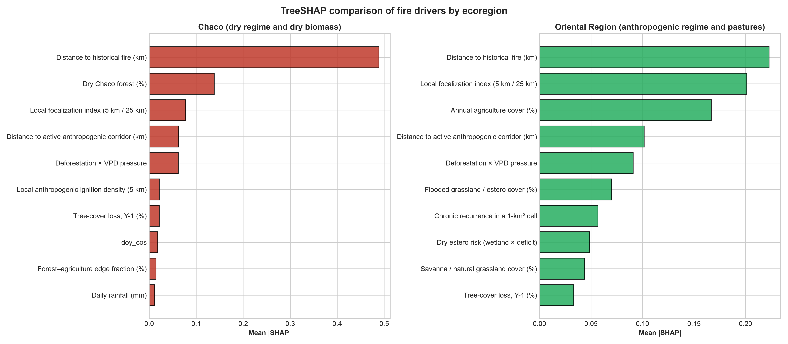
Figure S1. TreeSHAP comparison for the hybrid ignition model. The two regions use separate models and feature sets.
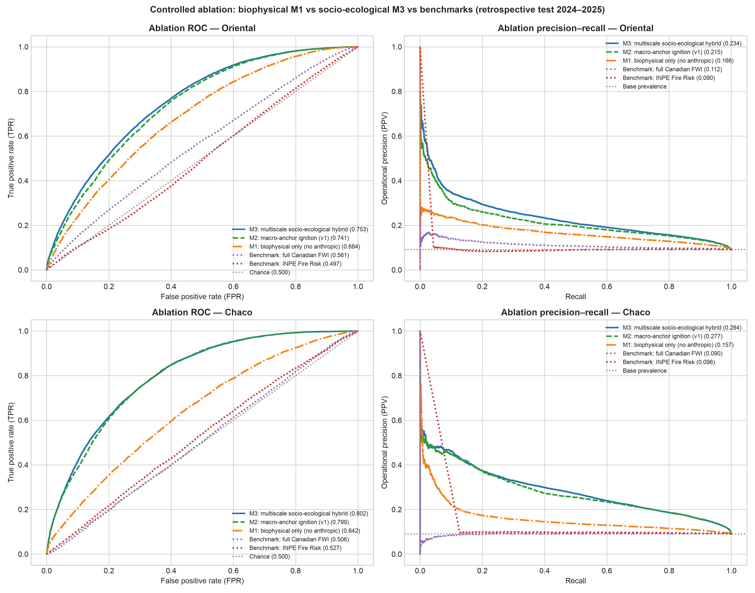
Figure S2. Controlled ablation under the D2 test. The figure complements Table S12.
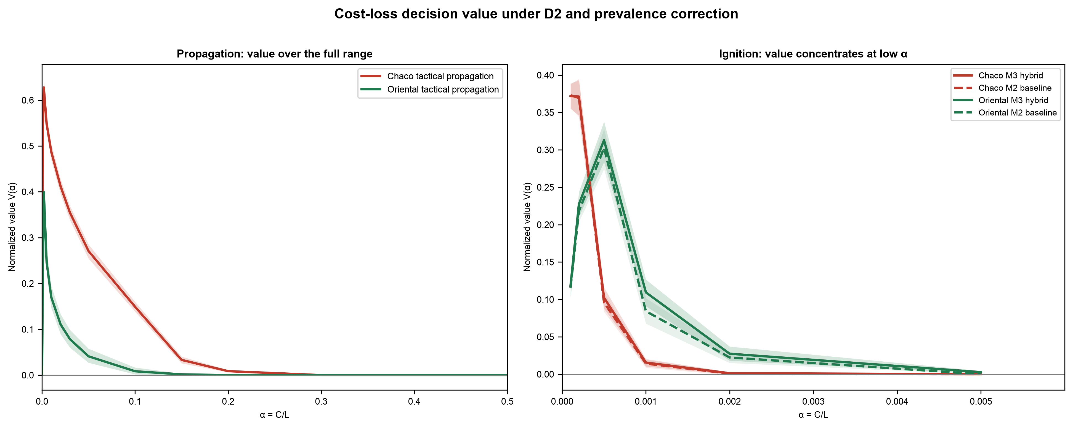
Figure S3. Cost-loss curves with 95 % date-grouped bootstrap bands (B = 1 000). The propagation panel uses the full $α$ range; the ignition panel is truncated at $α=0.006$ because the decision value is zero or negligible at larger values. The figure complements Table S14.
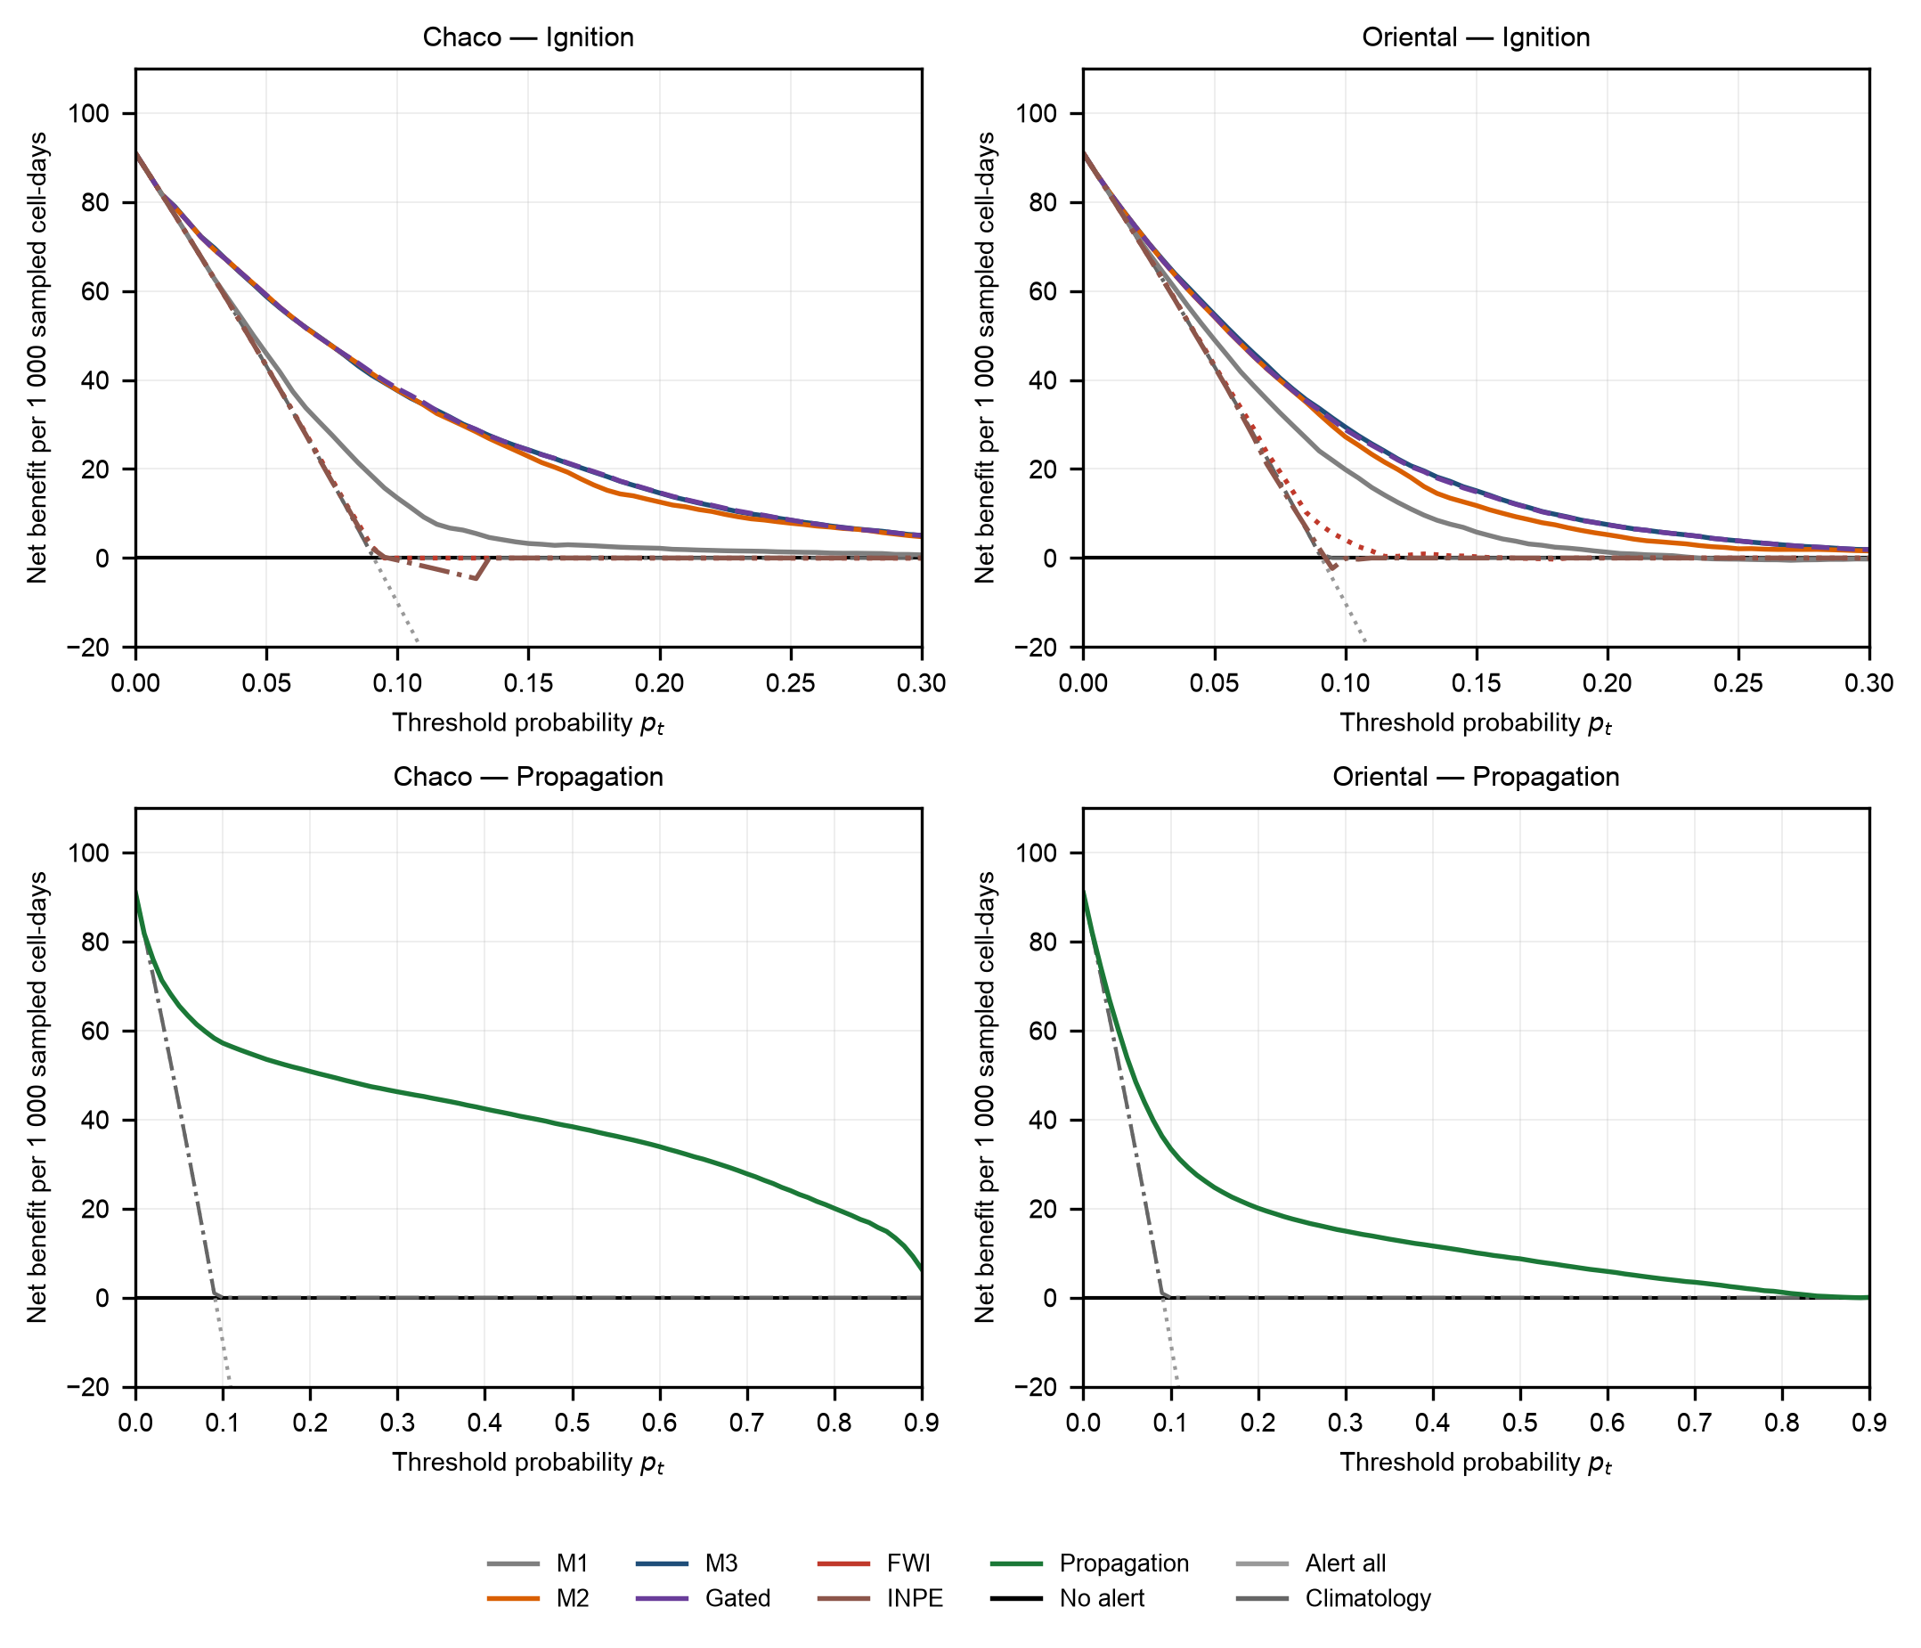
Figure S4. Decision curve analysis: net benefit per 1 000 sampled cell-days as a function of the threshold probability $p_{t}$, computed on the case-control test sample. Ignition (0–0.30) and propagation (0–0.90) are shown separately by region. References are no alert (NB = 0), alert all and climatology. FWI and INPE are uncalibrated indices; for each $p_{t}$ their operating threshold was selected on 2023 validation to maximize net benefit and then frozen for the test. The y-axis is clipped at −20; the alert-all reference falls below it at high $p_{t}$.
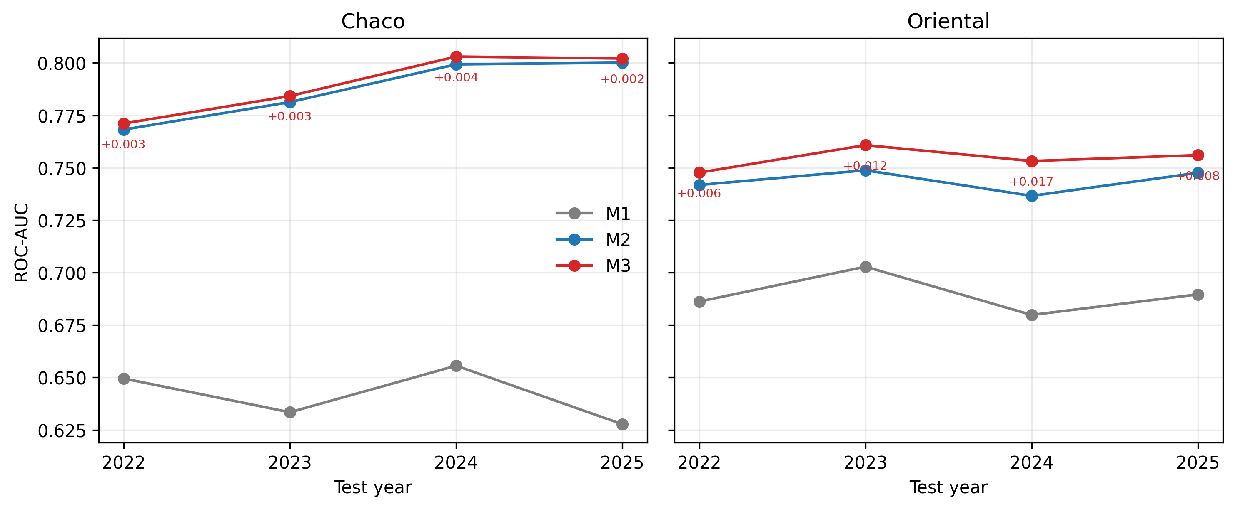
Figure S5. Rolling-origin ROC-AUC by test year for M1, M2 and M3. Numbers next to M3 are ΔROC(M3−M2).
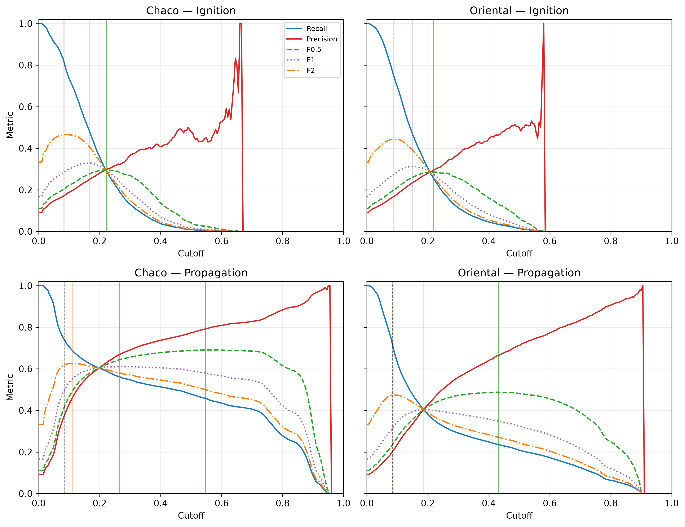
Figure S6. Validation precision, recall, F0.5, F1 and F2 versus cutoff for M3 ignition and the propagation model, by region. Vertical lines mark the F0.5, F1, F2 and Youden cutoffs; test metrics at those cutoffs are in Table S14 (continued).
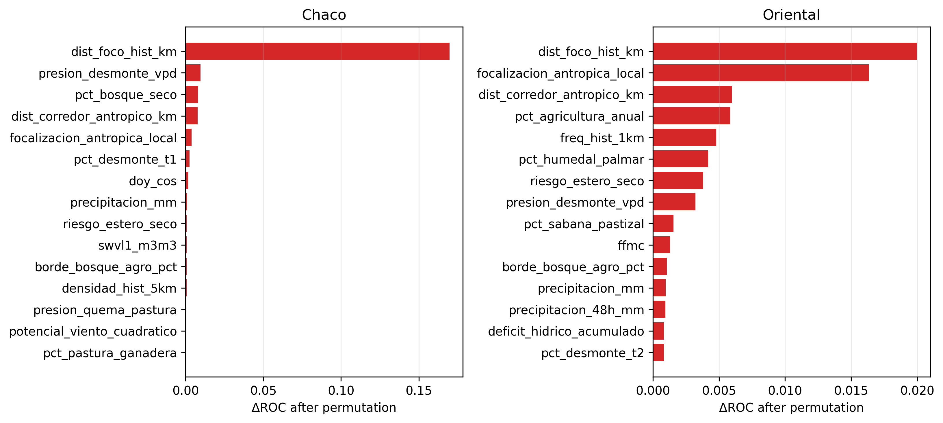
Figure S7. Permutation importance of the M3 features on the retrospective test (mean ΔROC after shuffling, three repeats), by region.
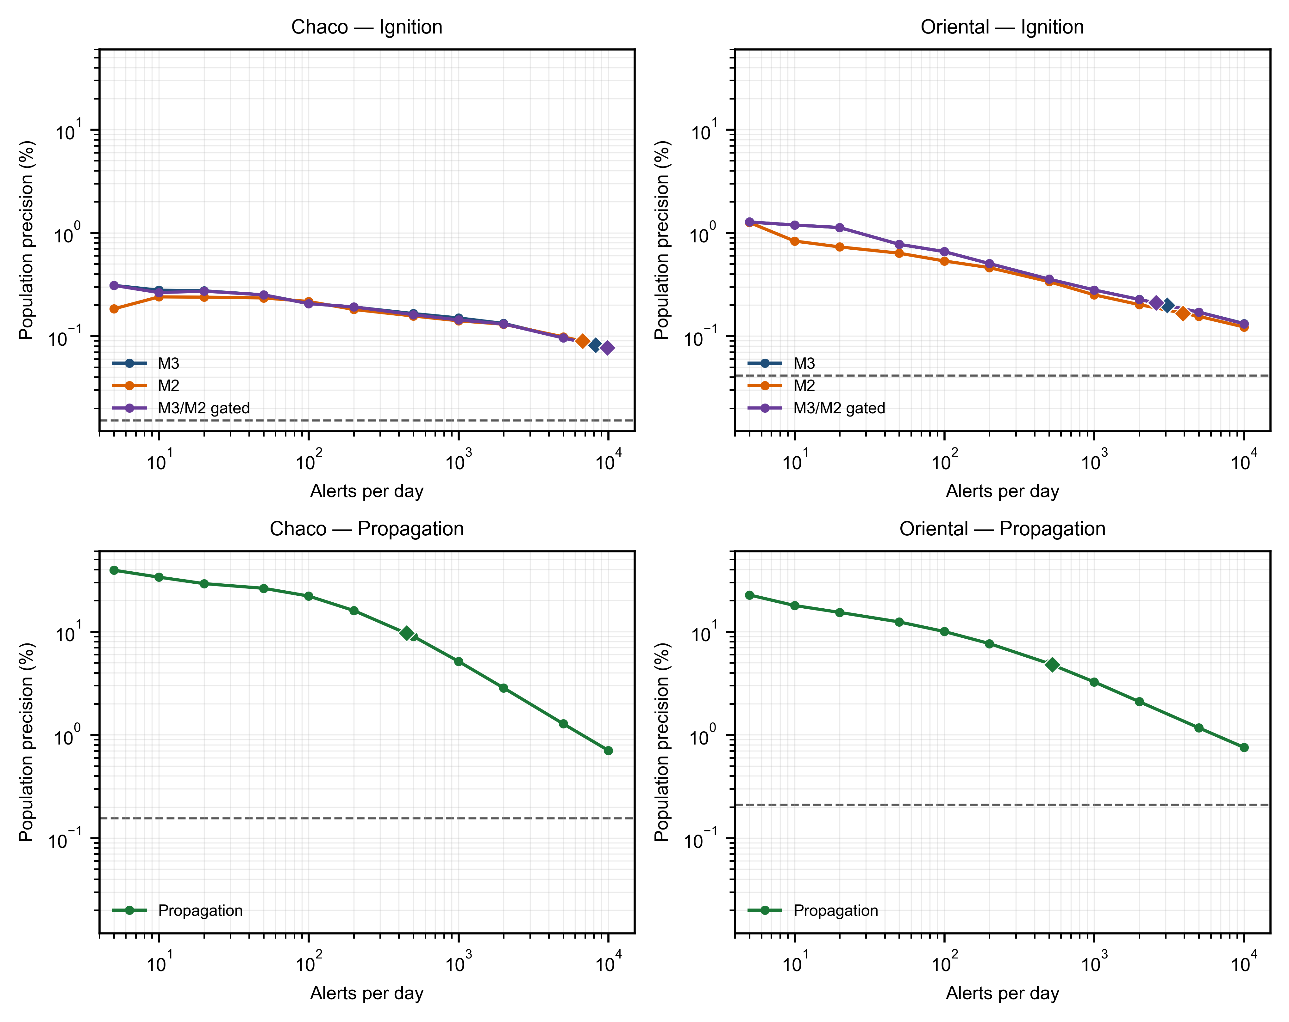
Figure S8. Population precision as a function of the daily alert budget. Curves sweep the population-corrected score threshold and report weighted precision at the resulting number of alerts per day; diamonds mark the frozen operating point. Ignition panels include M3, M2 and the gated policy; propagation panels show the tactical model. The dashed line is the population prevalence.
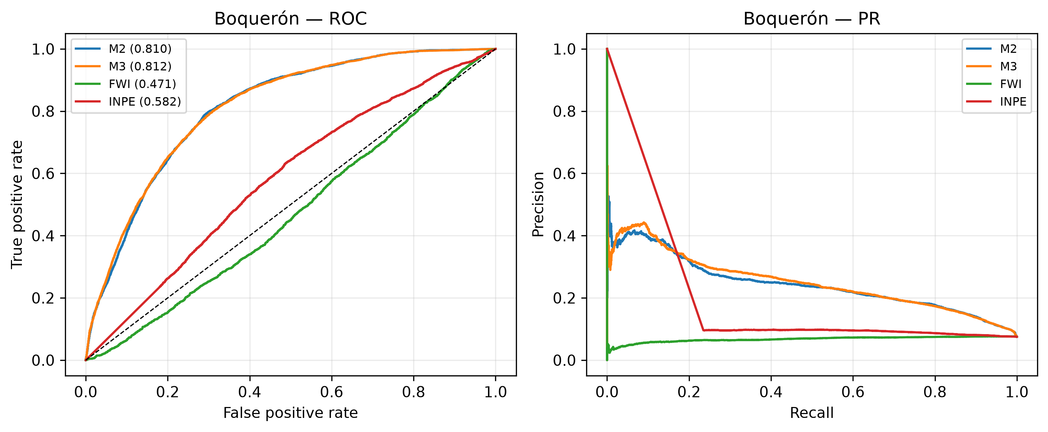
Figure S9. External validation in Boquerón: ROC and precision–recall curves for M2, M3, FWI and INPE on 2024–2025.
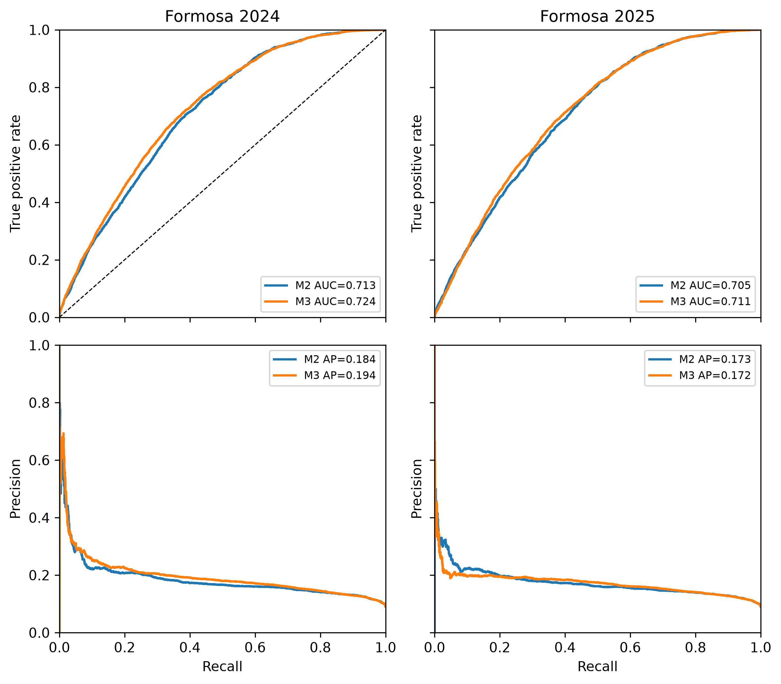
Figure S10. External cross-country validation in Formosa. ROC and precision–recall curves for G0-C in 2024 (left) and 2025 (right). M2 (blue) and M3 (orange) use frozen Chaco boosters with local Platt recalibration. The test is case-control (1:10), not population-weighted.

Data availability
Processed data, test predictions, trained models and derived tables are archived in the v2.0.1 data release (Incendios_PY_data_v2.0.1.zip, 1.18 GB) at github.com/sanchezmartin093-code/Incendios_PY/releases/tag/v2.0.1 under CC BY 4.0 and indexed by the data concept DOI 10.5281/zenodo.23675278. The v2.1.0 code and tabular artifacts are in the v2.1.0 GitHub release and in tablas_maestro.xlsx. Raw NASA FIRMS, ERA5-Land/CDS, MapBiomas, Hansen GFC and geoBoundaries data are obtained from their original providers under their own terms and are documented with SHA-256 hashes in fuentes/MANIFIESTO_DATOS_v3.csv. The archived test targets and probabilities are sufficient to regenerate every table and figure in this supplement without downloading the raw multi-terabyte archive.

Computer code availability
- Name of code: Incendios_PY (v2.1.0)
- Developer and contact address: Martín Sánchez Insfrán, Independent Researcher, Asunción, Paraguay.
- Telephone: +595 971 907 727
- E-mail: sanchez.martin093@gmail.com
- Year first available: 2026
- Hardware required: x86_64 or ARM64 CPU; minimum 8 GB RAM.
- Software required: macOS 13+, Linux Ubuntu 22.04+, or Windows 11 with WSL2; Python 3.12+ with Polars, DuckDB, NumPy and the LightGBM C++ backend; pinned in requirements-lock.txt.
- Program language: Python 3.12+.
- Program size: 1.7 MB source tree (approximately 0.9 MB Python source); the public data asset is 1.18 GB compressed; the full working archive is 11 GB.
- Availability and license: Freely available under the MIT License at github.com/sanchezmartin093-code/Incendios_PY. Code concept DOI: 10.5281/zenodo.23675104; data concept DOI: 10.5281/zenodo.23675278. The v2.1.0 source snapshot is the GitHub release; the Zenodo concept DOI currently resolves to v2.0.1.
- Tests: 76 tests pass with python -m pytest -q tests.

References
Ke, G., Meng, Q., Finley, T., Wang, T., Chen, W., Ma, W., Ye, Q., Liu, T.-Y., 2017. LightGBM: A highly efficient gradient boosting decision tree. Advances in Neural Information Processing Systems (NeurIPS) 30, 3146–3154.
MapBiomas Chaco, 2023. Colección 2 de los mapas anuales de cobertura y uso del suelo del Gran Chaco Americano [WWW Document]. URL https://chaco.mapbiomas.org/ (accessed 10.28.2026).
Muñoz-Sabater, J., Dutra, E., Agustí-Panareda, A., Albergel, C., Arduini, G., Balsamo, G., Boussetta, S., Choulga, M., Harrigan, S., Hersbach, H., Martens, B., Miralles, D.G., Piles, M., Rodríguez-Fernández, N.J., Zsoter, E., Buontempo, C., Thépaut, J.-N., 2021. ERA5-Land: A state-of-the-art global reanalysis dataset for land applications. Earth System Science Data 13, 4349–4383. https://doi.org/10.5194/essd-13-4349-2021
NASA FIRMS, 2026. Fire information for resource management system (FIRMS) [WWW Document]. URL https://firms.modaps.eosdis.nasa.gov/ (accessed 10.28.2026).
Platt, J., 1999. Probabilistic outputs for support vector machines and comparisons to regularized likelihood methods, in: Advances in Large Margin Classifiers. MIT Press, pp. 61–74.
Schroeder, W., Oliva, P., Giglio, L., Csiszar, I.A., 2014. The new VIIRS 375 m active fire detection data product: Algorithm description and initial assessment. Remote Sensing of Environment 143, 85–96. https://doi.org/10.1016/j.rse.2013.12.008
Setzer, A., Sismanoglu, F., Alberto, M.C., Silva, J., Morelli, F., 2019. O método de cálculo do risco de fogo do INPE - versão 2019 [WWW Document]. URL http://queimadas.dgi.inpe.br (accessed 10.28.2026).
Van Wagner, C.E., 1987. Development and structure of the Canadian Forest Fire Weather Index System. Canadian Forestry Service, Forestry Technical Report 35, 1–37.

