Forest Fragmentation Dynamics in the Andaman and Nicobar Islands (2000-2023): A
Remote Sensing and Landscape Metrics Approach
Project Report in Research Paper Format
Course / Department: IS Final Project
Submission date: 11 May 2026
Dashboard deliverable: Streamlit web application for interactive forest-fragmentation exploration
Code repository: https://github.com/sanchit-22/ContinentDeforestationAnalysis
Deployed dashboard: https://andaman-nicobar-forest-analysis.streamlit.app/
PPT Link: https://github.com/sanchit-22/ContinentDeforestationAnalysis/blob/main/Presentation.pptx
Data sources: Hansen Global Forest Change, ESA WorldCover 2021, GADM/vector island boundaries
Submitted By: Priyanshu Jha (2024201062)
Sanchit Kumar (2024201042)
Submitted To: Prof. Rama Chandra Prasad

Abstract
This study evaluates forest fragmentation across the Andaman and Nicobar archipelago from 2000 to 2023 using annual forest masks derived from Hansen Global Forest Change data and ancillary ESA WorldCover 2021 land cover. Individual island polygons were analysed with landscape metrics including percentage of landscape forested (PLAND), patch density (PD), edge density (ED), total core area (TCA), and mean Euclidean nearest-neighbour distance (ENN_MN). Three composite indicators were produced: Fragmentation Index (FI), Core Retention Ratio (CRR), and Isolation-Weighted Fragmentation Index (IWFI). The processed outputs include island-wise time-series tables, publication-quality figures, and an interactive Streamlit/Folium dashboard. Results show that aggregate forest loss is low by area, but core retention and edge density reveal meaningful fragmentation stress, especially in smaller and more isolated islands. South Andaman shows the lowest 2023 aggregate CRR, while Nicobar Islands show high isolation-weighted fragmentation because of their distance from the mainland.
Keywords: forest fragmentation; remote sensing; landscape metrics; Hansen GFC; ESA WorldCover; Andaman and Nicobar Islands

1. Introduction
Island forests are ecologically important because they often contain high endemism, limited dispersal pathways, and small habitat areas. In such systems, forest loss and the breaking apart of habitat can reduce interior forest, increase edge exposure, and isolate remaining patches. The Andaman and Nicobar Islands are a suitable study area for a fragmentation analysis because they form a long, separated archipelago in the Bay of Bengal and have experienced both human land-use pressure and natural disturbances such as the 26 December 2004 Indian Ocean tsunami.

1.1 Literature Survey
Remote sensing has become the main basis for consistent forest monitoring. Hansen et al. (2013) produced a global 30 m record of forest extent and annual forest loss from Landsat imagery, which is widely used for tree-cover change studies. ESA WorldCover provides a 10 m global land-cover product for 2021 using Sentinel-1 and Sentinel-2 data, giving a high-resolution ancillary land-cover snapshot for map interpretation (Zanaga et al., 2022).
Fragmentation research emphasizes that forest area alone is not enough to describe ecological condition. Fahrig (2003) distinguished habitat loss from the spatial breaking apart of habitat, while Haddad et al. (2015) showed that fragmentation can have long-lasting effects on biodiversity and ecosystem processes. Landscape metrics such as patch density, edge density, core area, and nearest-neighbour distance are standard tools for measuring such spatial patterns; FRAGSTATS formalized many of these measures (McGarigal and Marks, 1995), and PyLandStats implements comparable workflows in Python (Bosch, 2019).
Previous work in the Andaman and Nicobar region has used remote sensing to identify coastal ecosystem damage and land-cover change. Bahuguna et al. (2008) assessed the 2004 tsunami and earthquake impact on coastal ecosystems with RESOURCESAT data, while Tiwari et al. (2016) used multi-temporal satellite interpretation to study forest-cover change and encroachment in the islands. Veettil et al. (2020) mapped mangrove dynamics in the Andaman and Nicobar Islands using Landsat and Sentinel-2 data, showing the importance of multi-temporal satellite monitoring for island vegetation. This project extends that line of work by using annual 2000-2023 forest masks and island-wise landscape metrics to quantify fragmentation trajectories.

1.2 Objectives of the Study
The accompanying presentation frames the project around three research questions: whether smaller islands lose core forest faster than total forest area, whether forest-loss levels approach commonly discussed fragmentation or percolation thresholds, and whether fragmentation is explained better by mainland distance or by connectivity within the archipelago. These questions guide the selection of CRR, FI, IWFI, and EII as the main analytical indicators.
• Generate annual forest/non-forest masks for 2000-2023 using Hansen tree cover and annual loss layers.
• Compute island-wise landscape metrics including PLAND, PD, ED, TCA, ENN_MN, and number of forest patches.
• Derive CRR, FI, IWFI, EII, and cumulative loss indicators to summarize forest fragmentation and isolation stress.
• Compare fragmentation patterns by island group, size class, isolation, and temporal trajectory.
• Deploy an interactive Streamlit dashboard with metric charts, data tables, and map layers.

1.3 Study Area
The study area covers 212 processed island polygons in the Andaman and Nicobar archipelago, grouped into Nicobar Islands, North and Middle Andaman, and South Andaman. The rounded group areas shown in Table 1 sum to approximately 7609 km². Mainland distance was calculated from island centroids to a Chennai coast reference point used in the project scripts.
Table 1. Study-area summary for the processed island groups.
Island group | Island polygons | Processed area (km²) | Area-weighted mainland distance (km)
Nicobar Islands | 30 | 1726.80 | 1599
North and Middle Andaman | 119 | 3406.53 | 1364
South Andaman | 63 | 2477.54 | 1361

2. Materials and Methods

2.1 Data Used
Table 2. Data sources and their use in the project workflow.
Dataset / source | Resolution / role | Use in project
Hansen Global Forest Change | 30 m annual forest loss and tree cover | Forest masks for 2000-2023 using >=30% tree-cover threshold and annual loss year
ESA WorldCover 2021 V200 | 10 m land cover | Ancillary land-cover map layer in dashboard
Island boundaries / GADM-derived vectors | Vector island polygons | Island clipping, area, centroid, grouping, and distance calculations
Python geospatial stack | rasterio, GeoPandas, pylandstats, NumPy, Streamlit, Folium | Raster processing, metric computation, visualization, and web dashboard deployment

2.2 Data Processing
The raw tree-cover, loss-year, and ESA land-cover rasters were reprojected to EPSG:32646 (UTM Zone 46N). For each year from 2000 to 2023, a binary forest mask was created. Pixels with year-2000 tree cover greater than 30% were treated as forest, and pixels with Hansen loss-year values up to the selected year were removed from the forest class. Ocean and no-data areas were retained as no-data. Each annual raster was clipped to individual island polygons before landscape metrics were calculated.
Table 3. Analysis pipeline followed from raw data to final dashboard and figures.
Pipeline phase | Main output
1. Data harmonization and annual forest masks | Aligned 2000-2023 binary forest rasters
2. Island metadata and isolation indices | Area, centroids, mainland distance, nearest large-island distance, and EII
3. Landscape metrics | PLAND, PD, ED, TCA, ENN_MN, and patch counts from pylandstats
4. Novel composite metrics | FI, CRR, IWFI, and cumulative loss
5. Statistical modelling | OLS, piecewise threshold analysis, K-means trajectories, and correlations
6. Publication figures | Five PDF figures used in this report
7. Interactive dashboard | Streamlit charts, selectors, and data table
8. Network connectivity analysis | Prototype keystone-patch table
9. Geospatial map visualization | Folium/Leaflet map layers for forest, loss, and ESA land cover

2.3 Metrics and Indices
Table 4. Landscape metrics and composite indicators used in the analysis.
Metric | Meaning | Interpretation
PLAND | Percentage of the landscape classified as forest | Lower PLAND means reduced forest cover
PD | Patch density | Higher PD generally indicates more patches per area
ED | Edge density | Higher ED indicates more exposed forest edge
TCA | Total core area after edge-depth filtering | Interior forest habitat remaining after edge effects
ENN_MN | Mean Euclidean nearest-neighbour distance | Higher values indicate more separated patches
CRR = TCA / TA | Core Retention Ratio | Values near 1 indicate high interior forest retention; values below 0.5 are treated as core-stress signals
FI = (ED × PD) / PLAND | Fragmentation Index | Composite of edge and patch density scaled by forest proportion
IWFI = FI × ln(ENN_MN + 1) × ln(distance + 1) | Isolation-Weighted Fragmentation Index | Fragmentation severity adjusted for patch and mainland isolation
EII | Effective Isolation Index | Connectivity potential based on surrounding island area and distance-decay weighting

2.4 Statistical Analysis and Dashboard
The project used exploratory models to relate isolation and island size to fragmentation. K-means clustering was applied to CRR trajectories, and simple correlations compared mainland distance and effective isolation against IWFI. These statistics are interpreted cautiously because the available aggregate trajectory table has only three island groups. TA_ha in the metric tables refers to forest-class area returned by the landscape analysis, while island area is reported separately in square kilometres. A Streamlit dashboard was deployed as a production web application to allow users to select island level, year range, map layer, and view metric charts and data tables.

3. Results and Discussion

3.1 Aggregate Island-Group Summary
At the aggregate island-group scale, total forest-area loss from 2000 to 2023 is small, remaining below 1% in all three groups. However, core retention and edge metrics show that fragmentation stress can be present even when total forest area changes only slightly. South Andaman has the lowest 2023 aggregate CRR, indicating a larger proportion of edge-dominated forest, while Nicobar Islands have the greatest mainland distance and the highest 2023 aggregate IWFI.
This pattern is consistent with the fragmentation literature: Fahrig (2003) emphasized that habitat amount and habitat configuration are different components of landscape change, and Haddad et al. (2015) showed that edge-dominated forest can have ecological effects even where large amounts of forest remain. Therefore, the main result of this study is not high deforestation by area, but measurable changes in forest configuration and core retention.
Table 5. Aggregate 2023 forest fragmentation metrics by island group.
Island group | Forest 2023 (ha) | Loss since 2000 (%) | PLAND 2023 (%) | CRR 2023
Nicobar Islands | 172,122 | 0.32 | 99.68 | 0.598
North and Middle Andaman | 338,579 | 0.61 | 99.39 | 0.570
South Andaman | 246,358 | 0.56 | 99.44 | 0.292
Table 5 continued. Fragmentation and patch metrics for aggregate groups in 2023.
Island group | ED 2023 | FI 2023 | IWFI 2023 | Patches 2023
Nicobar Islands | 145.8 | 4.26 | 184.0 | 580
North and Middle Andaman | 69.6 | 2.55 | 99.9 | 2,970
South Andaman | 140.8 | 3.48 | 148.0 | 1,610

3.2 Edge Density by Island Size Class
The edge-density figure compares island size classes over selected years. Small and tiny islands show strong year-to-year variability because a small absolute change in forest arrangement can create a large change in edge density or patch density. In 2023, tiny islands have the highest mean FI and IWFI, showing that isolation and small area can amplify fragmentation signals.
The size-class comparison should be interpreted with care because very small polygons can produce unstable ratios. Still, the result agrees with island-biogeography expectations that small, isolated islands are more sensitive to changes in patch configuration than larger land masses.
Table 6. Mean 2023 fragmentation indicators by island size class.
Size class | No. of polygons | Mean loss 2023 (%) | Mean CRR 2023 | Mean ED 2023 | Mean FI 2023 | Mean IWFI 2023
tiny (<10) | 176 | 0.77 | 0.498 | 107.7 | 6.30 | 254.3
small (10-50) | 19 | 1.97 | 0.523 | 87.9 | 2.74 | 108.8
medium (50-200) | 11 | 2.30 | 0.462 | 105.9 | 2.20 | 89.5
large (>200) | 6 | 2.30 | 0.438 | 114.0 | 3.09 | 130.3
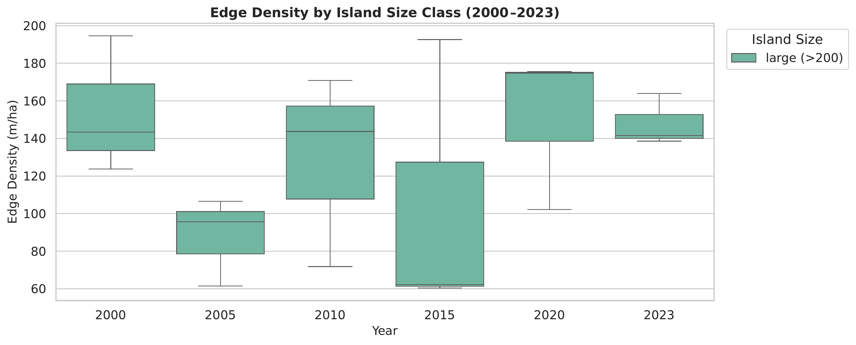
Figure 1. Edge density by island size class for selected years from 2000 to 2023. The x-axis shows year, the y-axis shows edge density (m/ha), and the legend separates island size classes.

3.3 Forest Loss and Core Retention
The cumulative-loss versus CRR plot shows that low total loss does not always mean high core habitat. Some islands retain high forest proportion but have reduced CRR, meaning forest occurs in shapes or patches that are more edge-exposed. This supports the use of core-area metrics alongside area-based forest-loss estimates.
The 30% loss line is used only as a reference threshold from fragmentation and percolation theory, including the threshold concept discussed in landscape-fragmentation literature (Andrén, 1994). Most islands in this project do not cross that level in the processed 2000-2023 data, so the threshold is a screening benchmark rather than an observed transition proved by this study.
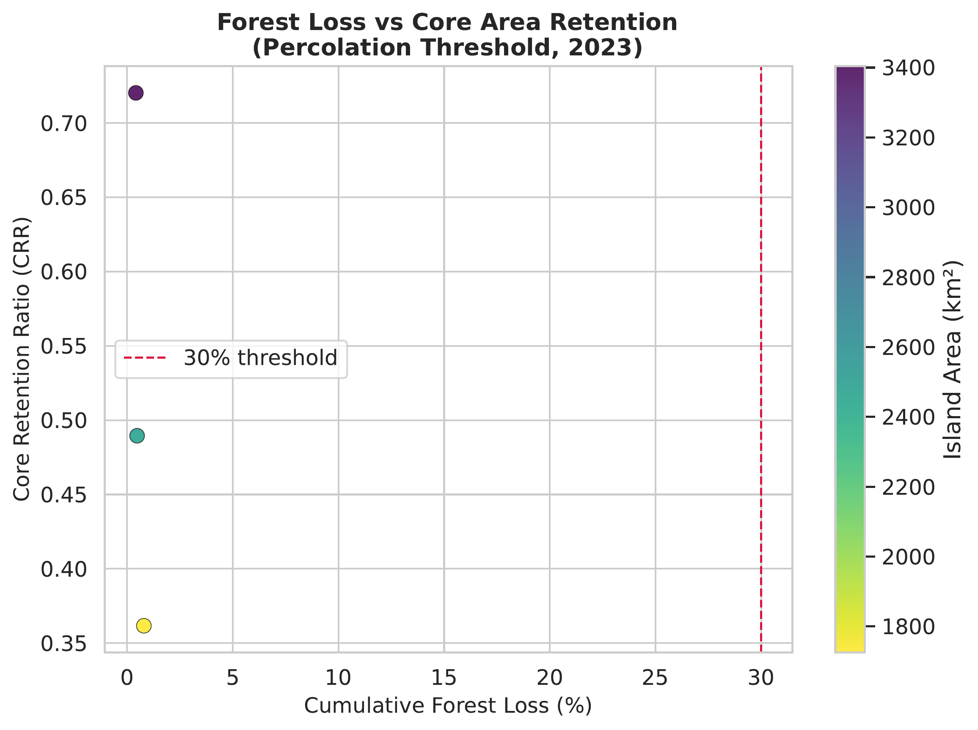
Figure 2. Cumulative forest loss percentage versus Core Retention Ratio in 2023. The x-axis shows cumulative loss, the y-axis shows CRR, and colour indicates island area.

3.4 Temporal CRR Trajectories and Clusters
Table 7. Descriptive CRR trajectory labels for the aggregate island groups.
Island group | Trajectory cluster | Trajectory label
Nicobar Islands | 2 | Rapid Collapse
North and Middle Andaman | 0 | Stable
South Andaman | 1 | Linear Degradation
The trajectory clustering separates the three aggregate groups into Stable, Linear Degradation, and Rapid Collapse labels. Because only three aggregate groups are present in this summary, these labels should be read as descriptive trajectory classes rather than statistically robust ecological categories.
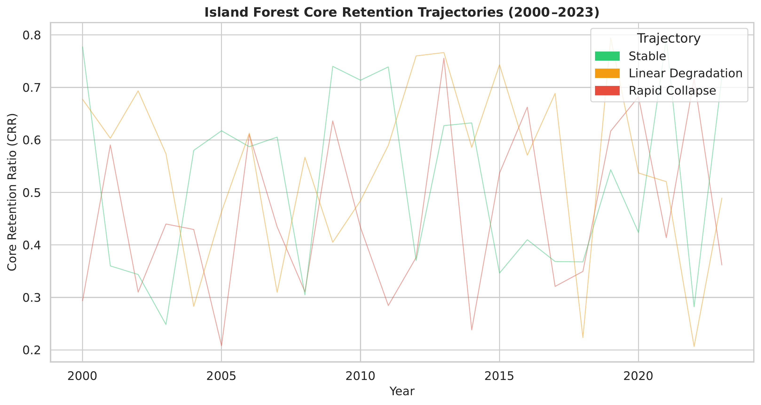
Figure 3. Core Retention Ratio trajectories for 2000-2023, coloured by K-means trajectory label. The x-axis shows year and the y-axis shows CRR.

3.5 Isolation Drivers
The isolation-driver analysis compares mainland distance and effective intra-archipelago isolation as predictors of IWFI. The regression output reports strong negative correlations, but p-values remain above the 0.05 level and the sample size is very small. Therefore, the result is best interpreted as an exploratory indication that isolation is ecologically relevant, not as a confirmed causal relationship.
Table 8. Exploratory statistical outputs and interpretation.
Exploratory comparison | Reported value | Interpretation
Mainland distance vs IWFI | r = -0.987, p = 0.1043 | Strong correlation but not significant at 0.05
Effective isolation vs IWFI | r = -0.989, p = 0.0959 | Slightly stronger in this output, but still exploratory
OLS model | R² = 1.000 with 3 observations | Not suitable for strong inference because residual degrees of freedom are zero
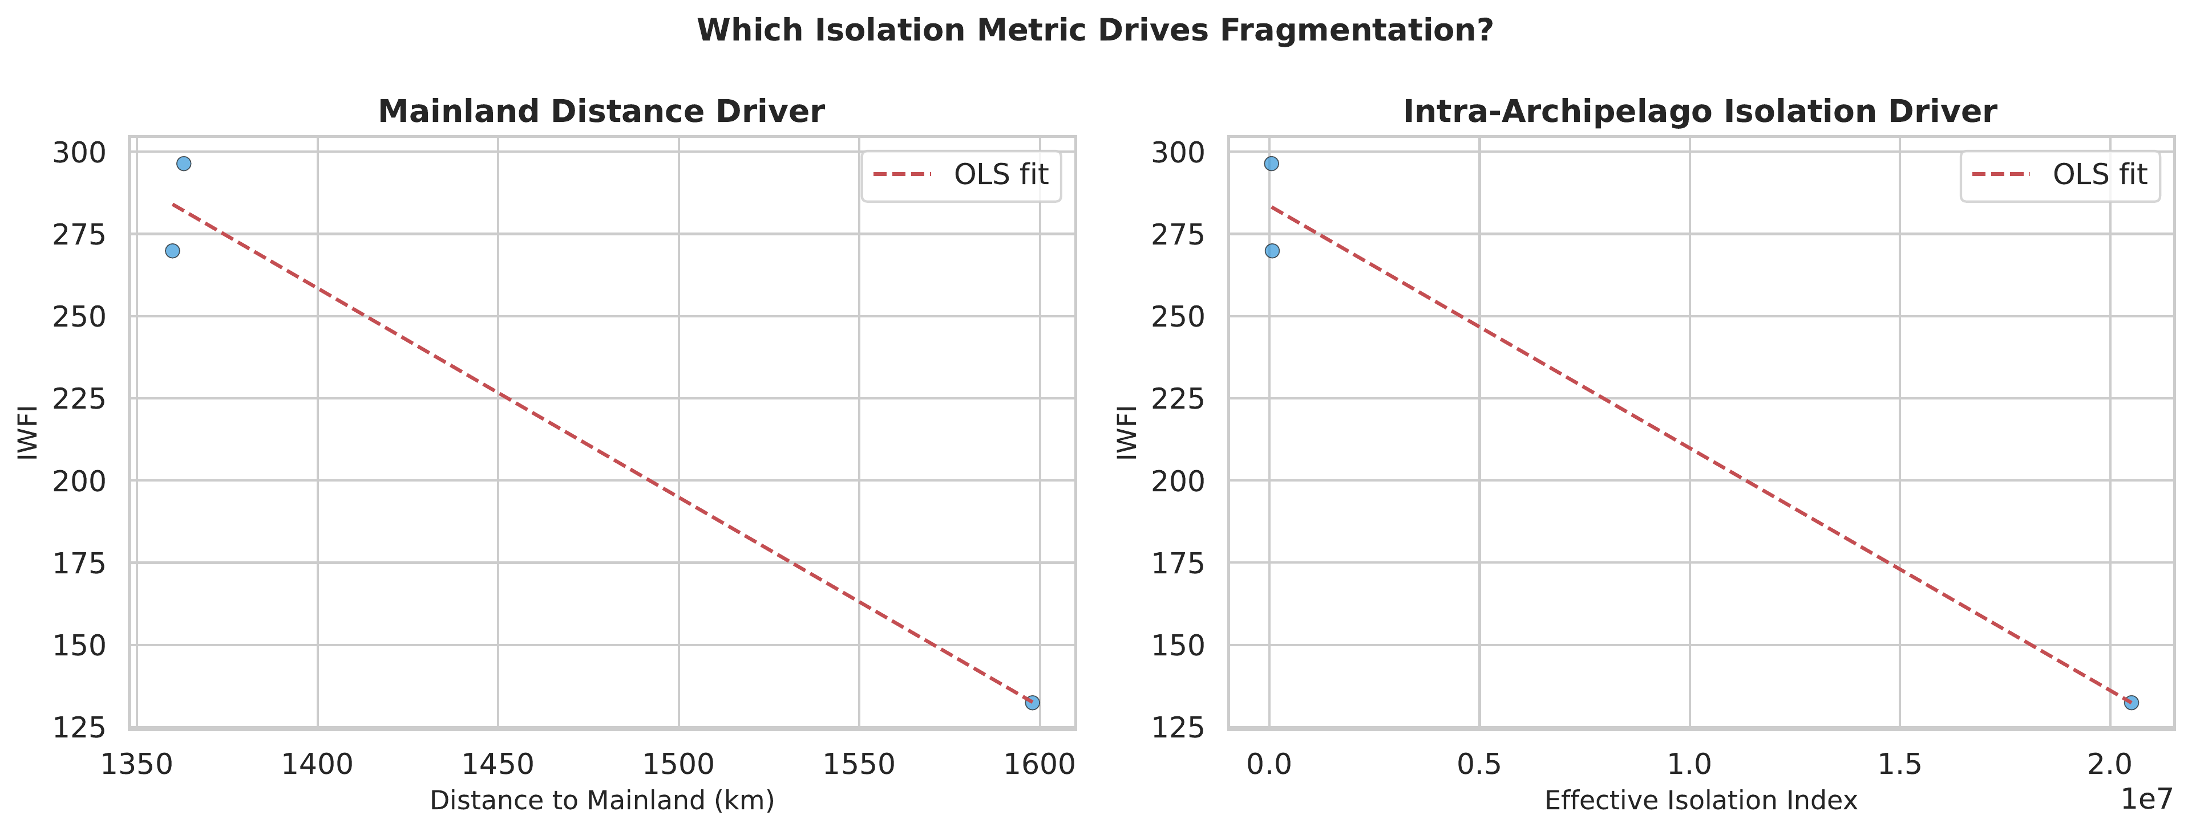
Figure 4. Isolation-driver scatter plots for 2023. The y-axis shows IWFI; the x-axes compare mainland distance and effective isolation index.

3.6 Tsunami-Period Edge-Density Signal
The 2003-2006 edge-density comparison was included because the 26 December 2004 earthquake and tsunami affected the Andaman and Nicobar region. The figure compares east- and west-facing island polygons around this period. The pattern should be treated as indicative rather than conclusive because the analysis uses annual forest masks and an aspect proxy, not direct field-based tsunami damage observations.
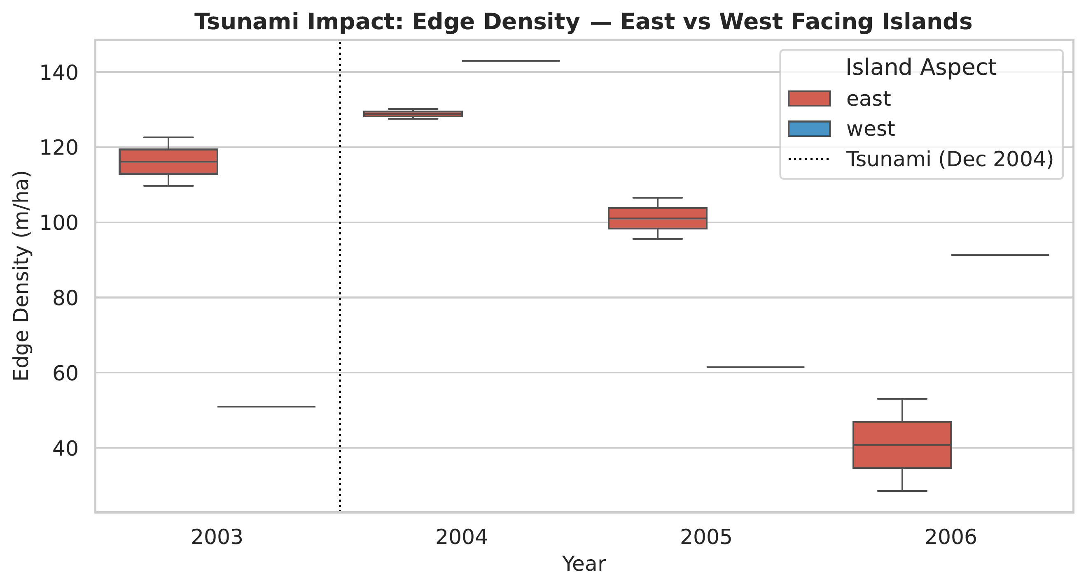
Figure 5. Edge density before and after the 2004 tsunami period, separated by east/west aspect proxy. The x-axis shows year and the y-axis shows edge density.

3.7 Comparison With Previous Studies
The study results are comparable to earlier remote-sensing work in the Andaman and Nicobar Islands, but they differ in scale and metric focus. Tiwari et al. (2016) mapped forest encroachment in Baratang Island using Landsat-5 TM, IRS-1D LISS-III, and Resourcesat-2 LISS-III imagery for 1989, 2003, and 2013, reporting a localized increase in encroachment from 21.3 ha to 201.3 ha. In contrast, the present study analyses 212 processed island polygons across the full archipelago and shows low aggregate forest-area loss from 2000 to 2023, while still detecting fragmentation stress through CRR, ED, FI, and IWFI.
Veettil et al. (2020) used Landsat and Sentinel-2 data to examine mangrove dynamics in the Andaman and Nicobar Islands from 1988 to 2018 and reported mangrove decline in the Andaman Islands, with important changes after 2010. The present analysis is broader because it treats forest cover rather than only mangroves; however, both studies support the same general conclusion that multi-temporal satellite data are necessary for detecting coastal and island vegetation change. The difference between low aggregate forest-loss percentages and reduced core retention in this report also shows why area-based change detection should be supplemented with spatial configuration metrics.
The tsunami-period interpretation is also consistent with, but less direct than, Bahuguna et al. (2008). Their RESOURCESAT AWiFS assessment directly documented coastal ecosystem impacts from the 26 December 2004 tsunami and earthquake, including mangrove disturbance through uprooting, seawater inundation, and stagnation. This project does not directly map tsunami damage; instead, it uses 2003-2006 edge-density patterns as an indirect fragmentation signal and therefore treats the tsunami-related result as indicative rather than conclusive.
Methodologically, the use of patch density, edge density, core area, and nearest-neighbour metrics follows the same landscape-ecology logic used by Midha and Mathur (2010), who assessed forest fragmentation in the Dudhwa landscape of India with FRAGSTATS class-level metrics. This project applies comparable metric families through a Python/pylandstats workflow and adds island-specific isolation weighting, which is important for archipelago systems where mainland distance and inter-island connectivity affect ecological interpretation.

3.8 Interactive Streamlit Dashboard
The interactive dashboard is the final project deliverable and converts the processed island-wise metric tables into an exploratory web portal. It is built with Streamlit for the interface and Folium/Leaflet for map visualization. The portal links the tabular analysis to an interactive map, allowing the user to move between island-level summaries, temporal metric trends, and spatial forest-loss layers. The production dashboard is available at https://andaman-nicobar-forest-analysis.streamlit.app/, and the source code is hosted at https://github.com/sanchit-22/ContinentDeforestationAnalysis.

3.8.1 Dashboard Controls and Analytical Outputs
• View-level selector: switches between an Individual island view and an Aggregate island group view, so the same analysis can be interpreted at local and regional scales.
• Island or group selector: loads the selected island polygon or island group and updates the metrics, charts, data table, and map view automatically.
• Year-range slider: covers 2000-2023. The upper year of the slider is used as the map year for forest-cover, annual-loss, and cumulative-loss layers.
• Summary indicators: display island or aggregate area, distance to mainland, latest Core Retention Ratio (CRR), and cumulative forest-loss percentage.
• Temporal charts: show CRR, Fragmentation Index (FI), and Isolation-Weighted Fragmentation Index (IWFI), allowing changes in forest configuration to be read alongside total loss.
• Interactive map layers: include forest cover, cumulative deforestation, annual loss events, and ESA WorldCover 2021 land-cover classification.
• Basemap and boundary overlays: allow comparison between a clean CartoDB light basemap and Esri satellite imagery while keeping the island boundary visible.
• Full data table: provides the annual metric values used to draw the charts, supporting transparency and reproducibility.

3.8.2 Dashboard Figure Interpretation
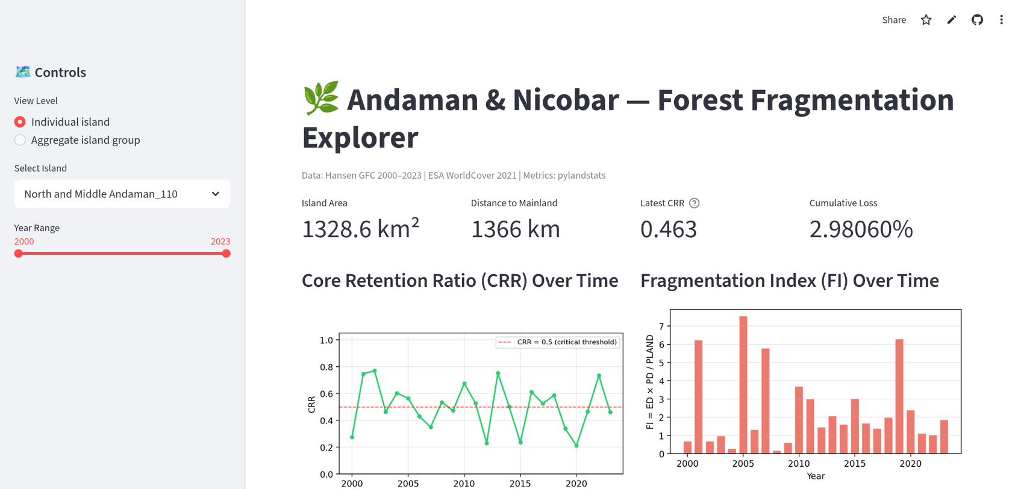
Figure 6. Dashboard overview for North and Middle Andaman_110.
The dashboard overview shows the main control panel and the selected individual island, North and Middle Andaman_110. The displayed island area is 1328.6 km², the distance to mainland is 1366 km, the latest CRR is 0.463, and cumulative loss is 2.98060%. The CRR plot includes a red 0.5 threshold line, making it clear when forest core retention falls below the stress benchmark. The FI bar chart highlights years with comparatively high fragmentation intensity.
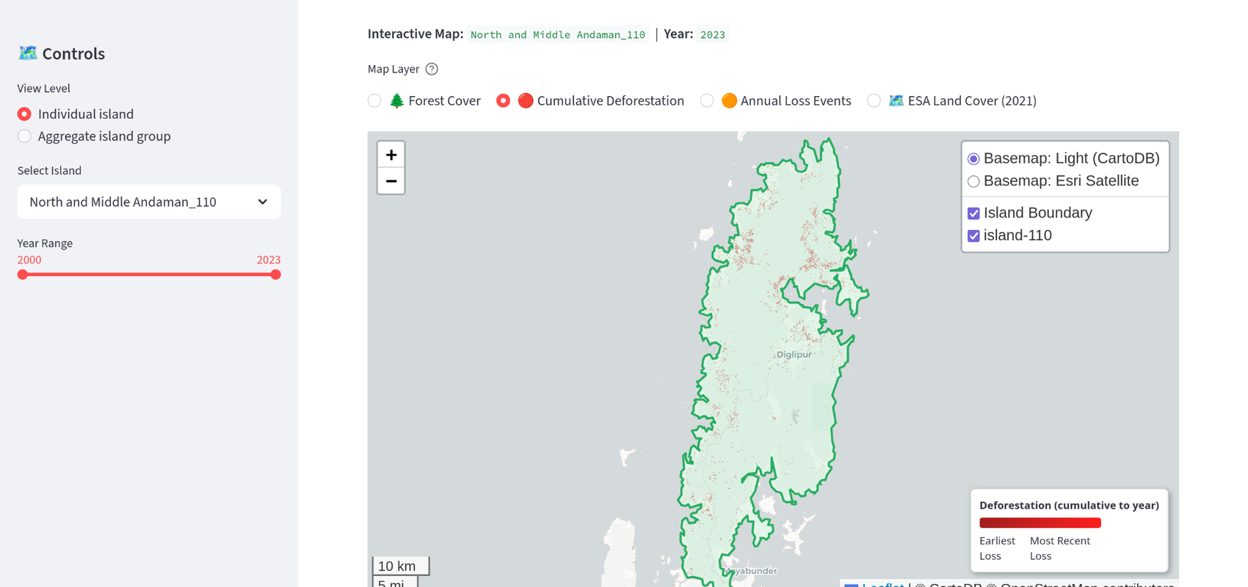
Figure 7. Cumulative deforestation layer on the light basemap.
This view uses the Cumulative Deforestation layer for the selected island and year 2023. Red pixels mark tree-cover-loss locations accumulated from 2001 to the selected year. The legend separates earlier losses from more recent losses, while the green boundary ensures that interpretation remains limited to the selected island polygon.
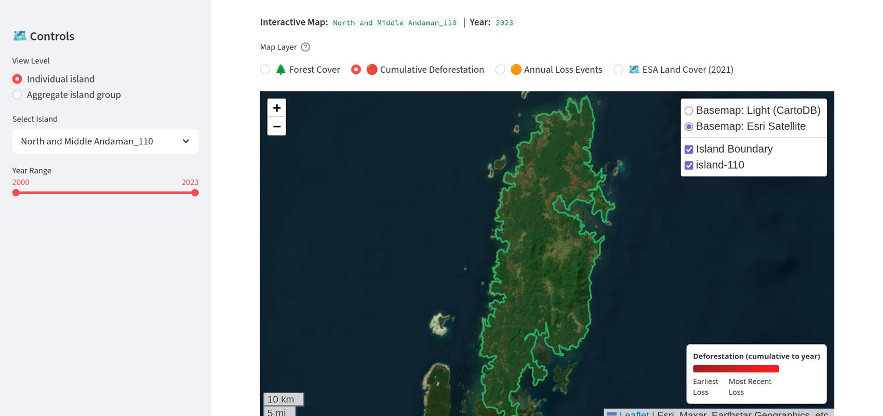
Figure 8. Cumulative deforestation layer on the Esri satellite basemap.
The same cumulative-loss layer is displayed over satellite imagery. This basemap provides real-world visual context, making it easier to relate forest-loss clusters to terrain, coastlines, settlements, roads, or other visible land-use patterns. The satellite view is useful for interpretation, while the light basemap is useful for clean reporting.
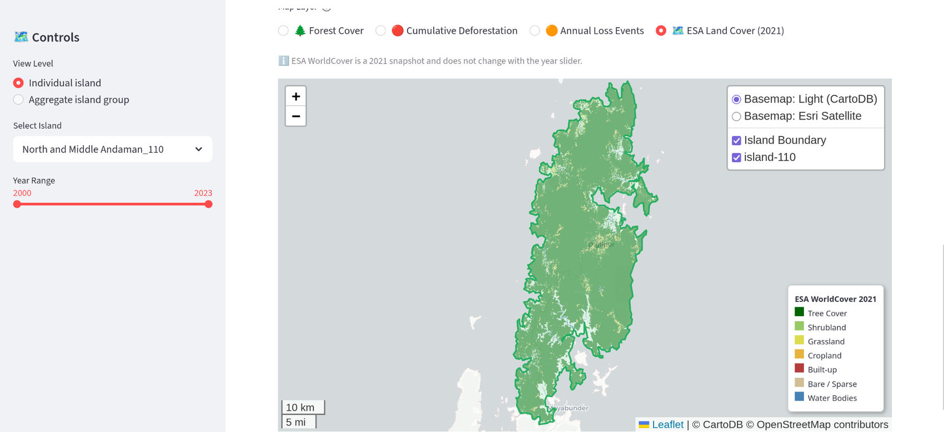
Figure 9. ESA WorldCover 2021 land-cover layer.
The ESA WorldCover map is a static 2021 land-cover snapshot and does not change with the year slider. The legend separates tree cover, shrubland, grassland, cropland, built-up land, bare or sparse areas, and water bodies. In the selected island view, tree cover dominates, while smaller non-forest classes provide context for where land conversion or settlement-related pressure may be present.
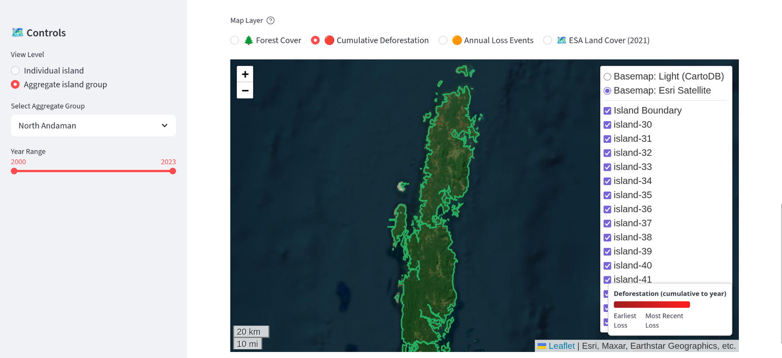
Figure 10. Aggregate island-group view for North Andaman.
The aggregate mode shows multiple island polygons together instead of one island. The layer list contains multiple island IDs, showing that the selected North Andaman group is built from several island polygons. This mode supports comparison of loss and fragmentation patterns across a broader regional unit and helps identify whether deforestation is concentrated on a major island or distributed across smaller islands.
Overall, the dashboard strengthens the report by connecting the numerical results with spatial evidence. It is especially useful for communicating that low percentage loss can still produce fragmentation stress when core forest area decreases, edge density rises, or isolated patches become more prominent. The dashboard should therefore be interpreted as a screening and communication tool that complements the statistical tables and static figures in the report.

3.9 Conservation and Policy Relevance
The presentation highlights four practical uses of the project: identifying islands where core habitat is most vulnerable, developing a reproducible remote-sensing workflow for other island ecosystems, supporting forest corridor and marine protected-area planning, and communicating results through an interactive dashboard rather than static maps alone. These outputs are most useful as screening evidence for conservation prioritization; site-level planning should still include field validation, local land-use history, and species-specific habitat requirements.

3.10 Limitations
Several limitations should be considered. First, Hansen GFC identifies tree-cover loss but does not directly separate natural disturbance, plantation rotation, classification error, and human clearing. Second, very small island polygons can produce unstable edge and patch metrics because a few pixels strongly affect ratios. Third, the statistical models are exploratory because the aggregate cluster/regression table contains only three island groups. Fourth, tsunami interpretation requires additional event-specific validation data.

4. Acknowledgements
The study acknowledges the Hansen Global Forest Change team, ESA WorldCover consortium, GADM/vector boundary data providers, and the open-source Python geospatial ecosystem used for processing and visualization. The interactive dashboard was implemented with Streamlit and Folium, with the production version hosted as a Streamlit web application. Guidance from the course instructor is gratefully acknowledged.

5. References
Andrén, H. (1994). Effects of habitat fragmentation on birds and mammals in landscapes with different proportions of suitable habitat: A review. Oikos, 71(3), 355-366. https://doi.org/10.2307/3545823
Bahuguna, A., Nayak, S., & Roy, D. (2008). Impact of the tsunami and earthquake of 26th December 2004 on the vital coastal ecosystems of the Andaman and Nicobar Islands assessed using RESOURCESAT AWiFS data. International Journal of Applied Earth Observation and Geoinformation, 10(2), 229-237. https://doi.org/10.1016/j.jag.2008.02.010
Bosch, M. (2019). PyLandStats: An open-source Pythonic library to compute landscape metrics. PLOS ONE, 14(12), e0225734. https://doi.org/10.1371/journal.pone.0225734
Fahrig, L. (2003). Effects of habitat fragmentation on biodiversity. Annual Review of Ecology, Evolution, and Systematics, 34, 487-515. https://doi.org/10.1146/annurev.ecolsys.34.011802.132419
Haddad, N. M., Brudvig, L. A., Clobert, J., Davies, K. F., Gonzalez, A., Holt, R. D., et al. (2015). Habitat fragmentation and its lasting impact on Earth's ecosystems. Science Advances, 1(2), e1500052. https://doi.org/10.1126/sciadv.1500052
Hansen, M. C., Potapov, P. V., Moore, R., Hancher, M., Turubanova, S. A., Tyukavina, A., et al. (2013). High-resolution global maps of 21st-century forest cover change. Science, 342(6160), 850-853. https://doi.org/10.1126/science.1244693
McGarigal, K., & Marks, B. J. (1995). FRAGSTATS: Spatial pattern analysis program for quantifying landscape structure. USDA Forest Service General Technical Report PNW-GTR-351. https://doi.org/10.2737/PNW-GTR-351
Midha, N., & Mathur, P. K. (2010). Assessment of forest fragmentation in the conservation priority Dudhwa landscape, India using FRAGSTATS computed class level metrics. Journal of the Indian Society of Remote Sensing, 38, 487-500. https://doi.org/10.1007/s12524-010-0034-6
Tiwari, L. K., Sinha, S. K., & Saran, S. (2016). Forest cover change detection in Andaman and Nicobar Islands using remote sensing and GIS techniques. Indian Forester, 142(5), 427-436. https://doi.org/10.36808/if/2016/v142i5/95042
Veettil, B. K., Doan Van, D., Quang, N. X., & Hoai, P. N. (2020). Spatiotemporal dynamics of mangrove forests in the Andaman and Nicobar Islands (India). Regional Studies in Marine Science, 39, 101455. https://doi.org/10.1016/j.rsma.2020.101455
Zanaga, D., Van De Kerchove, R., Daems, D., De Keersmaecker, W., Brockmann, C., Kirches, G., Wevers, J., et al. (2022). ESA WorldCover 10 m 2021 v200. Zenodo. https://doi.org/10.5281/zenodo.7254221

Appendix A. Project Outputs
Output | File path | Purpose
Island metrics time series | results/tables/island_metrics_timeseries.csv | Annual PLAND, PD, ED, TCA, ENN_MN, and patch counts
Novel metrics | results/tables/novel_metrics.csv | FI, CRR, IWFI, cumulative loss, metadata, and size class
Cluster labels | results/tables/cluster_labels.csv | Trajectory labels used in CRR plot
Regression summary | results/tables/regression_summary.txt | Exploratory statistical model output
Figures | results/figures/*.pdf | Publication figures converted to PNG for this report
Dashboard | app.py | Streamlit/Folium interactive explorer
GitHub repository | https://github.com/sanchit-22/ContinentDeforestationAnalysis | Source code and reproducible workflow
Deployed dashboard | https://andaman-nicobar-forest-analysis.streamlit.app/ | Production dashboard link

Appendix B. Prototype Connectivity Output
The table below is retained only as a prototype output from the connectivity phase. It is not used as final ecological evidence because it was not derived from a complete graph-based patch-connectivity analysis.
Table A1. Prototype keystone-patch output retained for transparency.
Patch ID | Area (ha) | Betweenness
1 | 10.5 | 0.8
2 | 20.1 | 0.4
3 | 5.0 | 0.1

Appendix C. Report Format Verification
The report was checked against the required project-report structure and updated where needed. The main additions in this revision are the expanded Section 3.8 dashboard description, dashboard screenshots with figure captions, and correction of deployment wording from Replit to the Streamlit web application link provided for the project.
Required component | Status in revised report | Location
Introduction | Included | Section 1
Literature survey with references | Included and retained | Section 1.1; Section 5
Objectives of the study | Included | Section 1.2
Study area | Included | Section 1.3
Materials and methods | Included | Section 2
Data used and data processing | Included | Sections 2.1-2.2
Method adopted / metrics | Included | Sections 2.3-2.4
Results and discussion | Included | Section 3
Comparison with previous studies | Included | Section 3.7
Dashboard details with images | Expanded in this revision | Section 3.8; Figures 6-10
Acknowledgements | Included | Section 4
References | Included | Section 5
Figures, tables, appendix | Included | Figures 1-10; Tables 1-8 and appendices
Font and spacing | Applied in revision | Times New Roman, 12 pt body, 1.5 spacing

