Manual Test Plan for Assignment 2.1

1. Running Analysis.py should give you three graphs
2. First graph you see is the different age groups of the actors
   1. 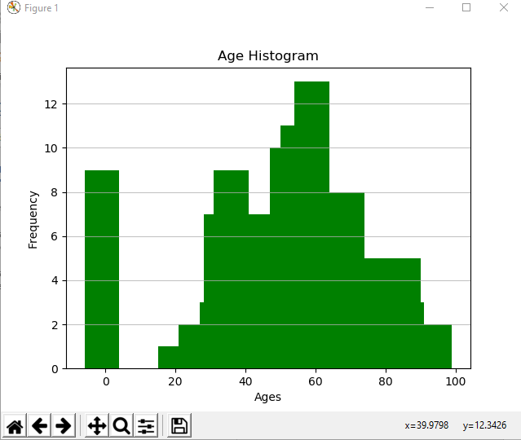
   2. Here you see on the X-axis the ages are split up into ten bins corresponding from 0-10, 10-20 and so on. The frequency represents the number of actors in that age-group that are stored in our graph.
   3. We can move our cursor over the X-axis to get the average frequency for that age. You can see this in the bottom right corner.
3. Second Graph is the revenue by age group of the actors
   1. 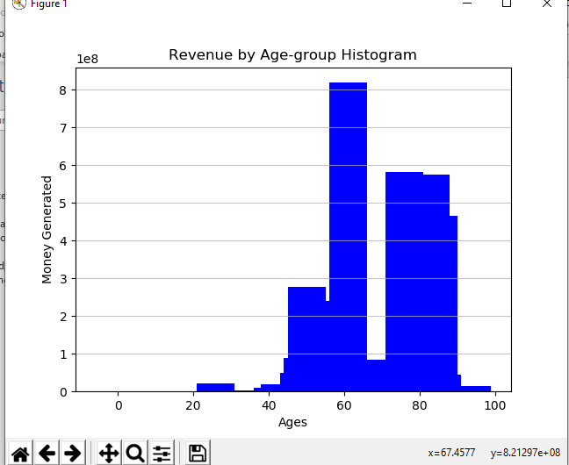
   2. Here the X-axis is again split into 10 bins, each bin representing an age group
   3. The Y-axis represents the total grossing amount for all actors in an age group. We can see the Money generated label, and the scaling of 1e8, which corresponds to 100 million.
   4. We notice that actors between 40-80 generate the most amount of money.
4. The third graph is the graph representing the number of connections each actor has
   1. 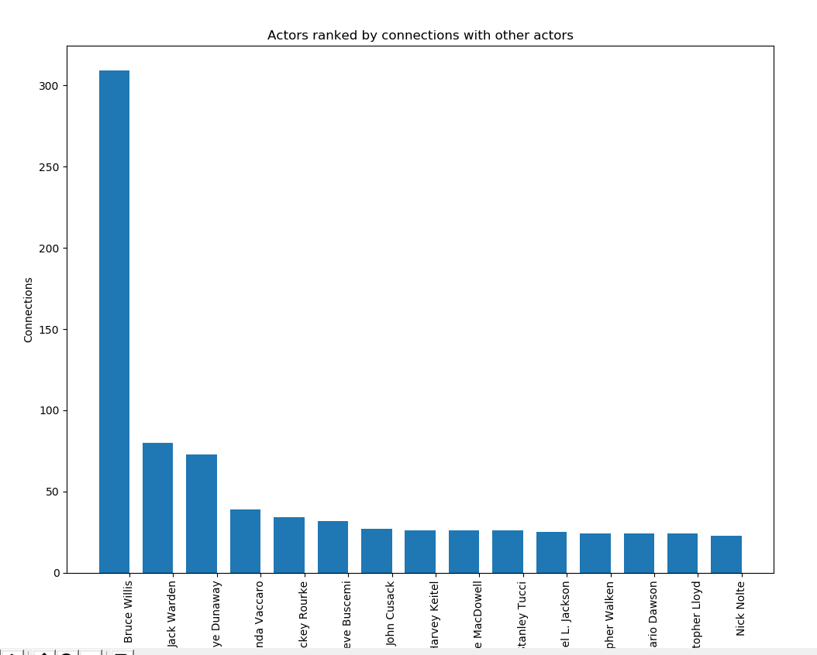
   2. Y-Axis represents the number of actors the actor has worked with in all the movies that the actor was involved in.
   3. X -Axis are the names of the actors
   4. Graph is sorted in descending order