**VISVESVARAYA TECHNOLOGICAL UNIVERSITY**

**“JnanaSangama”, Belgaum -590014, Karnataka.**



**LAB REPORT**

**on**

**Artificial Intelligence (23CS5PCAIN)**

***Submitted by***

**Sanchit Mehta (1BM23CS299)**

***in partial fulfillment for the award of the degree of***

**BACHELOR OF ENGINEERING**

***in***

**COMPUTER SCIENCE AND ENGINEERING**



**B.M.S. COLLEGE OF ENGINEERING**

**(Autonomous Institution under VTU)**

**BENGALURU-560019**

**Aug 2025 to Dec 2025**

**B.M.S. College of Engineering,**

**Bull Temple Road, Bangalore 560019**

(Affiliated To Visvesvaraya Technological University, Belgaum)

**Department of Computer Science and Engineering**



**CERTIFICATE**

This is to certify that the Lab work entitled “Artificial Intelligence (23CS5PCAIN)” carried out by **Sanchit Mehta(1BM23CS299),** who is bonafide student of **B.M.S. College of Engineering.** It is in partial fulfillment for the award of **Bachelor of Engineering in Computer Science and Engineering** of the Visvesvaraya Technological University, Belgaum. The Lab report has been approved as it satisfies the academic requirements in respect of an Artificial Intelligence (23CS5PCAIN) work prescribed for the said degree.

|  |  |
| --- | --- |
| Dr. Seema Patil  Assistant Professor  Department of CSE, BMSCE | Dr. Kavitha Sooda  Professor & HOD  Department of CSE, BMSCE |

**Index**

|  |  |  |  |
| --- | --- | --- | --- |
| **Sl.**  **No.** | **Date** | **Experiment Title** | **Page No.** |
| 1 | 30-9-2024 | Implement Tic –Tac –Toe Game  Implement vacuum cleaner agent |  |
| 2 | 7-10-2024 | Implement 8 puzzle problems using Depth First Search (DFS)  Implement Iterative deepening search algorithm |  |
| 3 | 14-10-2024 | Implement A* search algorithm |  |
| 4 | 21-10-2024 | Implement Hill Climbing search algorithm to solve N-Queens problem |  |
| 5 | 28-10-2024 | Simulated Annealing to Solve 8-Queens problem |  |
| 6 | 11-11-2024 | Create a knowledge base using propositional logic and show that the given query entails the knowledge base or not. |  |
| 7 | 2-12-2024 | Implement unification in first order logic |  |
| 8 | 2-12-2024 | Create a knowledge base consisting of first order logic statements and prove the given query using forward reasoning. |  |
| 9 | 16-12-2024 | Create a knowledge base consisting of first order logic statements and prove the given query using Resolution |  |
| 10 | 16-12-2024 | Implement Alpha-Beta Pruning. |  |

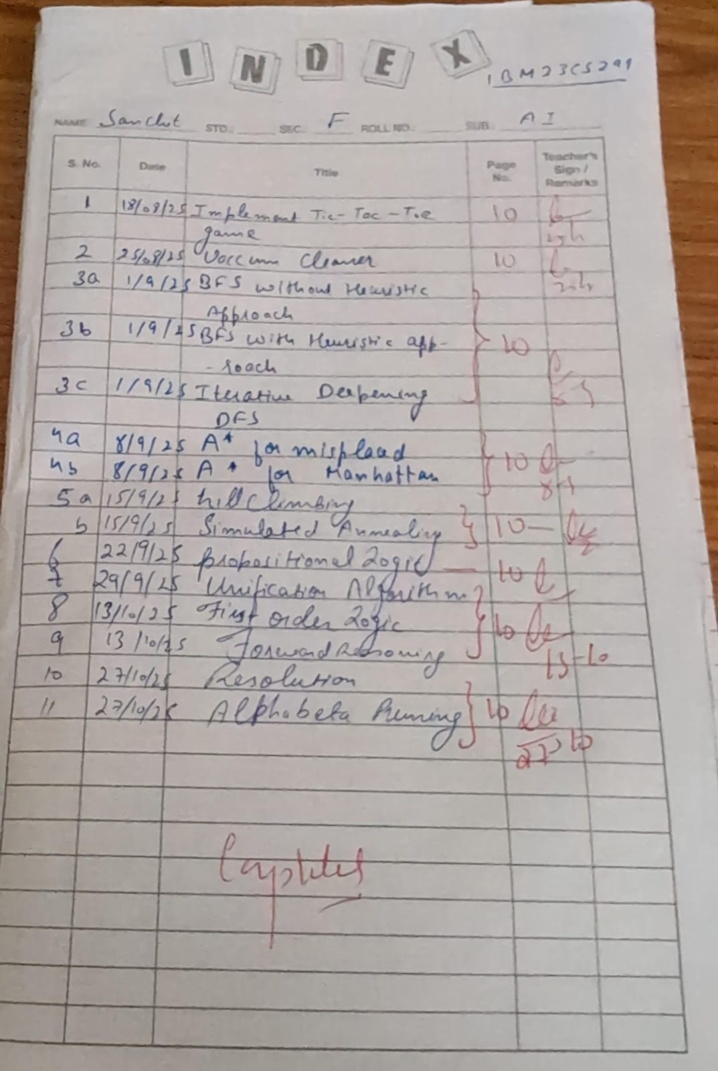

Github Link: https://github.com/sanchit299/AI_LAB_1BM23CS299

**Program 1**

Implement Tic –Tac –Toe Game

Implement vacuum cleaner agent

Algorithm:

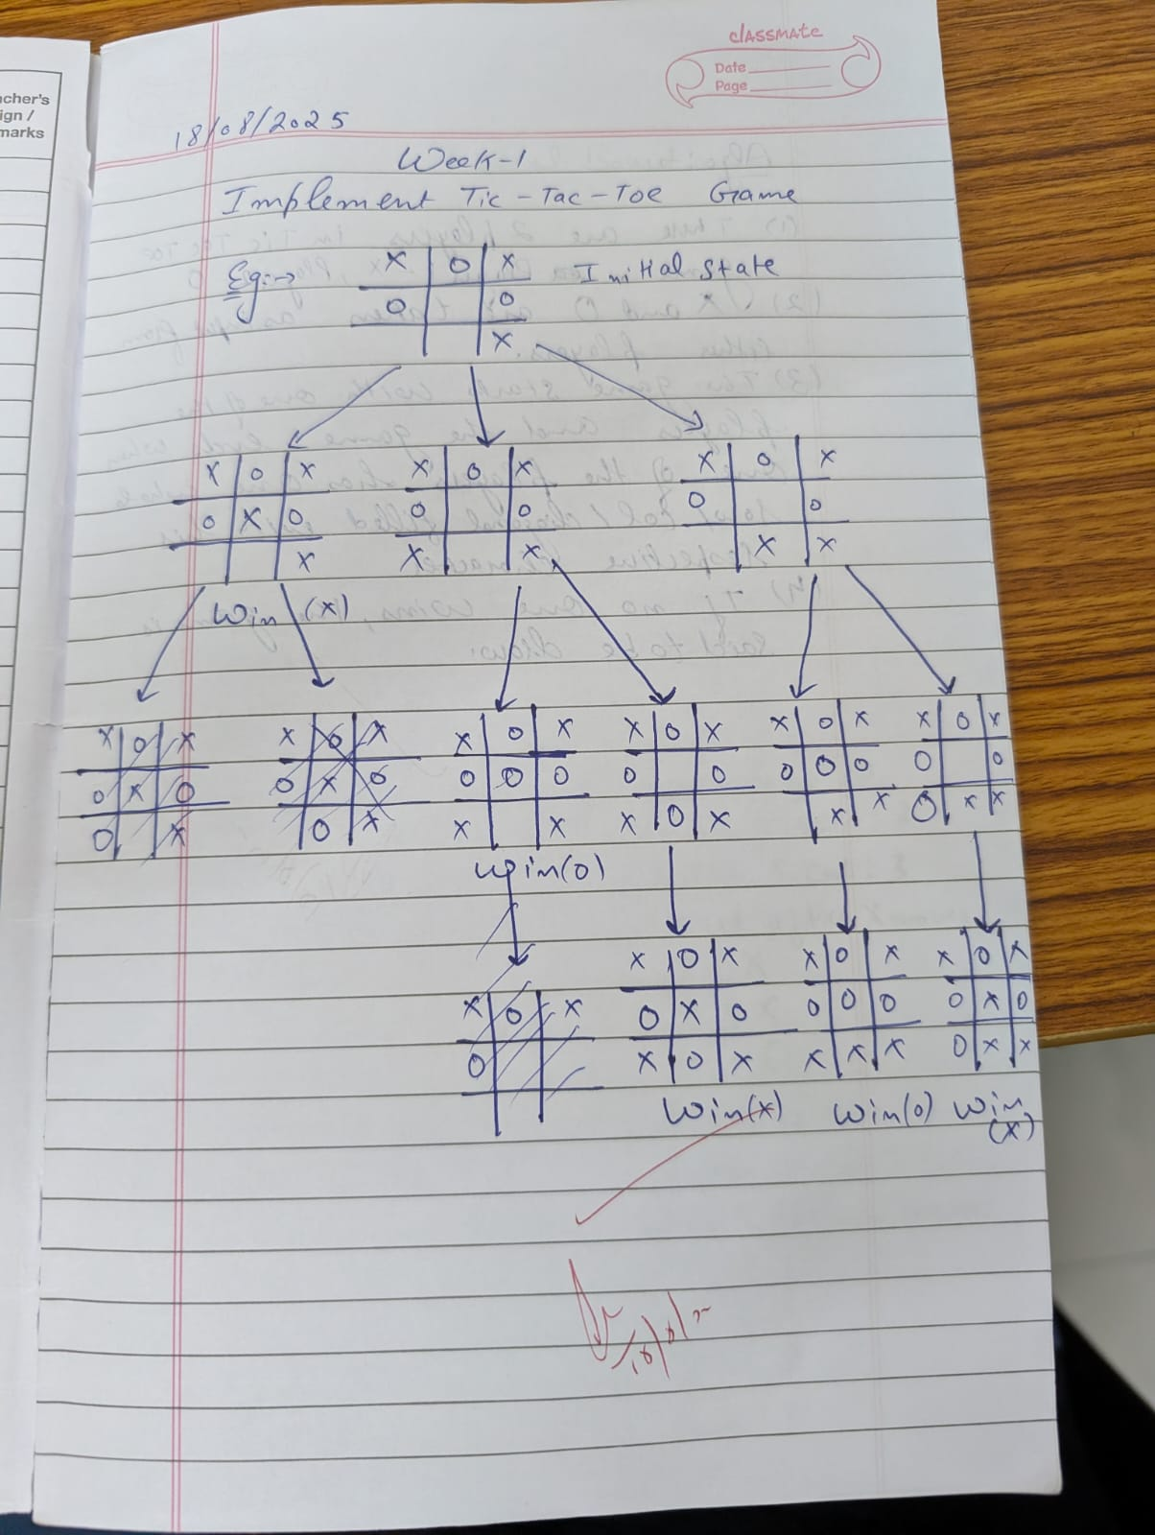

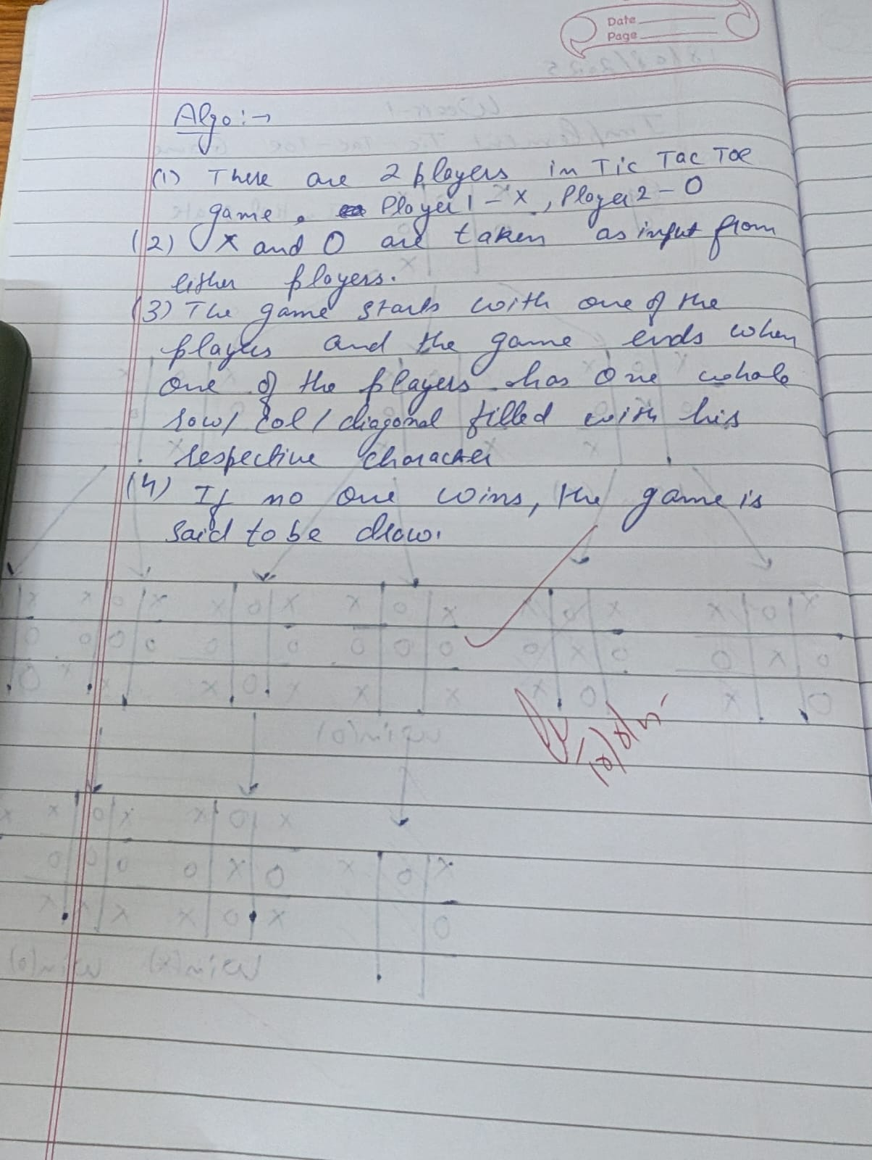 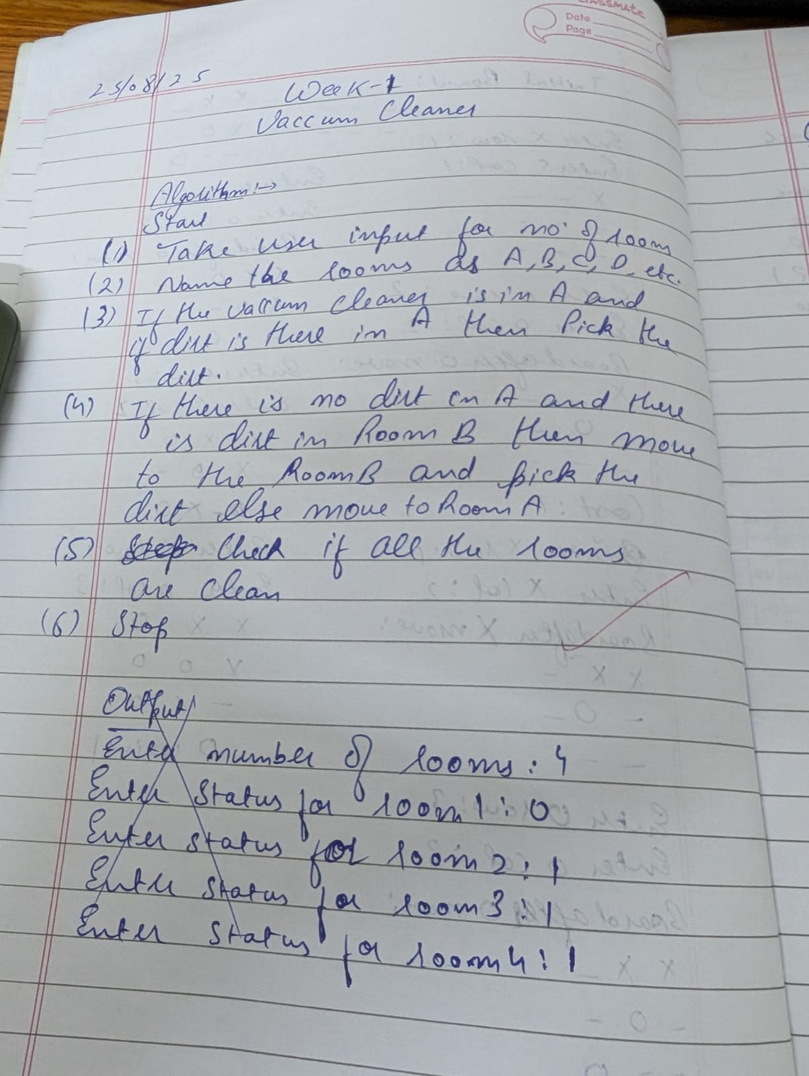

Code:

Tic tac toe:

def print_board(board):

for row in board:

print(" ".join(row))

print()

def check_winner(board, player):

for i in range(3):

if all(board[i][j] == player for j in range(3)):

return True

if all(board[j][i] == player for j in range(3)):

return True

if all(board[i][i] == player for i in range(3)):

return True

if all(board[i][2 - i] == player for i in range(3)):

return True

return False

def is_draw(board):

return all(board[i][j] != '-' for i in range(3) for j in range(3))

def minimax(board, is_ai_turn):

if check_winner(board, 'O'):

return 1

if check_winner(board, 'X'):

return -1

if is_draw(board):

return 0

if is_ai_turn:

best_score = -float('inf')

for i in range(3):

for j in range(3):

if board[i][j] == '-':

board[i][j] = 'O'

score = minimax(board, False)

board[i][j] = '-'

best_score = max(score, best_score)

return best_score

else:

best_score = float('inf')

for i in range(3):

for j in range(3):

if board[i][j] == '-':

board[i][j] = 'X'

score = minimax(board, True)

board[i][j] = '-'

best_score = min(score, best_score)

return best_score

def manual_game():

board = [['-' for _ in range(3)] for _ in range(3)]

print("Initial Board:")

print_board(board)

while True:

while True:

try:

x_row = int(input("Enter X row (1-3): ")) - 1

x_col = int(input("Enter X col (1-3): ")) - 1

if board[x_row][x_col] == '-':

board[x_row][x_col] = 'X'

break

else:

print("Cell occupied!")

except:

print("Invalid input!")

print("Board after X move:")

print_board(board)

if check_winner(board, 'X'):

print("X wins!")

break

if is_draw(board):

print("Draw!")

break

while True:

try:

o_row = int(input("Enter O row (1-3): ")) - 1

o_col = int(input("Enter O col (1-3): ")) - 1

if board[o_row][o_col] == '-':

board[o_row][o_col] = 'O'

break

else:

print("Cell occupied!")

except:

print("Invalid input!")

print("Board after O move:")

print_board(board)

if check_winner(board, 'O'):

print("O wins!")

break

if is_draw(board):

print("Draw!")

break

cost = minimax(board, True)

print(f"AI evaluation cost from this position: {cost}")

manual_game()

print("Name: Sanchit Mehta and USN : 1BM23CS299")

vaccum cleaner:

rooms = int(input("Enter Number of rooms: "))

Rooms = "ABCDEFGHIJKLMNOPQRSTUVWXYZ"

cost = 0

Roomval = {}

for i in range(rooms):

print(f"Enter Room {Rooms[i]} state (0 for clean, 1 for dirty): ")

n = int(input())

Roomval[Rooms[i]] = n

loc = input(f"Enter Location of vacuum ({Rooms[:rooms]}): ").upper()

while 1 in Roomval.values():

if Roomval[loc] == 1:

print(f"Room {loc} is dirty. Cleaning...")

Roomval[loc] = 0

cost += 1

else:

print(f"Room {loc} is already clean.")

move = input("Enter L or R to move left or right (or Q to quit): ").upper()

if move == "L":

if loc != Rooms[0]:

loc = Rooms[Rooms.index(loc) - 1]

else:

print("No room to move left.")

elif move == "R":

if loc != Rooms[rooms - 1]:

loc = Rooms[Rooms.index(loc) + 1]

else:

print("No room to move right.")

elif move == "Q":

break

else:

print("Invalid input. Please enter L, R, or Q.")

print("\nAll Rooms Cleaned." if 1 not in Roomval.values() else "Exited before cleaning all rooms.")

print(f"Total cost: {cost}")

print("1BM23CS299")

print("Sanchit Mehta")

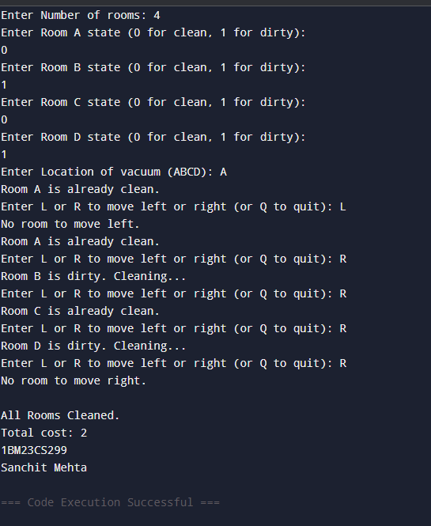

**Program 2**

Implement 8 puzzle problems using Depth First Search (DFS):

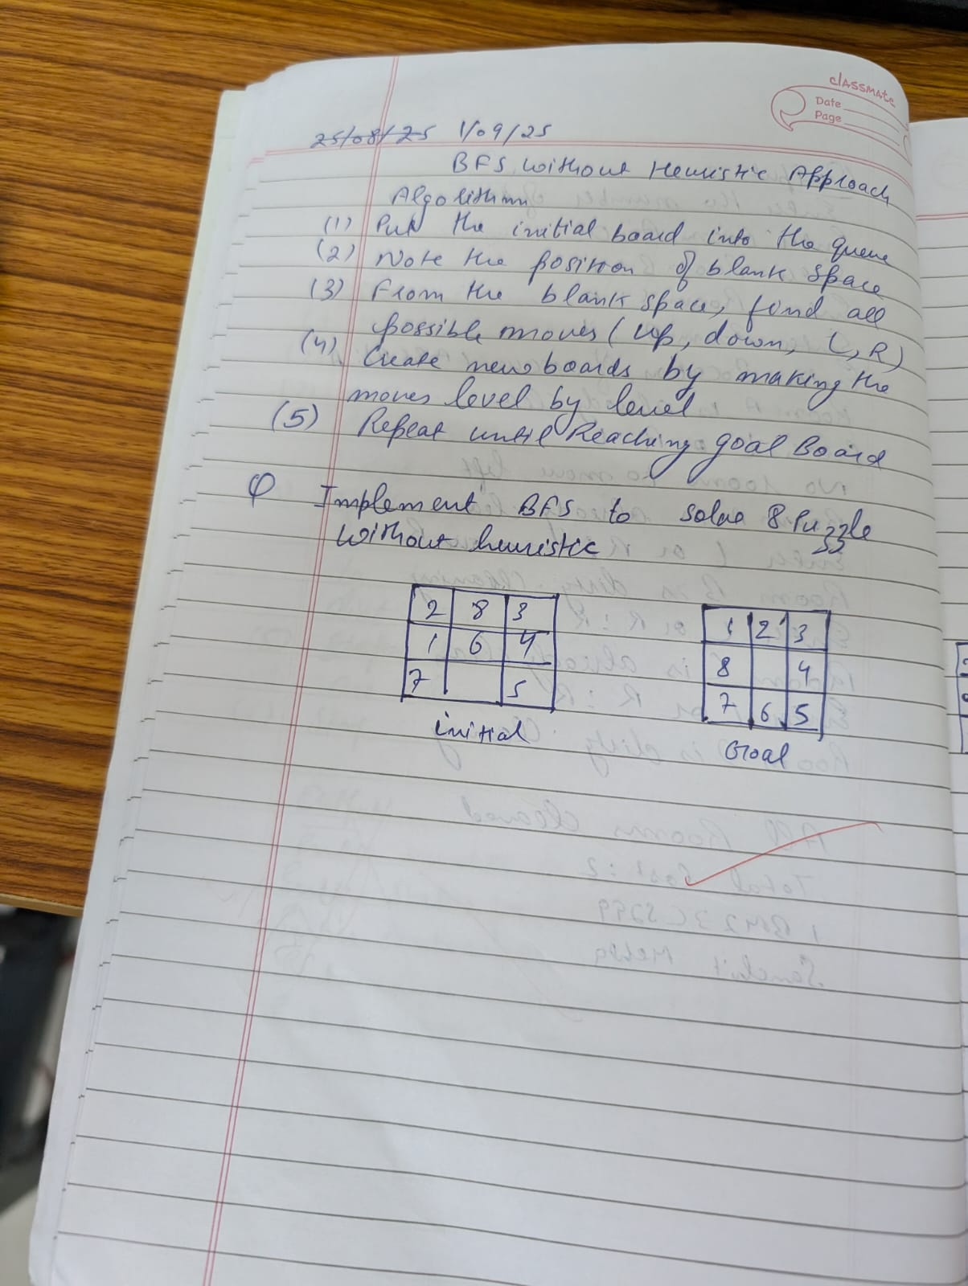 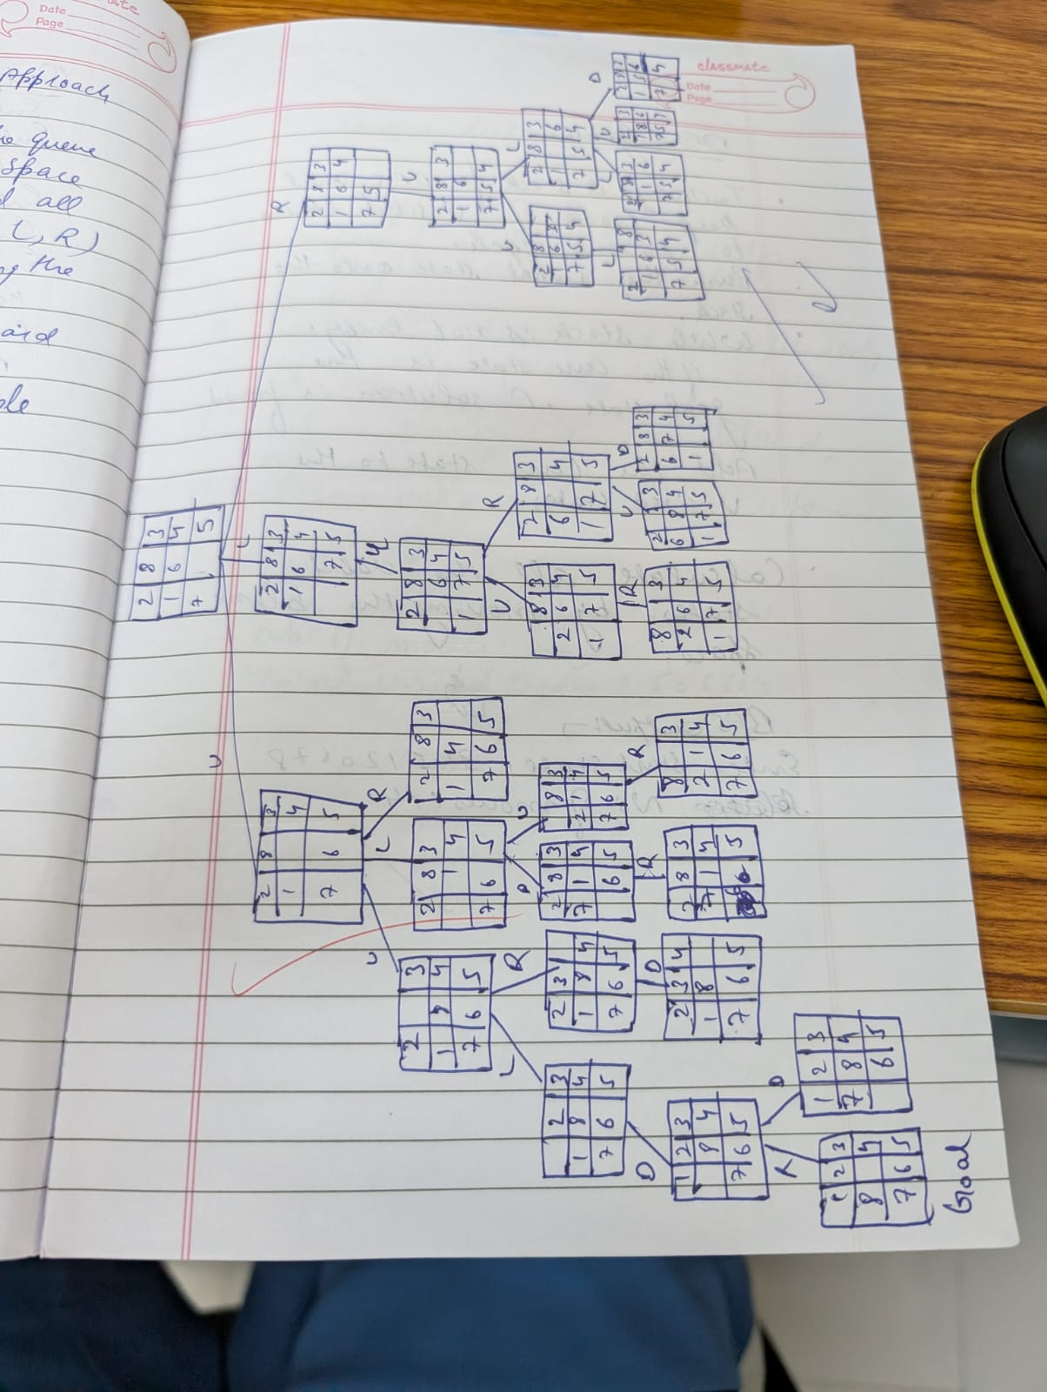 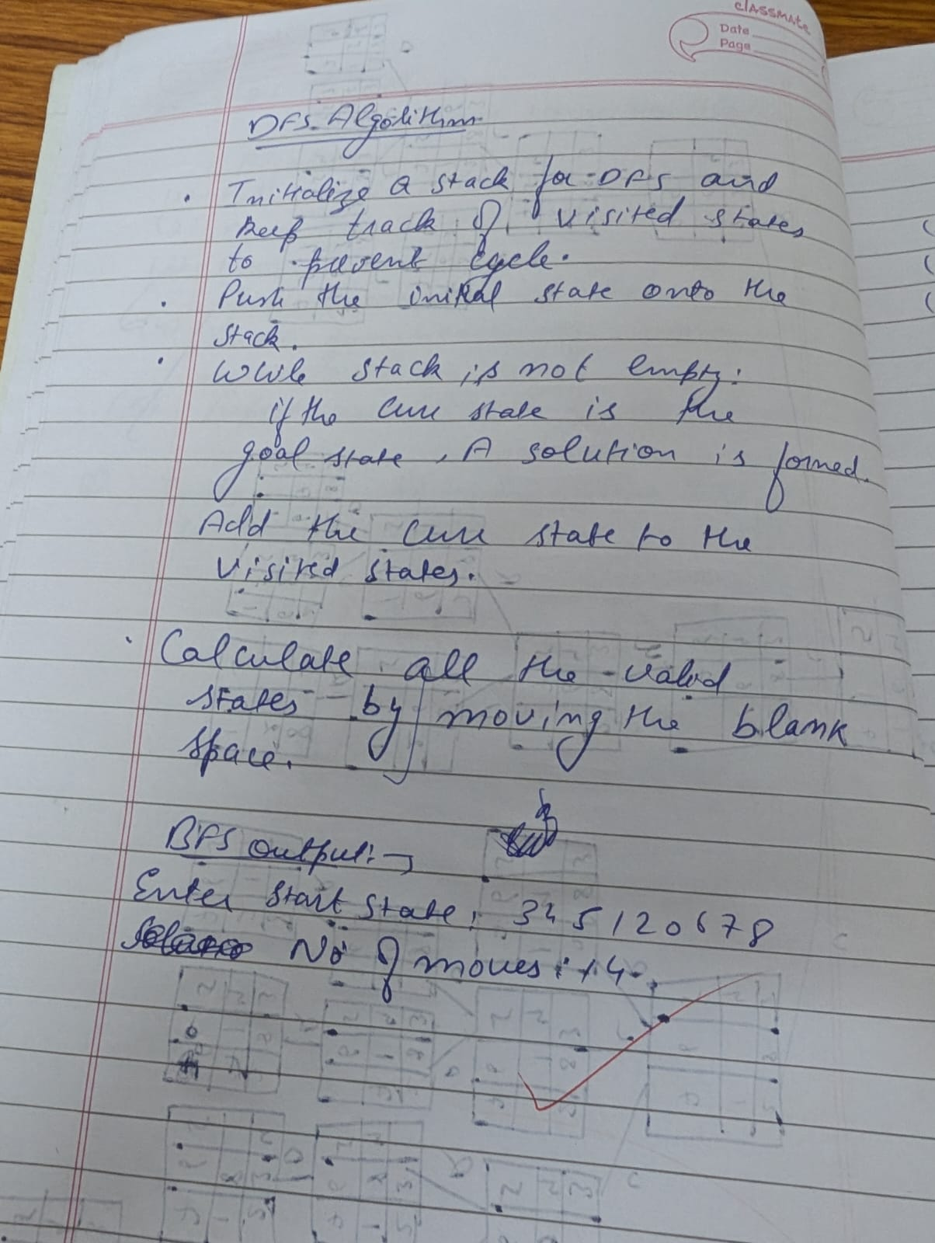

goal_state = '123804765'

moves = {

'U': -3,

'D': 3,

'L': -1,

'R': 1

}

count = 0

invalid_moves = {

0: ['U', 'L'], 1: ['U'], 2: ['U', 'R'],

3: ['L'], 5: ['R'],

6: ['D', 'L'], 7: ['D'], 8: ['D', 'R']

}

def move_tile(state, direction):

index = state.index('0')

if direction in invalid_moves.get(index, []):

return None

new_index = index + moves[direction]

if new_index < 0 or new_index >= 9:

return None

state_list = list(state)

state_list[index], state_list[new_index] = state_list[new_index], state_list[index]

return ''.join(state_list)

def print_state(state):

for i in range(0, 9, 3):

print(' '.join(state[i:i+3]).replace('0', ' '))

print()

def dfs(start_state, max_depth=50):

visited = set()

stack = [(start_state, [])] # Each element: (state, path)

while stack:

current_state, path = stack.pop()

if current_state in visited:

continue

# Print every visited state

print("Visited state:")

print_state(current_state)

if current_state == goal_state:

return path

visited.add(current_state)

global count

count +=1

if len(path) >= max_depth:

continue

for direction in moves:

new_state = move_tile(current_state, direction)

if new_state and new_state not in visited:

stack.append((new_state, path + [direction]))

return None

start = input("Enter start state (e.g., 724506831): ")

if len(start) == 9 and set(start) == set('012345678'):

print("Start state:")

print_state(start)

result = dfs(start)

if result is not None:

print("Solution found!")

print("Moves:", ' '.join(result))

print("Number of moves:", len(result))

print("Number of visited states",count)

print("1BM23CS299 Sanchit Mehta\n")

current_state = start

for i, move in enumerate(result, 1):

current_state = move_tile(current_state, move)

print(f"Move {i}: {move}")

print_state(current_state)

else:

print("No solution exists for the given start state or max depth reached.")

else:

print("Invalid input! Please enter a 9-digit string using digits 0-8 without repetition.")

Implement Iterative deepening search algorithm:

goal_state = '123456780'

moves = {

'U': -3,

'D': 3,

'L': -1,

'R': 1

}

invalid_moves = {

0: ['U', 'L'], 1: ['U'], 2: ['U', 'R'],

3: ['L'], 5: ['R'],

6: ['D', 'L'], 7: ['D'], 8: ['D', 'R']

}

def move_tile(state, direction):

index = state.index('0')

if direction in invalid_moves.get(index, []):

return None

new_index = index + moves[direction]

if new_index < 0 or new_index >= 9:

return None

state_list = list(state)

state_list[index], state_list[new_index] = state_list[new_index], state_list[index]

return ''.join(state_list)

def print_state(state):

for i in range(0, 9, 3):

print(' '.join(state[i:i+3]).replace('0', ' '))

print()

def dls(state, depth, path, visited, visited_count):

visited_count[0] += 1 # Increment visited states count

if state == goal_state:

return path

if depth == 0:

return None

visited.add(state)

for direction in moves:

new_state = move_tile(state, direction)

if new_state and new_state not in visited:

result = dls(new_state, depth - 1, path + [direction], visited, visited_count)

if result is not None:

return result

visited.remove(state)

return None

def iddfs(start_state, max_depth=50):

visited_count = [0] # Using list to pass by reference

for depth in range(max_depth + 1):

visited = set()

result = dls(start_state, depth, [], visited, visited_count)

if result is not None:

return result, visited_count[0]

return None, visited_count[0]

# Main

start = input("Enter start state (e.g., 724506831): ")

if len(start) == 9 and set(start) == set('012345678'):

print("Start state:")

print_state(start)

result, visited_states = iddfs(start,15)

print(f"Total states visited: {visited_states}")

if result is not None:

print("Solution found!")

print("Moves:", ' '.join(result))

print("Number of moves:", len(result))

print("1BM23CS307 Uzair\n")

current_state = start

for i, move in enumerate(result, 1):

current_state = move_tile(current_state, move)

print(f"Move {i}: {move}")

print_state(current_state)

else:

print("No solution exists for the given start state or max depth reached.")

else:

print("Invalid input! Please enter a 9-digit string using digits 0-8 without repetition.")

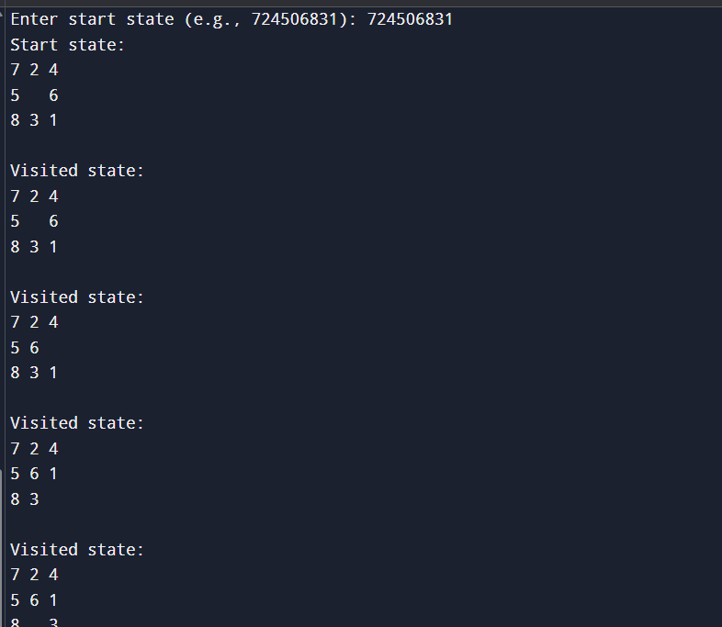

**Program 3**

Implement A* search algorithm

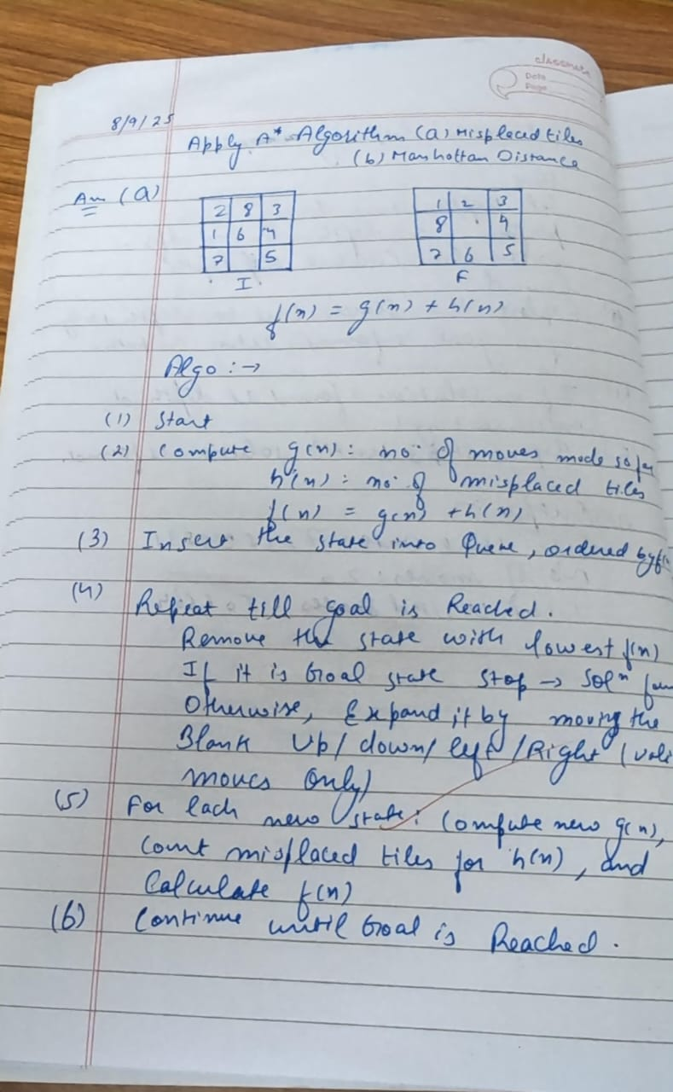

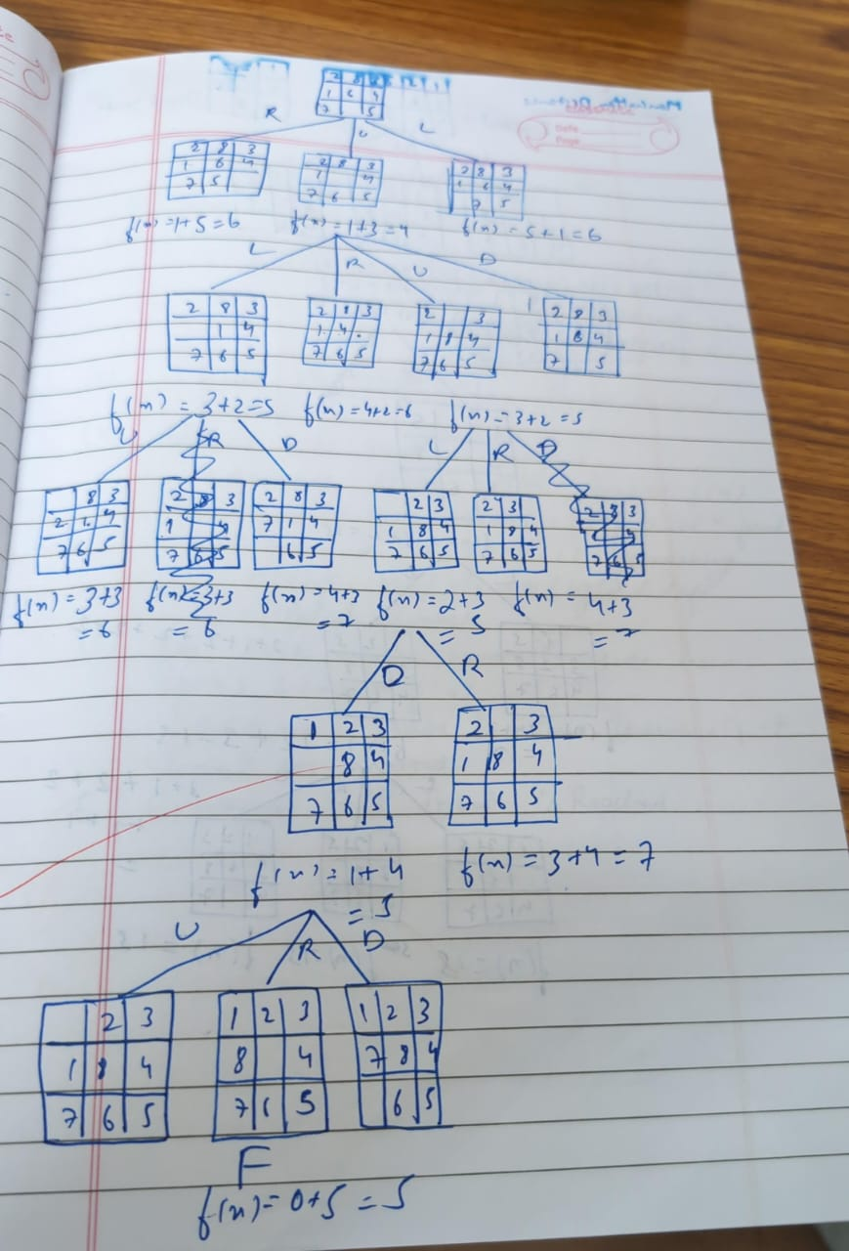

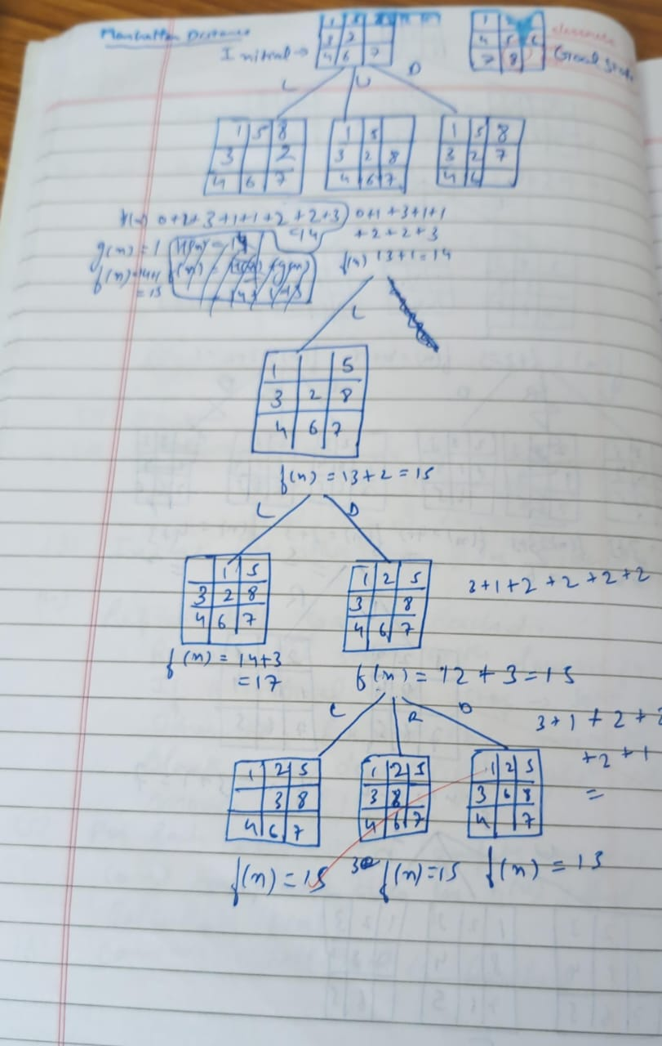

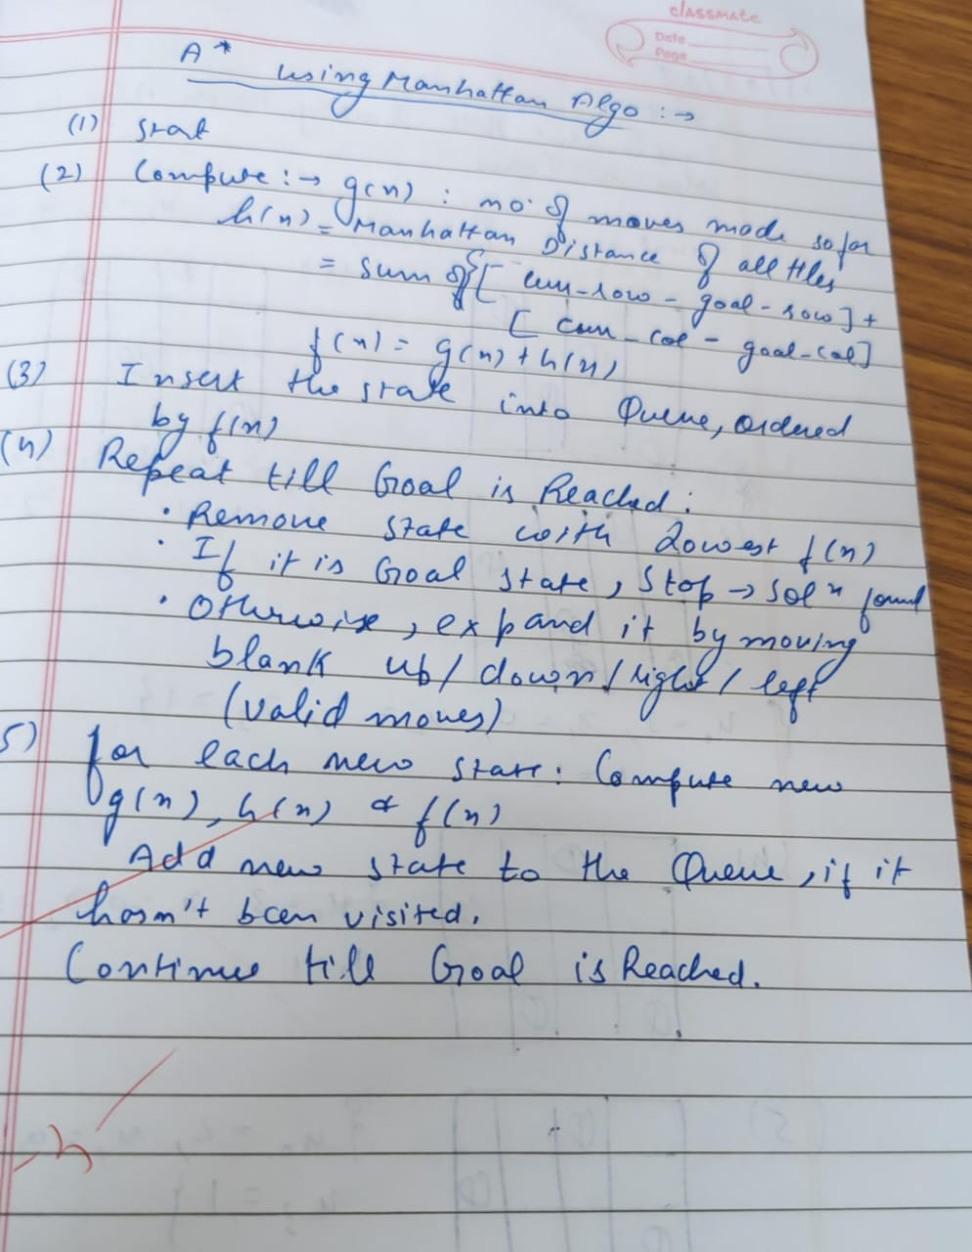

import heapq

goal_state = '123456780'

moves = {

'U': -3,

'D': 3,

'L': -1,

'R': 1

}

invalid_moves = {

0: ['U', 'L'], 1: ['U'], 2: ['U', 'R'],

3: ['L'], 5: ['R'],

6: ['D', 'L'], 7: ['D'], 8: ['D', 'R']

}

def move_tile(state, direction):

index = state.index('0')

if direction in invalid_moves.get(index, []):

return None

new_index = index + moves[direction]

if new_index < 0 or new_index >= 9:

return None

state_list = list(state)

state_list[index], state_list[new_index] = state_list[new_index], state_list[index]

return ''.join(state_list)

def print_state(state):

for i in range(0, 9, 3):

print(' '.join(state[i:i+3]).replace('0', ' '))

print()

def manhattan_distance(state):

distance = 0

for i, val in enumerate(state):

if val == '0':

continue

goal_pos = int(val) - 1

current_row, current_col = divmod(i, 3)

goal_row, goal_col = divmod(goal_pos, 3)

distance += abs(current_row - goal_row) + abs(current_col - goal_col)

return distance

def a_star(start_state):

visited_count = 0

open_set = []

heapq.heappush(open_set, (manhattan_distance(start_state), 0, start_state, []))

visited = set()

while open_set:

f, g, current_state, path = heapq.heappop(open_set)

visited_count += 1

if current_state == goal_state:

return path, visited_count

if current_state in visited:

continue

visited.add(current_state)

for direction in moves:

new_state = move_tile(current_state, direction)

if new_state and new_state not in visited:

new_g = g + 1

new_f = new_g + manhattan_distance(new_state)

heapq.heappush(open_set, (new_f, new_g, new_state, path + [direction]))

return None, visited_count

# Main

start = input("Enter start state (e.g., 724506831): ")

if len(start) == 9 and set(start) == set('012345678'):

print("Start state:")

print_state(start)

result, visited_states = a_star(start)

print(f"Total states visited: {visited_states}")

if result is not None:

print("Solution found!")

print("Moves:", ' '.join(result))

print("Number of moves:", len(result))

print("1BM23CS299 sanchit mehta\n")

current_state = start

for i, move in enumerate(result, 1):

current_state = move_tile(current_state, move)

print(f"Move {i}: {move}")

print_state(current_state)

else:

print("No solution exists for the given start state.")

else:

print("Invalid input! Please enter a 9-digit string using digits 0-8 without repetition.")

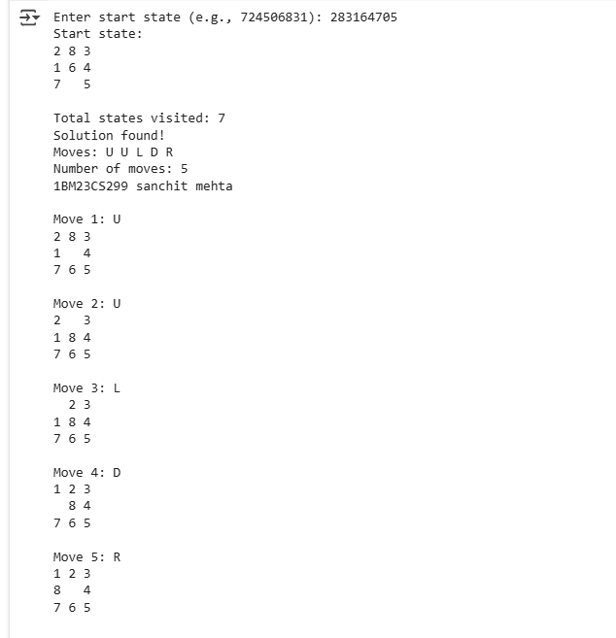

**Program 4**

Implement Hill Climbing search algorithm to solve N-Queens problem

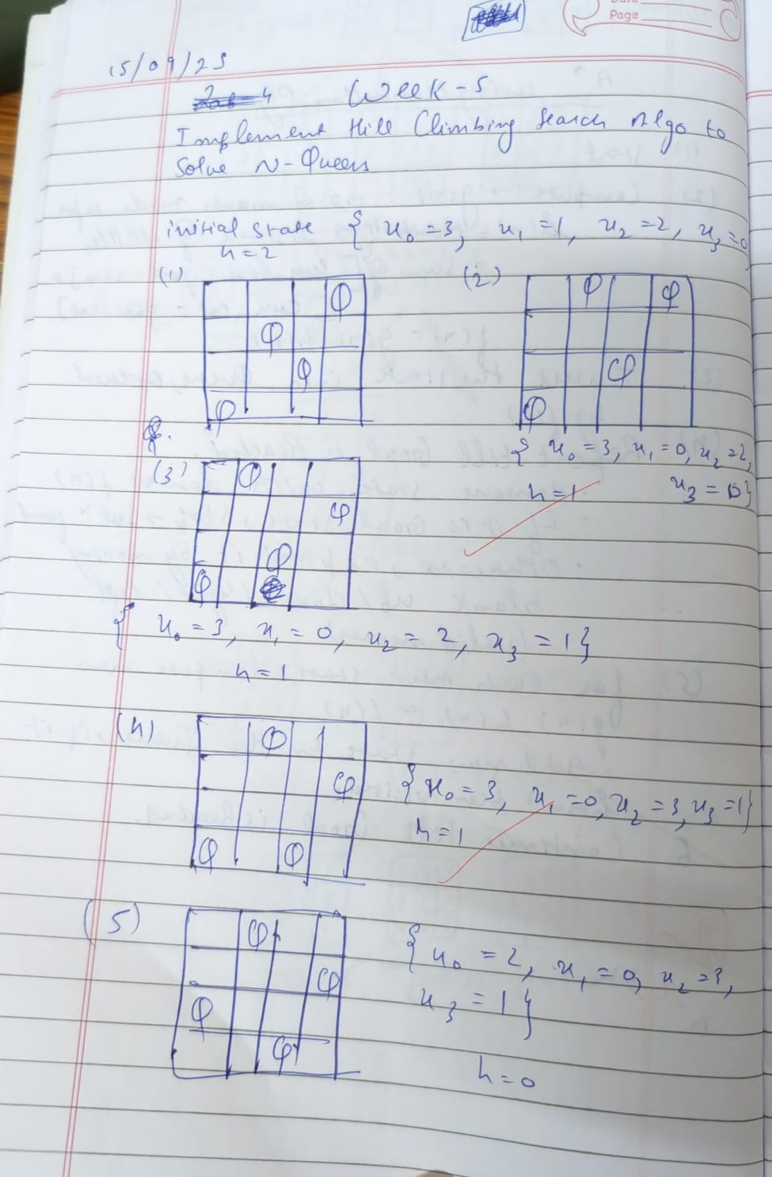

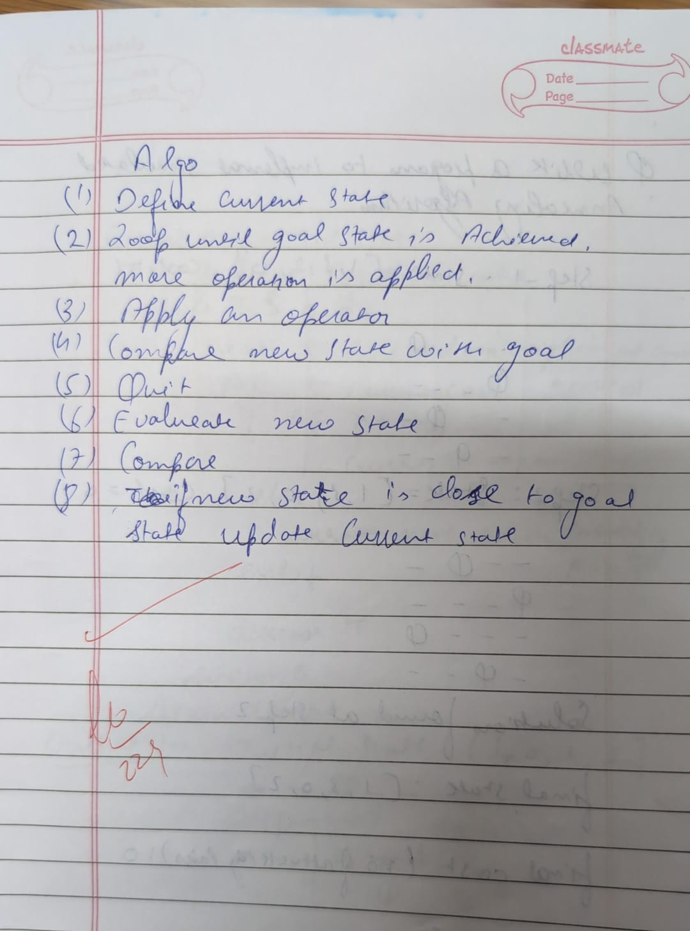

import random

import time

def print_board(state):

"""Prints the chessboard for a given state."""

n = len(state)

for row in range(n):

line = ""

for col in range(n):

if state[col] == row:

line += "Q "

else:

line += ". "

print(line)

print()

def compute_heuristic(state):

"""Computes the number of attacking pairs of queens."""

h = 0

n = len(state)

for i in range(n):

for j in range(i + 1, n):

if state[i] == state[j] or abs(state[i] - state[j]) == abs(i - j):

h += 1

return h

def get_neighbors(state):

"""Generates all possible neighbors by moving one queen in its column."""

neighbors = []

n = len(state)

for col in range(n):

for row in range(n):

if row != state[col]:

neighbor = list(state)

neighbor[col] = row

neighbors.append(neighbor)

return neighbors

def hill_climb_verbose(initial_state, step_delay=0.5):

"""Hill climbing algorithm with verbose output at each step."""

current = initial_state

current_h = compute_heuristic(current)

step = 0

print(f"Initial state (heuristic: {current_h}):")

print_board(current)

time.sleep(step_delay)

while True:

neighbors = get_neighbors(current)

next_state = None

next_h = current_h

for neighbor in neighbors:

h = compute_heuristic(neighbor)

if h < next_h:

next_state = neighbor

next_h = h

if next_h >= current_h:

print(f"Reached local minimum at step {step}, heuristic: {current_h}")

return current, current_h

current = next_state

current_h = next_h

step += 1

print(f"Step {step}: (heuristic: {current_h})")

print_board(current)

time.sleep(step_delay)

def solve_n_queens_verbose(n, max_restarts=1000):

"""Solves N-Queens problem using hill climbing with restarts and verbose output."""

for attempt in range(max_restarts):

print(f"\n=== Restart {attempt + 1} ===\n")

initial_state = [random.randint(0, n - 1) for _ in range(n)]

solution, h = hill_climb_verbose(initial_state)

if h == 0:

print(f" Solution found after {attempt + 1} restart(s):")

print_board(solution)

return solution

else:

print(f"No solution in this attempt (local minimum).\n")

print("Failed to find a solution after max restarts.")

return None

# --- Run the algorithm ---

if __name__ == "__main__":

N = int(input("Enter the number of queens (N): "))

solve_n_queens_verbose(N)

print("1BM23CS299 Sanchit Mehta")

Output:

Enter the number of queens (N): 4

=== Restart 1 ===

Initial state (heuristic: 3):

Q . Q .

. Q . .

. . . Q

. . . .

Step 1: (heuristic: 1)

. . Q .

. Q . .

. . . Q

Q . . .

Reached local minimum at step 1, heuristic: 1

❌ No solution in this attempt (local minimum).

=== Restart 2 ===

Initial state (heuristic: 3):

. Q . .

. . Q .

. . . .

Q . . Q

Step 1: (heuristic: 1)

. Q . .

. . Q .

Q . . .

. . . Q

Reached local minimum at step 1, heuristic: 1

❌ No solution in this attempt (local minimum).

=== Restart 3 ===

Initial state (heuristic: 2):

. . . .

. Q . Q

. . . .

Q . Q .

Step 1: (heuristic: 1)

. Q . .

. . . Q

. . . .

Q . Q .

Step 2: (heuristic: 0)

. Q . .

. . . Q

Q . . .

. . Q .

Reached local minimum at step 2, heuristic: 0

✅ Solution found after 3 restart(s):

. Q . .

. . . Q

Q . . .

. . Q .

1BM23CS299 sanchit

**Program 5**

Simulated Annealing to Solve 8-Queens problem

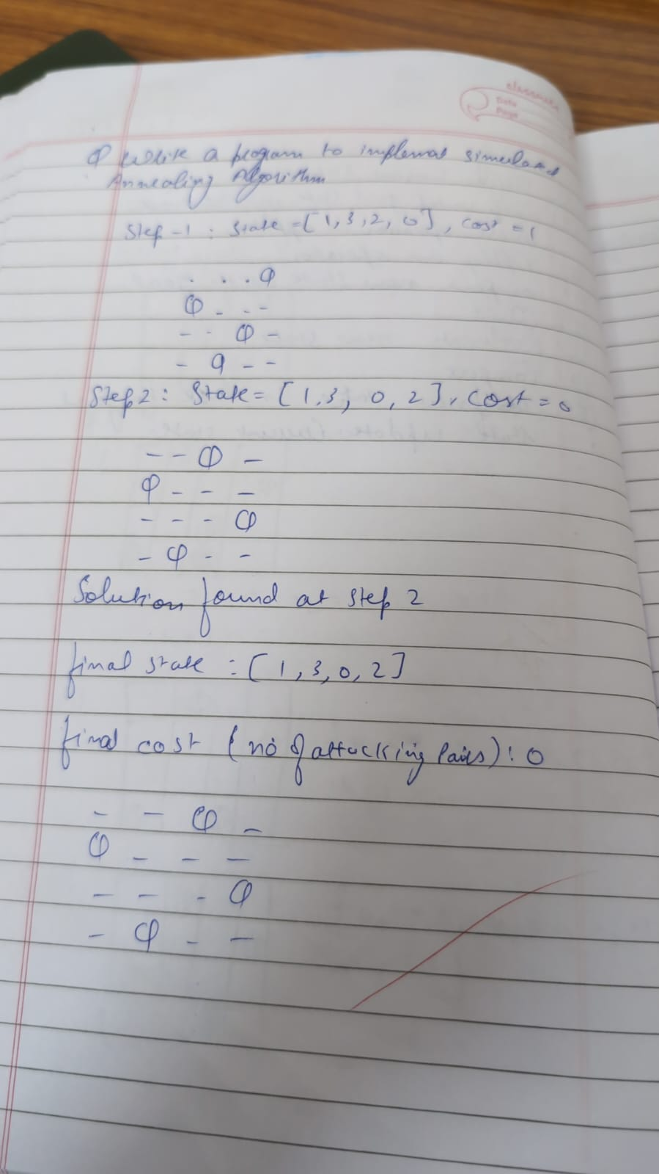

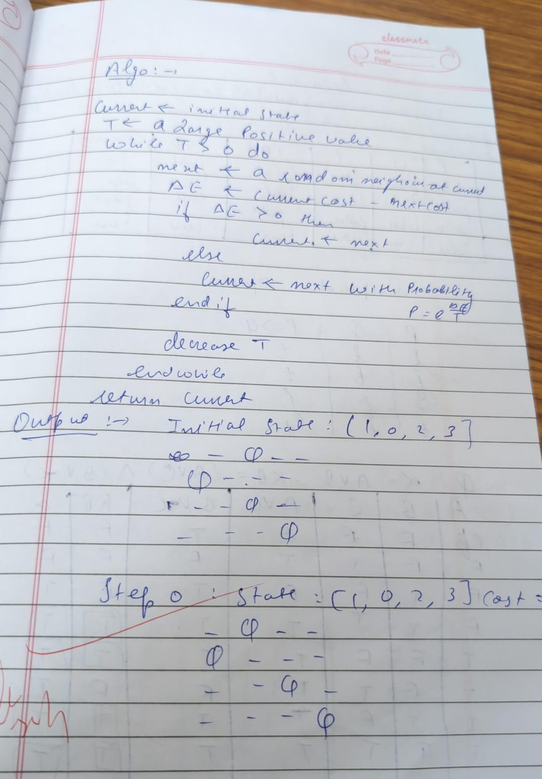

import random

import math

def compute_heuristic(state):

"""Number of attacking pairs."""

h = 0

n = len(state)

for i in range(n):

for j in range(i + 1, n):

if state[i] == state[j] or abs(state[i] - state[j]) == abs(i - j):

h += 1

return h

def random_neighbor(state):

"""Returns a neighbor by randomly changing one queen's row."""

n = len(state)

neighbor = state[:]

col = random.randint(0, n - 1)

old_row = neighbor[col]

new_row = random.choice([r for r in range(n) if r != old_row])

neighbor[col] = new_row

return neighbor

def dual_simulated_annealing(n, max_iter=10000, initial_temp=100.0, cooling_rate=0.99):

"""Simulated Annealing with dual acceptance strategy."""

current = [random.randint(0, n - 1) for _ in range(n)]

current_h = compute_heuristic(current)

temperature = initial_temp

for step in range(max_iter):

if current_h == 0:

print(f"✅ Solution found at step {step}")

return current

neighbor = random_neighbor(current)

neighbor_h = compute_heuristic(neighbor)

delta = neighbor_h - current_h

if delta < 0:

current = neighbor

current_h = neighbor_h

else:

# Dual acceptance: standard + small chance of higher uphill move

probability = math.exp(-delta / temperature)

if random.random() < probability:

current = neighbor

current_h = neighbor_h

temperature *= cooling_rate

if temperature < 1e-5: # Restart if stuck

temperature = initial_temp

current = [random.randint(0, n - 1) for _ in range(n)]

current_h = compute_heuristic(current)

print("❌ Failed to find solution within max iterations.")

return None

# --- Run the algorithm ---

if __name__ == "__main__":

N = int(input("Enter number of queens (N): "))

solution = dual_simulated_annealing(N)

if solution:

print("Position format:")

print("[", " ".join(str(x) for x in solution), "]")

print("Heuristic:", compute_heuristic(solution))

print("1BM23CS299 Sanchit")

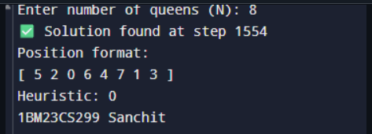

**Program 6**

Create a knowledge base using propositional logic and show that the given query entails the knowledge base or not: 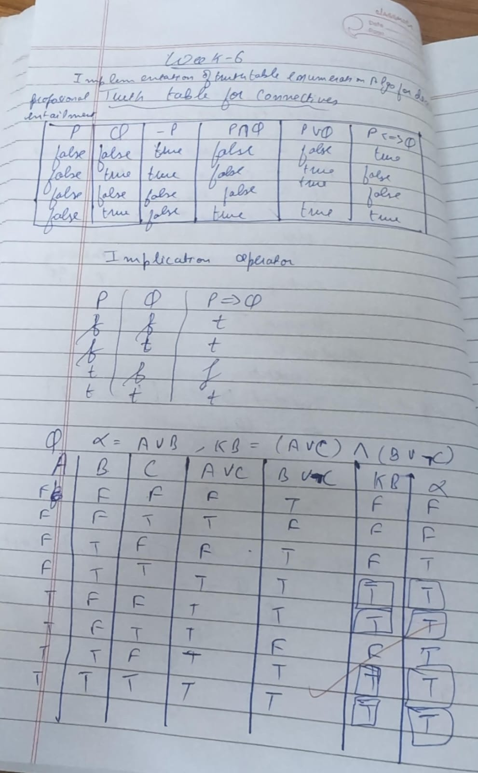

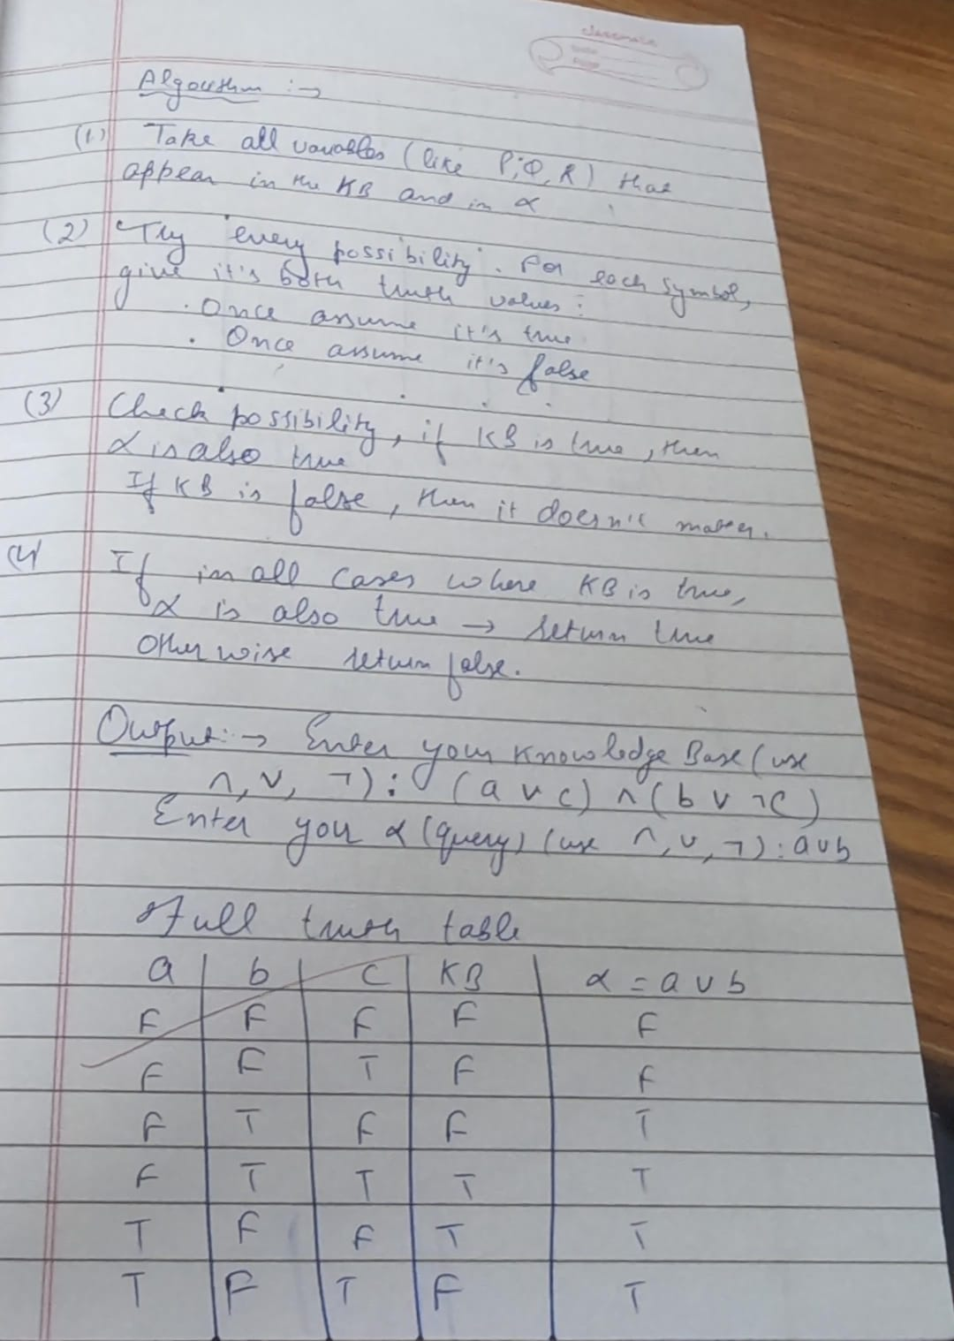

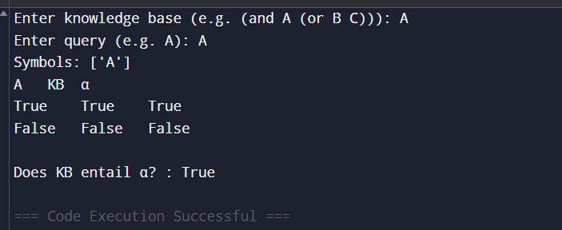

**Program 7**

Implement unification in first order logic:

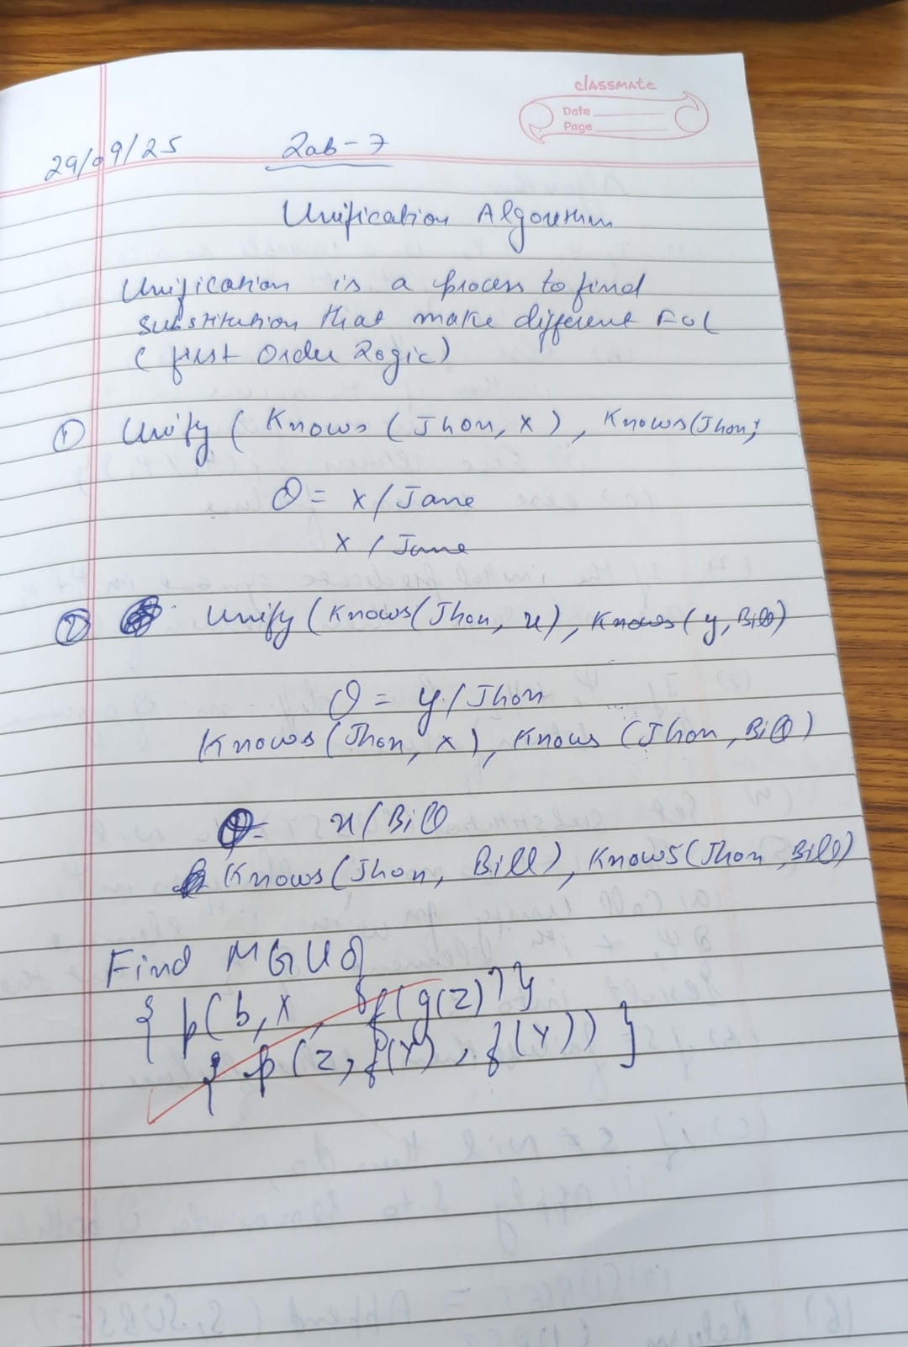

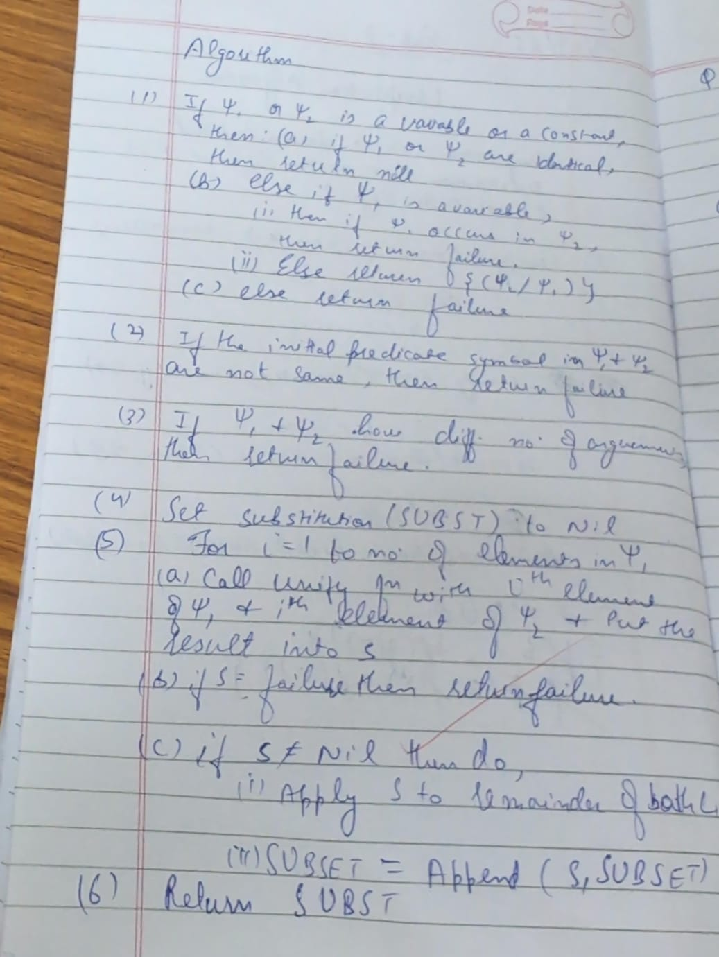

import json

# --- Helper Functions for Term Manipulation ---

def is_variable(term):

"""Checks if a term is a variable (a single capital letter string)."""

return isinstance(term, str) and len(term) == 1 and 'A' <= term[0] <= 'Z'

def occurs_check(variable, term, sigma):

"""

Checks if 'variable' occurs anywhere in 'term' under the current substitution 'sigma'.

This prevents infinite recursion (e.g., unifying X with f(X)).

"""

term = apply_substitution(term, sigma) # Check the substituted term

if term == variable:

return True

# If the term is a list (function/predicate), check its arguments recursively

if isinstance(term, list):

for arg in term[1:]:

if occurs_check(variable, arg, sigma):

return True

return False

def apply_substitution(term, sigma):

"""

Applies the current substitution 'sigma' to a 'term' recursively.

"""

if is_variable(term):

# If the variable is bound in sigma, apply the binding

if term in sigma:

# Recursively apply the rest of the substitutions to the binding's value

# This is critical for chains like X/f(Y), Y/a -> X/f(a)

return apply_substitution(sigma[term], sigma)

return term

if isinstance(term, list):

# Apply substitution to the arguments of the function/predicate

new_term = [term[0]] # Keep the function/predicate symbol

for arg in term[1:]:

new_term.append(apply_substitution(arg, sigma))

return new_term

# Term is a constant or an unhandled type, return as is

return term

def term_to_string(term):

"""

Converts the internal list representation of a term into standard logic notation string.

e.g., ['f', 'Y'] -> "f(Y)"

"""

if isinstance(term, str):

return term

if isinstance(term, list):

# Term is a function or predicate

symbol = term[0]

args = [term_to_string(arg) for arg in term[1:]]

return f"{symbol}({', '.join(args)})"

return str(term)

# --- Main Unification Function ---

def unify(term1, term2):

"""

Implements the Unification Algorithm to find the MGU for term1 and term2.

Returns the MGU as a dictionary or None if unification fails.

"""

# Initialize the substitution set (MGU)

sigma = {}

# Initialize the list of pairs to resolve (the difference set)

diff_set = [[term1, term2]]

print(f"--- Unification Process Started ---")

print(f"Initial Terms:")

print(f"L1: {term_to_string(term1)}")

print(f"L2: {term_to_string(term2)}")

print("-" * 35)

while diff_set:

# Pop the current pair of terms to unify

t1, t2 = diff_set.pop(0)

# 1. Apply the current MGU to the terms before comparison

t1_prime = apply_substitution(t1, sigma)

t2_prime = apply_substitution(t2, sigma)

print(f"Attempting to unify: {term_to_string(t1_prime)} vs {term_to_string(t2_prime)}")

# 2. Check if terms are identical

if t1_prime == t2_prime:

print(f" -> Identical. Current MGU: {term_to_string(sigma)}")

continue

# 3. Handle Variable-Term unification

if is_variable(t1_prime):

var, term = t1_prime, t2_prime

elif is_variable(t2_prime):

var, term = t2_prime, t1_prime

else:

var, term = None, None

if var:

# Check if term is a variable, and if so, don't bind V/V

if is_variable(term):

print(f" -> Both are variables. Skipping {var} / {term}")

# Ensure they are added back if not identical (which is caught by step 2).

# If V1 != V2, we add V1/V2 or V2/V1 to sigma. Since step 2 handles V/V, this means V1 != V2 here.

if var != term:

sigma[var] = term

print(f" -> Variable binding added: {var} / {term_to_string(term)}. New MGU: {term_to_string(sigma)}")

# Occurs Check: Fail if the variable occurs in the term it's being bound to

elif occurs_check(var, term, sigma):

print(f" -> OCCURS CHECK FAILURE: Variable {var} occurs in {term_to_string(term)}")

return None

# Create a new substitution {var / term}

else:

sigma[var] = term

print(f" -> Variable binding added: {var} / {term_to_string(term)}. New MGU: {term_to_string(sigma)}")

# 4. Handle Complex Term (Function/Predicate) unification

elif isinstance(t1_prime, list) and isinstance(t2_prime, list):

# Check functor/predicate symbol and arity (number of arguments)

if t1_prime[0] != t2_prime[0] or len(t1_prime) != len(t2_prime):

print(f" -> FUNCTOR/ARITY MISMATCH: {t1_prime[0]} != {t2_prime[0]} or arity mismatch.")

return None

# Add corresponding arguments to the difference set

# Start from index 1 (after the symbol)

for arg1, arg2 in zip(t1_prime[1:], t2_prime[1:]):

diff_set.append([arg1, arg2])

print(f" -> Complex terms matched. Adding arguments to difference set.")

# 5. Handle Constant-Constant or other mismatches (Fail)

else:

print(f" -> TYPE/CONSTANT MISMATCH: {term_to_string(t1_prime)} and {term_to_string(t2_prime)} cannot be unified.")

return None

print("-" * 35)

print("--- Unification Successful ---")

# Final cleanup to ensure all bindings are fully resolved

final_mgu = {k: apply_substitution(v, sigma) for k, v in sigma.items()}

return final_mgu

# --- Define the Input Terms ---

# L1 = Q(a, g(X, a), f(Y))

literal1 = ['Q', 'a', ['g', 'X', 'a'], ['f', 'Y']]

# L2 = Q(a, g(f(b), a), X)

literal2 = ['Q', 'a', ['g', ['f', 'b'], 'a'], 'X']

# --- Run the Unification ---

mgu_result = unify(literal1, literal2)

if mgu_result is not None:

print("\n[ Final MGU Result ]")

# Format the final MGU for display using the new helper function

clean_mgu = {k: term_to_string(v) for k, v in mgu_result.items()}

final_output = ', '.join([f"{k} / {v}" for k, v in clean_mgu.items()])

print(f"Final MGU: {{ {final_output} }}")

# --- Verification ---

print("\n[ Verification ]")

unified_l1 = apply_substitution(literal1, mgu_result)

unified_l2 = apply_substitution(literal2, mgu_result)

print(f"L1 after MGU: {term_to_string(unified_l1)}")

print(f"L2 after MGU: {term_to_string(unified_l2)}")

if unified_l1 == unified_l2:

print("-> SUCCESS: L1 and L2 are identical after applying the MGU.")

else:

print("-> ERROR: Unification failed verification.")

else:

print("\nUnification FAILED.")

print("Sanchit Mehta 1BM23CS299")

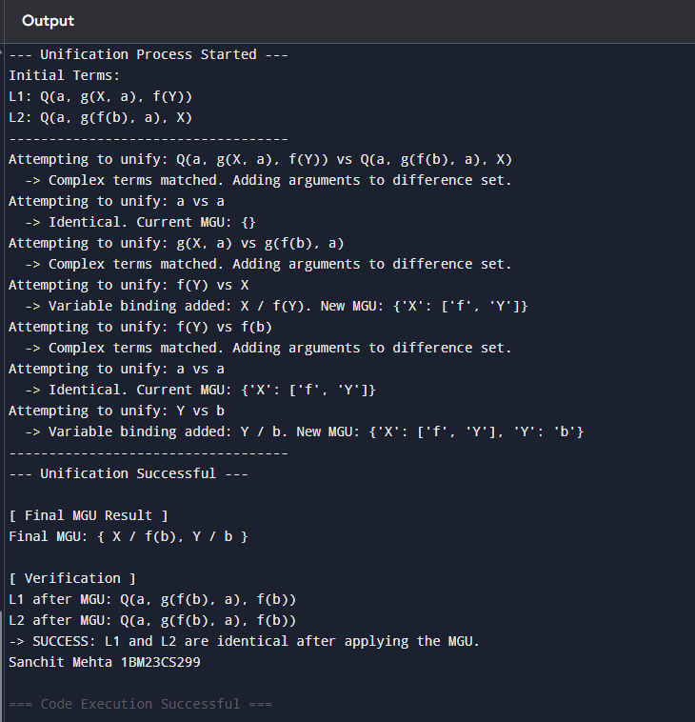

**Program 8**

Create a knowledge base consisting of first order logic statements and prove the given query using forward reasoning:

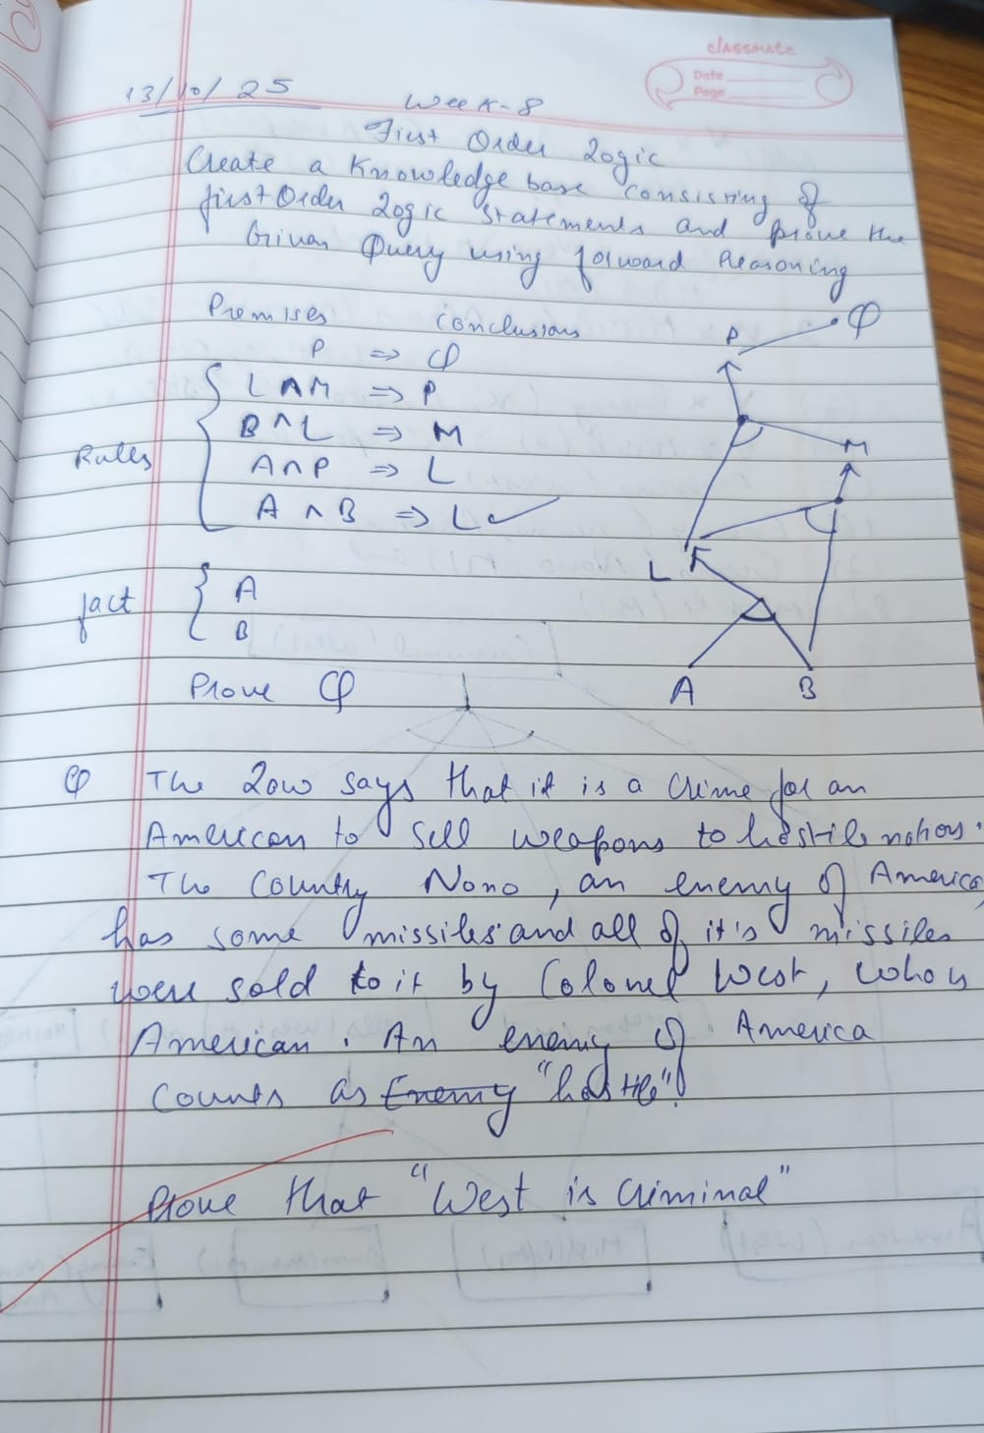

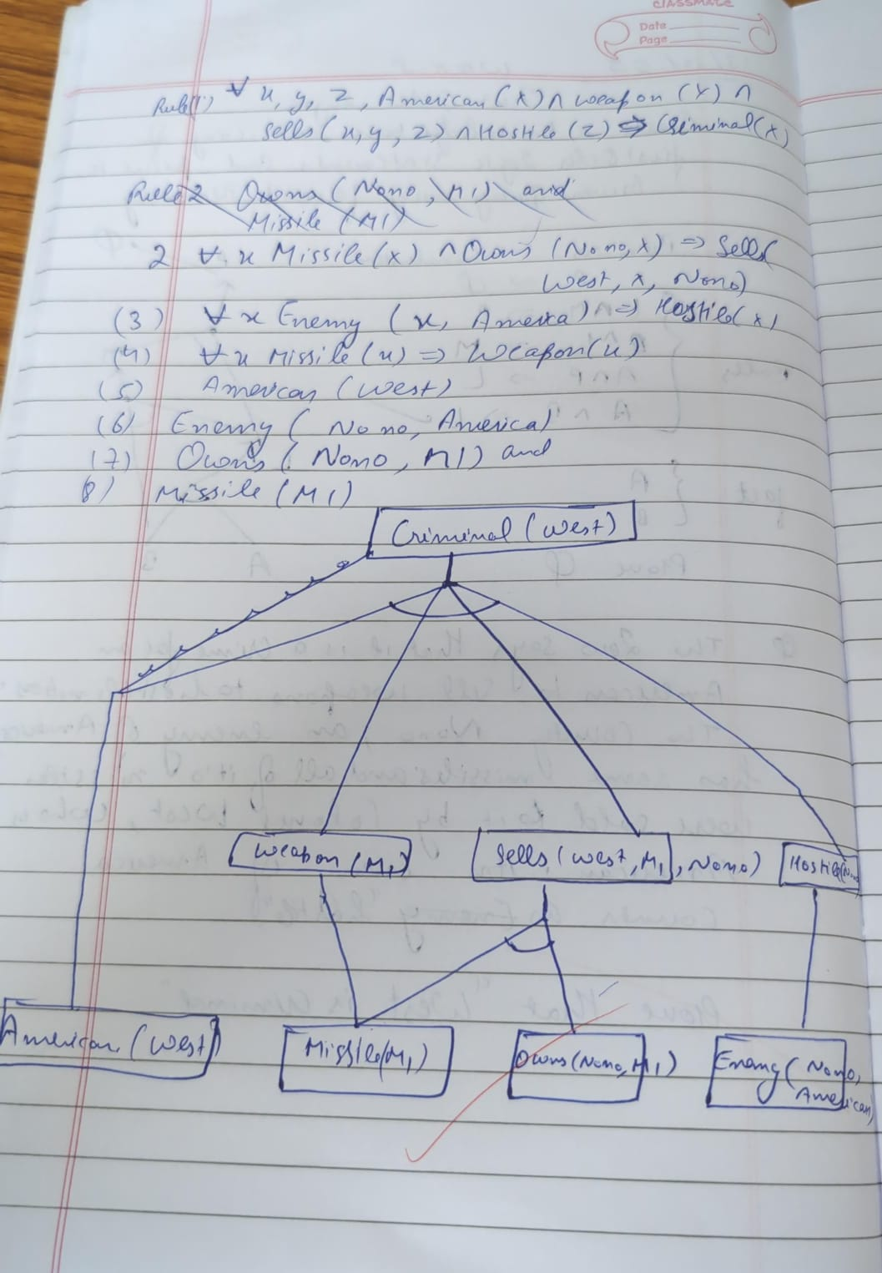

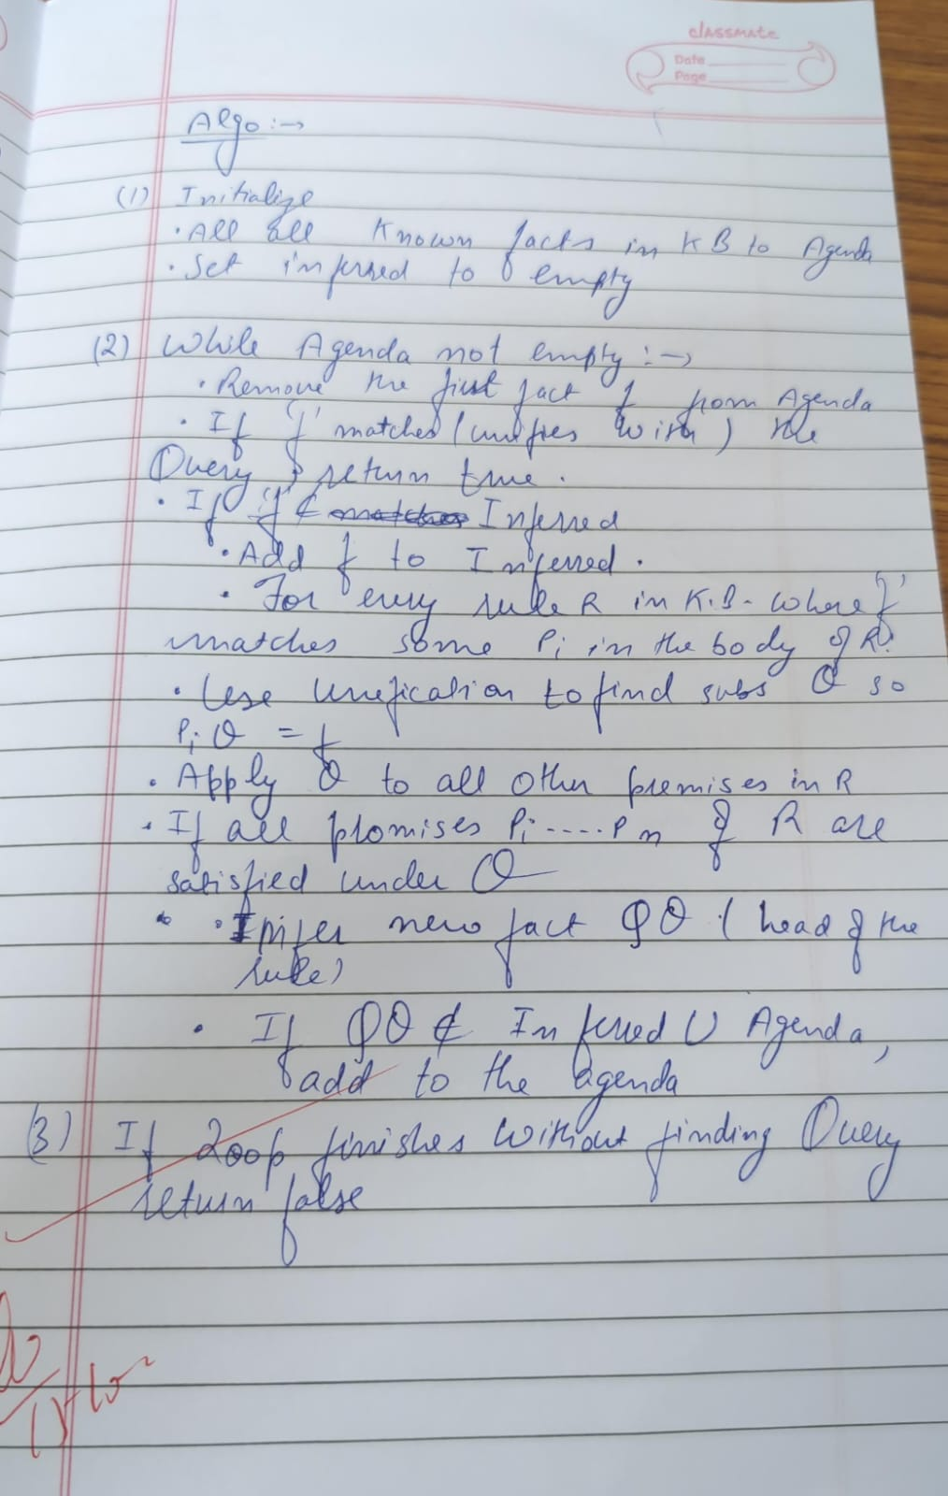

from typing import List, Tuple, Dict, Set, Union

Predicate = Tuple[str, Tuple[str, ...]]

class Rule:

def __init__(self, head: Predicate, body: List[Predicate]):

self.head = head

self.body = body

def __repr__(self):

body_str = ', '.join(f"{p[0]}{p[1]}" for p in self.body)

return f"{body_str} => {self.head[0]}{self.head[1]}"

# Knowledge base

class KnowledgeBase:

def __init__(self):

self.facts: Set[Predicate] = set()

self.rules: List[Rule] = []

def add_fact(self, fact: Predicate):

self.facts.add(fact)

def add_rule(self, rule: Rule):

self.rules.append(rule)

def forward_chain(self, query: Predicate) -> bool:

inferred = set(self.facts)

added = True

while added:

added = False

for rule in self.rules:

if all(self._match_fact(body_pred, inferred) for body_pred in rule.body):

if not self._match_fact(rule.head, inferred):

inferred.add(rule.head)

added = True

print(f"Inferred: {rule.head}")

if self._match_fact(query, inferred):

return True

return self._match_fact(query, inferred)

def _match_fact(self, pred: Predicate, fact_set: Set[Predicate]) -> bool:

return pred in fact_set

# --- Example usage ---

if __name__ == "__main__":

kb = KnowledgeBase()

kb.add_fact(("Parent", ("John", "Mary")))

kb.add_fact(("Parent", ("Mary", "Sue")))

facts_list = list(kb.facts)

for f1 in facts_list:

for f2 in facts_list:

if f1[0] == "Parent" and f2[0] == "Parent":

if f1[1][1] == f2[1][0]:

head = ("Grandparent", (f1[1][0], f2[1][1]))

body = [f1, f2]

kb.add_rule(Rule(head, body))

query = ("Grandparent", ("John", "Sue"))

result = kb.forward_chain(query)

print(f"Query {query} is", "True" if result else "False")

print("sanchit 1bm23cs299")

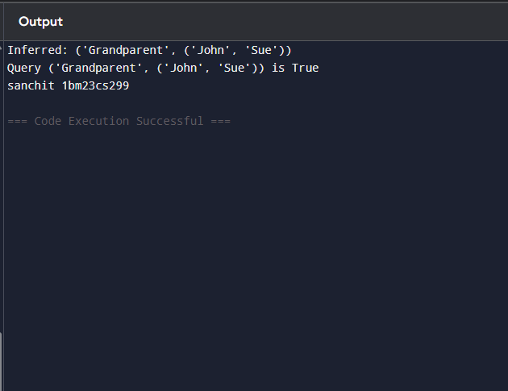

**Program 9**

Create a knowledge base consisting of first order logic statements and prove the given query using Resolution

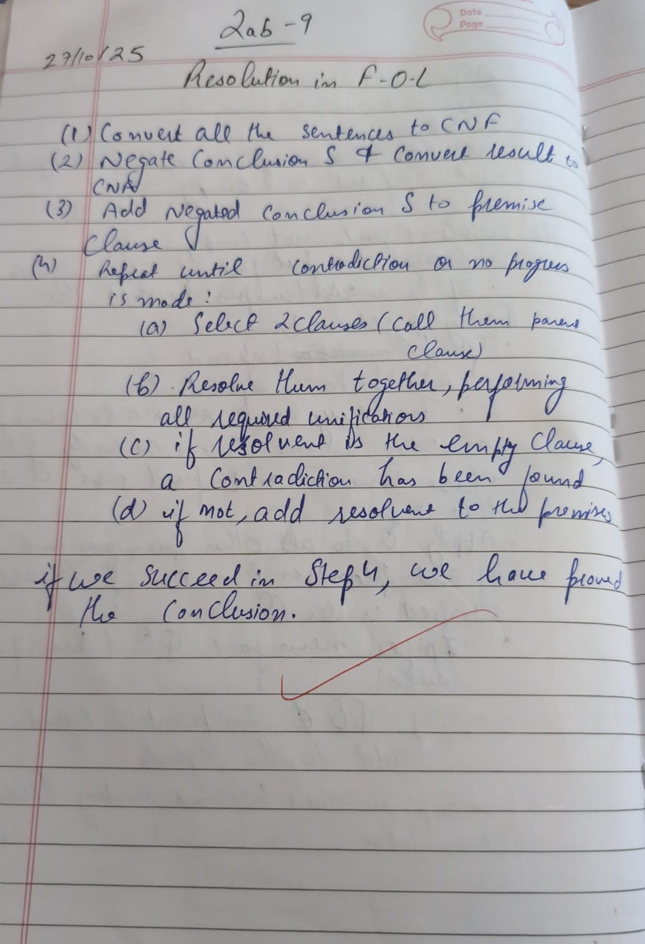

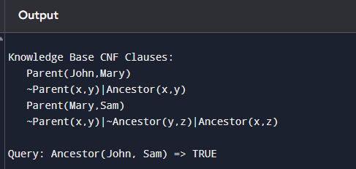

**Program 10**

Implement Alpha-Beta Pruning

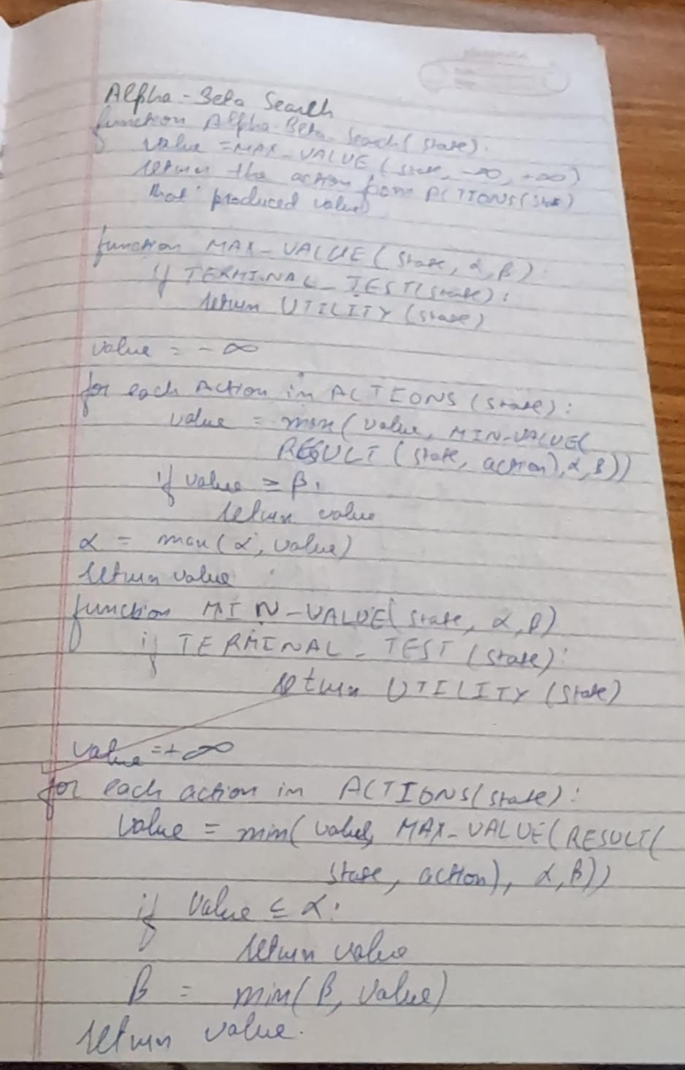

Code:

import math

def alpha_beta_search(state):

return max_value(state, -math.inf, math.inf)

def max_value(state, alpha, beta):

if terminal_test(state):

return utility(state)

v = -math.inf

for a in actions(state):

v = max(v, min_value(result(state, a), alpha, beta))

if v >= beta:

return v

alpha = max(alpha, v)

return v

def min_value(state, alpha, beta):

if terminal_test(state):

return utility(state)

v = math.inf

for a in actions(state):

v = min(v, max_value(result(state, a), alpha, beta))

if v <= alpha:

return v

beta = min(beta, v)

return v

values = [3, 5, 6, 9, 1, 2, 0, -1]

max_depth = 3

def terminal_test(state):

return state >= len(values) // 2**(max_depth - depth[state])

def utility(state):

return values[state]

def actions(state):

if depth[state] == max_depth:

return []

return [0, 1]

def result(state, action):

child = state * 2 + 1 + action

depth[child] = depth[state] + 1

return child

depth = {0: 0}

print("Optimal value:", alpha_beta_search(0))

print("Sanchit Mehta")

