Lab 1: Requirements Engineering and UML Use-Case Modelling
Problem Statement 50: Centralized Audit Trail Compliance Engine
Name | Sanchita Sunil | Section | G
SRN | PES1UG24CS419 | Semester | 5
1. Problem Overview
The Centralized Audit Trail Compliance Engine is a compliance logging platform for enterprise IT operations. Applications across the organisation emit event logs to it; the engine masks the personally identifiable fields those logs contain, stores what remains in a form that cannot be altered without detection, and produces export bundles that an outside auditor can verify without any access to the production system.
Three concerns shape the requirements. Personal data must not be written to storage in cleartext, which places masking on the ingest path rather than the read path. The stored trail must be tamper evident, because an audit log that can be edited carries no evidential weight. Exports must be verifiable by a party who does not trust the engine, which is what the hash manifest and the detached signature provide.
Actors
Actor | Type | Role in the system
Compliance Officer | Primary, human | Maintains the masking policy, queries the audit trail and produces signed export bundles for regulators.
Security Auditor | Primary, human | Searches the audit trail independently and verifies the integrity of the stored hash chain.
Enterprise Application | Secondary, system | Emits structured JSON event logs to the ingestion endpoint.
Signing Service (KMS) | Secondary, system | Holds the private signing key and signs export manifests on request.

2. Requirements
Functional requirements
ID | Type | Description | Priority | Acceptance criteria | Rationale
FR-001 | Data protection | The system shall parse structured JSON audit logs, identify and mask PII fields (Social Security Numbers, Credit Cards) before persisting records to storage. | High | Pass: masked audit log saved with SHA-256 integrity hash. Fail: cleartext credit card number stored in the database. | GDPR Article 32 requires that personal data is not held in cleartext in downstream systems. Masking before the first write means the raw value never reaches storage at all.
FR-002 | Data ingestion | The system shall accept JSON event logs from registered enterprise applications over an authenticated endpoint and validate every record against the active audit event schema. Records that fail validation shall be quarantined without halting the rest of the batch. | High | Pass: a schema-valid record from a registered application returns HTTP 202 and is stored, while a malformed record in the same batch is quarantined with a diagnostic reason and the remaining records are still ingested. Fail: an unauthenticated request is accepted, or one bad record causes the whole batch to be dropped. | The trail is only trustworthy if the origin of each record is known and its coverage is complete. Validating per record rather than per batch stops a single bad payload from leaving a silent gap in the log.
FR-003 | Data integrity | The system shall persist each masked record to an append-only store in which every record carries the SHA-256 hash of its predecessor, and shall expose no interface that permits a stored record to be updated or deleted. | High | Pass: chain verification recomputes every link successfully, and an out-of-band change to a record body makes verification report the exact sequence number at which the chain breaks. Fail: an update or delete on a stored record succeeds through any exposed API. | An audit log that can be edited is not evidence. Hash chaining makes tampering detectable rather than merely forbidden, so integrity does not rest on trusting the database administrator.
FR-004 | Query and retrieval | The system shall allow a Compliance Officer or Security Auditor to retrieve audit records using combined filters on time range, source application, event type and acting user, returning paginated results in reverse chronological order. | Medium | Pass: a combined filter query returns exactly the matching record set, paginated, with masked fields still masked in the response. Fail: the result set includes records outside the filter bounds, or an unmasked PII value appears in the response payload. | The trail is normally consulted under time pressure, during an investigation or a regulator request. Without compound filtering it is complete but not usable, and masking has to survive the read path or the protection applied at ingest is undone.
FR-005 | Reporting and attestation | The system shall generate an export bundle for a scope selected by the Compliance Officer, containing the chosen records, a manifest of their SHA-256 hashes and the chain head, and a digital signature over that manifest produced by the Signing Service. The bundle shall be verifiable offline using only the published public key. | High | Pass: an independent verifier confirms the signature and recomputes every manifest hash using only the bundle and the public key. Fail: the bundle still verifies after a single byte of an exported record has been altered, or the manifest signature is absent. | External auditors have no access to the engine, so trust cannot simply be asserted. A detached signature over a hash manifest lets a third party confirm authenticity and completeness without touching the production system.

Non-functional requirements
ID | Type | Description | Priority | Acceptance criteria | Rationale
NFR-001 | Performance and security | Audit log query endpoints must support complex filtering across 10 million historical records in under 1 second. | High | Pass: benchmarking tests confirm target latency and security standards under simulated peak load. Fail: p95 latency exceeds 1 second for a compound filter over the 10 million record benchmark dataset. | Investigation is iterative and an analyst refines a filter many times in one sitting. Latency above a second breaks that loop and pushes users towards bulk exports into local tools, which recreates the uncontrolled copies of personal data the system exists to prevent.
NFR-002 | Reliability and availability | The ingestion service shall sustain 99.9% monthly availability at a throughput of at least 5,000 events per second, and shall durably persist every record for which HTTP 202 has been returned. | High | Pass: a 72 hour soak test at 5,000 events per second with induced node failures shows every acknowledged record present in the store and monthly downtime within the 99.9% budget. Fail: an acknowledged record is missing after recovery, or a failover leaves a gap in the hash chain. | A gap in an audit trail cannot be distinguished from concealment, so a lost record is a compliance failure and not only a performance one. Tying durability to the acknowledgement lets source applications retry safely without creating duplicate entries.

3. UML Use-Case Diagram
The diagram below models the four actors and the eleven use cases of the engine. Included use cases are sub-behaviours that run every time the base use case runs; extending use cases run only when the guard condition shown in square brackets holds.
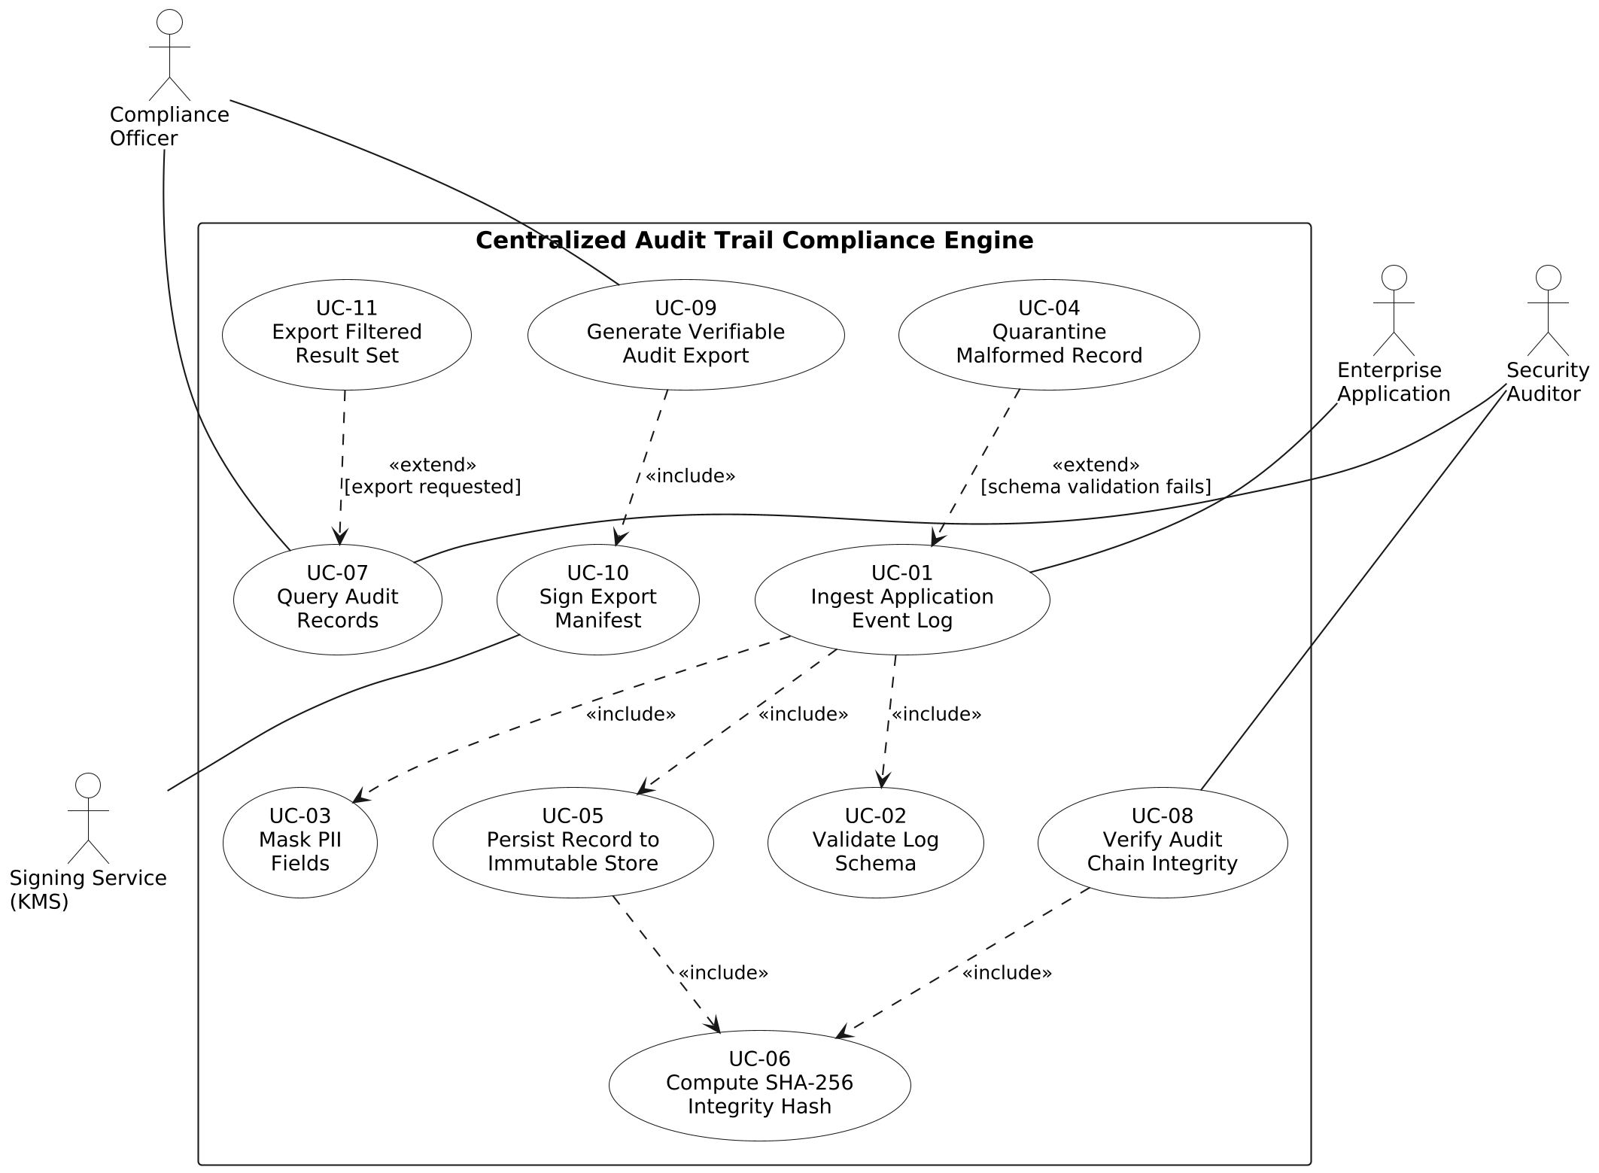
Relationships modelled
Stereotype | Direction | Reading
«include» | UC-01 → UC-02 | Every ingested record is validated against the audit event schema.
«include» | UC-01 → UC-03 | Masking is applied to every record before it is written.
«include» | UC-01 → UC-05 | Ingestion always ends in a write to the immutable store.
«include» | UC-05 → UC-06 | Each write computes the SHA-256 hash that extends the chain.
«include» | UC-08 → UC-06 | Verification recomputes the same hash over each stored record.
«include» | UC-09 → UC-10 | Every export bundle carries a signed manifest.
«extend» | UC-04 → UC-01 | Runs only when a record fails schema validation.
«extend» | UC-11 → UC-07 | Runs only when the user asks for the current result set as an export.
An «include» arrow points from the base use case to the sub-behaviour it always invokes. An «extend» arrow points the other way, from the optional behaviour back to the base use case it may interrupt.

4. Use-Case Flow Specification
UC-01 Ingest Application Event Log
Primary actor | Enterprise Application
Secondary actors | None
Related requirements | FR-001, FR-002, FR-003, NFR-002
Includes | UC-02 Validate Log Schema, UC-03 Mask PII Fields, UC-05 Persist Record to Immutable Store
Extended by | UC-04 Quarantine Malformed Record
Trigger | A registered enterprise application posts a batch of JSON event records to the ingestion endpoint.
Preconditions
1. The source application is registered with the engine and holds a valid, unexpired ingestion credential.
2. The active audit event schema and the masking policy are loaded and available to the ingestion service.
3. The immutable store is writable and the current hash chain head is known.
Postconditions
On success:
1. Every schema-valid record in the batch is stored with all configured PII fields replaced by masked tokens.
2. Each stored record carries its own SHA-256 hash and the hash of its predecessor, extending the chain by exactly the number of records accepted.
3. The chain head advances to the hash of the last record written.
4. The source application holds an acknowledgement listing the accepted and quarantined record identifiers.
On failure: no partial record is committed, the chain head is unchanged, and the source application receives an error that allows a safe retry.
Main Success Scenario
1. The Enterprise Application submits a batch of JSON event records to the ingestion endpoint together with its credential.
2. The system authenticates the credential and resolves the caller to a registered source application.
3. The system parses the batch and repeats steps 4 to 8 for each record in turn.
4. The system validates the record against the active schema, checking required fields, types and timestamp bounds. [includes UC-02]
5. The system applies the masking policy, replacing each detected PII value with a deterministic masked token. The raw value is not retained. [includes UC-03]
6. The system computes the SHA-256 hash of the canonicalised masked record together with the current chain head. [includes UC-06]
7. The system appends the record and its hash to the immutable store as one atomic write and advances the chain head. [includes UC-05]
8. The system marks the record as accepted in the batch result.
9. The system returns HTTP 202 with the batch result to the Enterprise Application.
10. The stored records become visible to Compliance Officer and Security Auditor queries.
Alternate Flow AF-1: Malformed Record
Branches from step 4 of the main success scenario when the record fails schema validation.
4a. The system detects that the record violates the active schema, through a missing required field, a type mismatch or a timestamp outside the accepted bounds.
4a.1. The record is not masked, not hashed and not written to the immutable store. The chain head is left unchanged.
4a.2. The system writes the record to the quarantine queue with the failure reason, the failing field path, the source application identity and the receipt timestamp.
4a.3. The system marks the record as quarantined in the batch result and returns to step 3 with the next record, so the remaining valid records in the batch are still ingested.
4a.4. If the quarantine rate for that source application exceeds the configured threshold, the system raises an alert to the Compliance Officer once the batch completes.
4a.5. The flow rejoins the main scenario at step 9. The response separates accepted from quarantined identifiers so the application can correct and resubmit only the failures.

