
Name – Sanchita Yadav
Registration no. – 25BAI11100
Date – 18-11-2025
Introduction

The Online Food Ordering System is a simple, menu-driven application designed to demonstrate the practical use of programming concepts in a real-world scenario. The main aim of this project is to allow users to place food orders conveniently by choosing from Veg and Non-Veg menus, each containing four categories: Snacks, Meal, Beverages, and Desserts. The system collects the user’s basic details, displays menu options with prices, allows multiple item selections, calculates the total bill, and finally provides an order summary.
This project showcases how user input, conditional statements, loops, functions, and object-oriented programming can be combined to build a functional system. It also demonstrates the use of UML diagrams, proper modular design, menu management, and clear workflow structure. Since food ordering systems are widely used in real life, creating a simplified version helps understand how such applications operate behind the scenes.
The entire system is console-based, making it easy to run and test, and follows a clear and logical flow. This project also helps build problem-solving skills, improves understanding of software design, and provides experience with real application development steps, from requirement gathering to testing.
Problem Statement

The problem is to design and develop a simple Online Food Ordering System where a user can enter their personal details, choose between Veg and Non-Veg food, browse four categories (Snacks, Meals, Beverages, Desserts), place multiple orders, and finally receive a total bill along with an order confirmation.

Objectives

• To create an interactive food ordering system.
• To take user details such as name, address, and mobile number.
• To provide a clear menu divided into modules.
• To allow users to order multiple items.
• To calculate the bill and display order summary.
Functional requirements
1. User details entry (Name, Address, Mobile No.)
2. Veg / Non-Veg module
3. Four sub-modules in each category:
• Snacks
• Meal
• Beverages
• Desserts
4. Menu display with prices
5. Order selection
6. Add more items or checkout
7. Bill calculation
8. Final order display with user details
Non-functional requirements

• Usability: Simple text-based interaction
• Performance: Fast and minimal delay
• Reliability: Correct billing
• Maintainability: Modular code structure
System Architecture Diagram

USER
Place order!
Display Total bill
Add items to bag
Veg thali:120/-
Paneer butter masala: 150/-
Veg biryani:140/-
Roti(2): 20/-
Pasta: 100/-

Gulab jamun: 30/-
Ice cream: 50/-
Rasmalai: 60/-
Kheer: 40/-

Lassi :40/-
Cold coffee: 70/-
Tea: 15/-
Juice:50/-

Chicken thali: 180/-
Butter chicken:200/-
Egg curry:120/-
Chicken biryani-160/-
Chicken pakoda :80/-
Egg roll: 50/-
Chicken sandwich: 90/-
Chicken momos: 30/-

Gulab jamun: 30/-
Ice cream: 50/-
Rasmalai: 60/-
Kheer: 40/-

Lassi :40/-
Cold coffee: 70/-
Tea: 15/-
Juice:50/-

Samosa :10/-
Pizza: 120/-
Burger: 60/-
Pasta: 100/-

DESSERTS
DRINKS
DRINKS
MEAL
SNACKS
DESSERTS
MEAL
SNACKS
NON VEG
VEG
ENTER: NAME – XYZ
ADDRESS- XYZ
MOB NO- 123

Workflow diagram
Start
Stop
Display bill and order summary
No
Yes
No
Yes
Veg
Input name, address and mobile no.
Final order???
Select items
Display non-veg menu
Display veg menu
Select category (snacks, meal, drinks, desserts)

Select category (snacks, meal, drinks, desserts)
Use-case diagram

Online food ordering system

Enter details
Select veg or non veg

Select category

View bill and summary
Checkout
Add more items
Select items
View menu
Actor(user)

Sequence diagram
USER
SYSTEM
Class diagram
DISPLAY BILL AND SUMMARY
CHECKOUT
ADD MORE?
SELECT ITEM
VIEW MENU
SELECT CATEGORY
CHOOSE VEG/NON VEG
ENTER DETAILS
USER
- name: String
- address: String
- mobile: String

+ getDetails(): void
ORDER
MENU
- vegSnacks: Dict<String,Int>
- vegMeals: Dict<String,Int> |
- vegBeverages: Dict<String,Int>
- vegDesserts: Dict<String,Int>
- nonvegSnacks: Dict<String,Int>
- nonvegMeals: Dict<String,Int>
- nonvegBeverages: Dict<String,Int>
- nonvegDesserts: Dict<String,Int>
+ showVegMenu(): void
+ showNonVegMenu(): void
+ getItemPrice(cat: String, item: String): Integerr
- items: List<String>
- prices: List<Integer>
- totalAmount: Integer

+ addItem(item: String, price: Integer): void
+ calculateTotal(): Integer
+ getSummary(): String
Design decisions and rationale

1. Choosing a Console-Based System

Decision:
I designed the food ordering system as a simple console-based application using Python.
Rationale:
Console applications are easy to run, require no external frameworks, and are suitable for demonstrating clear input–output flow as required in the project guidelines.

2. Using Three Main Classes (User, Order, Menu)

Decision:
The system is divided into three main classes: User, Order, and Menu.
Rationale:
This keeps the system modular.
Each class handles one responsibility:
• User → user information
• Order → items selected and calculations
• Menu → storing and displaying menu data
This follows good object-oriented design principles.

3. Separating Veg & Non-Veg Menus
Decision:
Veg and Non-Veg menus were kept separate but structured in the same format.
Rationale:
This makes the system neat, increases readability, and simplifies user navigation.
It also allows easy future expansion (adding more categories or items).

4. Keeping the Menu in Dictionaries

Decision:
Each food category was stored using Python dictionaries.
Rationale:
Dictionaries allow fast lookup, easy modification of prices, and clear key-value pairing of items and their prices — perfect for a menu design.

5. Using Lists for Order Storage

Decision:
The selected items and their prices were stored in lists inside the Order class.
Rationale:
Lists support ordered storage and easy addition of multiple items, making bill calculation simple.

6. Looping Structure for Adding Multiple Items
Decision:
A “Do you want to order more?” loop was added.
Rationale:
This makes the system realistic and flexible, allowing the user to choose more than one item before generating the final bill.

7. Simple, Clean User Interface

Decision:
The interface uses straightforward numbered menus and user prompts.
Rationale:
This improves usability and ensures even a non-technical user can operate the system without confusion.

Implementation details

The following code has been used to implement the idea:

#!/usr/bin/env python3
# -----------------------------
# ONLINE FOOD ORDERING SYSTEM
# -----------------------------

# VEG MENU
veg_menu = {
"Snacks": {
"Samosa": 10,
"Pizza": 120,
"Burger": 60,
"Pasta": 100
},
"Meal": {
"Veg Thali": 120,
"Paneer Butter Masala": 150,
"Veg Biryani": 140,
"Roti (2)": 20
},
"Beverages": {
"Lassi": 40,
"Cold Coffee": 70,
"Tea": 15,
"Juice": 50
},
"Desserts": {
"Gulab Jamun": 30,
"Ice Cream": 50,
"Rasmalai": 60,
"Kheer": 40
}
}

# NON-VEG MENU
nonveg_menu = {
"Snacks": {
"Chicken Pakoda": 80,
"Egg Roll": 50,
"Chicken Sandwich": 90,
"Chicken Momos": 100
},
"Meal": {
"Chicken Thali": 180,
"Butter Chicken": 200,
"Egg Curry": 120,
"Chicken Biryani": 160
},
"Beverages": {
"Lassi": 40,
"Cold Coffee": 70,
"Tea": 15,
"Juice": 50
},
"Desserts": {
"Gulab Jamun": 30,
"Ice Cream": 50,
"Rasmalai": 60,
"Kheer": 40
}
}

# -------------------------------
# ORDER SYSTEM
# -------------------------------
order_list = []
total_bill = 0

print("----- Welcome to Online Food Ordering System -----")

# USER DETAILS
name = input("Enter your Name: ")
address = input("Enter your Address: ")
mobile = input("Enter your Mobile Number: ")

while True:
print("\nChoose Food Type:")
print("1. Veg")
print("2. Non-Veg")
choice = int(input("Enter choice: "))

if choice == 1:
menu = veg_menu
else:
menu = nonveg_menu

print("\nSelect Category:")
print("1. Snacks")
print("2. Meal")
print("3. Beverages")
print("4. Desserts")

cat_choice = int(input("Enter choice: "))

categories = ["Snacks", "Meal", "Beverages", "Desserts"]
selected_category = categories[cat_choice - 1]

print(f"\n--- {selected_category} Menu ---")

items = list(menu[selected_category].keys())
prices = list(menu[selected_category].values())

for i in range(len(items)):
print(f"{i+1}. {items[i]} - ₹{prices[i]}")

item_choice = int(input("Choose an item: "))
selected_item = items[item_choice - 1]
item_price = prices[item_choice - 1]

order_list.append(selected_item)
total_bill += item_price

print(f"{selected_item} added to cart!")

more = input("Do you want to order more? (yes/no): ").lower()
if more != "yes":
break

# -------------------------------
# FINAL SUMMARY
# -------------------------------
print("\n------------------------------")
print("ORDER SUMMARY")
print("------------------------------")
print("Name:", name)
print("Address:", address)
print("Mobile:", mobile)
print("\nItems Ordered:")

for item in order_list:
print("•", item)

print("\nTotal Bill: ₹", total_bill)
print("\nYour order has been placed successfully!")
print("------------------------------")
Screenshots

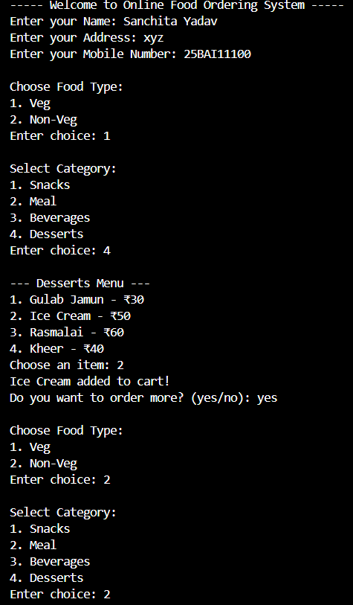
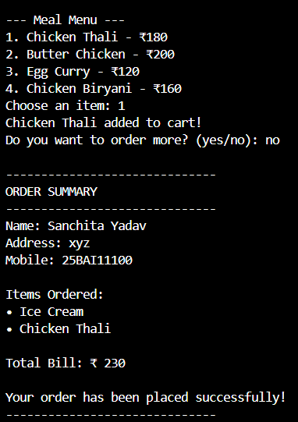
Testing approach

The testing approach for this project involved manual testing, where different inputs and actions were executed to ensure that every module of the Online Food Ordering System works correctly. The main focus was on validating user inputs, checking menu navigation, verifying bill calculation, and ensuring smooth control flow.

1. Input Validation Testing
• Entered valid and invalid names, addresses, and mobile numbers.
• Verified that mobile accepts only digits.
• Checked that empty inputs are handled by repeated prompts.

2. Menu Navigation Testing
• Tested Veg and Non-Veg menu selections.
• Verified all four categories: Snacks, Meal, Beverages, Desserts.
• Ensured the correct menu items and prices appear under each category.

3. Functional Testing
• Selected multiple items across different categories.
• Verified that selected items are correctly added to the order list.
• Ensured the “Do you want to order more?” loop works properly.

4. Bill Calculation Testing
• Selected known combinations of items and manually calculated totals.
• Compared manual totals with program output to confirm accuracy.

5. Decision Flow Testing
• Checked the system’s behavior for both “Yes” and “No” on adding more items.
• Verified that selecting “No” proceeds to checkout and bill generation.

6. Output Verification
• Ensured correct display of:
• Ordered items
• Total amount
• User details (name, address, mobile)
• Final order confirmation message

7. Error Handling Testing
• Entered out-of-range menu choices (e.g., choosing item 7 when only 4 exist).
• Ensured program does not crash and prompts again for valid input.

Final Summary
The testing confirmed that the Online Food Ordering System functions correctly across all modules, handles invalid inputs gracefully, and produces accurate outputs.

Challenges faced

During the development of the Online Food Ordering System, several challenges were encountered:

1. Designing a Clear Menu Structure
Creating separate Veg and Non-Veg menus with identical categories while keeping the program readable was initially confusing.
It required careful organization using dictionaries to make the structure maintainable.

2. Managing Control Flow for Repeated Orders
Handling the “Do you want to order more?” loop needed precise conditions.
A small mistake caused infinite loops or early exits.

3. Ensuring Input Validation
Users can enter invalid data (letters in mobile number, wrong menu choice).
Adding validation checks without cluttering the code was challenging.

4. Maintaining Modularity
Splitting the functionality into User, Menu, and Order classes required planning so that each class had a single responsibility.

5. Understanding UML Diagrams
Creating correct use-case, workflow, sequence, and class diagrams with proper symbols and relationships took effort since these diagrams were completely new concepts.

Learnings and key takeaways

This project provided several important learnings:

1. Understanding Real-World Application Flow
I learned how actual ordering systems work — from user registration to bill generation.

2. Improved Python Programming Skills
I gained confidence in using loops, dictionaries, functions, lists, and classes together.

3. Importance of Good Program Design
Using object-oriented concepts (User, Order, Menu classes) made the program more structured and easier to modify.

4. Practical Experience with Diagrams
I learned:
• How to draw UML diagrams
• What each shape means
• How the system looks visually

5. Better Problem-Solving Skills
Fixing errors, improving menu flow, and handling invalid inputs taught me logical thinking.

Future enhancements
There are several features that can be added to improve this project further:
1. Graphical User Interface (GUI)
Instead of console-based text, a GUI using Tkinter or PyQt can make the application more attractive and user-friendly.

2. Online Version with Database
Using Flask/Django + MySQL to save user details, order history, and menu items permanently.

3. Login and Registration System
Add user accounts so customers can save addresses, mobile numbers, favourites, and previous orders.

4. Admin Panel
Allow an admin to:
• Add/remove menu items
• Update prices
• View total orders

5. Add Quantity Feature
Users can choose how many plates of a food item they want.

6. GST/Tax Calculation
Add 5% or 18% GST and generate a more realistic bill.

7. Generate PDF Bill
Automatically save the bill as a PDF or send it to the user.
References

1. Python Official Documentation – https://docs.python.org
2. UML Basics – Visual Paradigm Tutorials
3. Class Diagram and Use-Case Diagram Concepts – Software Engineering textbooks
4. Project guidelines provided in BuildYourOwnProject.pdf (VITyarthi)
5. Diagram ideas from google.

