

Product Dissection for Google Pay
Company Overview:
Google Pay is a digital payment platform developed by Google, allowing users to make seamless financial transactions online and offline. Launched in 2018 after the merger of Android Pay and Google Wallet, Google Pay has become one of the leading digital wallets and payment systems globally. Its user-friendly interface, robust security features, and deep integration with the Google ecosystem have made it a go-to solution for millions of users and businesses around the world.

Product Dissection and Real-World Problems Solved by Google pay :
Google Pay has redefined how people manage and execute financial transactions, addressing several real-world challenges. By offering a platform that enables users to make instant payments, store financial information securely, and integrate various banking and merchant services, Google Pay solves problems related to convenience, security, and accessibility in digital financial transactions.
Real-World Problems Solved:

Problem 1: Complexity in Managing Multiple Payment Methods
Solution: Google Pay simplifies the management of multiple payment methods by allowing users to link various bank accounts, credit/debit cards, and even loyalty programs within a single interface. This centralization reduces the hassle of juggling between different payment apps or physical cards.
Problem 2: Security Concerns in Digital Transactions
Solution: Google Pay addresses security concerns through features like multi-factor authentication, biometric verification (fingerprint, face recognition), and real-time fraud detection. These measures ensure that users’ financial data and transactions are well-protected, significantly reducing the risk of fraud and unauthorized access.
Problem 3: Lack of Seamless Integration with Daily Activities
Solution: Google Pay integrates with various Google services and apps, such as Google Maps, Gmail, and Google Assistant, enabling users to make payments seamlessly within their daily routines. Whether paying for a ride, purchasing products online, or splitting bills with friends, Google Pay offers a frictionless experience.
Problem 4: Inefficient Reward and Cashback Systems
Solution: Google Pay’s reward system is designed to encourage usage by offering cashback, discounts, and points that can be redeemed across a wide network of merchants. This feature not only enhances user engagement but also addresses the inefficiency found in traditional reward programs.

Case Study: Real-World Problems and Google Pay's Innovative Solutions
Google Pay has effectively tackled several challenges in the digital payment landscape, making it a preferred choice for users across various demographics.
Problem 1: Inefficiency in Managing Financial Transactions Across Different Platforms
Real-World Challenge: Users often find it cumbersome to manage transactions across different platforms, especially when dealing with multiple bank accounts, cards, and payment apps. The fragmentation of financial services creates inefficiencies and increases the likelihood of errors or missed payments.
Google Pay's Solution: Google Pay consolidates various financial services into one platform, allowing users to manage their bank accounts, cards, and payments effortlessly. By offering features like instant bank transfers via UPI, bill payments, and the ability to store and use digital cards, Google Pay addresses the problem of inefficiency, providing a seamless and unified payment experience.
Outcome: Users experience a streamlined financial management process, reducing the need for multiple apps and enhancing convenience. This all-in-one approach significantly improves the user experience, making financial transactions more efficient and less error-prone.

Top Features of Google Pay:
User Profiles:
Google Pay allows users to create profiles that include their payment methods, linked bank accounts, transaction history, and more. This profile serves as a central hub for all financial activities on the platform.
Payments and Transactions:
The platform supports a wide range of payment types, including peer-to-peer (P2P) transfers, merchant payments (online and offline), bill payments, and contactless payments via NFC.
Security and Authentication:
Security is a top priority for Google Pay, with features like biometric authentication (fingerprint, face recognition), multi-factor authentication, and real-time fraud detection to ensure the safety of users’ transactions.
Rewards and Offers:
Users can earn rewards, cashback, and discounts through Google Pay's offers and loyalty programs, which are seamlessly integrated into the payment process.
Integration with Google Ecosystem:
Google Pay integrates deeply with other Google services, enabling users to make payments through Google Assistant, view transaction details in Gmail, and use the platform across Android, iOS, and web applications.

Transaction Insights:
Google Pay provides users with detailed insights into their spending patterns, categorizing transactions and offering budget tracking to help manage finances effectively.

Schema Description:
The schema for Google Pay involves multiple entities that represent different aspects of the platform. These entities include Users, Transactions, Payment Methods, Merchants, Rewards, and Security features. Each entity has specific attributes that describe its properties and relationships with other entities.
User Entity: Users are central to Google Pay’s functionality.
- UserID (Primary Key): A unique identifier for each user.
- Username: The chosen username for the user's account.
- Email: The user's email address for account-related communication.
- PhoneNumber: The user's phone number associated with the account.
- BiometricData: Data used for biometric authentication.
- RegistrationDate: The date when the user registered on Google Pay.
Transaction Entity: Transactions capture the financial activities on the platform.
- TransactionID (Primary Key): A unique identifier for each transaction.
- UserID (Foreign Key referencing User Entity): The user who initiated the transaction.
- Amount: The amount involved in the transaction.
- TransactionType: Type of transaction (P2P, merchant payment, bill payment, etc.).
- TransactionDate: The date when the transaction occurred.
- Status: The status of the transaction (Completed, Pending, Failed).
PaymentMethod Entity: Payment methods represent the various financial accounts and cards linked to the user’s profile.
- PaymentMethodID (Primary Key): A unique identifier for each payment method.
- UserID (Foreign Key referencing User Entity): The user who owns the payment method.
- PaymentType: Type of payment method (Bank Account, Credit Card, Debit Card, etc.).
- AccountNumber: The account or card number.
- BankName: The name of the bank associated with the account.
Merchant Entity: Merchants represent businesses that accept payments through Google Pay.
- MerchantID (Primary Key): A unique identifier for each merchant.
- MerchantName: The name of the merchant.
- MerchantCategory: The category of the business (Retail, Food, Transportation, etc.).
- MerchantAccount: The merchant’s bank account linked to Google Pay.
Reward Entity: Rewards track the cashback, discounts, and points users earn through transactions.
- RewardID (Primary Key): A unique identifier for each reward.
- UserID (Foreign Key referencing User Entity): The user who earned the reward.
- RewardType: The type of reward (Cashback, Discount, Points).
- Amount: The value of the reward.
- ExpiryDate: The date when the reward expires.
Security Entity: Security features ensure that transactions are safe and secure.
- SecurityID (Primary Key): A unique identifier for each security setup.
- UserID (Foreign Key referencing User Entity): The user who has the security setup.
- AuthenticationType: The type of authentication used (Password, Biometric).
- LastAuthDate: The last date when the user authenticated using this method.

Relationships:
- Users initiate Transactions: Each user can initiate multiple transactions.
- Users have Payment Methods: Users can link multiple payment methods to their profile.
- Transactions involve Merchants: Each transaction may involve a merchant if it’s a payment for goods or services.
- Users earn Rewards: Users can earn multiple rewards from transactions.
- Users have Security Features: Each user has one or more security features associated with their profile.

ER Diagram:
To represent the schema visually, create an ER diagram that shows the relationships and attributes of the entities within Google Pay’s data model. This diagram will illustrate how users, transactions, payment methods, merchants, rewards, and security features interact within the platform.

Conclusion:
In this case study, we explored the design of Google Pay’s schema and ER diagram. Google Pay has revolutionized digital payments by providing a secure, efficient, and user-friendly platform for managing financial transactions. The platform’s complex data model, which includes entities such as users, transactions, payment methods, merchants, rewards, and security features, is crucial to its functionality. Understanding this schema sheds light on how Google Pay effectively manages and streamlines the financial activities of millions of users, contributing to its global success as a leading digital payment platform.


Product Dissection for Instagram

Company Overview:

Instagram, founded in 2010 by Kevin Systrom and Mike Krieger, has transformed the way people interact, share, and explore visual content online. Acquired by Facebook, Instagram has become a global social media phenomenon, known for its captivating interface and innovative features. With a focus on visual storytelling and user engagement, Instagram has attracted millions of users worldwide, making it one of the leading platforms in the social networking landscape.

Product Dissection and Real-World Problems Solved by Instagram:

Instagram, a global social media phenomenon, has effectively addressed real-world challenges through its innovative product offerings. With a focus on visual storytelling, Instagram empowers users to authentically share their experiences and passions, bridging the gap between digital interactions and genuine connections. By allowing users to share photos and videos accompanied by captions, locations, and hashtags, Instagram provides a solution to the need for meaningful expression and engagement. This core feature solves the problem of connecting in an increasingly digital world, enabling users to form genuine relationships and engage in conversations that transcend geographical boundaries.

Instagram's ingenious engagement features, such as likes, comments, and personalised content recommendations through the "Explore" feature, have revolutionised how users interact with content. By addressing the challenge of content overload, Instagram curates relevant content, helping users discover new accounts, posts, and trends tailored to their interests. Furthermore, Instagram's introduction of hashtags has transformed content discovery by allowing users to categorise their posts with keywords. This innovative approach effectively addresses the challenge of navigating through a sea of content to find relevant information, making it easier for users to connect with content aligned with their interests and engage in conversations that matter to them.

In conclusion, Instagram's product design has successfully tackled real-world problems by creating a platform that nurtures creativity, fosters connections, and offers a space for self-expression. Through its diverse features, Instagram addresses the need for authentic engagement, content curation, and meaningful discovery, shaping the digital landscape and providing practical solutions to the evolving needs of its global user base.

Case Study: Real-World Problems and Instagram's Innovative Solutions

Instagram, a leading social media platform, has not only revolutionised the way we share and consume content but has also addressed significant real-world challenges through its innovative features. By identifying user needs and leveraging technology, Instagram has positioned itself as a solution-driven platform that fosters connections, encourages self-expression, and enhances digital interactions.

Problem 1: Disconnect in Digital Relationships

Real-World Challenge: As our lives become increasingly digital, the lack of genuine connections in online interactions has become a prevalent concern. Users often struggle to convey emotions and experiences effectively through text-based communication alone, leading to a disconnect in digital relationships.

Instagram's Solution:
Instagram recognized the need for authentic expression in digital interactions. By allowing users to share photos and videos alongside captions, locations, and hashtags, the platform creates a visually rich environment where users can share their lives more vividly. The power of visual storytelling bridges the gap between online interactions and real emotions, enabling users to connect on a deeper level. Through this approach, Instagram effectively tackles the problem of disconnection, nurturing meaningful relationships and promoting genuine interactions.

Problem 2: Information Overload
Real-World Challenge: The vast amount of content available online can overwhelm users, making it challenging to discover relevant and engaging content aligned with their interests.

Instagram's Solution:
Instagram addresses the issue of content overload through its innovative "Explore" feature. By leveraging advanced algorithms, the platform curates a personalised feed of content tailored to each user's preferences. This intelligent content recommendation system ensures that users encounter posts, accounts, and trends that resonate with their interests, mitigating the problem of information overload and enhancing the user experience.

Problem 3: Finding a Niche for Creativity
Real-World Challenge: Many individuals aspire to pursue creative endeavours, but finding a platform to showcase and monetize their talents can be daunting.

Instagram's Solution:
Instagram empowers creative individuals by providing a platform where they can showcase their talents, gain followers, and collaborate with brands. Influencers and content creators can turn their hobbies into viable careers, solving the problem of finding a niche for creativity and providing an avenue for personal and professional growth.

Problem 4: Limited Personal Branding
Real-World Challenge: Establishing a unique online identity can be challenging, as traditional text-based platforms often limit personal branding.

Instagram's Solution:
Instagram offers users a comprehensive profile space that includes a profile picture, username, bio, and highlights. This space allows users to express their personality and interests visually, solving the problem of limited personal branding on traditional platforms.

Conclusion:
Instagram's journey from a photo-sharing app to a global platform is a testament to its ability to identify real-world problems and provide innovative solutions. By fostering genuine connections, curating content, supporting creativity, and enabling personal branding, Instagram has addressed various challenges that users encounter in the digital landscape. This case study showcases how Instagram's user-centric approach and continuous innovation have positioned it as a leader in the social media domain, effectively shaping the way we engage and interact online.

Top Features of Instagram:

- User Profiles: Instagram allows users to create personal profiles, offering insights into their lives through features such as usernames, full names, bios, and profile pictures. This creates a personalised online presence that reflects each user's identity.

- Posts: A core feature of Instagram is the ability to share photos and videos as posts. Users can add captions, tag locations, and enhance their content using filters, stickers, and other creative tools.

- Interactions: Engagement lies at the heart of Instagram. Users can express appreciation by liking posts and sharing their thoughts through comments. The "Save" feature enables users to bookmark content for later viewing.

- Followers and Following: The platform fosters connections through the "Follow" functionality. Users can follow other accounts to see their posts in their feed, creating a network of connections. Users can also view who is following them, enhancing transparency.

- Explore: The "Explore" feature propels discovery by suggesting content based on user preferences and interactions. Users can explore posts, videos, and stories from accounts they don't follow, fostering a diverse online experience.

- Hashtags: Instagram pioneered the use of hashtags, which categorise posts and enhance discoverability. Users can add relevant hashtags to their posts, making them accessible to a broader audience.

Schema Description:

The schema for Instagram involves multiple entities that represent different aspects of the platform. These entities include Users, Posts, Comments, Likes, Followers, Hashtags, and more. Each entity has specific attributes that describe its properties and relationships with other entities.

User Entity:
Users are at the core of Instagram. The user entity contains information about each user:

- UserID (Primary Key): A unique identifier for each user.
- Username: The chosen username for the user's account.
- Email: The user's email address for account-related communication.
- Full_Name: The user's full name as displayed on their profile.
- Bio: A brief description that users can use to express themselves.
- Registration_Date: The date when the user joined Instagram.

Post Entity:
Posts capture the visual content shared on the platform:

- PostID (Primary Key): A unique identifier for each post.
- UserID (Foreign Key referencing User Entity): The user who created the post.
- Caption: Text accompanying the post, providing context.
- Image_URL: The URL of the image or video content.
- Location: The tagged location associated with the post.
- Post_Date: The date when the post was created.

Comment Entity:
Comments enable users to engage in conversations around posts:

- CommentID (Primary Key): A unique identifier for each comment.
- PostID (Foreign Key referencing Post Entity): The post being commented on.
- UserID (Foreign Key referencing User Entity): The user who posted the comment.
- Text: The text of the comment.
- Comment_Date: The date when the comment was posted.
Like Entity:
Likes represent user appreciation for posts:

- LikeID (Primary Key): A unique identifier for each like.
- PostID (Foreign Key referencing Post Entity): The post being liked.
- UserID (Foreign Key referencing User Entity): The user who liked the post.
- Like_Date: The date when the like was registered.
Follower Entity:
Followers establish connections between users:

- FollowerID (Primary Key): A unique identifier for each follower relationship.
- FollowingUserID (Foreign Key referencing User Entity): The user who is being followed.
- FollowerUserID (Foreign Key referencing User Entity): The user who is following.
- Follow_Date: The date when the following relationship was initiated.

Hashtag Entity:
Hashtags categorise and group content:

- HashtagID (Primary Key): A unique identifier for each hashtag.
- Tag: The actual text of the hashtag.

PostHashtag Entity:
Associates posts with hashtags:

- PostHashtagID (Primary Key): A unique identifier for each association.
- PostID (Foreign Key referencing Post Entity): The post associated with the hashtag.
- HashtagID (Foreign Key referencing Hashtag Entity): The hashtag associated with the post.

Relationships are:

- Users post Posts – Each user can post multiple posts.
- Users comment on Posts – Users can comment on multiple posts, and each post can have multiple comments.
- Users like Posts – Users can like multiple posts, and each post can have multiple likes.
- Users follow other Users – Users can follow multiple users and be followed by multiple users.
- Posts have Hashtags – Posts can have multiple hashtags, and each hashtag can be associated with multiple posts.

ER Diagram:

Let's construct an ER diagram that vividly portrays the relationships and attributes of the entities within the Instagram schema. This ER diagram will serve as a visual representation, shedding light on the pivotal components of Instagram's data model. By employing this diagram, you'll gain a clearer grasp of the intricate interactions and connections that define the platform's dynamics.

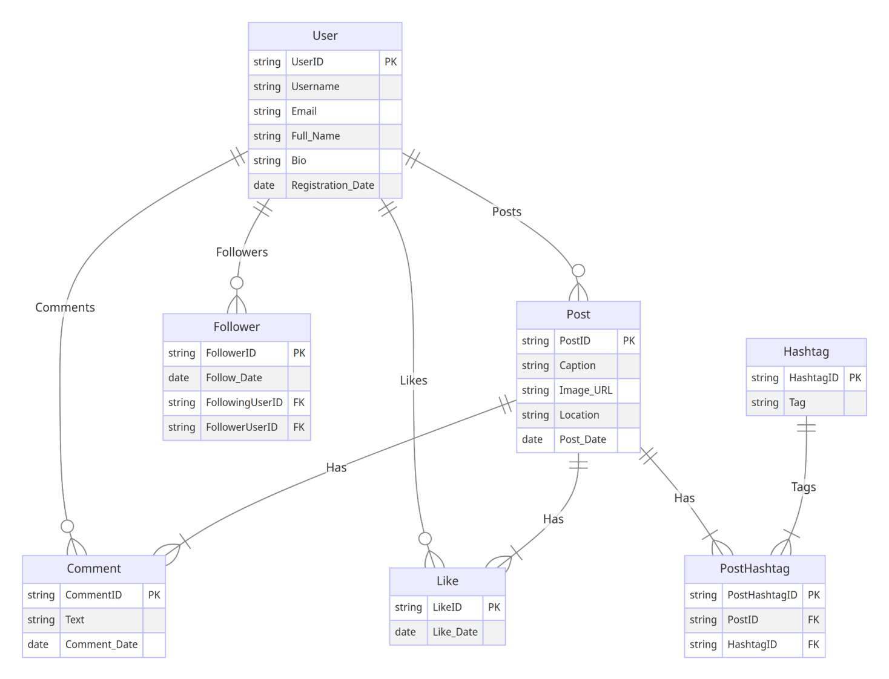

Conclusion

In this case study, we delved into the design of Instagram's schema and Entity-Relationship diagram. Instagram has revolutionised the way people share and engage with visual content, fostering connections and creative expression. The platform's intricate data model, consisting of entities like users, posts, comments, likes, followers, hashtags, and associations, forms the foundation for its seamless functionality. By understanding this schema, we gain insight into how Instagram effectively manages the complexities of user interactions and content sharing, contributing to its widespread popularity and continued growth in the world of social media.

