MD2201 Data Science
Course Project
S.NoDivBatch NoGroup NoRoll NoGr.NoName of Student1A335712110169Jidnyasa Dadmal26812110896Prathamesh Dhorage36912111512Dhruv Thakkar47012111225Om Dhumal57212110074Divyanshu JhaScience

Date of performance:

Project Title: Laptop Price Predictor

Data Set Name: Laptop Price

Data set Link: https://www.kaggle.com/datasets/muhammetvarl/laptop-price

Objective: The objective of this project is to use supervised machine learning algorithms to build models that can predict price of a Laptop based on its Specifications.

Project Description:

This project aims to use supervised machine learning Algorithms to build Regression models that can predict laptop prices based on specifications of the laptop. The dataset used for this project had 1303 data points. The independent variables includes: Company, Product, TypeName, Inches, Screen resolution , CPU , Ram , Memory, GPU, Operating System, Weight and the Dependent variable is Price of the laptop in Euros.

Before proceeding to build the models, Data preprocessing was performed on the dataset. This included converting character values to Numeric values for columns like “Ram” and “Weight”. The “Screen Resolution” column contained information about the availability of Touchscreen and IPS. This data was extracted from the “Screen Resolution” column and 2

separate columns named “Touchscreen” and “IPS” were added to the dataset. PPI (Pixels per Inch) was calculated for every laptop using the data from “Screen Resolution” and

“Inches” column and was added as a column in the dataset. The “Memory” column contained information about the SSD and HDD of the laptop , this data was extracted and separate columns for SSD and HDD was added to the dataset. The “CPU” column was filtered into 5 categories: “Intel core i3”, “Intel core i5” , “Intel core i7” , “AMD processor” and “Other Intel Processor”. The “GPU” column was filtered into 3 categories : “AMD” , “Intel” and “Nvidia”. All the categorical variables were converted to factor datatype. After dropping all the unnecessary columns the final dataset had the following variables : “Company” , “Typename”, “Cpu” , “Ram” , “Gpu” , “OpSys”, “Weight” , “Touchscreen” , “Ips” , “ppi” , “SSD” , “HDD”, “Price_euros”.

After performing data cleaning the dataset was split into training and testing data and algorithms like Multiple Linear Regression, Decision Tree Regressor and Random Forest Regressor were implemented.

The First Algorithm used was Multiple Linear Regression. Multiple linear regression is a regression model that estimates the relationship between a quantitative dependent variable and two or more independent variables using a straight line.

The Second model build was Decision tree regressor. Decision tree regression observes features of an object and trains a model in the structure of a tree to predict data in the future to produce meaningful continuous output. Continuous output means that the output/result is not discrete, i.e., it is not represented just by a discrete, known set of numbers or values.

The third model build was a Random Forest regressor. A random forest is a supervised algorithm that uses an ensemble learning method consisting of a multitude of decision trees, the output of which is the consensus of the best answer to the problem.

Performance Parameters were calculated for all the three models and compared.

Code:

#Importing all the required Libraries

library(ggplot2)

library(stringr)

library(rpart)

library(dplyr)

library(randomForest)

x=read.csv("laptop_price.csv")

x[,8]=gsub('GB','',x[,8])

x[,12]=substr(x[,12],1,nchar(x[,12])-2)

x[,8]=as.numeric(x[,8])

x[,12]=as.numeric(x[,12])

#checking density

p1=ggplot(x,aes(x=Price_euros))+geom_density()

p2=ggplot(x,aes(x=Company))+geom_bar()

print(p1)

print(p2)

#adding touchscreen AND Ips column

Touchscreen=c()

Ips=c()

for(tt in x[,6]){

if(grepl("Touchscreen",tt)){

Touchscreen=c(Touchscreen,1)

}else{

Touchscreen=c(Touchscreen,0)

}

}

for(zz in x[,6]){

if(grepl("Touchscreen",zz)){

Ips=c(Ips,1)

}else{

Ips=c(Ips,0)

}

}

x$Touchscreen=Touchscreen

x$Ips=Ips

p3=ggplot(x,aes(x=Touchscreen))+geom_bar()

p4=ggplot(x,aes(x=Ips))+geom_bar()

print(p3)

print(p4)

x_y=regmatches(x[,6], gregexpr("[[:digit:]]+", x[,6]))

x_res=c()

y_res=c()

count=0

for(gg in x_y){

check=TRUE

for(ff in gg){

if(check){

x_res=c(x_res,ff)

check=FALSE

}else{

y_res=c(y_res,ff)

}

}

}

x$x_res=x_res

x$y_res=y_res[1:1303]

x[,16]=as.numeric(x[,16])

x[,17]=as.numeric(x[,17])

x$ppi=((x$x_res)**2+(x$y_res)**2)**0.5/x$Inches

x=x[-c(5,6,16,17)]

x[,5]=word(x[,5],1,3,' ')

cp=c()

for(cpu in x[,5]){

if(cpu=="Intel Core i5" || cpu=="Intel Core i7" || cpu=="Intel Core i3"){

cp=c(cp,cpu)

}else if(word(cpu,1,1,' ')=="Intel"){

cp=c(cp,"Other Intel Processor")

}else{

cp=c(cp,"AMD Processor")

}

}

x[,5]=cp

print(ggplot(x,aes(x=Cpu,y=Price_euros))+geom_bar(stat="identity"))

ssd=c()

hdd=c()

for(mem in x[,7]){

temp=as.character(gsub("[^\\d]+", " ",mem, perl=TRUE))

if(grepl("SSD",mem) && grepl("HDD",mem)){

ssd=c(ssd,word(temp,1))

hdd=c(hdd,word(temp,2))

}else if(grepl("SSD",mem)){

ssd=c(ssd,word(temp,1))

hdd=c(hdd,"0")

}else if(grepl("HDD",mem)){

hdd=c(hdd,word(temp,1))

ssd=c(ssd,"0")

}else{

hdd=c(hdd,"0")

ssd=c(ssd,"0")

}

}

for(i in 1:length(ssd)){

if(ssd[i]=="1"){

ssd[i]="1024"

}

if(ssd[i]=="2"){

ssd[i]="2048"

}

}

for(j in 1:length(hdd)){

if(hdd[j]=="1"){

hdd[j]="1024"

}else if(hdd[j]=="2"){

hdd[j]="2048"

}

}

x$SSD=ssd

x$HDD=hdd

print(ggplot(x,aes(x=HDD))+geom_bar())

gpu=c()

for(gp in x[,8]){

if(word(gp,1)=="Intel"){

gpu=c(gpu,"Intel")

}else if(word(gp,1)=="Nvidia"){

gpu=c(gpu,"Nvidia")

}else{

gpu=c(gpu,"AMD")

}

}

x$Gpu=gpu

os=c()

for(o in x$OpSys){

if(word(o,1)=="Windows"){

os=c(os,"Windows")

}else if(word(o,1)=="Mac" || word(o,1)=="macOS"){

os=c(os,"Mac")

}else{

os=c(os,"Other")

}

}

x$OpSys=os

x=x[-c(1,3,7)]

x=x %>% relocate(Price_euros, .after=HDD)

# coverting char to factor

x[,1]=as.factor(x[,1])

x[,2]=as.factor(x[,2])

x[,3]=as.factor(x[,3])

x[,5]=as.factor(x[,5])

x[,6]=as.factor(x[,6])

x[,8]=as.factor(x[,8])

x[,9]=as.factor(x[,9])

x[,11]=as.factor(x[,11])

x[,12]=as.factor(x[,12])

r2=function(actual,predicted){cor(actual,predicted)**2}

mae=function(actual,predicted,n){sum(abs(actual-predicted))/n}

rmse=function(actual,predicted,n){(sum((actual-predicted)^2)/n)^(1/2)}

#testing the model

set.seed(101)

row =sample(1303)

x_shuffled=x[row,]

x_train=x_shuffled[1:1200,]

x_test=x_shuffled[1201:1303,]

#Multiple Linear Regression

mlr=lm(Price_euros~.,x_train)

mlr_sum=summary(mlr)

mae_mlr=mae(x_test$Price_euros,predict(mlr,x_test[-c(13)],method="anova"),nrow(x_test))

r2_mlr=r2(x_test$Price_euros,predict(mlr,x_test[-c(13)],method="anova"))

rmse_mlr=rmse(x_test$Price_euros,predict(mlr,x_test[-c(13)],method="anova"),nrow(x_test))

cat("The Performance parameters for Multiple linear regression model:\n")

cat("The MAE value for the mlr model is",mae_mlr,'\n')

cat("The R2 value for the mlr model is",r2_mlr,'\n')

cat("The RMSE value for the mlre model is",rmse_mlr,'\n\n')

#decision tree regressor

tree=rpart(Price_euros~.,x_train,method = "anova",control = c(maxdepth = 12, cp=0.001))

mae_decision_tree=mae(x_test$Price_euros,predict(tree,x_test[-c(13)],method="anova"),nrow(x_test))

r2_decision_tree=r2(x_test$Price_euros,predict(tree,x_test[-c(13)],method="anova"))

rmse_decision_tree=rmse(x_test$Price_euros,predict(tree,x_test[-c(13)],method="anova"),nrow(x_test))

cat("The Performance parameters for Decision tree regression model:\n")

cat("The MAE value for the decision tree model is",mae_decision_tree,'\n')

cat("The R2 value for the decision tree model is",r2_decision_tree,'\n')

cat("The RMSE value for the decision tree model is",rmse_decision_tree,'\n\n')

plot(tree)

#random forest regressor

rf=randomForest(Price_euros ~ .,x_train,ntree=50)

mae_random_forest=mae(x_test$Price_euros,predict(rf,x_test[-

c(13)],method="anova"),nrow(x_test))

r2_random_forest=r2(x_test$Price_euros,predict(rf,x_test[-c(13)],method="anova"))

rmse_random_forest=rmse(x_test$Price_euros,predict(rf,x_test[-c(13)],method="anova"),nrow(x_test))

cat("The Performance parameters for random forest regression model:\n")

cat("The MAE value for the random forest model is",mae_random_forest,'\n')

cat("The R2 value for the random forest model is",r2_random_forest,'\n')

cat("The RMSE value for the random forest model is",rmse_random_forest,'\n')

Results: Quantitative findings and Plots.
Performance  Parameters | ALGORITHM
Performance  Parameters | Multiple Regression | Decision Tree | Random Forest
R-Squared | 0.8067431 | 0.7980027 | 0.8736962
MAE | 265.352 | 232.5828 | 203.135
RMSE | 378.0033 | 391.518 | 323.2229

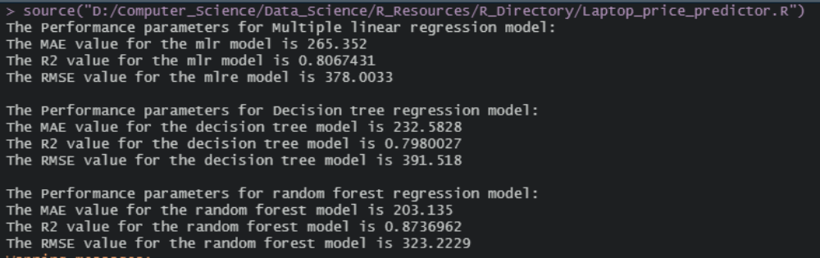

Plot for Comparison of R-Squared values

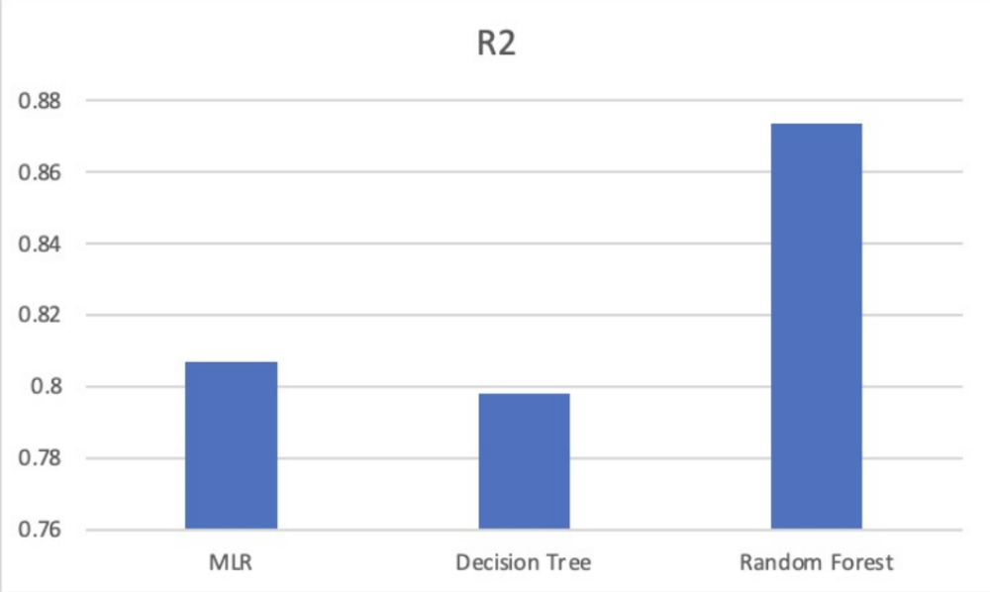

Plot for comparison of MAE value

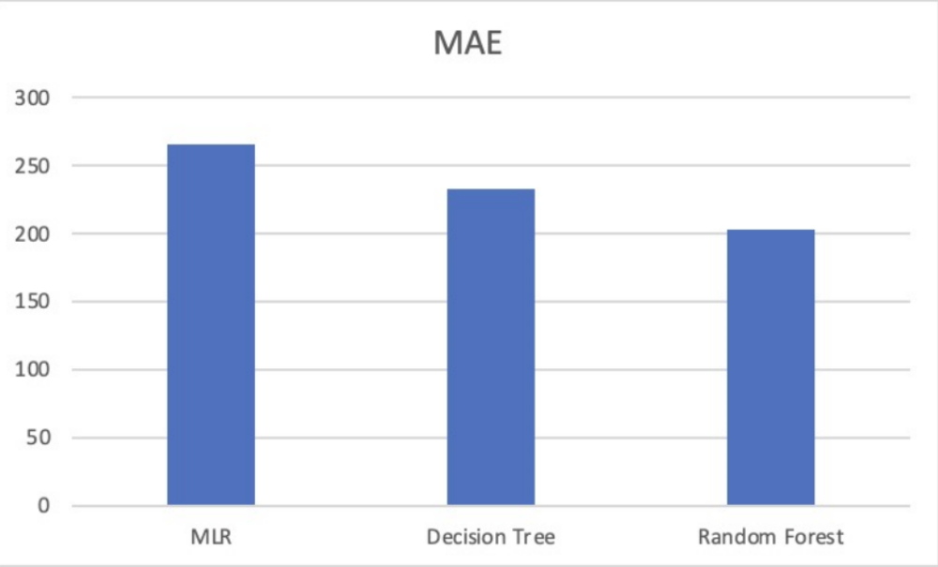

Plot for Comparison of RMSE value

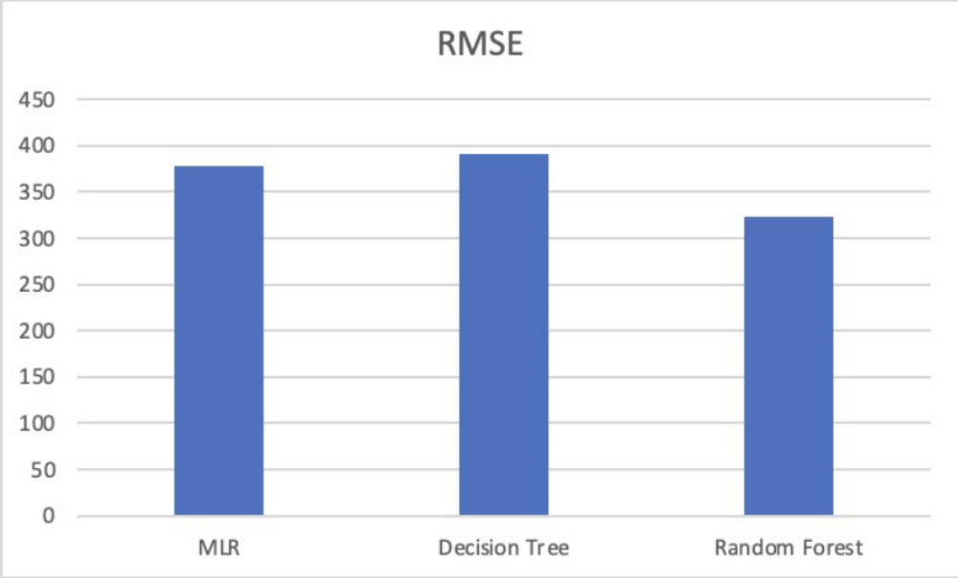

Conclusions:

After implementing various models like Multiple Linear regression, Decision tree regression and Random Forest regression on the laptop price dataset to predict the price of a laptop based on its specifications it was found that Random Forest regression model was able to provide the best results based on the Performance Parameters. The Random Forest regressor model was able to attain an accuracy of 87 percent. Hence Random Forest regressor is the most suitable model for Laptop price prediction.

