Expense Tracker CLI using Python
Subject: Python Programming
Internship: Python Programming Internship
Submitted by:
Name: Sanchita Pandey

1️. INTRODUCTION
Expense Tracker CLI is a Python-based command line application used to manage personal financial records. The program allows users to record income and expenses along with date, category, and amount. The data is stored in CSV file format, which makes it easy to access and manage.
This project helps users understand how Python can be used for real-life applications such as budget management.

2.Objectives
• To create a command-line based application
• To store income and expense records
• To perform financial calculations
• To generate summary of total income and expenses
• To create graphical representation using charts
• To understand file handling in Python

3.Technologies Used
Python – programming language
CSV – for storing data
Matplotlib – for creating charts
Datetime – for handling date

Working of Project
The Expense Tracker CLI works through a simple menu system.
User selects options from the menu:
- Add Entry
- Show Summary
- Show Chart
- Exit
When the user selects Add Entry, the program asks for:
- Date
- Type (Income or Expense)
- Category
- Amount
The entered data is stored in a CSV file.
When the user selects Show Summary, the program calculates:
- Total income
- Total expense
- Balance amount
When the user selects Show Chart, the program creates a bar chart showing expenses by category.

PROGRAM CODE:
import csv
from datetime import datetime
import matplotlib.pyplot as plt

FILE_NAME = "expenses.csv"

# create file if not exists
try:
with open(FILE_NAME, "x", newline="") as file:
writer = csv.writer(file)
writer.writerow(["Date", "Type", "Category", "Amount"])
except:
pass

def add_entry():
date = input("Enter date (YYYY-MM-DD): ")
entry_type = input("Type (Income/Expense): ")
category = input("Category (Food, Travel, Salary etc): ")
amount = float(input("Amount: "))

with open(FILE_NAME, "a", newline="") as file:
writer = csv.writer(file)
writer.writerow([date, entry_type, category, amount])

print("Entry added successfully!\n")

def show_summary():
total_income = 0
total_expense = 0

with open(FILE_NAME, "r") as file:
reader = csv.DictReader(file)

for row in reader:
if row["Type"] == "Income":
total_income += float(row["Amount"])
else:
total_expense += float(row["Amount"])

print("\nTotal Income:", total_income)
print("Total Expense:", total_expense)
print("Balance:", total_income - total_expense)

def show_chart():
categories = {}

with open(FILE_NAME, "r") as file:
reader = csv.DictReader(file)

for row in reader:
if row["Type"] == "Expense":
cat = row["Category"]
amt = float(row["Amount"])

if cat in categories:
categories[cat] += amt
else:
categories[cat] = amt

plt.bar(categories.keys(), categories.values())
plt.title("Expense by Category")
plt.xlabel("Category")
plt.ylabel("Amount")

plt.savefig("chart.png")
plt.show()

while True:
print("\n1. Add Entry")
print("2. Show Summary")
print("3. Show Chart")
print("4. Exit")

choice = input("Choose option: ")

if choice == "1":
add_entry()

elif choice == "2":
show_summary()

elif choice == "3":
show_chart()

elif choice == "4":
break

else:
print("Invalid choice")

OUTPUT:
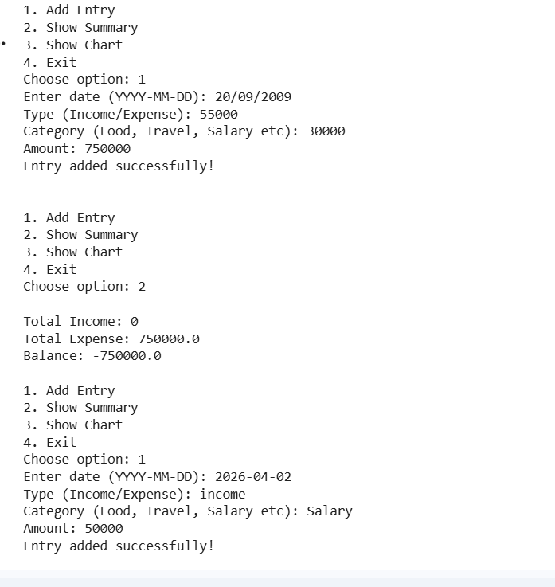

Conclusion
The Expense Tracker CLI project demonstrates the practical use of Python in managing financial data. This project helped in understanding file handling, data storage, calculations, and data visualization using Python libraries. It is a useful tool for tracking daily expenses.

