Student Management System

Internship Project Report
Name: Sanchita Pandey
Role: Python Programming Intern
Date: 16/03/2026

Introduction
This project is a Student Management System developed using Python.
It is a command line application that allows users to manage student records efficiently.
The system performs operations such as adding, updating, deleting, and displaying student records.
The purpose of this project is to demonstrate the use of Python classes, file handling, object-oriented programming (OOP), and user input handling.

Features of the Student Management System
• Add new student records
• Update student information
• Delete student records
• Display all student records
• Unique student ID validation
• Data stored in a file (JSON)
• Menu-driven interface

Programming Language and Tools
Programming Language: Python
Editor: Visual Studio Code / Online Compiler

Project 1: Student Management System
import json
class Student:
def __init__(self, student_id, name, grade):
self.student_id = student_id
self.name = name
self.grade = grade
def to_dict(self):
return {
"id": self.student_id,
"name": self.name,
"grade": self.grade
}
class StudentManager:
def __init__(self):
self.students = []
def add_student(self):
student_id = input("Enter Student ID: ")
name = input("Enter Student Name: ")
grade = input("Enter Grade: ")
for student in self.students:
if student["id"] == student_id:
print("Student ID already exists.")
return
student = Student(student_id, name, grade)
self.students.append(student.to_dict())
print("Student added successfully.")
def view_students(self):
if not self.students:
print("No student records found.")
return
for student in self.students:
print("ID:", student["id"],
"Name:", student["name"],
"Grade:", student["grade"])
def delete_student(self):
student_id = input("Enter Student ID to delete: ")
for student in self.students:
if student["id"] == student_id:
self.students.remove(student)
print("Student deleted.")
return
print("Student not found.")
def update_student(self):
student_id = input("Enter Student ID to update: ")
for student in self.students:
if student["id"] == student_id:
student["name"] = input("Enter new name: ")
student["grade"] = input("Enter new grade: ")
print("Student updated.")
return
print("Student not found.")
manager = StudentManager()
while True:
print("\n===== STUDENT MANAGEMENT SYSTEM =====")
print("1 Add Student")
print("2 View Students")
print("3 Update Student")
print("4 Delete Student")
print("5 Exit")
choice = input("Enter your choice: ")
if choice == "1":
manager.add_student()
elif choice == "2":
manager.view_students()
elif choice == "3":
manager.update_student()
elif choice == "4":
manager.delete_student()
elif choice == "5":
print("Exiting program.")
break
else:
print("Invalid choice.")

Output Screenshots
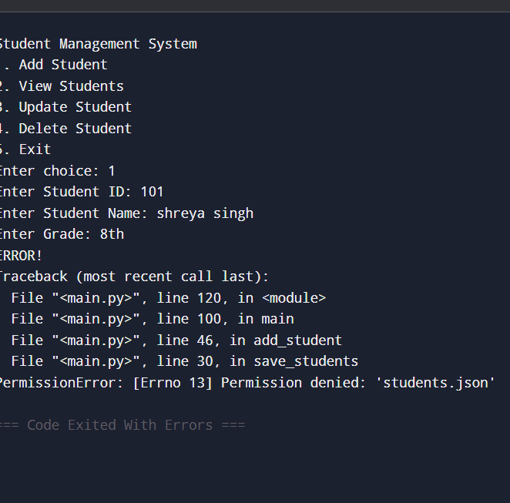

Conclusion
This project successfully demonstrates the implementation of a Student Management System using Python.
It allows users to manage student records using a menu-driven interface.
The project also demonstrates the use of classes, loops, conditional statements, and basic object-oriented programming concepts.

Bottom of Form

