  - Simple Command Line Calculator

  - Internship Project Report

  - Name: Sanchita Pandey
  - Role: Python Programming Intern
  - Date: 9/03/2026

This project is a Simple Command Line Calculator developed using Python.
The calculator performs basic arithmetic operations such as addition,
subtraction, multiplication, and division.

The purpose of this project is to demonstrate the use of Python functions,
user input handling, conditional statements, and loops.

Features of the Calculator:

• Addition of two numbers
• Subtraction of two numbers
• Multiplication of two numbers
• Division of two numbers
• Division by zero error handling
• Input validation
• Menu-driven interface

Programming Language: Python
Editor: Visual Studio Code

# Project 1: Simple Command Line Calculator

# Function definitions
def add(a, b):
return a + b

def subtract(a, b):
return a - b

def multiply(a, b):
return a * b

def divide(a, b):
if b == 0:
return "Error: Division by zero is not allowed."
return a / b

# Function to display menu
def show_menu():
print("\n===== SIMPLE CALCULATOR =====")
print("1. Addition (+)")
print("2. Subtraction (-)")
print("3. Multiplication (*)")
print("4. Division (/)")
print("5. Clear")
print("6. Exit")

# Main program
while True:
show_menu()
choice = input("Enter your choice (1-6): ")

if choice == "6":
print("Thank you for using the calculator.")
break

if choice == "5":
print("Calculator cleared.")
continue

if choice in ["1", "2", "3", "4"]:
try:
num1 = float(input("Enter first number: "))
num2 = float(input("Enter second number: "))
except ValueError:
print("Invalid input! Please enter numeric values.")
continue

if choice == "1":
result = add(num1, num2)

elif choice == "2":
result = subtract(num1, num2)

elif choice == "3":
result = multiply(num1, num2)

elif choice == "4":
result = divide(num1, num2)

print("Result:", result)

else:
print("Invalid choice! Please select a valid option.")

Output Screenshots
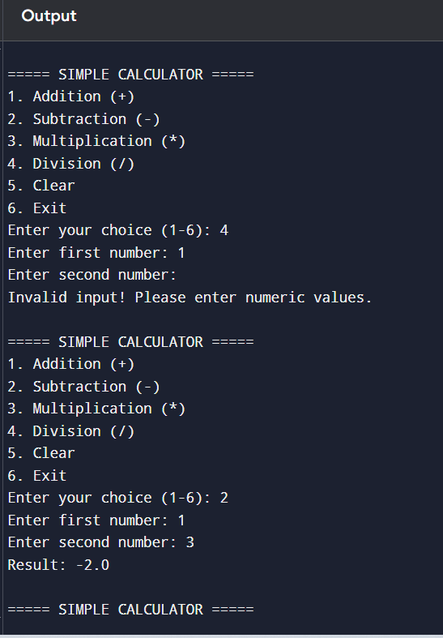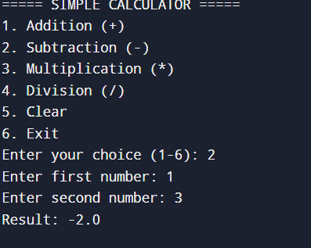
Conclusion: This project successfully demonstrates the implementation of a
menu-driven calculator using Python. It performs basic arithmetic
operations and handles invalid input and division errors.

