Assignment No. 1

AIM: Design a distributed application which consists of a server and client using threads
(Multithreading Using Sockets).

Pre Requisite: Operating systems, Computer Networks

THEORY:

Introduction to Client-Server communication
This is the architecture that is most often cited when distributed systems are discussed. It is historically the most important and remains the most widely employed.
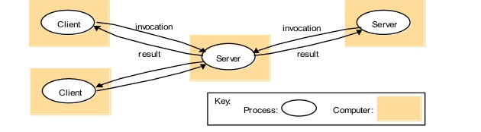

Figure illustrates the simple structure in which processes take on the roles of being clients or servers. In particular, client processes interact with individual server processes in potentially separate host computers in order to access the shared resources that they manage.

Introduction to Middleware technologies with examples.
the task of middleware is to provide a higher-level programming abstraction for the development of distributed systems and, through layering, to abstract over heterogeneity in the underlying infrastructure to promote interoperability and portability.
- Distributed object middleware
The key characteristic of distributed objects is that they allow you to adopt an object-oriented programming model for the development of distributed systems and, through this, hide the underlying complexity of distributed programming. In this approach, communicating entities are represented by objects. Objects communicate mainly using remote method invocation, but also possibly using an alternative communication paradigm (such as distributed events).A range of middleware solutions based on distributed objects are available, including Java RMI and CORBA.
- Component-based middleware:
Component-based solutions can best be understood as a natural evolution of object- based approaches, building on the strong heritage of this earlier work. Enterprise JavaBeans and Fractal, with the former offering a comprehensive solution that abstracts over many of the key issues in developing distributed applications and the latter representing a more lightweight solution often used to construct more complex middleware technologies.
Sockets and Socket-based Communication
Sockets :
Both forms of communication (UDP and TCP) use the socket abstraction, which provides an endpoint for communication between processes. Sockets originate from BSD UNIX but are also present in most other versions of UNIX, including Linux as well as Windows and the Macintosh OS. Interprocess communication consists of transmitting a message between a socket in one process and a socket in another process, as illustrated in Figure . For a process to receive messages, its socket must be bound to a local port and one of the Internet addresses of the computer on which it runs. Messages sent to a particular Internet address and port number can be received only by a process whose socket is associated with that Internet address and port number.
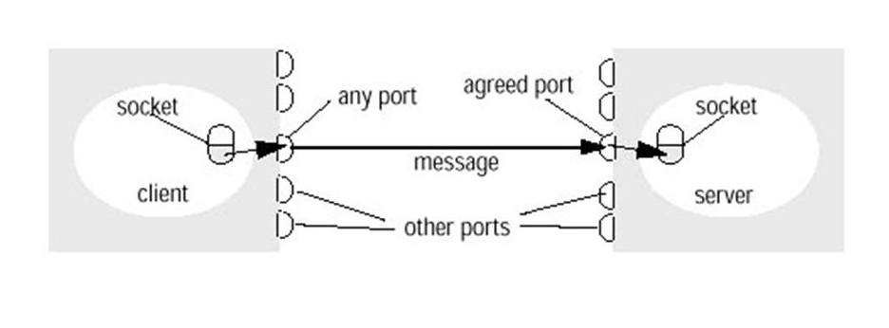

Processes may use the same socket for sending and receiving messages. Each computer has a large number (2 ¹⁶ ) of possible port numbers for use by local processes for receiving messages. Any process may make use of multiple ports to receive messages, but a process cannot share ports with other processes on the same computer. (Processes using IP multicast are an exception in that they do share ports) However, any number of processes may send messages to the same port. Each socket is associated with a particular protocol – either UDP or TCP.

Message Destination:
In the Internet protocols, messages are sent to (Internet address, local port) pairs. A local port is a message destination within a computer, specified as an integer. A port has exactly one receiver (multicast ports are an exception) but can have many senders. Processes may use multiple ports to receive messages. Any process that knows the number of a port can send a message to it. Servers generally publicize their port numbers for use by clients. If the client uses a fixed Internet address to refer to a service, then that service must always run on the same computer for its address to remain valid. This can be avoided by using the following approach to providing location transparency. Client programs refer to services by name and use a name server or binder to translate their names into server locations at runtime. This allows services to be relocated but not to migrate that is, to be moved while the system is running.
Concept of socket programming with TCP
The API to the TCP protocol, which originates from BSD 4.x UNIX, provides the abstraction of a stream of bytes to which data may be written and from which data may be read. The API for stream communication assumes that when a pair of processes are establishing a connection, one of them plays the client role and the other plays the server role, but thereafter they could be peers. The client role involves creating a stream socket bound to any port and then making a connect request asking for a connection to a server at its server port.
The server role involves creating a listening socket bound to a server port and waiting for clients to request connections. The listening socket maintains a queue of incoming connection requests. In the socket model, when the server accepts a connection, a new stream socket is created for the server to communicate with a client, meanwhile retaining its socket at the server port for listening for connect requests from other clients.
The pair of sockets in the client and server are connected by a pair of streams, one in each direction. Thus each socket has an input stream and an output stream. One of the pair of processes can send information to the other by writing to its output stream, and the other process obtains the information by reading from its input stream. When an application closes a socket, this indicates that it will not write any more data to its output stream.
Any data in the output buffer is sent to the other end of the stream and put in the queue at the destination socket, with an indication that the stream is broken. The process at the destination can read the data in the queue, but any further reads after the queue is empty will result in an indication of end of stream. When a process exits or fails, all of its sockets are eventually closed and any process attempting to communicate with it will discover that its connection has been broken.

Classes and methods in TCP and UDP with sockets
The Java interface to TCP streams is provided in the classes ServerSocket and Socket:
- ServerSocket:
This class is intended for use by a server to create a socket at a server port for listening for connect requests from clients. Its accept method gets a connect request from the queue or, if the queue is empty, blocks until one arrives. The result of executing accept is an instance of Socket – a socket to use for communicating with the client.
- Socket:
This class is for use by a pair of processes with a connection. The client uses a constructor to create a socket, specifying the DNS hostname and port of a server. This constructor not only creates a socket associated with a local port but also connects it to the specified remote computer and port number. It can throw an UnknownHostException if the hostname is wrong or an IOException if an IO error occurs.
The Socket class provides the methods getInputStream and getOutputStream for accessing the two streams associated with a socket. The return types of these methods are InputStream and OutputStream, respectively – abstract classes that define methods for reading and writing bytes. The return values can be used as the arguments of constructors for suitable input and output streams. DataInputStream and DataOutputStream, allow binary representations of primitive data types to be read and written in a machine-independent manner.
Concept of socket programming with UDP
A datagram sent by UDP is transmitted from a sending process to a receiving process without acknowledgement or retries. If a failure occurs, the message may not arrive. A datagram is transmitted between processes when one process sends it and another receives it. To send or receive messages a process must first create a socket bound to an Internet address of the local host and a local port. A server will bind its socket to a server port – one that it makes known to clients so that they can send messages to it.
A client binds its socket to any free local port. The receive method returns the Internet address and port of the sender, in addition to the message, allowing the recipient to send a reply.
Java API for UDP datagrams
The Java API provides datagram communication by means of two classes: DatagramPacket and DatagramSocket.
DatagramPacket: This class provides a constructor that makes an instance out of an array of bytes comprising a message, the length of the message and the Internet address and local port number of the destination socket, as follows:
Datagram packet
array of bytes containing message length of message Internet address port number
An instance of DatagramPacket may be transmitted between processes when one process sends it and another receives it. This class provides another constructor for use when receiving a message. Its arguments specify an array of bytes in which to receive the message and the length of the array. A received message is put in the DatagramPacket together with its length and the Internet address and port of the sending socket. The message can be retrieved from the DatagramPacket by means of the method getData. The methods getPort and getAddress access the port and Internet address.
DatagramSocket: This class supports sockets for sending and receiving UDP datagrams. It provides a constructor that takes a port number as its argument, for use by processes that need to use a particular port. It also provides a no-argument constructor that allows the system to choose a free local port. These constructors can throw a SocketException if the chosen port is already in use or if a reserved port (a number below 1024) is specified when running over UNIX.
The class DatagramSocket provides methods that include the following:
- send and receive: These methods are for transmitting datagrams between a pair of sockets. The argument of send is an instance of DatagramPacket containing a message and its destination. The argument of receive is an empty DatagramPacket in which to put the message, its length and its origin. The methods send and receive can throw IOExceptions.
- setSoTimeout: This method allows a timeout to be set. With a timeout set, the receive method will block for the time specified and then throw an InterruptedIOException.
- connect: This method is used for connecting to a particular remote port and Internet address, in which case the socket is only able to send messages to and receive messages from that address.
Advantages of Java Sockets:
a. Flexible and powerful.
b. Cause low network traffic if efficiently used.
c. Only updated information can be sent.

Disadvantages of Java Sockets:
a. The Java applets can establish communication only with the machine requested and not with any other machine on the network.
b. Sockets allow only raw data to be sent. This means that both client and server need to have mechanisms to interpret the data.
Concept of Multithreading:
Multithreading is a type of execution model that allows multiple threads to exist within the context of a process such that they execute independently but share their process resources. A thread maintains a list of information relevant to its execution including the priority schedule, exception handlers, a set of CPU registers, and stack state in the address space of its hosting process.
Threading can be useful in a single-processor system by allowing the main execution thread to be responsive to user input, while the additional worker thread can execute long-running tasks that do not need user intervention in the background. Threading in a multiprocessor system results in true concurrent execution of threads across multiple processors and is therefore faster.
Algorithm:
- The steps for establishing a socket on the server side are the following:
- Create and open a server socket.
- Wait for the client request.
- Open an input stream and an output stream to the client.
- Communicate with the client.
- Close the streams and then close the socket.
- The steps of establishing a socket communication on the client side are as follows:
- Create and open a client socket.
- Open an input stream and an output stream to the socket.
- Read from and write to the stream according to the server's protocol.
- Close the streams and then close the socket.
Software/Hardware Required:
- JDK 7.1
- Netbeans IDE 7.1.1
Conclusion:
Thus, we have studied Multithreading programming in Java using socket programming, java packages, classes and interfaces for UDP IP protocols, also its application for client server communication.

References:

- www.Webopedia.com
- Herbert Schildt, “JAVA complete reference”
- Kenneth L. Calvert, Michael J. Donahoo “TCP/IP Socket in JAVA- Practical Guide”
- www.tutorialpoint.com

