BLUESTOCK MUTUAL FUND ANALYTICS PLATFORM
• BlueStock Fintech •

Comprehensive Capstone Project Report
Prepared by: Hashmil Muhammed | Data Analyst
Contact: hashmilmuhammedparammal@gmail.com
Date: 10 June 2026

1. Executive Summary
The mutual fund industry in India is experiencing unprecedented growth, characterized by record-breaking Assets Under Management (AUM) and a massive surge in Systematic Investment Plans (SIPs). However, the fragmentation of data across various platforms makes it challenging for retail investors and financial institutions to derive actionable, risk-adjusted insights.
This project successfully addresses this gap by developing an end-to-end data engineering and analytics pipeline. Over the course of the project, over 87,000 transaction records and 4.5 years of daily Net Asset Value (NAV) data were ingested, cleaned, and structured into a robust SQL data warehouse. Advanced quantitative metrics—including the Sharpe Ratio, Value at Risk (VaR), and Herfindahl-Hirschman Index (HHI)—were calculated to assess fund performance and sector concentration. Finally, a dynamic Power BI dashboard and a Python-based Recommender System were deployed to translate these complex metrics into intuitive business intelligence.

2. Data Description & ETL Architecture
2.1 Data Sourcing
The project utilized a hybrid data ingestion strategy:
- Static Data: Provided by AMFI India, consisting of 10 interconnected CSV files detailing fund masters, historical NAVs, SIP inflows, portfolio holdings, and transaction logs.
- Dynamic Data: A custom Python script (live_nav_fetch.py) was engineered to interface with the public mfapi.in REST API, fetching real-time NAV data for six critical benchmark blue-chip funds to ensure the dataset remains current.
2.2 ETL Pipeline & Database Design
- Extraction & Transformation: Utilizing the pandas library, missing NAV values during weekends and market holidays were handled using forward-fill (ffill) logic. Date formats were standardized, and duplicate records were purged.
- Loading & Warehousing: An analytical Star Schema was designed using SQLite and SQLAlchemy. The architecture features central Fact tables (fact_nav, fact_transactions, fact_performance) linked via foreign keys to Dimension tables (dim_fund, dim_date, dim_investor), optimizing the database for rapid Online Analytical Processing (OLAP) queries.

3. Detailed EDA Findings & Visualizations
Exploratory Data Analysis revealed several critical macroeconomic and behavioral trends:
- Industry AUM Growth: The mutual fund industry witnessed a staggering growth trajectory, peaking at ₹81 Lakh Crore.
- SIP Dominance: A cultural shift towards disciplined investing is evident, with monthly SIP inflows hitting an all-time high of ₹31,002 Crore.

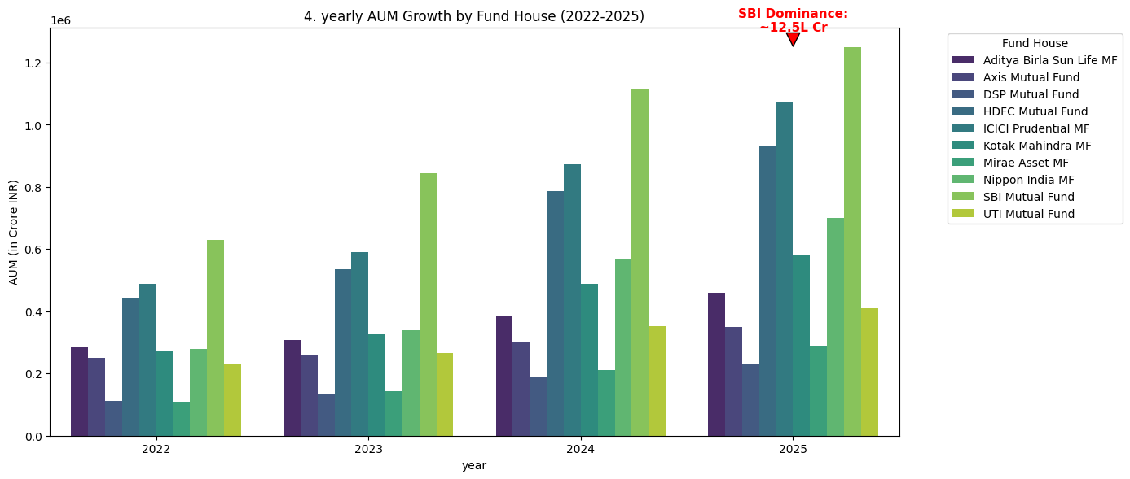
Figure 3.1: Industry AUM Growth and Fund House Dominance

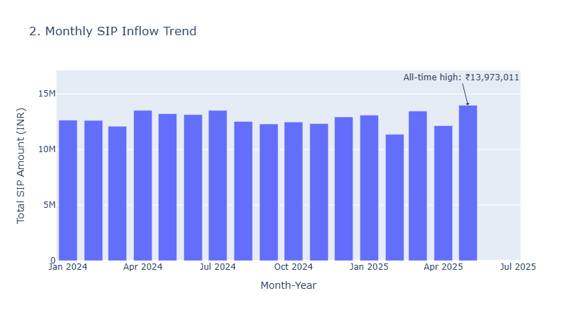
Figure 3.2: Monthly SIP Inflow Volumetric Trend Analysis

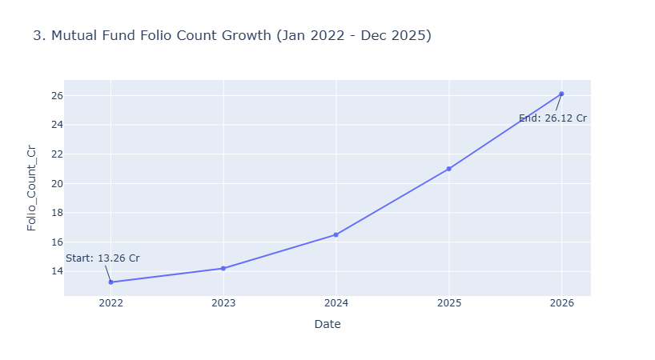
Figure 3.3: Growth of Total Active Mutual Fund Folios

- Demographic Insights: The investor base is notably young, with the 26-35 age bracket dominating participation. Geographically, Tier-1 cities and states like Maharashtra and Karnataka lead transaction volumes, highlighting an opportunity for targeted marketing in B30 (Beyond Top 30) cities.
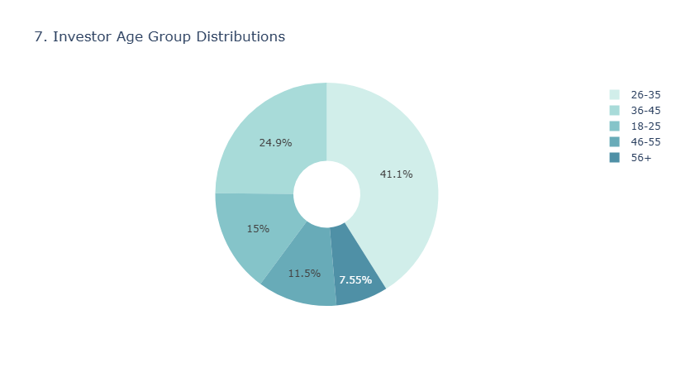
3.4: Investor Age Cohort Segmentation
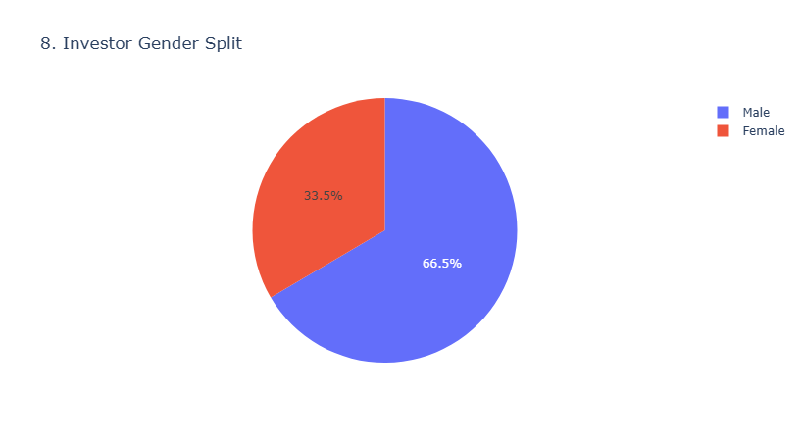
3.5: Demographics - Gender Diversity Split
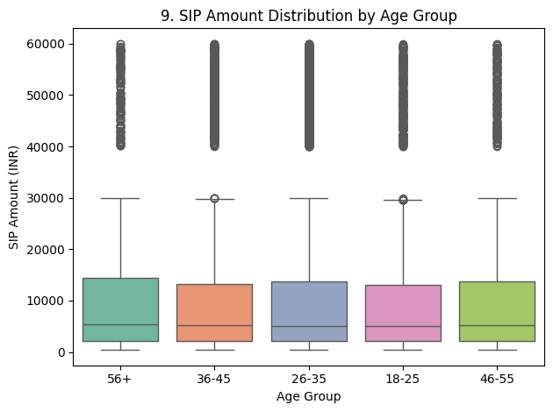
3.6: SIP Allocation and Ticket Size across Age Groups
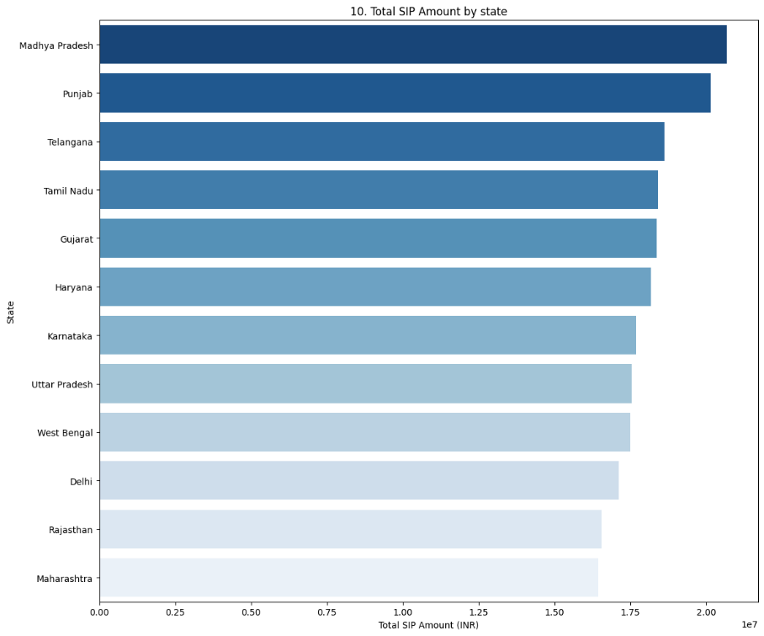
3.7: Geographic Distribution of Total SIP Investments
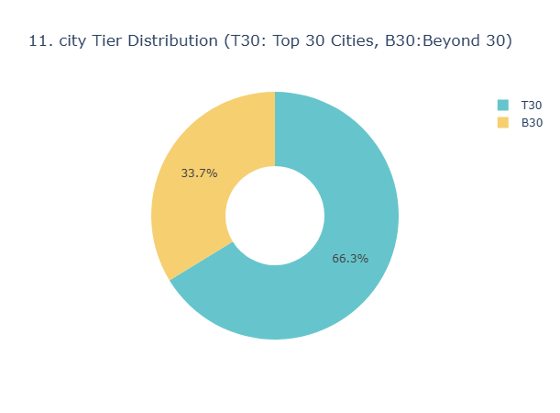
3.8: Market Penetration by City Tier Classification

4. Fund Performance & Advanced Risk Analysis
Moving beyond simple point-to-point returns, the project evaluated funds on institutional-grade risk-adjusted metrics.
4.1 Quantitative Performance Metrics
- CAGR & Volatility: Calculated 1Y, 3Y, and 5Y Compound Annual Growth Rates.
- Risk-Adjusted Returns: Computed the Sharpe Ratio (assuming a 6.5% risk-free rate) and Sortino Ratio (measuring downside deviation).
- Market Regression: Executed OLS regression against the Nifty 50 benchmark to extract annualized Alpha (excess return) and Beta (market correlation).
These metrics were aggregated into a proprietary Custom Fund Scorecard (0-100) to objectively rank the top 40 schemes.
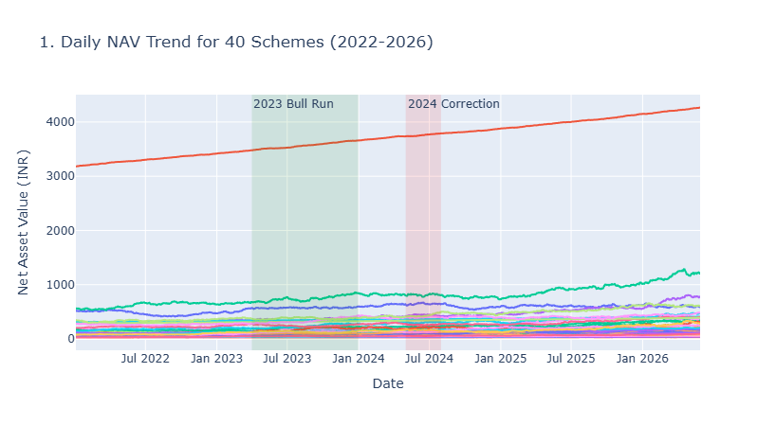
Figure 4.1: Historical NAV Trajectory for Evaluated Mutual Fund Schemes

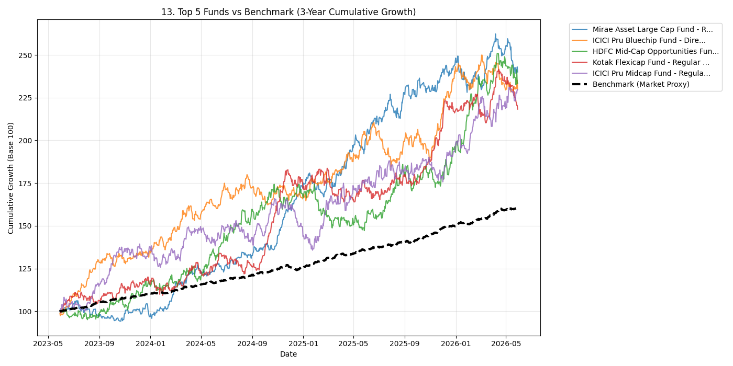
4.2: Alpha-Beta Performance Comparison Matrix against Benchmarks
4.2 Advanced Risk Analytics (VaR, CVaR, HHI)
- Value at Risk (VaR): Applied a 95% historical confidence interval to determine the maximum expected daily loss.
- Sector Concentration: Utilized the Herfindahl-Hirschman Index (HHI) to flag funds over-exposed to specific sectors (e.g., Banking or IT). A higher HHI indicates a lack of diversification, increasing localized risk.
- Rolling Metrics: Visualized the 90-day Rolling Sharpe ratio to track the consistency of fund managers over time.
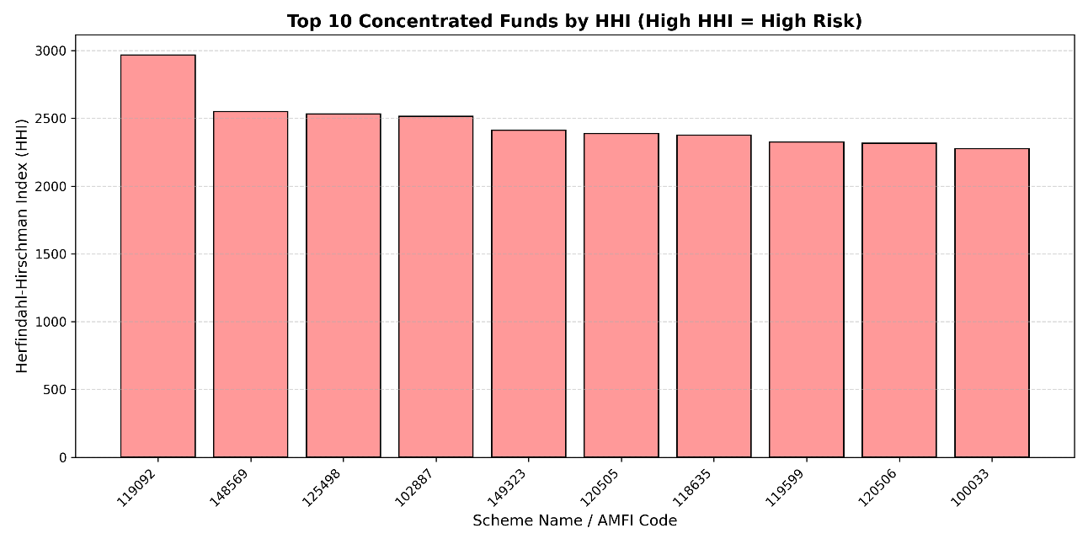
Figure 4.3: Portfolio Structural Risk and Sector Concentration (HHI)

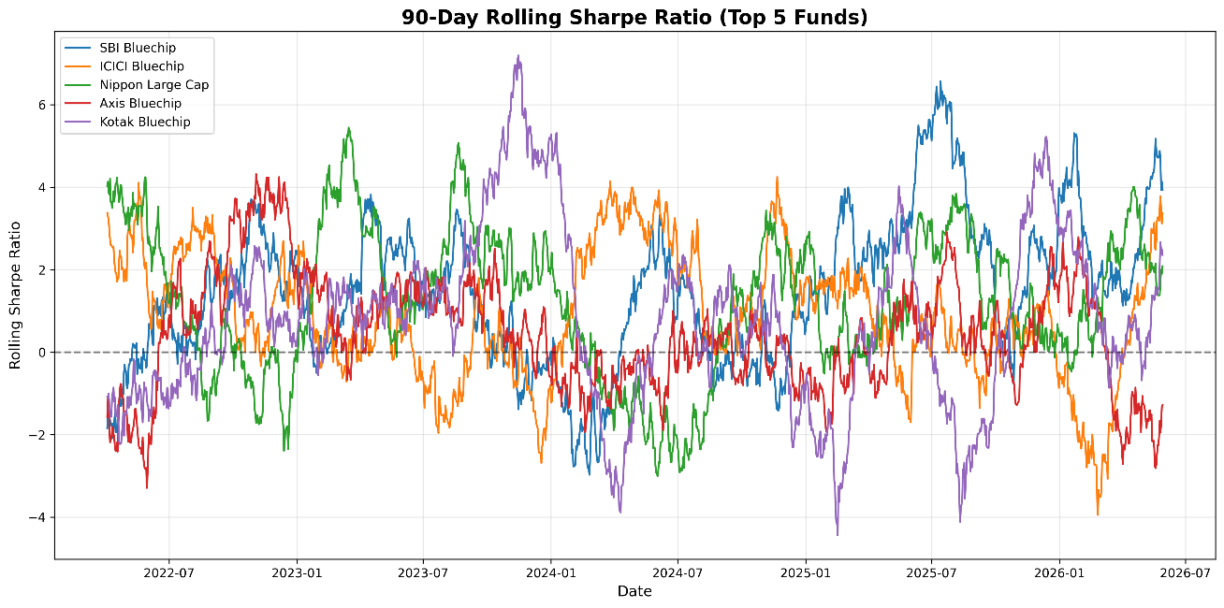
Figure 4.4: 90-Day Rolling Sharpe Ratio Consistency Evaluation

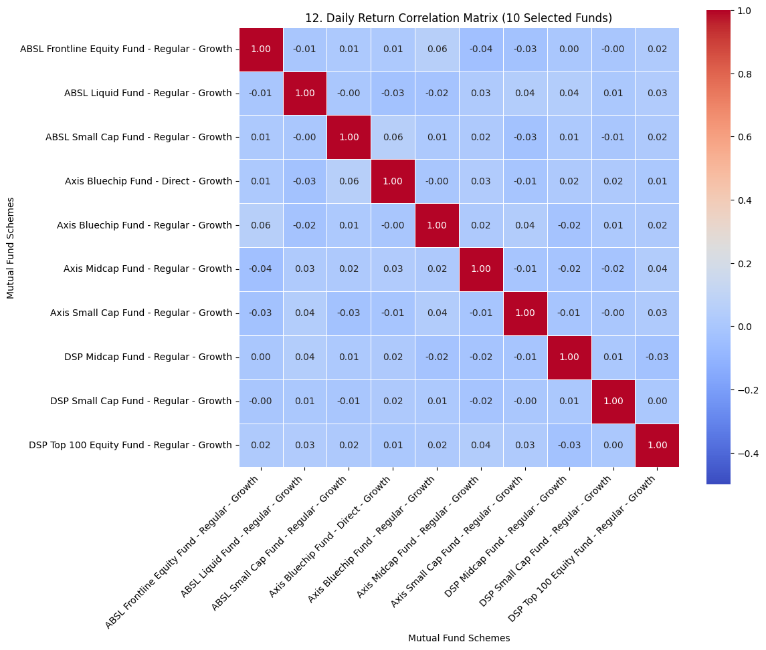
Figure 4.5: Return Inter-dependency & Cross-Correlation Heatmap

5. Dashboard Layout & User Guide
To democratize these insights, a comprehensive Power BI dashboard was deployed.
5.1 Dashboard Navigation
- Industry Overview (Page 1): Tracks macro KPIs, Folio counts, and AMC dominance.
- Fund Performance (Page 2): Features a Risk vs. Reward scatter plot and the sortable Fund Scorecard Matrix.
- Investor Analytics (Page 3): Visualizes demographic breakdowns, SIP vs. Lumpsum ratios, and state-wise contributions.
- Market Trends (Page 4): Dual-axis charts correlating Nifty 50 movements with retail SIP inflows.

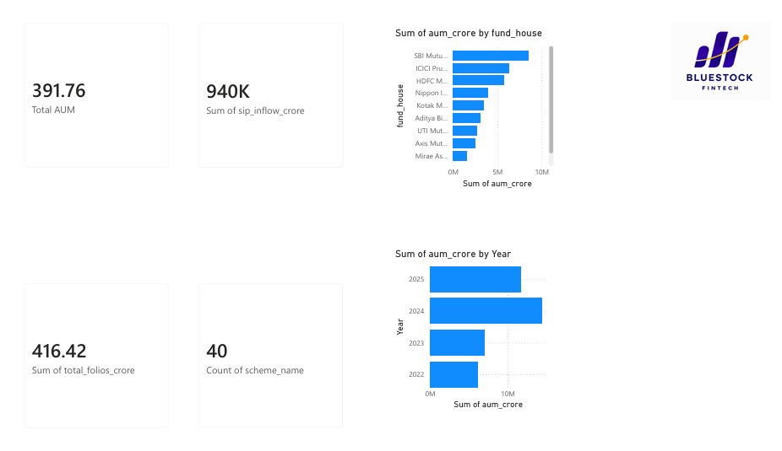
Figure 5.1: Power BI Interface - Executive Industry KPI Dashboard

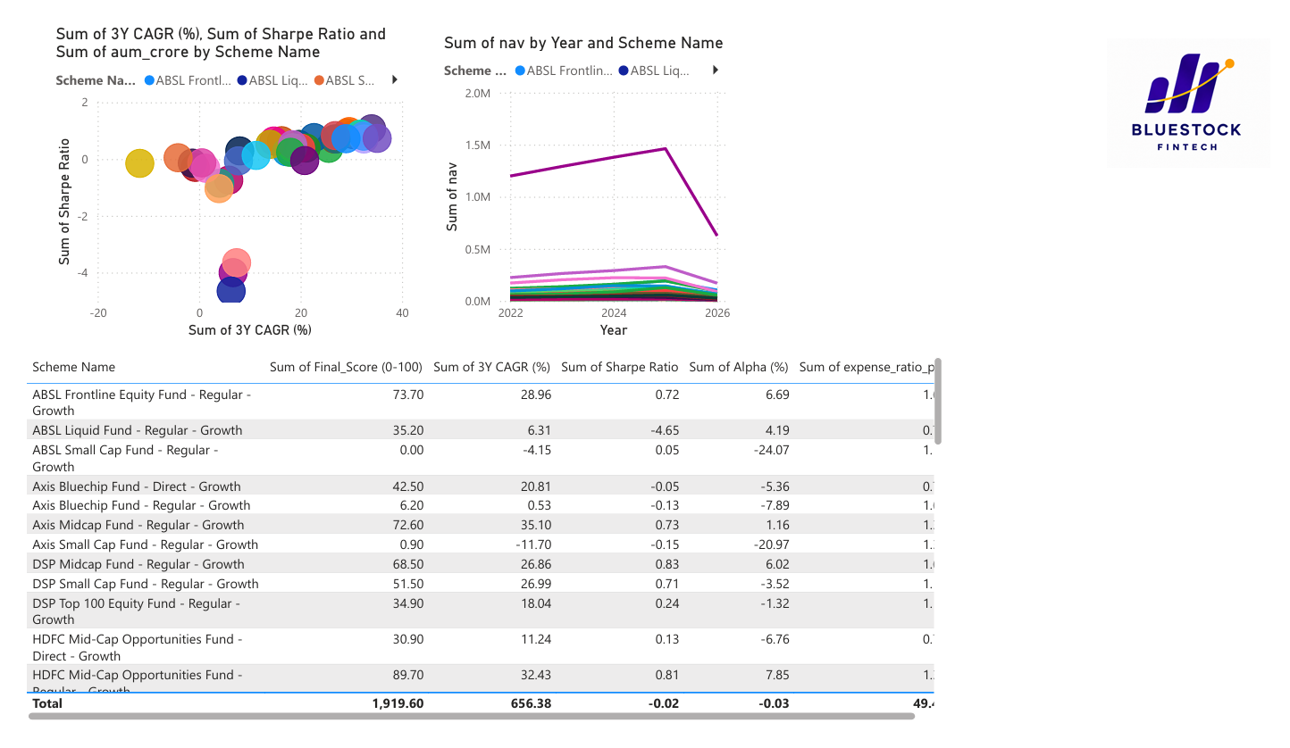
Figure 5.2: Power BI Interface - Fund Performance & Risk-Return Scatter Plot

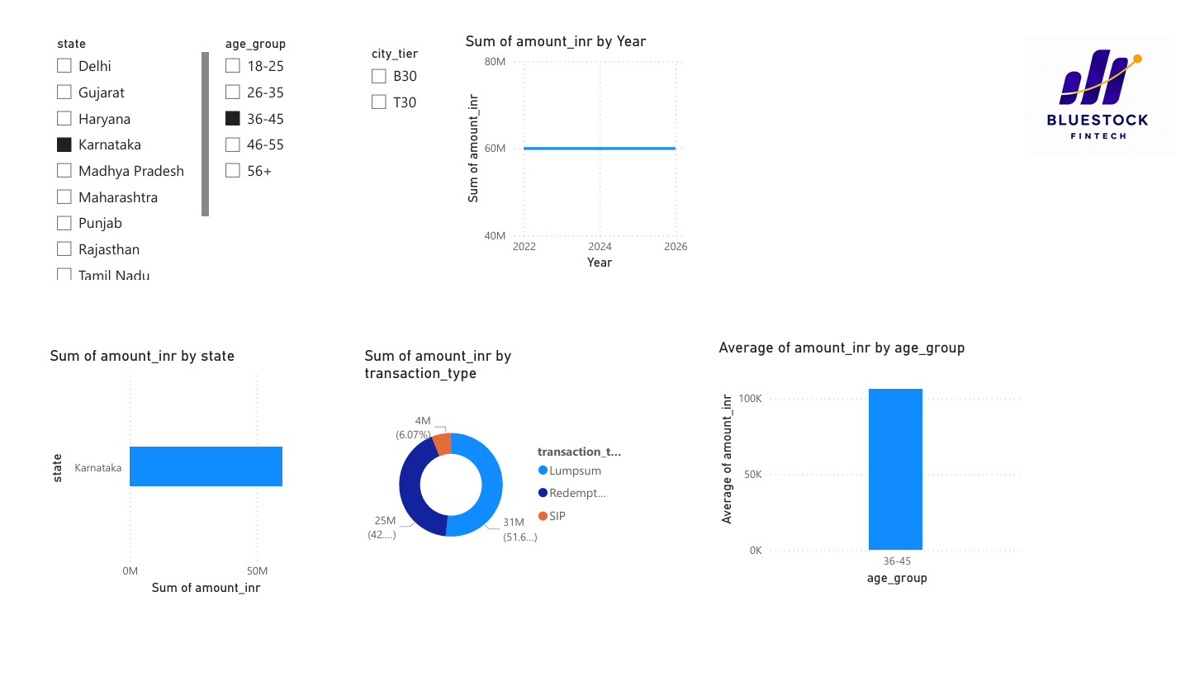
Figure 5.3: Power BI Interface - Investor Demographics and Behavioral Insights

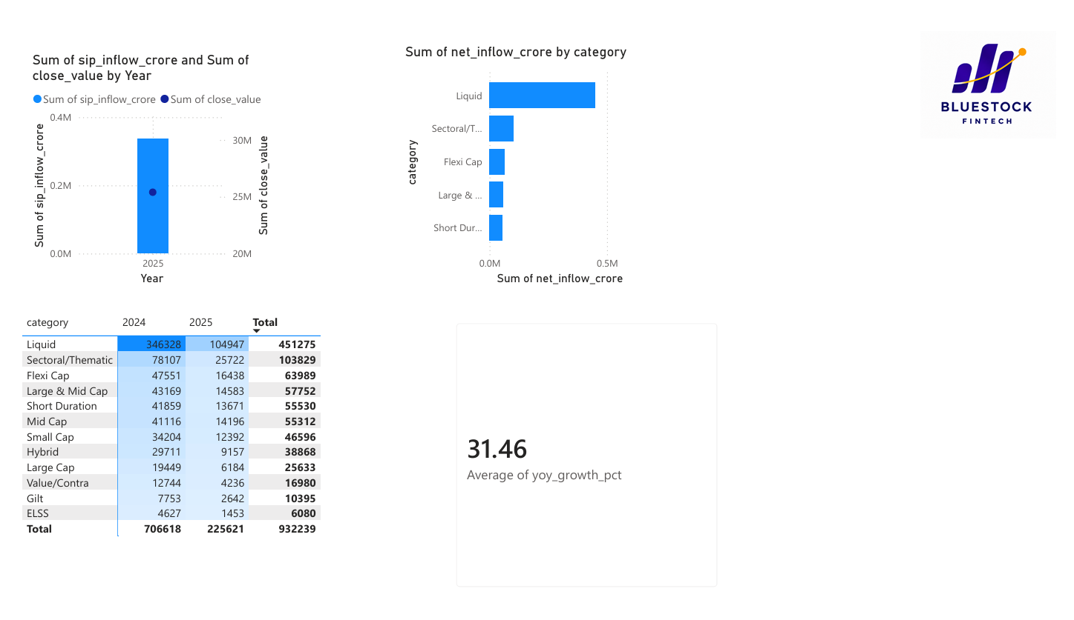
Figure 5.4: Power BI Interface - Market Trends and Macro Correlations

6. Strategic Recommendations for Bluestock Fintech
Based on the data models and analytics, the following strategies are recommended for business growth:
- Deploy Robo-Advisory Services: Utilize the developed Python Recommender logic to offer personalized, automated fund baskets based on an investor’s exact risk appetite (Low/Moderate/High).
- Proactive Churn Management: The cohort analysis identified 'at-risk' investors based on SIP payment gaps. Implementing automated nudges or relationship manager interventions for the 2025 cohort can significantly reduce churn.
- Dynamic Risk Alerts: Offer a premium feature that alerts investors when their portfolio's HHI concentration exceeds safe thresholds, prompting portfolio rebalancing.

7. Project Limitations & Future Scope
- Limitations: The VaR calculation currently relies on historical distribution, which may not accurately predict unprecedented 'Black Swan' market events. Furthermore, real-time API integrations are subject to rate limits.
- Future Scope: * Machine Learning Integration: Implement predictive models (e.g., LSTM or ARIMA) to forecast short-term NAV movements.
  - Sentiment Analysis: Integrate NLP models to analyze financial news and Twitter sentiment to adjust the Fund Scorecard dynamically based on market mood.

