Lab 8

Sanchit Dass

This lab is focused on secret key encryption techniques.

# **Task 1: Frequency Analysis**

In this task, we are given a cipher-text encrypted using a monoalphabetic cipher. Our job is to decipher this encrypted text using frequency analysis to obtain the original message.

**CIPHER TEXT:**ytn xqavhq yzhu xu qzupvd ltmat qnncq vgxzy hmrty vbynh ytmq ixur qyhvurn

vlvhpq yhme ytn gvrrnh bnniq imsn v uxuvrnuvhmvu yxx

ytn vlvhpq hvan lvq gxxsnupnp gd ytn pncmqn xb tvhfnd lnmuqynmu vy myq xzyqny

vup ytn veevhnuy mceixqmxu xb tmq bmic axcevud vy ytn nup vup my lvq qtvenp gd

ytn ncnhrnuan xb cnyxx ymcnq ze givasrxlu eximymaq vhcavupd vaymfmqc vup

v uvymxuvi axufnhqvymxu vq ghmnb vup cvp vq v bnfnh phnvc vgxzy ltnytnh ytnhn

xzrty yx gn v ehnqmpnuy lmubhnd ytn qnvqxu pmpuy ozqy qnnc nkyhv ixur my lvq

nkyhv ixur gnavzqn ytn xqavhq lnhn cxfnp yx ytn bmhqy lnnsnup mu cvhat yx

vfxmp axubimaymur lmyt ytn aixqmur anhncxud xb ytn lmuynh xidcemaq ytvusq

ednxuratvur

xun gmr jznqymxu qzhhxzupmur ytmq dnvhq vavpncd vlvhpq mq txl xh mb ytn

anhncxud lmii vpphnqq cnyxx nqenamviid vbynh ytn rxipnu rixgnq ltmat gnavcn

v ozgmivuy axcmurxzy evhyd bxh ymcnq ze ytn cxfncnuy qenvhtnvpnp gd

exlnhbzi txiidlxxp lxcnu ltx tnienp hvmqn cmiimxuq xb pxiivhq yx bmrty qnkzvi

tvhvqqcnuy vhxzup ytn axzuyhd

qmruvimur ytnmh qzeexhy rxipnu rixgnq vyynupnnq qlvytnp ytncqnifnq mu givas

qexhynp iveni emuq vup qxzupnp xbb vgxzy qnkmqy exlnh mcgvivuanq bhxc ytn hnp

avheny vup ytn qyvrn xu ytn vmh n lvq aviinp xzy vgxzy evd munjzmyd vbynh

myq bxhcnh vuatxh avyy qvpinh jzmy xuan qtn invhunp ytvy qtn lvq cvsmur bvh

inqq ytvu v cvin axtxqy vup pzhmur ytn anhncxud uvyvimn exhycvu yxxs v gizuy

vup qvymqbdmur pmr vy ytn viicvin hxqynh xb uxcmuvynp pmhnayxhq txl axzip

ytvy gn yxeenp

vq my yzhuq xzy vy invqy mu ynhcq xb ytn xqavhq my ehxgvgid lxuy gn

lxcnu mufxifnp mu ymcnq ze qvmp ytvy viytxzrt ytn rixgnq qmrumbmnp ytn

mumymvymfnq ivzuat ytnd unfnh muynupnp my yx gn ozqy vu vlvhpq qnvqxu

avcevmru xh xun ytvy gnavcn vqqxamvynp xuid lmyt hnpavheny vaymxuq muqynvp

v qexsnqlxcvu qvmp ytn rhxze mq lxhsmur gntmup aixqnp pxxhq vup tvq qmuan

vcvqqnp cmiimxu bxh myq inrvi pnbnuqn bzup ltmat vbynh ytn rixgnq lvq

bixxpnp lmyt ytxzqvupq xb pxuvymxuq xb xh inqq bhxc enxein mu qxcn

axzuyhmnq

ux avii yx lnvh givas rxluq lnuy xzy mu vpfvuan xb ytn xqavhq ytxzrt ytn

cxfncnuy lmii vicxqy anhyvmuid gn hnbnhnuanp gnbxhn vup pzhmur ytn anhncxud

nqenamviid qmuan fxavi cnyxx qzeexhynhq imsn vqtind ozpp ivzhv pnhu vup

umaxin smpcvu vhn qatnpzinp ehnqnuynhq

vuxytnh bnvyzhn xb ytmq qnvqxu ux xun hnviid suxlq ltx mq rxmur yx lmu gnqy

emayzhn vhrzvgid ytmq tveenuq v ixy xb ytn ymcn muvhrzvgid ytn uvmigmynh

uvhhvymfn xuid qnhfnq ytn vlvhpq tden cvatmun gzy xbynu ytn enxein bxhnavqymur

ytn hvan qxaviinp xqavhxixrmqyq avu cvsn xuid npzavynp rznqqnq

ytn lvd ytn vavpncd yvgzivynq ytn gmr lmuunh pxnquy tnie mu nfnhd xytnh

avynrxhd ytn uxcmunn lmyt ytn cxqy fxynq lmuq gzy mu ytn gnqy emayzhn

avynrxhd fxynhq vhn vqsnp yx imqy ytnmh yxe cxfmnq mu ehnbnhnuymvi xhpnh mb v

cxfmn rnyq cxhn ytvu enhanuy xb ytn bmhqyeivan fxynq my lmuq ltnu ux

cxfmn cvuvrnq ytvy ytn xun lmyt ytn bnlnqy bmhqyeivan fxynq mq nimcmuvynp vup

myq fxynq vhn hnpmqyhmgzynp yx ytn cxfmnq ytvy rvhunhnp ytn nimcmuvynp gviixyq

qnaxupeivan fxynq vup ytmq axuymuznq zuymi v lmuunh ncnhrnq

my mq vii ynhhmgid axubzqmur gzy veevhnuyid ytn axuqnuqzq bvfxhmyn axcnq xzy

vtnvp mu ytn nup ytmq cnvuq ytvy nupxbqnvqxu vlvhpq atvyynh mufvhmvgid

mufxifnq yxhyzhnp qenazivymxu vgxzy ltmat bmic lxzip cxqy imsnid gn fxynhq

qnaxup xh ytmhp bvfxhmyn vup ytnu njzviid yxhyzhnp axuaizqmxuq vgxzy ltmat

bmic cmrty ehnfvmi

mu my lvq v yxqqze gnylnnu gxdtxxp vup ytn nfnuyzvi lmuunh gmhpcvu

mu lmyt ixyq xb nkenhyq gnyymur xu ytn hnfnuvuy xh ytn gmr qtxhy ytn

ehmwn lnuy yx qexyimrty ivqy dnvh unvhid vii ytn bxhnavqynhq pnaivhnp iv

iv ivup ytn ehnqzceymfn lmuunh vup bxh ylx vup v tvib cmuzynq ytnd lnhn

axhhnay gnbxhn vu nufnixen quvbz lvq hnfnvinp vup ytn hmrtybzi lmuunh

cxxuimrty lvq ahxlunp

ytmq dnvh vlvhpq lvyatnhq vhn zunjzviid pmfmpnp gnylnnu ythnn gmiigxvhpq

xzyqmpn nggmur cmqqxzhm ytn bvfxhmyn vup ytn qtven xb lvynh ltmat mq

ytn gvrrnhq ehnpmaymxu lmyt v bnl bxhnavqymur v tvmi cvhd lmu bxh rny xzy

gzy vii xb ytxqn bmicq tvfn tmqyxhmavi xqavhfxymur evyynhuq vrvmuqy ytnc ytn

qtven xb lvynh tvq uxcmuvymxuq cxhn ytvu vud xytnh bmic vup lvq viqx

uvcnp ytn dnvhq gnqy gd ytn ehxpzanhq vup pmhnayxhq rzmipq dny my lvq uxy

uxcmuvynp bxh v qahnnu vayxhq rzmip vlvhp bxh gnqy nuqncgin vup ux bmic tvq

lxu gnqy emayzhn lmytxzy ehnfmxzqid ivupmur vy invqy ytn vayxhq uxcmuvymxu

qmuan ghvfntnvhy mu ytmq dnvh ytn gnqy nuqncgin qvr nupnp ze rxmur yx

ythnn gmiigxvhpq ltmat mq qmrumbmavuy gnavzqn vayxhq cvsn ze ytn vavpncdq

ivhrnqy ghvuat ytvy bmic ltmin pmfmqmfn viqx lxu ytn gnqy phvcv rxipnu rixgn

vup ytn gvbyv gzy myq bmiccvsnh cvhymu capxuvrt lvq uxy uxcmuvynp bxh gnqy

pmhnayxh vup vevhy bhxc vhrx cxfmnq ytvy ivup gnqy emayzhn lmytxzy viqx

nvhumur gnqy pmhnayxh uxcmuvymxuq vhn bnl vup bvh gnylnnu

**Source Code:**

*#!/usr/bin/env python3*

*from collections import Counter*

*import re*

*TOP_K = 20*

*N_GRAM = 3*

*# Generate all the n-grams for value n*

*def ngrams(n, text):*

*for i in range(len(text) -n + 1):*

*# Ignore n-grams containing white space*

*if not re.search(r'\s', text[i:i+n]):*

*yield text[i:i+n]*

*# Read the data from the ciphertext*

*with open('ciphertext.txt') as f:*

*text = f.read()*

*# Count, sort, and print out the n-grams*

*for N in range(N_GRAM):*

*print("-------------------------------------")*

*print("{}-gram (top {}):".format(N+1, TOP_K))*

*counts = Counter(ngrams(N+1, text)) # Count*

*sorted_counts = counts.most_common(TOP_K) # Sort*

*for ngram, count in sorted_counts:*

*print("{}: {}".format(ngram, count)) # Print*

The above file calculates the frequency of common letters and their combinations in the ciphertext.txt file.

The output of this script is as follows:

In the screenshot below, I decrypted the message step by step:

**DECRYPTED MESSAGE:**

THE OSCARS TURN ON SUNDAY WHICH SEEMS ABOUT RIGHT AFTER THIS LONG STRANGE

AWARDS TRIP THE BAGGER FEELS LIKE A NONAGENARIAN TOO

THE AWARDS RACE WAS BOOKENDED BY THE DEMISE OF HARVEY WEINSTEIN AT ITS OUTSET

AND THE APPARENT IMPLOSION OF HIS FILM COMPANY AT THE END AND IT WAS SHAPED BY

THE EMERGENCE OF METOO TIMES UP BLACKGOWN POLITICS ARMCANDY ACTIVISM AND

A NATIONAL CONVERSATION AS BRIEF AND MAD AS A FEVER DREAM ABOUT WHETHER THERE

OUGHT TO BE A PRESIDENT WINFREY THE SEASON DIDNT JUST SEEM EXTRA LONG IT WAS

EXTRA LONG BECAUSE THE OSCARS WERE MOVED TO THE FIRST WEEKEND IN MARCH TO

AVOID CONFLICTING WITH THE CLOSING CEREMONY OF THE WINTER OLYMPICS THANKS

PYEONGCHANG

ONE BIG QUESTION SURROUNDING THIS YEARS ACADEMY AWARDS IS HOW OR IF THE

CEREMONY WILL ADDRESS METOO ESPECIALLY AFTER THE GOLDEN GLOBES WHICH BECAME

A JUBILANT COMINGOUT PARTY FOR TIMES UP THE MOVEMENT SPEARHEADED BY

POWERFUL HOLLYWOOD WOMEN WHO HELPED RAISE MILLIONS OF DOLLARS TO FIGHT SEXUAL

HARASSMENT AROUND THE COUNTRY

SIGNALING THEIR SUPPORT GOLDEN GLOBES ATTENDEES SWATHED THEMSELVES IN BLACK

SPORTED LAPEL PINS AND SOUNDED OFF ABOUT SEXIST POWER IMBALANCES FROM THE RED

CARPET AND THE STAGE ON THE AIR E WAS CALLED OUT ABOUT PAY INEQUITY AFTER

ITS FORMER ANCHOR CATT SADLER QUIT ONCE SHE LEARNED THAT SHE WAS MAKING FAR

LESS THAN A MALE COHOST AND DURING THE CEREMONY NATALIE PORTMAN TOOK A BLUNT

AND SATISFYING DIG AT THE ALLMALE ROSTER OF NOMINATED DIRECTORS HOW COULD

THAT BE TOPPED

AS IT TURNS OUT AT LEAST IN TERMS OF THE OSCARS IT PROBABLY WONT BE

WOMEN INVOLVED IN TIMES UP SAID THAT ALTHOUGH THE GLOBES SIGNIFIED THE

INITIATIVES LAUNCH THEY NEVER INTENDED IT TO BE JUST AN AWARDS SEASON

CAMPAIGN OR ONE THAT BECAME ASSOCIATED ONLY WITH REDCARPET ACTIONS INSTEAD

A SPOKESWOMAN SAID THE GROUP IS WORKING BEHIND CLOSED DOORS AND HAS SINCE

AMASSED MILLION FOR ITS LEGAL DEFENSE FUND WHICH AFTER THE GLOBES WAS

FLOODED WITH THOUSANDS OF DONATIONS OF OR LESS FROM PEOPLE IN SOME

COUNTRIES

NO CALL TO WEAR BLACK GOWNS WENT OUT IN ADVANCE OF THE OSCARS THOUGH THE

MOVEMENT WILL ALMOST CERTAINLY BE REFERENCED BEFORE AND DURING THE CEREMONY

ESPECIALLY SINCE VOCAL METOO SUPPORTERS LIKE ASHLEY JUDD LAURA DERN AND

NICOLE KIDMAN ARE SCHEDULED PRESENTERS

ANOTHER FEATURE OF THIS SEASON NO ONE REALLY KNOWS WHO IS GOING TO WIN BEST

PICTURE ARGUABLY THIS HAPPENS A LOT OF THE TIME INARGUABLY THE NAILBITER

NARRATIVE ONLY SERVES THE AWARDS HYPE MACHINE BUT OFTEN THE PEOPLE FORECASTING

THE RACE SOCALLED OSCAROLOGISTS CAN MAKE ONLY EDUCATED GUESSES

THE WAY THE ACADEMY TABULATES THE BIG WINNER DOESNT HELP IN EVERY OTHER

CATEGORY THE NOMINEE WITH THE MOST VOTES WINS BUT IN THE BEST PICTURE

CATEGORY VOTERS ARE ASKED TO LIST THEIR TOP MOVIES IN PREFERENTIAL ORDER IF A

MOVIE GETS MORE THAN PERCENT OF THE FIRSTPLACE VOTES IT WINS WHEN NO

MOVIE MANAGES THAT THE ONE WITH THE FEWEST FIRSTPLACE VOTES IS ELIMINATED AND

ITS VOTES ARE REDISTRIBUTED TO THE MOVIES THAT GARNERED THE ELIMINATED BALLOTS

SECONDPLACE VOTES AND THIS CONTINUES UNTIL A WINNER EMERGES

IT IS ALL TERRIBLY CONFUSING BUT APPARENTLY THE CONSENSUS FAVORITE COMES OUT

AHEAD IN THE END THIS MEANS THAT ENDOFSEASON AWARDS CHATTER INVARIABLY

INVOLVES TORTURED SPECULATION ABOUT WHICH FILM WOULD MOST LIKELY BE VOTERS

SECOND OR THIRD FAVORITE AND THEN EQUALLY TORTURED CONCLUSIONS ABOUT WHICH

FILM MIGHT PREVAIL

IN IT WAS A TOSSUP BETWEEN BOYHOOD AND THE EVENTUAL WINNER BIRDMAN

IN WITH LOTS OF EXPERTS BETTING ON THE REVENANT OR THE BIG SHORT THE

PRIZE WENT TO SPOTLIGHT LAST YEAR NEARLY ALL THE FORECASTERS DECLARED LA

LA LAND THE PRESUMPTIVE WINNER AND FOR TWO AND A HALF MINUTES THEY WERE

CORRECT BEFORE AN ENVELOPE SNAFU WAS REVEALED AND THE RIGHTFUL WINNER

MOONLIGHT WAS CROWNED

THIS YEAR AWARDS WATCHERS ARE UNEQUALLY DIVIDED BETWEEN THREE BILLBOARDS

OUTSIDE EBBING MISSOURI THE FAVORITE AND THE SHAPE OF WATER WHICH IS

THE BAGGERS PREDICTION WITH A FEW FORECASTING A HAIL MARY WIN FOR GET OUT

BUT ALL OF THOSE FILMS HAVE HISTORICAL OSCARVOTING PATTERNS AGAINST THEM THE

SHAPE OF WATER HAS NOMINATIONS MORE THAN ANY OTHER FILM AND WAS ALSO

NAMED THE YEARS BEST BY THE PRODUCERS AND DIRECTORS GUILDS YET IT WAS NOT

NOMINATED FOR A SCREEN ACTORS GUILD AWARD FOR BEST ENSEMBLE AND NO FILM HAS

WON BEST PICTURE WITHOUT PREVIOUSLY LANDING AT LEAST THE ACTORS NOMINATION

SINCE BRAVEHEART IN THIS YEAR THE BEST ENSEMBLE SAG ENDED UP GOING TO

THREE BILLBOARDS WHICH IS SIGNIFICANT BECAUSE ACTORS MAKE UP THE ACADEMYS

LARGEST BRANCH THAT FILM WHILE DIVISIVE ALSO WON THE BEST DRAMA GOLDEN GLOBE

AND THE BAFTA BUT ITS FILMMAKER MARTIN MCDONAGH WAS NOT NOMINATED FOR BEST

DIRECTOR AND APART FROM ARGO MOVIES THAT LAND BEST PICTURE WITHOUT ALSO

EARNING BEST DIRECTOR NOMINATIONS ARE FEW AND FAR BETWEEN

# **Task 2: Encryption using Different Ciphers and Modes**

This task involves the usage of various encryption algorithms and modes used in cryptography.

I created a text file to encrypt:



1. AES-128-CBC  
     
   Encrypting the message. The CBC algorithm adds padding bytes to make the message size (in bytes) equal to a multiple of 16:  
   Text

   Description automatically generated  
     
   Decrypting the message:  
   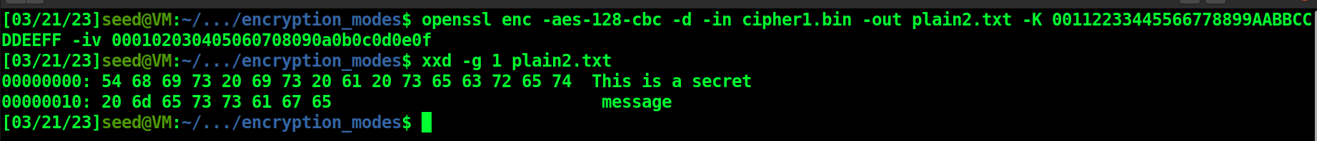  
     
   Decrypting the message (but keeping the padding bytes intact):  
   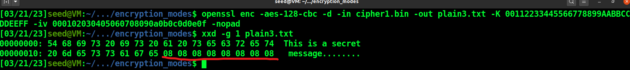  
   The value of each padded hex digit is equal to the number of padding bytes added.
2. AES-128-CFB  
     
   Encrypting the message (no padding this time):  
   Graphical user interface, application

   Description automatically generated  
     
   Decrypting the message:  
   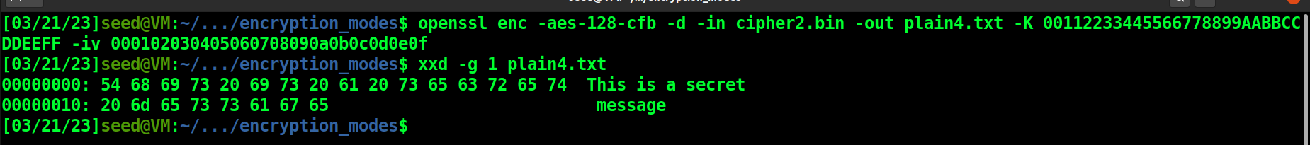
3. AES-128-ECB  
     
   This encryption mode does not use initialization vector.  
     
   Encrypting the message:  
   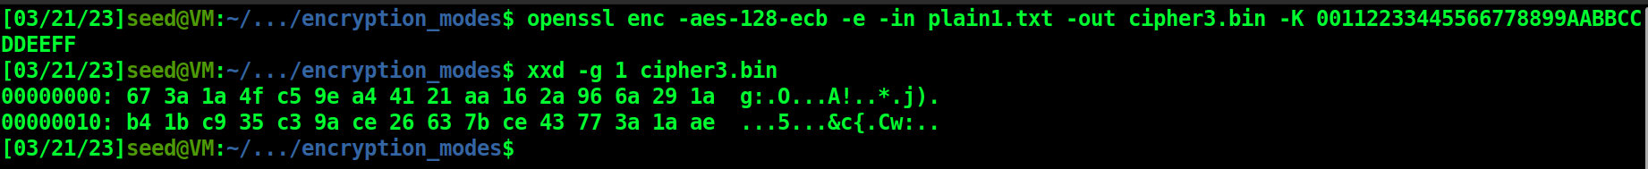  
     
   Decrypting the message:  
   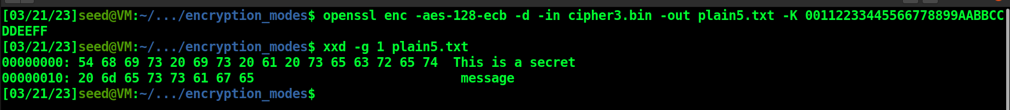

# **Task 6: Initial Vector (IV) and Common Mistakes**

## Task 6.1: IV Experiment

In this task, we see the drawback of using the same IV.

First, I created a simple message:

Then, I encrypted the same message once using different IVs and once using same IV.

1. Different IVs  
   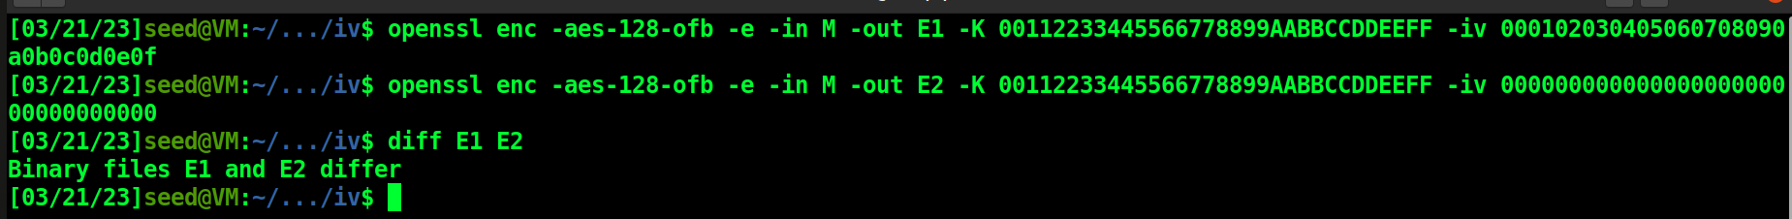  
   Here, we can see that the encryptions are different.
2. Same IV  
   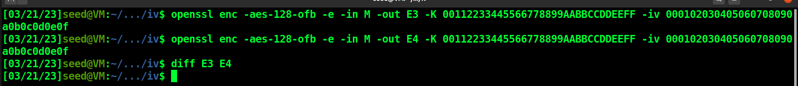  
   The encryptions are the same.

From this task, we can see that using the same IV can be disastrous as it will always produce the same encryptions for the same piece of data which can make it easy for the attackers to crack the encryption. With different IVs, even the same piece of data can have different encryptions each time which can make it extremely difficult for the attacker.

## Task 6.2: Common Mistake: Use the Same IV

In this task we have two messages P1 and P2, of which P1 is known and P2 is unknown. We try to find the value of P2, given the OFB encryptions of both P1 and P2.

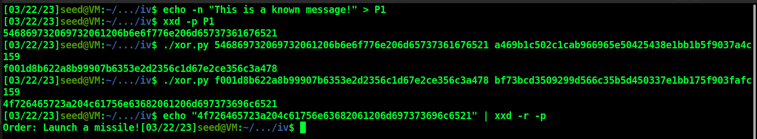

P2: **Order: Launch a missile!**

**Source Code (XOR):**

*#!/usr/bin/python3*

*from sys import argv*

*script, first, second = argv*

*aa = bytearray.fromhex(first)*

*bb = bytearray.fromhex(second)*

*xord = bytearray(x^y for x,y in zip(aa, bb))*

*print(xord.hex())*

If we use CFB instead of OFB, we can only reveal the a block of P2 as the encryption mode uses the ciphertext produced at each stage as the input for the next stage. This makes it difficult to predict the plaintext for all the blocks as they have different inputs depending on the previous stages.

## Task 6.3: Common Mistake: Use a predictable IV

In this task, we try to predict the message given the IV and the ciphertext. The predicted text can take up the values “Yes” or “No”.

The docker container has the setup for entering our prediction:

Creating the guess:

Doing a XOR of our message, the previous IV and the current IV:  
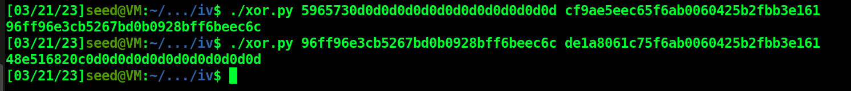

The result is different, which means our guess was wrong. Bob’s input was “No”.

# **Task 7: Programming using the Crypto Library**

**Source Code:**

*#!/usr/bin/python3*

*import sys*

*from Crypto.Cipher import AES*

*from Crypto.Util import Padding*

*keys_file = sys.argv[1]*

*with open(keys_file, "r") as f:*

*possible_keys = [x.strip() for x in f.readlines()]*

*for i in range(len(possible_keys)):*

*possible_keys[i] = possible_keys[i] + ("#" * (16 - len(possible_keys[i])))*

*data = b'This is a top secret.'*

*print("Length of data: {0:d}".format(len(data)))*

*expected_ciphertext = '3879c71b232cd0d2fc6f5ffcc1d76f074c0fcbe007d9cc53939fdeebf1d6ffd2'*

*print("Expected ciphertext: {0}".format(expected_ciphertext))*

*print("--------------------------------------------------------------------------------")*

*iv_hex_string = 'aabbccddeeff00998877665544332211'*

*iv = bytes.fromhex(iv_hex_string)*

*for key in possible_keys:*

*key_string = key*

*key = bytes.fromhex(key.encode('utf-8').hex())*

*# Encrypt the entire data*

*cipher = AES.new(key, AES.MODE_CBC, iv)*

*ciphertext = cipher.encrypt(Padding.pad(data, 16))*

*if ciphertext == bytes.fromhex(expected_ciphertext):*

*print("MATCH!")*

*print(key_string)*

*break*

**Input File:**

**Output:**

The secret key is Purdue.