AI-Powered Fake News Detection Using Text Classification

Abstract
This project implements a complete machine learning pipeline to classify news articles as real or fake. Various text preprocessing techniques, feature extraction methods (TF-IDF, Bag of Words, Word2Vec), and models (KNN, Logistic Regression, Random Forest, Neural Networks) are compared.

1. Introduction
Fake news poses a significant threat to information integrity. This project aims to automate the detection of misinformation using NLP and ML.

2. Dataset Description
The dataset used is the Kaggle Fake News dataset.
Dataset Statistics:
- Total Articles: 16604
- Fake News Articles: 7661
- Real News Articles: 8943
- Average Words per Article: 307.26
- Missing Text Rows Removed: 0

3. Methodology
Preprocessing included lowercase conversion, punctuation removal, stopword removal, tokenization, and lemmatization. Feature extraction used TF-IDF. Models trained include KNN, Logistic Regression, Random Forest, and MLP Classifier.

4. Results
Model Comparison Table:
Model | CV Accuracy | Accuracy | Precision | Recall | F1-Score | AUC
Logistic Regression | 0.7062 | 0.7061 | 0.6880 | 0.6641 | 0.6758 | 0.7882
KNN | 0.5283 | 0.5347 | 0.4977 | 0.9617 | 0.6560 | 0.6163
Random Forest | 0.6848 | 0.6889 | 0.8610 | 0.3882 | 0.5351 | 0.7803
Neural Network | 0.6581 | 0.6744 | 0.6404 | 0.6710 | 0.6553 | 0.7486
DistilBERT (Fine-Tuned) | nan | 0.6945 | 0.7449 | 0.5135 | 0.6079 | 0.7847

4.1 Model Accuracy & ROC-AUC
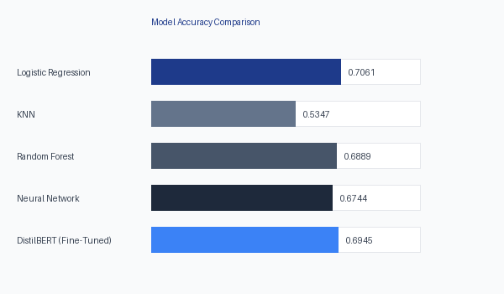
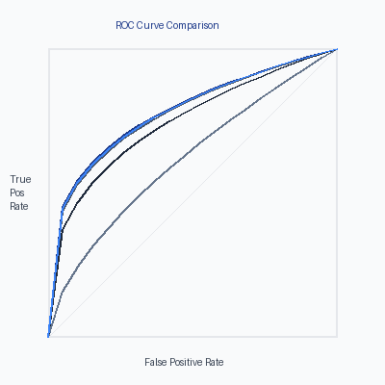

4.2 Confusion Matrices
KNN Confusion Matrix:
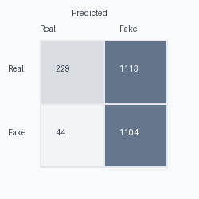
Logistic Regression Confusion Matrix:
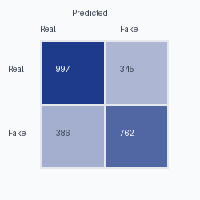
Random Forest Confusion Matrix:
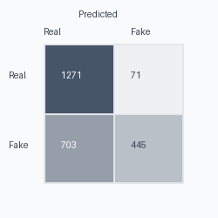
Neural Network Confusion Matrix:
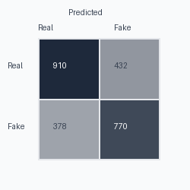
DistilBERT (Fine-Tuned) Confusion Matrix:
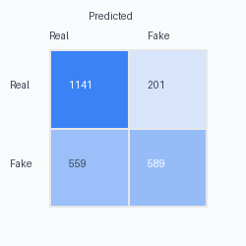

5. Discussion
Parametric models like Logistic Regression often perform well and quickly on linearly separable text features (TF-IDF). Non-parametric models like KNN suffer from the curse of dimensionality. Ensemble methods (Random Forest) and Neural Networks offer high accuracy but take longer to train.

6. Conclusion
The pipeline successfully identifies fake news. Future scope includes utilizing advanced embeddings like BERT.

