iNeuron

Sanchit Jayesh

Assignment - 2

1. What does the dollar($) sign do?

Solution – $ is used to make a cell reference value absolute. As shown in below example

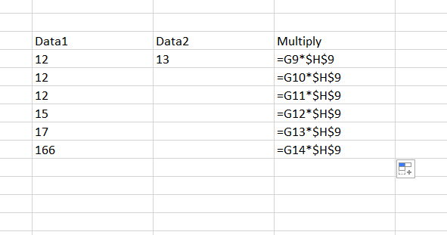

1. How to Change the Reference from Relative to Absolute (or Mixed)?

Solution – We can reference from Relative to Absolute by putting ‘$’ sign in front of cell address (i.e $ row number $column number)

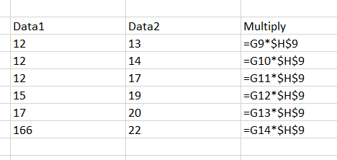

1. Explain the order of operations in excel?

Solution – Order of Operations is basically defined as how algebraic expression is getting evaluated i.e which operations are performed first and so on.

Excel follows BODMAS rule in which

* Value inside bracket is evaluated first and then
* Division
* Multiplication
* Addition
* Subtraction

1. What, according to you, are the top 5 functions in excel and write a basic syntax

for any of two?

Solution – Top function are SUM, AVERAGE, CONCATENATE, VLOOKUP, TEXT FUNCTION

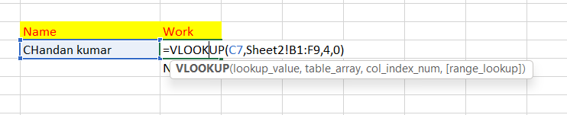



1. When would you use the subtotal function?

Solution – I will use it when

* There are multiple sub-categories
* It makes it easy to find grand total as while doing grand total it only add cells with values which contain subtotal function.

Like in below example

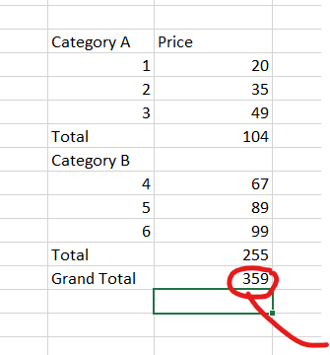

* It contains many functions like average, sum, max, min

1. What is the syntax of the vlookup function? Explain the terms in it?

Solution : Below is the syntax of VLOOKUP

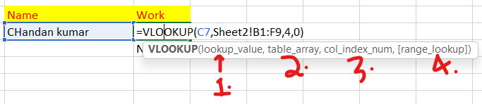

1. Look Up Value = It is the value corresponds to which we want to find resultant value.

E.g – Using ‘Name’ column to find value of ‘Work’ Column

2.) table_array = It is the data from which we want to find value. It contains data in form of cell

3.) col_index_num = It is the index of the value which we want. It is found by counting from 1st column

4.) range_lookup = It can be either true or false. If, value entered here is

-> 0, then excel looks for exact match

-> 1, then excel looks for approximate match