2/3/2023

Sanchit Jayesh

Assignment - 3

1. How and when to use the AutoSum command in excel?

Solution: We can use Auto Sum by following below steps

Step 1: Select the cell in which you want to get resultant value

Step 2: Go on Home section

Step 3: Select AutoSum Option

Step 4: We will get resultant value as shown below

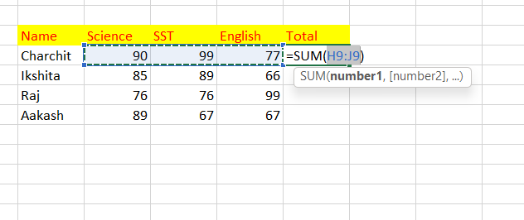

1. What is the shortcut key to perform AutoSum?

Solution: Shortcut key is, ALT + =

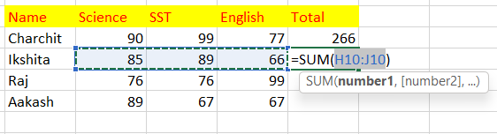

1. How do you get rid of Formula that omits adjacent cells?

Solution: Below is the example where we are getting Formula Omits Adjacent Cells error.

To get rid of this error, click on yellow sign and select ignore this error

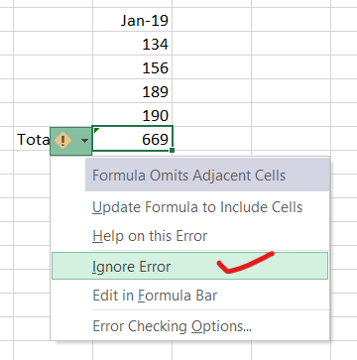

1. How do you select non-adjacent cells in Excel 2016?

Solution: Steps are given below

Step 1: Select any cell first

Step 2: Now, press SHIFT + F8

Step 3: Now, below you will get Add or remove option, click on that

Step 4: Now simply select remaining cells

Below is an example I performed



1. What happens if you choose a column, hold down the Alt key and press the letters ocw in quick succession?

Solution: We get an option to define column width

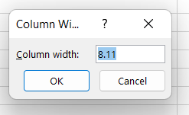

1. If you right-click on a row reference number and click on Insert, where will the row

be added?

Solution: A row will be added above selected row

Below is example of before and after inserting

Before:

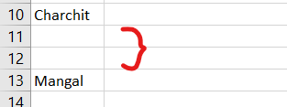

After:

