SLE-2: Profiling Report
Course: 02AML204 – Introduction to Artificial Intelligence
PRN: 25UAM133
Name: Sanchit Sachin Magdum
Division: B
Date: 22-09-2026
GitHub Link: https://github.com/sanchitmagdum17

1. Algorithms / Versions Profiled
• Algorithm A: Breadth-First Search (BFS)
• Algorithm B: Depth-First Search (DFS)
• Problem used: 8-Puzzle with one blank cell. Three fixed test cases were selected as easy/best, medium/average and hard/worst experimental cases.
• All moves have unit cost and both algorithms use the same goal state.

2. Profiling Method
• Tool used: Python time.perf_counter() for wall-clock timing and a manual node counter inside each search function.
• Fair comparison: both algorithms use the same state representation, movement rules and goal state for every test case.
• Number of runs: 7 runs per algorithm per test case; the table reports average time.
• Nodes expanded: number of states popped from the search frontier.
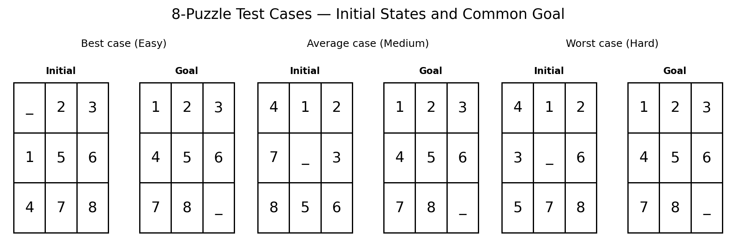
Fig. 1 — Initial and goal states for the three 8-Puzzle test cases.
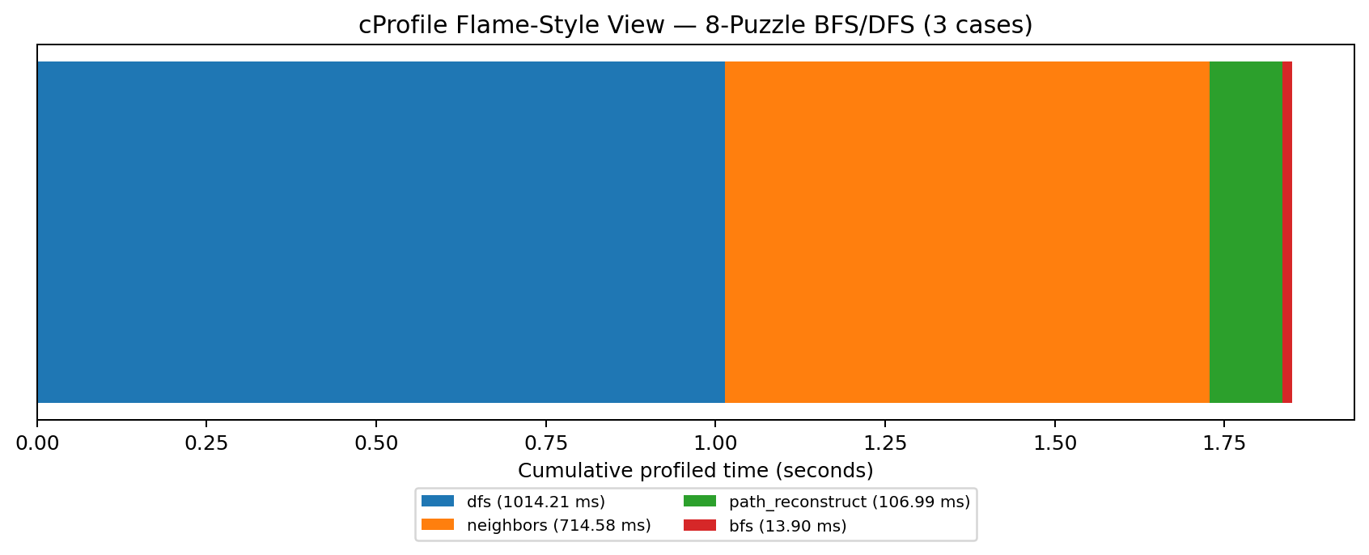
Fig. 2 — cProfile flame-style view across the three 8-Puzzle cases.

3. Results
Detailed Results by Test Case (Best / Average / Worst Case)
Test Case | Algo | Avg Time (ms) | Nodes Expanded | Path Length | Optimal? | Observation
Best case (Easy) | BFS | 0.1383 | 17 | 4 | Yes | Shortest path
Best case (Easy) | DFS | 496.9879 | 120,489 | 59124 | Not guaranteed | May be longer
Average case (Medium) | BFS | 0.4977 | 244 | 8 | Yes | Shortest path
Average case (Medium) | DFS | 262.5609 | 105,311 | 65110 | Not guaranteed | May be longer
Worst case (Hard) | BFS | 3.9239 | 2,149 | 12 | Yes | Shortest path
Worst case (Hard) | DFS | 127.8745 | 51,549 | 46516 | Not guaranteed | May be longer
Summary Comparison Table
Metric | BFS | DFS | Observation
Average of 3 case times | 1.5200 ms | 295.8078 ms | See individual cases
Average nodes expanded | 803.3 | 92449.7 | Depends on search order
Solution optimality | Shortest for unit-cost puzzle | Not guaranteed | BFS guarantee

4. Short Observation
Across the three selected cases, the search effort changes substantially with the starting state. BFS explores states level-by-level and therefore returns a shortest solution for these unit-cost moves. DFS can reach a goal through a different branch and its returned path is not guaranteed to be shortest.
- The measured execution time depends on the selected puzzle state and the machine running the experiment, so the three cases should be treated as experimental comparisons rather than universal complexity measurements.
- BFS returned the shortest solution for each unit-cost test case. DFS followed its depth-first stack order and did not guarantee the shortest solution.
- The easy 8-Puzzle case required the least search effort, while the hard case required substantially more BFS expansion.
Fig. 4 — Nodes expanded: BFS vs DFS across the three 8-Puzzle test cases.
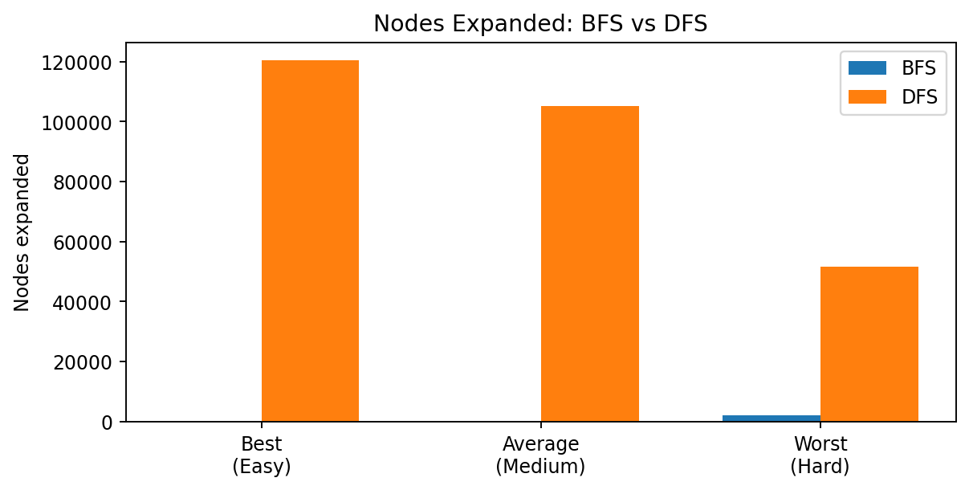
Fig. 3 — Average execution time: BFS vs DFS across the three 8-Puzzle test cases.
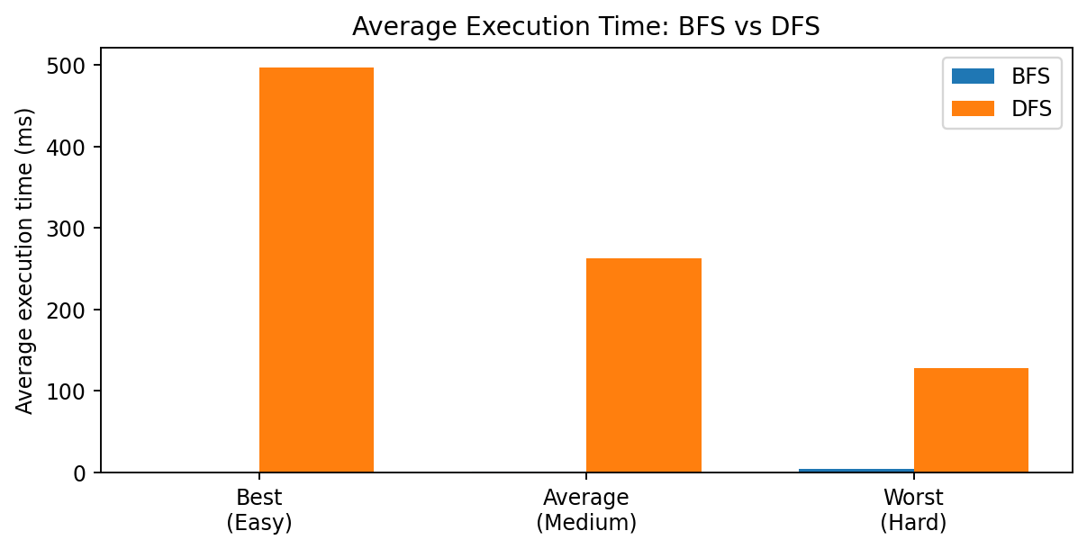
Short observation:

5. Justification & Analysis
The best, average and worst labels in this report describe the three selected experimental difficulty levels, not mathematical best/average/worst-case complexity. This makes the comparison easier to present while keeping the results tied to actual fixed puzzle instances.
The timing values are measured on the same computer and can vary slightly with system load. Node counts and path lengths are determined by the fixed puzzle states, move order and implementations. The cProfile figure provides a visual indication of where cumulative execution time is spent in the workload.

6. AI Contribution Note
• AI tools used: Claude and ChatGPT for code structure, profiling setup, visualization and report organization.
• What AI helped with: adapting the experiment to 8-Puzzle, creating the three-case comparison, timing structure, node counting, diagrams and documentation.
• What I did myself: reviewed and ran the code, checked the results and used the measured data for the report.

7. Conclusion
This profiling exercise compares BFS and DFS on three 8-Puzzle instances of increasing experimental difficulty. It shows how search time, node expansion and solution-path length can change from one puzzle instance to another. BFS provides shortest solutions for this unit-cost problem, whereas DFS does not provide that optimality guarantee.
Department of CSE (AI & ML) | 02AML204 — Introduction to Artificial Intelligence

